ACLC COLLEGE OF BUKIDNON
College of Computer Studies — Bachelor of Science in Information Technology (BSIT)
AMAYA’S DRINKS AND BITES:
POINT OF SALE AND SALES MONITORING SYSTEM
Comprehensive System Updates, Engineering Architecture & Illustrated Upgrade Documentation
Document Classification: | Illustrated Engineering Upgrade Record (2026)
Lead Maintainer & Programmer: | Ken (@Fushitowa)
Helper & Contributor: | Markie
Project: | Amaya's Drinks and Bites POS & Inventory System
Date of Full Audit & Verification: | October 19, 2026
Repository: | https://github.com/Fushitowa/amaya.git

1. EXECUTIVE SUMMARY & UPGRADE OVERVIEW
This engineering report provides an exhaustive, verified record of all architectural improvements, bug fixes, database migrations, Python desktop automation tooling, and user-facing feature additions implemented across the Amaya’s Drinks and Bites Point of Sale (POS) and Sales Monitoring System. Developed for Amaya’s Drinks and Bites by Lead Developer Ken with contributions from Markie, the software automates daily retail counter order taking, kitchen order preparation tracking, culinary recipe-based ingredient inventory deduction, and multi-tier sales reporting.
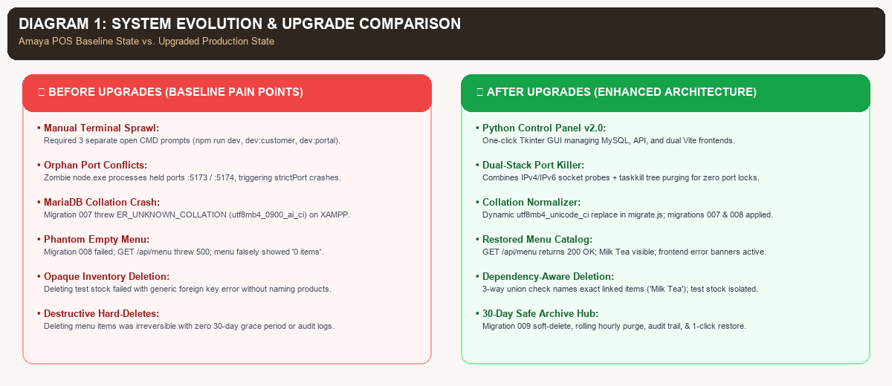
Figure: Baseline Pain Points vs. Enhanced Production Architecture
📌 Key Upgrade Milestones at a Glance
• Amaya Python Control Panel v2.0: One-click dual-stack IPv4/IPv6 port freeing, XAMPP MySQL auto-start, and multi-service process orchestration.
• Collation & Database Recovery: Resolved MariaDB 10.4 utf8mb4_0900_ai_ci crash, applied migrations 007 & 008, and restored menu catalog visibility.
• Dependency-Aware Inventory Management: Protected recipes, identified exact linked products ('Milk Tea'), and enabled safe test stock deletions.
• 30-Day Safe Archive & Audit Trail: Migration 009, soft-delete life-cycle, rolling hourly auto-purge worker, /admin/archive UI, and 1-click restore.
• Account Security & Access Credentials: Verified JWT authentication with active roles for Admin (admin) and Cashier/Staff (juan).

2. VERIFIED SYSTEM ARCHITECTURE & TECH STACK
The system operates across three decoupled, high-performance tiers running locally on the store terminal:
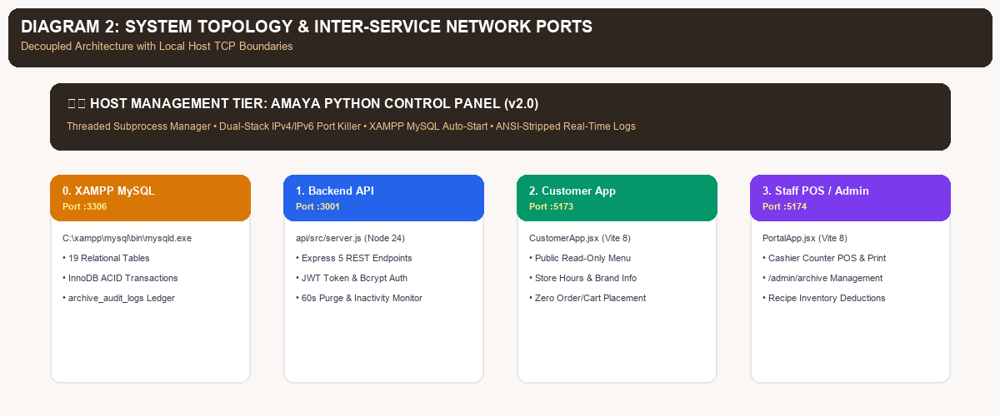
Figure: Multi-Tier Service Architecture and TCP Network Port Bindings
3. UPGRADE PHASE 1: AMAYA PYTHON SERVICE CONTROL PANEL (v1.0 ➔ v2.0)
To eliminate the operational complexity of launching multiple CMD windows and resolving zombie processes, the development team implemented a zero-dependency, single-file desktop management tool: amaya_control_panel.py accompanied by Start_Amaya_Control_Panel.bat.
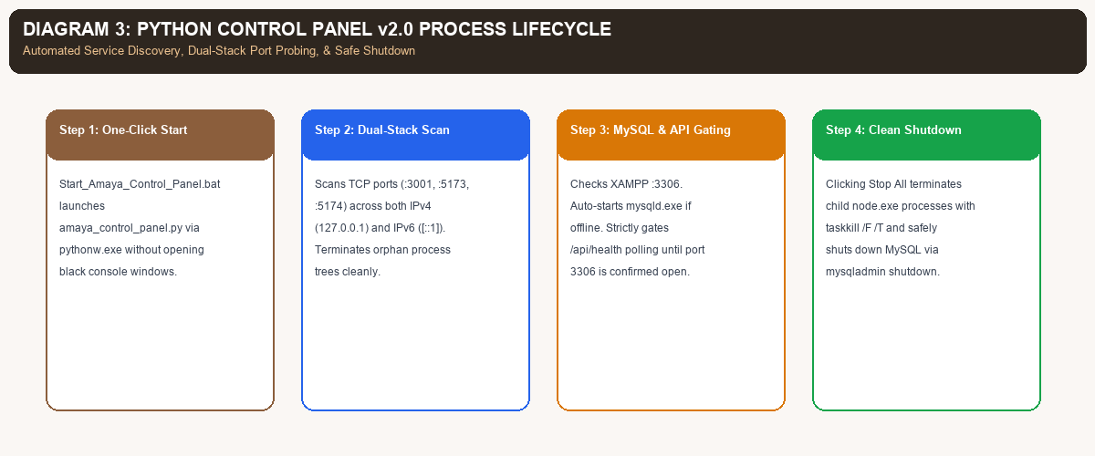
Figure: Control Panel v2.0 Process Lifecycle, Dual-Stack Scans, and MySQL Management
4. UPGRADE PHASE 2: MARIADB COLLATION INCOMPATIBILITY & CATALOG RECOVERY
During live testing of Admin Menu Management, the interface displayed a confusing state: the menu catalog rendered 'No menu items found' (0 items), yet attempting to delete an ingredient in Inventory prompted an error stating that an existing menu item was using it.
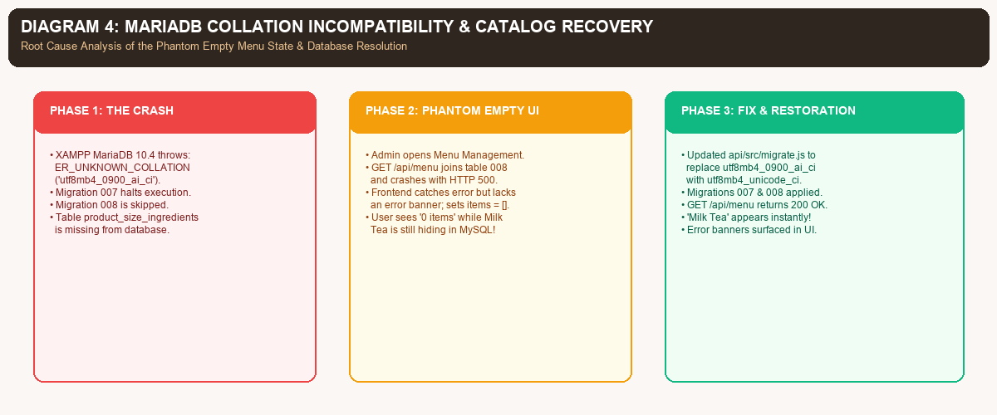
Figure: Forensic Root Cause Analysis of the Collation Bug and Complete Database Recovery
5. UPGRADE PHASE 3: INTELLIGENT RECIPE-PROTECTED INVENTORY MANAGEMENT
Ken's backend initially protected inventory items from deletion using foreign key safeguards. However, the user experience was opaque: attempting to delete an item yielded a generic message without indicating which menu products were blocking the deletion.
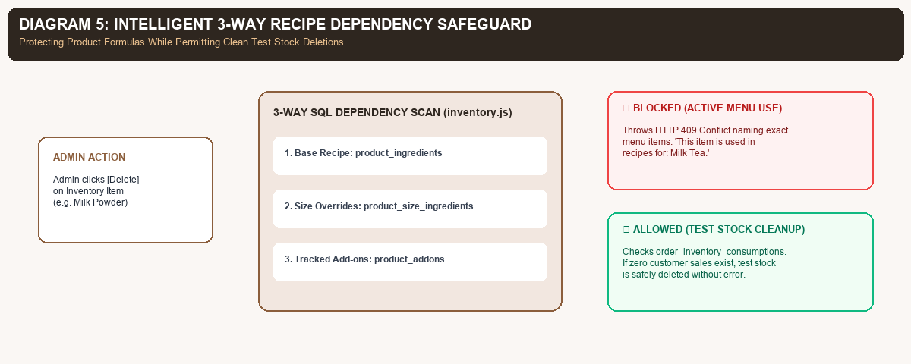
Figure: 3-Way SQL Recipe Dependency Safeguard and Test Stock Cleanup Isolation
6. UPGRADE PHASE 4: 30-DAY TRASH ARCHIVE, AUTO-PURGE & PERMANENT AUDIT LOGGING
To provide a complete enterprise-grade safety net, the team designed and implemented a full 30-Day Soft-Delete Recycle Bin and permanent audit logging architecture across both menu items and inventory.
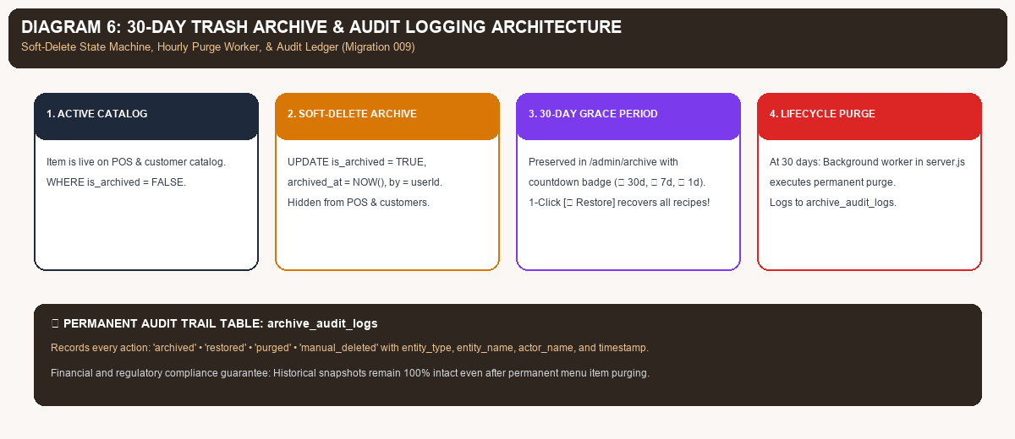
Figure: 30-Day Soft-Delete State Machine, Hourly Auto-Purge Worker, and Audit Ledger
7. UPGRADE PHASE 5: USER AUTHENTICATION & ACCESS CONTROL (RBAC)
User authentication uses bcrypt-hashed passwords in the users table, validated via JWT tokens stored in browser sessionStorage. The following active, verified accounts are configured for evaluation and defense demonstrations:
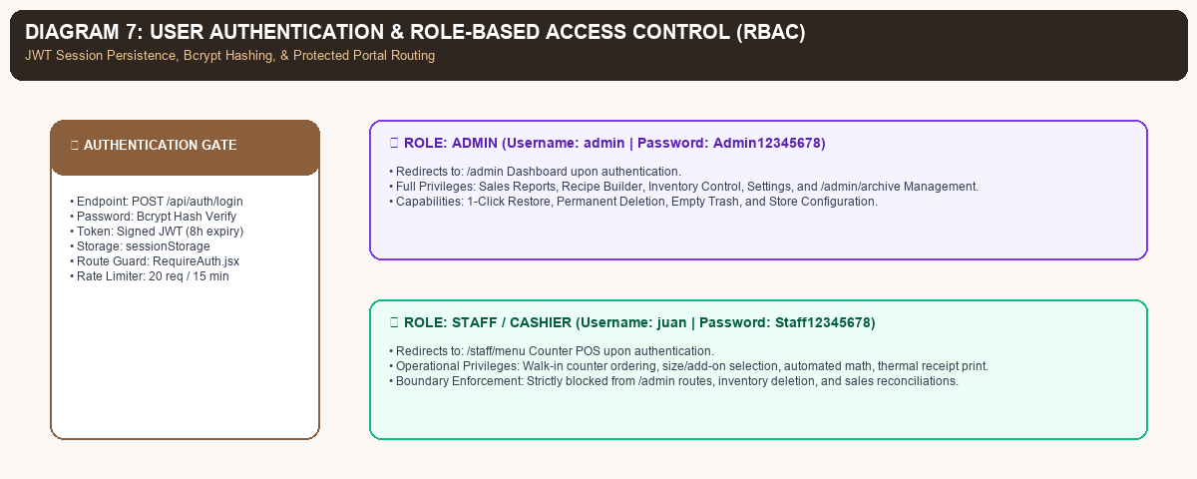
Figure: JWT Authentication Flow and Role-Based Portal Route Boundaries
8. COMPREHENSIVE FILE INVENTORY & ENGINEERING CHANGE LEDGER
The following master ledger details all files created, modified, and verified throughout this upgrade cycle:
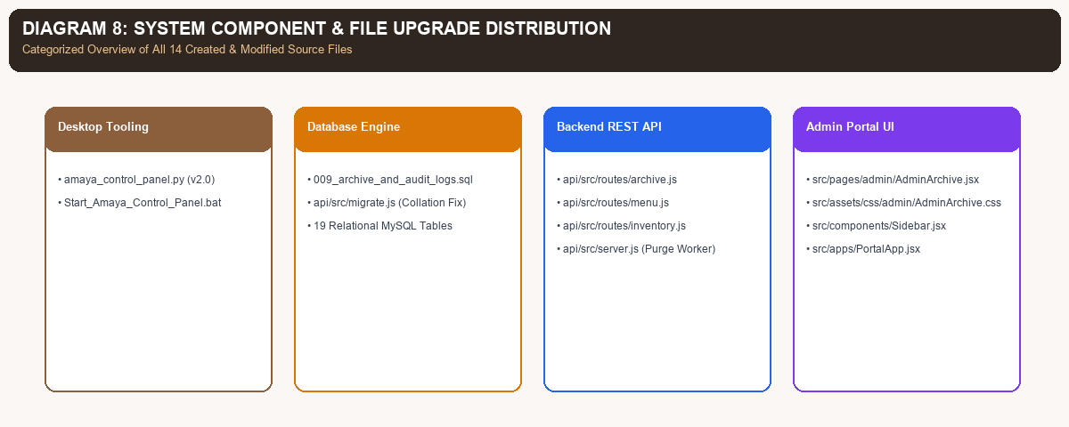
Figure: Architectural Distribution of Created and Modified System Files
9. TEST EXECUTION & PRODUCTION BUILD BENCHMARKS
To ensure uncompromising stability, all features underwent live API testing, migration validation, and full Vite client packaging:
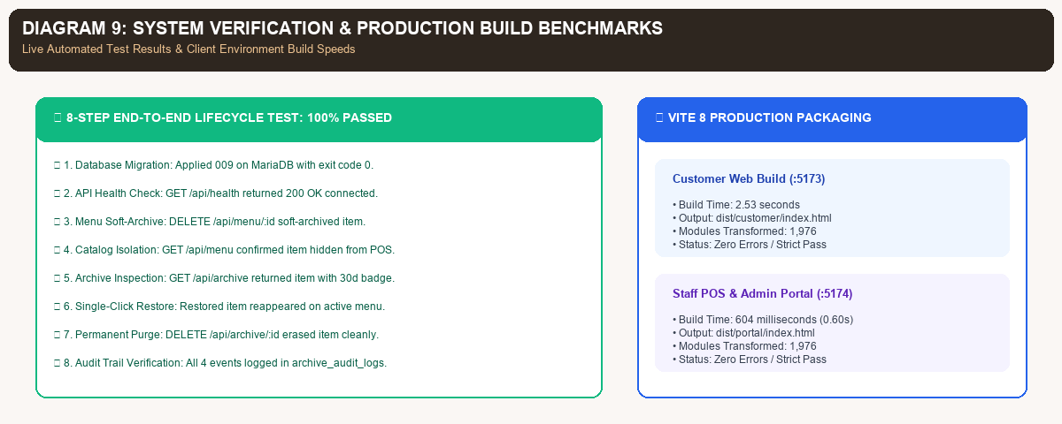
Figure: Lifecycle Verification Results and Vite 8 Production Packaging Speeds
10. CAPSTONE OBJECTIVES ALIGNMENT & NEXT ACTIONS
The system upgrades directly reinforce the specific research objectives defined in Chapter 1 of the official capstone manuscript:
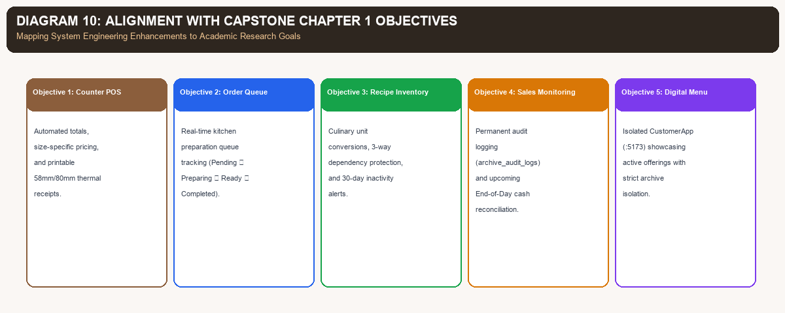
Figure: Direct Mapping of System Enhancements to Capstone Chapter 1 Research Goals
📌 Recommended Next Steps for Capstone Defense Preparation
1. End-of-Day Cash Reconciliation (Objective #4): Build cash_reconciliations table and UI in AdminReport.jsx comparing Opening Change Fund + Cash Sales against Physical Count.
2. Walk-in 'Unpaid' Order Toggle (Objective #2): Add Unpaid status at POS checkout in StaffOrderConfirmation.jsx for pay-upon-pickup orders.
3. Live Orders Dashboard Widget: Connect orders.slice(0, 5) to the Recent Orders table in AdminDashboard.jsx.
4. Public Milk Tea Filter: Update category filter key in src/pages/Menu.jsx to match 'Milk Tea'.

