Joseph McCullough

Twilight – Programming Parody

**1) Purpose of the image**

I will be making a blog post that covers a peculiar aspect of web programming. There are various open source languages that have a considerable number of zealots advocating their supremacy. This zeal is necessary for the language to exist, primarily because the people who develop the languages are doing it for free. Regardless, these open source languages have so many “fan boys” that their gaze has become an unreasonable obsession. My way of mocking this will be a blog post entitled:

“What Twilight can teach us about Programming”

The image will be the logos of the open sourced programming languages used in place of the character of this twilight dvd cover. (Image URL: <http://www.twilightguy.com/wp-content/uploads/2009/01/twilight-us-dvd.jpg>)

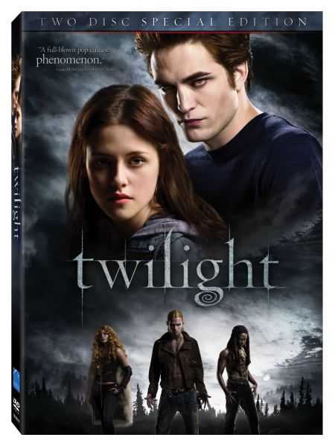

By replacing the characters with the logos, people will be able to identify the teenage angst associated with twilight and its application to open source zealots.

(Note: The spine of the dvd cover does not need to be included)

**2) The logos that will be used.**

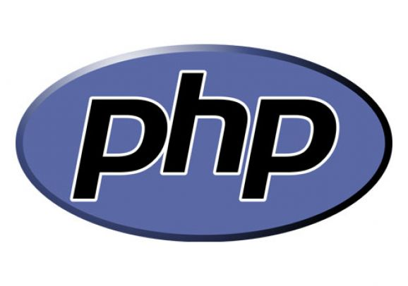

Programming Language: PHP

Image URL: <http://www.frooit.com/imgs/iconos/php-logo.jpg>

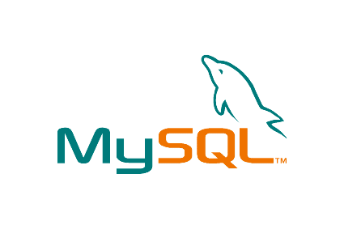

Programming Language: MySQL

Image URL: <http://www.n2h.it/blog/wp-content/uploads/2008/05/mysql.gif>

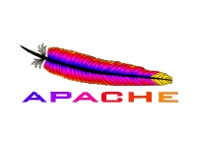

Programming Language: Apache Server

Image URL: <http://www.webdesignblog.biz/wp-content/uploads/2009/09/apache-http-server-logo1.jpg>



Programming language: Ruby

Image URL: <http://www.prestonlee.com/wp-content/uploads/2008/09/ruby.png>

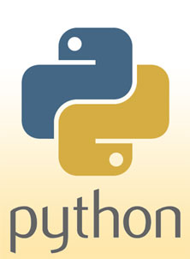

Programming language: Python

Image URL: <http://www.symbian-freeware.com/img2/python_logo.jpg>

**3) Designing notes**

PHP should be Edward (that pale fuck in the top right) and MySQL should be bella (Edwards angsty tramp)

The remaining three logos will take the place of the three characters below. It doesn’t really matter which of the remaining programming languages (Apache, ruby, python) you use in place of the three smaller characters.

I’d like the typography to be the same. The font is called called Zephyr I believe. You can download the brush for it here. It’s $29.95 for the actual commercial font, so maybe you could draw it or just use the brushes.

<http://laceface1011.deviantart.com/art/Twilight-Font-Brushes-83338967>

The critic quotes and the “two disc special edition” don’t need to be in.

Thanks for doing this!