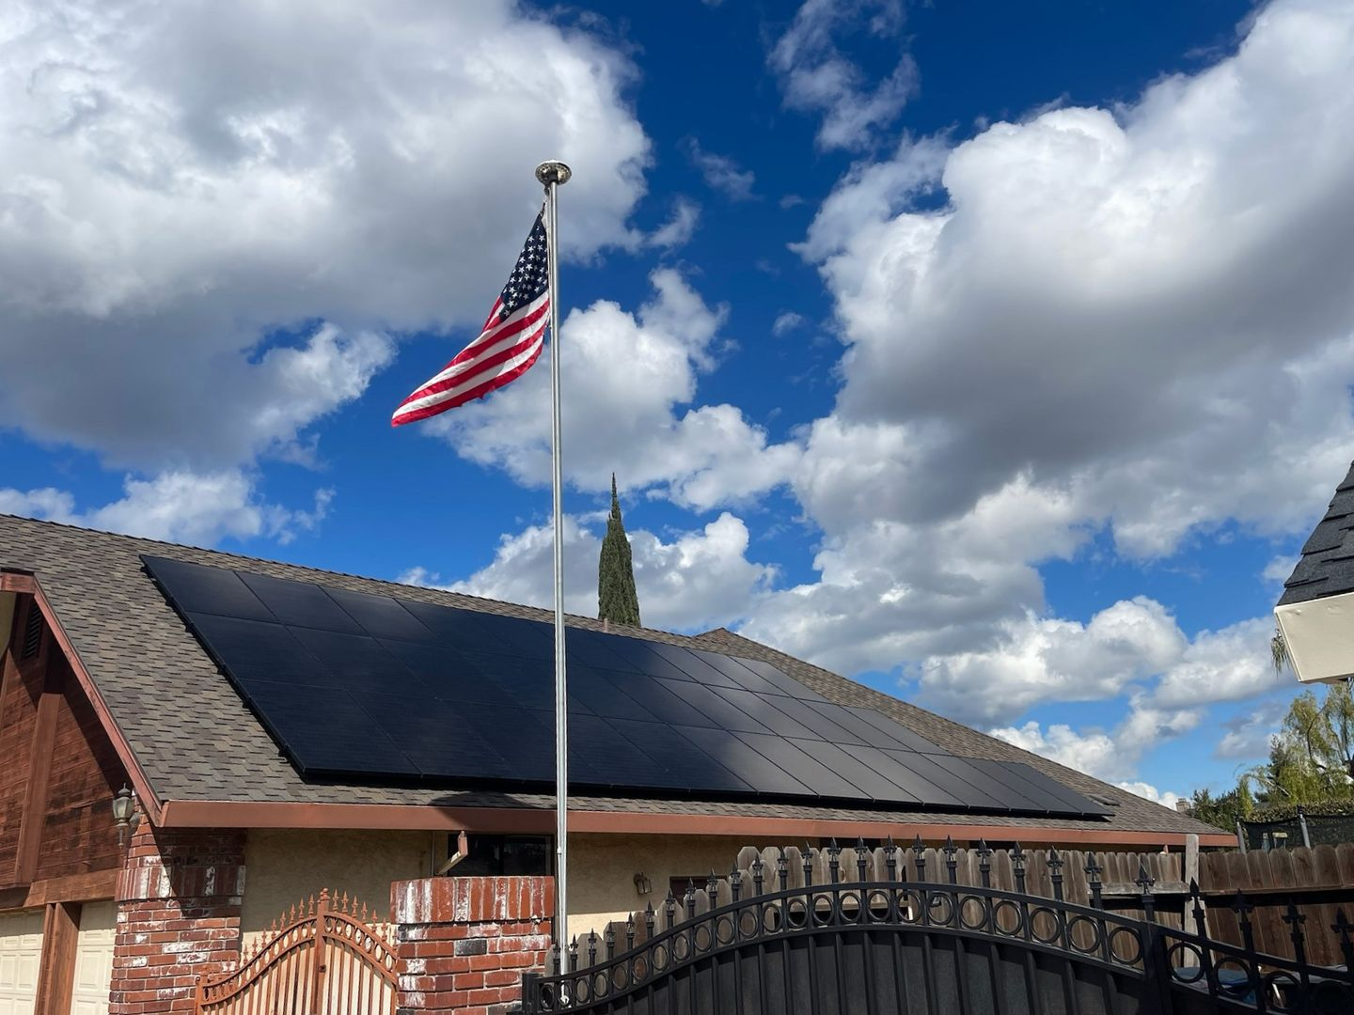
Generated date: July 24, 2026
Company
Mid-State Solar
+1 (209) 551-7800
www.midstatesolar.com
450 Glass Ln Suite A1, Modesto, CA 95356, USA
aaron@midstatesolar.com
License #370265
Your energy consultant
Aaron Yakligian
aaron@midstatesolar.com
+1 (209) 480-4941
Proposal for a 10.875 kW solar project
Option 1

Dave Anderson
20058 Bloss Ave,
Hilmar, CA 95324, USA
Solar details
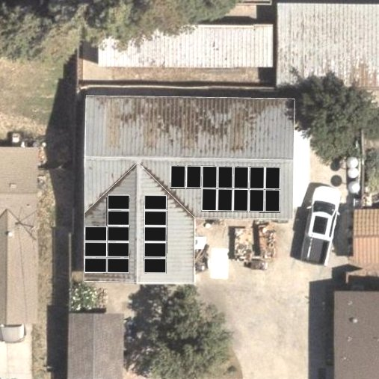
System size
10.875 kW DC
Panels
MSX10-435HN0B
Inverters
IQ8A-72-2-US [240V]
CEC-AC rating
9.35kW AC
Estimated First Year Production
16,588 kWh
Consumption Offset
101%

Array details
Panel: MSX10-435HN0B
Quantity: 12 Watts: 435 Azimuth: 181° (2) Tilt: 18.43° Mounting: Flush
Panel: MSX10-435HN0B
Quantity: 5 Watts: 435 Azimuth: 90° (2) Tilt: 18.43° Mounting: Flush
Panel: MSX10-435HN0B
Quantity: 8 Watts: 435 Azimuth: 270° (2) Tilt: 18.43° Mounting: Flush

Cash
Old utility bill | $236.22/month
Estimated new utility bill | $51.67/month
Estimated bill difference | $184.55/month

# Actual new utility bill may vary if there are changes in utility rates, adjustments to energy usage, or modifications to the consumption profile.

Pricing
 | Price | Total price
Base Price for Solar  Based on a 10.875 kW installation | $32,625.00
Gross Cost | $32,625.00 | $32,625.00
Cost after rebates & incentives* | $32,625.00 | $32,625.00

Note:
* Not everyone is eligible for credits, incentives, or rebates or can fully use them. Please consult your tax professional or legal professional for further information.
* Incentives are subject to change. The actual amount can be higher or lower than what is quoted and may not stay at a fixed rate over time. It can also change based on the tax bracket you are in.

Materials
Material | Description | Data sheet | Quantity
Panels | MSX10-435HN0B (435 Watts) | Download | 25
Inverters | IQ8A-72-2-US [240V] | Download | 25

Usage Breakdown
Estimated First Year Consumption
16,500.0 kWh
Estimated First Year Production
16,588.3 kWh
Consumption Offset
101%

Estimated Savings

Month-by-month details
Month (2027) | Production AC (kWh) | Grid usage (kWh) | New utility bill | Net credits (kWh) | Net savings
JAN | 702.47 | 465.14 | $74.05 | 0 | $129.58
FEB | 871.86 | 157.73 | $52.05 | 0 | $130.15
MAR | 1,324.72 | 0 | $35.73 | 239.2 | $147.94
APR | 1,604.09 | 0 | $38.73 | 495.1 | $156.50
MAY | 1,895.18 | 0 | $38.52 | 639.5 | $183.01
JUN | 2,002.73 | 0 | $43.62 | 474.6 | $246.35
JUL | 2,000.7 | 0 | $44.00 | 125.8 | $300.68
AUG | 1,834.69 | 0 | $45.13 | 1 | $387.77
SEP | 1,563.85 | 105.07 | $56.96 | 0 | $244.47
OCT | 1,268.04 | 0 | $40.35 | 0.4 | $185.17
NOV | 841.86 | 276.6 | $73.15 | 0 | $138.28
DEC | 678.06 | 505.87 | $77.73 | 0 | $127.50
Total | 16,588.3 kWh | 1,510.4 kWh | $620.02 | $62.74 | $2,277.39

* For Net Savings, the cash price is not included in the monthly breakdown because it is assumed that it will be paid upfront (Month 0).

