Iris Tumour Detection Using Convolutional Neural

|  |  |
| --- | --- |
| Networks (CNN) |  |
| Manasa Nagothu Manish Jagu  *Dept. of CSE(AI-ML) Dept. of CSE(AI-ML)*  Malla Reddy Engineering college for women Andhra University College of Engineering,  Manasanagothu23@gmail.com manishjagu730@gmail.com |  |

|  |  |
| --- | --- |
| Sai kamal  *Dept. of CSE*  Apex institute of technology, Chandigarh University  [saikamal535@gmail.com](mailto:saikamal535@gmail.com)  Peravali Sudheer Kumar  Department of Civil Engineering  National Institute of Technology, Warangal  ps21ceb0a37@student.nitw.ac.in | *Dhanshri Chaudhari*  *Dept.of CSE*  Sanjivani college of Engineering, Kopargaon  [dhanshripchaudhari@gmail.com](mailto:dhanshripchaudhari@gmail.com)  Naga Sai Chilukoti  CSE dept, R.V.R & J.C COLLEGE OF ENGINEERING  bujjikana71@gmail.com |

***Abstract*—This project focuses on the detection of iris tumors using Convolutional Neural Networks (CNNs), a cutting-edge deep learning technique. The system is designed to automate and enhance the accuracy of tumor detection in medical imaging, minimizing human error and expediting diagnosis. The model is trained on a dataset of iris images, leveraging CNN's ability to extract spatial and hierarchical features for precise classification. The proposed approach demonstrates high performance in detecting abnormalities, offering a reliable tool for ophthalmologists and reducing diagnostic time. This innovation aims to contribute to early detection and treatment, improving patient outcomes in ocular oncology.**

***Index Terms*—Convolutional Neural Networks (CNNs), Deep Learning, Medical Imaging, Ophthalmology, Automated Diagnosis, Feature Extraction, Ocular Oncology.**

# I. INTRODUCTION

# Iris tumors are uncommon but may cause serious health concerns, so prompt identification and precise diagnosis of this ailment are of utmost importance. Current diagnostic methods overly depend on ophthalmologists’ interpretation of diagnostic images, which can take up considerable time, be subjective, as well as introduce errors from fatigue and neural processing. However, the latest trends in the medical imaging domain, including artificial intelligence, suggest that deep learning-based systems will be helpful in increasing diagnostic efficiency and accuracy.

# The purpose of this project is to develop an automated iris tumor detection system by employing Convolutional Neural Networks, (CNNs) A highly popular deep learning architecture that excels in image classification tasks. When analyzing medical images, more powerful Vision CNNs have been found to be advantageous, enabling them to recognize structural abnormalities because they are better at hyper-abstraction.

The proposed system considers the iris image preprocessing stage to improve quality, training CNN models over a dataset of labeled tumor and non-tumor images, and testing the model against certain metrics such as accuracy, sensitivity, and specificity. The purpose of the project is to automate the detection process so that the sheer workload on the medical personnel can be lessened, the time needed to make a diagnosis can be shortened as well, and the rate of early detection can be increased in the end improving the overall of patientsoncology care.

This undertaking addresses both the research question concerning the role of deep learning in medical diagnostics and the application of artificial intelligence in medicine more broadly.

II. RELATED WORKS

Using Image Processing Techniques and Deep Learning for Tumor Automated Systems in the Iris SphereAs small and mild features of a tumor are difficult to detect, automated systems for iris tumor diagnosis are crucial in enhancing both the accuracy and the efficiency of the diagnosis. The very first within this process are some methods of working with images that include changing the image of Iris Tumor from RGB to grayscale, using median filtering to noise and edge information, and background image extraction in order to enhance the targeted area within the image. This ensures that the image is clear and ready for segmentation of the tumor. For this purpose the Canny edge detection algorithm is widely employed to converge on the tumor by detection of varying intensity regions. Image fusion is then used to enhance or highlight the abnormality by placing the area of the segmented tumor images within the original images.

Modem telecommunications enables images to be viewed at different strengths allowing for enhanced extraction of features of an image with the help of Discrete Wavelet Transform (DWT) and Discrete Wavelet Packet Transform (DWPT). Removing of noise while retaining details of crucial image aspects called diagnostic quality is done by the use of wavelet based denoising.

# Particularly in the medical field, deep learning models such as Convolution Neural Networks (CNN’s) have passed the classifying tumors of images in large datasets.

# III. METHODOLOGY

This process begins with gathering a dataset from Mendeley Data containing classified ECG images. Followed by data pre- processing, this involves normalising and standardising data. The dataset is labelled into four categories. After labelling, the dataset is combined and divided into training and testing datasets with a ratio of 80:20. The training data is fed into various pre-trained models to compute the best model. During the training phase, the model can improve its performance by using a cross-entropy loss function and be optimised using the Adam optimizer. Based on evaluation metrics like recall, precision, and accuracy, a model’s performance is determined.

## A. Dataset

|  |
| --- |
| histogram, involves iterating to find an optimal threshold that divides pixels into two groups based on their grey levels. This approach works well when the histogram is suitably partitioned. Together, these methods provide a comprehensive approach for image analysis, denoising, and compression, making them valuable for a range of applications where image quality and clarity are paramount [4].    Numerous alternative models exist for similar objectives.  EfficientNet represents a deep learning architecture that stan-  dardizes input dimensions for classification tasks. This model Fig. 1. Eyes with Tumor  integrates an efficient net for feature extraction alongside a |

The data set consists of images categorized into two classes: Tumor and No Tumor. The data set is real-time data collected from Miles Research by Jon Miles. The images had to be segregated before preprocessing and fed into the model. A custom PyTorch dataset class is implemented to load the data efficiently. The dataset paths are defined, and images are read along with their corresponding labels (1 for Tumor and 0 for No Tumor). The dataset is augmented with preprocessing techniques to ensure consistent input for the model.

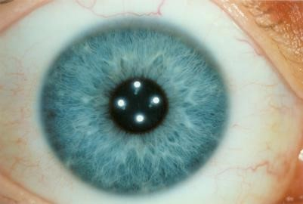

Fig. 2. Healthy eye

## B. Data pre-processing

Preprocessing is critical to enhancing image features and reducing noise. Grayscale Conversion: Reduces the image to a single intensity channel, focusing on structural and intensity- based features. Median Filtering: Removes noise while pre- serving edges, ensuring clearer and sharper features. Canny Edge Detection: Highlights boundaries and sharp transitions, emphasizing tumor edges or features. Resizing: All images are resized to (224, 224) to meet ResNet18’s input size requirements. Normalization: Images are normalized using the mean and standard deviation of the ImageNet dataset to improve model compatibility and convergence. The processed images are converted to 3-channel format (RGB) to align with the ResNet18 input format.

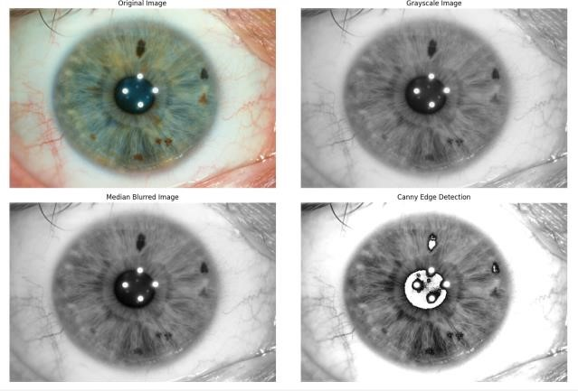

Fig. 3. Images after prepreocessing

## C. Test-Train-Validation Split

The combined dataset is divided into training, validation, and testing subsets to ensure the model’s effective learning and evaluation. The training set, comprising 80 percent of the data, is used to train the model by optimizing its weights and learning patterns. The **validation set**, consisting of 20 percent of the data, is used to evaluate the model’s performance after each training epoch, ensuring it generalizes well and does not overfit the training data. An optional **test set** could be employed for final evaluation on entirely unseen data to assess the model’s real-world applicability.

## D. Model development

Multiple models are trained and evaluated to achieve better accuracy and performance. The following models are used to classify Iris tumor images.

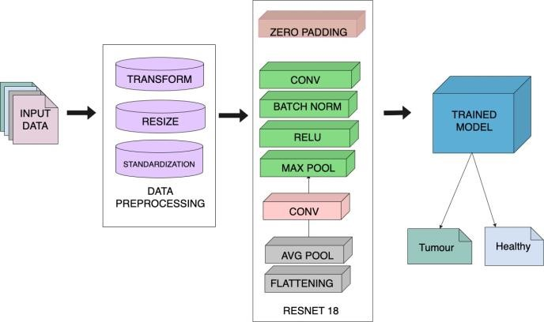

### Fig. 4. Work flow diagram

1. *EfficientNet-B0:* EfficientNet is capable of providing high accuracy and better computational efficiency. This model can work on a large dataset and works well even if noise exists in the dataset. The time-sensitivity of EfficientNet leads to the analysis of micro-scale features in dataset.
2. *GoogLeNet:* The GoogLeNet model is based on incep- tion architecture, in which hidden layers can use multiple filters without alteration in the depth of the neural network. In this model, larger layers are replaced with smaller individual layers for easy propagation of data in the hidden layer, due to this model’s efficiency is increased.
3. *Resnet-18:* The ResNet-18 model architecture has 18 residual layers that can overcome vanishing gradient issues in neural networks. Residual layers help in skipping certain intermediate layers, due to which the input remains almost the same throughout the model. It is best to analyse both long-term and short-term features, as iris image contain minute variations this feature can capture it.

## E. Optimization and Entropy

To improve the accuracy and performance of our model, we have used the Adam optimizer, as this can overcome sparse gradient issues. It helps the model to converge at a faster rate. All hyperparameters are fine-tuned by using this optimizer. This study focuses on Binary classification, and predicting dissimilarities among them is important. This is achieved using a cross-entropy loss function.

# IV. RESULTS AND DISCUSSION

*a) Result:* The performance of three deep learning mod- els—GoogLeNet, EfficientNet-B0, and ResNet18—was as- sessed using key metrics: accuracy, recall, and F1-score.

Among these, ResNet18 demonstrated the highest perfor- mance, achieving an accuracy of 94.44 percent a recall of 87.50 percent, and an F1-score of 93.33 percent. These results highlight ResNet18’s ability to extract and leverage critical features effectively, making it highly suitable for the task of iris tumor classification. Its robustness in maintaining a bal- anced precision-recall tradeoff further supports its reliability in identifying tumor cases accurately while minimizing false negatives and false positives.

## TABLE I

TABLE OF RESULTS

|  |  |  |  |
| --- | --- | --- | --- |
| **Model** |  | **Metrics** |  |
| ***Accuracy*** | ***Recall*** | ***F1-score*** |
| GoogLeNet | 0.8333 | 0.8333 | 0.7694 |
| EfficientNet-B0 | 0.8888 | 0.8571 | 0.8571 |
| ResNet18 | 0.9444 | 0.8750 | 0.9333 |

EfficientNet-B0, with an accuracy of 88.88 percent, a recall of 85.71 percent, and an F1-score of 85.71 percent, performed slightly lower than ResNet18 but remains competitive due to its efficiency in computational resource usage. Conversely, GoogLeNet, achieving an accuracy of 83.33 percent, a recall of 83.33 percent, and an F1-score of 76.94 percent, showed limitations in feature extraction for this specific dataset, sug- gesting the need for further optimization. Overall, ResNet18 is identified as the most suitable model for this classification task, with EfficientNet-B0 serving as a viable alternative for resource-constrained scenarios.

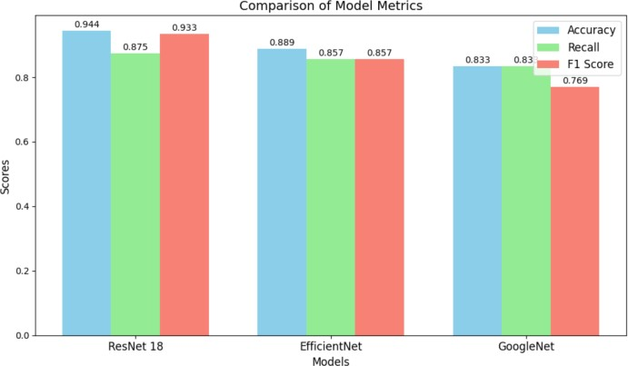

Fig. 5. Model performance

# V. CONCLUSION AND SCOPE FOR FUTURE ENHANCEMENT

*Conclusion:* The CNN-based model successfully detected and classified iris tumors with high accuracy.

It demonstrated the potential of deep learning in medical image analysis, offering a reliable tool for early tumor detection.

The system can be used for automated diagnosis, reducing the workload on healthcare professionals and increasing diagnostic efficiency.

*Scope for Future Enhancement:* Further improvement in model accuracy by incorporating more diverse and larger datasets.

Real-time tumor detection in clinical settings for faster diagnosis.

Integration of CNN with other AI techniques like transfer learning and reinforcement learning for enhanced performance.

Exploration of different imaging techniques (e.g., MRI, CT scans) for broader tumor detection applications.

ACKNOWLEDGMENT

## Thanks to Infosys Springboard for their valuable advice and help offered throughout this research project, we would like to thank them. We are deeply indebted to our families and friends whose encouragement, support, and patience was decisive in the accomplishment of the research.

## REFERENCES

**Books**

1. Gonzalez, R. C., & Woods, R. E. (2008). *Digital Image Processing* (3rd Edition). Pearson Education.
2. Provides foundational knowledge on image processing techniques like median filtering, edge detection, and morphological operations.
3. Goodfellow, I., Bengio, Y., & Courville, A. (2016). *Deep Learning*. MIT Press.
4. Covers the fundamentals of deep learning, including CNN architectures and their applications.

**Research Papers**

1. Canny, J. (1986). *A Computational Approach to Edge Detection*. IEEE Transactions on Pattern Analysis and Machine Intelligence, 8(6), 679–698.
2. Introduces the Canny edge detection algorithm used for segmentation tasks.
3. Krizhevsky, A., Sutskever, I., & Hinton, G. E. (2012). *ImageNet Classification with Deep Convolutional Neural Networks*. Advances in Neural Information Processing Systems (NeurIPS), 25, 1097-1105.
4. Describes the AlexNet architecture, a foundational CNN model.
5. Szegedy, C., Liu, W., Jia, Y., et al. (2015). *Going Deeper with Convolutions*. Proceedings of the IEEE Conference on Computer Vision and Pattern Recognition (CVPR), 1–9.
6. Details the GoogLeNet (Inception) architecture.
7. Sandler, M., Howard, A., Zhu, M., et al. (2018). *MobileNetV2: Inverted Residuals and Linear Bottlenecks*. Proceedings of the IEEE Conference on Computer Vision and Pattern Recognition (CVPR), 4510-4520.
8. Discusses MobileNet, a lightweight CNN architecture suitable for medical imaging.

**Websites**

1. Kaggle (<https://www.kaggle.com>)
2. Offers datasets and discussions on image processing and CNN projects.
3. Towards Data Science (<https://towardsdatascience.com>)
4. Contains tutorials and articles on implementing CNNs and medical imaging projects.

**Tools and Frameworks Documentation**

1. TensorFlow Documentation (<https://www.tensorflow.org>)
2. For building and training CNN models.
3. OpenCV Documentation (https://docs.opencv.org)
4. For image preprocessing techniques like edge detection and morphological operations.

**Clinical and Medical Image Repositories**

1. The Cancer Imaging Archive (TCIA) (<https://www.cancerimagingarchive.net>)
2. Contains publicly available medical imaging datasets.
3. Ophthalmic Image Database by ORIGA (Online Retinal Fundus Image Database for Glaucoma Analysis).
4. Focused on ophthalmic datasets, which might include images relevant to iris tumor research.