Employee Leave Management (ELM)
Workflow Specifications — Final Synchronized v1.6
Corrected Basis-Workflow completeness • 17 complete Basis Workflows • 4 Composite Workflows • authoritative STTs

1. Revision Scope and Authority
Version 1.6 corrects a Basis-Workflow derivation defect in v1.5: reusable substitute-consent/recovery prefixes were incorrectly counted as Basis Workflows, leaving some complete valid UC sequences (for example EL-UC-001 → EL-UC-002 → EL-UC-003 for substitute-required CL/RH) without a corresponding Basis Workflow. No PS, CFR/AFR, UC, or BR semantics are changed.
The Composite Workflows remain semantically unchanged. Their constituent Basis-Workflow references are updated to the corrected complete-path set. The State-Transition Table (STT) remains authoritative and each diagram is a corresponding visual view.

2. Workflow Derivation Decisions
- Derive workflows only from validated state-changing UCs and applicable BRs.
- A Basis Workflow shall be a complete finite valid progression from a meaningful process start/context to a meaningful business outcome; a reusable prefix, suffix, or recovery fragment is not by itself a Basis Workflow unless it independently constitutes such a progression.
- A sequence such as Apply → Substitute Response → Unit Head Review must therefore appear as a complete Basis Workflow when it is a valid business path.
- When terminal outcomes differ only in the outcome of the same final decision UC and all preceding steps are identical, they may be represented as alternative terminal rows in one Basis Workflow to avoid duplicate path specifications.
- A purely configuration-controlled optional/bypass step (for example the Establishment routing step) may remain within the same Basis Workflow when it does not create a different business outcome.
- For a meaningful loop, represent zero traversal and exactly one traversal; do not enumerate further equivalent repetitions.
- Composite Workflows integrate complete Basis Workflows and may additionally represent cross-cutting transitions such as pending withdrawal and routing-changing SLA escalation.
- ELM is not its own UC actor. System may appear in an STT only as the performer of a meaningful automatic transition; time/external events remain triggers/guards.
- Pending requests are not modified in place. Change before final approval is handled through withdrawal and, if needed, a fresh application.
- Year-end processing and reminder/notification-only SLA handling remain event-triggered UC+BR behavior, not standalone workflows.
- The STT is authoritative; diagrams must correspond to it exactly.

3. Workflow Registry
Workflow ID | Workflow Name | Type | Purpose / Scope | Constituent / Related Workflows | Primary Related UCs
BW-EL-01 | New CL/RH — No Substitute Gate | Basis | CL/RH: no substitute → Unit Head decision | CW-EL-01 | EL-UC-001, EL-UC-003
BW-EL-02 | New CL/RH — Substitute Accepted (No Loop) | Basis | CL/RH: substitute accept → Unit Head decision | CW-EL-01 | EL-UC-001, EL-UC-002, EL-UC-003
BW-EL-03 | New CL/RH — Substitute Declined, Replacement Accepted (One Loop Traversal) | Basis | CL/RH: one decline/replacement loop → Unit Head decision | CW-EL-01 | EL-UC-001, EL-UC-002, EL-UC-019, EL-UC-003
BW-EL-04 | New Higher-Sanction Leave — No Substitute Gate | Basis | Higher-sanction: no substitute → final decision | CW-EL-01 | EL-UC-001, EL-UC-003, EL-UC-004, EL-UC-005
BW-EL-05 | New Higher-Sanction Leave — Substitute Accepted (No Loop) | Basis | Higher-sanction: substitute accept → final decision | CW-EL-01 | EL-UC-001, EL-UC-002, EL-UC-003, EL-UC-004, EL-UC-005
BW-EL-06 | New Higher-Sanction Leave — Substitute Declined, Replacement Accepted (One Loop Traversal) | Basis | Higher-sanction: one decline/replacement loop → final decision | CW-EL-01 | EL-UC-001, EL-UC-002, EL-UC-019, EL-UC-003, EL-UC-004, EL-UC-005
BW-EL-07 | Director Self-Sanction — No Substitute Gate | Basis | Director: no substitute → self-sanction decision | CW-EL-01 | EL-UC-001, EL-UC-005
BW-EL-08 | Director Self-Sanction — Substitute Accepted (No Loop) | Basis | Director: substitute accept → self-sanction decision | CW-EL-01 | EL-UC-001, EL-UC-002, EL-UC-005
BW-EL-09 | Director Self-Sanction — Substitute Declined, Replacement Accepted (One Loop Traversal) | Basis | Director: one decline/replacement loop → self-sanction decision | CW-EL-01 | EL-UC-001, EL-UC-002, EL-UC-019, EL-UC-005
BW-EL-10 | CL/RH Approved-Leave Cancellation | Basis | CL/RH cancellation → Unit Head decision | CW-EL-02 | EL-UC-008, EL-UC-003
BW-EL-11 | Higher-Sanction Approved-Leave Cancellation | Basis | Higher-sanction cancellation → final decision | CW-EL-02 | EL-UC-008, EL-UC-003, EL-UC-004, EL-UC-005
BW-EL-12 | Ongoing Leave Extension — No Substitute Gate | Basis | Extension: no substitute → final decision | CW-EL-03 | EL-UC-009, EL-UC-003, EL-UC-004, EL-UC-005
BW-EL-13 | Ongoing Leave Extension — Substitute Accepted (No Loop) | Basis | Extension: substitute accept → final decision | CW-EL-03 | EL-UC-009, EL-UC-002, EL-UC-003, EL-UC-004, EL-UC-005
BW-EL-14 | Ongoing Leave Extension — Substitute Declined, Replacement Accepted (One Loop Traversal) | Basis | Extension: one decline/replacement loop → final decision | CW-EL-03 | EL-UC-009, EL-UC-002, EL-UC-019, EL-UC-003, EL-UC-004, EL-UC-005
BW-EL-15 | Normal Resumption Review | Basis | Normal resumption → review | CW-EL-04 | EL-UC-010, EL-UC-011
BW-EL-16 | Early Resumption Review | Basis | Early resumption → review and synchronize | CW-EL-04 | EL-UC-010, EL-UC-011
BW-EL-17 | Late Resumption Review | Basis | Late resumption → review and synchronize | CW-EL-04 | EL-UC-010, EL-UC-011
CW-EL-01 | New Leave Processing and Pending Withdrawal | Composite | Integrated new-leave progression + pending withdrawal | BW-EL-01–09 | EL-UC-001–005, EL-UC-007, EL-UC-019
CW-EL-02 | Approved Leave Cancellation | Composite | Integrated approved-leave cancellation | BW-EL-10–11 | EL-UC-008, EL-UC-003–005
CW-EL-03 | Ongoing Leave Extension | Composite | Integrated ongoing-leave extension + withdrawal | BW-EL-12–14 | EL-UC-009, EL-UC-002–005, EL-UC-007, EL-UC-019
CW-EL-04 | Resumption Review | Composite | Integrated normal/early/late resumption review | BW-EL-15–17 | EL-UC-010, EL-UC-011

4. Basis Workflow Specifications
All Basis Workflows below are complete finite valid paths; no prefix/recovery fragment is counted as a Basis Workflow.

BW-EL-01 — New CL/RH — No Substitute Gate
Type | Basis
Purpose / Scope | Process a valid CL/RH application that does not require substitute consent from submission through the Unit Head final decision.
Trigger | Employee submits a valid CL/RH request for which substitute coverage is not required.
Participants | Employee; Unit Head
Related Workflows | CW-EL-01
Related CFRs | CFR-EL-002–003, CFR-EL-013, CFR-EL-016
Related UCs | EL-UC-001, EL-UC-003
Related BRs | BR-EL-001–013, BR-EL-016, BR-EL-030–031

Authoritative State-Transition Table
S. No. | From State | Actor | Use Case ID / Name | Guard / Outcome | Resulting State | BR Reference(s)
1 | Draft / Not Submitted | Employee | EL-UC-001 / Apply for Leave | Submission valid; no substitute required; applicant is not Director | Awaiting Unit Head Review | BR-EL-001–013, BR-EL-030–031
2 | Awaiting Unit Head Review | Unit Head | EL-UC-003 / Review Leave-Related Request at Unit Head | CL/RH; outcome = Approve | Approved | BR-EL-016
3 | Awaiting Unit Head Review | Unit Head | EL-UC-003 / Review Leave-Related Request at Unit Head | CL/RH; outcome = Reject | Rejected | BR-EL-016
Specification Notes
- The two terminal outcomes share the same complete UC sequence; they are retained as alternative terminal rows rather than duplicated as separate Basis Workflows.

Workflow Diagram
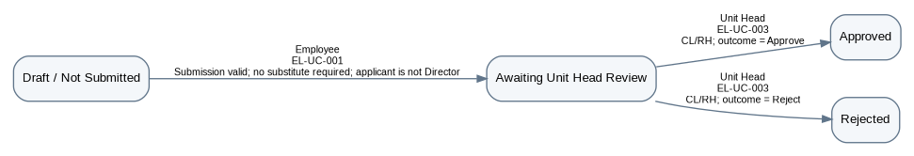

BW-EL-02 — New CL/RH — Substitute Accepted (No Loop)
Type | Basis
Purpose / Scope | Process a valid CL/RH application requiring substitute coverage through accepted substitute consent and the Unit Head final decision.
Trigger | Employee submits a valid CL/RH request for which substitute coverage is required.
Participants | Employee; Substitute / Responsibility Holder; Unit Head
Related Workflows | CW-EL-01
Related CFRs | CFR-EL-002–003, CFR-EL-011–013, CFR-EL-016
Related UCs | EL-UC-001, EL-UC-002, EL-UC-003
Related BRs | BR-EL-001–016, BR-EL-030–031

Authoritative State-Transition Table

S. No. | From State | Actor | Use Case ID / Name | Guard / Outcome | Resulting State | BR Reference(s)
1 | Draft / Not Submitted | Employee | EL-UC-001 / Apply for Leave | Submission valid; substitute required | Awaiting Substitute Response | BR-EL-001–015, BR-EL-030–031
2 | Awaiting Substitute Response | Substitute / Responsibility | EL-UC-002 / Respond to Substitute Request | Outcome = Accept; applicant is not Director | Awaiting Unit Head Review | BR-EL-014–015
3 | Awaiting Unit Head Review | Unit Head | EL-UC-003 / Review Leave-Related Request at Unit Head | CL/RH; outcome = Approve | Approved | BR-EL-016
4 | Awaiting Unit Head Review | Unit Head | EL-UC-003 / Review Leave-Related Request at Unit Head | CL/RH; outcome = Reject | Rejected | BR-EL-016
Specification Notes
- This is the previously missing complete Basis path EL-UC-001 → EL-UC-002 → EL-UC-003 for CL/RH.

Workflow Diagram
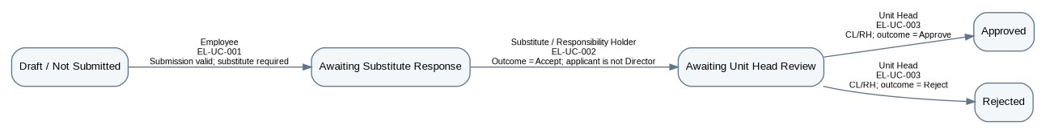

BW-EL-03 — New CL/RH — Substitute Declined, Replacement Accepted (One Loop Traversal)
Type | Basis
Purpose / Scope | Process a valid CL/RH application through one substitute-decline recovery traversal, replacement acceptance, and the Unit Head final decision.
Trigger | Employee submits a valid CL/RH request requiring substitute coverage; the first nominee declines.
Participants | Employee; Substitute / Responsibility Holder; Unit Head
Related Workflows | CW-EL-01
Related CFRs | CFR-EL-002–003, CFR-EL-011–013, CFR-EL-016
Related UCs | EL-UC-001, EL-UC-002, EL-UC-019, EL-UC-003
Related BRs | BR-EL-001–016, BR-EL-030–031

Authoritative State-Transition Table
S. No. | From State | Actor | Use Case ID / Name | Guard / Outcome | Resulting State | BR Reference(s)
1 | Draft / Not Submitted | Employee | EL-UC-001 / Apply for Leave | Submission valid; substitute required | Awaiting Substitute Response | BR-EL-001–015, BR-EL-030–031
2 | Awaiting Substitute Response | Substitute / Responsibility Holder | EL-UC-002 / Respond to Substitute Request | Outcome = Decline | Applicant Action Required | BR-EL-014–015
3 | Applicant Action Required | Employee | EL-UC-019 / Nominate Replacement Substitute After Decline | Eligible replacement nominated | Awaiting Substitute Response | BR-EL-014–015
4 | Awaiting Substitute Response | Substitute / Responsibility Holder | EL-UC-002 / Respond to Substitute Request | Outcome = Accept; applicant is not Director | Awaiting Unit Head Review | BR-EL-014–015
5 | Awaiting Unit Head Review | Unit Head | EL-UC-003 / Review Leave-Related Request at Unit Head | CL/RH; outcome = Approve | Approved | BR-EL-016
6 | Awaiting Unit Head Review | Unit Head | EL-UC-003 / Review Leave-Related Request at Unit Head | CL/RH; outcome = Reject | Rejected | BR-EL-016
Specification Notes
- Exactly one decline → replacement → accept traversal is shown, per the loop rule.

Workflow Diagram
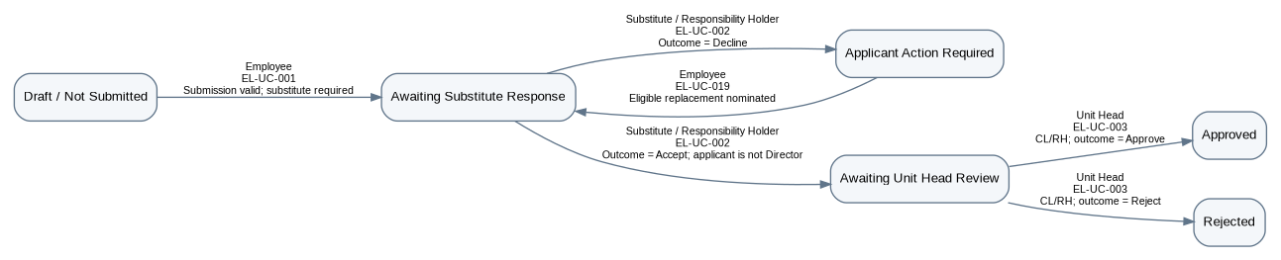

BW-EL-04 — New Higher-Sanction Leave — No Substitute Gate
Type | Basis
Purpose / Scope | Process a valid SCL/EL/COL/VL application not requiring substitute consent from submission through Unit Head recommendation and final sanction.
Trigger | Employee submits a valid higher-sanction leave request for which substitute coverage is not required.
Participants | Employee; Unit Head; Establishment where configured; final Sanctioning Authority
Related Workflows | CW-EL-01
Related CFRs | CFR-EL-002–003, CFR-EL-014, CFR-EL-016
Related UCs | EL-UC-001, EL-UC-003, EL-UC-004, EL-UC-005
Related BRs | BR-EL-001–013, BR-EL-017–019, BR-EL-030–031

Authoritative State-Transition Table
S. No. | From State | Actor | Use Case ID / Name | Guard / Outcome | Resulting State | BR Reference(s)
1 | Draft / Not Submitted | Employee | EL-UC-001 / Apply for Leave | Submission valid; no substitute required; applicant is not Director | Awaiting Unit Head Review | BR-EL-001–013, BR-EL-030–031
2 | Awaiting Unit Head Review | Unit Head | EL-UC-003 / Review Leave-Related Request at Unit Head | Higher-sanction; Recommended or Not Recommended; Establishment configured | Awaiting Establishment Routing | BR-EL-017–019, BR-EL-030
3 | Awaiting Unit Head Review | Unit Head | EL-UC-003 / Review Leave-Related Request at Unit Head | Higher-sanction; Recommended or Not Recommended; no Establishment step | Awaiting Final Sanction Decision | BR-EL-017–019, BR-EL-030
4 | Awaiting Establishment Routing | Establishment | EL-UC-004 / Verify and Route Higher-Sanction Request | Routing context valid | Awaiting Final Sanction Decision | BR-EL-018–019, BR-EL-030
5 | Awaiting Final Sanction Decision | Sanctioning Authority | EL-UC-005 / Make Final Sanctioning Decision | Outcome = Approve | Approved | BR-EL-004, BR-EL-017–019
6 | Awaiting Final Sanction Decision | Sanctioning Authority | EL-UC-005 / Make Final Sanctioning Decision | Outcome = Reject | Rejected | BR-EL-004, BR-EL-017–019
Specification Notes
- The Establishment step is configuration-controlled; its bypass does not create a distinct business outcome and therefore remains within the same Basis Workflow.

Workflow Diagram

BW-EL-05 — New Higher-Sanction Leave — Substitute Accepted (No Loop)
Type | Basis
Purpose / Scope | Process a valid SCL/EL/COL/VL application requiring substitute coverage through accepted consent, Unit Head recommendation, and final sanction.
Trigger | Employee submits a valid higher-sanction leave request for which substitute coverage is required.
Participants | Employee; Substitute / Responsibility Holder; Unit Head; Establishment where configured; final Sanctioning Authority
Related Workflows | CW-EL-01
Related CFRs | CFR-EL-002–003, CFR-EL-011–012, CFR-EL-014, CFR-EL-016
Related UCs | EL-UC-001, EL-UC-002, EL-UC-003, EL-UC-004, EL-UC-005
Related BRs | BR-EL-001–019, BR-EL-030–031

Authoritative State-Transition Table
S. No. | From State | Actor | Use Case ID / Name | Guard / Outcome | Resulting State | BR Reference(s)
1 | Draft / Not Submitted | Employee | EL-UC-001 / Apply for Leave | Submission valid; substitute required | Awaiting Substitute Response | BR-EL-001–015, BR-EL-030–031
2 | Awaiting Substitute Response | Substitute / Responsibility Holder | EL-UC-002 / Respond to Substitute Request | Outcome = Accept; applicant is not Director | Awaiting Unit Head Review | BR-EL-014–015
3 | Awaiting Unit Head Review | Unit Head | EL-UC-003 / Review Leave-Related Request at Unit Head | Higher-sanction; Recommended or Not Recommended; Establishment configured | Awaiting Establishment Routing | BR-EL-017–019, BR-EL-030
4 | Awaiting Unit Head Review | Unit Head | EL-UC-003 / Review Leave-Related Request at Unit Head | Higher-sanction; Recommended or Not Recommended; no Establishment step | Awaiting Final Sanction Decision | BR-EL-017–019, BR-EL-030
5 | Awaiting Establishment Routing | Establishment | EL-UC-004 / Verify and Route Higher-Sanction Request | Routing context valid | Awaiting Final Sanction Decision | BR-EL-018–019, BR-EL-030
6 | Awaiting Final Sanction Decision | Sanctioning Authority | EL-UC-005 / Make Final Sanctioning Decision | Outcome = Approve | Approved | BR-EL-004, BR-EL-017–019
7 | Awaiting Final Sanction Decision | Sanctioning Authority | EL-UC-005 / Make Final Sanctioning Decision | Outcome = Reject | Rejected | BR-EL-004, BR-EL-017–019

Workflow Diagram

BW-EL-06 — New Higher-Sanction Leave — Substitute Declined, Replacement Accepted (One Loop Traversal)
Type | Basis
Purpose / Scope | Process a valid SCL/EL/COL/VL application through one substitute-decline recovery traversal, Unit Head recommendation, and final sanction.
Trigger | Employee submits a valid higher-sanction leave request requiring substitute coverage; the first nominee declines.
Participants | Employee; Substitute / Responsibility Holder; Unit Head; Establishment where configured; final Sanctioning Authority
Related Workflows | CW-EL-01
Related CFRs | CFR-EL-002–003, CFR-EL-011–012, CFR-EL-014, CFR-EL-016
Related UCs | EL-UC-001, EL-UC-002, EL-UC-019, EL-UC-003, EL-UC-004, EL-UC-005
Related BRs | BR-EL-001–019, BR-EL-030–031

Authoritative State-Transition Table
S. No. | From State | Actor | Use Case ID / Name | Guard / Outcome | Resulting State | BR Reference(s)
1 | Draft / Not Submitted | Employee | EL-UC-001 / Apply for Leave | Submission valid; substitute required | Awaiting Substitute Response | BR-EL-001–015, BR-EL-030–031
2 | Awaiting Substitute Response | Substitute / Responsibility Holder | EL-UC-002 / Respond to Substitute Request | Outcome = Decline | Applicant Action Required | BR-EL-014–015
3 | Applicant Action Required | Employee | EL-UC-019 / Nominate Replacement Substitute After Decline | Eligible replacement nominated | Awaiting Substitute Response | BR-EL-014–015
4 | Awaiting Substitute Response | Substitute / Responsibility Holder | EL-UC-002 / Respond to Substitute Request | Outcome = Accept; applicant is not Director | Awaiting Unit Head Review | BR-EL-014–015
5 | Awaiting Unit Head Review | Unit Head | EL-UC-003 / Review Leave-Related Request at Unit Head | Higher-sanction; Recommended or Not Recommended; Establishment configured | Awaiting Establishment Routing | BR-EL-017–019, BR-EL-030
6 | Awaiting Unit Head Review | Unit Head | EL-UC-003 / Review Leave-Related Request at Unit Head | Higher-sanction; Recommended or Not Recommended; no Establishment step | Awaiting Final Sanction Decision | BR-EL-017–019, BR-EL-030
7 | Awaiting Establishment Routing | Establishment | EL-UC-004 / Verify and Route Higher-Sanction Request | Routing context valid | Awaiting Final Sanction Decision | BR-EL-018–019, BR-EL-030
8 | Awaiting Final Sanction Decision | Sanctioning Authority | EL-UC-005 / Make Final Sanctioning Decision | Outcome = Approve | Approved | BR-EL-004, BR-EL-017–019
9 | Awaiting Final Sanction Decision | Sanctioning Authority | EL-UC-005 / Make Final Sanctioning Decision | Outcome = Reject | Rejected | BR-EL-004, BR-EL-017–019
Specification Notes
- Exactly one decline → replacement → accept traversal is shown, per the loop rule.

Workflow Diagram
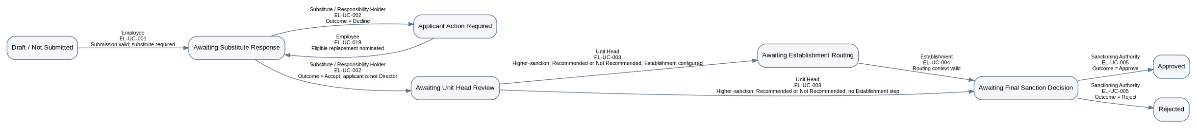

BW-EL-07 — Director Self-Sanction — No Substitute Gate
Type | Basis
Purpose / Scope | Process a valid Director-applicant new leave request not requiring substitute consent from submission through the Director self-sanction decision.
Trigger | Director, acting as employee applicant, submits a valid request for which substitute coverage is not required.
Participants | Director as Employee; Director as Sanctioning Authority
Related Workflows | CW-EL-01
Related CFRs | CFR-EL-002–003, CFR-EL-015–016
Related UCs | EL-UC-001, EL-UC-005
Related BRs | BR-EL-001–013, BR-EL-020, BR-EL-030–031

Authoritative State-Transition Table
S. No. | From State | Actor | Use Case ID / Name | Guard / Outcome | Resulting State | BR Reference(s)
1 | Draft / Not Submitted | Employee (Director as applicant) | EL-UC-001 / Apply for Leave | Submission valid; no substitute required; applicant is Director | Awaiting Director Self-Sanction | BR-EL-001–013, BR-EL-020, BR-EL-030–031
2 | Awaiting Director Self-Sanction | Director (Sanctioning Authority role) | EL-UC-005 / Make Final Sanctioning Decision | Outcome = Approve | Approved | BR-EL-020
3 | Awaiting Director Self-Sanction | Director (Sanctioning Authority role) | EL-UC-005 / Make Final Sanctioning Decision | Outcome = Reject | Rejected | BR-EL-020

Workflow Diagram
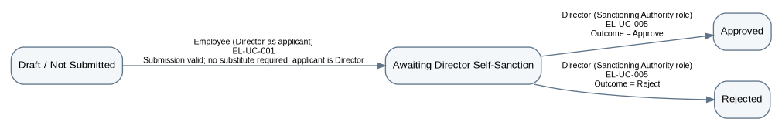

BW-EL-08 — Director Self-Sanction — Substitute Accepted (No Loop)
Type | Basis
Purpose / Scope | Process a valid Director-applicant new leave request requiring substitute coverage through accepted consent and the Director self-sanction decision.
Trigger | Director, acting as employee applicant, submits a valid request requiring substitute coverage.
Participants | Director as Employee; Substitute / Responsibility Holder; Director as Sanctioning Authority
Related Workflows | CW-EL-01
Related CFRs | CFR-EL-002–003, CFR-EL-011–012, CFR-EL-015–016
Related UCs | EL-UC-001, EL-UC-002, EL-UC-005
Related BRs | BR-EL-001–015, BR-EL-020, BR-EL-030–031

Authoritative State-Transition Table
S. No. | From State | Actor | Use Case ID / Name | Guard / Outcome | Resulting State | BR Reference(s)
1 | Draft / Not Submitted | Employee | EL-UC-001 / Apply for Leave | Submission valid; substitute required | Awaiting Substitute Response | BR-EL-001–015, BR-EL-030–031
2 | Awaiting Substitute Response | Substitute / Responsibility Holder | EL-UC-002 / Respond to Substitute Request | Outcome = Accept; applicant is Director | Awaiting Director Self-Sanction | BR-EL-014–015, BR-EL-020
3 | Awaiting Director Self-Sanction | Director (Sanctioning Authority role) | EL-UC-005 / Make Final Sanctioning Decision | Outcome = Approve | Approved | BR-EL-020
4 | Awaiting Director Self-Sanction | Director (Sanctioning Authority role) | EL-UC-005 / Make Final Sanctioning Decision | Outcome = Reject | Rejected | BR-EL-020

Workflow Diagram
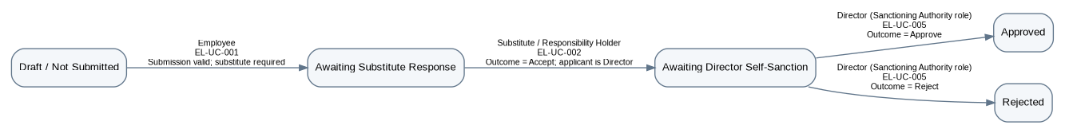

BW-EL-09 — Director Self-Sanction — Substitute Declined, Replacement Accepted (One Loop Traversal)
Type | Basis
Purpose / Scope | Process a valid Director-applicant new leave request through one substitute-decline recovery traversal and the Director self-sanction decision.
Trigger | Director, acting as employee applicant, submits a valid request requiring substitute coverage; the first nominee declines.
Participants | Director as Employee; Substitute / Responsibility Holder; Director as Sanctioning Authority
Related Workflows | CW-EL-01
Related CFRs | CFR-EL-002–003, CFR-EL-011–012, CFR-EL-015–016
Related UCs | EL-UC-001, EL-UC-002, EL-UC-019, EL-UC-005
Related BRs | BR-EL-001–015, BR-EL-020, BR-EL-030–031

Authoritative State-Transition Table
S. No. | From State | Actor | Use Case ID / Name | Guard / Outcome | Resulting State | BR Reference(s)
1 | Draft / Not Submitted | Employee | EL-UC-001 / Apply for Leave | Submission valid; substitute required | Awaiting Substitute Response | BR-EL-001–015, BR-EL-030–031
2 | Awaiting Substitute Response | Substitute / Responsibility Holder | EL-UC-002 / Respond to Substitute Request | Outcome = Decline | Applicant Action Required | BR-EL-014–015
3 | Applicant Action Required | Employee | EL-UC-019 / Nominate Replacement Substitute After Decline | Eligible replacement nominated | Awaiting Substitute Response | BR-EL-014–015
4 | Awaiting Substitute Response | Substitute / Responsibility Holder | EL-UC-002 / Respond to Substitute Request | Outcome = Accept; applicant is Director | Awaiting Director Self-Sanction | BR-EL-014–015, BR-EL-020
5 | Awaiting Director Self-Sanction | Director (Sanctioning Authority role) | EL-UC-005 / Make Final Sanctioning Decision | Outcome = Approve | Approved | BR-EL-020
6 | Awaiting Director Self-Sanction | Director (Sanctioning Authority role) | EL-UC-005 / Make Final Sanctioning Decision | Outcome = Reject | Rejected | BR-EL-020
Specification Notes
- Exactly one decline → replacement → accept traversal is shown, per the loop rule.

Workflow Diagram
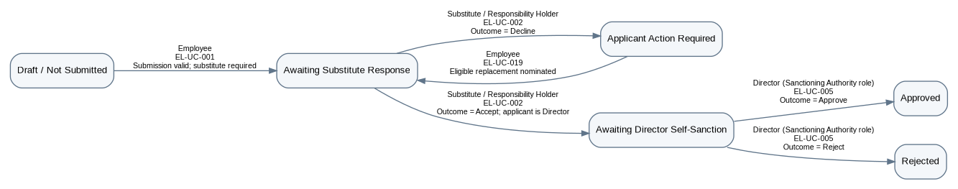

BW-EL-10 — CL/RH Approved-Leave Cancellation
Type | Basis
Purpose / Scope | Process cancellation of an approved CL/RH before its start from employee request through the Unit Head final cancellation decision.
Trigger | Employee requests cancellation of approved CL/RH before its start.
Participants | Employee; Unit Head
Related Workflows | CW-EL-02
Related CFRs | CFR-EL-019
Related UCs | EL-UC-008, EL-UC-003
Related BRs | BR-EL-016, BR-EL-023–024

Authoritative State-Transition Table
S. No. | From State | Actor | Use Case ID / Name | Guard / Outcome | Resulting State | BR Reference(s)
1 | Approved / Not Started | Employee | EL-UC-008 / Request Cancellation of Approved Leave | Cancellation eligible | Cancellation Pending — Unit Head Review | BR-EL-023
2 | Cancellation Pending — Unit Head Review | Unit Head | EL-UC-003 / Review Leave-Related Request at Unit Head | Original leave Unit-Head-final; outcome = Approve cancellation | Cancelled; deducted balance restored/adjusted | BR-EL-016, BR-EL-023–024
3 | Cancellation Pending — Unit Head Review | Unit Head | EL-UC-003 / Review Leave-Related Request at Unit Head | Original leave Unit-Head-final; outcome = Reject cancellation | Approved / Unchanged | BR-EL-016, BR-EL-023

Workflow Diagram
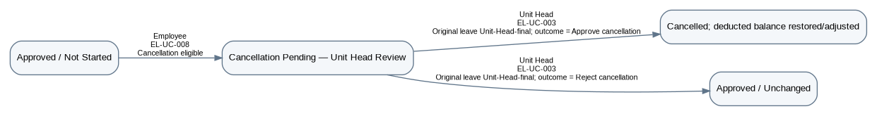

BW-EL-11 — Higher-Sanction Approved-Leave Cancellation
Type | Basis
Purpose / Scope | Process cancellation of an approved higher-sanction leave before its start through the applicable recommendation/routing hierarchy and final cancellation decision.
Trigger | Employee requests cancellation of approved SCL/EL/COL/VL before its start.
Participants | Employee; Unit Head; Establishment where configured; final Sanctioning Authority
Related Workflows | CW-EL-02
Related CFRs | CFR-EL-019
Related UCs | EL-UC-008, EL-UC-003, EL-UC-004, EL-UC-005
Related BRs | BR-EL-017–019, BR-EL-023–024, BR-EL-030

Authoritative State-Transition Table
S. No. | From State | Actor | Use Case ID / Name | Guard / Outcome | Resulting State | BR Reference(s)
1 | Approved / Not Started | Employee | EL-UC-008 / Request Cancellation of Approved Leave | Cancellation eligible | Cancellation Pending — Unit Head Review | BR-EL-023
2 | Cancellation Pending — Unit Head Review | Unit Head | EL-UC-003 / Review Leave-Related Request at Unit Head | Higher-sanction cancellation; recommendation recorded; Establishment configured | Cancellation Pending — Establishment | BR-EL-017–019, BR-EL-023, BR-EL-030
3 | Cancellation Pending — Unit Head Review | Unit Head | EL-UC-003 / Review Leave-Related Request at Unit Head | Higher-sanction cancellation; recommendation recorded; no Establishment step | Cancellation Pending — Final Decision | BR-EL-017–019, BR-EL-023, BR-EL-030
4 | Cancellation Pending — Establishment | Establishment | EL-UC-004 / Verify and Route Higher-Sanction Request | Routing context valid | Cancellation Pending — Final Decision | BR-EL-018–019, BR-EL-023, BR-EL-030
5 | Cancellation Pending — Final Decision | Sanctioning Authority | EL-UC-005 / Make Final Sanctioning Decision | Outcome = Approve cancellation | Cancelled; deducted balance restored/adjusted | BR-EL-023–024
6 | Cancellation Pending — Final Decision | Sanctioning Authority | EL-UC-005 / Make Final Sanctioning Decision | Outcome = Reject cancellation | Approved / Unchanged | BR-EL-023

Workflow Diagram

BW-EL-12 — Ongoing Leave Extension — No Substitute Gate
Type | Basis
Purpose / Scope | Process an admissible EL/COL/VL extension not requiring substitute consent from submission through Unit Head recommendation and final sanction.
Trigger | Employee on ongoing EL/COL/VL requests additional leave time; substitute coverage is not required.
Participants | Employee; Unit Head; Establishment where configured; final Sanctioning Authority
Related Workflows | CW-EL-03
Related CFRs | CFR-EL-020
Related UCs | EL-UC-009, EL-UC-003, EL-UC-004, EL-UC-005
Related BRs | BR-EL-001, BR-EL-005–013, BR-EL-017–019, BR-EL-025, BR-EL-030–031

Authoritative State-Transition Table
S. No. | From State | Actor | Use Case ID / Name | Guard / Outcome | Resulting State | BR Reference(s)
1 | Ongoing EL/COL/VL | Employee | EL-UC-009 / Request Extension of Ongoing Leave | Valid extension; no substitute required | Awaiting Extension Unit Head Review | BR-EL-001, BR-EL-005–013, BR-EL-025, BR-EL-030–031
2 | Awaiting Extension Unit Head Review | Unit Head | EL-UC-003 / Review Leave-Related Request at Unit Head | Recommendation recorded; Establishment configured | Extension Pending — Establishment | BR-EL-017–019, BR-EL-025, BR-EL-030
3 | Awaiting Extension Unit Head Review | Unit Head | EL-UC-003 / Review Leave-Related Request at Unit Head | Recommendation recorded; no Establishment step | Extension Pending — Final Decision | BR-EL-017–019, BR-EL-025, BR-EL-030
4 | Extension Pending — Establishment | Establishment | EL-UC-004 / Verify and Route Higher-Sanction Request | Routing context valid | Extension Pending — Final Decision | BR-EL-018–019, BR-EL-025, BR-EL-030
5 | Extension Pending — Final Decision | Sanctioning Authority | EL-UC-005 / Make Final Sanctioning Decision | Outcome = Approve | Extended Leave in Effect — Incremental Period Posted | BR-EL-025
6 | Extension Pending — Final Decision | Sanctioning Authority | EL-UC-005 / Make Final Sanctioning Decision | Outcome = Reject | Original Ongoing Leave Unchanged | BR-EL-025

Workflow Diagram

BW-EL-13 — Ongoing Leave Extension — Substitute Accepted (No Loop)
Type | Basis
Purpose / Scope | Process an admissible EL/COL/VL extension requiring substitute coverage through accepted consent, Unit Head recommendation, and final sanction.
Trigger | Employee on ongoing EL/COL/VL requests additional leave time; substitute coverage is required.
Participants | Employee; Substitute / Responsibility Holder; Unit Head; Establishment where configured; final Sanctioning Authority
Related Workflows | CW-EL-03
Related CFRs | CFR-EL-011–012, CFR-EL-020
Related UCs | EL-UC-009, EL-UC-002, EL-UC-003, EL-UC-004, EL-UC-005
Related BRs | BR-EL-001, BR-EL-005–019, BR-EL-025, BR-EL-030–031

Authoritative State-Transition Table
S. No. | From State | Actor | Use Case ID / Name | Guard / Outcome | Resulting State | BR Reference(s)
1 | Ongoing EL/COL/VL | Employee | EL-UC-009 / Request Extension of Ongoing Leave | Valid extension; substitute required | Awaiting Extension Substitute Response | BR-EL-001, BR-EL-005–015, BR-EL-025, BR-EL-030–031
2 | Awaiting Extension Substitute Response | Substitute / Responsibility Holder | EL-UC-002 / Respond to Substitute Request | Outcome = Accept | Awaiting Extension Unit Head Review | BR-EL-014–015, BR-EL-025
3 | Awaiting Extension Unit Head Review | Unit Head | EL-UC-003 / Review Leave-Related Request at Unit Head | Recommendation recorded; Establishment configured | Extension Pending — Establishment | BR-EL-017–019, BR-EL-025, BR-EL-030
4 | Awaiting Extension Unit Head Review | Unit Head | EL-UC-003 / Review Leave-Related Request at Unit Head | Recommendation recorded; no Establishment step | Extension Pending — Final Decision | BR-EL-017–019, BR-EL-025, BR-EL-030
5 | Extension Pending — Establishment | Establishment | EL-UC-004 / Verify and Route Higher-Sanction Request | Routing context valid | Extension Pending — Final Decision | BR-EL-018–019, BR-EL-025, BR-EL-030
6 | Extension Pending — Final Decision | Sanctioning Authority | EL-UC-005 / Make Final Sanctioning Decision | Outcome = Approve | Extended Leave in Effect — Incremental Period Posted | BR-EL-025
7 | Extension Pending — Final Decision | Sanctioning Authority | EL-UC-005 / Make Final Sanctioning Decision | Outcome = Reject | Original Ongoing Leave Unchanged | BR-EL-025

Workflow Diagram

BW-EL-14 — Ongoing Leave Extension — Substitute Declined, Replacement Accepted (One Loop Traversal)
Type | Basis
Purpose / Scope | Process an admissible EL/COL/VL extension through one substitute-decline recovery traversal, Unit Head recommendation, and final sanction.
Trigger | Employee on ongoing EL/COL/VL requests additional leave time requiring substitute coverage; the first nominee declines.
Participants | Employee; Substitute / Responsibility Holder; Unit Head; Establishment where configured; final Sanctioning Authority
Related Workflows | CW-EL-03
Related CFRs | CFR-EL-011–012, CFR-EL-020
Related UCs | EL-UC-009, EL-UC-002, EL-UC-019, EL-UC-003, EL-UC-004, EL-UC-005
Related BRs | BR-EL-001, BR-EL-005–019, BR-EL-025, BR-EL-030–031

Authoritative State-Transition Table
S. No. | From State | Actor | Use Case ID / Name | Guard / Outcome | Resulting State | BR Reference(s)
1 | Ongoing EL/COL/VL | Employee | EL-UC-009 / Request Extension of Ongoing Leave | Valid extension; substitute required | Awaiting Extension Substitute Response | BR-EL-001, BR-EL-005–015, BR-EL-025, BR-EL-030–031
2 | Awaiting Extension Substitute Response | Substitute / Responsibility Holder | EL-UC-002 / Respond to Substitute Request | Outcome = Decline | Extension Applicant Action Required | BR-EL-014–015, BR-EL-025
3 | Extension Applicant Action Required | Employee | EL-UC-019 / Nominate Replacement Substitute After Decline | Eligible replacement nominated | Awaiting Extension Substitute Response | BR-EL-014–015
4 | Awaiting Extension Substitute Response | Substitute / Responsibility Holder | EL-UC-002 / Respond to Substitute Request | Outcome = Accept | Awaiting Extension Unit Head Review | BR-EL-014–015, BR-EL-025
5 | Awaiting Extension Unit Head Review | Unit Head | EL-UC-003 / Review Leave-Related Request at Unit Head | Recommendation recorded; Establishment configured | Extension Pending — Establishment | BR-EL-017–019, BR-EL-025, BR-EL-030
6 | Awaiting Extension Unit Head Review | Unit Head | EL-UC-003 / Review Leave-Related Request at Unit Head | Recommendation recorded; no Establishment step | Extension Pending — Final Decision | BR-EL-017–019, BR-EL-025, BR-EL-030
7 | Extension Pending — Establishment | Establishment | EL-UC-004 / Verify and Route Higher-Sanction Request | Routing context valid | Extension Pending — Final Decision | BR-EL-018–019, BR-EL-025, BR-EL-030
8 | Extension Pending — Final Decision | Sanctioning Authority | EL-UC-005 / Make Final Sanctioning Decision | Outcome = Approve | Extended Leave in Effect — Incremental Period Posted | BR-EL-025
9 | Extension Pending — Final Decision | Sanctioning Authority | EL-UC-005 / Make Final Sanctioning Decision | Outcome = Reject | Original Ongoing Leave Unchanged | BR-EL-025
Specification Notes
- Exactly one decline → replacement → accept traversal is shown, per the loop rule.

Workflow Diagram
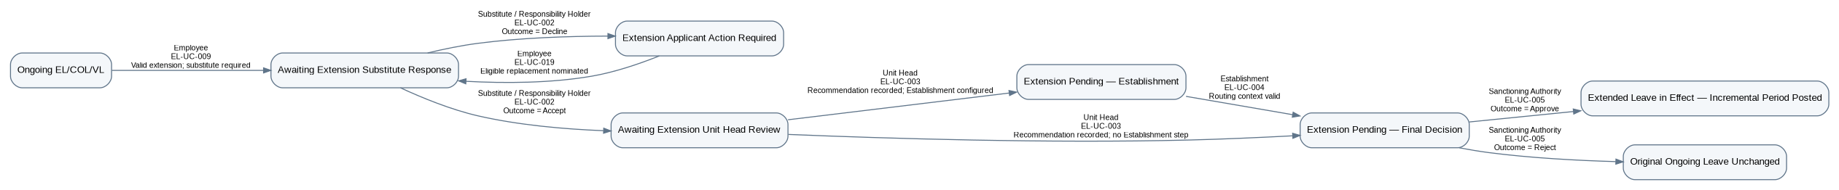

BW-EL-15 — Normal Resumption Review
Type | Basis
Purpose / Scope | Record employee resumption and review a normal return from EL/COL/VL without changing the approved period or balance.
Trigger | Employee returns on the approved end date and submits actual resumption information.
Participants | Employee; applicable Sanctioning Authority
Related Workflows | CW-EL-04
Related CFRs | CFR-EL-021
Related UCs | EL-UC-010, EL-UC-011
Related BRs | BR-EL-027–028

Authoritative State-Transition Table
S. No. | From State | Actor | Use Case ID / Name | Guard / Outcome | Resulting State | BR Reference(s)
1 | Returned from EL/COL/VL | Employee | EL-UC-010 / Submit Resumption of Duty | Actual resumption details submitted | Resumption Review Pending | BR-EL-027
2 | Resumption Review Pending | Applicable Sanctioning Authority | EL-UC-011 / Review Resumption | Actual date = approved end date | Resumption Reviewed — No Adjustment | BR-EL-027–028
Specification Notes
- No generic Closed leave state is introduced.

Workflow Diagram

BW-EL-16 — Early Resumption Review
Type | Basis
Purpose / Scope | Record employee resumption and review an early return from EL/COL/VL, then synchronize the actual period, balance, leave record, and attendance.
Trigger | Employee returns before the approved end date and submits actual resumption information.
Participants | Employee; applicable Sanctioning Authority
Related Workflows | CW-EL-04
Related CFRs | CFR-EL-021
Related UCs | EL-UC-010, EL-UC-011
Related BRs | BR-EL-027–028

Authoritative State-Transition Table
S. No. | From State | Actor | Use Case ID / Name | Guard / Outcome | Resulting State | BR Reference(s)
1 | Returned from EL/COL/VL | Employee | EL-UC-010 / Submit Resumption of Duty | Actual resumption details submitted | Resumption Review Pending | BR-EL-027
2 | Resumption Review Pending | Applicable Sanctioning Authority | EL-UC-011 / Review Resumption | Actual date < approved end date | Resumption Reviewed — Early Return Synchronized | BR-EL-028
Specification Notes
- No generic Closed leave state is introduced.

Workflow Diagram

BW-EL-17 — Late Resumption Review
Type | Basis
Purpose / Scope | Record employee resumption and review a late return from EL/COL/VL, then synchronize the actual period, balance, leave record, and attendance.
Trigger | Employee returns after the approved end date and submits actual resumption information.
Participants | Employee; applicable Sanctioning Authority
Related Workflows | CW-EL-04
Related CFRs | CFR-EL-021
Related UCs | EL-UC-010, EL-UC-011
Related BRs | BR-EL-027–028

Authoritative State-Transition Table
S. No. | From State | Actor | Use Case ID / Name | Guard / Outcome | Resulting State | BR Reference(s)
1 | Returned from EL/COL/VL | Employee | EL-UC-010 / Submit Resumption of Duty | Actual resumption details submitted | Resumption Review Pending | BR-EL-027
2 | Resumption Review Pending | Applicable Sanctioning Authority | EL-UC-011 / Review Resumption | Actual date > approved end date | Resumption Reviewed — Late Return Synchronized | BR-EL-028
Specification Notes
- No generic Closed leave state is introduced.

Workflow Diagram

5. Composite Workflow Specifications

CW-EL-01 — New Leave Processing and Pending Withdrawal
Type | Composite
Purpose / Scope | Provide the end-to-end progression for a new leave request, including substitute consent/recovery, Unit-Head-final CL/RH decisions, higher-sanction routing, the Director-specific self-sanction route, and immediate withdrawal from every valid pending pre-final state.
Trigger | Employee submits a valid new leave request.
Participants | Employee; Substitute / Responsibility Holder where required; Unit Head; Establishment where configured; final Sanctioning Authority; Director in self-sanction case
Constituent Workflows | BW-EL-01–09
Related Workflows | CW-EL-02; CW-EL-03; CW-EL-04
Related CFRs | CFR-EL-002–003, CFR-EL-011–018
Related UCs | EL-UC-001–005, EL-UC-007, EL-UC-019
Related BRs | BR-EL-001–020, BR-EL-022, BR-EL-030–035

Authoritative State-Transition Table
S. No. | From State | Actor | Use Case ID / Name | Guard / Outcome | Resulting State | BR Reference(s)
1 | Draft / Not Submitted | Employee | EL-UC-001 / Apply for Leave | Submission valid; substitute required | Awaiting Substitute Response | BR-EL-001–015, BR-EL-030–031
2 | Draft / Not Submitted | Employee | EL-UC-001 / Apply for Leave | Submission valid; no substitute required; applicant is Director | Awaiting Director Self-Sanction | BR-EL-001–013, BR-EL-020, BR-EL-030–031
3 | Draft / Not Submitted | Employee | EL-UC-001 / Apply for Leave | Submission valid; no substitute required; applicant is not Director | Awaiting Unit Head Review | BR-EL-001–013, BR-EL-030–031
4 | Awaiting Substitute Response | Substitute / Responsibility Holder | EL-UC-002 / Respond to Substitute Request | Outcome = Accept; applicant is Director | Awaiting Director Self-Sanction | BR-EL-014–015, BR-EL-020
5 | Awaiting Substitute Response | Substitute / Responsibility Holder | EL-UC-002 / Respond to Substitute Request | Outcome = Accept; applicant is not Director | Awaiting Unit Head Review | BR-EL-014–015
6 | Awaiting Substitute Response | Substitute / Responsibility Holder | EL-UC-002 / Respond to Substitute Request | Outcome = Decline | Applicant Action Required | BR-EL-014–015
7 | Applicant Action Required | Employee | EL-UC-019 / Nominate Replacement Substitute After Decline | Eligible replacement nominated | Awaiting Substitute Response | BR-EL-014–015
8 | Awaiting Unit Head Review | Unit Head | EL-UC-003 / Review Leave-Related Request at Unit Head | CL/RH; outcome = Approve | Approved | BR-EL-016
9 | Awaiting Unit Head Review | Unit Head | EL-UC-003 / Review Leave-Related Request at Unit Head | CL/RH; outcome = Reject | Rejected | BR-EL-016
10 | Awaiting Unit Head Review | Unit Head | EL-UC-003 / Review Leave-Related Request at Unit Head | Higher-sanction; Recommended or Not Recommended; Establishment configured | Awaiting Establishment Routing | BR-EL-017–019, BR-EL-030
11 | Awaiting Unit Head Review | Unit Head | EL-UC-003 / Review Leave-Related Request at Unit Head | Higher-sanction; Recommended or Not Recommended; no Establishment step | Awaiting Final Sanction Decision | BR-EL-017–019, BR-EL-030
12 | Awaiting Establishment Routing | Establishment | EL-UC-004 / Verify and Route Higher-Sanction Request | Routing context valid | Awaiting Final Sanction Decision | BR-EL-018–019, BR-EL-030
13 | Awaiting Final Sanction Decision | Sanctioning Authority | EL-UC-005 / Make Final Sanctioning Decision | Outcome = Approve | Approved | BR-EL-004, BR-EL-017–019
14 | Awaiting Final Sanction Decision | Sanctioning Authority | EL-UC-005 / Make Final Sanctioning Decision | Outcome = Reject | Rejected | BR-EL-004, BR-EL-017–019
15 | Awaiting Director Self-Sanction | Director (Sanctioning Authority role) | EL-UC-005 / Make Final Sanctioning Decision | Outcome = Approve | Approved | BR-EL-020
16 | Awaiting Director Self-Sanction | Director (Sanctioning Authority role) | EL-UC-005 / Make Final Sanctioning Decision | Outcome = Reject | Rejected | BR-EL-020
17 | Awaiting Substitute Response; Applicant Action Required; Awaiting Unit Head Review; Awaiting Establishment Routing; Awaiting Final Sanction Decision; Awaiting Director Self-Sanction | Employee | EL-UC-007 / Withdraw Pending Request | Withdrawal succeeds before final approval | Withdrawn | BR-EL-022, BR-EL-034
Specification Notes
- Pending in-place modification is not supported. Change before final approval is handled by withdrawal and, if needed, a fresh application.
- Pending withdrawal is cross-cutting across every valid pending pre-final state.
- Conditional routing/responsibility-changing SLA escalation uses XTP-EL-01 where applicable.

Workflow Diagram
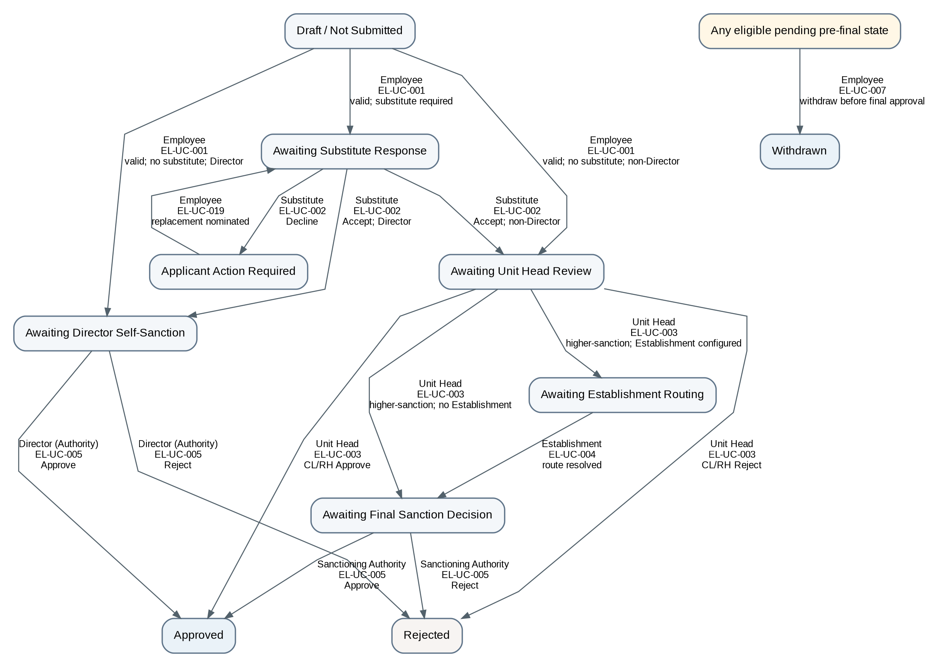

CW-EL-02 — Approved Leave Cancellation
Type | Composite
Purpose / Scope | Represent cancellation of approved leave before its start through the same applicable decision hierarchy, with distinct cancellation-approved and cancellation-rejected effects. A later revised leave request is a fresh New Leave instance, not part of this workflow.
Trigger | Employee requests cancellation of an approved leave before its start date.
Participants | Employee; Unit Head; Establishment where configured; final Sanctioning Authority
Constituent Workflows | BW-EL-10–11
Related Workflows | CW-EL-01; CW-EL-03; CW-EL-04
Related CFRs | CFR-EL-019
Related UCs | EL-UC-008, EL-UC-003–005
Related BRs | BR-EL-016–019, BR-EL-023–024, BR-EL-030

Authoritative State-Transition Table
S. No. | From State | Actor | Use Case ID / Name | Guard / Outcome | Resulting State | BR Reference(s)
1 | Approved / Not Started | Employee | EL-UC-008 / Request Cancellation of Approved Leave | Cancellation eligible | Cancellation Pending — Unit Head Review | BR-EL-023
2 | Cancellation Pending — Unit Head Review | Unit Head | EL-UC-003 / Review Leave-Related Request at Unit Head | Original leave Unit-Head-final; outcome = Approve cancellation | Cancelled; deducted balance restored/adjusted | BR-EL-016, BR-EL-023
3 | Cancellation Pending — Unit Head Review | Unit Head | EL-UC-003 / Review Leave-Related Request at Unit Head | Original leave Unit-Head-final; outcome = Reject cancellation | Approved / Unchanged | BR-EL-016, BR-EL-023
4 | Cancellation Pending — Unit Head Review | Unit Head | EL-UC-003 / Review Leave-Related Request at Unit Head | Higher-sanction cancellation; recommendation recorded; Establishment configured | Cancellation Pending — Establishment | BR-EL-017–019, BR-EL-023, BR-EL-030
5 | Cancellation Pending — Unit Head Review | Unit Head | EL-UC-003 / Review Leave-Related Request at Unit Head | Higher-sanction cancellation; recommendation recorded; no Establishment step | Cancellation Pending — Final Decision | BR-EL-017–019, BR-EL-023, BR-EL-030
6 | Cancellation Pending — Establishment | Establishment | EL-UC-004 / Verify and Route Higher-Sanction Request | Routing context valid | Cancellation Pending — Final Decision | BR-EL-018–019, BR-EL-023, BR-EL-030
7 | Cancellation Pending — Final Decision | Sanctioning Authority | EL-UC-005 / Make Final Sanctioning Decision | Outcome = Approve cancellation | Cancelled; deducted balance restored/adjusted | BR-EL-023
8 | Cancellation Pending — Final Decision | Sanctioning Authority | EL-UC-005 / Make Final Sanctioning Decision | Outcome = Reject cancellation | Approved / Unchanged | BR-EL-023
Specification Notes
- A successful cancellation marks the leave Cancelled and restores/adjusts deducted balance; it does not edit the approved leave in place.
- A revised leave request after cancellation is a fresh instance of CW-EL-01.

Workflow Diagram
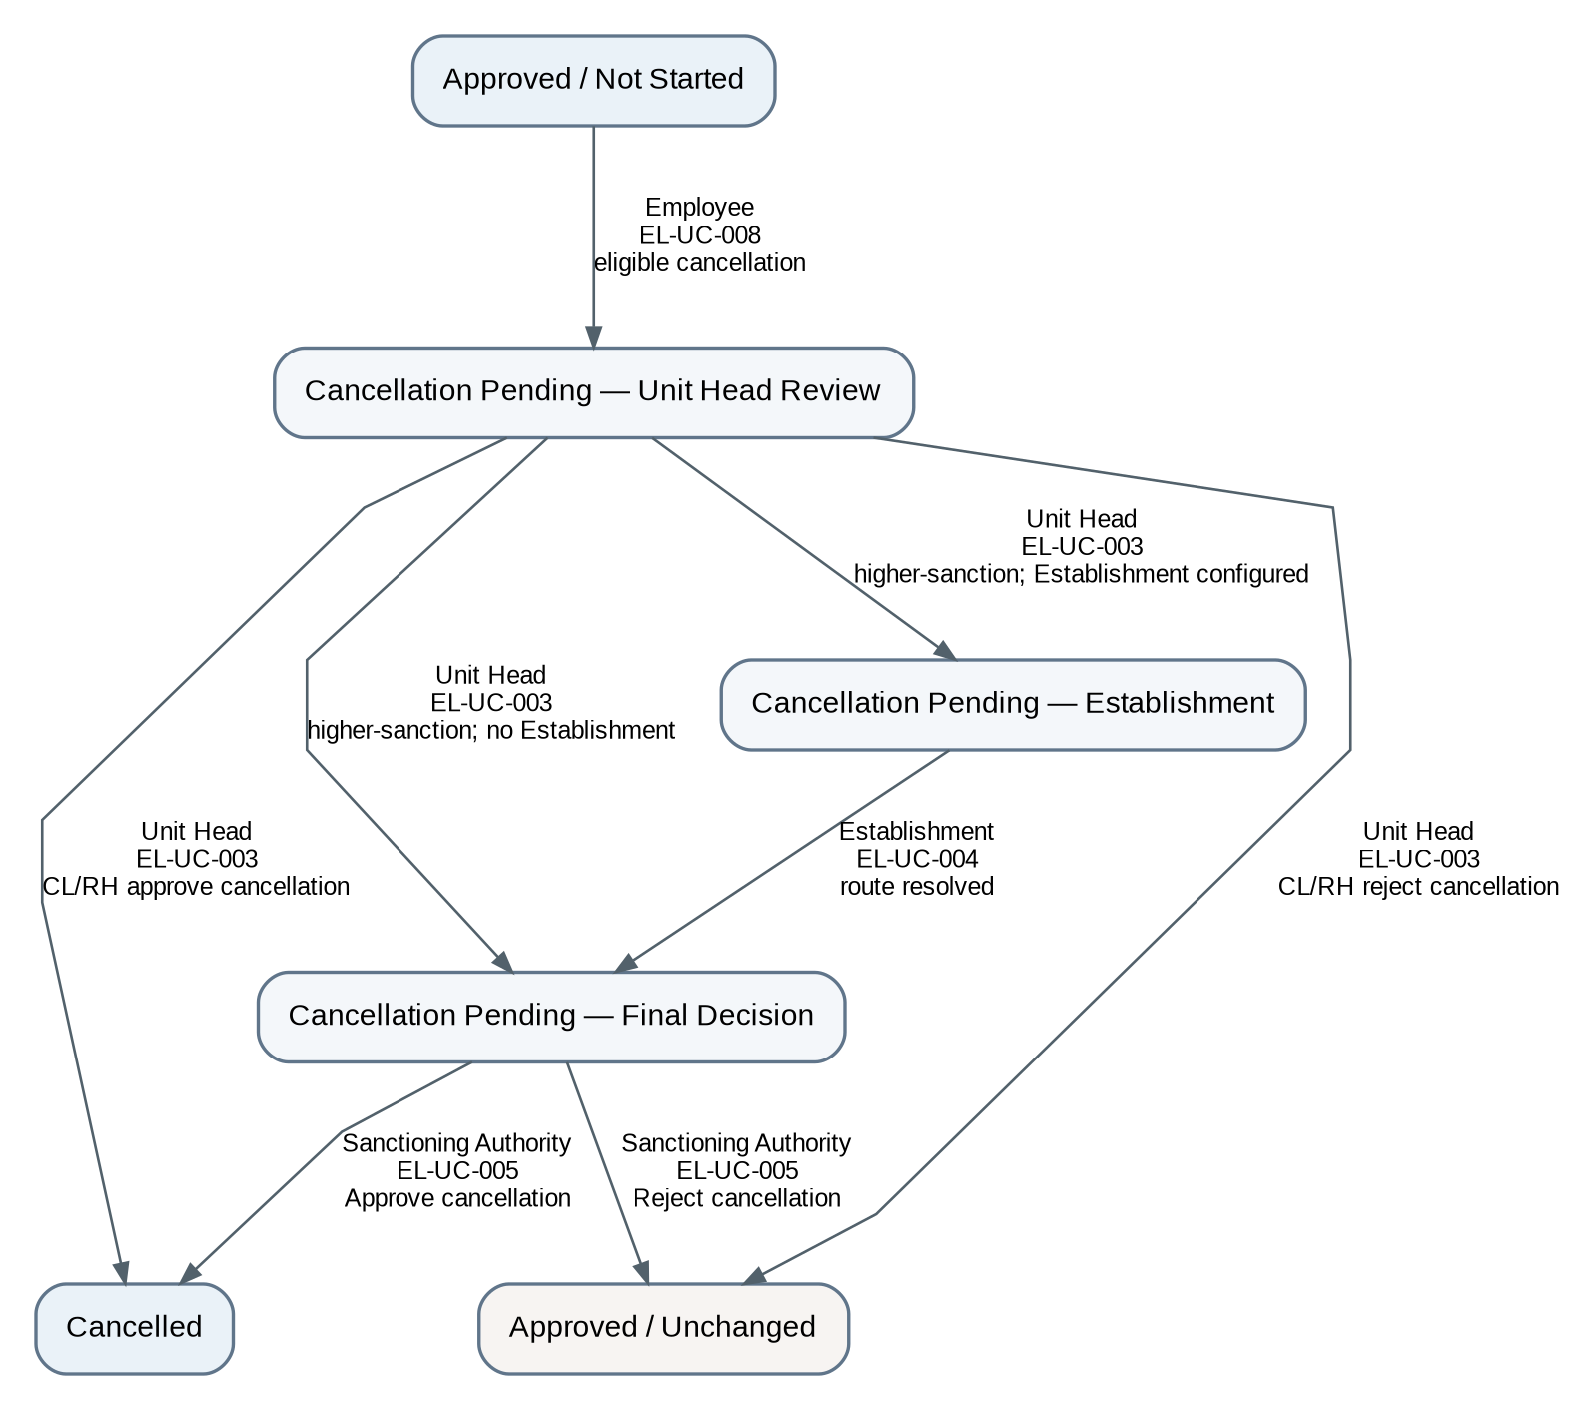

CW-EL-03 — Ongoing Leave Extension
Type | Composite
Purpose / Scope | Represent an extension of ongoing EL/COL/VL through applicable validation, substitute consent/recovery where required, Unit Head recommendation, configured higher-sanction decision, and immediate withdrawal of the pending extension request where applicable.
Trigger | Employee on ongoing EL/COL/VL requests additional leave time.
Participants | Employee; Substitute / Responsibility Holder where required; Unit Head; Establishment where configured; final Sanctioning Authority
Constituent Workflows | BW-EL-12–14
Related Workflows | CW-EL-01; CW-EL-02; CW-EL-04
Related CFRs | CFR-EL-020, CFR-EL-018 where pending-extension withdrawal applies
Related UCs | EL-UC-009, EL-UC-002–005, EL-UC-007, EL-UC-019
Related BRs | BR-EL-001, BR-EL-005–019, BR-EL-022, BR-EL-025, BR-EL-030–031

Authoritative State-Transition Table
S. No. | From State | Actor | Use Case ID / Name | Guard / Outcome | Resulting State | BR Reference(s)
1 | Ongoing EL/COL/VL | Employee | EL-UC-009 / Request Extension of Ongoing Leave | Valid extension; substitute required | Awaiting Extension Substitute Response | BR-EL-001, BR-EL-005–015, BR-EL-025, BR-EL-030–031
2 | Ongoing EL/COL/VL | Employee | EL-UC-009 / Request Extension of Ongoing Leave | Valid extension; no substitute required | Awaiting Extension Unit Head Review | BR-EL-001, BR-EL-005–013, BR-EL-025, BR-EL-030–031
3 | Awaiting Extension Substitute Response | Substitute / Responsibility Holder | EL-UC-002 / Respond to Substitute Request | Outcome = Accept | Awaiting Extension Unit Head Review | BR-EL-014–015, BR-EL-025
4 | Awaiting Extension Substitute Response | Substitute / Responsibility Holder | EL-UC-002 / Respond to Substitute Request | Outcome = Decline | Extension Applicant Action Required | BR-EL-014–015, BR-EL-025
5 | Extension Applicant Action Required | Employee | EL-UC-019 / Nominate Replacement Substitute After Decline | Eligible replacement nominated | Awaiting Extension Substitute Response | BR-EL-014–015
6 | Awaiting Extension Unit Head Review | Unit Head | EL-UC-003 / Review Leave-Related Request at Unit Head | Recommendation recorded; Establishment configured | Extension Pending — Establishment | BR-EL-017–019, BR-EL-025, BR-EL-030
7 | Awaiting Extension Unit Head Review | Unit Head | EL-UC-003 / Review Leave-Related Request at Unit Head | Recommendation recorded; no Establishment step | Extension Pending — Final Decision | BR-EL-017–019, BR-EL-025, BR-EL-030
8 | Extension Pending — Establishment | Establishment | EL-UC-004 / Verify and Route Higher-Sanction Request | Routing context valid | Extension Pending — Final Decision | BR-EL-018–019, BR-EL-025, BR-EL-030
9 | Extension Pending — Final Decision | Sanctioning Authority | EL-UC-005 / Make Final Sanctioning Decision | Outcome = Approve | Extended Leave in Effect — Incremental Period Posted | BR-EL-025
10 | Extension Pending — Final Decision | Sanctioning Authority | EL-UC-005 / Make Final Sanctioning Decision | Outcome = Reject | Original Ongoing Leave Unchanged | BR-EL-025
11 | Awaiting Extension Substitute Response; Extension Applicant Action Required; Awaiting Extension Unit Head Review; Extension Pending — Establishment; Extension Pending — Final Decision | Employee | EL-UC-007 / Withdraw Pending Request | Withdrawal succeeds while extension request remains pending | Extension Request Withdrawn — Original Leave Unchanged | BR-EL-022
Specification Notes
- Extension approval posts only the incremental additional period; rejection preserves the original approved leave.
- Pending extension withdrawal is cross-cutting across all valid pending extension states.

Workflow Diagram
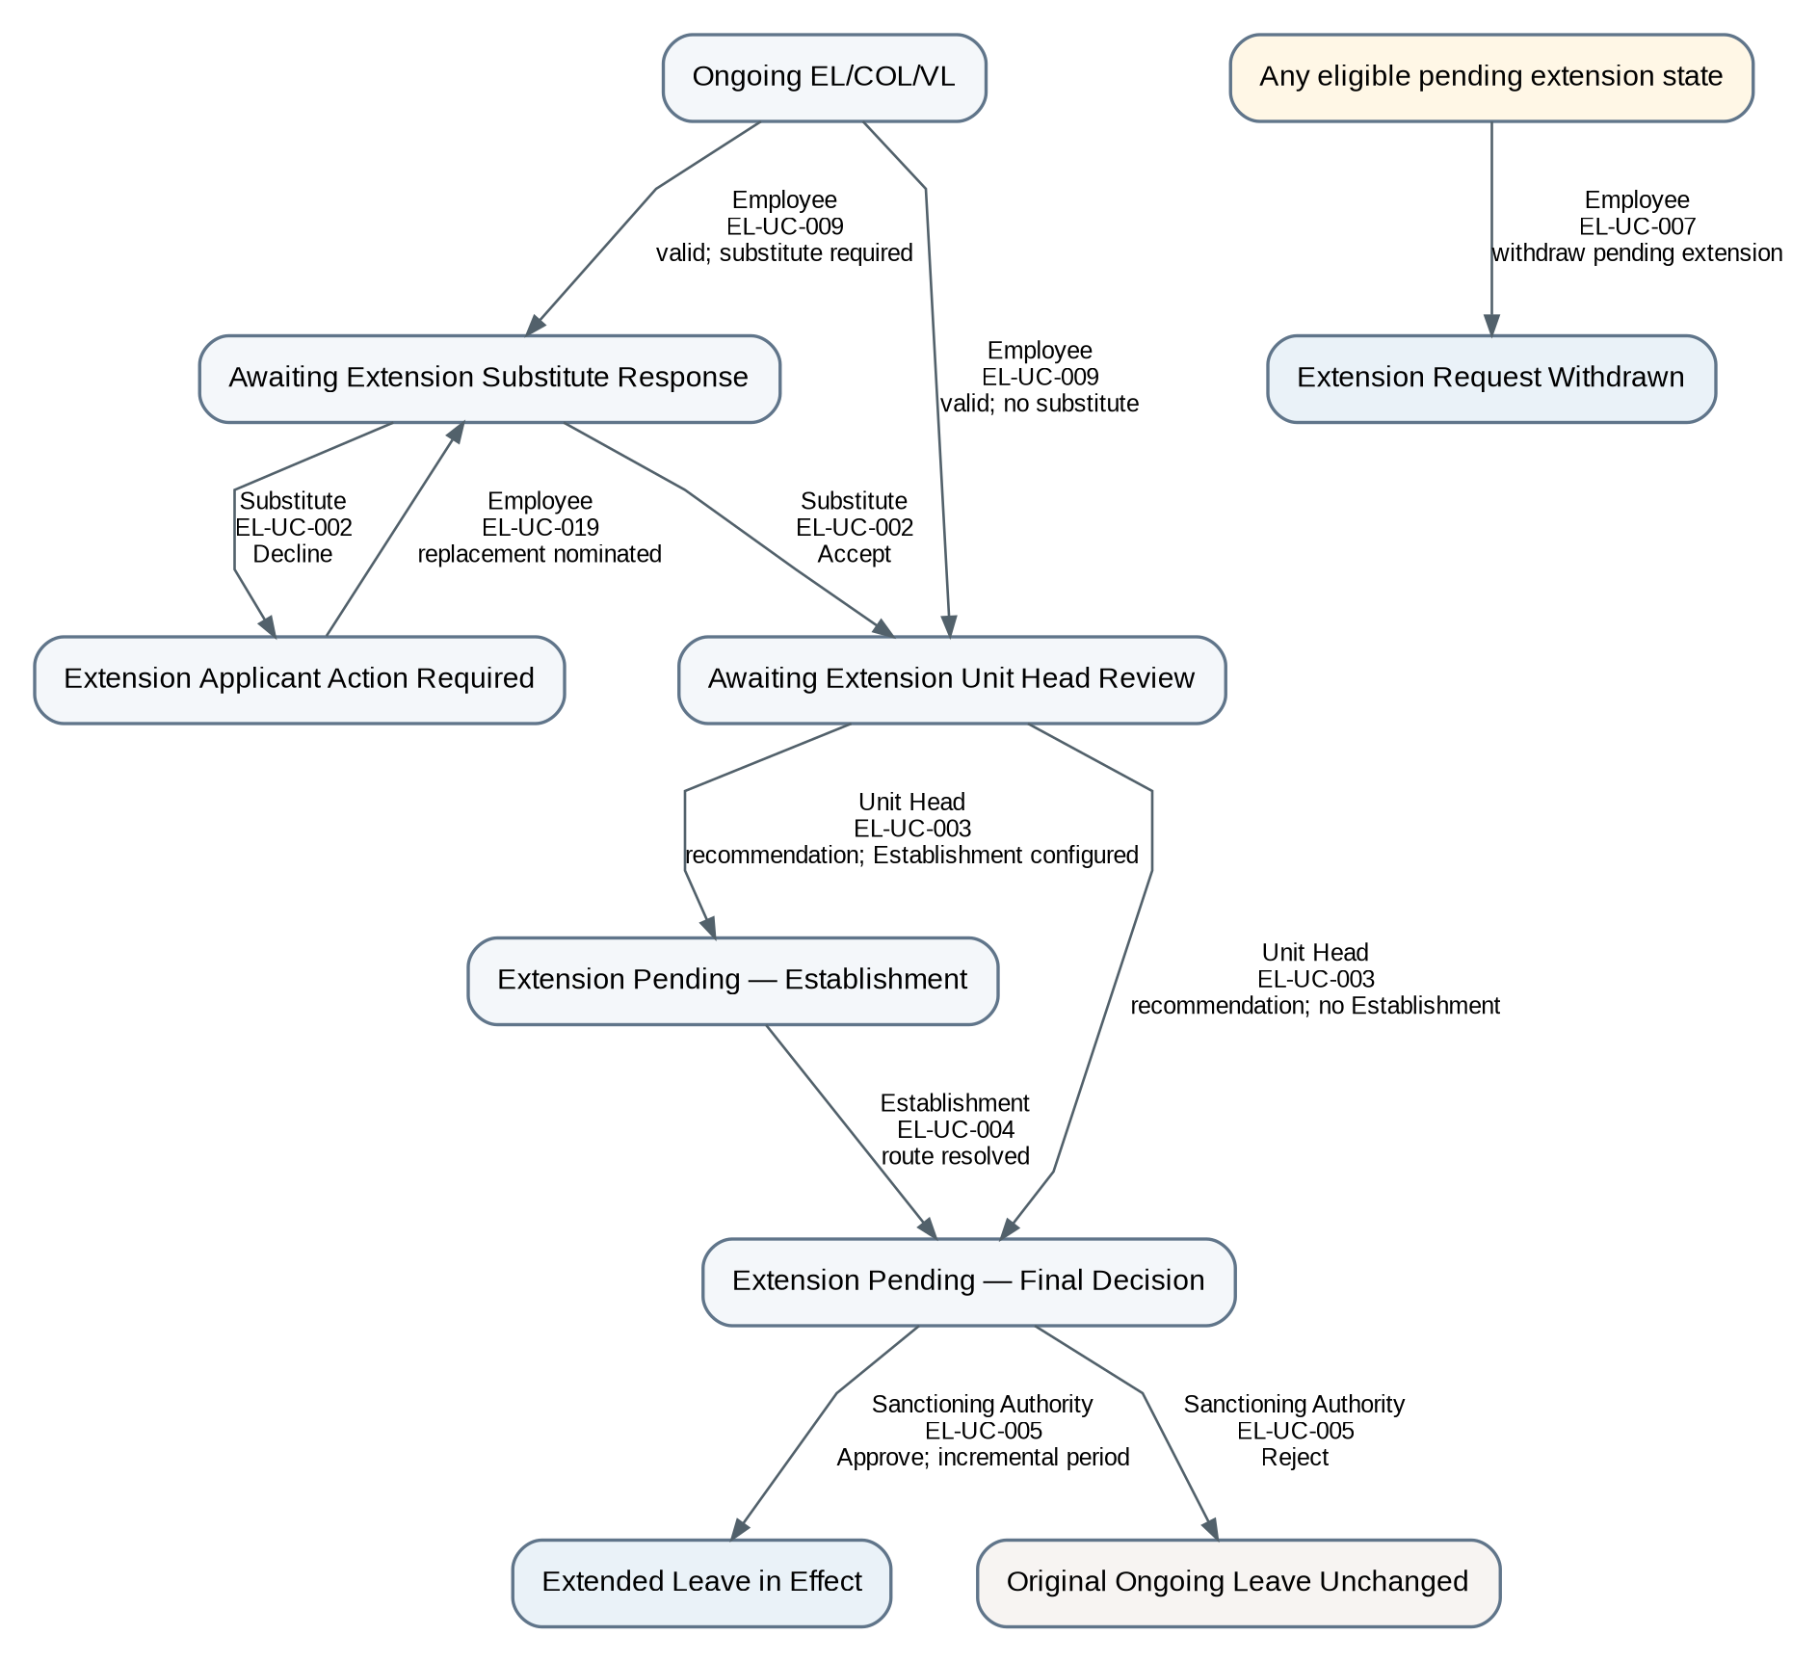

CW-EL-04 — Resumption Review
Type | Composite
Purpose / Scope | Coordinate employee submission of actual resumption information with review by the applicable Sanctioning Authority, distinguishing normal, early, and late return without inventing a generic leave-closure state.
Trigger | Employee returns from EL/COL/VL and submits actual resumption information.
Participants | Employee; applicable Sanctioning Authority
Constituent Workflows | BW-EL-15–17
Related Workflows | CW-EL-02; CW-EL-03
Related CFRs | CFR-EL-021
Related UCs | EL-UC-010, EL-UC-011
Related BRs | BR-EL-027–028

Authoritative State-Transition Table
S. No. | From State | Actor | Use Case ID / Name | Guard / Outcome | Resulting State | BR Reference(s)
1 | Returned from EL/COL/VL | Employee | EL-UC-010 / Submit Resumption of Duty | Actual resumption details submitted | Resumption Review Pending | BR-EL-027
2 | Resumption Review Pending | Applicable Sanctioning Authority | EL-UC-011 / Review Resumption | Actual date = approved end date | Resumption Reviewed — No Adjustment | BR-EL-027–028
3 | Resumption Review Pending | Applicable Sanctioning Authority | EL-UC-011 / Review Resumption | Actual date < approved end date | Resumption Reviewed — Early Return Synchronized | BR-EL-028
4 | Resumption Review Pending | Applicable Sanctioning Authority | EL-UC-011 / Review Resumption | Actual date > approved end date | Resumption Reviewed — Late Return Synchronized | BR-EL-028
Specification Notes
- No generic Closed leave state is introduced.
- Normal, early, and late return are distinguished by review outcome and synchronization effect.

Workflow Diagram
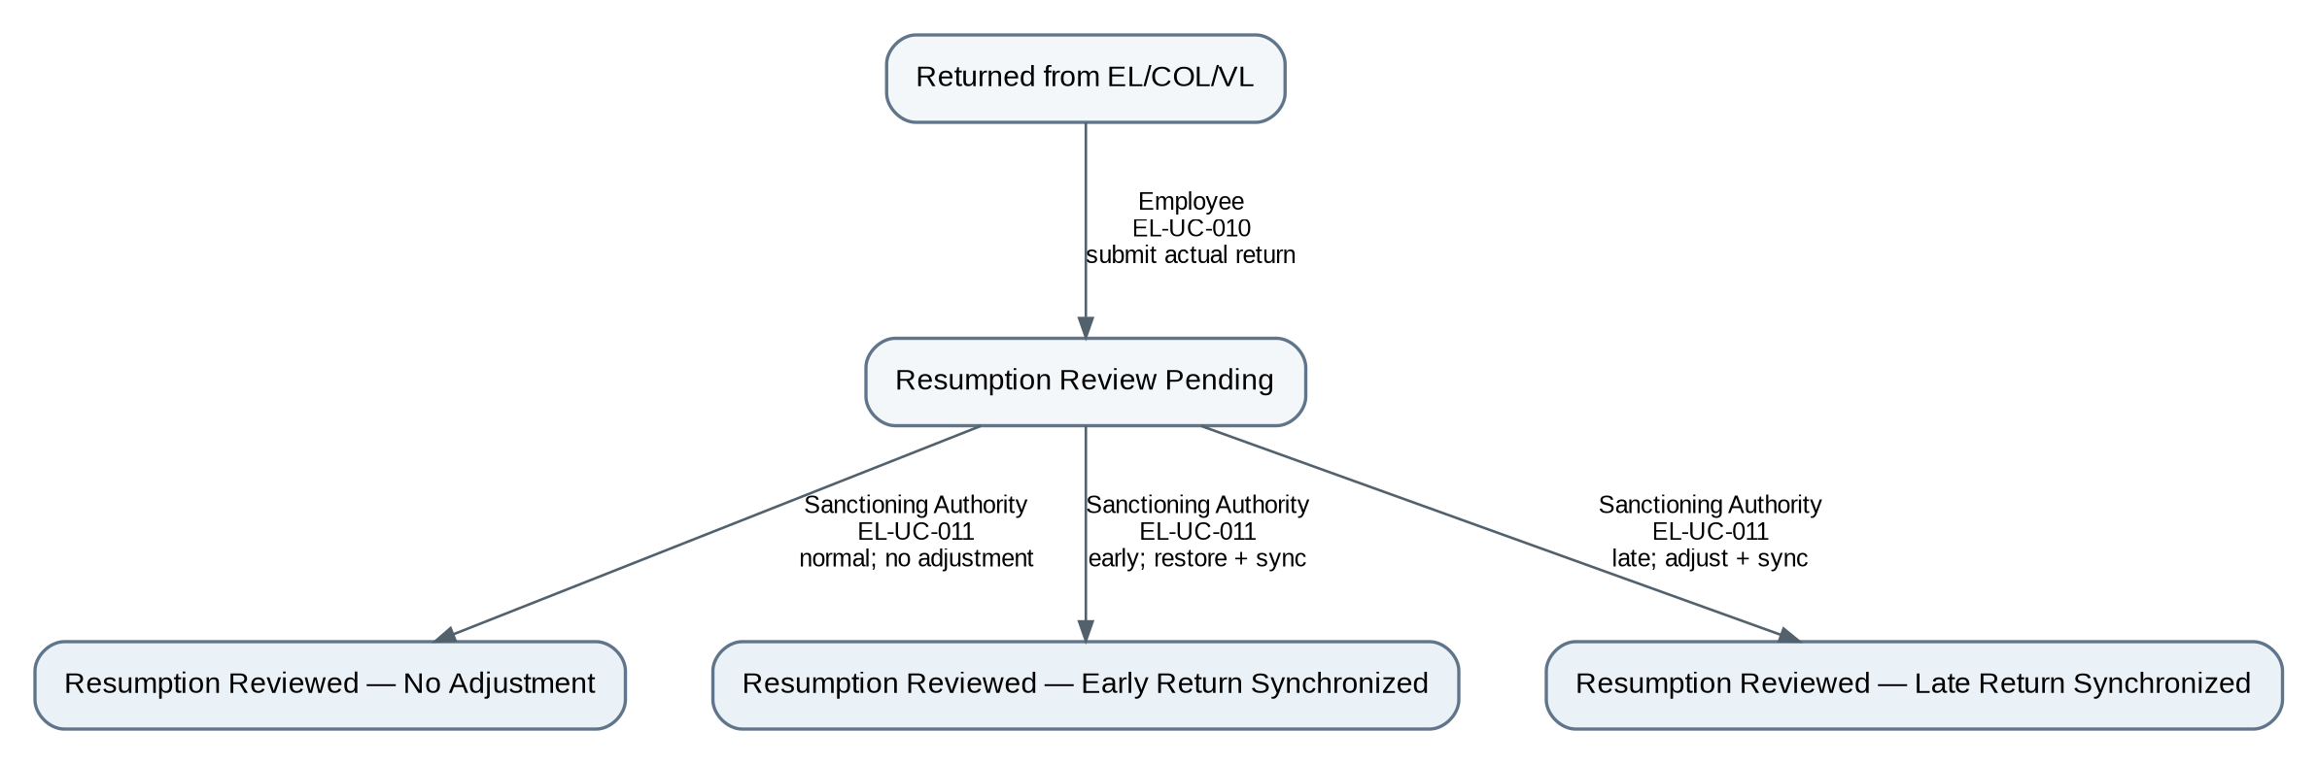

6. Cross-Cutting Automatic SLA Routing / Responsibility Escalation Pattern
Pattern ID | XTP-EL-01
Applies To | Any SLA-controlled actionable task state in CW-EL-01–04 where the configured escalation changes routing/responsibility.
Trigger | Configured escalation threshold reached.
Performer | System (workflow transition performer; not a UC actor).
Related UC | EL-UC-021 / Process SLA Threshold Event
Related BRs | BR-EL-033, BR-EL-038

Authoritative State-Transition Pattern
S. No. | From State | Actor | Use Case ID / Name | Guard / Outcome | Resulting State | BR Reference(s)
1 | Any SLA-controlled actionable task state that remains pending | System | EL-UC-021 / Process SLA Threshold Event | Escalation threshold reached; task still pending; configured action changes routing/responsibility | Same business process state; actionable task responsibility/routing updated to configured higher/responsible authority | BR-EL-033, BR-EL-038

Transition Diagram

7. Functions Intentionally Outside the Workflow Registry
Artifact | Reason outside Workflow Registry | Retained Representation
EL-UC-006 | Retired. Pending in-place modification is not part of the synchronized baseline. | Retired identifier + BR-EL-034 no-modification rule
EL-UC-012 / EL-UC-013 | Informational inquiry/export capabilities; no connected persistent business-state progression. | Use Cases
EL-UC-014 / EL-UC-015 / EL-UC-017 / EL-UC-018 | Administrative configuration/maintenance interactions; isolated actor-goal functions rather than connected process progression. | Use Cases + applicable BRs
EL-UC-016 | Retrospective synchronization of already-sanctioned offline leave; explicitly not a second approval progression. | Use Case + BR-EL-029
EL-UC-020 | Event-triggered year-end leave-account processing; an isolated timed operation applying year-end BRs, not by itself a connected workflow progression. | Event-triggered Use Case + BR-EL-002–009
EL-UC-021 reminder / notification-only escalation | Event-triggered threshold behavior that does not change process routing/responsibility. | Event-triggered Use Case + BR-EL-032/033/038
BR-EL-035 task-assignment notification | Notification effect attached to actionable task assignment; not a standalone workflow. | Business Rule / UC effect

Appendix A — Legacy Workflow Migration / Disposition
Previous Workflow | Disposition | Replacement | Rationale
WF-EL-01 Apply and Decide Leave | Reconstructed | CW-EL-01 + BW-EL-01–09 | Uses complete new-leave Basis paths; substitute consent/recovery fragments are embedded within the applicable CL/RH, higher-sanction, and Director paths.
WF-EL-02 Modify or Withdraw Pending Request | Retired / redistributed | Withdrawal in CW-EL-01 and CW-EL-03; no Modify workflow | Pending in-place modification is removed. Withdrawal is represented where it is actually valid.
WF-EL-03 Cancel Approved Leave | Reconstructed | CW-EL-02 + BW-EL-10–11 | Uses complete cancellation paths with terminal approve/reject alternatives; fresh application remains outside cancellation.
WF-EL-04 Extend Ongoing Leave | Reconstructed | CW-EL-03 + BW-EL-12–14 | Uses complete extension paths for no-substitute, accepted-consent, and one decline/replacement traversal variants.
WF-EL-05 Resume Duty and Close Leave | Reconstructed | CW-EL-04 + BW-EL-15–17 | Replaces “closure” and verifier semantics with Sanctioning Authority review and normal/early/late outcomes.
WF-EL-06 Record Offline-Sanctioned Leave | Retired as workflow | EL-UC-016 + BR-EL-029 | Record synchronization, not a second approval progression.
WF-EL-07 Year-End Leave Processing | Retired as workflow | EL-UC-020 + BR-EL-002–009 | Event-triggered isolated system operation; no SF representation type.
WF-EL-08 SLA Reminder / Escalation | Retired as standalone workflow | EL-UC-021 + BR-EL-032/033/038; XTP-EL-01 where routing changes | Reminder/notification-only behavior is UC+BR; routing-changing escalation is cross-cutting System transition only.

