Fusneica Florentin-Cristian, grupa 241

PLSQL1 EX1

SET SERVEROUTPUT ON;
SET VERIFY OFF;

DECLARE
numar number(3):=100;
mesaj1 varchar2(255):='text 1';
mesaj2 varchar2(255):='text 2';
BEGIN
DECLARE
numar number(3):=1;
mesaj1 varchar2(255):='text 2';
mesaj2 varchar2(255):='text 3';
BEGIN
numar:=numar+1;
--a--
DBMS_OUTPUT.PUT_LINE(numar);
mesaj2:=mesaj2||' adaugat in sub-bloc';
END;
numar:=numar+1;
mesaj1:=mesaj1||' adaugat un blocul principal';
--b--
DBMS_OUTPUT.PUT_LINE(mesaj1);
mesaj2:=mesaj2||' adaugat in blocul principal';
--c--
DBMS_OUTPUT.PUT_LINE(mesaj2);
numar := numar + 1;
-- d) --
DBMS_OUTPUT.PUT_LINE(numar);
mesaj1 := mesaj1 || ' adaugat in blocul principal';
-- e)--
DBMS_OUTPUT.PUT_LINE(mesaj1);
mesaj2 := mesaj2 || ' adaugat in blocul principal';
-- f) --
DBMS_OUTPUT.PUT_LINE(mesaj2);
END;
/

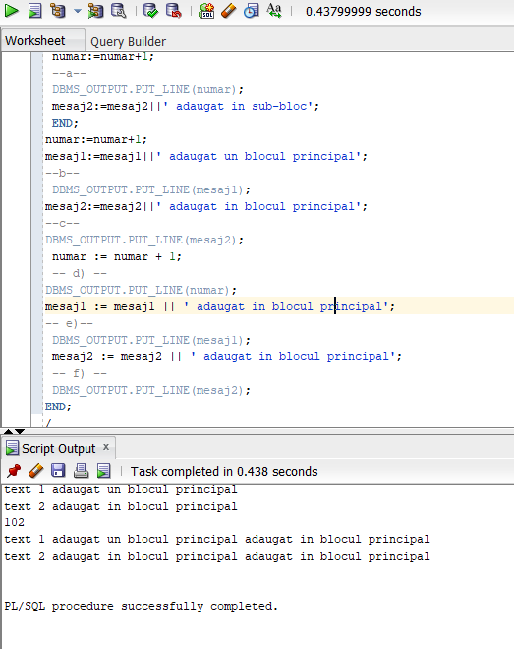

PLSQL1 EX2

-- 2
--a
SELECT all_days_oct.book_date, NVL(days_with_rentals.num, 0) AS num
FROM (
-- Toate zilele cu închirieri
SELECT TO_DATE(book_date) AS book_date, COUNT(1) AS num
FROM rental
GROUP BY book_date
) days_with_rentals
RIGHT JOIN (
-- Toate zilele din octombrie
SELECT TO_DATE(TRUNC (last_day('01-OCT-2020') - ROWNUM)) AS book_date
FROM DUAL CONNECT BY ROWNUM < 31
) all_days_oct
ON days_with_rentals.book_date = all_days_oct.book_date
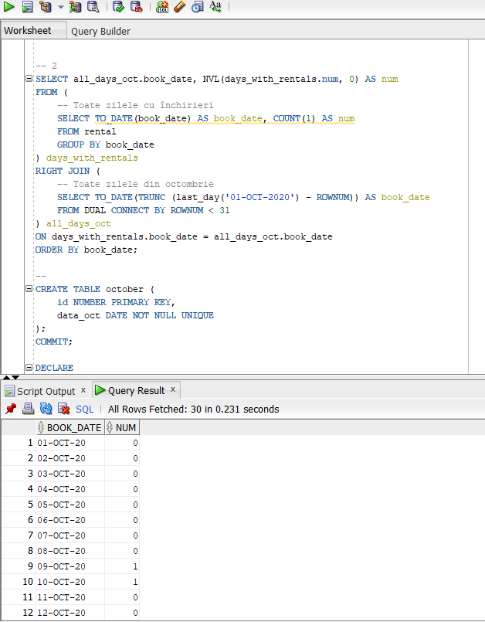
ORDER BY book_date;

--b--
--Crearea tabelei October
CREATE TABLE october (
id NUMBER PRIMARY KEY,
data_oct DATE NOT NULL UNIQUE
);
COMMIT;

DECLARE
day_o DATE := '01-OCT-2020';
BEGIN
--Parcurgerea zilelor din luna octombrie
FOR i IN 1..31 LOOP
INSERT INTO october VALUES (i, day_o);
day_o := day_o + 1;
END LOOP;
END;
/
SELECT data_oct, NVL(num, 0)
FROM october
LEFT JOIN (
--selectarea datelor cu inchirieri
SELECT TO_DATE(book_date) AS data_oct, COUNT(1) AS num
FROM rental
GROUP BY book_date
)
USING (data_oct)
ORDER BY data_oct;
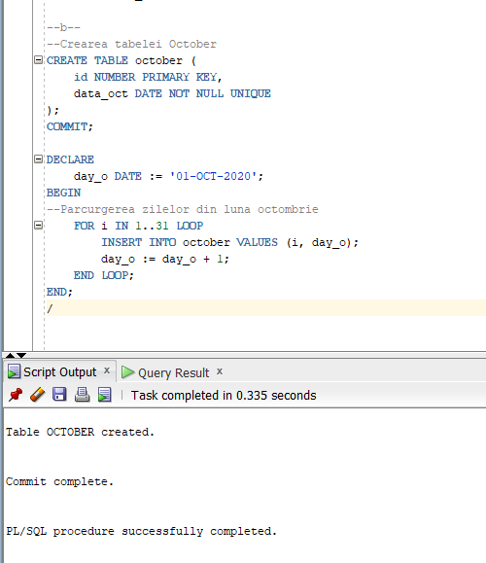

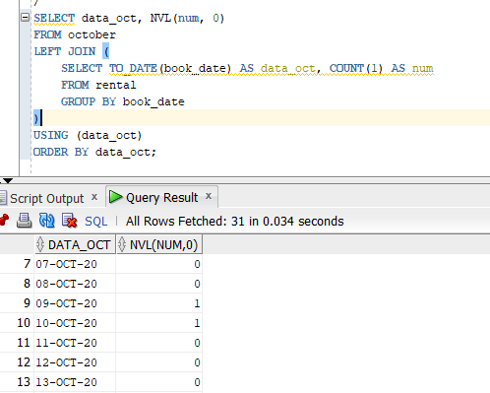

PLSQL1 EX 3
-- 3
DECLARE
--member id si nr de filme
memberr NUMBER;
num_movies NUMBER;
BEGIN
SELECT member_id INTO memberr
FROM member
WHERE first_name = &nume;

SELECT COUNT(*) INTO num_movies
FROM title
INNER JOIN rental
USING (title_id)
WHERE member_id = memberr;

IF num_movies = 0 THEN
DBMS_OUTPUT.PUT_LINE('Nu exista filme inchiriate');
ELSE
DBMS_OUTPUT.PUT_LINE('Filme inchiriate: ' || num_movies);
END IF;

EXCEPTION
WHEN too_many_rows THEN
DBMS_OUTPUT.PUT_LINE('Mai multi oameni cu acelasi nume');

when no_data_found then
DBMS_OUTPUT.PUT_LINE('Nu exista membrul cautat');
END;
/

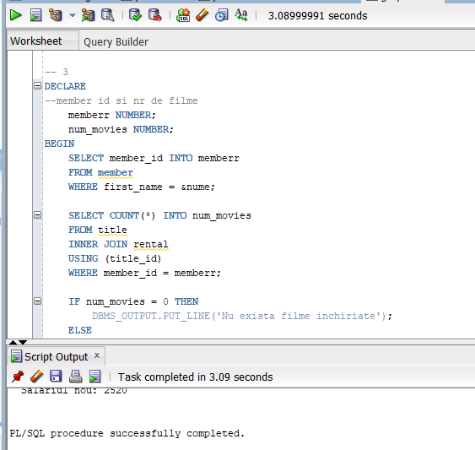

PLSQL1 EX 4

-- 4
DECLARE
memberr NUMBER;
num_movies NUMBER;
total_movies NUMBER;
percent_rented NUMBER;
BEGIN
SELECT member_id INTO memberr
FROM member
WHERE first_name = &nume;

SELECT COUNT(*) INTO num_movies
FROM title
INNER JOIN rental
USING (title_id)
WHERE member_id = memberr;

IF num_movies = 0 THEN
DBMS_OUTPUT.PUT_LINE('Nu exista filme inchiriate');
ELSE
DBMS_OUTPUT.PUT_LINE('Filme inchiriate: ' || num_movies);
END IF;

SELECT COUNT(*) INTO total_movies
FROM title;

percent_rented := num_movies / total_movies;
IF percent_rented >= 0.75 THEN
DBMS_OUTPUT.PUT_LINE('Categorie 1');
ELSIF percent_rented >= 0.5 THEN
DBMS_OUTPUT.PUT_LINE('Categorie 2');
ELSIF percent_rented >= 0.25 THEN
DBMS_OUTPUT.PUT_LINE('Categorie 3');
ELSE
DBMS_OUTPUT.PUT_LINE('Categorie 4');
END IF;
EXCEPTION
WHEN too_many_rows THEN
DBMS_OUTPUT.PUT_LINE('Mai multi oameni cu acelasi nume');
END;
/
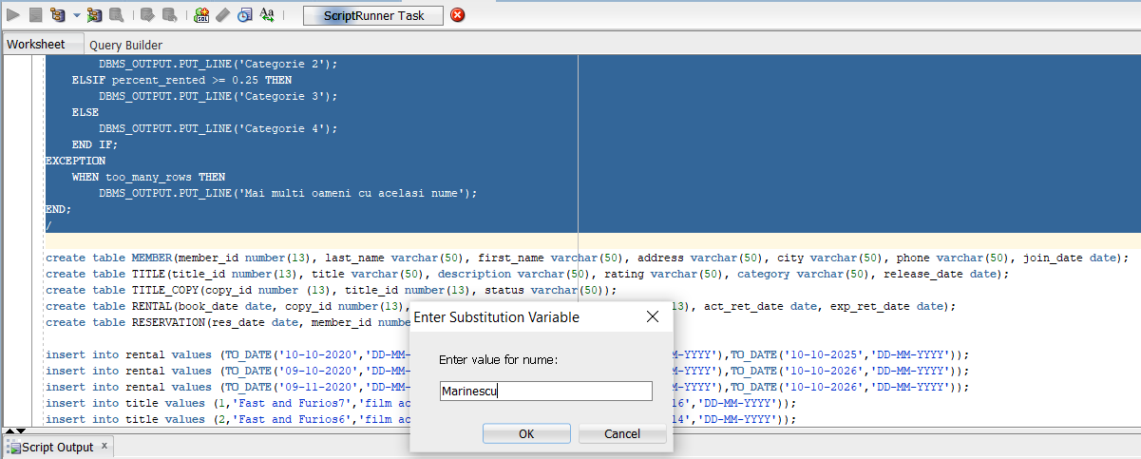

PLSQL1 EX 5

-- 5
DROP TABLE membru_discount;

CREATE TABLE membru_discount AS (
SELECT * FROM member
);

ALTER TABLE membru_discount
ADD discount NUMBER DEFAULT NULL;

DECLARE
membru NUMBER;
num_filme NUMBER;
total NUMBER;
procent NUMBER;
discount_in NUMBER;
discount_nou NUMBER;
BEGIN
--codul introdus de la tastatura
membru := &cod_membru;
--selectarea numarului de filme
SELECT COUNT(*) INTO num_filme
FROM title
INNER JOIN rental
USING (title_id)
WHERE member_id = membru;
--numarul total de filme existente
SELECT COUNT(*) INTO total
FROM title;
SELECT discount INTO discount_in
FROM membru_discount
WHERE member_id = membru;
--calcularea procentului de inchiriere
procent := num_filme / total;
--calcularea procentului in functie de categorie
IF procent >= 0.75 THEN
discount_nou := 0.10;
ELSIF procent >= 0.5 THEN
discount_nou := 0.05;
ELSIF procent >= 0.25 THEN
discount_nou := 0.03;
ELSE
discount_nou := NULL;
END IF;

IF NVL(discount_in, 0) != NVL(discount_nou, 0) THEN
UPDATE membru_discount
SET discount = discount_nou
WHERE member_id = membru;
DBMS_OUTPUT.PUT_LINE('Noul discount ' || discount_nou);
ELSE
DBMS_OUTPUT.PUT_LINE('Discount neschimbat');
END IF;
END;
/
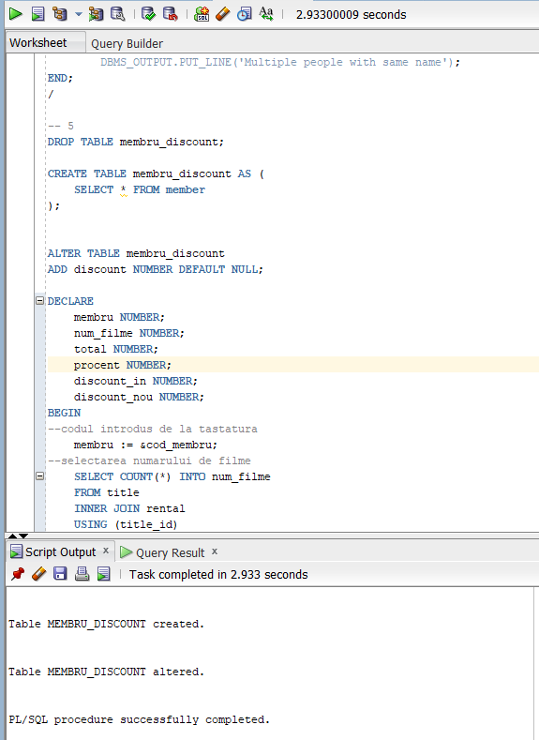

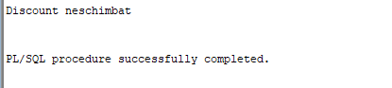

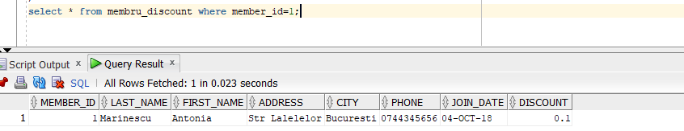
PLSQL2 EX 1

-- 1

-- fac o copie a tabelei employees pt a putea face modificari pe ea
DROP TABLE empl_copie;
CREATE TABLE empl_copie AS (SELECT * FROM employees);
COMMIT;

DECLARE
-- Colecție cu idurile celor care nu castiga comision
TYPE emp_ids_vector IS VARRAY(5)
OF empl_copie.employee_id%TYPE NOT NULL;
emps emp_ids_vector := emp_ids_vector();
emp_id empl_copie.employee_id%TYPE;
emp_salary empl_copie.salary%TYPE;
BEGIN
SELECT *
BULK COLLECT INTO emps
FROM
(
SELECT employee_id
FROM empl_copie
WHERE commission_pct IS NULL
ORDER BY salary ASC
)
WHERE rownum <= 5;

FOR i IN emps.FIRST..emps.LAST LOOP
emp_id := emps(i);

DBMS_OUTPUT.PUT_LINE('Actualizez salariatul cu id ul' || emp_id);

SELECT salary
INTO emp_salary
FROM empl_copie
WHERE employee_id = emp_id;

DBMS_OUTPUT.PUT_LINE(' Salariu vechi: ' || emp_salary);
--maresc salariul cu 5%
UPDATE empl_copie
SET salary = salary * 1.05
WHERE employee_id = emp_id;

SELECT salary
INTO emp_salary
FROM empl_copie
WHERE employee_id = emp_id;

DBMS_OUTPUT.PUT_LINE(' Salariul nou: ' || emp_salary);
END LOOP;
END;
/

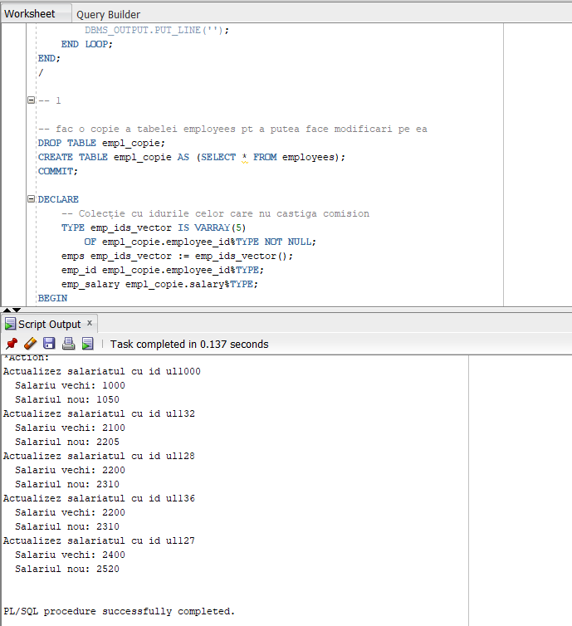

PLSQL2 EX2
-- 2
-- VARRAY

-- Creez tabelul care reține excursiile
DROP TABLE excursie;

CREATE OR REPLACE TYPE tip_orase_1 AS VARRAY(50) OF VARCHAR2(10);
/

CREATE TABLE excursie_1 (
cod_excursie NUMBER(4) PRIMARY KEY,
denumire VARCHAR(20) NOT NULL,
orase tip_orase_1 NOT NULL,
status VARCHAR(20) NOT NULL
);

-- Inserare date
DELETE FROM excursie_1;
INSERT ALL
INTO excursie_1 (cod_excursie, denumire, orase,status)
VALUES (1, 'Romania', tip_orase_1('Bucuresti', 'Iasi'),'disponibila')
INTO excursie_1 (cod_excursie, denumire, orase,status)
VALUES (2, 'Spania', tip_orase_1('Barcelona'),'disponibila')
INTO excursie_1 (cod_excursie, denumire, orase,status)
VALUES (3, 'Bulgaria', tip_orase_1('Sofia', 'Ruse'),'disponibila')
INTO excursie_1 (cod_excursie, denumire, orase,status)
VALUES (5, 'Romania', tip_orase_1('Sighisoara'),'disponibila')
INTO excursie_1 (cod_excursie, denumire, orase,status)
VALUES (6, 'Franta', tip_orase_1('Paris'),'disponibila')
INTO excursie_1 (cod_excursie, denumire, orase,status)
VALUES (10, 'Italia', tip_orase_1('Roma'),'disponibila')
INTO excursie_1 (cod_excursie, denumire, orase,status)
VALUES (11, 'Portugalia', tip_orase_1('Madeira'),'anulata')
SELECT * FROM dual;

COMMIT;
/
SELECT * FROM excursie_1;
/
set serveroutput on;
DECLARE
v_cod_excursie CONSTANT NUMBER NOT NULL := &cod;
v_orase tip_orase_1;
BEGIN
SELECT orase INTO v_orase
FROM excursie_1
WHERE cod_excursie = v_cod_excursie;

-- Adaug orașul nou la finalul listei
v_orase.EXTEND;
v_orase(v_orase.COUNT) := &oras;

UPDATE excursie_1
SET orase = v_orase
WHERE cod_excursie = v_cod_excursie;
END;
/

SELECT * FROM excursie_1;
/
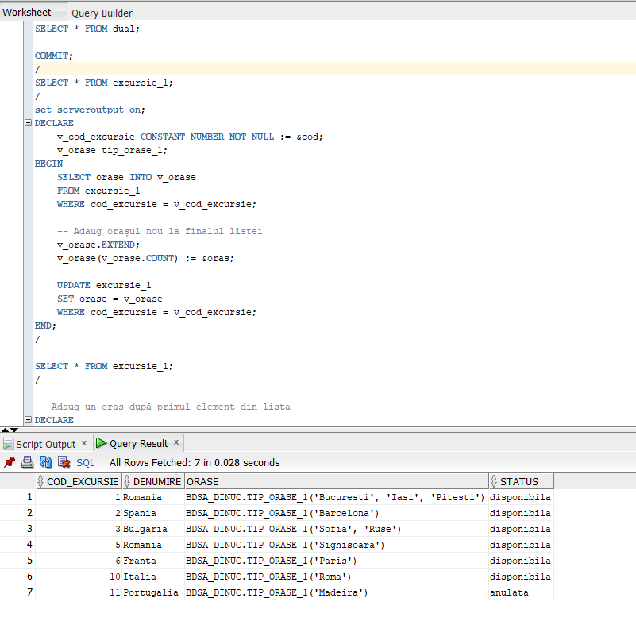
-- Adaug un oraș după primul element din lista
DECLARE
--codul introdus de la tastatura
v_cod_excursie CONSTANT NUMBER NOT NULL := &cod;
v_orase tip_orase_1;
BEGIN
SELECT orase INTO v_orase
FROM excursie_1
WHERE cod_excursie = v_cod_excursie;

-- Adaug orasul după primul element din vector.
v_orase.EXTEND;
FOR i IN REVERSE v_orase.NEXT(2)..v_orase.LAST LOOP
v_orase(i) := v_orase(i - 1);
END LOOP;
v_orase(2) := &oras;
--update dupa ce am adaugat orasul
UPDATE excursie_1
SET orase = v_orase
WHERE cod_excursie = v_cod_excursie;
END;
/

SELECT * FROM excursie_1;
/

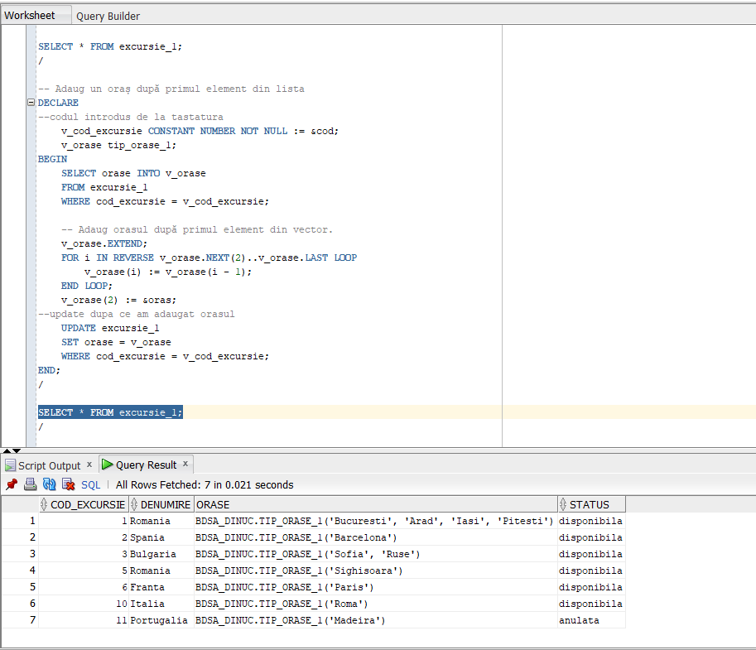

-- inversare ordine
DECLARE
v_cod_excursie CONSTANT NUMBER NOT NULL := &cod;
v_orase tip_orase;
v_index1 NUMBER;
v_index2 NUMBER;
v_oras_aux VARCHAR(20);
BEGIN
SELECT orase INTO v_orase
FROM excursie_1
WHERE cod_excursie = v_cod_excursie;

-- caut orasele in vector
FOR i IN v_orase.FIRST..v_orase.LAST LOOP
IF v_orase(i) = &nume_oras1 THEN
v_index1 := i;
ELSIF v_orase(i) = &nume_oras2 THEN
v_index2 := i;
END IF;
END LOOP;

-- Interschimb
v_oras_aux := v_orase(v_index1);
v_orase(v_index1) := v_orase(v_index2);
v_orase(v_index2) := v_oras_aux;
--update dupa schimbare
UPDATE excursie
SET orase = v_orase
WHERE cod_excursie = v_cod_excursie;
END;
/

SELECT * FROM excursie_1;
/

-- stergere oras dupa nume dat de la tastatura
DECLARE
v_cod_excursie CONSTANT NUMBER NOT NULL := &cod;
v_orase tip_orase_1;
v_index NUMBER := NULL;
BEGIN
SELECT orase INTO v_orase
FROM excursie_1
WHERE cod_excursie = v_cod_excursie;

-- Caut orașul în vector
FOR i IN v_orase.FIRST..v_orase.LAST LOOP
IF v_orase(i) = &nume_oras THEN
v_index := i;
END IF;
END LOOP;

-- Șterg orașul
FOR i IN (v_index + 1)..v_orase.COUNT LOOP
v_orase(i - 1) := v_orase(i);
END LOOP;

v_orase.TRIM;

UPDATE excursie_1
SET orase = v_orase
WHERE cod_excursie = v_cod_excursie;
END;
/

SELECT * FROM excursie_1;
/

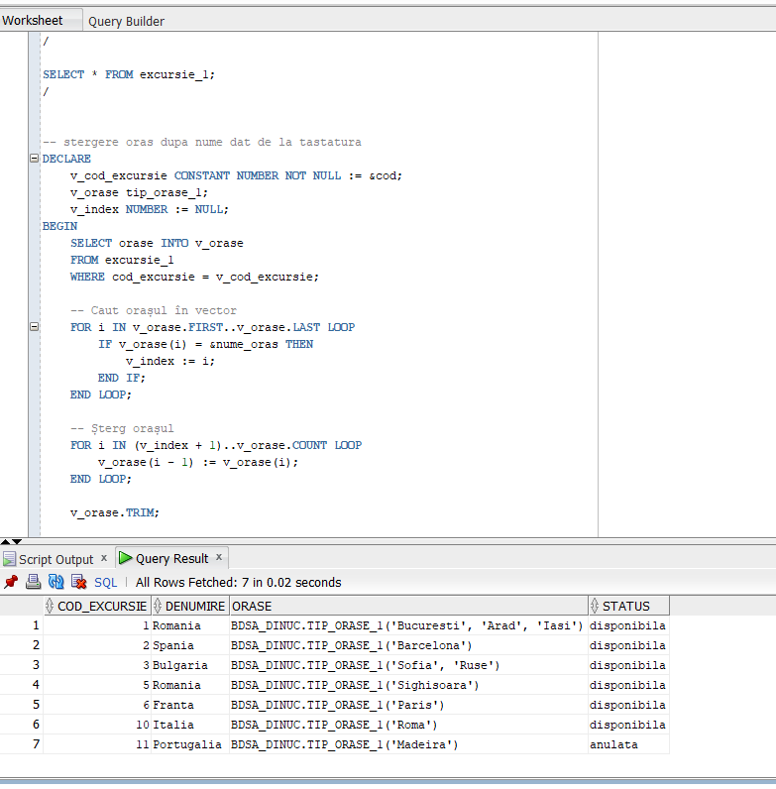

-- afisare detalii
DECLARE
v_cod_excursie CONSTANT NUMBER NOT NULL := &cod;
v_orase tip_orase;
BEGIN
SELECT orase INTO v_orase
FROM excursie_1
WHERE cod_excursie = v_cod_excursie;
--lista
DBMS_OUTPUT.PUT_LINE('Nr. orase: ' || v_orase.COUNT);

FOR i IN v_orase.FIRST..v_orase.LAST LOOP
DBMS_OUTPUT.PUT_LINE('Oras #' || i || ': ' || v_orase(i));
END LOOP;
END;
/
-- Afisare lista de orașe pentru fiecare excursie, pe rând
DECLARE
TYPE tip_coduri_excursii IS TABLE OF excursie.cod_excursie%TYPE;
v_coduri_excursii tip_coduri_excursii;
v_orase tip_orase;
BEGIN
FOR e IN (SELECT cod_excursie, orase FROM excursie) LOOP
DBMS_OUTPUT.PUT_LINE('Excursie #' || e.cod_excursie);

FOR j IN 1..(e.orase.COUNT) LOOP
DBMS_OUTPUT.PUT_LINE(' Oras #' || j || ': ' || e.orase(j));
END LOOP;
END LOOP;
END;
/
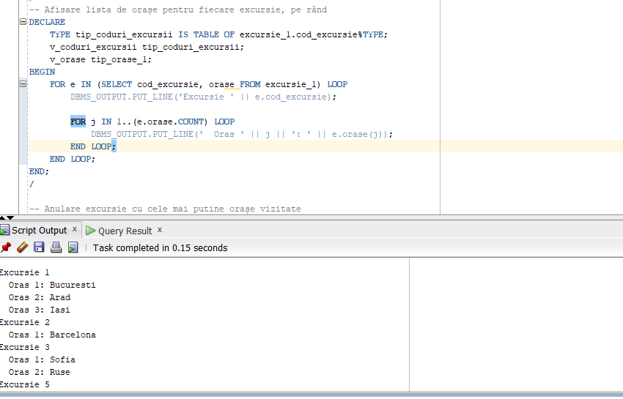

-- Anulare excursie cu cele mai putine orașe vizitate
DECLARE
v_nr_min NUMBER := 99999;
BEGIN
FOR e IN (SELECT orase FROM excursie_1) LOOP
IF e.orase.COUNT < v_nr_min THEN
v_nr_min := e.orase.COUNT;
END IF;
END LOOP;

FOR e IN (SELECT cod_excursie, orase FROM excursie_1) LOOP
-- Daca are număr minim de orașe
IF e.orase.COUNT = v_nr_min THEN
-- anulez excursia
UPDATE excursie_1
SET status = 'anulata'
WHERE cod_excursie = e.cod_excursie;
END IF;
END LOOP;
END;
/

SELECT * FROM excursie_1;
/
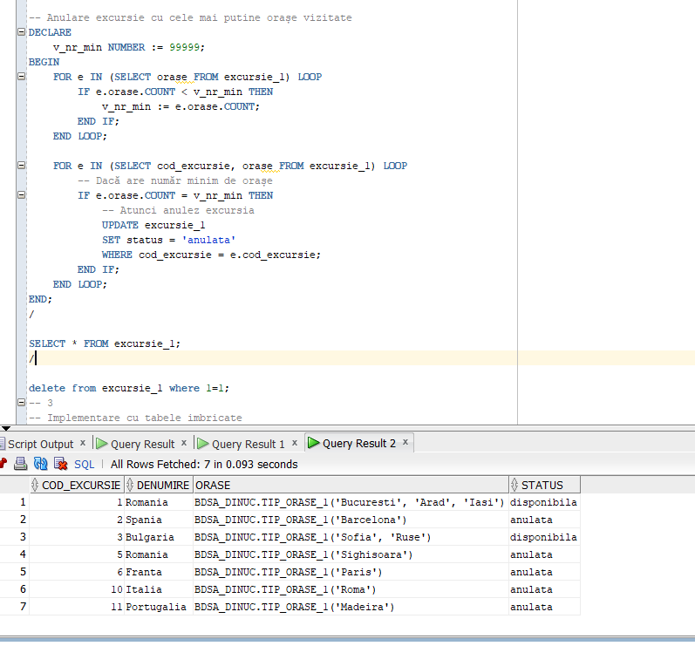

PLSQL2 EX 3
CREATE OR REPLACE TYPE tip_orase_1 AS TABLE OF VARCHAR2(10);
/

CREATE TABLE excursie_1 (
cod_excursie NUMBER(4) PRIMARY KEY,
denumire VARCHAR2(20) NOT NULL,
orase tip_orase,
status VARCHAR2(20) DEFAULT 'disponibila' NOT NULL
)
NESTED TABLE orase STORE AS excursie_orase;

-- Inserez date
DELETE FROM excursie_1;
INSERT ALL
INTO excursie_1 (cod_excursie, denumire, orase,status)
VALUES (1, 'Romania', tip_orase_1('Bucuresti', 'Iasi'),'disponibila')
INTO excursie_1 (cod_excursie, denumire, orase,status)
VALUES (2, 'Spania', tip_orase_1('Barcelona'),'disponibila')
INTO excursie_1 (cod_excursie, denumire, orase,status)
VALUES (3, 'Bulgaria', tip_orase_1('Sofia', 'Ruse'),'disponibila')
INTO excursie_1 (cod_excursie, denumire, orase,status)
VALUES (5, 'Romania', tip_orase_1('Sighisoara'),'disponibila')
INTO excursie_1 (cod_excursie, denumire, orase,status)
VALUES (6, 'Franta', tip_orase_1('Paris'),'disponibila')
INTO excursie_1 (cod_excursie, denumire, orase,status)
VALUES (10, 'Italia', tip_orase_1('Roma'),'disponibila')
INTO excursie_1 (cod_excursie, denumire, orase,status)
VALUES (11, 'Portugalia', tip_orase_1('Madeira'),'anulata')
SELECT * FROM dual;

COMMIT;
/
set serveroutput on;
DECLARE
v_cod_excursie CONSTANT NUMBER NOT NULL := &cod;
v_orase tip_orase_1;
BEGIN
SELECT orase INTO v_orase
FROM excursie_1
WHERE cod_excursie = v_cod_excursie;

-- Adaug orașul nou la finalul listei
v_orase.EXTEND;
v_orase(v_orase.COUNT) := &oras;

UPDATE excursie_1
SET orase = v_orase
WHERE cod_excursie = v_cod_excursie;
END;
/

SELECT * FROM excursie_1;
/
-- Adaug un oraș după primul element din lista
DECLARE
--codul introdus de la tastatura
v_cod_excursie CONSTANT NUMBER NOT NULL := &cod;
v_orase tip_orase_1;
BEGIN
SELECT orase INTO v_orase
FROM excursie_1
WHERE cod_excursie = v_cod_excursie;

-- Adaug orasul după primul element din vector.
v_orase.EXTEND;
FOR i IN REVERSE v_orase.NEXT(2)..v_orase.LAST LOOP
v_orase(i) := v_orase(i - 1);
END LOOP;
v_orase(2) := &oras;
--update dupa ce am adaugat orasul
UPDATE excursie_1
SET orase = v_orase
WHERE cod_excursie = v_cod_excursie;
END;
/

SELECT * FROM excursie_1;
/

-- inversare ordine
DECLARE
v_cod_excursie CONSTANT NUMBER NOT NULL := &cod;
v_orase tip_orase;
v_index1 NUMBER;
v_index2 NUMBER;
v_oras_aux VARCHAR(20);
BEGIN
SELECT orase INTO v_orase
FROM excursie_1
WHERE cod_excursie = v_cod_excursie;

-- caut orasele in vector
FOR i IN v_orase.FIRST..v_orase.LAST LOOP
IF v_orase(i) = &nume_oras1 THEN
v_index1 := i;
ELSIF v_orase(i) = &nume_oras2 THEN
v_index2 := i;
END IF;
END LOOP;

-- Interschimb
v_oras_aux := v_orase(v_index1);
v_orase(v_index1) := v_orase(v_index2);
v_orase(v_index2) := v_oras_aux;
--update dupa schimbare
UPDATE excursie
SET orase = v_orase
WHERE cod_excursie = v_cod_excursie;
END;
/

SELECT * FROM excursie_1;
/

-- stergere oras dupa nume dat de la tastatura
DECLARE
v_cod_excursie CONSTANT NUMBER NOT NULL := &cod;
v_orase tip_orase_1;
v_index NUMBER := NULL;
BEGIN
SELECT orase INTO v_orase
FROM excursie_1
WHERE cod_excursie = v_cod_excursie;

-- Caut orașul în vector
FOR i IN v_orase.FIRST..v_orase.LAST LOOP
IF v_orase(i) = &nume_oras THEN
v_index := i;
END IF;
END LOOP;

-- Șterg orașul
FOR i IN (v_index + 1)..v_orase.COUNT LOOP
v_orase(i - 1) := v_orase(i);
END LOOP;

v_orase.TRIM;

UPDATE excursie_1
SET orase = v_orase
WHERE cod_excursie = v_cod_excursie;
END;
/

SELECT * FROM excursie_1;
/

-- afisare detalii
DECLARE
v_cod_excursie CONSTANT NUMBER NOT NULL := &cod;
v_orase tip_orase;
BEGIN
SELECT orase INTO v_orase
FROM excursie_1
WHERE cod_excursie = v_cod_excursie;
--lista
DBMS_OUTPUT.PUT_LINE('Nr. orase: ' || v_orase.COUNT);

FOR i IN v_orase.FIRST..v_orase.LAST LOOP
DBMS_OUTPUT.PUT_LINE('Oras #' || i || ': ' || v_orase(i));
END LOOP;
END;
/
-- Afisare lista de orașe pentru fiecare excursie, pe rând
DECLARE
TYPE tip_coduri_excursii IS TABLE OF excursie.cod_excursie%TYPE;
v_coduri_excursii tip_coduri_excursii;
v_orase tip_orase;
BEGIN
FOR e IN (SELECT cod_excursie, orase FROM excursie) LOOP
DBMS_OUTPUT.PUT_LINE('Excursie #' || e.cod_excursie);

FOR j IN 1..(e.orase.COUNT) LOOP
DBMS_OUTPUT.PUT_LINE(' Oras #' || j || ': ' || e.orase(j));
END LOOP;
END LOOP;
END;
/

-- Anulare excursie cu cele mai putine orașe vizitate
DECLARE
v_nr_min NUMBER := 99999;
BEGIN
FOR e IN (SELECT orase FROM excursie_1) LOOP
IF e.orase.COUNT < v_nr_min THEN
v_nr_min := e.orase.COUNT;
END IF;
END LOOP;

FOR e IN (SELECT cod_excursie, orase FROM excursie_1) LOOP
-- Daca are număr minim de orașe
IF e.orase.COUNT = v_nr_min THEN
-- anulez excursia
UPDATE excursie_1
SET status = 'anulata'
WHERE cod_excursie = e.cod_excursie;
END IF;
END LOOP;
END;
/

SELECT * FROM excursie_1;
/

PLSQL 3 EX 1 SI EX 2

SET VERIFY OFF;
set serveroutput on
-- 1

DECLARE
v_num_ang NUMBER;
v_sal_lunar NUMBER;
v_sal_mediu NUMBER;
v_contor_ang NUMBER;

v_nr_ang NUMBER;
v_sal_total NUMBER;
v_sal_total_med NUMBER;
BEGIN
-- Parcurgere joburi folosind un ciclu cursor
FOR i IN (SELECT job_id, job_title FROM jobs)
LOOP
DBMS_OUTPUT.PUT_LINE('Job: ' || i.job_title);
--Extragere despre jobul curent (nr, salariu lunar, salariu mediu)
SELECT COUNT(1), SUM(salary), AVG(salary)
INTO v_num_ang, v_sal_lunar, v_sal_mediu
FROM employees
WHERE job_id = i.job_id;
IF v_num_ang = 0 THEN
--afisare si tratarea cazului in care nu exista angajati cu jobul precizat
DBMS_OUTPUT.PUT_LINE('Nu avem angajati cu acest job');
ELSE
DBMS_OUTPUT.PUT_LINE('- Numar angajati: ' || v_num_ang);
DBMS_OUTPUT.PUT_LINE('- Salariu lunar total: ' || v_sal_lunar);
DBMS_OUTPUT.PUT_LINE('- Salariu mediu: ' || v_sal_mediu);
END IF;

-- Afisare angajati
v_contor_ang := 1;
FOR j IN (SELECT first_name, last_name, salary
FROM employees
WHERE job_id = i.job_id)
LOOP
DBMS_OUTPUT.PUT_LINE(
' Angajatul ' || v_contor_ang || ': '
|| j.first_name || ' ' || j.last_name
|| ' are salariul ' || j.salary
);

-- folosesc cursor pentru a numara angajatii
v_contor_ang := v_contor_ang + 1;
END LOOP;

END LOOP;
SELECT
--selectez detalii pentru toti angajatii--
COUNT(1),
SUM(salary),
Round(AVG(salary))
INTO
v_nr_ang,
v_sal_total,
v_sal_total_med
FROM employees;

DBMS_OUTPUT.PUT_LINE('Numar total angajati: ' || v_nr_ang);
DBMS_OUTPUT.PUT_LINE('Salariu total angajati: ' || v_sal_total);
DBMS_OUTPUT.PUT_LINE('Salariu mediu angajati: ' || v_sal_total_med);
END;
/
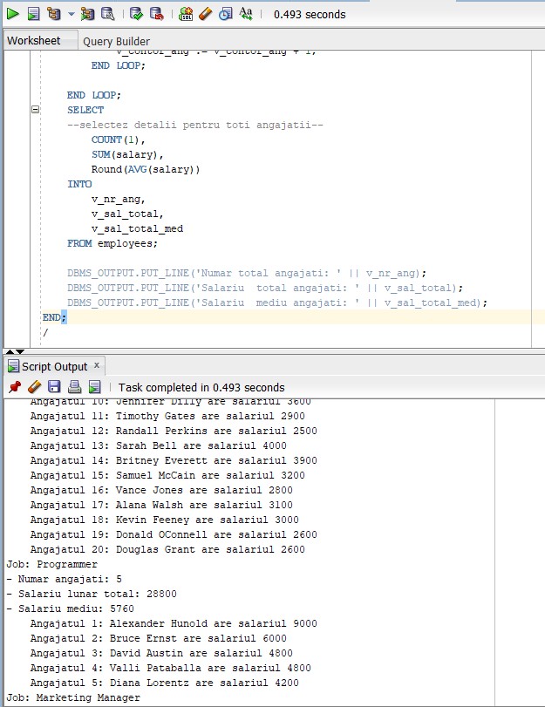

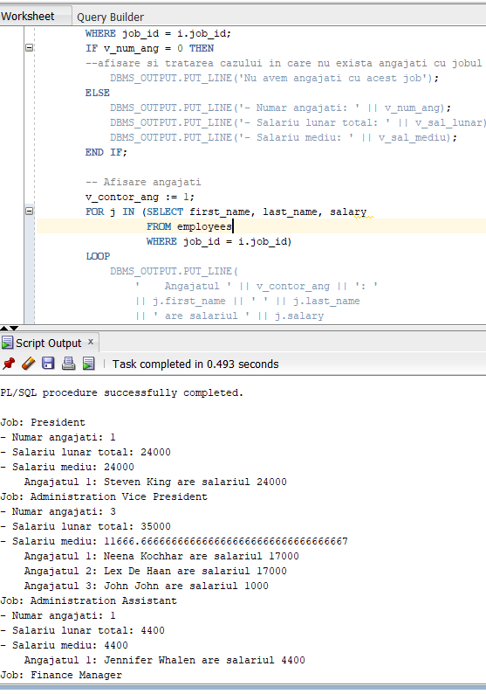

PLSQL3 EX 3

-- 3
DECLARE
v_sum_tot NUMBER;
v_sum_ang NUMBER;
BEGIN
-- calculare suma totală alocata lunar pt salarii
SELECT SUM(salary) + SUM(salary * NVL(commission_pct, 0))
--incarc suma in variabila
INTO v_sum_tot
FROM employees;
DBMS_OUTPUT.PUT_LINE('Suma totala lunara: ' || v_sum_tot);
-- pqarcurgere joburi cu un ciclu cursor
FOR i IN (SELECT job_id, job_title FROM jobs)
LOOP
DBMS_OUTPUT.PUT_LINE('Jobul ' || i.job_title);
-- Afisare angajati
FOR j IN (SELECT first_name, last_name, salary, commission_pct
FROM employees
WHERE job_id = i.job_id)
LOOP
--calcul suma pt un angajat
v_sum_ang := j.salary * (1 + NVL(j.commission_pct, 0));
DBMS_OUTPUT.PUT_LINE(
' Angajatul '
|| j.first_name || ' ' || j.last_name
|| ' incaseaza lunar ' ||
ROUND(v_sum_ang / v_sum_tot * 100, 4)
|| ' la suta din total'
);
END LOOP;

DBMS_OUTPUT.PUT_LINE('');
END LOOP;
END
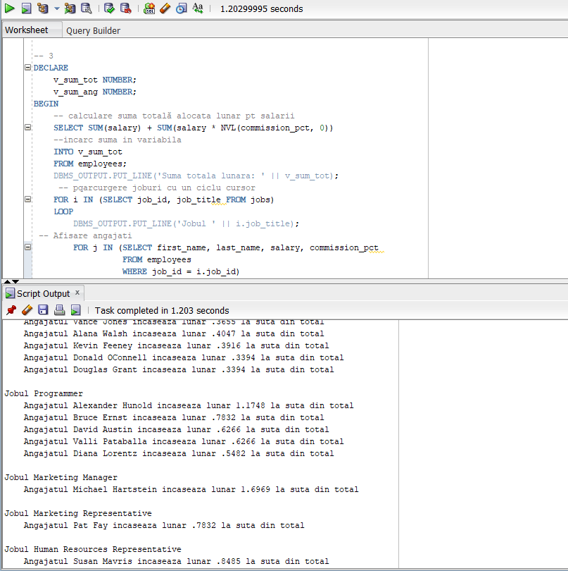

PLSQL3 EX 4

-- 4
DECLARE
TYPE t_sal_ang IS RECORD (
id NUMBER,
name VARCHAR2(50),
salary NUMBER
);
TYPE t_vec_sal_ang IS VARRAY(5) OF t_sal_ang;
v_top_ang t_vec_sal_ang;
BEGIN
--parcurg joburile
FOR i IN (SELECT job_id, job_title FROM jobs)
LOOP
DBMS_OUTPUT.PUT_LINE('Job: ' || i.job_title);

-- selectez primii 5 angajati in functie de salariu
SELECT *
BULK COLLECT INTO v_top_ang
FROM (
SELECT
employee_id,
first_name || ' ' || last_name,
salary
FROM employees
WHERE job_id = i.job_id
ORDER BY salary DESC
)
WHERE rownum <= 5;
--tratez cazul in care sunt mai putin de 5 angajati pt jobul precizat
IF v_top_ang.COUNT < 5 THEN
DBMS_OUTPUT.PUT_LINE('Jobul precizat are mai putin de 5 angajati');
END IF;
-- Dacă am macar un angajat -->afisez
IF v_top_ang.COUNT > 0 THEN
FOR i IN v_top_ang.FIRST..v_top_ang.LAST LOOP
DBMS_OUTPUT.PUT_LINE(v_top_ang(i).name);
END LOOP;
END IF;

DBMS_OUTPUT.PUT_LINE('');
END LOOP;
END;
/

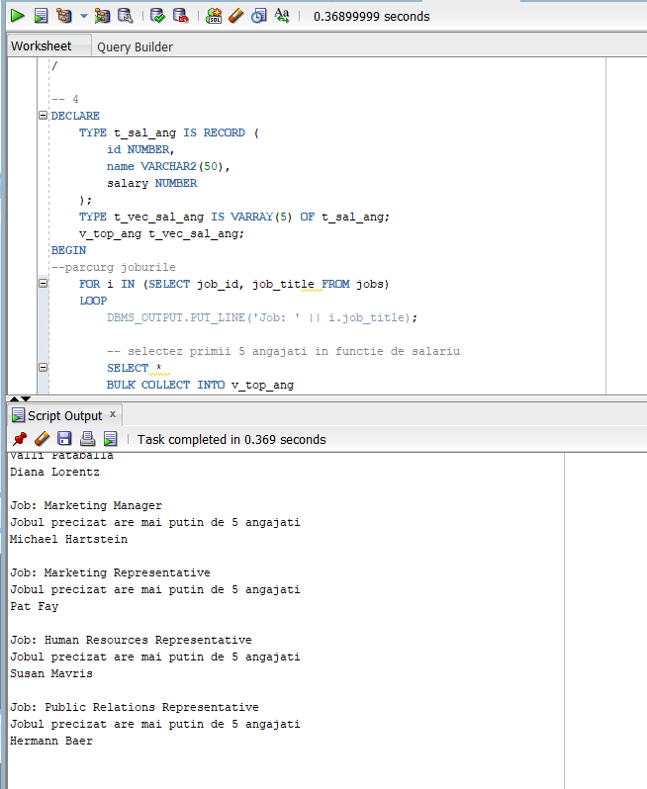

PLSQL 3 EX 5

-- 5
DECLARE
-- incarc in variabila v_nr_ang nr de salarii distincte calculate
v_nr_ang NUMBER;
v_ult_sal NUMBER;
BEGIN
FOR i IN (SELECT job_id, job_title FROM jobs)
LOOP
DBMS_OUTPUT.PUT_LINE('Job: ' || i.job_title);

v_nr_ang := 0;
v_ult_sal := -1;
-- Parcurgere angajați in functie de salariu
FOR e IN (
SELECT
employee_id,
first_name || ' ' || last_name AS name,
salary
FROM employees
WHERE job_id = i.job_id
ORDER BY salary DESC
)
LOOP
-- ies din loop cand am afisat primii 5 angajati cu cele mai mari salarii
EXIT WHEN v_nr_ang >= 5;
IF e.salary != v_ult_sal THEN
v_nr_ang := v_nr_ang + 1;
END IF;

DBMS_OUTPUT.PUT_LINE('Locul: ' || v_nr_ang || ': '
|| e.name || ' cu ' || e.salary);

v_ult_sal := e.salary;
END LOOP;

DBMS_OUTPUT.PUT_LINE('');
END LOOP;
END;
/

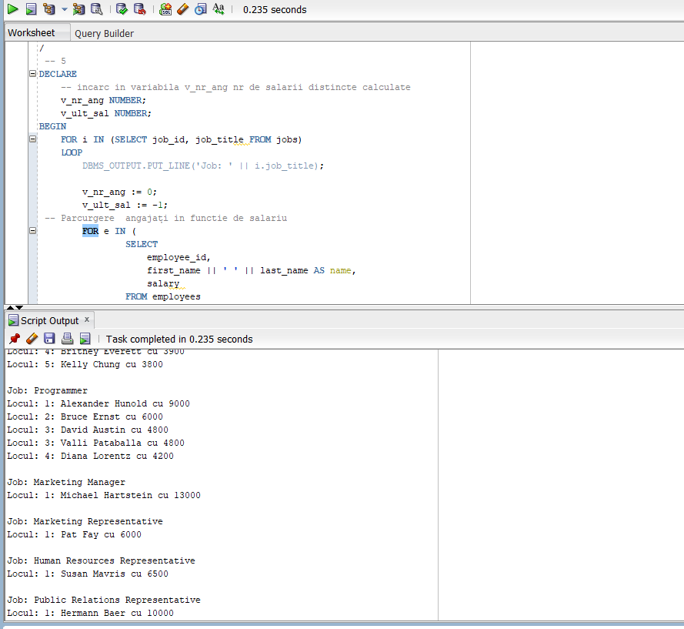

PLSQL4 EX 1

-- 1

DROP TABLE info;
--creare tabela info cu atributele mentionate
CREATE TABLE info (
utilizator NVARCHAR2(30),
data DATE,
comanda NVARCHAR2(50),
nr_linii NUMBER,
eroare NVARCHAR2(100)
);

COMMIT;
--inserare in tabela
insert into info values ('user1',to_date('20-03-2021','dd-mm-yyyy'),'prima comanda',4,'prima eroare');
SELECT *
FROM info;

/
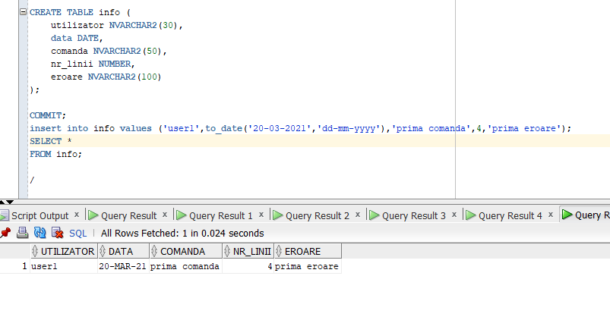
PLSQL4 EX2
--f2--
-- 2
set serveroutput on
CREATE OR REPLACE FUNCTION f2 (
--daun numele angajatului prin parametru
v_nume employees.last_name%TYPE
)
RETURN NUMBER IS
salariu employees.salary%TYPE;
BEGIN
--selectez salariul pentru angajatul dat prin parametru
SELECT
salary
INTO salariu
FROM
employees
WHERE
last_name = v_nume;

-- daca s-a gasit doar un angajat cu numele dat -->inserez
INSERT INTO info VALUES (USER, SYSDATE, 'F2', 1, NULL);
COMMIT;
RETURN salariu;
EXCEPTION
WHEN no_data_found THEN
--nu s-a gasit angajatul--
INSERT INTO info VALUES (USER, SYSDATE, 'F2', 0, 'Nu exista angajatul');
COMMIT;
raise_application_error(-20000, 'Nu exista angajati cu numele dat');
WHEN too_many_rows THEN
--s-au gasit mai multi angajati cu numele dat
INSERT INTO info VALUES (USER, SYSDATE, 'F2', 0, 'Exista mai multi angajati cu numele dat');
COMMIT;
raise_application_error(-20001, 'Exista mai multi angajati cu numele dat');
WHEN OTHERS THEN
INSERT INTO info VALUES (USER, SYSDATE, 'F2', 0, 'Alta eroare');
COMMIT;

raise_application_error(-20002, 'Alta eroare');
END f2;
/

DECLARE
v_salary NUMBER;
BEGIN
v_salary := f2('Bell2');
END;
/

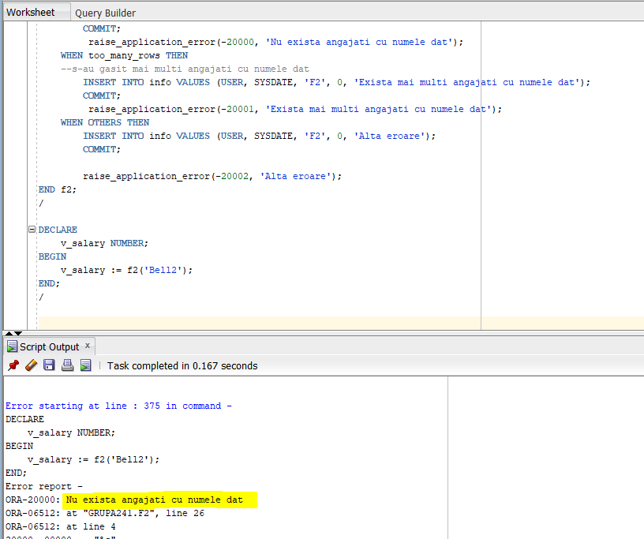

--p4--
set serveroutput on
CREATE OR REPLACE PROCEDURE p4 (
v_nume employees.last_name%TYPE
) IS
salariu employees.salary%TYPE;
BEGIN
--selectez salariul pentru angajatul dat prin parametru
SELECT
salary
INTO salariu
FROM
employees
WHERE
last_name = v_nume;

dbms_output.put_line('Salariul --> ' || salariu);

INSERT INTO info VALUES (USER, SYSDATE, 'F2', 1, NULL);
COMMIT;
EXCEPTION
WHEN no_data_found THEN
INSERT INTO info VALUES (USER, SYSDATE, 'F2', 0, 'Nu exista angajatul');
COMMIT;
raise_application_error(-20000, 'Nu exista angajati cu numele dat');
WHEN too_many_rows THEN
INSERT INTO info VALUES (USER, SYSDATE, 'F2', 0, 'Exista mai multi angajati cu numele dat');
COMMIT;

raise_application_error(-20001, 'Exista mai multi angajati cu numele dat');
WHEN OTHERS THEN
INSERT INTO info VALUES (USER, SYSDATE, 'F2', 0, 'Alta eroare');
COMMIT;

raise_application_error(-20002, 'Alta eroare');
END p4;
/

BEGIN
p4(NULL);
END;
/
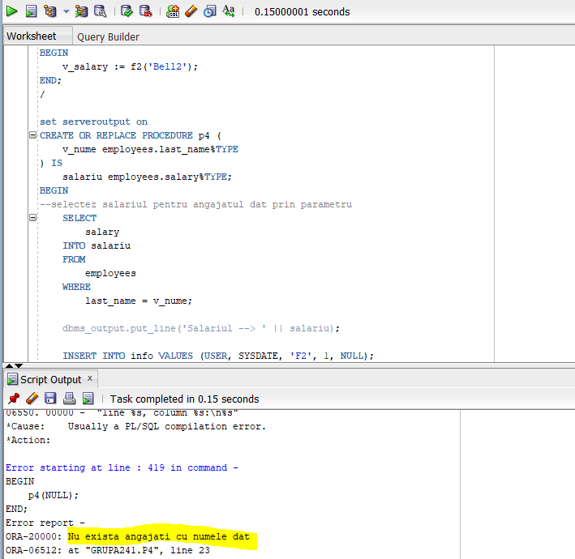

PLSQL4 EX4

-- 4
set serveroutput on
CREATE OR REPLACE PROCEDURE marire_sal (
v_manager_id employees.manager_id%TYPE
) IS
--index by table
TYPE t_ids IS TABLE OF employees.employee_id%TYPE;
v_ids t_ids;
BEGIN
-- Selectez angajatii care lucrează direct sau indirect pt managerul dat prin parametru
SELECT employee_id
BULK COLLECT INTO v_ids
FROM employees
START WITH employee_id = v_manager_id
CONNECT BY manager_id = PRIOR employee_id;
-- tratez cazul in care nu exista manager cu codul dat
IF v_ids.COUNT = 0 THEN
DBMS_OUTPUT.PUT_LINE('Nu există un manager cu codul dat');
RETURN;
END IF;
--daca exista-->
-- Măresc salariile
FOR i IN v_ids.FIRST..v_ids.LAST
LOOP
UPDATE employees
SET salary = salary * 1.1
WHERE employee_id = v_ids(i);
END LOOP;
END;
/

set serveroutput on
BEGIN

marire_sal(100);
END;
/
select * from employees where manager_id=100;

SELECT salary
FROM employees;
ROLLBACK;

INAINTE DE ROLLBACK:
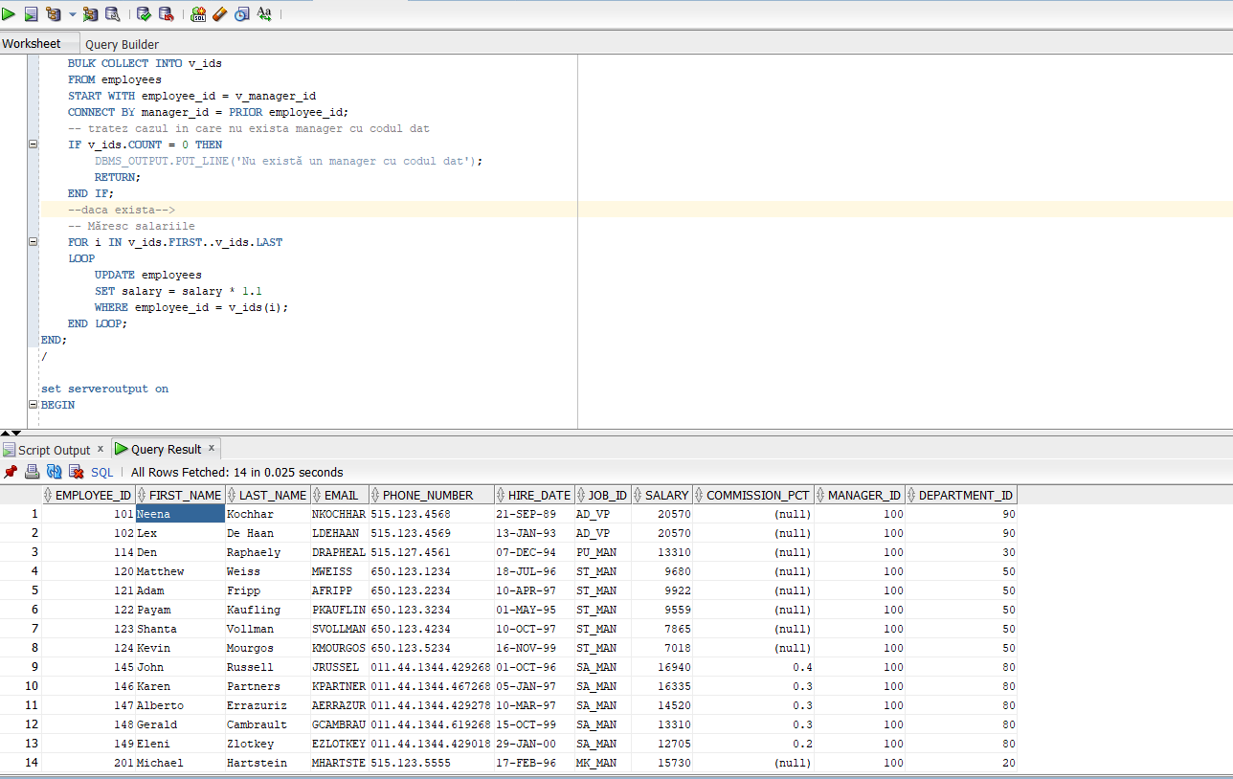

DUPA ROLLBACK:
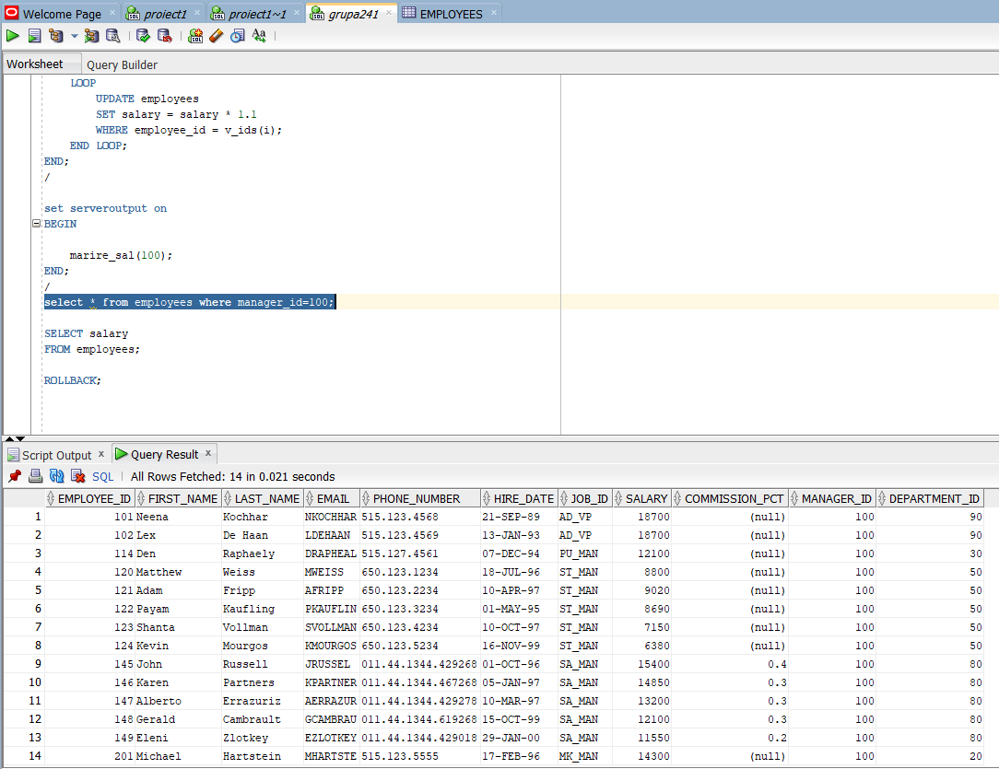

PLSQL 5 EX 1

CREATE OR REPLACE PACKAGE pachet_gest_companie
IS
-- gaseste jobul dat prin parametru
FUNCTION gas_job(
nume jobs.job_title%TYPE
) RETURN jobs.job_id%TYPE;
-- gaseste angajatul dat prin parametru
FUNCTION gas_angajat(
prenume emp.first_name%TYPE,
nume emp.last_name%TYPE
) RETURN emp.employee_id%TYPE;
--gaseste departamentul dat prin parametru
FUNCTION gas_departament(
nume dept.department_name%TYPE
) RETURN dept.department_id%TYPE;
FUNCTION gas_cel_mai_mic_salariu(
id_dept dept.department_id%TYPE,
id_job jobs.job_id%TYPE
) RETURN emp.salary%TYPE;
-- comisionul minim pentru jobul si departamentul dat prin parametru--
--trateaza si exceptia daca nu exista departamentul dat--
FUNCTION gas_cel_mai_mic_comision(
id_dept dept.department_id%TYPE,
id_job jobs.job_id%TYPE
) RETURN emp.commission_pct%TYPE;
-- Adaugă un nou angajat.
PROCEDURE adauga_ang(
prenume emp.first_name%TYPE,
nume emp.last_name%TYPE,
adresa_email emp.email%TYPE,
telefon emp.phone_number%TYPE,
prenume_manager emp.first_name%TYPE,
nume_manager emp.last_name%TYPE,
nume_departament dept.department_name%TYPE,
nume_job jobs.job_title%TYPE
);

--muta angajatul dat prin parametru in alt departament
PROCEDURE muta_ang(
prenume emp.first_name%TYPE,
nume emp.last_name%TYPE,
nume_departament dept.department_name%TYPE,
nume_job jobs.job_title%TYPE,
prenume_manager emp.first_name%TYPE,
nume_manager emp.last_name%TYPE
);
--calculeaza nr de subalterni ai unui manager
FUNCTION nr_subalterni(
prenume emp.first_name%TYPE,
nume emp.last_name%TYPE
) RETURN NUMBER;
-- cursor care afiseaza angajatii de pe un anumit job
CURSOR angajati_job (id_job jobs.job_id%TYPE)
RETURN emp%ROWTYPE
IS
SELECT * FROM emp
WHERE job_id = id_job;
-- Cursor care returnează toate joburile din companie.
CURSOR toate_joburile
RETURN jobs%ROWTYPE
IS
SELECT * FROM jobs;

PROCEDURE afiseaza_angajati_per_job;
END;
/

CREATE OR REPLACE PACKAGE BODY pachet_gest_companie
IS
FUNCTION gas_job(
nume jobs.job_title%TYPE
) RETURN jobs.job_id%TYPE
IS
v_id jobs.job_id%TYPE;
BEGIN
SELECT job_id INTO v_id
FROM jobs
WHERE job_title = nume;

RETURN v_id;

EXCEPTION
WHEN no_data_found THEN
raise_application_error(-20000, 'Nu am gasit jobul ' || nume);
END;

FUNCTION gas_angajat(
prenume emp.first_name%TYPE,
nume emp.last_name%TYPE
) RETURN emp.employee_id%TYPE
IS
v_id emp.employee_id%TYPE;
BEGIN
SELECT employee_id INTO v_id
FROM emp
WHERE first_name = prenume AND last_name = nume;

RETURN v_id;

EXCEPTION
WHEN no_data_found THEN
raise_application_error(-20000, 'Nu am gasit angajatul '
|| prenume || ' ' || nume);
END;

FUNCTION gas_departament(
nume dept.department_name%TYPE
) RETURN dept.department_id%TYPE
IS
v_id dept.department_id%TYPE;
BEGIN
SELECT department_id INTO v_id
FROM dept
WHERE department_name = nume;

RETURN v_id;

EXCEPTION
WHEN no_data_found THEN
raise_application_error(-20000, 'Nu am gasit departamentul ' || nume);
END;

FUNCTION gas_cel_mai_mic_salariu(
id_dept dept.department_id%TYPE,
id_job jobs.job_id%TYPE
) RETURN emp.salary%TYPE
IS
v_salariu emp.salary%TYPE;
BEGIN
SELECT MIN(salary) INTO v_salariu
FROM emp
WHERE department_id = id_dept AND job_id = id_job;

IF v_salariu IS NULL THEN
raise_application_error(-20000,
'Nu exista angajati cu departamentul si jobul dat');
END IF;

RETURN v_salariu;
END;

FUNCTION gas_cel_mai_mic_comision(
id_dept dept.department_id%TYPE,
id_job jobs.job_id%TYPE
) RETURN emp.commission_pct%TYPE
IS
v_com emp.commission_pct%TYPE;
BEGIN
SELECT MIN(commission_pct) INTO v_com
FROM emp
WHERE department_id = id_dept AND job_id = id_job;

RETURN v_com;
END;

PROCEDURE adauga_ang(
prenume emp.first_name%TYPE,
nume emp.last_name%TYPE,
adresa_email emp.email%TYPE,
telefon emp.phone_number%TYPE,
prenume_manager emp.first_name%TYPE,
nume_manager emp.last_name%TYPE,
nume_departament dept.department_name%TYPE,
nume_job jobs.job_title%TYPE
) IS
v_emp_id emp.employee_id%TYPE;
v_dept_id dept.department_id%TYPE;
v_job_id emp.job_id%TYPE;
v_salariu emp.salary%TYPE;
BEGIN
v_emp_id := emp_seq.NEXTVAL;
v_dept_id := gas_departament(nume_departament);
v_job_id := gas_job(nume_job);
v_salariu := gas_cel_mai_mic_salariu(v_dept_id, v_job_id);

INSERT INTO emp (
employee_id, first_name, last_name,
email, phone_number, hire_date,
job_id,
salary, commission_pct,
manager_id,
department_id
)
VALUES (
v_emp_id, prenume, nume,
adresa_email, telefon, SYSDATE,
v_job_id,
v_salariu, 0,
gas_angajat(prenume_manager, nume_manager),
v_dept_id
);
END;

PROCEDURE muta_ang(
prenume emp.first_name%TYPE,
nume emp.last_name%TYPE,
nume_departament dept.department_name%TYPE,
nume_job jobs.job_title%TYPE,
prenume_manager emp.first_name%TYPE,
nume_manager emp.last_name%TYPE
) IS
v_ang emp%ROWTYPE;
v_manager_nou emp.employee_id%TYPE;
v_dept_nou dept.department_id%TYPE;
v_job_nou emp.job_id%TYPE;
v_salariu_nou emp.salary%TYPE;
v_com_nou emp.commission_pct%TYPE;
BEGIN
SELECT * INTO v_ang
FROM emp
WHERE employee_id = gas_angajat(prenume, nume);

INSERT INTO job_hist (
employee_id,
start_date, end_date,
job_id, department_id
)
VALUES (
v_ang.employee_id,
v_ang.hire_date, SYSDATE,
v_ang.job_id, v_ang.department_id
);

v_dept_nou := gas_departament(nume_departament);
v_job_nou := gas_job(nume_job);
v_manager_nou := gas_angajat(prenume_manager, nume_manager);
v_salariu_nou := gas_cel_mai_mic_salariu(v_dept_nou, v_job_nou);
v_com_nou := gas_cel_mai_mic_comision(v_dept_nou, v_job_nou);

UPDATE emp
SET
department_id = v_dept_nou,
job_id = v_job_nou,
manager_id = v_manager_nou,
salary = v_salariu_nou,
commission_pct = v_com_nou,
hire_date = SYSDATE
WHERE employee_id = v_ang.employee_id;
END;

FUNCTION nr_subalterni(
prenume emp.first_name%TYPE,
nume emp.last_name%TYPE
) RETURN NUMBER
IS
v_num NUMBER;
BEGIN
SELECT COUNT(*) INTO v_num
FROM employees
START WITH employee_id = gas_angajat(prenume, nume)
CONNECT BY PRIOR employee_id = manager_id;

RETURN v_num;
END;

PROCEDURE afiseaza_angajati_per_job
IS
v_nume_job jobs.job_title%TYPE;
v_nume_ang NVARCHAR2(500);
a_mai_avut_jobul NUMBER;
BEGIN
FOR job IN toate_joburile LOOP
DBMS_OUTPUT.PUT_LINE('Jobul ' || job.job_title || ':');

FOR emp IN angajati_job(job.job_id) LOOP
v_nume_ang := emp.first_name || ' ' || emp.last_name;

SELECT COUNT(*) INTO a_mai_avut_jobul
FROM job_hist
WHERE (employee_id = emp.employee_id) AND
(job_id = job.job_id);

DBMS_OUTPUT.PUT_LINE(' ' || v_nume_ang ||
' - ' || a_mai_avut_jobul);
END LOOP;
END LOOP;
END;
END;
/

-- Testez funcțiile din pachet.
BEGIN

pachet_gest_companie.adauga_ang(
'Ang1', 'Test1',
'test1@gmail.com', '0000000',
'Steven', 'King',
'Sales',
'Sales Manager'
);
end;
/

--afisez angajatul nou
SELECT *
FROM emp
WHERE employee_id >= 1000;

-- Vezi câți subalterni direcți și indirecți are Steven King.
SELECT pachet_gest_companie.nr_subalterni('Steven', 'King')
FROM dual;

--afiseaza_angajati_per_job
BEGIN
pachet_gest_companie.afiseaza_angajati_per_job;
END;
/
begin
pachet_gest_companie.gas_cel_mai_mic_comision(80,'Sales Manager');
end;
/
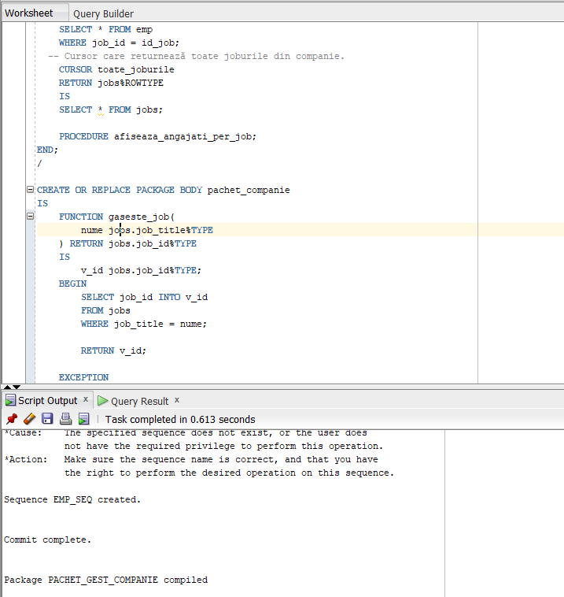

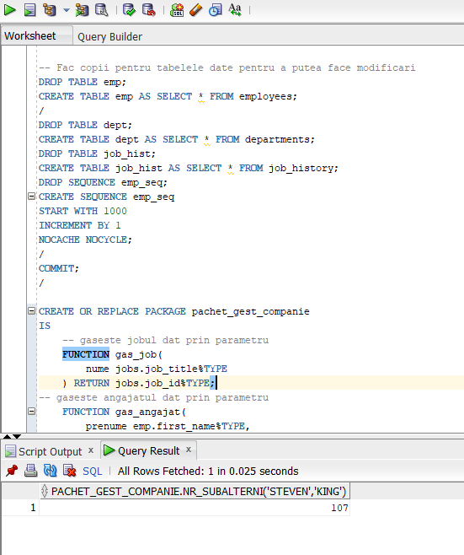

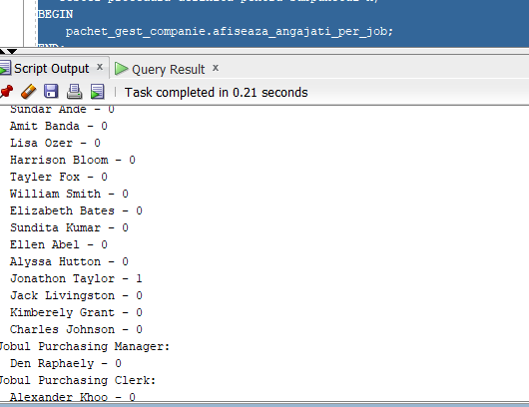

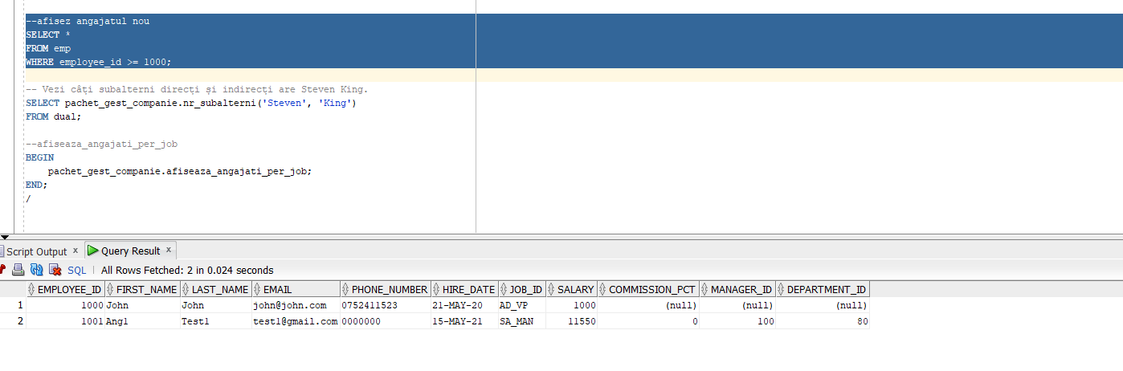
PLSQL6 EX1

-- 1
DROP TABLE dept;
CREATE TABLE dept AS (SELECT * FROM departments);
-- trigger la nivel de linie care sa-i permita doar utilizatorului SCOTT sa stearga informatii din tabela DEPT.
CREATE OR REPLACE TRIGGER tr_scott
BEFORE DELETE ON dept
FOR EACH ROW
BEGIN
IF USER != 'SCOTT' THEN
RAISE_APPLICATION_ERROR(-20000, 'Utilizatorul nu este Scott!!');
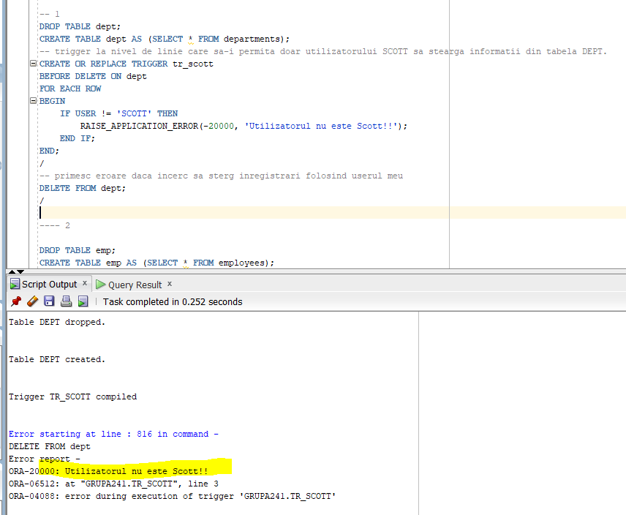
END IF;
END;
/
-- primesc eroare daca incerc sa sterg inregistrari folosind userul meu
DELETE FROM dept;
/

PLSQL6 EX2

-- 2

DROP TABLE emp;
CREATE TABLE emp AS (SELECT * FROM employees);

CREATE OR REPLACE TRIGGER trig_marire
BEFORE UPDATE OF commission_pct ON emp
FOR EACH ROW
BEGIN
-- Dacă comisionul depășește 50%--->nu permit actualizarea.
IF :NEW.commission_pct > 0.5 THEN
RAISE_APPLICATION_ERROR(-20000, 'Nu se poate mari comisionul cu mai mult de 50% din salariu!!!');
END IF;
END;
/

-- vreau sa modific cu un comision de 0,76
UPDATE emp
SET commission_pct = 0.76
WHERE employee_id = 100;
/
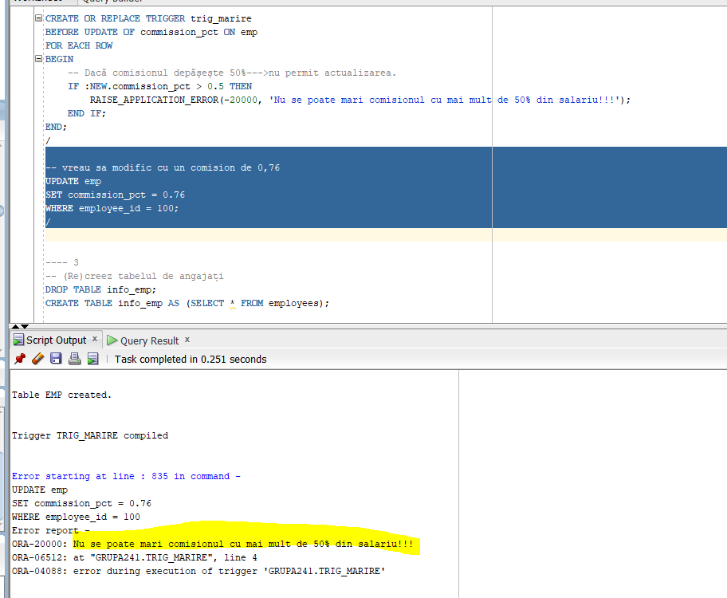

PLSQL6 EX3

--3
DROP TABLE info_emp;
CREATE TABLE info_emp AS (SELECT * FROM employees);

DROP TABLE info_dept;
CREATE TABLE info_dept AS (SELECT * FROM departments);

--Adaug o noua coloana pt nr de angajati dintr-un departament
ALTER TABLE info_dept
ADD numar NUMBER;

-- initializez coloana
UPDATE info_dept d
SET numar = (
SELECT COUNT(1)
FROM info_emp
WHERE department_id = d.department_id
);

-- adaug restrictie de NOT NULL
ALTER TABLE info_dept
MODIFY numar NUMBER NOT NULL;

-- Creez un trigger care sa pastreze coloana actualizata
CREATE OR REPLACE TRIGGER trigger_actualizare
AFTER INSERT OR UPDATE OR DELETE ON info_emp
BEGIN
-- Rulez din nou codul de mai sus
UPDATE info_dept d
SET numar = (
SELECT COUNT(1)
FROM info_emp
WHERE department_id = d.department_id
);
END;
/
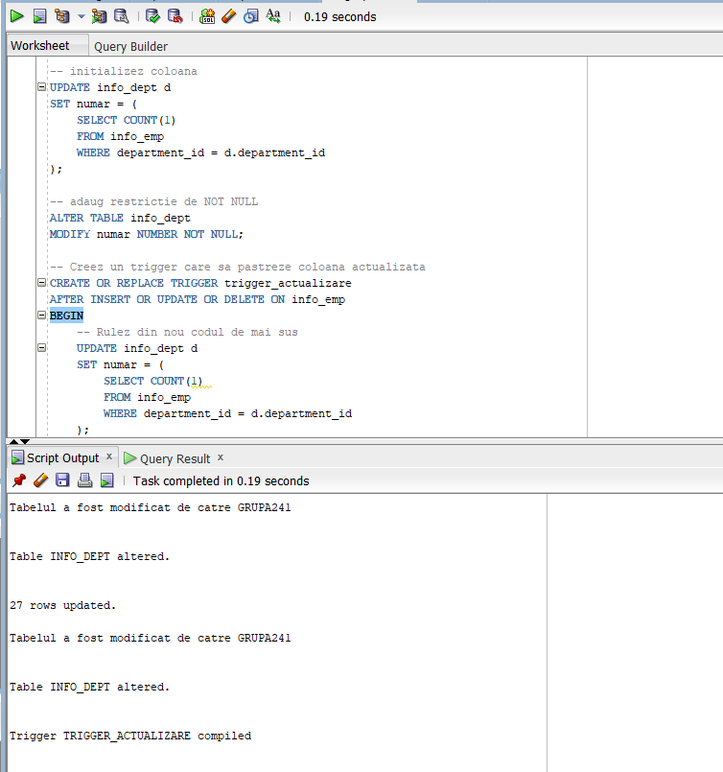

PLSQL6 EX4

-- 4
-- Creez o noua tabela in care stochez cati angajati am in fiecare departament
DROP TABLE nr_emps;
CREATE TABLE nr_emps AS (
SELECT department_id, COUNT(1) AS num_emp
FROM emp
GROUP BY department_id
);

CREATE OR REPLACE TRIGGER trigger_initializare1
--triggerul inițializează tabela creata la fiecare insert/update
BEFORE INSERT OR UPDATE ON employees
BEGIN
DELETE FROM num_emps;
-- Inserez valori
INSERT INTO nr_emps (department_id, num_emp)
SELECT department_id, COUNT(1)
FROM emp
GROUP BY department_id;
END;
/
--trigger care sa se declanseze la insert-ul unui angajat intr-un departament in care lucreaza deja 45 de persoane
CREATE OR REPLACE TRIGGER trigger2_ex4
BEFORE INSERT OR UPDATE ON emp
FOR EACH ROW
DECLARE
--declar o variabila in care incarc numarul angajatilor
v_num_ang NUMBER;
BEGIN
-- selectez nr de angajati
SELECT num_emp INTO v_num_ang
FROM num_emps
WHERE department_id = :NEW.department_id;
IF v_num_ang >= 45 THEN
--tratez cazul in care sunt mai mult de 45 de angajati
RAISE_APPLICATION_ERROR(-20000, 'Prea multi angajati');
END IF;
-- daca sunt mai putin de 45 de angajati → facem update si contorizam si noul angajat
UPDATE num_emps
SET num_emp = num_emp + 1
WHERE department_id = :NEW.department_id;
END;
/

-- fac insert intr-un departament in care sunt deja 45 de angajati
INSERT ALL
INTO emp (employee_id, department_id)
VALUES (1234, 50)
INTO emp (employee_id, department_id)
VALUES (1235, 50)
SELECT 1 FROM dual;

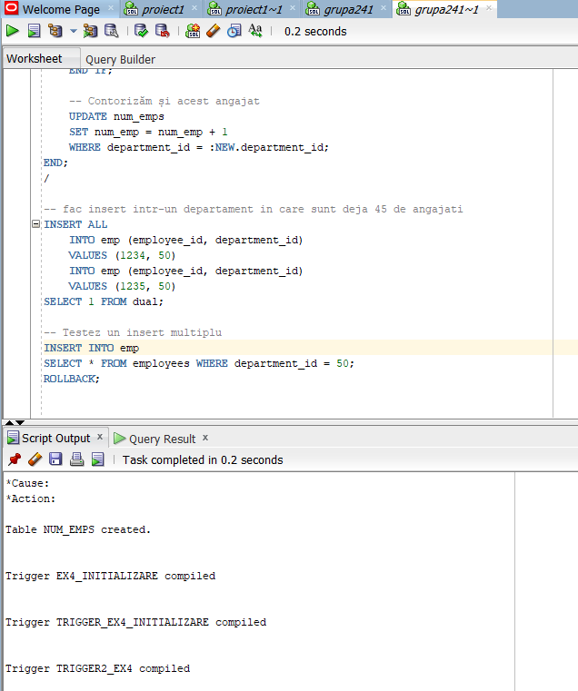

PLSQL6 EX5

-- 5
DROP TABLE emp_test;

CREATE TABLE emp_test AS (
SELECT employee_id, last_name, first_name, department_id
FROM employees
);

ALTER TABLE emp_test
ADD CONSTRAINT emp_test_pk PRIMARY KEY (employee_id);

CREATE TABLE dept_test AS (
SELECT department_id, department_name
FROM departments
);

ALTER TABLE dept_test
ADD CONSTRAINT dept_test_pk PRIMARY KEY (department_id);
--trigger stergere--
CREATE OR REPLACE TRIGGER trigg_stergere
AFTER DELETE ON dept_test
--trigger la nivel de rand--
FOR EACH ROW
BEGIN
-- Șterg angajații care erau in acest departament
DELETE FROM emp_test
WHERE department_id = :OLD.department_id;
END;
/

CREATE OR REPLACE TRIGGER trigg_modificare
AFTER UPDATE ON dept_test
FOR EACH ROW
BEGIN
-- Modific angajații care erau deja în departament.
UPDATE emp_test
SET department_id = :NEW.department_id
WHERE department_id = :OLD.department_id;
END;
/

--testare
ALTER TABLE emp_test
DROP CONSTRAINT emp_test_dept_fk;

ALTER TABLE emp_test
ADD CONSTRAINT emp_test_dept_fk
FOREIGN KEY (department_id)
REFERENCES dept_test(department_id);

ALTER TABLE emp_test
ADD CONSTRAINT emp_test_dept_fk
FOREIGN KEY (department_id)
REFERENCES dept_test(department_id)
ON DELETE CASCADE;

ALTER TABLE emp_test
ADD CONSTRAINT emp_test_dept_fk
FOREIGN KEY (department_id)
REFERENCES dept_test(department_id)
ON DELETE SET NULL;
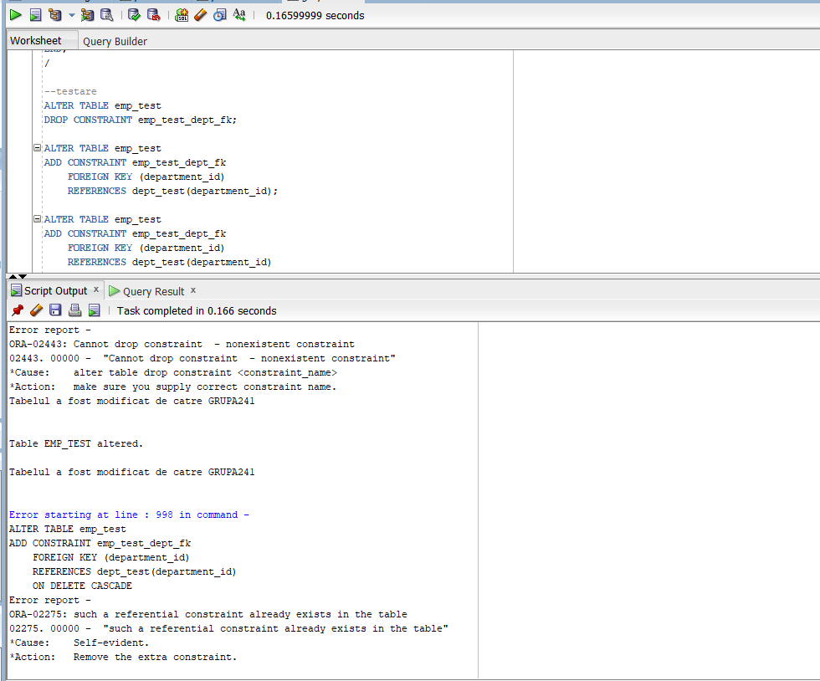

PLSQL6 EX 6

-- 6

DROP TABLE database_errors;
CREATE TABLE database_errors (
user_id NVARCHAR2(100),
nume_bd NVARCHAR2(100),
erori NVARCHAR2(2000),
data DATE
);

--trigger insert
CREATE OR REPLACE TRIGGER trigger_insert
AFTER SERVERERROR
ON DATABASE
BEGIN
INSERT INTO database_errors
VALUES (
SYS.LOGIN_USER,
SYS.DATABASE_NAME,
DBMS.FORMAT_ERROR_STACK,
SYSDATE
);
END;

Nu am suficiente permisiuni.
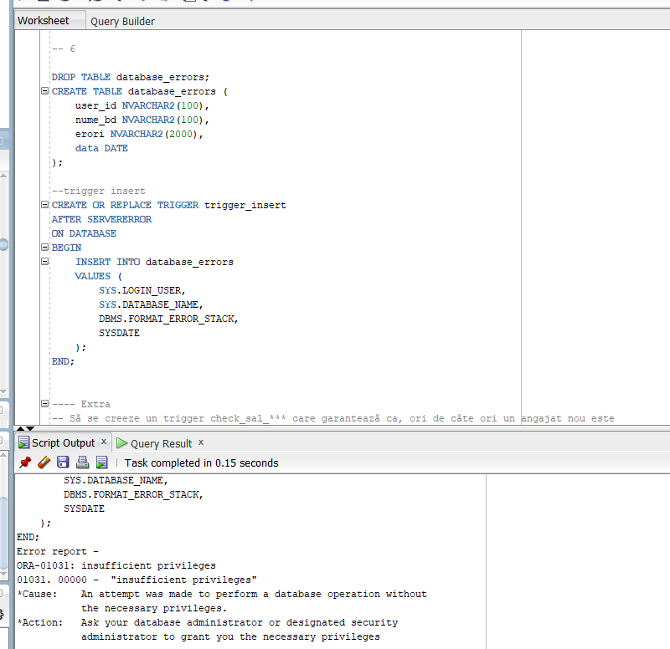

PLSQL7 EX1

--1--
set serveroutput on
DECLARE
v_nr NUMBER;
--exceptie pt valoare negativa
val_negativa EXCEPTION;
BEGIN
v_nr := &numar;
--declansarea exceptiei
IF v_nr < 0 THEN
RAISE val_negativa;
END IF;

DBMS_OUTPUT.PUT_LINE(SQRT('Numarul '||v_nr));
EXCEPTION
WHEN val_negativa THEN
RAISE_APPLICATION_ERROR(
-20000,
'Numarul este negativ'
);

END;
/

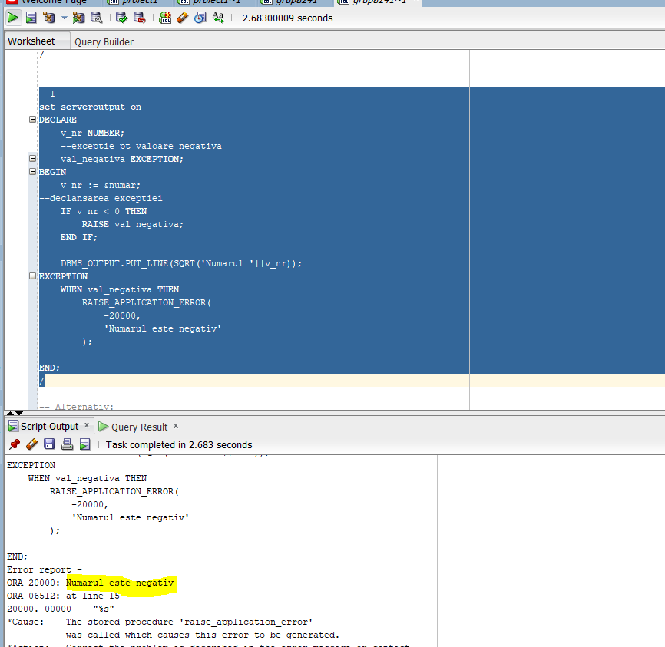

PLSQL7 EX2
--2--
DECLARE
v_salariu emp.salary%TYPE;
v_nume NVARCHAR2(200);
BEGIN
--citesc valoarea data de la tastatura
v_salariu := &salariu;
--caz in care angajatul cu salariul dat exista --> afisez informatii despre el
SELECT first_name || ' ' || last_name AS nume
INTO v_nume
FROM emp
WHERE salary = v_salariu;

DBMS_OUTPUT.PUT_LINE('Angajat cu salariul ' || v_salariu || ': ' || v_nume);
EXCEPTION
--tratez exceptia--
--nu exista angajatul cu salariul dat--
WHEN no_data_found THEN
DBMS_OUTPUT.PUT_LINE(
'Nu exista angajati cu salariul dat'
);
WHEN too_many_rows THEN
DBMS_OUTPUT.PUT_LINE(
'Exista mai multi angajati cu acestt salariu'
);
END;
/
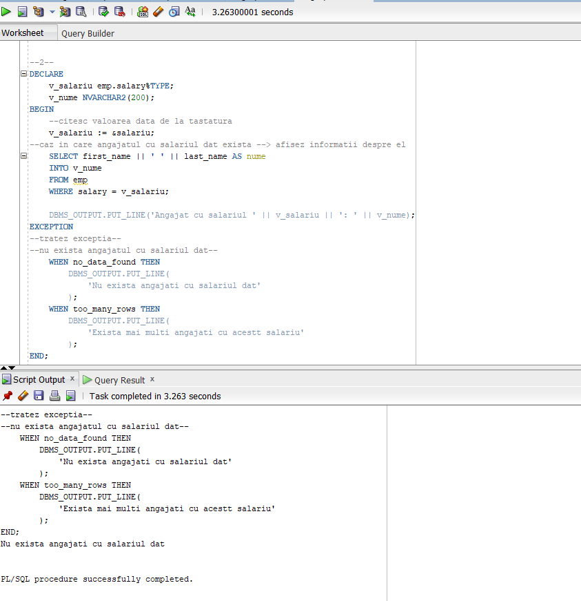

PLSQL7 EX3
-- 3--
DECLARE

exc_constraint EXCEPTION;
PRAGMA EXCEPTION_INIT( exc_constraint, -2292);
BEGIN
-- modific id-ul unui departament care are angajați.
UPDATE departments
SET department_id = 101
WHERE department_id = 100;

EXCEPTION
WHEN exc_constraint THEN
raise_application_error(-20000,
'Nu se poate actualiza id-ul');
END;
/
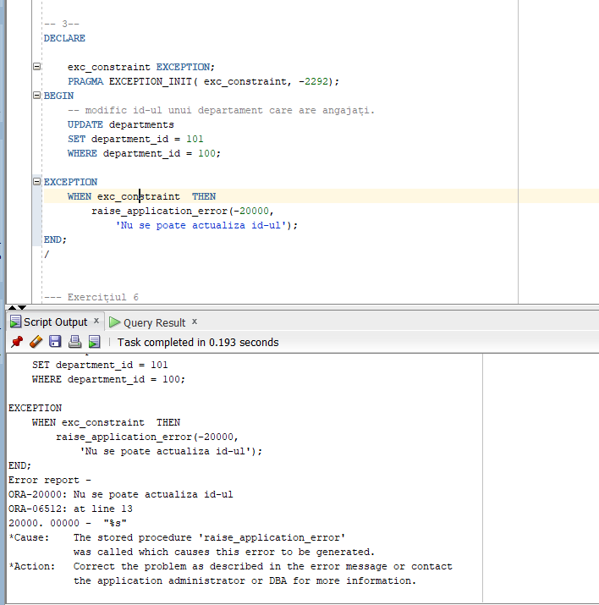

PLSQL7 EX6

-- 6--
set serveroutput on
DECLARE
v_nume departments.department_name%TYPE;
BEGIN
BEGIN
--incarc numele departamentului in variabila v_nume
--fac join pt a gasi departamenul dintr-o anumita locatie
SELECT department_name INTO v_nume
FROM departments
INNER JOIN locations
USING (location_id)
WHERE city LIKE &oras;

DBMS_OUTPUT.PUT_LINE('Nume departament--> ' || v_nume);
EXCEPTION
WHEN no_data_found THEN
--tratez cazul in care nu am gasit departamenul cu locatia data
raise_application_error(
-20000,
'Nu am gasit un departamentul!!'
);
END;

BEGIN

SELECT department_name INTO v_nume
FROM departments
--introduc id-ul departamentului de la tastatura
WHERE department_id = &id_departament;

DBMS_OUTPUT.PUT_LINE('Nume departament: ' || v_nume);
EXCEPTION
WHEN no_data_found THEN
raise_application_error(
-20001,
'Nu am gasit un departament cu id-ul dat'
);
END;
END;
/

