PLSQL1 EX1

SET SERVEROUTPUT ON;
SET VERIFY OFF;

-- plsql1 ex 1--

DECLARE
numar number(3):=100;
mesaj1 varchar2(255):='text 1';
mesaj2 varchar2(255):='text 2';
BEGIN
DECLARE
numar number(3):=1;
mesaj1 varchar2(255):='text 2';
mesaj2 varchar2(255):='text 3';
BEGIN
numar:=numar+1;
--a--
DBMS_OUTPUT.PUT_LINE(numar);
mesaj2:=mesaj2||' adaugat in sub-bloc';
END;
numar:=numar+1;
mesaj1:=mesaj1||' adaugat un blocul principal';
--b--
DBMS_OUTPUT.PUT_LINE(mesaj1);
mesaj2:=mesaj2||' adaugat in blocul principal';
--c--
DBMS_OUTPUT.PUT_LINE(mesaj2);
numar := numar + 1;
-- d) --
DBMS_OUTPUT.PUT_LINE(numar);
mesaj1 := mesaj1 || ' adaugat in blocul principal';
-- e)--
DBMS_OUTPUT.PUT_LINE(mesaj1);
mesaj2 := mesaj2 || ' adaugat in blocul principal';
-- f) --
DBMS_OUTPUT.PUT_LINE(mesaj2);
END;
/

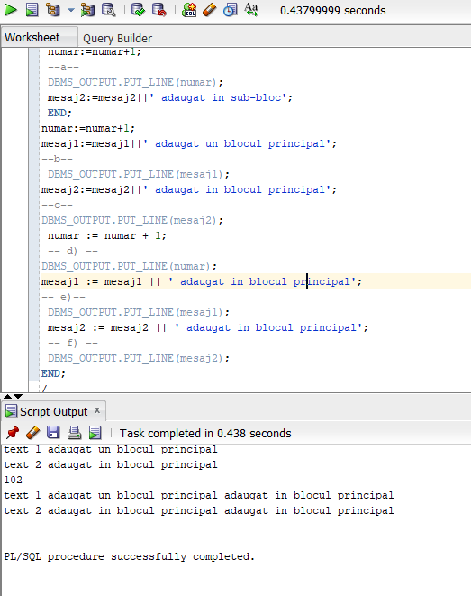

PLSQL1 EX2

-- 2
--a
SELECT all_days_oct.book_date, NVL(days_with_rentals.num, 0) AS num
FROM (
-- Toate zilele cu închirieri
SELECT TO_DATE(book_date) AS book_date, COUNT(1) AS num
FROM rental
GROUP BY book_date
) days_with_rentals
RIGHT JOIN (
-- Toate zilele din octombrie
SELECT TO_DATE(TRUNC (last_day('01-OCT-2020') - ROWNUM)) AS book_date
FROM DUAL CONNECT BY ROWNUM < 31
) all_days_oct
ON days_with_rentals.book_date = all_days_oct.book_date
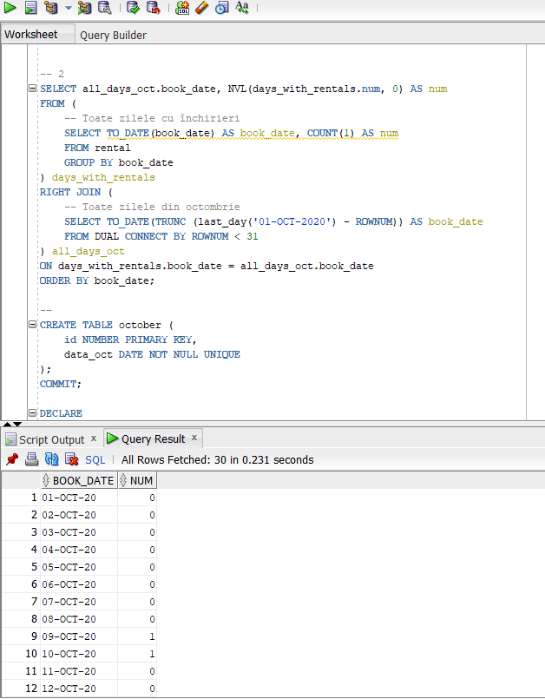
ORDER BY book_date;

--b--
--Crearea tabelei October
CREATE TABLE october (
id NUMBER PRIMARY KEY,
data_oct DATE NOT NULL UNIQUE
);
COMMIT;

DECLARE
day_o DATE := '01-OCT-2020';
BEGIN
--Parcurgerea zilelor din luna octombrie
FOR i IN 1..31 LOOP
INSERT INTO october VALUES (i, day_o);
day_o := day_o + 1;
END LOOP;
END;
/
SELECT data_oct, NVL(num, 0)
FROM october
LEFT JOIN (
--selectarea datelor cu inchirieri
SELECT TO_DATE(book_date) AS data_oct, COUNT(1) AS num
FROM rental
GROUP BY book_date
)
USING (data_oct)
ORDER BY data_oct;
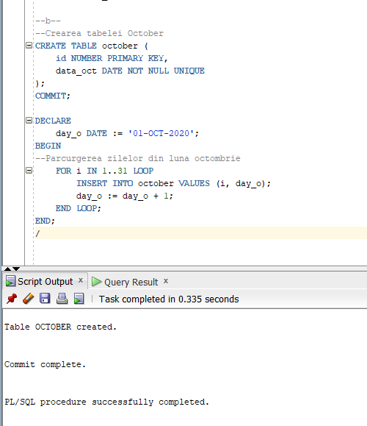

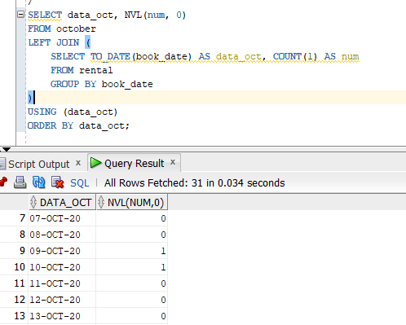

PLSQL1 EX 3
-- 3
DECLARE
--member id si nr de filme
memberr NUMBER;
num_movies NUMBER;
BEGIN
SELECT member_id INTO memberr
FROM member
WHERE first_name = &nume;

SELECT COUNT(*) INTO num_movies
FROM title
INNER JOIN rental
USING (title_id)
WHERE member_id = memberr;

IF num_movies = 0 THEN
DBMS_OUTPUT.PUT_LINE('Nu exista filme inchiriate');
ELSE
DBMS_OUTPUT.PUT_LINE('Filme inchiriate: ' || num_movies);
END IF;

EXCEPTION
WHEN too_many_rows THEN
DBMS_OUTPUT.PUT_LINE('Mai multi oameni cu acelasi nume');

when no_data_found then
DBMS_OUTPUT.PUT_LINE('Nu exista membrul cautat');
END;
/

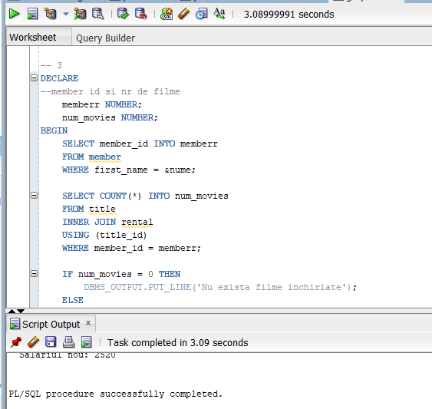

PLSQL1 EX 4

-- 4
DECLARE
memberr NUMBER;
num_movies NUMBER;
total_movies NUMBER;
percent_rented NUMBER;
BEGIN
SELECT member_id INTO memberr
FROM member
WHERE first_name = &nume;

SELECT COUNT(*) INTO num_movies
FROM title
INNER JOIN rental
USING (title_id)
WHERE member_id = memberr;

IF num_movies = 0 THEN
DBMS_OUTPUT.PUT_LINE('Nu exista filme inchiriate');
ELSE
DBMS_OUTPUT.PUT_LINE('Filme inchiriate: ' || num_movies);
END IF;

SELECT COUNT(*) INTO total_movies
FROM title;

percent_rented := num_movies / total_movies;
IF percent_rented >= 0.75 THEN
DBMS_OUTPUT.PUT_LINE('Categorie 1');
ELSIF percent_rented >= 0.5 THEN
DBMS_OUTPUT.PUT_LINE('Categorie 2');
ELSIF percent_rented >= 0.25 THEN
DBMS_OUTPUT.PUT_LINE('Categorie 3');
ELSE
DBMS_OUTPUT.PUT_LINE('Categorie 4');
END IF;
EXCEPTION
WHEN too_many_rows THEN
DBMS_OUTPUT.PUT_LINE('Mai multi oameni cu acelasi nume');
END;
/
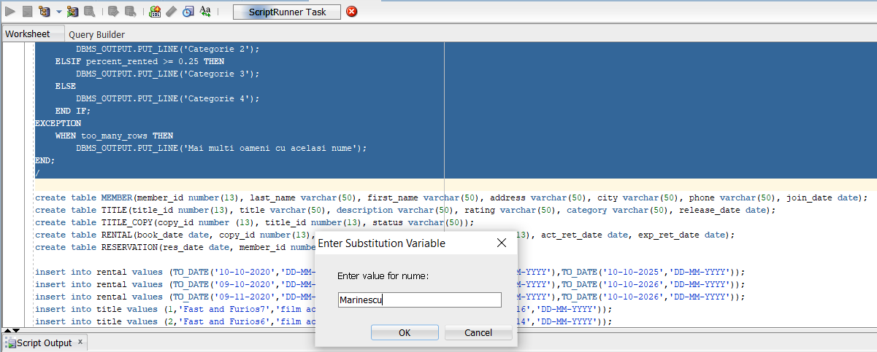

PLSQL1 EX 5

-- 5
DROP TABLE membru_discount;

CREATE TABLE membru_discount AS (
SELECT * FROM member
);

ALTER TABLE membru_discount
ADD discount NUMBER DEFAULT NULL;

DECLARE
membru NUMBER;
num_filme NUMBER;
total NUMBER;
procent NUMBER;
discount_in NUMBER;
discount_nou NUMBER;
BEGIN
--codul introdus de la tastatura
membru := &cod_membru;
--selectarea numarului de filme
SELECT COUNT(*) INTO num_filme
FROM title
INNER JOIN rental
USING (title_id)
WHERE member_id = membru;
--numarul total de filme existente
SELECT COUNT(*) INTO total
FROM title;
SELECT discount INTO discount_in
FROM membru_discount
WHERE member_id = membru;
--calcularea procentului de inchiriere
procent := num_filme / total;
--calcularea procentului in functie de categorie
IF procent >= 0.75 THEN
discount_nou := 0.10;
ELSIF procent >= 0.5 THEN
discount_nou := 0.05;
ELSIF procent >= 0.25 THEN
discount_nou := 0.03;
ELSE
discount_nou := NULL;
END IF;

IF NVL(discount_in, 0) != NVL(discount_nou, 0) THEN
UPDATE membru_discount
SET discount = discount_nou
WHERE member_id = membru;
DBMS_OUTPUT.PUT_LINE('Noul discount ' || discount_nou);
ELSE
DBMS_OUTPUT.PUT_LINE('Discount neschimbat');
END IF;
END;
/
