PLSQL 3 EX 1 SI EX 2

SET VERIFY OFF;
set serveroutput on
-- 1

DECLARE
v_num_ang NUMBER;
v_sal_lunar NUMBER;
v_sal_mediu NUMBER;
v_contor_ang NUMBER;

v_nr_ang NUMBER;
v_sal_total NUMBER;
v_sal_total_med NUMBER;
BEGIN
-- Parcurgere joburi folosind un ciclu cursor
FOR i IN (SELECT job_id, job_title FROM jobs)
LOOP
DBMS_OUTPUT.PUT_LINE('Job: ' || i.job_title);
--Extragere despre jobul curent (nr, salariu lunar, salariu mediu)
SELECT COUNT(1), SUM(salary), AVG(salary)
INTO v_num_ang, v_sal_lunar, v_sal_mediu
FROM employees
WHERE job_id = i.job_id;
IF v_num_ang = 0 THEN
--afisare si tratarea cazului in care nu exista angajati cu jobul precizat
DBMS_OUTPUT.PUT_LINE('Nu avem angajati cu acest job');
ELSE
DBMS_OUTPUT.PUT_LINE('- Numar angajati: ' || v_num_ang);
DBMS_OUTPUT.PUT_LINE('- Salariu lunar total: ' || v_sal_lunar);
DBMS_OUTPUT.PUT_LINE('- Salariu mediu: ' || v_sal_mediu);
END IF;

-- Afisare angajati
v_contor_ang := 1;
FOR j IN (SELECT first_name, last_name, salary
FROM employees
WHERE job_id = i.job_id)
LOOP
DBMS_OUTPUT.PUT_LINE(
' Angajatul ' || v_contor_ang || ': '
|| j.first_name || ' ' || j.last_name
|| ' are salariul ' || j.salary
);

-- folosesc cursor pentru a numara angajatii
v_contor_ang := v_contor_ang + 1;
END LOOP;

END LOOP;
SELECT
--selectez detalii pentru toti angajatii--
COUNT(1),
SUM(salary),
Round(AVG(salary))
INTO
v_nr_ang,
v_sal_total,
v_sal_total_med
FROM employees;

DBMS_OUTPUT.PUT_LINE('Numar total angajati: ' || v_nr_ang);
DBMS_OUTPUT.PUT_LINE('Salariu total angajati: ' || v_sal_total);
DBMS_OUTPUT.PUT_LINE('Salariu mediu angajati: ' || v_sal_total_med);
END;
/
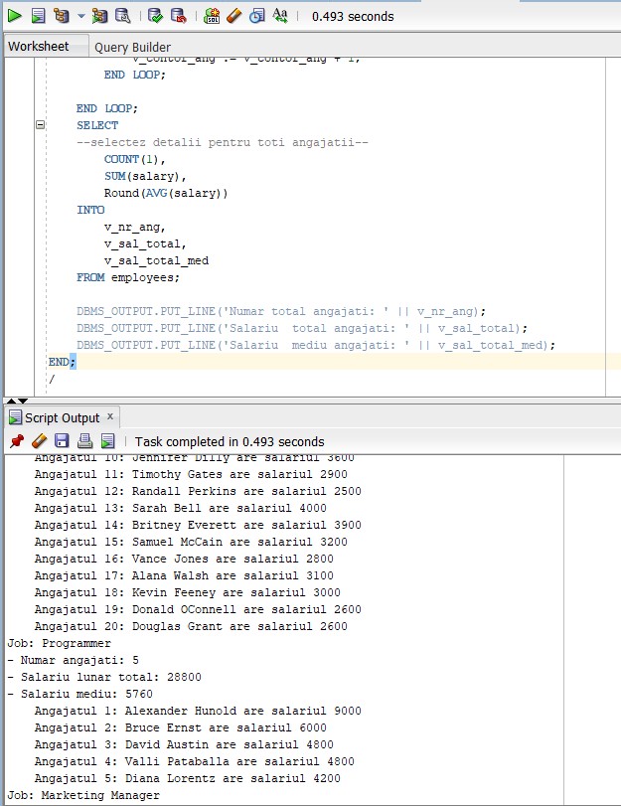

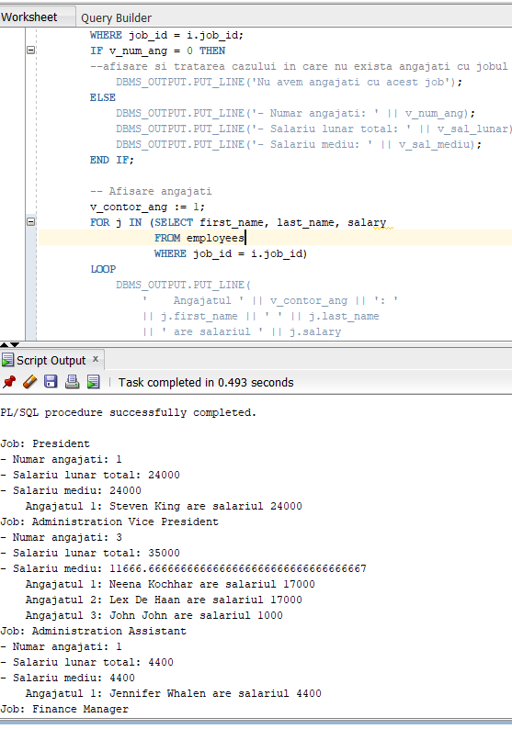

PLSQL3 EX 3

-- 3
DECLARE
v_sum_tot NUMBER;
v_sum_ang NUMBER;
BEGIN
-- calculare suma totală alocata lunar pt salarii
SELECT SUM(salary) + SUM(salary * NVL(commission_pct, 0))
--incarc suma in variabila
INTO v_sum_tot
FROM employees;
DBMS_OUTPUT.PUT_LINE('Suma totala lunara: ' || v_sum_tot);
-- pqarcurgere joburi cu un ciclu cursor
FOR i IN (SELECT job_id, job_title FROM jobs)
LOOP
DBMS_OUTPUT.PUT_LINE('Jobul ' || i.job_title);
-- Afisare angajati
FOR j IN (SELECT first_name, last_name, salary, commission_pct
FROM employees
WHERE job_id = i.job_id)
LOOP
--calcul suma pt un angajat
v_sum_ang := j.salary * (1 + NVL(j.commission_pct, 0));
DBMS_OUTPUT.PUT_LINE(
' Angajatul '
|| j.first_name || ' ' || j.last_name
|| ' incaseaza lunar ' ||
ROUND(v_sum_ang / v_sum_tot * 100, 4)
|| ' la suta din total'
);
END LOOP;

DBMS_OUTPUT.PUT_LINE('');
END LOOP;
END
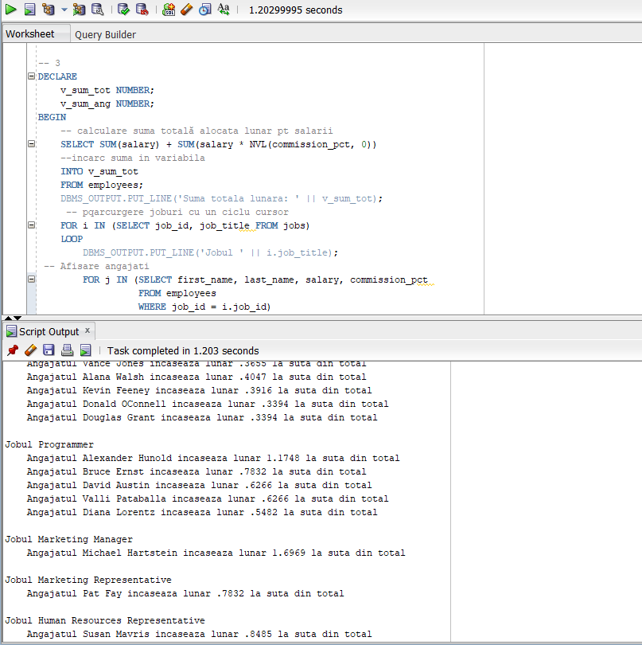

PLSQL3 EX 4

-- 4
DECLARE
TYPE t_sal_ang IS RECORD (
id NUMBER,
name VARCHAR2(50),
salary NUMBER
);
TYPE t_vec_sal_ang IS VARRAY(5) OF t_sal_ang;
v_top_ang t_vec_sal_ang;
BEGIN
--parcurg joburile
FOR i IN (SELECT job_id, job_title FROM jobs)
LOOP
DBMS_OUTPUT.PUT_LINE('Job: ' || i.job_title);

-- selectez primii 5 angajati in functie de salariu
SELECT *
BULK COLLECT INTO v_top_ang
FROM (
SELECT
employee_id,
first_name || ' ' || last_name,
salary
FROM employees
WHERE job_id = i.job_id
ORDER BY salary DESC
)
WHERE rownum <= 5;
--tratez cazul in care sunt mai putin de 5 angajati pt jobul precizat
IF v_top_ang.COUNT < 5 THEN
DBMS_OUTPUT.PUT_LINE('Jobul precizat are mai putin de 5 angajati');
END IF;
-- Dacă am macar un angajat -->afisez
IF v_top_ang.COUNT > 0 THEN
FOR i IN v_top_ang.FIRST..v_top_ang.LAST LOOP
DBMS_OUTPUT.PUT_LINE(v_top_ang(i).name);
END LOOP;
END IF;

DBMS_OUTPUT.PUT_LINE('');
END LOOP;
END;
/

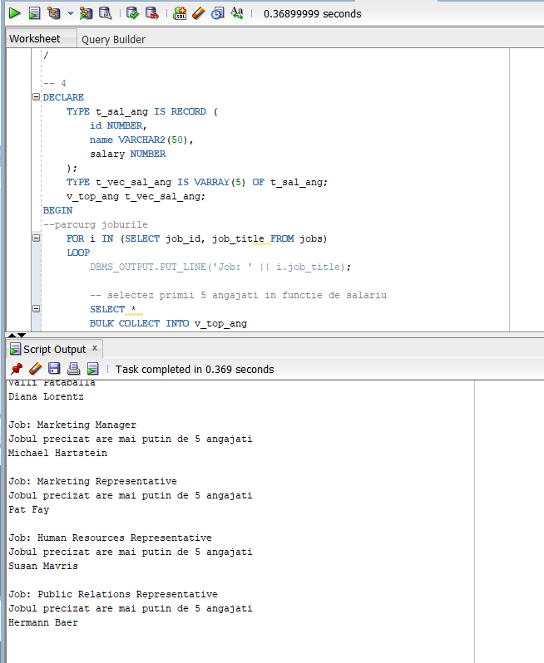

PLSQL 3 EX 5

-- 5
DECLARE
-- incarc in variabila v_nr_ang nr de salarii distincte calculate
v_nr_ang NUMBER;
v_ult_sal NUMBER;
BEGIN
FOR i IN (SELECT job_id, job_title FROM jobs)
LOOP
DBMS_OUTPUT.PUT_LINE('Job: ' || i.job_title);

v_nr_ang := 0;
v_ult_sal := -1;
-- Parcurgere angajați in functie de salariu
FOR e IN (
SELECT
employee_id,
first_name || ' ' || last_name AS name,
salary
FROM employees
WHERE job_id = i.job_id
ORDER BY salary DESC
)
LOOP
-- ies din loop cand am afisat primii 5 angajati cu cele mai mari salarii
EXIT WHEN v_nr_ang >= 5;
IF e.salary != v_ult_sal THEN
v_nr_ang := v_nr_ang + 1;
END IF;

DBMS_OUTPUT.PUT_LINE('Locul: ' || v_nr_ang || ': '
|| e.name || ' cu ' || e.salary);

v_ult_sal := e.salary;
END LOOP;

DBMS_OUTPUT.PUT_LINE('');
END LOOP;
END;
/

