PLSQL4 EX 1

-- 1

DROP TABLE info;
--creare tabela info cu atributele mentionate
CREATE TABLE info (
utilizator NVARCHAR2(30),
data DATE,
comanda NVARCHAR2(50),
nr_linii NUMBER,
eroare NVARCHAR2(100)
);

COMMIT;
--inserare in tabela
insert into info values ('user1',to_date('20-03-2021','dd-mm-yyyy'),'prima comanda',4,'prima eroare');
SELECT *
FROM info;

/
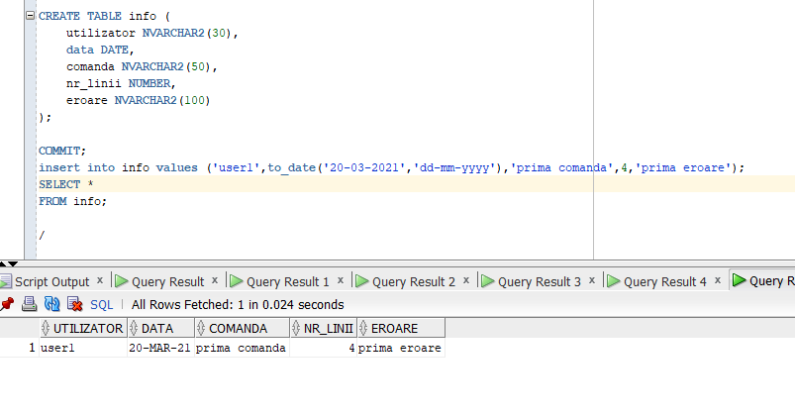
PLSQL4 EX2
--f2--
-- 2
set serveroutput on
CREATE OR REPLACE FUNCTION f2 (
--daun numele angajatului prin parametru
v_nume employees.last_name%TYPE
)
RETURN NUMBER IS
salariu employees.salary%TYPE;
BEGIN
--selectez salariul pentru angajatul dat prin parametru
SELECT
salary
INTO salariu
FROM
employees
WHERE
last_name = v_nume;

-- daca s-a gasit doar un angajat cu numele dat -->inserez
INSERT INTO info VALUES (USER, SYSDATE, 'F2', 1, NULL);
COMMIT;
RETURN salariu;
EXCEPTION
WHEN no_data_found THEN
--nu s-a gasit angajatul--
INSERT INTO info VALUES (USER, SYSDATE, 'F2', 0, 'Nu exista angajatul');
COMMIT;
raise_application_error(-20000, 'Nu exista angajati cu numele dat');
WHEN too_many_rows THEN
--s-au gasit mai multi angajati cu numele dat
INSERT INTO info VALUES (USER, SYSDATE, 'F2', 0, 'Exista mai multi angajati cu numele dat');
COMMIT;
raise_application_error(-20001, 'Exista mai multi angajati cu numele dat');
WHEN OTHERS THEN
INSERT INTO info VALUES (USER, SYSDATE, 'F2', 0, 'Alta eroare');
COMMIT;

raise_application_error(-20002, 'Alta eroare');
END f2;
/

DECLARE
v_salary NUMBER;
BEGIN
v_salary := f2('Bell2');
END;
/

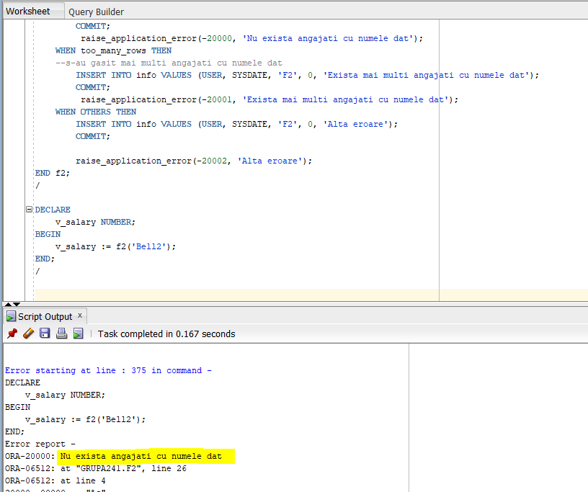

--p4--
set serveroutput on
CREATE OR REPLACE PROCEDURE p4 (
v_nume employees.last_name%TYPE
) IS
salariu employees.salary%TYPE;
BEGIN
--selectez salariul pentru angajatul dat prin parametru
SELECT
salary
INTO salariu
FROM
employees
WHERE
last_name = v_nume;

dbms_output.put_line('Salariul --> ' || salariu);

INSERT INTO info VALUES (USER, SYSDATE, 'F2', 1, NULL);
COMMIT;
EXCEPTION
WHEN no_data_found THEN
INSERT INTO info VALUES (USER, SYSDATE, 'F2', 0, 'Nu exista angajatul');
COMMIT;
raise_application_error(-20000, 'Nu exista angajati cu numele dat');
WHEN too_many_rows THEN
INSERT INTO info VALUES (USER, SYSDATE, 'F2', 0, 'Exista mai multi angajati cu numele dat');
COMMIT;

raise_application_error(-20001, 'Exista mai multi angajati cu numele dat');
WHEN OTHERS THEN
INSERT INTO info VALUES (USER, SYSDATE, 'F2', 0, 'Alta eroare');
COMMIT;

raise_application_error(-20002, 'Alta eroare');
END p4;
/

BEGIN
p4(NULL);
END;
/
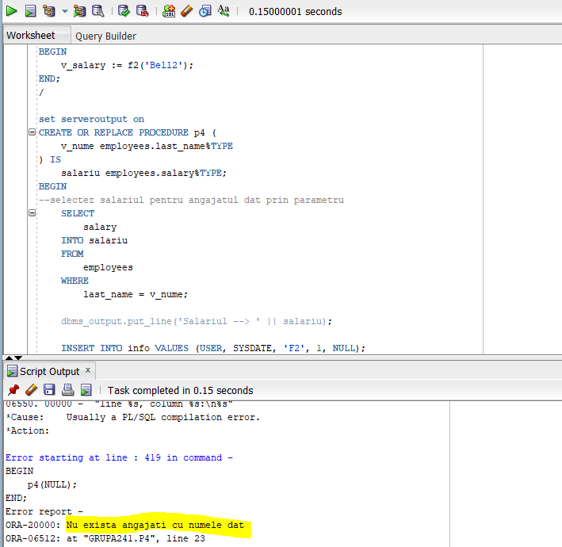

PLSQL4 EX4

-- 4
set serveroutput on
CREATE OR REPLACE PROCEDURE marire_sal (
v_manager_id employees.manager_id%TYPE
) IS
--index by table
TYPE t_ids IS TABLE OF employees.employee_id%TYPE;
v_ids t_ids;
BEGIN
-- Selectez angajatii care lucrează direct sau indirect pt managerul dat prin parametru
SELECT employee_id
BULK COLLECT INTO v_ids
FROM employees
START WITH employee_id = v_manager_id
CONNECT BY manager_id = PRIOR employee_id;
-- tratez cazul in care nu exista manager cu codul dat
IF v_ids.COUNT = 0 THEN
DBMS_OUTPUT.PUT_LINE('Nu există un manager cu codul dat');
RETURN;
END IF;
--daca exista-->
-- Măresc salariile
FOR i IN v_ids.FIRST..v_ids.LAST
LOOP
UPDATE employees
SET salary = salary * 1.1
WHERE employee_id = v_ids(i);
END LOOP;
END;
/

set serveroutput on
BEGIN

marire_sal(100);
END;
/
select * from employees where manager_id=100;

SELECT salary
FROM employees;

ROLLBACK;

INAINTE DE ROLLBACK:
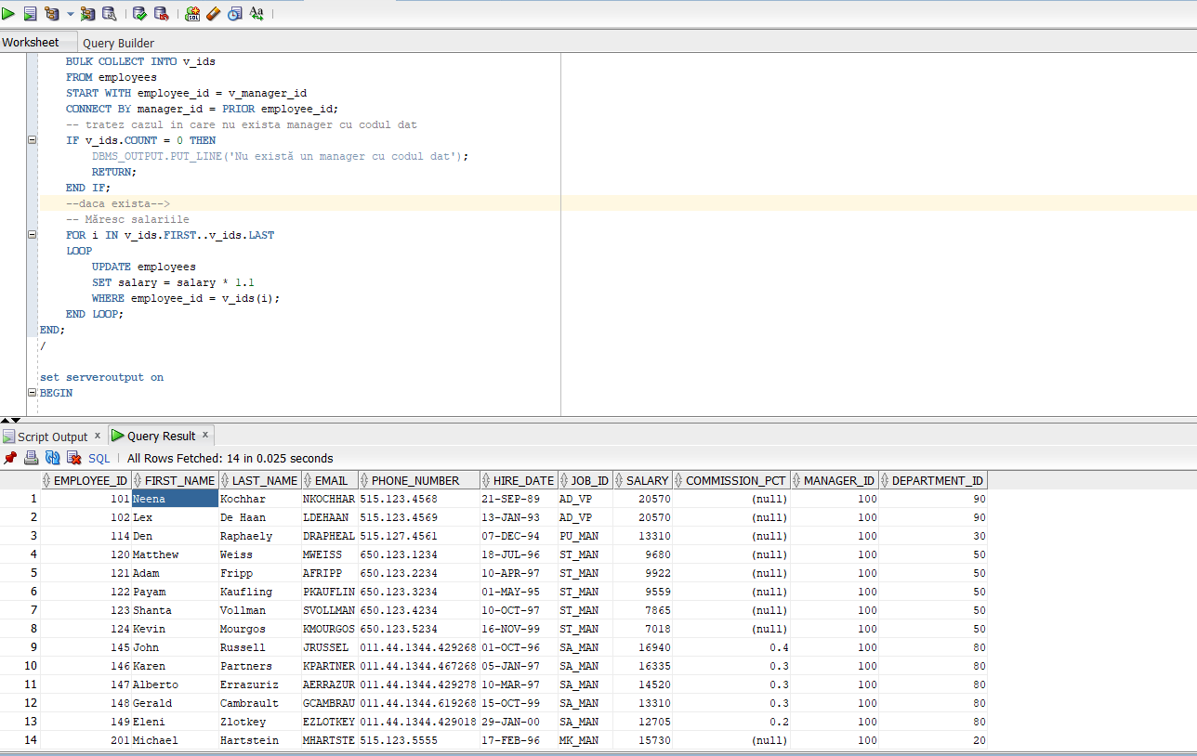

DUPA ROLLBACK:
