PLSQL6 EX1

-- 1
DROP TABLE dept;
CREATE TABLE dept AS (SELECT * FROM departments);
-- trigger la nivel de linie care sa-i permita doar utilizatorului SCOTT sa stearga informatii din tabela DEPT.
CREATE OR REPLACE TRIGGER tr_scott
BEFORE DELETE ON dept
FOR EACH ROW
BEGIN
IF USER != 'SCOTT' THEN
RAISE_APPLICATION_ERROR(-20000, 'Utilizatorul nu este Scott!!');
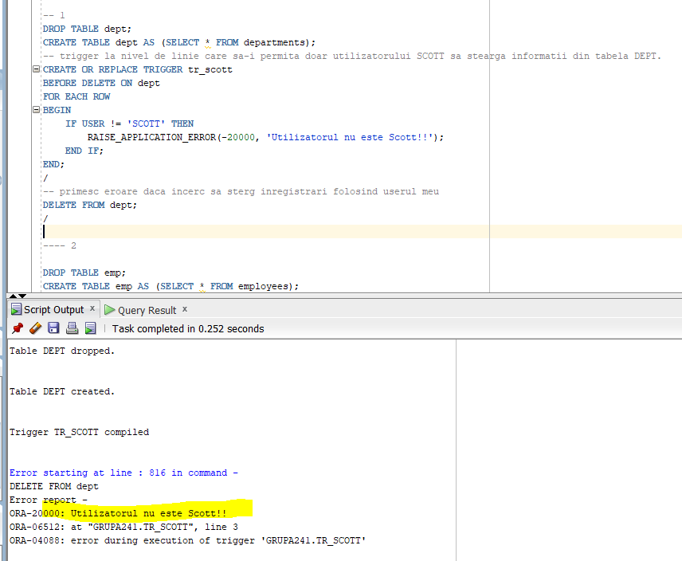
END IF;
END;
/
-- primesc eroare daca incerc sa sterg inregistrari folosind userul meu
DELETE FROM dept;
/

PLSQL6 EX2

-- 2

DROP TABLE emp;
CREATE TABLE emp AS (SELECT * FROM employees);

CREATE OR REPLACE TRIGGER trig_marire
BEFORE UPDATE OF commission_pct ON emp
FOR EACH ROW
BEGIN
-- Dacă comisionul depășește 50%--->nu permit actualizarea.
IF :NEW.commission_pct > 0.5 THEN
RAISE_APPLICATION_ERROR(-20000, 'Nu se poate mari comisionul cu mai mult de 50% din salariu!!!');
END IF;
END;
/

-- vreau sa modific cu un comision de 0,76
UPDATE emp
SET commission_pct = 0.76
WHERE employee_id = 100;
/
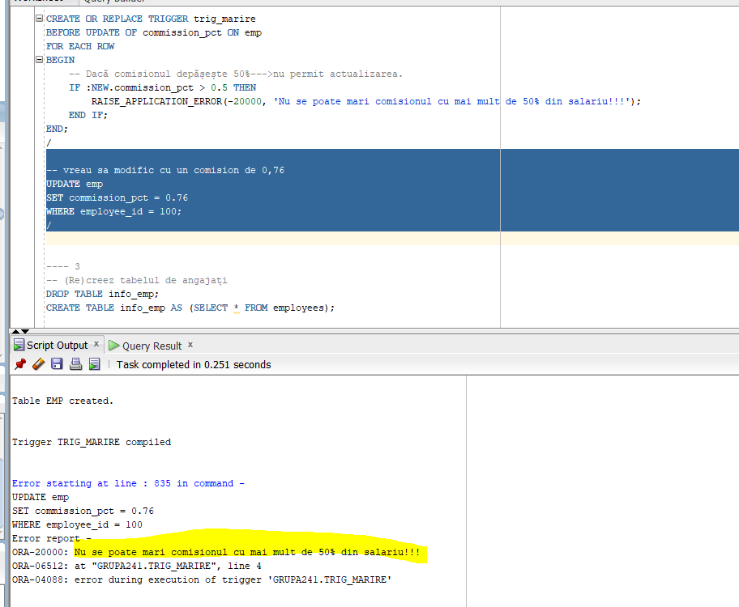

PLSQL6 EX3

--3
DROP TABLE info_emp;
CREATE TABLE info_emp AS (SELECT * FROM employees);

DROP TABLE info_dept;
CREATE TABLE info_dept AS (SELECT * FROM departments);

--Adaug o noua coloana pt nr de angajati dintr-un departament
ALTER TABLE info_dept
ADD numar NUMBER;

-- initializez coloana
UPDATE info_dept d
SET numar = (
SELECT COUNT(1)
FROM info_emp
WHERE department_id = d.department_id
);

-- adaug restrictie de NOT NULL
ALTER TABLE info_dept
MODIFY numar NUMBER NOT NULL;

-- Creez un trigger care sa pastreze coloana actualizata
CREATE OR REPLACE TRIGGER trigger_actualizare
AFTER INSERT OR UPDATE OR DELETE ON info_emp
BEGIN
-- Rulez din nou codul de mai sus
UPDATE info_dept d
SET numar = (
SELECT COUNT(1)
FROM info_emp
WHERE department_id = d.department_id
);
END;
/
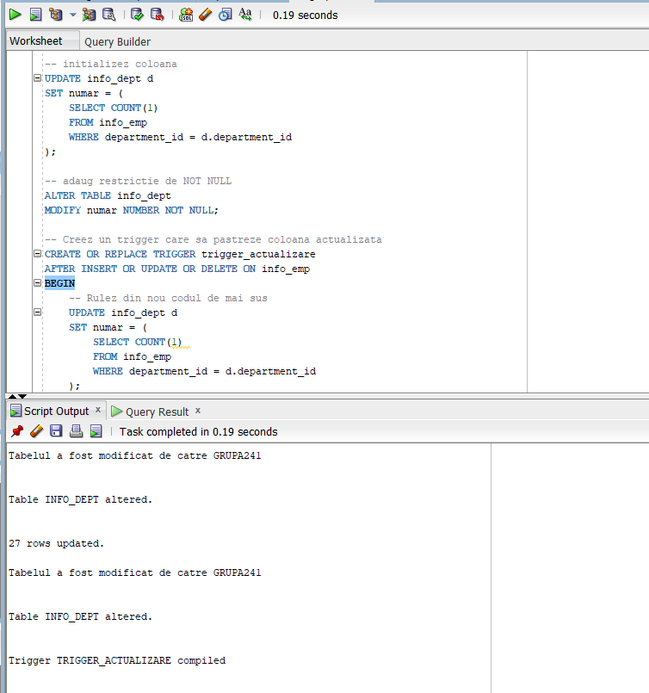

PLSQL6 EX4

-- 4
-- Creez o noua tabela in care stochez cati angajati am in fiecare departament
DROP TABLE nr_emps;
CREATE TABLE nr_emps AS (
SELECT department_id, COUNT(1) AS num_emp
FROM emp
GROUP BY department_id
);

CREATE OR REPLACE TRIGGER trigger_initializare1
--triggerul inițializează tabela creata la fiecare insert/update
BEFORE INSERT OR UPDATE ON employees
BEGIN
DELETE FROM num_emps;
-- Inserez valori
INSERT INTO nr_emps (department_id, num_emp)
SELECT department_id, COUNT(1)
FROM emp
GROUP BY department_id;
END;
/
--trigger care sa se declanseze la insert-ul unui angajat intr-un departament in care lucreaza deja 45 de persoane
CREATE OR REPLACE TRIGGER trigger2_ex4
BEFORE INSERT OR UPDATE ON emp
FOR EACH ROW
DECLARE
--declar o variabila in care incarc numarul angajatilor
v_num_ang NUMBER;
BEGIN
-- selectez nr de angajati
SELECT num_emp INTO v_num_ang
FROM num_emps
WHERE department_id = :NEW.department_id;
IF v_num_ang >= 45 THEN
--tratez cazul in care sunt mai mult de 45 de angajati
RAISE_APPLICATION_ERROR(-20000, 'Prea multi angajati');
END IF;
-- daca sunt mai putin de 45 de angajati → facem update si contorizam si noul angajat
UPDATE num_emps
SET num_emp = num_emp + 1
WHERE department_id = :NEW.department_id;
END;
/

-- fac insert intr-un departament in care sunt deja 45 de angajati
INSERT ALL
INTO emp (employee_id, department_id)
VALUES (1234, 50)
INTO emp (employee_id, department_id)
VALUES (1235, 50)
SELECT 1 FROM dual;

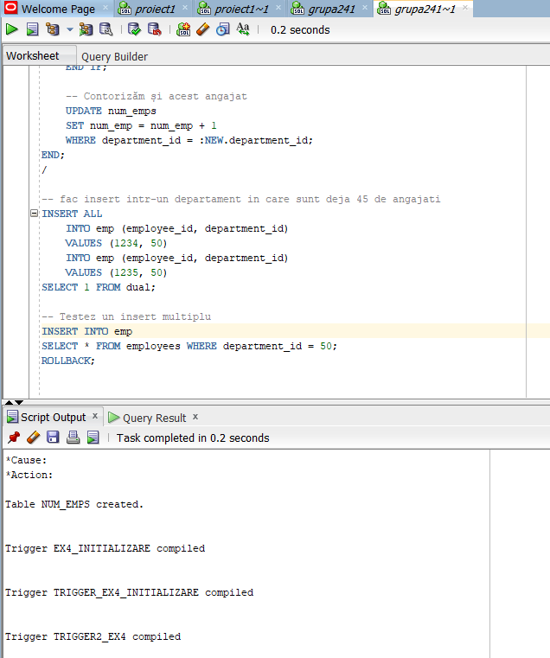

PLSQL6 EX5

-- 5
DROP TABLE emp_test;

CREATE TABLE emp_test AS (
SELECT employee_id, last_name, first_name, department_id
FROM employees
);

ALTER TABLE emp_test
ADD CONSTRAINT emp_test_pk PRIMARY KEY (employee_id);

CREATE TABLE dept_test AS (
SELECT department_id, department_name
FROM departments
);

ALTER TABLE dept_test
ADD CONSTRAINT dept_test_pk PRIMARY KEY (department_id);
--trigger stergere--
CREATE OR REPLACE TRIGGER trigg_stergere
AFTER DELETE ON dept_test
--trigger la nivel de rand--
FOR EACH ROW
BEGIN
-- Șterg angajații care erau in acest departament
DELETE FROM emp_test
WHERE department_id = :OLD.department_id;
END;
/

CREATE OR REPLACE TRIGGER trigg_modificare
AFTER UPDATE ON dept_test
FOR EACH ROW
BEGIN
-- Modific angajații care erau deja în departament.
UPDATE emp_test
SET department_id = :NEW.department_id
WHERE department_id = :OLD.department_id;
END;
/

--testare
ALTER TABLE emp_test
DROP CONSTRAINT emp_test_dept_fk;

ALTER TABLE emp_test
ADD CONSTRAINT emp_test_dept_fk
FOREIGN KEY (department_id)
REFERENCES dept_test(department_id);

ALTER TABLE emp_test
ADD CONSTRAINT emp_test_dept_fk
FOREIGN KEY (department_id)
REFERENCES dept_test(department_id)
ON DELETE CASCADE;

ALTER TABLE emp_test
ADD CONSTRAINT emp_test_dept_fk
FOREIGN KEY (department_id)
REFERENCES dept_test(department_id)
ON DELETE SET NULL;
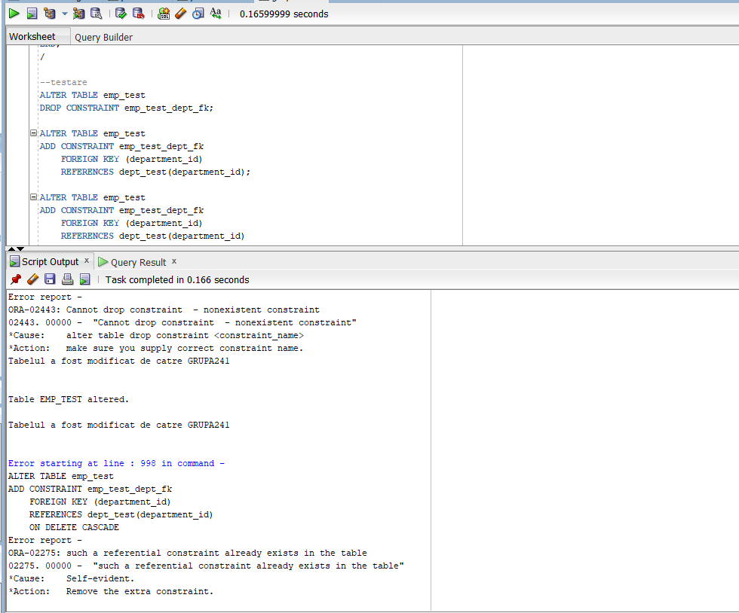
PLSQL6 EX 6

-- 6

DROP TABLE database_errors;
CREATE TABLE database_errors (
user_id NVARCHAR2(100),
nume_bd NVARCHAR2(100),
erori NVARCHAR2(2000),
data DATE
);

--trigger insert
CREATE OR REPLACE TRIGGER trigger_insert
AFTER SERVERERROR
ON DATABASE
BEGIN
INSERT INTO database_errors
VALUES (
SYS.LOGIN_USER,
SYS.DATABASE_NAME,
DBMS.FORMAT_ERROR_STACK,
SYSDATE
);
END;

Nu am suficiente permisiuni.
