The Zips football game on August 30th will require that some lots be closed during the day. Lots 6, 8, 9, and 10 will be closed at midnight on Wednesday, and will remain closed all day Thursday. Students, faculty and staff will be required to park elsewhere. All other lots thayo dt are normally closed the entire day of a game will be open until 3:00 p.m., when attendants will arrive and limit access to those with pre-purchased football permits. Lots 14, 15, 27, and 34 are also normally closed the entire day of a game, but will remain open on game day until 3:00 p.m., when attendants will begin charging $10 per vehicle for fan tailgating **while allowing students and employees with permits to park free.**

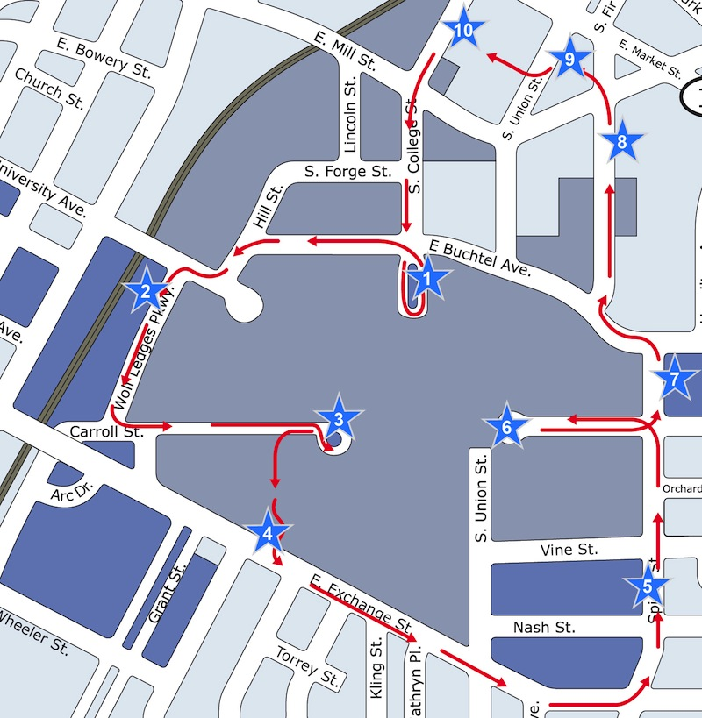 The following lots will be designated as alternative parking, with a modified Roo Express Campus Circulator route serving as a park-and ride on that day: Lots 36, 20, 30, 32, 35, 40, 52, and 71(Click a lot number to view on map). About 880 parking spaces are expected to be available in these lots to absorb additional vehicles. Temporary signage will be set up at the new Roo Express stops to denote pickup locations. The map to the right shows what the Roo Express Circulator Route will look like on August 30th.

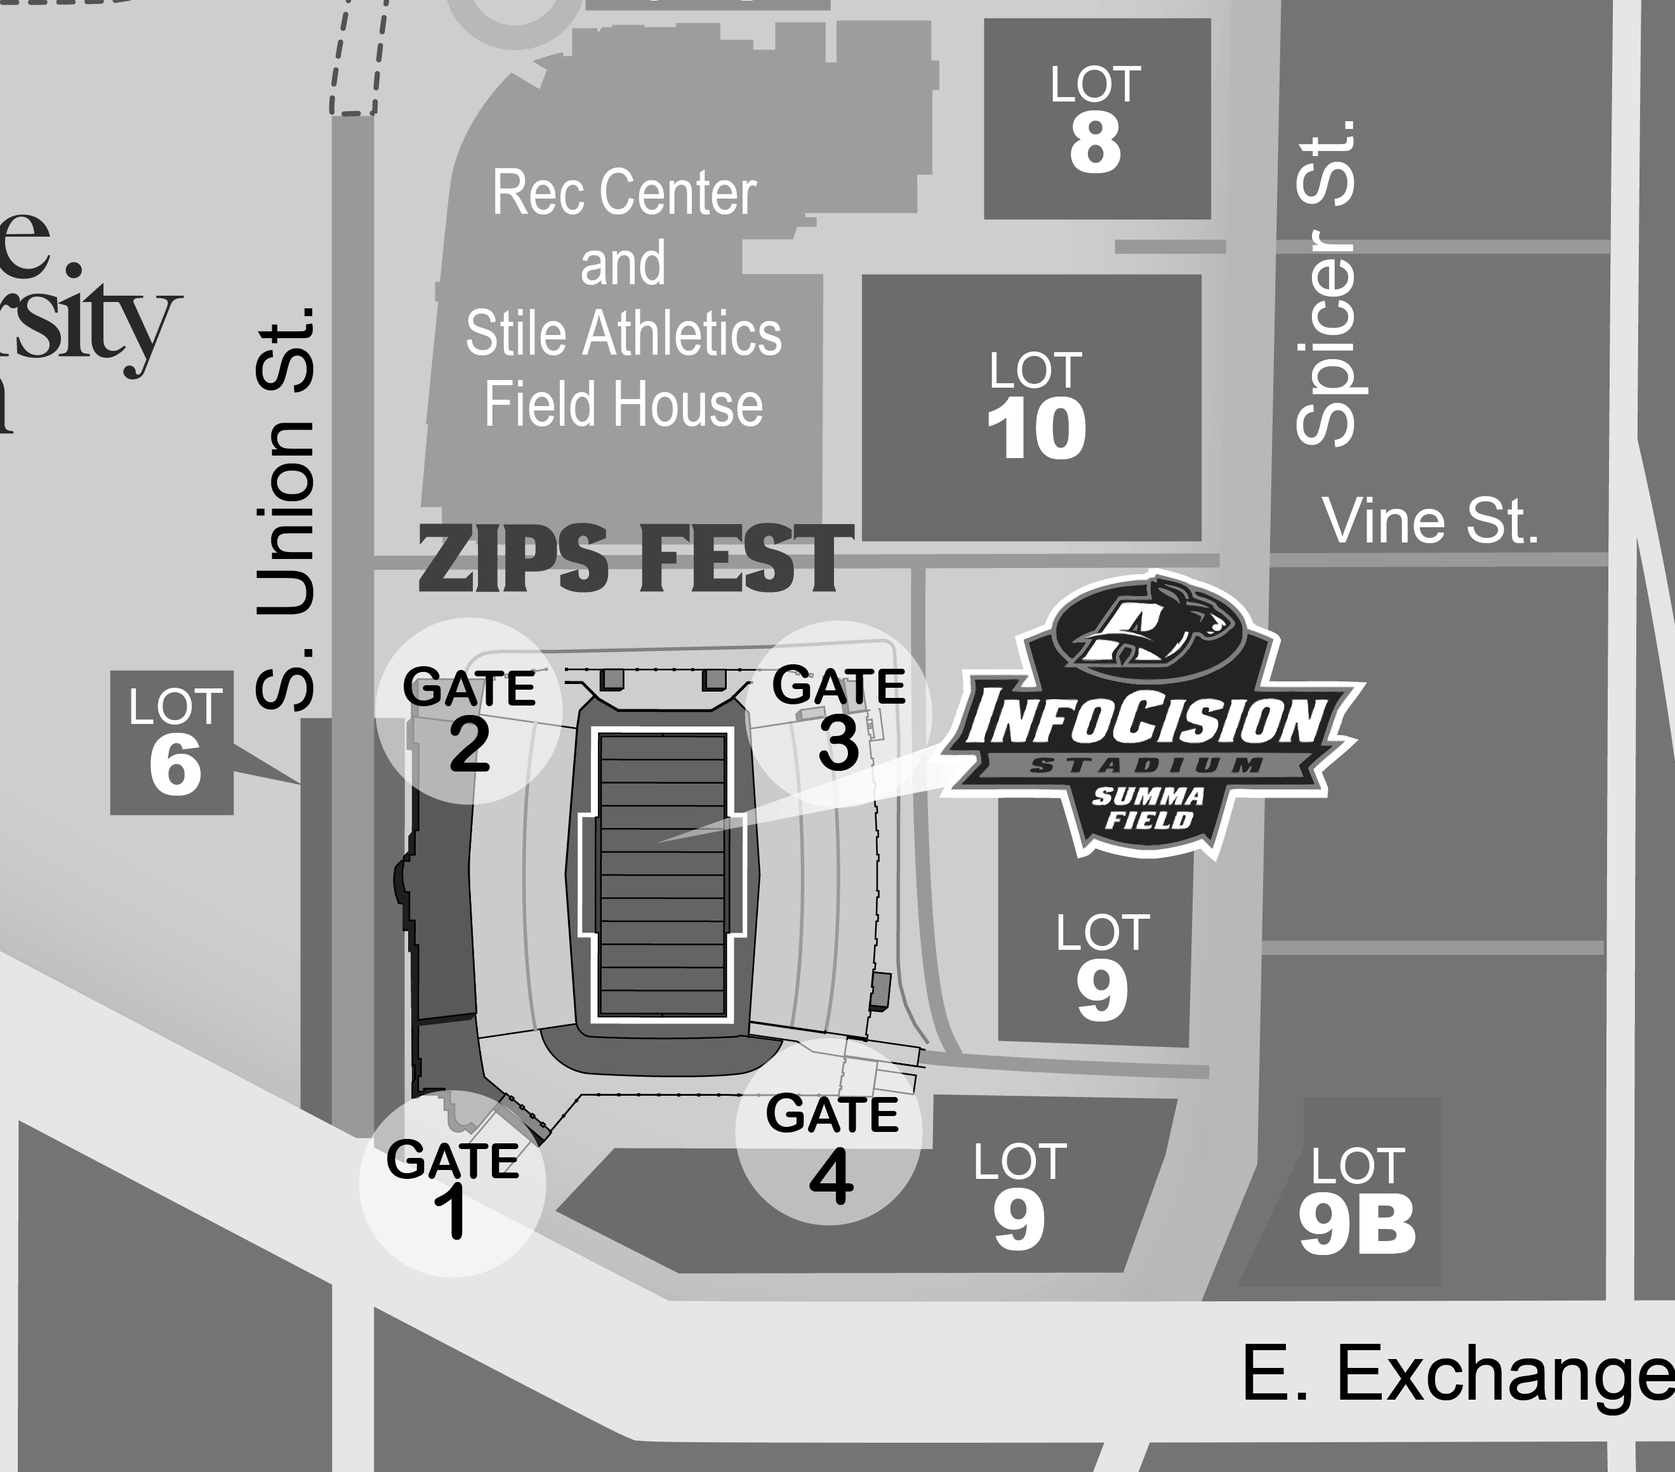

The map to the right shows the location of lots that will be closed all day on Thursday. The lots will close at midnight, Wednesday night. These lots will reopen Friday, August 31st.

Everyone's cooperation and patience will make for a successful home opener for an exciting season of Zips football!