NOTE: You need to pip install keyboard in order to run the code and tests properly.

TEST: When the prompt library is imported and a prompt instance is created, the user can set up key bind combinations that can call certain methods on the buffer. Because of what was causing the issue in the redo buffer, which was resetting it on every keystroke, this manual test is required to properly test the fix. NOTE: An editable version of the prompt_toolkit should be installed using the local version pulled from our github to be able to see this change. To install an editable version, clone the repository and run the command **pip install -e <DIRECTORY FILE PATH>**. If the editable version is installed and a sample program importing the prompt_toolkit is run correctly from the command line, it should look like the following:

Sample program: key binds for undo, redo, and clear set up for the PromptSession buffer

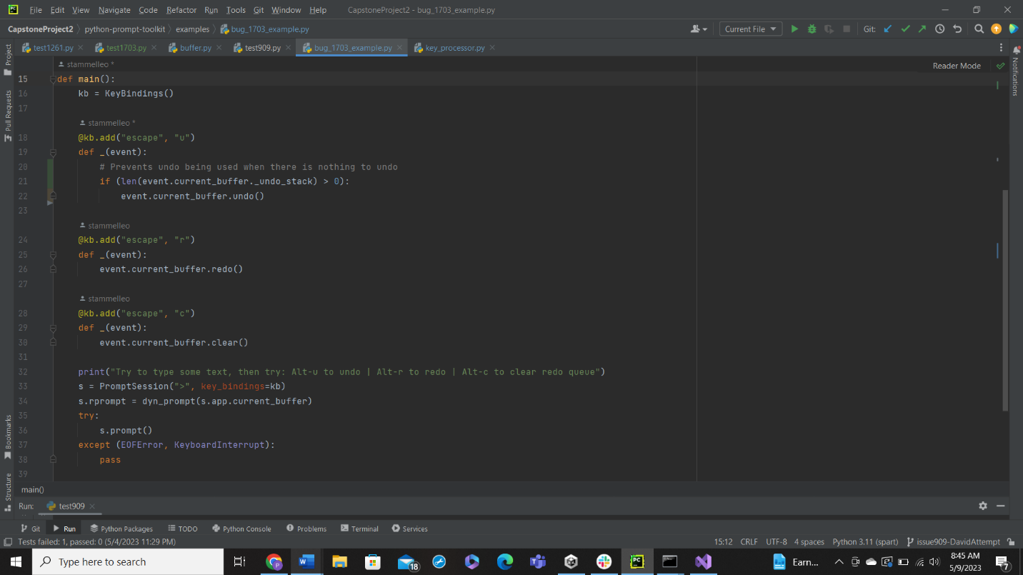

Run the sample program from the command line to get the following:

The undo and redo counters show the user the length of the related buffers. When the user starts typing, the undo buffer goes up as shown below.

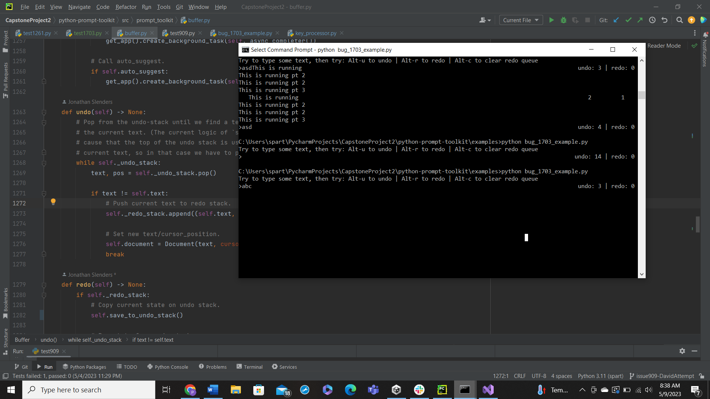

The user can then use the undo key bind which removes the letter, lowers undo by one and raises redo by one. At this point, the original program would break, and redo would not work and any additional undos would not increase the redo stack. With my fix, the user may use redo right here or continue to undo which keeps adding to the redo stack as shown below.

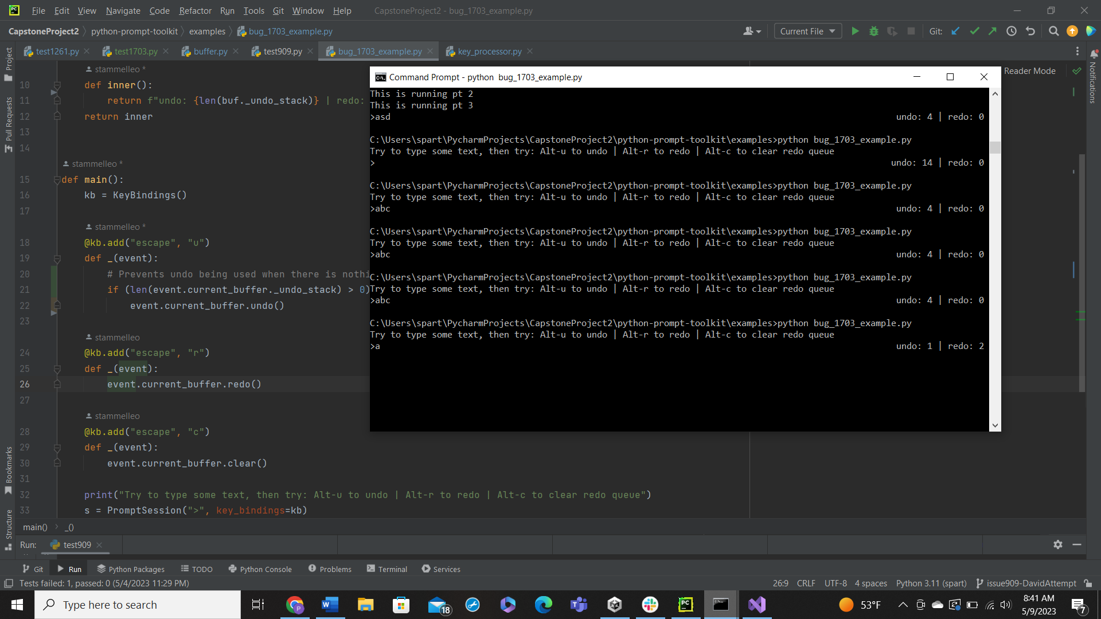

Then the user can either apply the redos or use the clear function I created to clear the redo stack shown below. NOTE using the clear button will raise the undo counter by one because of how the key presses are registered, however this is corrected the moment the user presses any other key so the problem resolves itself.

NOTE: This does not automatically clear the redo buffer when alphanumeric keys are pressed, which allows for a bug where the user can undo, type, then redo and it will overwrite what was typed. I would suggest submitting a bug report that asks for the clear() command to be called only when alphanumeric or special characters are pressed instead of having to do it manually.