Sample program: examples/test1715.py

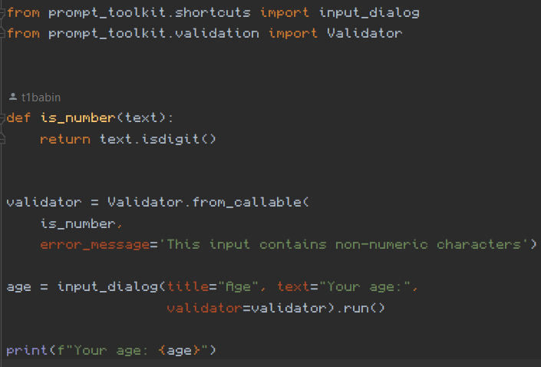

Run the sample program from the command line to get the following:



Type “abc” and press tab to move to the OK button. If you press enter, the cursor should return to the textbox. Then type in a valid age and press enter twice to see the program print the age value to the command line.