BEYOND THE RATINGS
What 56,000 displayed football player records reveal about ability, potential, playing style and position suitability
EA Sports FC Analytics | Power BI project documentation | November 2026
Prepared by: [Your name] • GitHub: [Add repository URL] • Dashboard: [Add report URL]

Cover visual — EA Sports FC Analytics home page, supplied dashboard PDF, page 1.
A research-informed portfolio report using dashboard evidence, a supplied Power BI model screenshot, and published football analytics literature.

Executive summary
I started this project with a simple question: when we say a football player is rated 86, what does that number really tell us? Overall ratings are useful, but they can hide the things that make players different. A goalkeeper, a centre-back and a striker are asked to do very different jobs. I wanted to explore those differences instead of stopping at a leaderboard.
I brought together six male and female football datasets and developed a Power BI report covering players, teams, coaches, attributes, playing style and position suitability across FIFA editions. The dashboard displays about 56K player records, an average overall rating of 66, average potential of 71 and a highest overall rating of 94. The clearest example comes from a historical Courtois profile: goalkeeper suitability 85 and centre-back suitability 34—a 51-point difference for the same player.
The central finding: a rating makes more sense when we know the position, the edition and the attributes behind it.
Dashboard indicator | Displayed value | Interpretation
Player count | ~56K | Count definition needs PBIX verification
Average overall / potential | 66 / 71 | Five-point difference in displayed averages
Highest overall / potential | 94 / 95 | Highest values on Player Intelligence page
Average team overall | 69 | Displayed team measure
Average coach age | 53 | Displayed coach measure
Average position suitability | 53.4 | Average across position-rating records

Evidence note. All dashboard figures in this report come from the supplied 10-page PDF. They describe game data, not observed match performance. The newly supplied model screenshot is used for the model discussion. Published research is cited separately and is not presented as evidence for the dashboard figures.

1. Introduction: why this project matters
When football fans compare players, they often begin with the overall rating. It is easy to read and quick to understand. But I kept wondering what I might miss by looking only at that number. Two players can have similar overall ratings and completely different strengths. The same player can also be a strong fit for one position and a poor fit for another.
That curiosity shaped the project. Rather than build a report that only lists top-rated players, I wanted one that could answer practical questions: Which positions appear most often? How do overall and potential ratings compare? What do pace, passing and preferred foot add to the story? Can the report show a specific player’s suitability across many roles?

1.1 Problem statement
The raw files contain many columns and repeated observations across FIFA editions. Without a clear model, a player can be counted more than once, a market value can be added across years, and a comparison between groups can be distorted by missing information. The project therefore needed both an interactive dashboard and careful rules for interpreting its figures.

1.2 Objectives
- Bring player, team and coach information into a coherent analytical model.
- Describe player records by position, gender and edition.
- Compare current ability, potential, attributes and playing characteristics.
- Examine team and league ratings and coach information.
- Reshape position ratings so a single player can be compared across roles.
- Provide a drillthrough profile that turns a summary statistic into a concrete player example.

2. Data and scope
The source material consists of six files: male_players, female_players, male_teams, female_teams, male_coaches and female_coaches. The player records include identifiers, edition, club, position, nationality, ratings, physical information, technical attributes, preferred foot, wage and game market value. The team files contain league and team strength measures; the coach files contain identity and demographic information.
Source group | Core content | Important caution
Players (male + female) | Overall, potential, attributes, positions, club, age, value | A player can appear in multiple editions
Teams (male + female) | Team and league identity, attack, midfield, defense | Club and national-team contexts can differ
Coaches (male + female) | Coach identity, age, nationality, gender | Coverage reflects the game dataset

Unit of analysis matters. A “player record” may be a player in a particular FIFA edition rather than one unique person. The displayed ~56K should not be described as 56K unique footballers until the exact count measure is checked. The same caution applies to team and coach counts.

3. Research background: what existing work tells us
Published football analytics research helps explain why it is useful to move beyond a single score. The studies below are not direct tests of this Power BI dashboard. They provide context for interpreting its findings.

3.1 Football performance has many dimensions
Wakelam, Steuber and Wakelam (2022) reviewed 132 studies of footballer attributes and distinguished relatively stable attributes, such as height and age, from changing performance measures, such as passes and shots. This supports the decision to look at several groups of player characteristics rather than only overall rating [R1].

3.2 Position changes what “good performance” means
Forcher and colleagues (2022) examined technical match performance in the German Bundesliga and asked how much differences depend on positional role and the individual player. Another study of Brazilian professional players found position-specific differences in physical, technical and passing-network measures [R2, R3]. These studies use real match data, while this project uses game ratings. The useful connection is conceptual: position is an important part of performance interpretation.

3.3 Prediction and valuation need care
Research involving 96 football coaches and scouts found that predicting future performance is difficult, with generally limited reliability and small-to-moderate predictive validity [R4]. This does not validate or invalidate EA potential ratings, but it is a reminder not to treat a potential score as a promise of future performance.

3.4 Representation changes across FIFA editions
EA introduced women’s national teams in FIFA 16, and EA Sports FC 24 later added women’s club leagues and women players to Ultimate Team [R5, R6]. This helps explain why male and female game datasets may have different historical coverage. It does not explain every missing field in the supplied files; that requires a dataset-level audit.

4. Data preparation: making the tables usable
The project approach was to combine male and female versions of each source while keeping gender information, standardize useful field types and prepare edition-aware keys. The most important analytical reshaping concerned the many position-suitability columns.
In the raw player data, suitability is spread across columns such as GK, CB, CM, LM and ST. That layout is convenient for reading one player, but awkward for a chart comparing all positions. A dedicated position table turns these columns into rows: one player-edition record can have many position ratings. This makes it possible to build position comparisons and a drillthrough profile.
- Combine the male and female player files; repeat for teams and coaches.
- Keep an edition and gender identifier when building unique keys.
- Check missing values rather than assuming missing means zero.
- Unpivot the position rating columns into position name/code and numeric rating.
- Validate keys, row counts and the numeric interpretation of any rating modifiers.
- Use consistent edition filters for comparisons across player and team data.
Verification boundary. The supplied PDF does not show Power Query Applied Steps. These steps describe the documented project approach and should be checked against the saved PBIX before they are presented as a precise audit trail.

5. The actual Power BI data model
The supplied Model View screenshot confirms the model contains Fact_Players, Fact_Teams and FactPlayer_Positions, with dimensions including Dim_Edition, Dim_Gender, Dim_TeamEdition, Dim_Position, Dim_Nationality, Dim_Coach and Dim_Player. The diagram shows several one-to-many relationships and filter-direction indicators. The screenshot is evidence of the model structure, but it is not clear enough to verify every relationship column or whether any relationship is inactive.
The key design idea is to separate the detailed measurements from the descriptive tables used for filtering. Player records hold player ratings and attributes; team records hold team ratings; the position fact holds the many possible position ratings for each player-edition. Dimensions organize edition, gender, team, player, nationality, coach and position information.
One point worth checking in Power BI: the screenshot shows several relationship lines close together around the fact tables. Verify cardinality, active status, and filter direction in Manage Relationships, especially for paths that could allow ambiguous filtering between player, team and position facts.
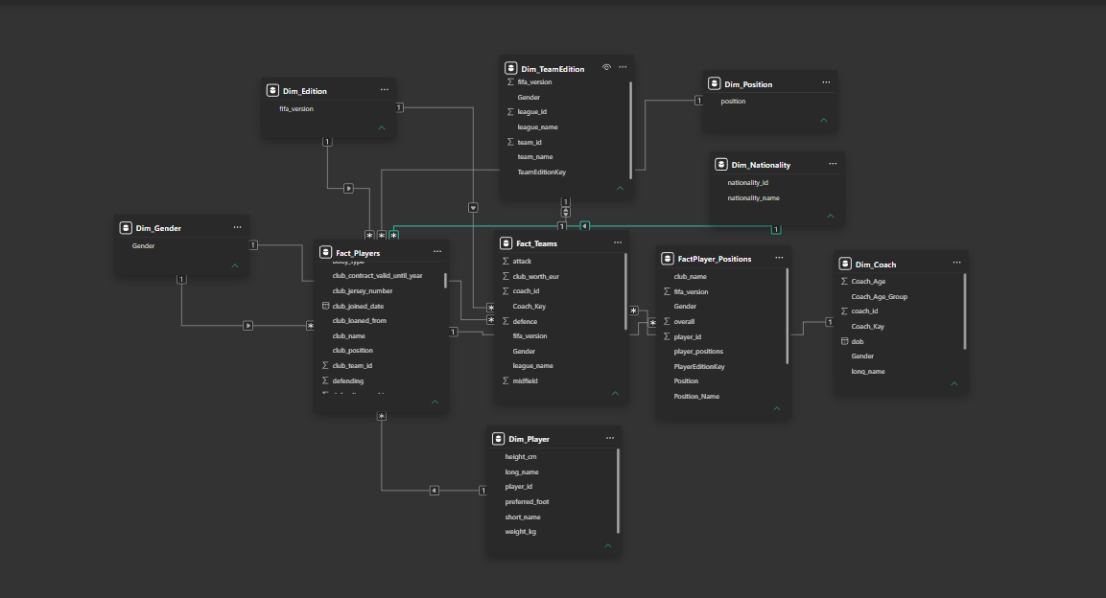
Figure 1. Actual Power BI Model View supplied for this documentation.

5.1 Suggested model checks
- Confirm that the player-edition key is unique in the intended player dimension or parent table.
- Confirm that the position fact contains multiple rows per player-edition, not accidental duplicates.
- Confirm that team-edition joins include edition and gender where needed.
- Check that filters from edition, gender and player reach the expected visuals.
- Review any many-to-many or bidirectional relationships and document why they are needed.

6. Measures, reporting logic and interaction
DAX measures summarize the data in the current filter context. The report uses cards, bar charts, tables, comparisons and drillthrough navigation. Because the final measure definitions were not supplied, the formulas below are illustrative patterns, not verified copies from the PBIX.
Average Player Rating = AVERAGE(Fact_Players[overall])
Highest Player Potential = MAX(Fact_Players[potential])
Average Position Rating = AVERAGE(FactPlayer_Positions[PositionRating])
Before publishing technical code, confirm the exact table and column names, and record the definitions of Player Count, gender percentage, Coach Coverage and market-value measures. A count of rows is not the same as a distinct count of people.

7. Results: what the dashboard actually shows
The following sections use the figures visible in the supplied report PDF. Each screenshot is followed by a short interpretation and, where appropriate, a comparison with published research.

7.1 Executive Overview — where the records are concentrated
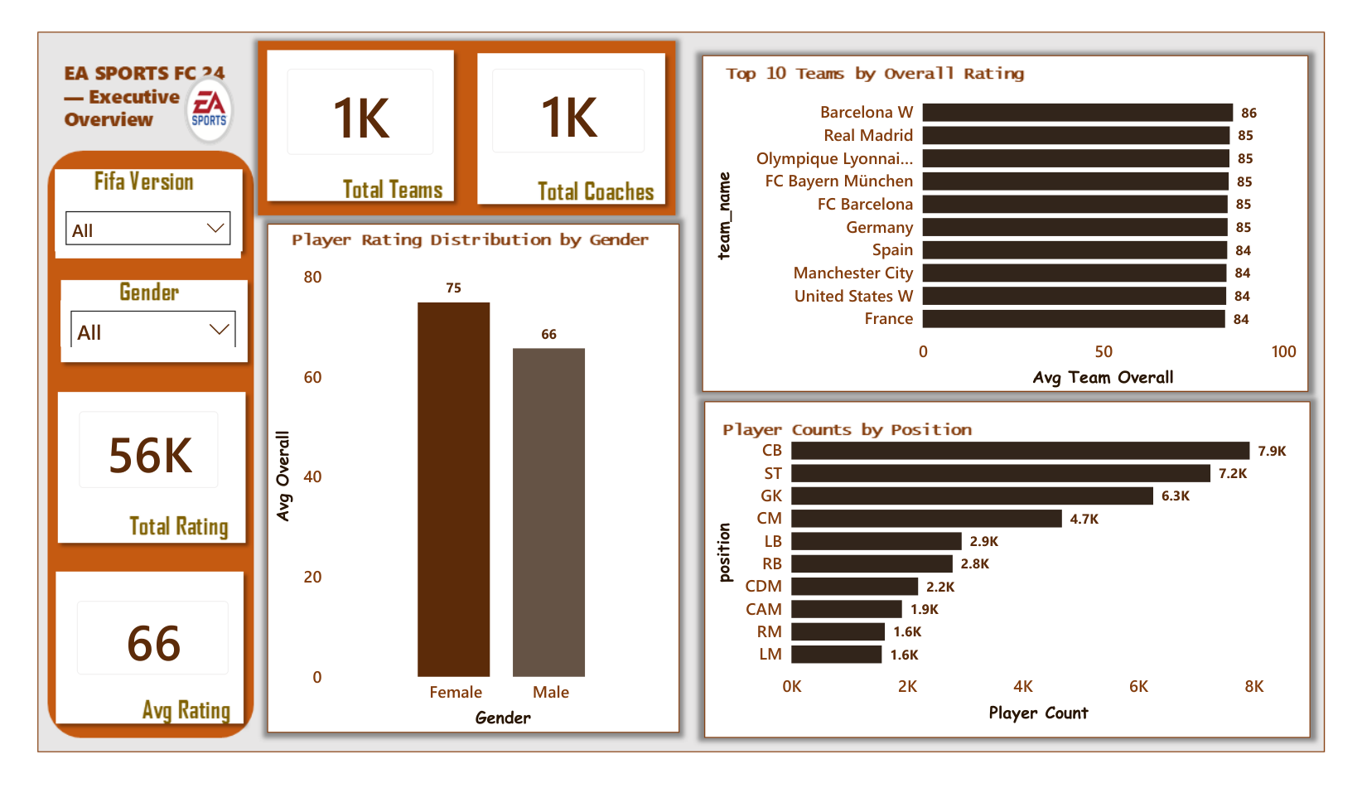
Figure 2. Executive Overview — supplied dashboard PDF, page 2.
The overview shows about 56K displayed player records and an average overall rating of 66. The largest listed position groups are centre-back (7.9K), striker (7.2K), goalkeeper (6.3K), central midfielder (4.7K) and left-back (2.9K). Centre-backs, strikers and goalkeepers together account for about 21.4K records, or roughly 38% of the displayed total. This percentage is approximate because the dashboard labels are rounded.
Why it matters. A dataset with many records in some positions can produce overall attribute averages that are strongly shaped by those positions. Research on positional differences supports the idea that player comparisons should consider roles [R2, R3]. Our chart does not show the distribution of all professional footballers; it shows the records in this game dataset.

7.2 Player Intelligence — ability, potential and value
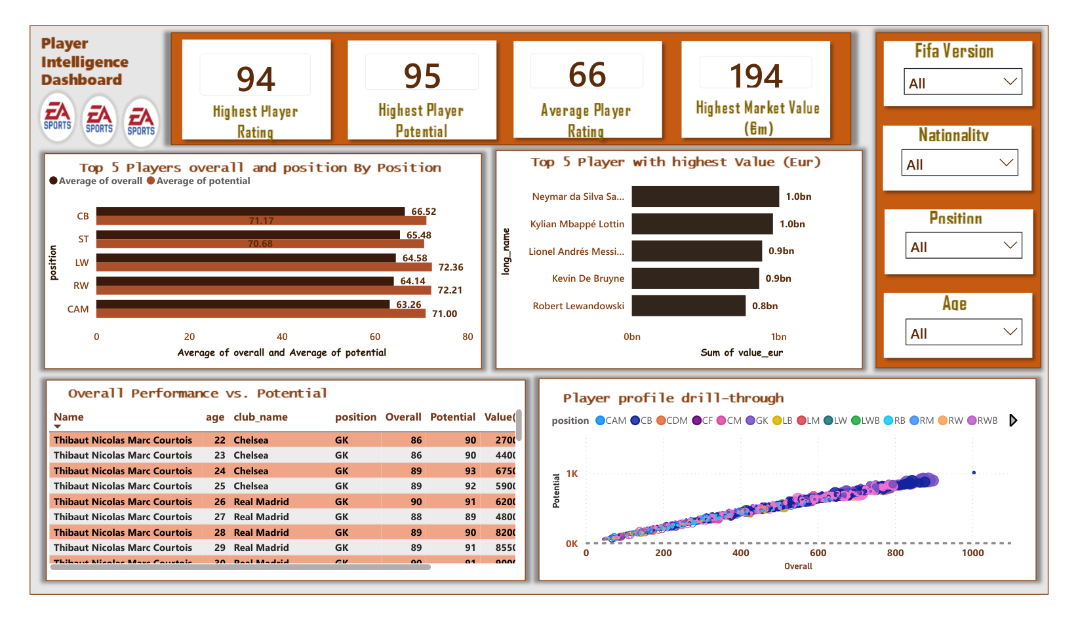
Figure 3. Player Intelligence — supplied dashboard PDF, page 3.
The highest overall rating shown is 94 and the highest potential is 95. Average overall is 66 and average potential is 71, a five-point difference. That does not mean every player will improve by five points; it means the displayed average potential is higher than the displayed average current rating.
The market-value chart shows sums of value_eur by player name, reaching approximately €1.0bn for some names. These are summed values across records, not credible single-edition prices. The overall-versus-potential scatter also shows an axis extending to around 1,000, suggesting a visual aggregation or scale issue that should be checked. Both charts need review before being used to make strong valuation or relationship claims.
Research comparison. The coaches-and-scouts study [R4] shows that predicting player futures is challenging. Our potential measure is an in-game rating, not an observed future outcome; a proper validation study would compare it with later real performance or later game ratings.

7.3 Team and League Intelligence — one score is not the whole team
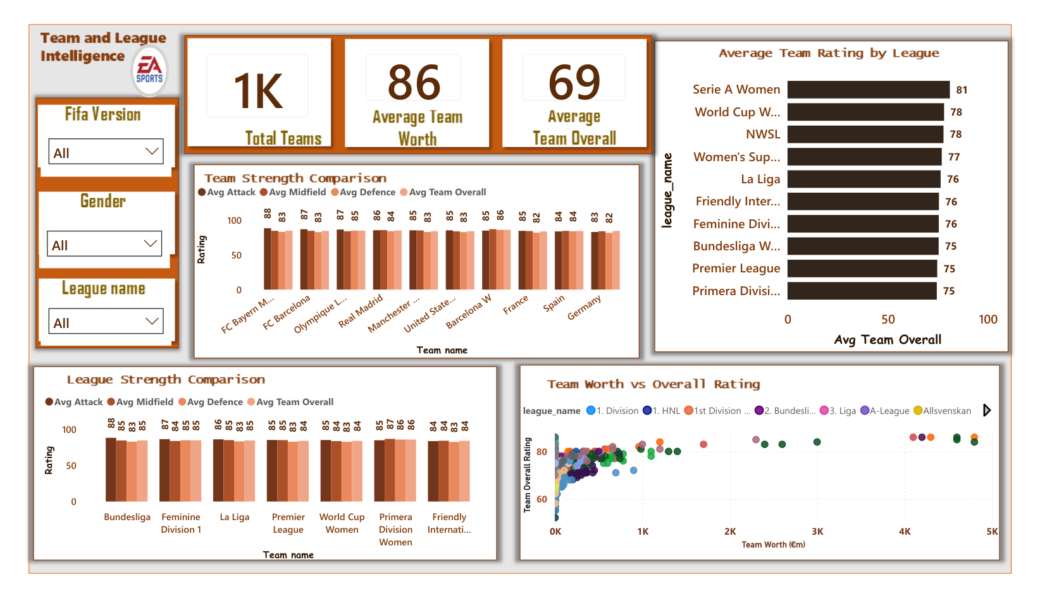
Figure 4. Team and League Intelligence — supplied dashboard PDF, page 4.
The average team overall rating is 69. The executive ranking shows Barcelona W at 86, with Real Madrid, Olympique Lyonnais W, Bayern Munich and Barcelona around 85. The league view includes Serie A Women at 81, Women’s World Cup at 78, NWSL at 78 and Women’s Super League at 77. These are displayed game ratings, not measured league competitiveness.
What I learned. Teams with similar overall ratings can differ in attack, midfield and defense. That is a better starting point for comparison than declaring a winner from a one-point overall gap. League comparisons should be filtered carefully because the report includes different competition types and editions.

7.4 Gender Comparison — compare like with like
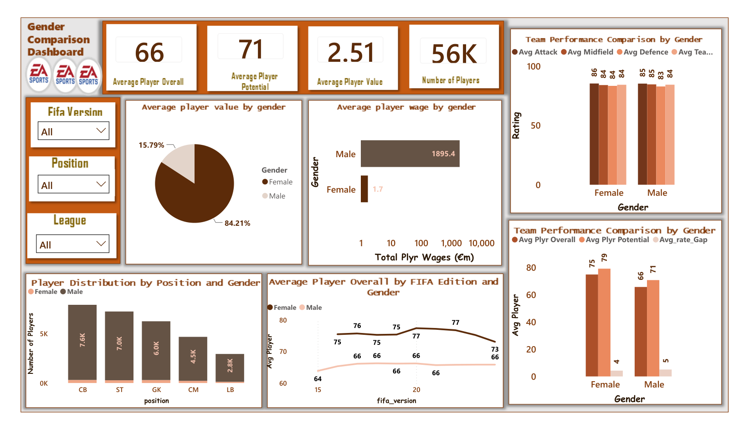
Figure 5. Gender Comparison — supplied dashboard PDF, page 5.
The page shows average overall 66, average potential 71 and about 56K displayed records. Its financial visuals include male total wages around €1,895.4m and female total wages around €1.7m in the shown selection. The page also contains an 84.21% / 15.79% pie, but the screenshot does not clearly establish that the pie measures player counts; it must not be labeled a player-count share without checking the visual field.
This is not evidence of a real-world gender pay gap. These are game fields aggregated over a dataset with different historical coverage and missing financial values. EA’s documented expansion of women’s football from FIFA 16 to FC 24 [R5, R6] makes edition coverage an especially important consideration. A fairer study would select comparable editions, show nonmissing sample sizes and compare clearly defined per-record statistics.

7.5 Coach Insight — a wider view of football
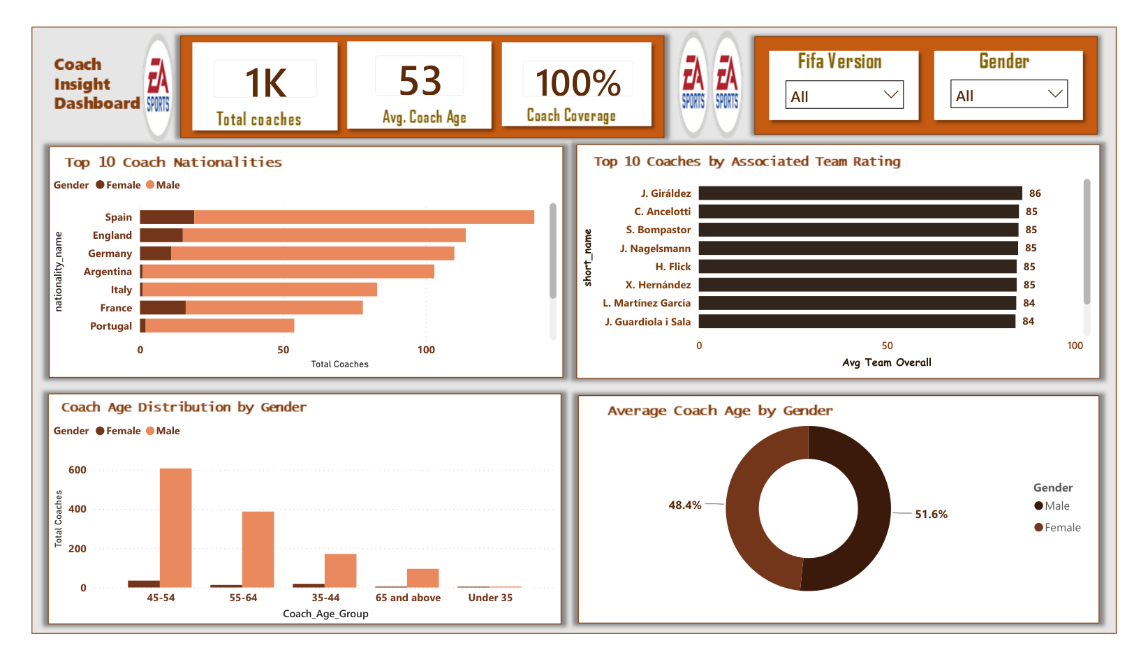
Figure 6. Coach Insight — supplied dashboard PDF, page 6.
The dashboard shows about 1K coach records, an average coach age of 53 and a displayed coach coverage measure of 100% (definition not supplied). Nationality and age-group charts add detail. A gender donut appears close to 51.6% and 48.4%, but its exact categories and denominator should be verified in the PBIX before quoting it as a population split.
This section is useful because it widens the story beyond players. It does not establish the age or gender composition of professional coaches worldwide.

7.6 Player Performance & Attributes — the skills behind the score
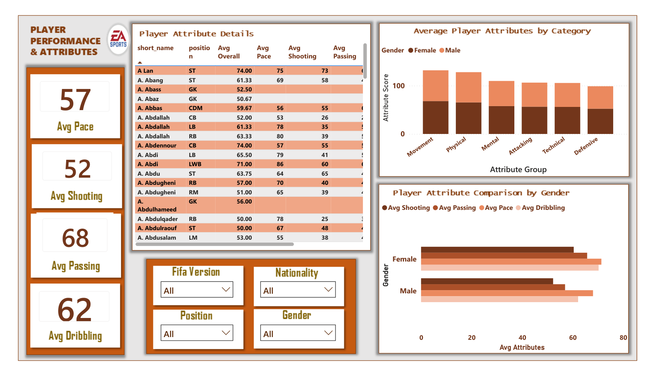
Figure 7. Player Performance & Attributes — supplied dashboard PDF, page 7.
The displayed KPI averages include pace 57, shooting 52, passing 68 and dribbling 62. Passing is 16 rating points above shooting in these displayed summaries. This does not prove passing is more important than shooting: the measures describe different skills, and missing attributes may mean the averages use different groups of records.
Research comparison. The systematic review of footballer attributes [R1] and the match-performance study [R2] both support a multidimensional approach. Our attribute groups provide a richer game-data profile, but they are not substitutes for measured passing success, pressing, match movement or goals in real games.

7.7 Playing Style — a clear preferred-foot imbalance
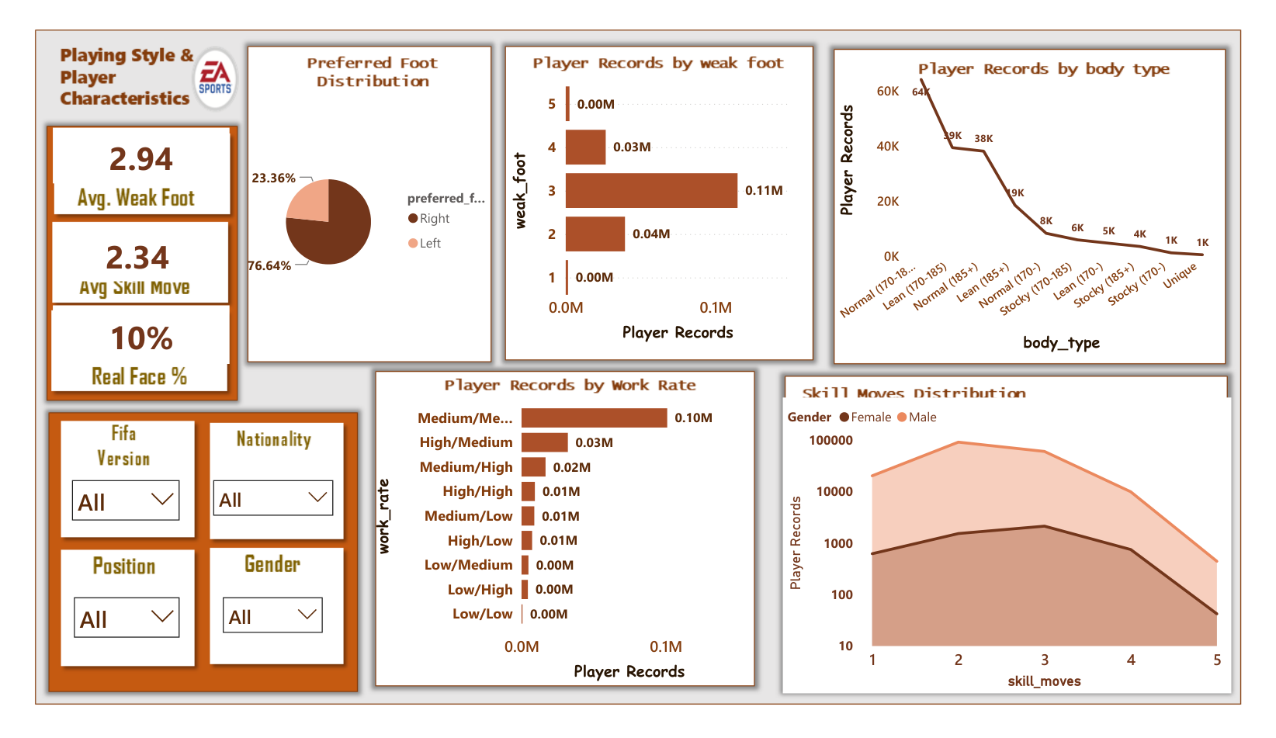
Figure 8. Playing Style & Characteristics — supplied dashboard PDF, page 8.
The preferred-foot chart shows 76.64% right-footed and 23.36% left-footed records. Right-footed records therefore outnumber left-footed ones by about 3.3 to 1. Average weak foot is 2.94 and average skill moves is 2.34. These are separate game characteristics: a player can be comfortable using their weaker foot without having a high skill-move rating.
The preferred-foot finding is a strong descriptive result for this dataset. It should not be presented as a measured worldwide proportion of professional players without an independent population study.

7.8 Position Suitability — why the role matters
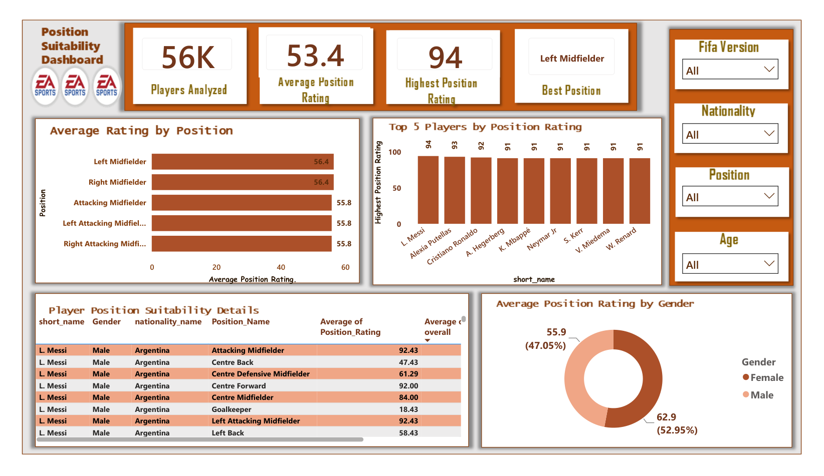
Figure 9. Position Suitability — supplied dashboard PDF, page 9.
The average displayed position suitability rating is 53.4, with a highest rating of 94. Left and right midfielder both appear at around 56.4, while attacking midfield positions are near 55.8. The displayed differences are small, and these averages should not be read as a ranking of which football position is “best”.
This is where the report’s design is particularly useful. By turning position columns into rows, it becomes possible to compare a player across roles. The real-match studies [R2, R3] also emphasize positional context, although their measurements and methods are different from game ratings.

7.9 Player Profile — the example that brings the story together
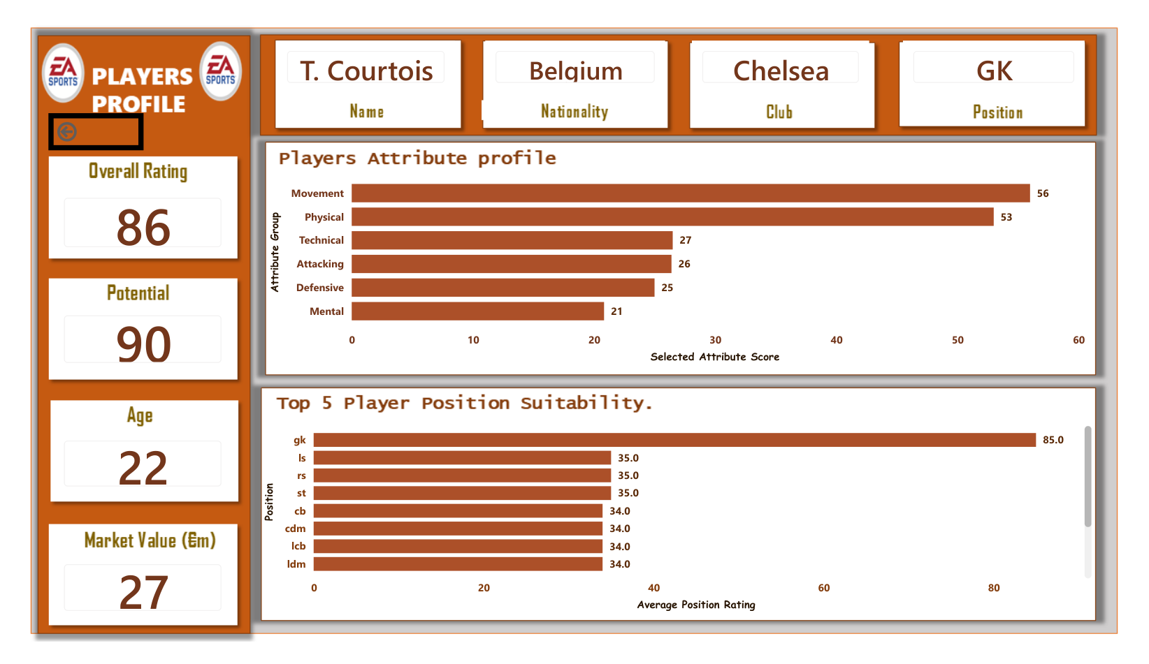
Figure 10. Historical Courtois player profile — supplied dashboard PDF, page 10.
The selected historical Thibaut Courtois profile shows age 22, Chelsea, overall rating 86, potential 90 and market value €27m. His goalkeeper suitability is 85, while centre-back suitability is 34 and left-striker suitability is about 35. The goalkeeper-to-centre-back gap is 51 points.
This is the most memorable result in the project. It does not say Courtois is a poor footballer; it says the same player is rated very differently depending on the job. That is exactly why the dashboard goes beyond overall rating.
Same player. Different position. A 51-point difference.

8. Discussion: how our results compare with the literature
Theme | Our dashboard finding | What research adds
Position | Courtois 85 GK vs 34 CB; role averages differ | Match studies find position-specific performance patterns [R2, R3]
Attributes | Passing 68; shooting 52 in displayed averages | Player assessment uses many static and dynamic attributes [R1]
Potential | Average 71 vs overall 66 | Future performance is hard to predict reliably [R4]
Gender coverage | Edition and financial coverage differ | EA added women’s teams and leagues over time [R5, R6]

The comparisons above are agreements in direction or useful context, not statistical replication. Published studies use actual match actions, tracking data or assessment experiments; this dashboard uses EA game ratings. It would be incorrect to claim the project proves the same effects in professional match performance.

9. Limitations and quality checks
- Player counts may represent player-edition records rather than distinct footballers.
- Several charts pool multiple FIFA editions; summed values across editions are not current valuations.
- Some gender and coach percentages need their exact measures and denominators checked.
- Game ratings are editorial/game-model estimates, not directly observed real-match outcomes.
- Some financial and attribute fields may be missing, especially across editions and groups.
- The Player Intelligence scatter axis and market-value sum should be corrected or clearly relabeled.
- The PDF shows dashboard output, not complete DAX definitions or Power Query history.

10. Recommendations

10.1 Improvements to the existing report
- Create separate, clearly labeled measures for distinct players and player-edition records.
- Make the FIFA edition slicer prominent on value, wage and gender comparison pages.
- Replace summed multi-edition market value with a selected-edition value or a true time trend.
- Check scatter-chart aggregation and axes; avoid misleading 1,000-point rating scales.
- Add sample sizes and missing-value coverage alongside gender and attribute averages.
- Show exact coach and gender measure definitions in a report glossary.
- Test all drillthrough fields and confirm they preserve the correct player-edition context.

10.2 Further analysis
- Compare players within similar roles, not only across the full dataset.
- Track how the same player’s overall, potential and attributes change between editions.
- Study which attributes contribute most to positional suitability using clearly documented methods.
- Where possible, validate game ratings against independent match-event or tracking data.
- Build a dedicated data-quality page showing missingness, duplicate keys and coverage by edition.

11. Conclusion
I began this project thinking about player ratings. The dashboard helped me see why a single number can be useful and still be incomplete. It showed where player records are concentrated, how average potential differs from current rating, how playing characteristics vary, and why a player’s role changes the meaning of a score.
The Courtois example made the lesson easy to understand: 85 for goalkeeper suitability and 34 for centre-back suitability in the selected historical record. The difference is not a contradiction; it reflects the importance of position. Published football analytics research points in a similar direction by showing that player assessment is multidimensional and role-dependent, although the research uses different data from this project.
For me, the biggest achievement was not a single chart. It was building a report that lets someone move from a broad question to a specific player and then ask better questions about the data. The next stage is to strengthen the technical audit trail and refine the measures that could mislead when editions are combined.
Good data analysis is not only about finding the highest number. It is about understanding what that number means.

References and further reading
[R1] Wakelam, E., Steuber, V., & Wakelam, J. (2022). The collection, analysis and exploitation of footballer attributes: A systematic review. Journal of Sports Analytics.
https://doi.org/10.3233/JSA-200554
[R2] Forcher, L., et al. (2022). Does technical match performance in professional soccer depend on the positional role or the individuality of the player?
https://pmc.ncbi.nlm.nih.gov/articles/PMC9197445/
[R3] The influence of playing position on the physical, technical, and network variables of sub-elite professional soccer athletes (2020/2021). Human Movement.
https://doi.org/10.5114/hm.2020.100010
[R4] Examining the reliability and predictive validity of performance assessments by soccer coaches and scouts (2022). Psychology of Sport and Exercise.
https://www.sciencedirect.com/science/article/pii/S146902922200125X
[R5] Electronic Arts (2015). Women’s National Teams Take the Pitch in EA SPORTS FIFA 16.
https://news.ea.com/press-releases/press-releases-details/2015/Womens-National-Teams-Take-the-Pitch-in-EA-SPORTS-FIFA-16/default.aspx
[R6] EA SPORTS (2023). FC 24 Ultimate Team Deep Dive: Women’s Football in Ultimate Team.
https://www.ea.com/games/ea-sports-fc/pitch-notes/news/fc-24-ultimate-team-deep-dive

Appendix A. Evidence and reproducibility checklist
Item | Status
Dashboard screenshots (10 PDF pages) | Included
Actual Model View screenshot | Included
Final Power Query Applied Steps | Not supplied — add screenshot
Final DAX measures | Not supplied — verify and add
Dataset source and license | Not supplied — add URL
PBIX / GitHub / public dashboard link | Add before publishing
Measure audit (counts, wages, gender shares) | Recommended before publication

Appendix B. Suggested repository structure
- README.md — project overview, questions, screenshots and findings
- data_dictionary.md — field meanings, units and missing-value rules
- model/ — model screenshot and relationship notes
- measures/ — verified DAX definitions
- images/ — dashboard screenshots
- report/ — PBIX or published report link, subject to sharing permissions
- documentation/ — this report and presentation
Document note: this report is based on the supplied dashboard PDF and Model View screenshot, plus the external research listed above. It deliberately distinguishes observed dashboard values from research context and items requiring PBIX verification.

