A Perspective on Explanations of Molecular

Prediction Models

 [Geemi P. Wellawatte,](https://orcid.org/0000-0002-3772-6927)†  [Heta A. Gandhi,](https://orcid.org/0000-0002-9465-3840)‡  [Aditi Seshadri,](https://orcid.org/0000-0001-6362-1371)‡ and  [Andrew](https://orcid.org/0000-0002-6647-3965) [D. White](https://orcid.org/0000-0002-6647-3965)∗,‡



†Department of Chemistry, University of Rochester, Rochester, NY, 14627

‡Department of Chemical Engineering, University of Rochester, Rochester, NY, 14627

¶Vial Health Technology, Inc., San Francisco, CA 94111

E-mail: <andrew.white@rochester.edu>

Abstract

Chemists can be skeptical in using deep learning (DL) in decision making, due to the lack of interpretability in “black-box” models. Explainable artificial intelligence (XAI) is a branch of AI which addresses this drawback by providing tools to interpret DL models and their predictions. We review the principles of XAI in the domain of chemistry and emerging methods for creating and evaluating explanations. Then we focus on methods developed by our group and their applications in predicting solubil-ity, blood-brain barrier permeability, and the scent of molecules. We show that XAI methods like chemical counterfactuals and descriptor explanations can explain DL pre-dictions while giving insight into structure-property relationships. Finally, we discuss how a two-step process of developing a black-box model and explaining predictions can uncover structure-property relationships.

1

Introduction

Deep learning (DL) is advancing the boundaries of computational chemistry because it can accurately model non-linear structure-function relationships.1–3 Applications of DL can be found in a broad spectrum spanning from quantum computing4,5 to drug discovery6–10 to materials design.11,12 According to Kre 13 , DL models can contribute to scientific discovery in three “dimensions” - 1) as a ‘computational microscope’ to gain insight which are not attainable through experiments 2) as a ‘resource of inspiration’ to motivate scientific thinking 3) as an ‘agent of understanding’ to uncover new observations. However, the rationale of a DL prediction is not always apparent due to the model architecture consisting a large parameter count.14,15 DL models are thus often termed“black box” models. We can only reason about the input and output of an DL model, not the underlying cause that leads to a specific prediction.

It is routine in chemistry now for DL to exceed human level performance — humans are not good at predicting solubility from structure for example161 — and so understanding how a model makes predictions can guide hypotheses. This is in contrast to a topic like finding a stop sign in an image, where there is little new to be learned about visual perception by explaining a DL model. However, the black box nature of DL has its own limitations. Users are more likely to trust and use predictions from a model if they can understand why the prediction was made.17 Explaining predictions can help developers of DL models ensure the model is not learning spurious correlations.18,19 Two infamous examples are, 1)neural networks that learned to recognize horses by looking for a photographer’s watermark20 and,

1. neural networks that predicted a COVID-19 diagnoses by looking at the font choice on medical images.21 As a result, there is an emerging regulatory framework for when any computer algorithms impact humans.22–24 Although we know of no examples yet in chemistry, one can assume the use of AI in predicting toxicity, carcinogenicity, and environmental persistence will require rationale for the predictions due to regulatory consequences.

* there does happen to be one human solubility savant, participant 11, who matched machine performance

2

EXplainable Artificial Intelligence (XAI) is a field of growing importance that aims to provide model interpretations of DL predictions Three terms highly associated with XAI are, interpretability, justifications and explainability. Miller25 defines that interpretability of a model refers to the degree of human understandability intrinsic within the model. Murdoch et al. 26 clarify that interpretability can be perceived as “knowledge” which provide insight to a particular problem. Justifications are quantitative metrics tell the users “why the model should be trusted,” like test error.27 Justifications are evidence which defend why a prediction is trustworthy.25 An “explanation” is a description on why a certain prediction was made.9,28 Interpretability and explanation are often used interchangeably. Arrieta et al. 14 distinguish that interpretability is a passive characteristic of a model, whereas explainability is an active characteristic which is used to clarify the internal decision-making process. Namely, an explanation is extra information that gives the context and a cause for one or more predictions.29 We adopt the same nomenclature in this perspective.

Accuracy and interpretability are two attractive characteristics of DL models. However, DL models are often highly accurate and less interpretable.28,30 XAI provides a way to avoid that trade-off in chemical property prediction. XAI can be viewed as a two-step process. First, we develop an accurate but uninterpretable DL model. Next, we add explanations to predictions. Ideally, if the DL model has correctly learned the input-output relations, then the explanations should give insight into the underlying mechanism.

In the remainder of this article, we review recent approaches for XAI of chemical property prediction while drawing specific examples from our recent XAI work.9,10,31 We show how in various systems these methods yield explanations that are consistent with known and mechanisms in structure-property relationships.

3

Theory

In this work, we aim to assemble a common taxonomy for the landscape of XAI while providing our perspectives. We utilized the vocabulary proposed by Das and Rad 32 to classify XAI. According to their classification, interpretations can be categorized as global or local interpretations on the basis of “what is being explained?”. For example, counterfactuals are local interpretations, as these can explain only a given instance. The second classification is based on the relation between the model and the interpretation – is interpretability post-hoc (extrinsic) or intrinsic to the model?.32,33 An intrinsic XAI method is part of the model and is self-explanatory32 These are also referred to as white-box models to contrast them with non-interpretable black box models.28 An extrinsic method is one that can be applied post-training to any model.33 Post-hoc methods found in the literature focus on interpreting models through 1) training data34 and feature attribution,35 2) surrogate models10 and, 3) counterfactual9 or contrastive explanations.36

Often, what is a “good” explanation and what are the required components of an ex-planation are debated.32,37,38 Palacio et al. 29 state that the lack of a standard framework has caused the inability to evaluate the interpretability of a model. In physical sciences, we may instead consider if the explanations somehow reflect and expand our understanding of physical phenomena. For example, Oviedo et al. 39 propose that a model explanation can be evaluated by considering its agreement with physical observations, which they term “correctness.” For example, if an explanation suggests that polarity affects solubility of a molecule, and the experimental evidence strengthen the hypothesis, then the explanation is assumed “correct”. In instances where such mechanistic knowledge is sparse, expert bi-ases and subjectivity can be used to measure the correctness.40 Other similar metrics of correctness such as “explanation satisfaction scale” can be found in the literature.41,42 In a recent study, Humer et al. 43 introduced CIME an interactive web-based tool that allows the users to inspect model explanations. The aim of this study is to bridge the gap between analysis of XAI methods. Based on the above discussion, we identify that an agreed upon

4

evaluation metric is necessary in XAI. We suggest the following attributes can be used to evaluate explanations. However, the relative importance of each attribute may depend on the application - actionability may not be as important as faithfulness when evaluating the interpretability of a static physics based model. Therefore, one can select relative importance of each attribute based on the application.

* Actionable. Is it clear how we could change the input features to modify the output?
* Complete. Does the explanation completely account for the prediction? Did features not included in the explanation really contribute zero effect to the prediction?44
* Correct. Does the explanation agree with hypothesized or known underlying physical mechanism?39
* Domain Applicable. Does the explanation use language and concepts of domain ex-perts?
* Fidelity/Faithful. Does the explanation agree with the black box model?
* Robust. Does the explanation change significantly with small changes to the model or instance being explained?
* Sparse/Succinct. Is the explanation succinct?

We present an example evaluation of the SHAP explanation method based on the above attributes.44 Shapley values were proposed as a local explanation method based on feature attribution, as they offer a complete explanation - each feature is assigned a fraction of the prediction value.44,45 Completeness is a clearly measurable and well-defined metric, but yields explanations with many components. Yet Shapley values are not actionable nor sparse. They are non-sparse as every feature has a non-zero attribution and not-actionable because they do not provide a set of features which changes the outcome.46 Ribeiro et al. 35 proposed a surrogate model method that aims to provide sparse/succinct explanations that have high

5

fidelity to the original model. In Wellawatte et al.9 we argue that counterfactuals are “bet-ter” explanations because they are actionable and sparse. We highlight that, evaluation of explanations is a difficult task because explanations are fundamentally for and by humans. Therefore, these evaluations are subjective, as they depend on “complex human factors and application scenarios.”37

Self-explaining models

A self-explanatory model is one that is intrinsically interpretable to an expert.47 Two com-mon examples found in the literature are linear regression models and decision trees (DT). Intrinsic models can be found in other XAI applications acting as surrogate models (proxy models) due to their transparent nature.48,49 A linear model is described by the equation 1 where, W ’s are the weight parameters and x’s are the input features associated with the prediction yˆ. Therefore, we observe that the weights can be used to derive a complete expla-nation of the model - trained weights quantify the importance of each feature.47 DT models are another type of self-explaining models which have been used in classification and high-throughput screening tasks. Gajewicz et al. 50 used DT models to classify nanomaterials that identify structural features responsible for surface activity. In another study by Han et al. 51 , a DT model was developed to filter compounds by their bioactivity based on the chemical fingerprints.

|  |  |
| --- | --- |
| yˆ = ΣiWixi | (1) |

Regularization techniques such as EXPO52 and RRR53 are designed to enhance the black-box model interpretability.54 Although one can argue that “simplicity” of models are posi-tively correlated with interpretability, this is based on how the interpretability is evaluated. For example, Lipton 55 argue that, from the notion of “simulatability” (the degree to which a human can predict the outcome based on inputs), self-explanatory linear models, rule-based

6

systems, and DT’s can be claimed uninterpretable. A human can predict the outcome given the inputs only if the input features are interpretable. Therefore, a linear model which takes in non-descriptive inputs may not be as transparent. On the other hand, a linear model is not innately accurate as they fail to capture non-linear relationships in data, limiting is applicability. Similarly, a DT is a rule-based model and lacks physics informed knowledge. Therefore, an existing drawback is the trade-off between the degree of understandability and the accuracy of a model. For example, an intrinsic model (linear regression or decision trees) can be described through the trainable parameters, but it may fail to “correctly” capture non-linear relations in the data.

Attribution methods

Feature attribution methods explain black box predictions by assigning each input feature a numerical value, which indicates its importance or contribution to the prediction. Feature attributions provide local explanations, but can be averaged or combined to explain multi-ple instances. Atom-based numerical assignments are commonly referred to as heatmaps.56 Sheridan 57 describes an atom-wise attribution method for interpreting QSAR models. Re-cently, Rasmussen et al. 58 showed that Crippen logP models serve as a benchmark for heatmap approaches. Other most widely used feature attribution approaches in the litera-ture are gradient based methods,59,60 Shapley Additive exPlanations (SHAP),44 and layer-wise relevance prorogation.61

Gradient based approaches are based on the hypothesis that gradients for neural net-works are analogous to coefficients for regression models62. Class activation maps (CAM),63 gradCAM,64 smoothGrad,,65 and integrated gradients62 are examples of this method. The main idea behind feature attributions with gradients can be represented with equation 2.

|  |  |  |  |  |  |
| --- | --- | --- | --- | --- | --- |
| ∆fˆ(⃗x) | | ≈ | ∂fˆ(⃗x) | (2) |  |
| ∆xi |  | ∂xi |  |

7

∆xi

∆fˆ(⃗x)

where fˆ(x) is the black-box model and are used as our attributions. The left-

hand side of equation 2 says that we attribute each input feature xi by how much one unit change in it would affect the output of fˆ(x). If fˆ(x) is a linear surrogate model, then this method reconciles with LIME.35 In DL models, ∇xf(x), suffers from the shattered gradients problem.62 This means directly computing the quantity leads to numeric problems. The different gradient based approaches are mostly distinguishable based on how the gradient is approximated.

Gradient based explanations have been widely used to interpret chemistry predictions.60,66–70 McCloskey et al. 60 used graph convolutional networks (GCNs) to predict protein-ligand binding and explained the binding logic for these predictions using integrated gradients. Pope et al. 66 and Jim´enez-Luna et al. 67 show application of gradCAM and integrated gradi-ents to explain molecular property predictions from trained graph neural networks (GNNs). Sanchez-Lengeling et al. 68 present comprehensive, open-source XAI benchmarks to explain GNNs and other graph based models. They compare the performance of class activation maps (CAM),63 gradCAM,64 smoothGrad,,65 integrated gradients62 and attention mecha-nisms for explaining outcomes of classification as well as regression tasks. They concluded that CAM and integrated gradients perform well for graph based models. Another attempt at creating XAI benchmarks for graph models was made by Rao et al. 70 . They compared these gradient based methods to find subgraph importance when predicting activity cliffs and concluded that gradCAM and integrated gradients provided the most interpretability for GNNs. The GNNExplainer69 is an approach for generating explanations (local and global) for graph based models. This method focuses on identifying which sub-graphs con-tribute most to the prediction by maximizing mutual information between the prediction and distribution of all possible sub-graphs. Ying et al. 69 show that GNNExplainer can be used to obtain model-agnostic explanations. SubgraphX is a similar method that explains GNN predictions by identifying important subgraphs.71

Another set of approaches like DeepLIFT72 and Layerwise Relevance backPropagation73

8

(LRP) are based on backpropagation of the prediction scores through each layer of the neu-ral network. The specific backpropagation logic across various activation functions differs in these approaches, which means each layer must have its own implementation. Baldas-sarre and Azizpour 74 showed application of LRP to explain aqueous solubility prediction for molecules.

SHAP is a model-agnostic feature attribution method that is inspired from the game theory concept of Shapley values.44,46 SHAP has been popularly used in explaining molecular prediction models.75–78 It’s an additive feature contribution approach, which assumes that an explanation model is a linear combination of binary variables z. If the Shapley value for the ith feature is ϕi, then the explanation is fˆ(⃗x) = i ϕi(⃗x)zi(⃗x). Shapley values for features are computed using Equation 3.79,80

|  |  |  |  |  |
| --- | --- | --- | --- | --- |
|  | 1 | M |  |  |
| ϕi(⃗x) = |  | fˆ(⃗z+i) − fˆ(⃗z−i) | (3) |  |
| M |  |

Here ⃗z is a fabricated example created from the original ⃗x and a random perturbation ⃗x′. ⃗z+i has the feature i from ⃗x and ⃗z−i has the ith feature from ⃗x′. Some care should be taken in constructing ⃗z when working with molecular descriptors to ensure that an impossible ⃗z is not sampled (e.g., high count of acid groups but no hydrogen bond donors). M is the sample size of perturbations around ⃗x. Shapley value computation is expensive, hence M is chosen accordingly. Equation 3 is an approximation and gives contributions with an expectation term as ϕ0 + i=1 ϕi(⃗x) = fˆ(⃗x).

Visualization based feature attribution has also been used for molecular data. In com-puter science, saliency maps are a way to measure spatial feature contribution.81 Simply put, saliency maps draw a connection between the model’s neural fingerprint components (trained weights) and input features. Weber et al. 82 used saliency maps to build an explainable GCN architecture that gives subgraph importance for small molecule activity prediction. On the other hand, similarity maps compare model predictions for two or more molecules based on their chemical fingerprints.83 Similarity maps provide atomic weights or predicted probabil-

9

ity difference between the molecules by removing one atom at a time. These weights can then be used to color the molecular graph and give a visual presentation. ChemInformatics Model Explorer (CIME) is an interactive web based toolkit which allows visualization and comparison of different explanation methods for molecular property prediction models.84

Surrogate models

One approach to explain black box predictions is to fit a self-explaining or interpretable model to the black box model, in the vicinity of one or a few specific examples. These are known as surrogate models. Generally, one model per explanation is trained. However, if we could find one surrogate model that explained the whole DL model, then we would simply have a globally accurate interpretable model. This means that the black-box model is no longer needed.79 In the work by White 79 , a weighted least squares linear model is used as the surrogate model. This model provides natural language based descriptor explanations by replacing input features with chemically interpretable descriptors. This approach is similar to the concept-based explanations approach used by McGrath et al. 85 , where human under-standable concepts were used in place of input features in acquisition of chess knowledge in AlphaZero. Any of the self-explaining models detailed in the Self-explaining models section can be used as a surrogate model.

The most commonly used surrogate model based method is Locally Interpretable Model Explanations (LIME).35 LIME creates perturbations around the example of interest and fits an interpretable model to these local perturbations. Ribeiro et al. 35 mathematically define an explanation ξ for an example ⃗x using Equation 4.

|  |  |  |  |  |  |  |  |  |
| --- | --- | --- | --- | --- | --- | --- | --- | --- |
| ξ ⃗x | ) = arg | min | | | L | (f, g, π ) + Ω(g) | (4) |  |
| ( | g | ∈ | G | x |  |  |
|  |  |  |  |  |  |  |  |

Here f is the black box model and g ∈ G is the interpretable explanation model. G is a class of potential interpretable models (e.g.: linear models). πx is a similarity measure

10

between original input ⃗x and it’s perturbed input ⃗x′. In context of molecular data, this can be a chemical similarity metric like Tanimoto86 similarity between fingerprints. The goal for LIME is to minimize the loss, L, such that f is closely approximated by g. Ω is a parameter that controls the complexity (sparsity) of g. Ribeiro et al. 35 termed the agreement (how low the loss is) between f and g as the “fidelity”.

GraphLIME87 and LIMEtree88 are modifications to LIME as applicable to graph neural networks and regression trees, respectively. LIME has been used in chemistry previously, such as Whitmore et al. 89 who used LIME to explain octane number predictions of molecules from a random forest classifier. Mehdi and Tiwary90 used LIME to explain thermodynamic contributions of features. Gandhi and White 10 use an approach similar to GraphLIME, but use chemistry specific fragmentation and descriptors to explain molecular property pre-diction. Some examples are highlighted in the Applications section. In recent work by Mehdi and Tiwary 90 , a thermodynamic-based surrogate model approach was used to inter-pret black-box models. The authors define an “interpretation free energy” which can be achieved by minimizing the surrogate model’s uncertainty and maximizing simplicity.

Counterfactual explanations

Counterfactual explanations can be found in many fields such as statistics, mathematics and philosophy.91–94 According to Woodward and Hitchcock 92 , a counterfactual is an example with minimum deviation from the initial instance but with a contrasting outcome. They can be used to answer the question, “which smallest change could alter the outcome of an instance of interest?” While the difference between the two instances is based on the exis-tence of similar worlds in philosophy,95 a distance metric based on molecular similarity is employed in XAI for chemistry. For example, in the work by Wellawatte et al. 9 distance between two molecules is defined as the Tanimoto distance96 between ECFP4 fingerprints.97 Additionally, Mohapatra et al. 98 introduced a chemistry-informed graph representation for computing macromolecular similarity. Contrastive explanations are peripheral to counterfac-

11

tual explanations. Unlike the counterfactual approach, contrastive approach employ a dual optimization method, which works by generating a similar and a dissimilar (counterfactuals) example. Contrastive explanations can interpret the model by identifying contribution of presence and absence of subsets of features towards a certain prediction.36,99

A counterfactual x′ of an instance x is one with a dissimilar prediction fˆ(x) in classi-fication tasks. As shown in equation 5, counterfactual generation can be thought of as a constrained optimization problem which minimizes the vector distance d(x, x′) between the features.9,100

|  |  |
| --- | --- |
| minimize | d(x, x′) |
|  | (5) |
| such that | fˆ(x) ̸= fˆ(x′) |

For regression tasks, equation 6 adapted from equation 5 can be used. Here, a counter-factual is one with a defined increase or decrease in the prediction.

minimize d(x, x′)

(6)

such that fˆ(x) − fˆ(x′) ≥ ∆

Counterfactuals explanations have become a useful tool for XAI in chemistry, as they provide intuitive understanding of predictions and are able to uncover spurious relationships in training data.101 Counterfactuals create local (instance-level), actionable explanations. Actionability of an explanation suggest which features can be altered to change the outcome. For example, changing a hydrophobic functional group in a molecule to a hydrophilic group to increase solubility.

Counterfactual generation is a demanding task as it requires gradient optimization over discrete features that represents a molecule. Recent work by Fu et al. 102 and Shen et al. 103 present two techniques which allow continuous gradient-based optimization. Although, these methodologies are shown to circumvent the issue of discrete molecular optimization, counter-factual explanation based model interpretation still remains unexplored compared to other

12

post-hoc methods.

CF-GNNExplainer104 is a counterfactual explanation generating method based on GN-NExplainer69 for graph data. This method generate counterfactuals by perturbing the input data (removing edges in the graph), and keeping account of perturbations which lead to changes in the output. However, this method is only applicable to graph-based models and can generate infeasible molecular structures. Another related work by Numeroso and Bacciu 105 focus on generating counterfactual explanations for deep graph networks. Their method MEG (Molecular counterfactual Explanation Generator) uses a reinforcement learn-ing based generator to create molecular counterfactuals (molecular graphs). While this method is able to generate counterfactuals through a multi-objective reinforcement learner, this is not a universal approach and requires training the generator for each task.

Work by Wellawatte et al. 9 present a model agnostic counterfactual generator MMACE (Molecular Model Agnostic Counterfactual Explanations) which does not require training or computing gradients. This method firstly populates a local chemical space through ran-dom string mutations of SELFIES106 molecular representations using the STONED algo-rithm.107 Next, the labels (predictions) of the molecules in the local space are generated using the model that needs to be explained. Finally, the counterfactuals are identified and sorted by their similarities – Tanimoto distance96 between ECFP4 fingerprints.97 Unlike the CF-GNNExplainer104 and MEG105 methods, the MMACE algorithm ensures that generated molecules are valid, owing to the surjective property of SELFIES. Additionally, the MMACE method can be applied to both regression and classification models. However, like most XAI methods for molecular prediction, MMACE does not account for the chemical stability of predicted counterfactuals. To circumvent this drawback, Wellawatte et al. 9 propose an-other approach, which identift counterfactuals through a similarity search on the PubChem database.108

13

Similarity to adjacent fields

Tangential examples to counterfactual explanations are adversarial training and matched molecular pairs. Adversarial perturbations are used during training to deceive the model to expose the vulnerabilities of a model109,110 whereas counterfactuals are applied post-hoc. Therefore, the main difference between adversarial and counterfactual examples are in the application, although both are derived from the same optimization problem.100 Grabocka et al. 111 have developed a method named Adversarial Training on EXplanations (ATEX) which improves model robustness via exposure to adversarial examples. While there are conceptual disparities, we note that the counterfactual and adversarial explanations are equivalent mathematical objects.

Matched molecular pairs (MMPs) are pairs of molecules that differ structurally at only one site by a known transformation.112,113 MMPs are widely used in drug discovery and medicinal chemistry as these facilitate fast and easy understanding of structure-activity re-lationships.114–116 Counterfactuals and MMP examples intersect if the structural change is associated with a significant change in the properties. In the case the associated changes in the properties are non-significant, the two molecules are known as bioisosteres.117,118 The con-nection between MMPs and adversarial training examples has been explored by van Tilborg et al. 119 . MMPs which belong to the counterfactual category are commonly used in outlier and activity cliff detection.113 This approach is analogous to counterfactual explanations, as the common objective is to uncover learned knowledge pertaining to structure-property relationships.70

Applications

Model interpretation is certainly not new and a common step in ML in chemistry, but XAI for DL models is becoming more important60,66–69,73,88,104,105 Here we illustrate some practical examples drawn from our published work on how model-agnostic XAI can be utilized to

14

interpret black-box models and connect the explanations to structure-property relationships. The methods are “Molecular Model Agnostic Counterfactual Explanations” (MMACE)9 and “Explaining molecular properties with natural language”.10 Then we demonstrate how counterfactuals and descriptor explanations can propose structure-property relationships in the domain of molecular scent.31

Blood-brain barrier permeation prediction

The passive diffusion of drugs from the blood stream to the brain is a critical aspect in drug development and discovery.120 Small molecule blood-brain barrier (BBB) permeation is a classification problem routinely assessed with DL models.121,122 To explain why DL models work, we trained two models a random forest (RF) model123 and a Gated Recurrent Unit Recurrent Neural Network (GRU-RNN). Then we explained the RF model with generated counterfactuals explanations using the MMACE9 and the GRU-RNN with descriptor expla-nations.10 Both the models were trained on the dataset developed by Martins et al. 124 . The RF model was implemented in Scikit-learn125 using Mordred molecular descriptors126 as the input features. The GRU-RNN model was implemented in Keras.127 See Wellawatte et al. 9 and Gandhi and White 10 for more details.

According to the counterfactuals of the instance molecule in figure 1, we observe that the modifications to the carboxylic acid group enable the negative example molecule to permeate the BBB. Experimental findings by Fischer et al.120 show that the BBB permeation of molecules are governed by hydrophobic interactions and surface area. The carboxylic group is a hydrophilic functional group which hinders hydrophobic interactions and addition of atoms enhances the surface area. This proves the advantage of using counterfactual explanations, as they suggest actionable modification to the molecule to make it cross the BBB.

In Figure 2 we show descriptor explanations generated for Alprozolam, a molecule that permeates the BBB, using the method described by Gandhi and White 10 . We see that predicted permeability is positively correlated with the aromaticity of the molecule, while

15

negatively correlated with the number of hydrogen bonds donors and acceptors. A similar structure-property relationship for BBB permeability is proposed in more mechanistic stud-ies.128–130 The substructure attributions indicates a reduction in hydrogen bond donors and acceptors. These descriptor explanations are quantitative and interpretable by chemists. Finally, we can use a natural language model to summarize the findings into a written explanation, as shown in the printed text in Figure 2.

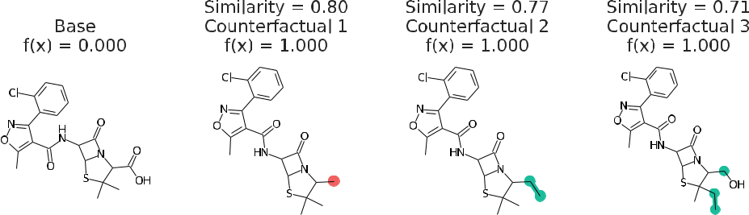

Figure 1: Counterfactuals of a molecule which cannot permeate the blood-brain barrier. Similarity is the Tanimoto similarity of ECFP4 fingerprints.131 Red indicates deletions and green indicates substitutions and addition of atoms. Republished from Ref.9 with permission from the Royal Society of Chemistry.

Solubility prediction

Small molecule solubility prediction is a classic cheminformatics regression challenge and is important for chemical process design, drug design and crystallization.133–136 In our previous works,9,10 we implemented and trained an RNN model in Keras to predict solubilities (log molarity) of small molecules.127 The AqSolDB curated database137 was used to train the RNN model.

In this task, counterfactuals are based on equation 6. Figure 3 illustrates the generated local chemical space and the top four counterfactuals. Based on the counterfactuals, we ob-serve that the modifications to the ester group and other heteroatoms play an important role in solubility. These findings align with known experimental and basic chemical intuition.134 Figure 4 shows a quantitative measurement of how substructures are contributing to the pre-

16

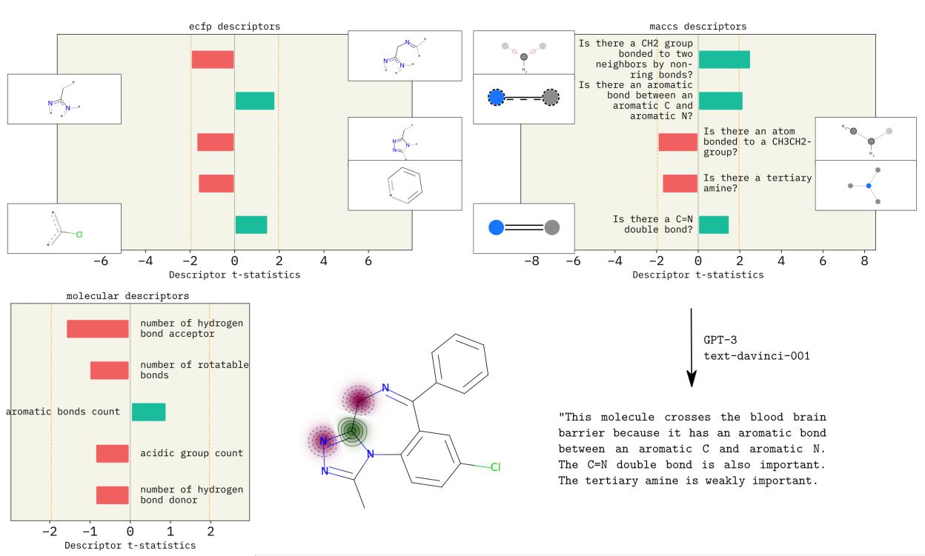

Figure 2: Descriptor explanations along with natural language explanation obtained for BBB permeability of Alprozolam molecule. The green and red bars show descriptors that influ-ence predictions positively and negatively, respectively. Dotted yellow lines show significance threshold (α = 0.05) for the t-statistic. Molecular descriptors show molecule-level proper-ties that are important for the prediction. ECFP and MACCS descriptors indicate which substructures influence model predictions. MACCS explanations lead to text explanations as shown. Republished from Ref.10 with permission from authors. SMARTS annotations for MACCS descriptors were created using SMARTSviewer (smartsview.zbh.uni-hamburg.de, Copyright: ZBH, Center for Bioinformatics Hamburg) developed by Schomburg et al. 132 .

17

diction. For example, we see that adding acidic and basic groups as well as hydrogen bond

acceptors, increases solubility. Substructure importance from ECFP97 and MACCS138 de-

scriptors indicate that adding heteroatoms increases solubility, while adding rings structures

makes the molecule less soluble. Although these are established hypotheses, it is interesting

to see they can be derived purely from the data via DL and XAI.

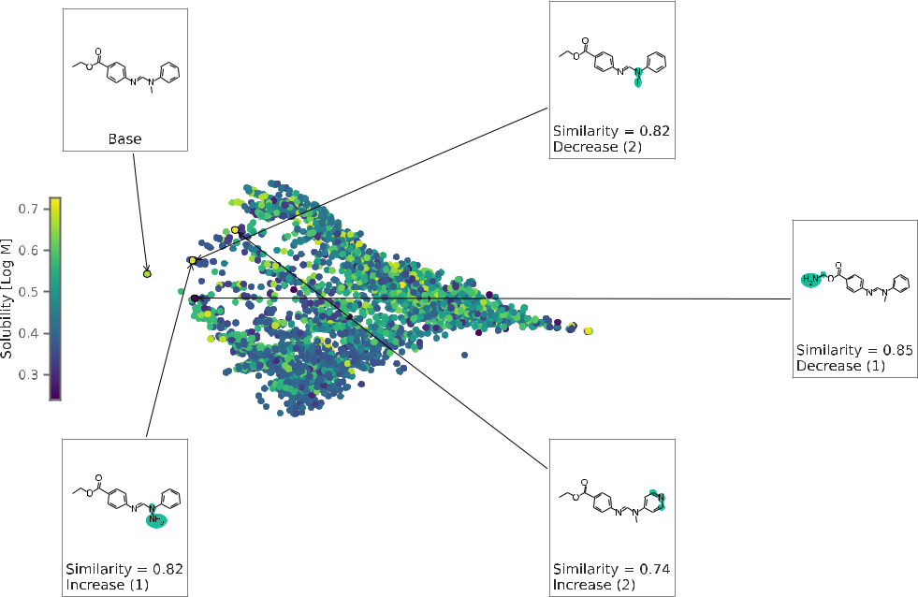

Figure 3: Generated chemical space for solubility prediction using the RNN model. The chemical space is a 2D projection of the pairwise Tanimoto similarities of the local coun-terfactuals. Each data point is colored by solubility. Top 4 counterfactuals are shown here. Republished from Ref.9 with permission from the Royal Society of Chemistry.

Generalizing XAI – interpreting scent-structure relationships

In this example, we show how non-local structure-property relationships can be learned with

XAI across multiple molecules. Molecular scent prediction is a multi-label classification task

because a molecule can be described by more than one scent. For example, the molecule

jasmone can be described as having ‘jasmine,’ ‘woody,’ ‘floral,’ and ’herbal’ scents.139 The

scent-structure relationship is not very well understood,140 although some relationships are

known. For example, molecules with an ester functional group are often associated with

18

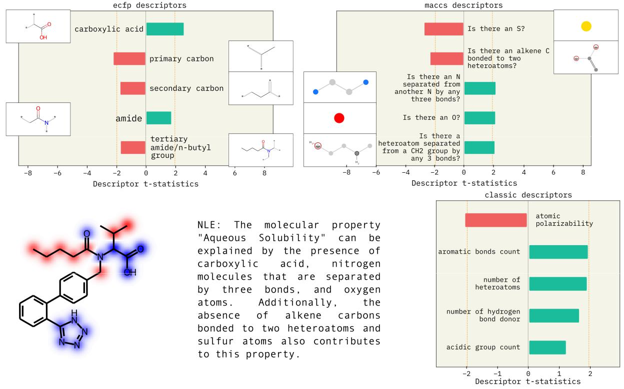

Figure 4: Descriptor explanations for solubility prediction model. The green and red bars show descriptors that influence predictions positively and negatively, respectively. Dotted yellow lines show significance threshold (α = 0.05) for the t-statistic. The MACCS and ECFP descriptors indicate which substructures influence model predictions. MACCS sub-structures may either be present in the molecule as is or may represent a modification. ECFP fingerprints are substructures in the molecule that affect the prediction. MACCS descriptor are used to obtain text explanations as shown. Republished from Ref.10 with permission from authors. SMARTS annotations for MACCS descriptors were created using SMARTSviewer (smartsview.zbh.uni-hamburg.de, Copyright: ZBH, Center for Bioinformatics Hamburg) de-veloped by Schomburg et al. 132 .

19

the ‘fruity’ scent. There are some exceptions though, like tert-amyl acetate which has a ‘camphoraceous’ rather than ‘fruity’ scent.140,141

In Seshadri et al. 31 , we trained a GNN model to predict the scent of molecules and utilized counterfactuals9 and descriptor explanations10 to quantify scent-structure relationships. The MMACE method was modified to account for the multi-label aspect of scent prediction. This modification defines molecules that differed from the instance molecule by only the selected scent as counterfactuals. For instance, counterfactuals of the jasmone molecule would be false for the ‘jasmine’ scent but would still be positive for ‘woody,’ ‘floral’ and ‘herbal’ scents.

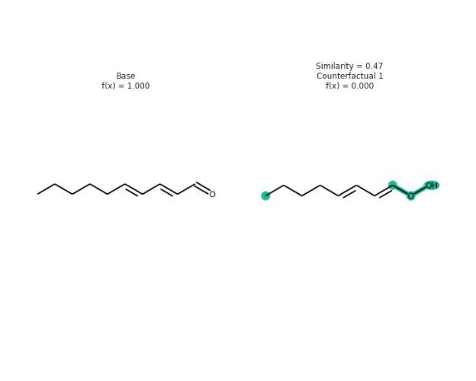

Figure 5: Counterfactual for the 2,4 decadienal molecule. The counterfactual indicates structural changes to ethyl benzoate that would result in the model predicting the molecule to not contain the ‘fruity’ scent. The Tanimoto96 similarity between the counterfactual and 2,4 decadienal is also provided. Republished with permission from authors.31

The molecule 2,4-decadienal, which is known to have a ‘fatty’ scent, is analyzed in Fig-ure 5.142,143 The resulting counterfactual, which has a shorter carbon chain and no carbonyl groups, highlights the influence of these structural features on the ‘fatty’ scent of 2,4 deca-dienal. To generalize to other molecules, Seshadri et al. 31 applied the descriptor attribution method to obtain global explanations for the scents. The global explanation for the ‘fatty’ scent was generated by gathering chemical spaces around many ‘fatty’ scented molecules. The resulting natural language explanation is: “The molecular property “fatty scent” can be explained by the presence of a heptanyl fragment, two CH2 groups separated by four

20

bonds, and a C=O double bond, as well as the lack of more than one or two O atoms.”31 The importance of a heptanyl fragment aligns with that reported in the literature, as ‘fatty’ molecules often have a long carbon chain.144 Furthermore, the importance of a C=O dou-ble bond is supported by the findings reported by Licon et al. 145 , where in addition to a “larger carbon-chain skeleton”, they found that ‘fatty’ molecules also had “aldehyde or acid functions”.145 For the ‘pineapple’ scent, the following natural language explanation was ob-tained: “The molecular property “pineapple scent” can be explained by the presence of ester, ethyl/ether O group, alkene/ether O group, and C=O double bond, as well as the absence of an Aromatic atom.”31 Esters, such as ethyl 2-methylbutyrate, are present in many pineap-ple volatile compounds.146,147 The combination of a C=O double bond with an ether could also correspond to an ester group. Additionally, aldehydes and ketones, which contain C=O double bonds, are also common in pineapple volatile compounds.146,148

Discussion

We have shown two post-hoc XAI applications based on molecular counterfactual expla-nations9 and descriptor explanations.10 These methods can be used to explain black-box models whose input is a molecule. These two methods can be applied for both classification and regression tasks. Note that the “correctness” of the explanations strongly depends on the accuracy of the black-box model.

A molecular counterfactual is one with a minimal distance from a base molecular, but with contrasting chemical properties. In the above examples, we used Tanimoto similar-ity96 of ECFP4 fingreprints97 as distance, although this should be explored in the future. Counterfactual explanations are useful because they are represented as chemical structures (familiar to domain experts), sparse, and are actionable. A few other popular examples of counterfactual on graph methods are GNNExplainer, MEG and CF-GNNExplainer.69,104,105

The descriptor explanation method developed by Gandhi and White 10 fits a self-explaining

21

surrogate model to explain the black-box model. This is similar to the GraphLIME87 method, although we have the flexibility to use explanation features other than subgraphs. Futher-more, we show that natural language combined with chemical descriptor attributions can create explanations useful for chemists, thus enhancing the accessibility of DL in chemistry. Lastly, we examined if XAI can be used beyond interpretation. Work by Seshadri et al. 31 use MMACE and surrogate model explanations to analyze the structure-property relationships of scent. They recovered known structure-property relationships for molecular scent purely from explanations, demonstrating the usefulness of a two step process: fit an accurate model and then explain it.

Choosing among the plethora of XAI methods described here is still an open question. It remains to be seen if there will ever be a consensus benchmark, since this field sits on the intersection of human-machine interaction, machine learning, and philosophy (i.e., what constitutes an explanation?). Our current advice is to consider first the audience – domain experts or ML experts or non-experts – and what the explanations should accomplish. Are they meant to inform data selection or model building, how a prediction is used, or how the features can be changed to affect the outcome. The second consideration is what access you have to the underlying model. The ability to have model derivatives or propagate gradients to the input to models informs the XAI method.

Conclusion and outlook

We should seek to explain molecular property prediction models because users are more likely to trust explained predictions, and explanations can help assess if the model is learning the correct underlying chemical principles. We also showed that black-box modeling first, followed by XAI, is a path to structure-property relationships without needing to trade between accuracy and interpretability. However, XAI in chemistry has some major open questions, that are also related to the black-box nature of the deep learning. Some are

22

highlighted below:

* Explanation representation: How is an explanation presented – text, a molecule, attri-butions, a concept, etc?
* Molecular distance: in XAI approaches such as counterfactual generation, the “dis-tance” between two molecules is minimized. Molecular distance is subjective. Possibil-ities are distance based on molecular properties, synthesis routes, and direct structure comparisons.
* Regulations: As black-box models move from research to industry, healthcare, and environmental settings, we expect XAI to become more important to explain decisions to chemists or non-experts and possibly be legally required. Explanations may need to be tuned for be for doctors instead of chemists or to satisfy a legal requirement.
* Chemical space: Chemical space is the set of molecules that are realizable; “realiz-able” can be defined from purchasable to synthesizable to satisfied valences. What is most useful? Can an explanation consider nearby impossible molecules? How can we generate local chemical spaces centered around a specific molecule for finding counter-factuals or other instance explanations? Similarly, can “activity cliffs” be connected to explanations and the local chemical space.149
* Evaluating XAI : there is a lack of a systematic framework (quantitative or qualitative) to evaluate correctness and applicability of an explanation. Can there be a universal framework, or should explanations be chosen and evaluated based on the audience and domain? For example, work by Rasmussen et al. 58 attempts to focus on comparing feature attribution XAI methods via Crippen’s logP scores.

23

Acknowledgements

Research reported in this work was supported by the National Institute of General Medical Sciences of the National Institutes of Health under award number R35GM137966. This work was supported by the NSF under awards 1751471 and 1764415. We thank the Center for Integrated Research Computing at the University of Rochester for providing computational resources.

References

1. Choudhary, K.; DeCost, B.; Chen, C.; Jain, A.; Tavazza, F.; Cohn, R.; Park, C. W.; Choudhary, A.; Agrawal, A.; Billinge, S. J.; Holm, E.; Ong, S. P.; Wolverton, C. Recent advances and applications of deep learning methods in materials science. npj Computational Materials 2022, 8 .
2. Keith, J. A.; Vassilev-Galindo, V.; Cheng, B.; Chmiela, S.; Gastegger, M.; M¨uller, K.-R.; Tkatchenko, A. Combining Machine Learning and Computational Chemistry for Predictive Insights Into Chemical Systems. Chemical Reviews 2021, 121, 9816–9872, PMID: 34232033.
3. Goh, G. B.; Hodas, N. O.; Vishnu, A. Deep learning for computational chemistry. Journal of Computational Chemistry 2017, 38, 1291–1307.
4. Deringer, V. L.; Caro, M. A.; Cs´anyi, G. Machine Learning Interatomic Potentials as Emerging Tools for Materials Science. Advanced Materials 2019, 31, 1902765.
5. Faber, F. A.; Hutchison, L.; Huang, B.; Gilmer, J.; Schoenholz, S. S.; Dahl, G. E.; Vinyals, O.; Kearnes, S.; Riley, P. F.; von Lilienfeld, O. A. Prediction Errors of Molec-ular Machine Learning Models Lower than Hybrid DFT Error. Journal of Chemical Theory and Computation 2017, 13, 5255–5264, PMID: 28926232.

24

1. Duch, W.; Swaminathan, K.; Meller, J. Artificial Intelligence Approaches for Rational Drug Design and Discovery. Current Pharmaceutical Design 2007, 13, 1497–1508.
2. Dara, S.; Dhamercherla, S.; Jadav, S. S.; Babu, C. M.; Ahsan, M. J.; darasuresh, S. D.; Dara, S. Machine Learning in Drug Discovery: A Review. Artificial Intelligence Review 123, 55, 1947–1999.
3. Gupta, R.; Srivastava, D.; Sahu, M.; Tiwari, S.; Ambasta, R. K.; Kumar, P. Artifi-cial intelligence to deep learning: machine intelligence approach for drug discovery. Molecular diversity 2021, 25, 1315–1360.
4. Wellawatte, G. P.; Seshadri, A.; White, A. D. Model agnostic generation of counter-factual explanations for molecules. Chemical Science 2022, 13, 3697–3705.
5. Gandhi, H. A.; White, A. D. Explaining structure-activity relationships using locally faithful surrogate models. chemrxiv 2022,
6. Gormley, A. J.; Webb, M. A. Machine learning in combinatorial polymer chemistry. Nature Reviews Materials 2021,
7. Gomes, C. P.; Fink, D.; Dover, R. B. V.; Gregoire, J. M. Computational sustainability meets materials science. Nature Reviews Materials 2021,
8. On scientific understanding with artificial intelligence. Nature Reviews Physics 2022 4:12 2022, 4, 761–769.
9. Arrieta, A. B.; D´ıaz-Rodr´ıguez, N.; Ser, J. D.; Bennetot, A.; Tabik, S.; Barbado, A.; Garcia, S.; Gil-Lopez, S.; Molina, D.; Benjamins, R.; Chatila, R.; Herrera, F. Explain-able Artificial Intelligence (XAI): Concepts, Taxonomies, Opportunities and Chal-lenges toward Responsible AI. Information Fusion 2019, 58, 82–115.
10. Murdoch, W. J.; Singh, C.; Kumbier, K.; Abbasi-Asl, R.; Yu, B. Interpretable machine learning: definitions, methods, and applications. ArXiv 2019, abs/1901.04592 .

25

1. Boobier, S.; Osbourn, A.; Mitchell, J. B. Can human experts predict solubility better than computers? Journal of cheminformatics 2017, 9, 1–14.
2. Lee, J. D.; See, K. A. Trust in automation: Designing for appropriate reliance. Human Factors 2004, 46, 50–80.
3. Bolukbasi, T.; Chang, K.-W.; Zou, J. Y.; Saligrama, V.; Kalai, A. T. Man is to com-puter programmer as woman is to homemaker? debiasing word embeddings. Advances in neural information processing systems 2016, 29 .
4. Buolamwini, J.; Gebru, T. Gender Shades: Intersectional Accuracy Disparities in Commercial Gender Classification. Proceedings of the 1st Conference on Fairness, Accountability and Transparency. 2018; pp 77–91.
5. Lapuschkin, S.; W¨aldchen, S.; Binder, A.; Montavon, G.; Samek, W.; M¨uller, K.-R. Unmasking Clever Hans predictors and assessing what machines really learn. Nature communications 2019, 10, 1–8.
6. DeGrave, A. J.; Janizek, J. D.; Lee, S.-I. AI for radiographic COVID-19 detection selects shortcuts over signal. Nature Machine Intelligence 2021, 3, 610–619.
7. Goodman, B.; Flaxman, S. European Union regulations on algorithmic decision-making and a “right to explanation”. AI Magazine 2017, 38, 50–57.
8. ACT, A. I. European Commission. On Artificial Intelligence: A European Approach to Excellence and Trust. 2021, COM/2021/206.
9. Blueprint for an AI Bill of Rights, The White House. 2022; [https://www.whitehouse.](https://www.whitehouse.gov/ostp/ai-bill-of-rights/) [gov/ostp/ai-bill-of-rights/](https://www.whitehouse.gov/ostp/ai-bill-of-rights/).
10. Miller, T. Explanation in artificial intelligence: Insights from the social sciences. Ar-tificial intelligence 2019, 267, 1–38.

26

1. Murdoch, W. J.; Singh, C.; Kumbier, K.; Abbasi-Asl, R.; Yu, B. Definitions, meth-ods, and applications in interpretable machine learning. Proceedings of the National Academy of Sciences of the United States of America 2019, 116, 22071–22080.
2. Gunning, D.; Aha, D. DARPA’s Explainable Artificial Intelligence (XAI) Program. AI Magazine 2019, 40, 44–58.
3. Biran, O.; Cotton, C. Explanation and justification in machine learning: A survey. IJCAI-17 workshop on explainable AI (XAI). 2017; pp 8–13.
4. Palacio, S.; Lucieri, A.; Munir, M.; Ahmed, S.; Hees, J.; Dengel, A. Xai handbook: Towards a unified framework for explainable ai. Proceedings of the IEEE/CVF Inter-national Conference on Computer Vision. 2021; pp 3766–3775.
5. Kuhn, D. R.; Kacker, R. N.; Lei, Y.; Simos, D. E. Combinatorial Methods for Ex-plainable AI. 2020 IEEE International Conference on Software Testing, Verification and Validation Workshops (ICSTW) 2020, 167–170.
6. Seshadri, A.; Gandhi, H. A.; Wellawatte, G. P.; White, A. D. Why does that molecule smell? ChemRxiv 2022,
7. Das, A.; Rad, P. Opportunities and challenges in explainable artificial intelligence (xai): A survey. arXiv preprint arXiv:2006.11371 2020,
8. Machlev, R.; Heistrene, L.; Perl, M.; Levy, K. Y.; Belikov, J.; Mannor, S.; Levron, Y. Explainable Artificial Intelligence (XAI) techniques for energy and power systems: Review, challenges and opportunities. Energy and AI 2022, 9, 100169.
9. Koh, P. W.; Liang, P. Understanding black-box predictions via influence functions. International Conference on Machine Learning. 2017; pp 1885–1894.
10. Ribeiro, M. T.; Singh, S.; Guestrin, C. ” Why should i trust you?” Explaining the predictions of any classifier. Proceedings of the 22nd ACM SIGKDD international

27

conference on knowledge discovery and data mining. San Diego, CA, USA, 2016; pp 1135–1144.

1. Dhurandhar, A.; Chen, P.-Y.; Luss, R.; Tu, C.-C.; Ting, P.; Shanmugam, K.; Das, P. Explanations based on the missing: Towards contrastive explanations with pertinent negatives. Advances in neural information processing systems 2018, 31 .
2. Jin, W.; Li, X.; Hamarneh, G. Evaluating Explainable AI on a Multi-Modal Medical Imaging Task: Can Existing Algorithms Fulfill Clinical Requirements? Proceedings of the AAAI Conference on Artificial Intelligence 2022, 36, 11945–11953.
3. Zhang, Y.; Xu, F.; Zou, J.; Petrosian, O. L.; Krinkin, K. V. XAI Evaluation: Evalu-ating Black-Box Model Explanations for Prediction. 2021 II International Conference on Neural Networks and Neurotechnologies (NeuroNT). 2021; pp 13–16.
4. Oviedo, F.; Ferres, J. L.; Buonassisi, T.; Butler, K. T. Interpretable and Explain-able Machine Learning for Materials Science and Chemistry. Accounts of Materials Research 2022, 3, 597–607.
5. Yalcin, O.; Fan, X.; Liu, S. Evaluating the correctness of explainable AI algorithms for classification. arXiv preprint arXiv:2105.09740 2021,
6. Hoffman, R. R.; Mueller, S. T.; Klein, G.; Litman, J. Metrics for Explainable AI: Challenges and Prospects. 2018,
7. Mohseni, S.; Zarei, N.; Ragan, E. D. A Multidisciplinary Survey and Framework for Design and Evaluation of Explainable AI Systems. ACM Transactions on Interactive Intelligent Systems 2018, 11, 46.
8. Humer, C.; Heberle, H.; Montanari, F.; Wolf, T.; Huber, F.; Henderson, R.; Hein-rich, J.; Streit, M. ChemInformatics Model Explorer (CIME): exploratory analysis of chemical model explanations. Journal of Cheminformatics 2022, 14, 1–14.

28

1. Lundberg, S. M.; Lee, S.-I. In Advances in Neural Information Processing Systems 30 ; Guyon, I., Luxburg, U. V., Bengio, S., Wallach, H., Fergus, R., Vishwanathan, S., Garnett, R., Eds.; Curran Associates, Inc., 2017; pp 4765–4774.

ˇ

1. Strumbelj, E.; Kononenko, I. Explaining prediction models and individual predictions with feature contributions. Knowledge and information systems 2014, 41, 647–665.
2. Shapley, L. S. A Value for N-Person Games; RAND Corporation: Santa Monica, CA, 1952.
3. Molnar, C.; Casalicchio, G.; Bischl, B. Interpretable machine learning–a brief history, state-of-the-art and challenges. Joint European Conference on Machine Learning and Knowledge Discovery in Databases. 2020; pp 417–431.
4. Lou, Y.; Caruana, R.; Gehrke, J. Intelligible models for classification and regression. Proceedings of the 18th ACM SIGKDD international conference on Knowledge dis-covery and data mining. 2012; pp 150–158.
5. Bastani, O.; Kim, C.; Bastani, H. Interpreting blackbox models via model extraction. arXiv preprint arXiv:1705.08504 2017,
6. Gajewicz, A.; Puzyn, T.; Odziomek, K.; Urbaszek, P.; Haase, A.; Riebeling, C.; Luch, A.; Irfan, M. A.; Landsiedel, R.; van der Zande, M.; Bouwmeester, H. Deci-sion tree models to classify nanomaterials according to the DF4nanoGrouping scheme.

Nanotoxicology 2018, 12, 1–17.

1. Han, L.; Wang, Y.; Bryant, S. H. Developing and validating predictive decision tree models from mining chemical structural fingerprints and high–throughput screening data in PubChem. BMC Bioinformatics 2008, 9, 401.

´

(52) Plumb, G.; Al-Shedivat, M.; Cabrera, A. A.; Perer, A.; Xing, E.; Talwalkar, A. Regu-

29

larizing black-box models for improved interpretability. Advances in Neural Informa-tion Processing Systems 2020, 33, 10526–10536.

1. Shao, X.; Skryagin, A.; Stammer, W.; Schramowski, P.; Kersting, K. Right for bet-ter reasons: Training differentiable models by constraining their influence functions. Proceedings of the AAAI Conference on Artificial Intelligence. 2021; pp 9533–9540.
2. Ouyang, R.; Curtarolo, S.; Ahmetcik, E.; Scheffler, M.; Ghiringhelli, L. M. SISSO: A compressed-sensing method for identifying the best low-dimensional descriptor in an immensity of offered candidates. Physical Review Materials 2018, 2, 083802.
3. Lipton, Z. C. The mythos of model interpretability: In machine learning, the concept of interpretability is both important and slippery. Queue 2018, 16, 31–57.
4. Harren, T.; Matter, H.; Hessler, G.; Rarey, M.; Grebner, C. Interpretation of structure– activity relationships in real-world drug design data sets using explainable artificial intelligence. Journal of Chemical Information and Modeling 2022, 62, 447–462.
5. Sheridan, R. P. Interpretation of QSAR Models by Coloring Atoms According to Changes in Predicted Activity: How Robust Is It? Journal of Chemical Information and Modeling 2019, 59, 1324–1337.
6. Rasmussen, M. H.; Christensen, D. S.; Jensen, J. H. Do machines dream of atoms? Crippen’s logP as a quantitative molecular benchmark for explainable AI heatmaps. 2022,
7. Smilkov, D.; Thorat, N.; Kim, B.; Vi´egas, F.; Wattenberg, M. SmoothGrad: removing noise by adding noise. 2017; <https://arxiv.org/abs/1706.03825>.
8. McCloskey, K.; Taly, A.; Monti, F.; Brenner, M. P.; Colwell, L. Using Attribution to Decode Dataset Bias in Neural Network Models for Chemistry. Proceedings of the

30

National Academy of Sciences of the United States of America 2018, 116, 11624– 11629.

1. Bach, S.; Binder, A.; Montavon, G.; Klauschen, F.; M¨uller, K.-R.; Samek, W. On pixel-wise explanations for non-linear classifier decisions by layer-wise relevance prop-agation. PloS one 2015, 10, e0130140.
2. Sundararajan, M.; Taly, A.; Yan, Q. Axiomatic attribution for deep networks. Inter-national Conference on Machine Learning. 2017; pp 3319–3328.
3. Zhou, B.; Khosla, A.; Lapedriza, A.; Oliva, A.; Torralba, A. Learning Deep Features for Discriminative Localization. 2015; <https://arxiv.org/abs/1512.04150>.
4. Selvaraju, R. R.; Cogswell, M.; Das, A.; Vedantam, R.; Parikh, D.; Batra, D. Grad-CAM: Visual Explanations from Deep Networks via Gradient-Based Localization. In-ternational Journal of Computer Vision 2019, 128, 336–359.
5. Smilkov, D.; Thorat, N.; Kim, B.; Vi´egas, F.; Wattenberg, M. Smoothgrad: removing noise by adding noise. arXiv preprint arXiv:1706.03825 2017,
6. Pope, P.; Kolouri, S.; Rostrami, M.; Martin, C.; Hoffmann, H. Discovering Molec-ular Functional Groups Using Graph Convolutional Neural Networks. 2018; [https:](https://arxiv.org/abs/1812.00265) [//arxiv.org/abs/1812.00265](https://arxiv.org/abs/1812.00265).
7. Jim´enez-Luna, J.; Skalic, M.; Weskamp, N.; Schneider, G. Coloring molecules with ex-plainable artificial intelligence for preclinical relevance assessment. Journal of Chem-ical Information and Modeling 2021, 61, 1083–1094.
8. Sanchez-Lengeling, B.; Wei, J.; Lee, B.; Reif, E.; Wang, P. Y.; Qian, W. W.; Mc-Closkey, K.; Colwell, L.; Wiltschko, A. Evaluating Attribution for Graph Neural Networks. Proceedings of the 34th International Conference on Neural Information Processing Systems. Red Hook, NY, USA, 2020.

31

1. Ying, R.; Bourgeois, D.; You, J.; Zitnik, M.; Leskovec, J. GNNExplainer: Generating Explanations for Graph Neural Networks. Advances in neural information processing systems 2019, 32, 9240–9251.
2. Rao, J.; Zheng, S.; Yang, Y. Quantitative Evaluation of Explainable Graph Neural Networks for Molecular Property Prediction. arXiv preprint arXiv:2107.04119 2021,
3. Yuan, H.; Yu, H.; Wang, J.; Li, K.; Ji, S. On Explainability of Graph Neural Net-works via Subgraph Explorations. Proceedings of the 38th International Conference on Machine Learning. 2021; pp 12241–12252.
4. Shrikumar, A.; Greenside, P.; Kundaje, A. Learning Important Features Through Propagating Activation Differences. 2017,
5. Montavon, G.; Binder, A.; Lapuschkin, S.; Samek, W.; M¨uller, K. R. Layer-Wise Relevance Propagation: An Overview. Lecture Notes in Computer Science (including subseries Lecture Notes in Artificial Intelligence and Lecture Notes in Bioinformatics) 2019, 11700 LNCS, 193–209.
6. Baldassarre, F.; Azizpour, H. Explainability Techniques for Graph Convolutional Net-works. 2019; <https://arxiv.org/abs/1905.13686>.
7. Hochuli, J.; Helbling, A.; Skaist, T.; Ragoza, M.; Koes, D. R. Visualizing convolutional neural network protein-ligand scoring. Journal of Molecular Graphics and Modelling 2018, 84, 96–108.
8. Rodr´ıguez-P´erez, R.; Bajorath, J. Interpretation of Compound Activity Predictions from Complex Machine Learning Models Using Local Approximations and Shapley Values. Journal of Medicinal Chemistry 2020, 63, 8761–8777, PMID: 31512867.
9. Wojtuch, A.; Jankowski, R.; Podlewska, S. How can SHAP values help to shape

32

metabolic stability of chemical compounds? Journal of Cheminformatics 2021, 13, 1–20.

1. Mastropietro, A.; Pasculli, G.; Feldmann, C.; Rodr´ıguez-P´erez, R.; Bajorath, J. Edge-SHAPer: Bond-Centric Shapley Value-Based Explanation Method for Graph Neural Networks. iScience 2022, 25, 105043.
2. White, A. D. Deep learning for molecules and materials. Living Journal of Computa-tional Molecular Science 2022, 3 .

˘

1. Strumbelj, E.; Kononenko, I. Explaining prediction models and individual predictions with feature contributions. Knowledge and Information Systems 2014, 41, 647–665.
2. Erhan, D.; Bengio, Y.; Courville, A.; Vincent, P. Visualizing Higher-Layer Features of a Deep Network. Technical Report, Univerist´ de Montr´eal 2009,
3. Weber, J. K.; Morrone, J. A.; Bagchi, S.; Pabon, J. D.; gu Kang, S.; Zhang, L.; Cornell, W. D. Simplified, interpretable graph convolutional neural networks for small molecule activity prediction. Journal of Computer-Aided Molecular Design 2022, 36, 391–404.
4. Riniker, S.; Landrum, G. A. Similarity maps - A visualization strategy for molecular fingerprints and machine-learning methods. Journal of Cheminformatics 2013, 5, 1–7.
5. Humer, C.; Heberle, H.; Montanari, F.; Wolf, T.; Huber, F.; Henderson, R.; Hein-rich, J.; Streit, M. ChemInformatics Model Explorer (CIME): exploratory analysis of chemical model explanations. Journal of Cheminformatics 2022, 14, 1–14.
6. McGrath, T.; Kapishnikov, A.; Tomaˇsev, N.; Pearce, A.; Wattenberg, M.; Hass-abis, D.; Kim, B.; Paquet, U.; Kramnik, V. Acquisition of chess knowledge in Al-phaZero. Proceedings of the National Academy of Sciences 2022, 119, e2206625119.

33

1. Bajusz, D.; R´acz, A.; H´eberger, K. Why is Tanimoto index an appropriate choice for fingerprint-based similarity calculations? Journal of Cheminformatics 2015, 7, 1–13.
2. Huang, Q.; Yamada, M.; Tian, Y.; Singh, D.; Yin, D.; Chang, Y. GraphLIME: Local Interpretable Model Explanations for Graph Neural Networks. CoRR 2020, abs/2001.06216 .
3. Sokol, K.; Flach, P. A. LIMEtree: Interactively Customisable Explanations Based on Local Surrogate Multi-output Regression Trees. CoRR 2020, abs/2005.01427 .
4. Whitmore, L. S.; George, A.; Hudson, C. M. Mapping chemical performance on molec-ular structures using locally interpretable explanations. 2016; [https://arxiv.org/](https://arxiv.org/abs/1611.07443) [abs/1611.07443](https://arxiv.org/abs/1611.07443).
5. Mehdi, S.; Tiwary, P. Thermodynamics of Interpretation. 2022,
6. H¨ofler, M. Causal inference based on counterfactuals. BMC Medical Research Method-ology 2005, 5, 1–12.
7. Woodward, J.; Hitchcock, C. Explanatory Generalizations, Part I: A Counterfactual Account. Noˆus 2003, 37, 1–24.
8. Frisch, M. F. Theories, models, and explanation; University of California, Berkeley, 1998.
9. Reutlinger, A. Is There A Monist Theory of Causal and Non-Causal Explanations? The Counterfactual Theory of Scientific Explanation. Philosophy of Science 2016, 83, 733–745.
10. Lewis, D. Causation. The journal of philosophy 1974, 70, 556–567.
11. Tanimoto, T. T. Elementary mathematical theory of classification and prediction. Internal IBM Technical Report 1958,

34

1. Rogers, D.; Hahn, M. Extended-Connectivity Fingerprints. Journal of Chemical In-formation and Modeling 2010, 50, 742–754, PMID: 20426451.
2. Mohapatra, S.; An, J.; G´omez-Bombarelli, R. Chemistry-informed macromolecule graph representation for similarity computation, unsupervised and supervised learn-ing. Machine Learning: Science and Technology 2022, 3, 015028.
3. Doshi-Velez, F.; Kortz, M.; Budish, R.; Bavitz, C.; Gershman, S.; O’Brien, D.; Scott, K.; Schieber, S.; Waldo, J.; Weinberger, D.; Weller, A.; Wood, A. Account-ability of AI Under the Law: The Role of Explanation. SSRN Electronic Journal 2017,
4. Wachter, S.; Mittelstadt, B.; Russell, C. Counterfactual explanations without opening the black box: Automated decisions and the GDPR. Harv. JL & Tech. 2017, 31, 841.
5. Jim´enez-Luna, J.; Grisoni, F.; Schneider, G. Drug discovery with explainable artificial intelligence. Nature Machine Intelligence 2020 2:10 2020, 2, 573–584.
6. Fu, T.; Gao, W.; Xiao, C.; Yasonik, J.; Coley, C. W.; Sun, J. Differentiable Scaffold-ing Tree for Molecule Optimization. International Conference on Learning Represen-tations. 2022.
7. Shen, C.; Krenn, M.; Eppel, S.; Aspuru-Guzik, A. Deep molecular dreaming: inverse machine learning for de-novo molecular design and interpretability with surjective representations. Machine Learning: Science and Technology 2021, 2, 03LT02.
8. Lucic, A.; ter Hoeve, M.; Tolomei, G.; Rijke, M.; Silvestri, F. CF-GNNExplainer: Counterfactual Explanations for Graph Neural Networks. arXiv preprint arXiv:2102.03322 2021,
9. Numeroso, D.; Bacciu, D. Explaining Deep Graph Networks with Molecular Counter-factuals. arXiv preprint arXiv:2011.05134 2020,

35

1. Krenn, M.; H¨ase, F.; Nigam, A.; Friederich, P.; Aspuru-Guzik, A. Self-Referencing Embedded Strings (SELFIES): A 100% robust molecular string representation. Ma-chine Learning: Science and Technology 2020, 1, 045024.
2. Nigam, A.; Pollice, R.; Krenn, M.; dos Passos Gomes, G.; Aspuru-Guzik, A. Beyond generative models: superfast traversal, optimization, novelty, exploration and discov-ery (STONED) algorithm for molecules using SELFIES. Chemical science 2021, 12, 7079–7090.
3. Kim, S.; Chen, J.; Cheng, T.; Gindulyte, A.; He, J.; He, S.; Li, Q.; Shoemaker, B. A.; Thiessen, P. A.; Yu, B.; Zaslavsky, L.; Zhang, J.; Bolton, E. E. PubChem in 2021: new data content and improved web interfaces. Nucleic Acids Research 2020, 49, D1388–D1395.
4. Tolomei, G.; Silvestri, F.; Haines, A.; Lalmas, M. Interpretable predictions of tree-based ensembles via actionable feature tweaking. Proceedings of the 23rd ACM SIGKDD international conference on knowledge discovery and data mining. 2017; pp 465–474.
5. Freiesleben, T. The intriguing relation between counterfactual explanations and ad-versarial examples. Minds and Machines 2022, 32, 77–109.
6. Grabocka, J.; Schilling, N.; Wistuba, M.; Schmidt-Thieme, L. Learning time-series shapelets. Proceedings of the 20th ACM SIGKDD international conference on Knowl-edge discovery and data mining. 2014; pp 392–401.
7. Kenny, P. W.; Sadowski, J. Structure modification in chemical databases. Chemoin-formatics in drug discovery 2005, 271–285.
8. Tyrchan, C.; Evertsson, E. Matched Molecular Pair Analysis in Short: Algorithms, Applications and Limitations. Computational and Structural Biotechnology Journal 2017, 15, 86–90.

36

1. Griffen, E.; Leach, A. G.; Robb, G. R.; Warner, D. J. Matched Molecular Pairs as a Medicinal Chemistry Tool. Journal of Medicinal Chemistry 2011, 54, 7739–7750, PMID: 21936582.
2. He, J.; Nittinger, E.; Tyrchan, C.; Czechtizky, W.; Patronov, A.; Bjerrum, E. J.; Engkvist, O. Transformer-based molecular optimization beyond matched molecular pairs. Journal of cheminformatics 2022, 14, 1–14.
3. Park, J.; Sung, G.; Lee, S.; Kang, S.; Park, C. ACGCN: Graph Convolutional Networks for Activity Cliff Prediction between Matched Molecular Pairs. Journal of Chemical Information and Modeling 2022,
4. Langdon, S. R.; Ertl, P.; Brown, N. Bioisosteric Replacement and Scaffold Hopping in Lead Generation and Optimization. Molecular Informatics 2010, 29, 366–385.
5. Turk, S.; Merget, B.; Rippmann, F.; Fulle, S. Coupling Matched Molecular Pairs with Machine Learning for Virtual Compound Optimization. Journal of Chemical Information and Modeling 2017, 57, 3079–3085, PMID: 29131617.
6. van Tilborg, D.; Alenicheva, A.; Grisoni, F. Exposing the limitations of molecular machine learning with activity cliffs. 2022,
7. Fischer, H.; Gottschlich, R.; Seelig, A. Blood-brain barrier permeation: molecular parameters governing passive diffusion. The Journal of membrane biology 1998, 165, 201–211.
8. Liu, L.; Zhang, L.; Feng, H.; Li, S.; Liu, M.; Zhao, J.; Liu, H. Prediction of the Blood–Brain Barrier (BBB) Permeability of Chemicals Based on Machine-Learning and Ensemble Methods. Chemical Research in Toxicology 2021, 34, 1456–1467, PMID: 34047182.

37

1. Wu, Z.; Ramsundar, B.; Feinberg, E. N.; Gomes, J.; Geniesse, C.; Pappu, A. S.; Leswing, K.; Pande, V. MoleculeNet: a benchmark for molecular machine learning. Chemical science 2018, 9, 513–530.
2. Ho, T. K. Random decision forests. Proceedings of 3rd international conference on document analysis and recognition. 1995; pp 278–282.
3. Martins, I. F.; Teixeira, A. L.; Pinheiro, L.; Falcao, A. O. A Bayesian approach to in silico blood-brain barrier penetration modeling. Journal of chemical information and modeling 2012, 52, 1686–1697.
4. Pedregosa, F. et al. Scikit-learn: Machine Learning in Python. Journal of Machine Learning Research 2011, 12, 2825–2830.
5. Moriwaki, H.; Tian, Y.-S.; Kawashita, N.; Takagi, T. Mordred: a molecular descriptor calculator. Journal of cheminformatics 2018, 10, 1–14.
6. Chollet, F., et al. Keras. <https://keras.io>, 2015.
7. Wager, T. T.; Chandrasekaran, R. Y.; Hou, X.; Troutman, M. D.; Verhoest, P. R.; Vil-lalobos, A.; Will, Y. Defining Desirable Central Nervous System Drug Space through the Alignment of Molecular Properties, in Vitro ADME, and Safety Attributes. ACS Chemical Neuroscience 2010, 1, 420–434.
8. Ghose, A. K.; Herbertz, T.; Hudkins, R. L.; Dorsey, B. D.; Mallamo, J. P. Knowledge-Based, Central Nervous System (CNS) Lead Selection and Lead Optimization for CNS Drug Discovery. ACS Chemical Neuroscience 2012, 3, 50–68.
9. Polishchuk, P.; Tinkov, O.; Khristova, T.; Ognichenko, L.; Kosinskaya, A.; Varnek, A.; Kuz’min, V. Structural and Physico-Chemical Interpretation (SPCI) of QSAR Mod-els and Its Comparison with Matched Molecular Pair Analysis. Journal of Chemical Information and Modeling 2016, 56, 1455–1469.

38

1. Hassan, M.; Brown, R. D.; Varma-O’Brien, S.; Rogers, D. Cheminformatics analysis and learning in a data pipelining environment. Molecular diversity 2006, 10, 283–299.
2. Schomburg, K.; Ehrlich, H. C.; Stierand, K.; Rarey, M. From structure diagrams to visual chemical patterns. Journal of Chemical Information and Modeling 2010, 50, 1529–1535.
3. Sheikholeslamzadeh, E.; Rohani, S. Solubility prediction of pharmaceutical and chem-ical compounds in pure and mixed solvents using predictive models. Industrial & engineering chemistry research 2012, 51, 464–473.
4. Boobier, S.; Hose, D. R.; Blacker, A. J.; Nguyen, B. N. Machine learning with physic-ochemical relationships: solubility prediction in organic solvents and water. Nature Communications 2020 11:1 2020, 11, 1–10.
5. Loschen, C.; Klamt, A. Solubility prediction, solvate and cocrystal screening as tools for rational crystal engineering. Journal of Pharmacy and Pharmacology 2015, 67, 803–811.
6. Diorazio, L. J.; Hose, D. R.; Adlington, N. K. Toward a more holistic framework for solvent selection. Organic Process Research & Development 2016, 20, 760–773.
7. Sorkun, M. C.; Khetan, A.; Er, S. AqSolDB, a curated reference set of aqueous sol-ubility and 2D descriptors for a diverse set of compounds. Scientific data 2019, 6, 1–8.
8. Durant, J. L.; Leland, B. A.; Henry, D. R.; Nourse, J. G. Reoptimization of MDL keys for use in drug discovery. Journal of chemical information and computer sciences 2002, 42, 1273–1280.
9. National Center for Biotechnology Information, PubChem Compound Summary for

39

CID 1549018, Jasmone. <https://pubchem.ncbi.nlm.nih.gov/compound/Jasmone>, Accessed September 26, 2022.

1. Sell, C. S. On the unpredictability of odor. Angewandte Chemie International Edition 2006, 45, 6254–6261.
2. Genva, M.; Kenne Kemene, T.; Deleu, M.; Lins, L.; Fauconnier, M.-L. Is It Possible to Predict the Odor of a Molecule on the Basis of its Structure? International journal of molecular sciences 2019, 20, 3018.
3. Rowe, D. Aroma chemicals for savory flavors. Perfumer and Flavorist 1998, 23, 9–18.
4. Mallia, S.; Escher, F.; Schlichtherle-Cerny, H. Aroma-active compounds of butter: a review. European Food Research and Technology 2008, 226, 315–325.
5. Jelen, H.; Gracka, A. Characterization of aroma compounds: Structure, physico-

chemical and sensory properties. Flavour: From food to perception 2016, 126–153.

1. Licon, C. C.; Bosc, G.; Sabri, M.; Mantel, M.; Fournel, A.; Bushdid, C.; Golebiowski, J.; Robardet, C.; Plantevit, M.; Kaytoue, M., et al. Chemical features mining provides new descriptive structure-odor relationships. PLoS computational bi-ology 2019, 15, e1006945.
2. Mostafa, S.; Wang, Y.; Zeng, W.; Jin, B. Floral Scents and Fruit Aromas: Functions, Compositions, Biosynthesis, and Regulation. Frontiers in plant science 2022, 13 .
3. Tokitomo, Y.; Steinhaus, M.; B¨uttner, A.; Schieberle, P. Odor-active constituents in fresh pineapple (Ananas comosus [L.] Merr.) by quantitative and sensory evaluation. Bioscience, Biotechnology, and Biochemistry 2005, 69, 1323–1330.
4. Wei, C.-B.; Liu, S.-H.; Liu, Y.-G.; Lv, L.-L.; Yang, W.-X.; Sun, G.-M. Characteristic aroma compounds from different pineapple parts. Molecules 2011, 16, 5104–5112.

40

1. Stumpfe, D.; Bajorath, J. Exploring Activity Cliffs in Medicinal Chemistry. Journal of Medicinal Chemistry 2012, 55, 2932–2942, PMID: 22236250.

41