Product Launch Summary
The chart below shows adoption; the table breaks it down by region.
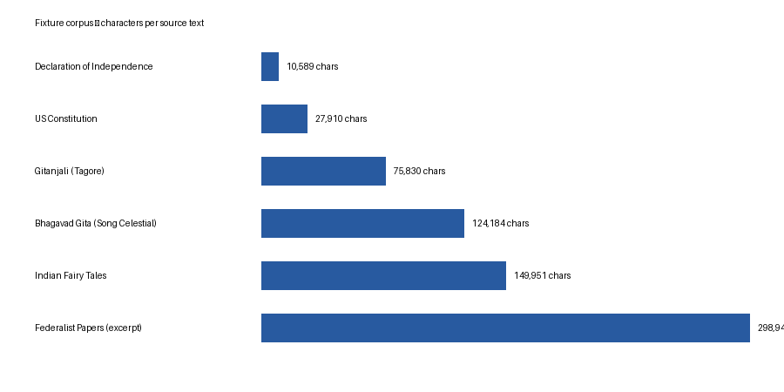
Region | Adoption %
APAC | 34%
EMEA | 41%
End of summary.

