

HOL: Develop Universal Windows Apps on Windows 10

**Set up:**

1. **Windows 10 PC** running **Visual Studio 2015** and **Windows 10 SDK**
2. Configure **VS2015** to use code snippets for this HOL –
   1. Click on **Tools** menu
   2. Click on **Code Snippets Manager**
   3. Click on **Add…**
   4. Navigate to **Documents** and create a folder called **My Snippets**
   5. Select this folder and click on **Select Folder -**

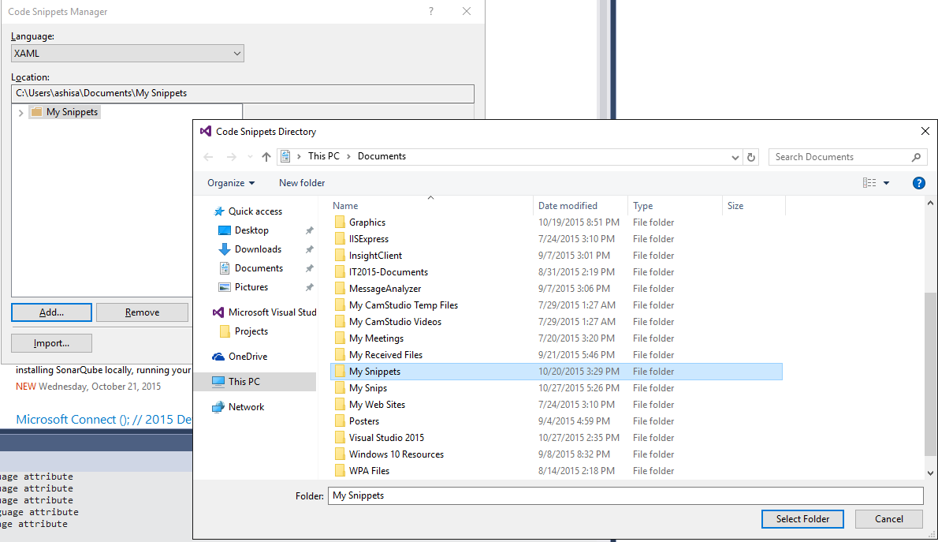

* 1. Download all the files from here - [**https://github.com/FutureUnleashed/HOL**](https://github.com/FutureUnleashed/HOL)
  2. Copy all the files in the downloaded “**My Snippets**” folder to the “**My Snippets**” under Documents folder

**Lab 1: Writing Adaptive Code for UWP Apps**

1. Start **Visual Studio 2015**
2. Create a blank app -  
   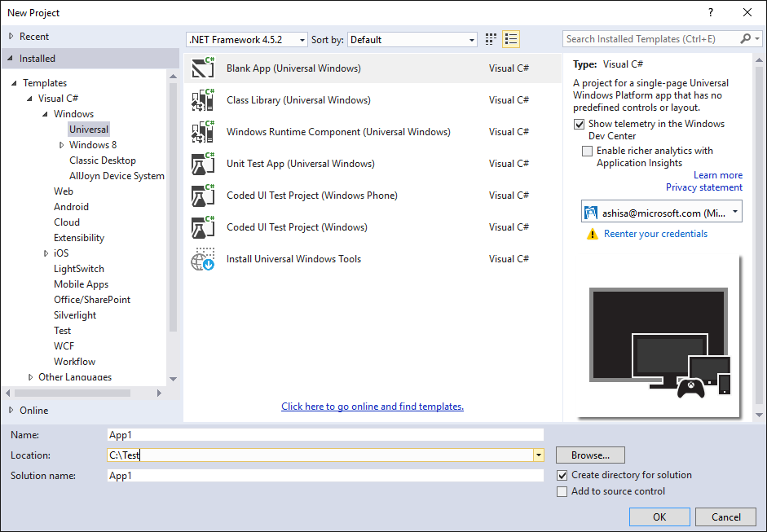
3. Click on **Assets** folder in the project, right click, click on **Add…,** click on **Existing Item…** and select all the file from the downloaded **Assets** folder
4. Open **MainPage**.**xaml**.**cs** and add the Camera Button handler in the constructor –
   1. Type **mainpagecamerabutton** and press tab **twice.** Or,
   2. Right click under the Grid control, click on **Insert snippet…,** click **My Snippets** and select “**Camera button handler in MainPage.xaml.cs**”
   3. Now, right click on the project and add references to –
      1. **Windows Desktop Extensions for the UWP**
      2. **Windows Mobile Extensions for the UWP**

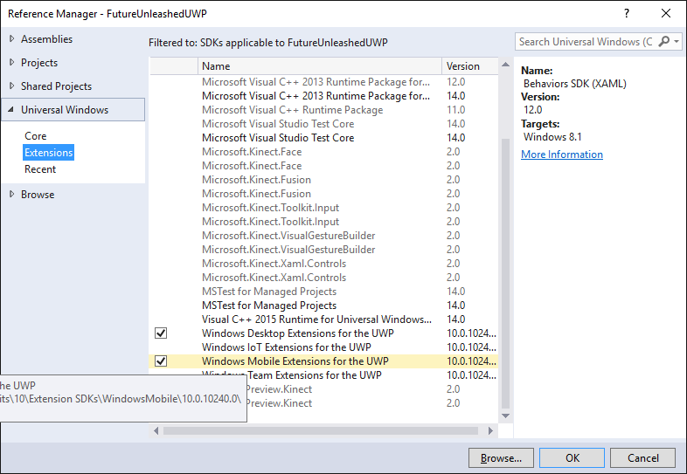

* 1. Delete the line added in the step (b) above and add the adaptive code for camera button handler –
     1. Type **adaptivecamerabutton** and press tab twice. Or,
     2. Right click under the Grid control, click on **Insert snippet…** and select “**Adaptive code for camera button handler**”

1. Add the BackRequest event handler to the MainPage.xaml.cs –
   1. In the constructor, register the BackRequested event handler –
      1. Type **BackButtonEventHandler** and press tab twice. Or,
      2. Right click, click on **Insert snippet…,** click on **My Snippets** and select “**Register BackButton event handler in MainPage.xaml.cs**”
   2. Add the event handler code –
      1. Type **BackButtonFunction** and press tab twice. Or,
      2. Right click, click on **Insert snippet…,** click on **My Snippets** and select “**BackButton Event Handler Function in MainPage.xaml.cs**”
   3. Add code to enable/disable back button visibility in **App.xaml.cs** –
      1. Under the OnLaunched method in App.xaml.cs, find the line that says –

rootFrame.Navigate(typeof(MainPage), e.Arguments);  
  
Add code to toggle the visibility of the back button before this line –

* + - 1. Type **BackButtonVisibility** and press tab twice. Or,
      2. Right click, click on **Insert snippet…,** click on **My Snippets** and select “**Enable BackButton visibility in App.xaml.cs**”

1. Open **MainPage.xaml** and insert the grid and row definitions XAML snippet under the Grid control –
   1. Type **mainpagegriddef** and press tab. Or,
   2. Right click under the Grid control, click on **Insert snippet…** and select “**Row/Column definition for MainPage.xaml**”
2. Add the XAML for the page header Text Block –
   1. Type **mainpagetitletext** and press tab. Or,
   2. Right click under the Grid control, click on **Insert snippet…** and select “**Title text block for MainPage.xaml**”
3. Add Visual State Groups to the page –
   1. Type **mainpagevsgroups** and press tab. Or,
   2. Right click under the Grid control, click on **Insert snippet…** and select “**Visual State Groups for MainPage.xaml**”
4. Add Buttons on the MainPage for the rest of the labs –
   1. Type **mainpagebuttonsxaml** and press tab. Or,
   2. Right click under the Grid control, click on **Insert snippet…** and select “**HOL buttons - MainPage**”
5. In MainPage.xaml.cs, add the button click event handler and wire the page navigation etc. –
   1. Open **MainPage.xaml.cs**
   2. Add the Button Click handler after the constructor –
   3. Type **mainpagebuttonclickcode** and press tab twice. Or,
   4. Right click, click on **Insert snippet…,** click **My Snippets** and select “**Button click handler in MainPage.xaml.cs**”
6. Add a Blank XAML page named **RPanel.xaml** to the project
7. In the MainPage.xaml.cs, uncomment the following line of code –  
     
   this.Frame.Navigate(typeof(RPanel));
8. Open RPanel.xaml in designer and add the XAML to set up the page similar to the MainPage –
   1. Under the Grid control –
      1. Type **mainpagesetupxaml** and press tab. Or,
      2. Right click under the Grid control, click on **Insert snippet…** and select “**XAML Page Setup**”
9. Add the XAML code for RelativePanel
   1. Type **rpanelxaml** and press tab. Or,
   2. Right click, click on **Insert snippet…** and select “**RelativePanel XAML Code**”
   3. Change the first nested **Stack Panel** in to a **Relative Panel**
   4. Move the Image and the Text Block from the second **Stack Panel** to the **Relative Panel**
   5. Remove the second **Stack Panel** now
   6. Add the Setters to the Wide visual state group using the **rpanelsetterswide** code snippet
   7. Add the Setters to the NarrowView visual state group using the **rpanelsettersnarrow** snippet

**Lab 2: Designing Adaptive Tiles**

1. Open MainPage.xaml.cs and uncomment the following line –  
     
   **LaunchNVApps();**
2. Also uncomment the **LaunchNVApps()** function
3. Run the app and click on the **Tiles** button

**Lab 3: Adding Interactive Toast Notifications**

1. Add a new XAML page and name it **ToastPage.xaml**
2. Open MainPage.xaml.cs and uncomment the following line –  
     
   this.Frame.Navigate(typeof(ToastPage));
3. Open ToastPage.xaml in designer and add the snippet for the page setup –
   1. Type **mainpagesetupxaml** and press tab. Or,
   2. Right click, click on **Insert snippet…** and select “**HOL Buttons - Toasts**”
4. Open ToastPage.xaml.cs and after the constructor, add the button click handler –
   1. Type **toastswitchcasecode** and press tab twice. Or,
   2. Right click, click on **Insert snippet…** and click on **“C# Code for Toast Switch..Case”**
5. After this button click handler function, add the code for Normal Toast –
   1. Type **normaltoastcode** and press tab twice. Or,
   2. Right click, click on **Insert snippet…** and select “**C# Code for normal toasts”**
6. After this button click handler function, add the code for Toast with actions –
   1. Type **actiontoastcode** and press tab twice. Or,
   2. Right click, click on **Insert snippet…** and select “**C# Code for toasts with action”**
7. After this button click handler function, add the code for toast with inputs –
   1. Type **inputtoastcode** and press tab twice. Or,
   2. Right click, click on **Insert snippet…** and select “**C# Code for toasts with inputs”**
8. After this button click handler function, add the code for another toast with inputs –
   1. Type **inputtoast2code** and press tab twice. Or,
   2. Right click, click on **Insert snippet…** and select “**C# Code for toasts with inputs 2”**
9. After this button click handler function, add the code for toast with selection –
   1. Type **selecttoastcode** and press tab twice. Or,
   2. Right click, click on **Insert snippet…** and select “**C# Code for toasts with selection”**
10. After this button click handler function, add the code for reminder toast –
    1. Type **remindtoastcode** and press tab twice. Or,
    2. Right click, click on **Insert snippet…** and select “**C# Code for reminder toast”**
11. After this button click handler function, add the code for a snooze toast –
    1. Type **snoozetoastcode** and press tab twice. Or,
    2. Right click, click on **Insert snippet…** and select “**C# Code for snooze and dismiss toast”**
12. After this button click handler function, add the code for another snooze toast –
    1. Type **snoozetoast2code** and press twice. Or,
    2. Right click, click on **Insert snippet…** and select “**C# Code for snooze and dismiss toast 2”**

**Lab 4: Adding Context Menu**

1. Open MainPage.xaml.cs and uncomment the following line –  
     
   this.Frame.Navigate(typeof(ContextMenu));
2. Add a new XAML page and name it ContextMenu.xaml
3. Open ContextMenu.xaml in designer and add the code to set up the page –
   1. Type **mainpagesetupxaml** and press tab. Or,
   2. Right click, click on **Insert snippet…** and select “**XAML Page Setup**”
4. Add the code to add a variable size wrap grid and a tested stack panel –
   1. Type **contextmenupanels** and press tab. Or,
   2. Right click, click on **Insert snippet…** and select “**Containers for context menu lab**”
5. Under the stack panel, add a button that has a flyout menu attached to itself
   1. Type **contextmenubutton** and press tab. Or,
   2. Right click, click on **Insert snippet…** and select “**Button with a flyout menu**”
6. Open ContextMenu.xaml.cs and add button click handler after the constructor -
   1. Type **contextmenubuttoncode** and press tab twice. Or,
   2. Right click, click on **Insert snippet…** and select “**C# Code for Button Flyout Event Handlers**”
7. Open ContextMenu.xaml and add an image control that has a flyout menu attached to itself
   1. Type **contextmenuimage** and press tab. Or,
   2. Right click, click on **Insert snippet…** and select “**Image with a flyout menu**”
8. Just above the Grid control on this page, add the flyout resource XAML for the image flyout menus –
   1. Type contextmenupageresource and press tab. Or,
   2. Right click, click on **Insert snippet…** and select “**Flyout page resource**”
9. Open ContextMenu.xaml.cs and add image click handlers after the button click handlers-
   1. Type **contextmenuimagecode** and press tab twice. Or,
   2. Right click, click on **Insert snippet…** and select “**C# Code for Image Flyout Event Handlers**”
10. Open ContextMenu.xaml and add a command bar in that has a flyout menu attached to itself -
    1. Type **contextmenucmdbar** and press tab. Or,
    2. Right click, click on **Insert snippet…** and select “**Command bar with a flyout menu**”
11. Open ContextMenu.xaml.cs and add the code for command bar click handlers after other event handlers -
    1. Type **contextmenucmdbarcode** and press tab twice. Or,
    2. Right click, click on **Insert snippet…** and select “**C# Code for Command Bar Flyout Event Handlers**”

**Lab 5: Roam data to connect your app across devices**

1. Add a new XAML page and name it RoamingData.xaml
2. Open MainPage.xaml.cs and uncomment the following line –  
     
   this.Frame.Navigate(typeof(RoamingData));
3. Open RoamingData.xaml in designer and add the code to set up the page –
   1. Type **mainpagesetupxaml** and press tab. Or,
   2. Right click, click on **Insert snippet…** and select “**XAML Page Setup**”
4. Add the XAML for a media element –
   1. Type **roamingdatamediaelement** and press tab. Or,
   2. Right click, click on **Insert snippet…** and select “**Media Element XAML for roaming data page**”
5. Open RoamingData.xaml.cs and add the code after the constructor to handle the media element events –
   1. Type roamingdatacode and press tab twice. Or,
   2. Right click, click on **Insert snippet…** and select “**C# Code for roaming data**”

**Lab 6: a. Background Tasks**

1. a. Right Click on Solution > Add > New Project > **Windows Runtime Component**

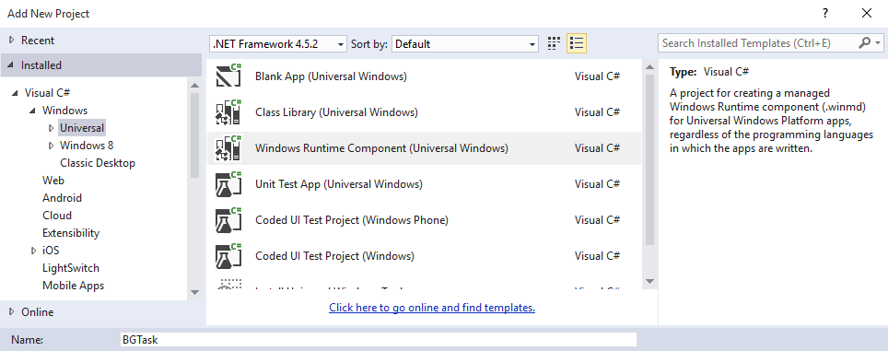b. Give it a name – BGTasks.

1. Implement the **IBackgroundTask** interface to **BG** class. It is under the namespace Windows.ApplicationModel.Background
2. Code Snippet : **BGTaskClass**
3. Go to Package.appmanifest > Declarations > Background Tasks > Add.
4. Check **System event**
5. 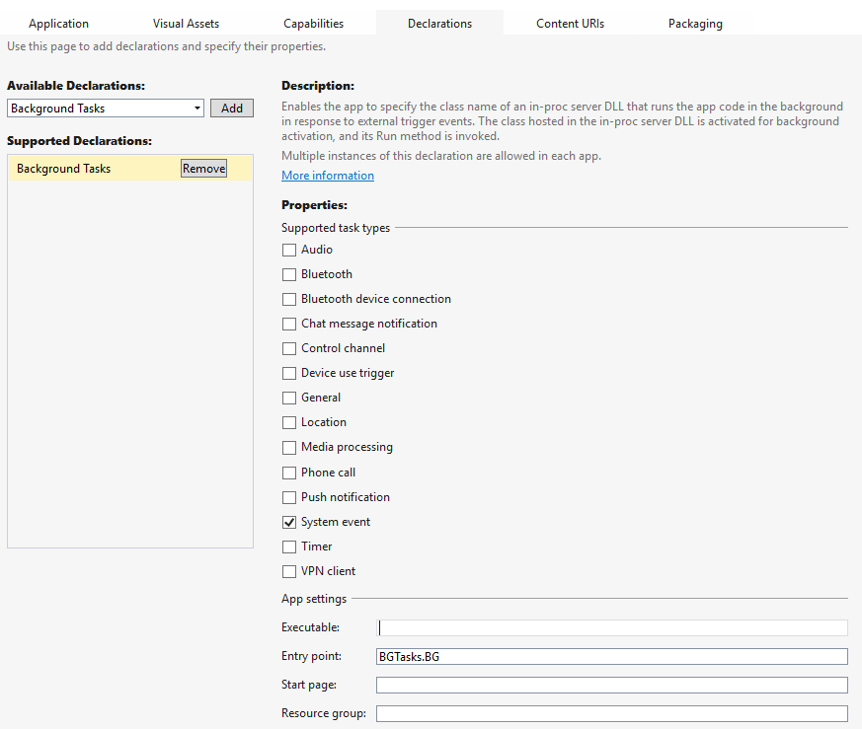Enter **BGTasks.BG** in the **Entry point**
6. Right Click on the **FutureUnleashedUWP Project** > Add new item > BlankPage > name it **BGTaskPage**
7. Right click on References in **FutureUnleashedUWP** Project > Add Reference > Projects > Solution > check **BGTasks** > Ok

Code Snippet: **BGTaskPage**

1. Pin the **FutureUnleashedUWP** Project to start > **Disconnect** the computer from Network > You can now see the live tile being updated with the last access time of network.

**Lab 6: b. Background Downloaders**

1. Right Click on **FutureUnleashedUWP** project > Add New Item > Blank Page > name it BackGroundTransfer.xaml
2. Open BackGroundTransfer.xaml

codesnippet : **BGTransferXaml**

1. a. Open **BackgroundTransfer.xaml.cs** Code Snippet: **BGTransferButton**b. Uncomment the last line

Code Snippet **– BGTransferProgress**

Create a new object of CancellationTokenSource in the constructor.

1. Go to Package.appxmanifest > Capabilities > **Picture Library**.

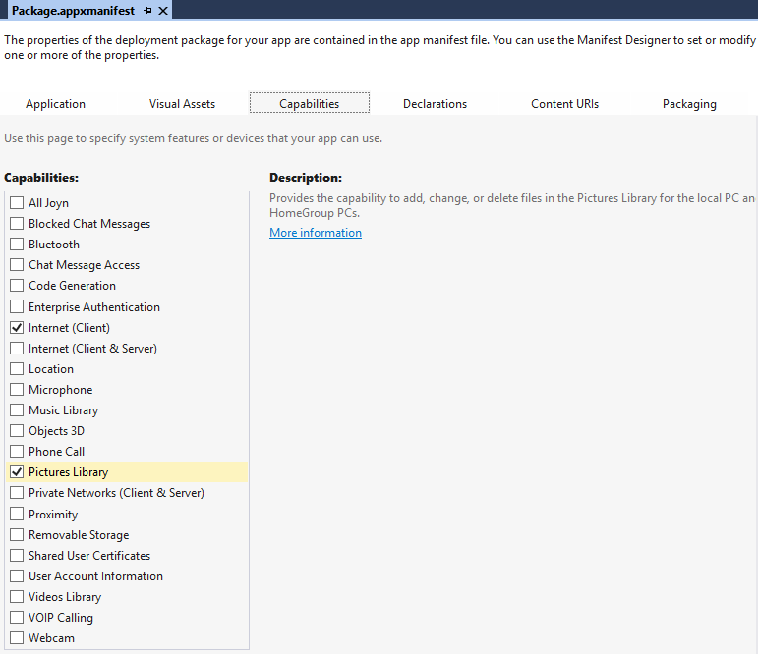

**Lab 7: a. Target contracts**

1. Right click on FutureUnleashedUWP project > File > New > Blank Page > name it **ShareTarget.xaml**
2. a. Go to **Package.appmanifest** > Declarations > **ShareTarget** > Add
3. Add new **DataFormat** – **Text** , **html** , **storagefiles** (seperately)
4. Check **Support Any File** type checkbox
5. Go to App.xaml.cs

Code Snippet : **OnShareTargetActivated**

1. Go to **ShareTarget**.xaml  
   Code snippet : **ShareTargetXaml**
2. Go to **ShareTarget**.xaml.cs  
   Code snippet : **ShareTarget**

**b.Share Source**

1. Right Click on FutureUnleashedUWP > Add New Item > Blank Page > Name it ShareSource.xaml
2. Open ShareSource.xaml

Code snippet : **ShareSourceXAML**

1. Open ShareSource.xaml.cs

Code snippet:

a. **ShareButtonCSharp**

a. **ShareSourceOnNavigatedTo**  
b. **ShareHandler**

**Lab 8: Cortana Integration for your app**

1. Right Click on FutureunleashedUWP project > Add New Item > **XML File** > name it **VoiceCommandDefinition.xml**
2. Open Package.manifest > Capabilities > **Microphone**
3. Code Snippet : **VCD**
4. Open App.xaml.cs

Code snippet : **CortanaRegister** and **CortanaOnActivated**

1. Right click FutureunleashedUWP > Add New Item > Blank Page > Name it CortanaPage.xaml

Open CortanaPage.xaml

Code snippet : **CortanaXaml**

1. Open CortanaPage.xaml.cs

Code snippet : **CortanaPage**