# Vinod Kumar M

@vinodk_sql

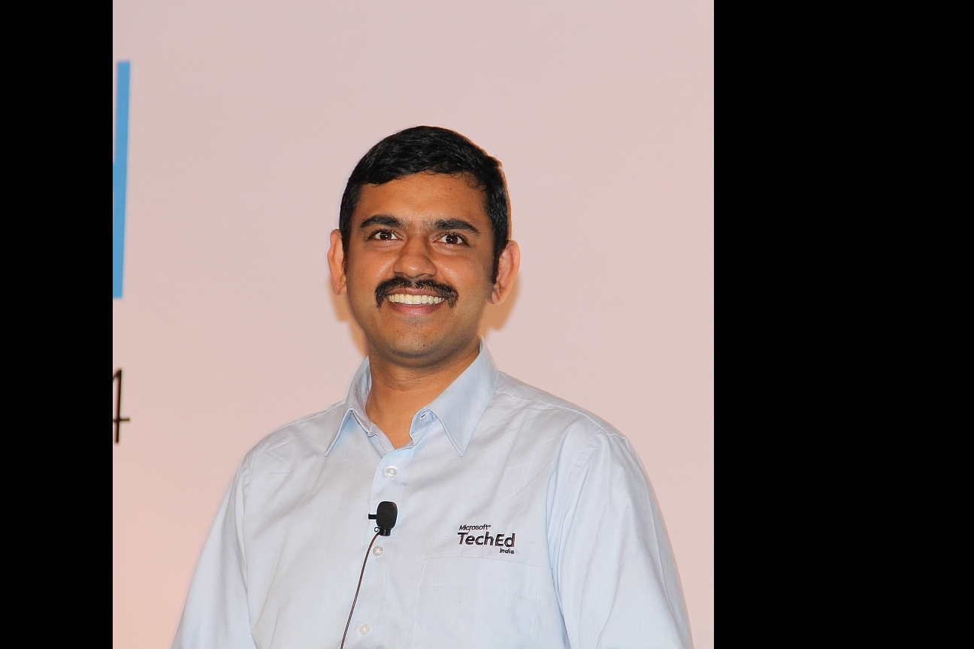

Vinod Kumar M currently works at the MTC as Technical Architect. He has been helping customers take technology decisions for their high performance enterprise software’s. He is a regular speaker in all Microsoft conferences for the past 10+ years on databases, application tuning, and performance tuning topics. He is author of two books and writes at various sites and on his blog.

# Rangarajan Srirangam

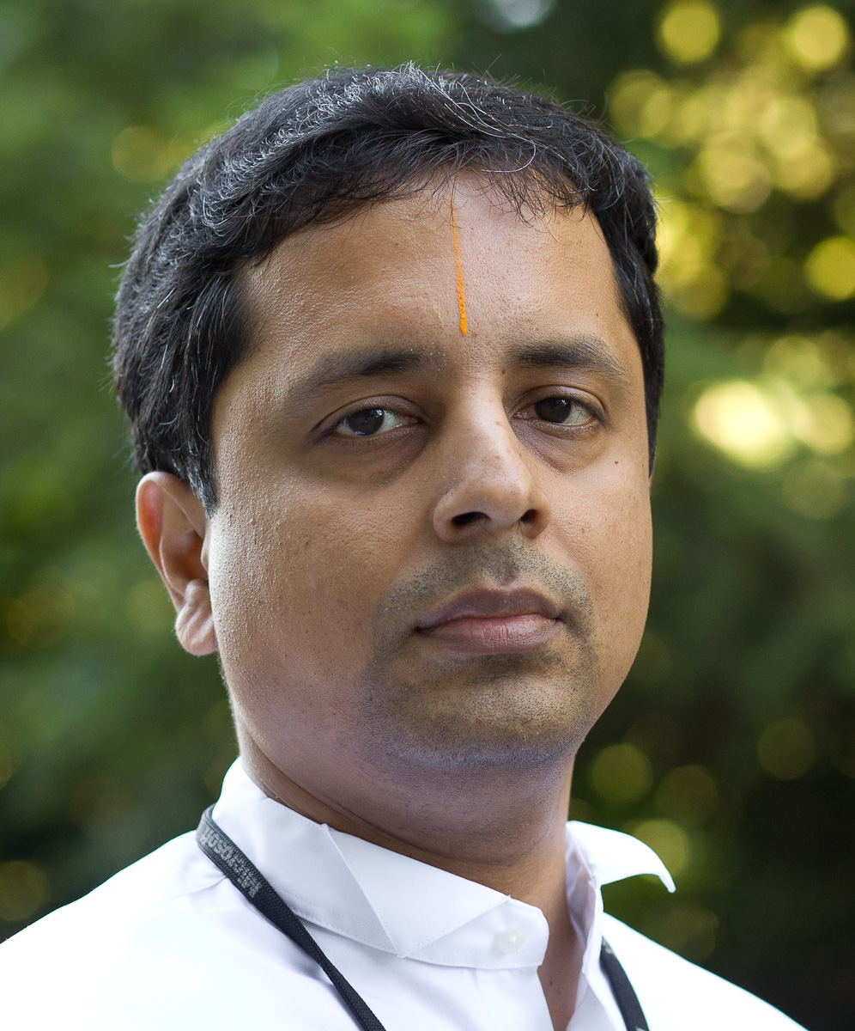

Rangarajan Srirangam is Senor Program Manager in the Azure Customer Advisory (Azure CAT) team. He has worked in the IT Industry for over 18 years and with Microsoft for the past 14 years. He has consulted on diverse projects for large customers and delivered complex solutions spanning multiple Microsoft technologies. Ranga specializes on Azure focusing on the developer and data technologies. He has spoken in many conferences and events and published technical papers. He currently works with field teams and customers on interesting Azure projects

# Aditee Rele

@aditeerele



Aditee has worked extensively with enterprise customers in India and Abroad, architecting and designing large scale enterprise solutions on Microsoft Stack with specific expertise in the Retail, Pharma and Manufacturing domain.

At Microsoft, Aditee leads technical evangelism for India and is responsible for driving adoption of Microsoft products & technologies for Devices, Apps and Cloud. In her role, she works with the developer ecosystem to help them build world-class solutions on the Microsoft Stack. In addition, she also works with large enterprises, small business, start-ups and ISV’s to provide strategic and technical guidance to them realize the potential of mobility and cloud for their businesses to fuel innovation.

Aditee is a proponent of women in technology and is passionate about helping women build and sustain long term careers in IT and also provide a platform for Women to be successful in their Entrepreneurial journey.

Mohammed Nasiruddin



Muhammad has been one of the first few advocates of Azure since its inception and has been an evangelist for Microsoft technologies for over 15 years

At Microsoft, he is responsible for evangelizing Azure and assisting partners and customers in adopting Azure. He has been instrumental in architecting, designing, developing and testing a large number of apps on Azure.

As part of his role he works on deploying a wide range of Open Source Technologies on Azure including Java, PHP, Drupal, MySQL, Mongo DB, Hadoop.

Manish Gupta

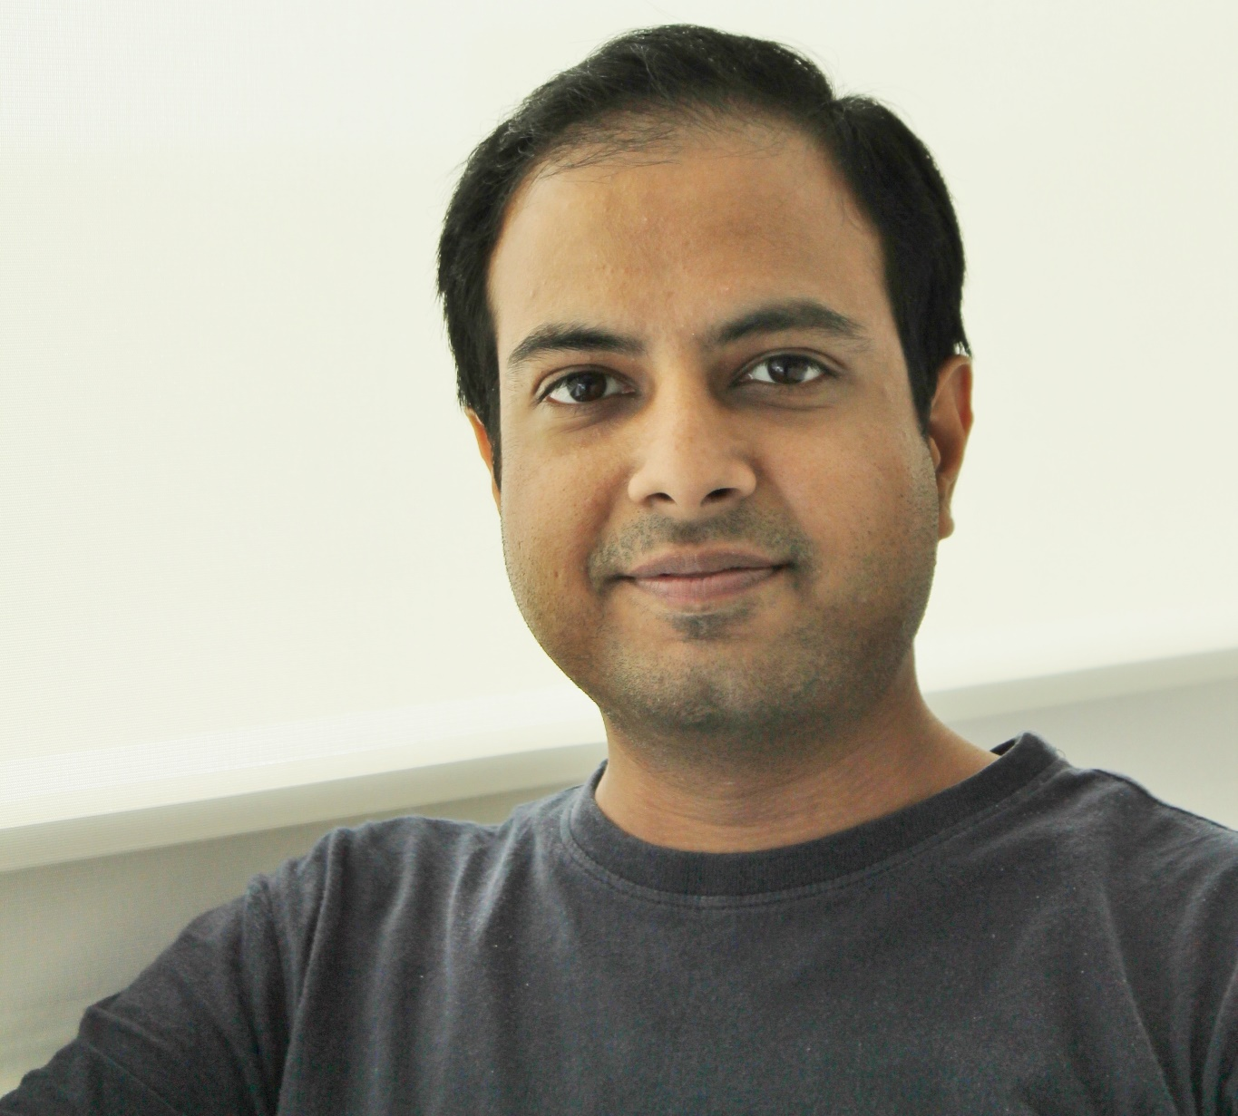

[Manish Gupta](http://research.microsoft.com/en-us/people/gmanish/) is a Senior Applied Scientist at the Bing team in Microsoft India R&D Private Limited at Hyderabad, India. He is also an Adjunct Faculty at International Institute of Information Technology, Hyderabad. He received his Masters in Computer Science from IIT Bombay in 2007 and his Ph.D. from the University of Illinois at Urbana-Champaign in 2013. Before this, he worked for Yahoo! Bangalore for two years. His research interests are in the areas of web mining, data mining and information retrieval. He has published more than 40 research papers in reputable referred journals and conferences. He has also co-authored two books: one on Outlier Detection for Temporal Data and another one on Information Retrieval with Verbose Queries.”

Prashanth Gupta



Prashant Gupta is Director in Microsoft Cloud + Enterprise Division with current focus on emerging market opportunities in data science. He has contributed to server computing business since 2008 with core focus around open cloud incl. introduction of linux in Azure IaaS, incubation of cross-platform App Insights in Visual Studio Online and acquisition of Revolution Analytics bringing parallel R in SQL and Azure ML. He also co-founded Microsoft Accelerator for India startups in May ’12 that later became Microsoft Ventures. Prashant started his career with Motorola in Chicago in 1999 and spent several years in cellphone business introducing new products incl. award-winning RAZR Maxx V6 – first 3.5G broadband device. He has MS degree from University of Florida, MBA from Kellogg and a recipient of IEEE Larry K. Wilson Award, Lt. Governor Gold Medal from Delhi College of Engineering.

# Shweta Gupta

@Shwetastweets

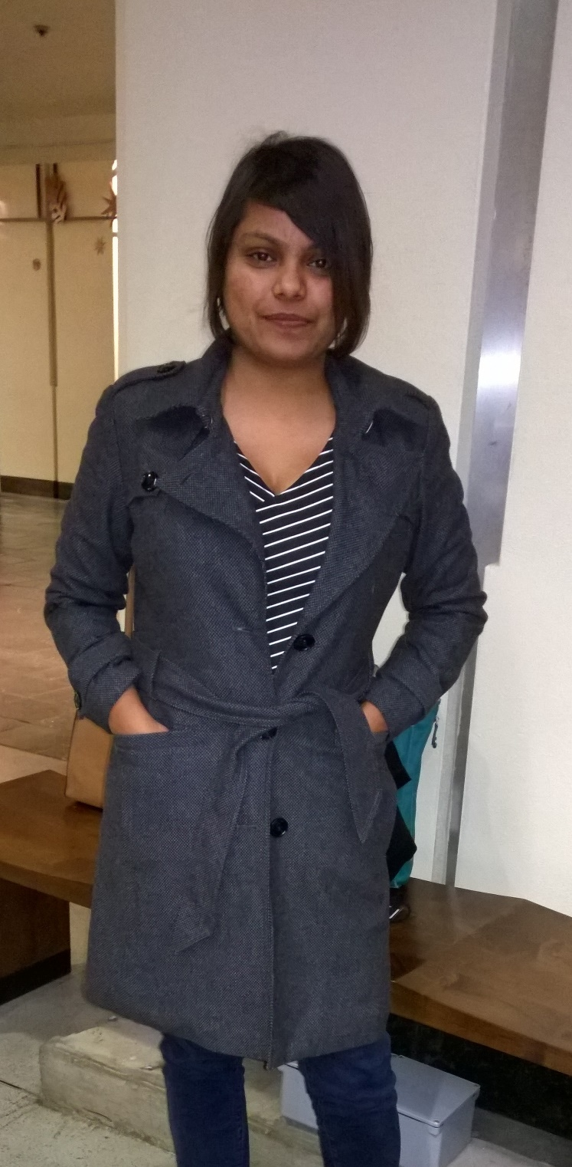

Shweta Gupta, is a Senior Program Manager with Microsoft and has been working on Microsoft Azure for more than four years. She works with partners in architecting, optimizing and hands down implementation to adopt Azure. She has a degree in Computer Application and Finance management and has an industry experience of eight years in financial reporting. She is passionate about technology, and off late Internet of Things.

Sagar Bhanudas Joshi

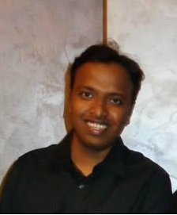

Sagar is a Technology Evangelist with Microsoft India, He has been with Microsoft for 4.5+ years and worked on various technologies including WPF, Windows Store Apps, Azure and Office. As a Technology Evangelist, he works closely with Partners to onboard their applications to Microsoft Cloud Platform, Windows Universal Apps and Office. He is passionate about devices and learning new technologies