**1.** A channel has a bit rate of 4 kbps and a propagation delay of 20 msec. For what range of frame sizes does stop-and-wait give an efficiency of at least 50%?

**answer:** 发送一帧的时间等于信道的传播延迟的2倍，信道的利用率为50%，所以，在帧长满足发送时间大于延迟时间的2倍是，效率将会高于50%。由于4kbps=4000bps故

4000*20*0.001*2=160bit

只有在帧长不小于160bit时，停止等待协议的效率才会至少是50%。

解此题可供参考的公式有两个，下面这两种情况下都可以得到答案：

一个是效率= $\frac{P}{P+2t}$ 其中P是传输一帧所需要的时间，t是端到端传送时延。所以可以由 $\frac{P}{P+2t}$ >=50%，解出帧N>=160bit；

二是中第42张中讲到的公式，公式综合考虑了多种因素，信道丢失率 $P_{f}$，帧头的大小 $n_{a}-n_{o}$，以及ACK的发送时间 $n_{a}/R$。在不考虑数据帧的处理时间tproc和ACK发送时间的情况下，我们可以推出帧的最小大小为160bit。答案详情参看上次文档。

作业中得到错误答案有两个（1）N>=80bit得出此答案的同学没有弄清楚停等协议，在停等协议公式1分母下面的2t是往返时间，而不是t。

（2）160kbit，单位换算错误。我可以负责任的告诉你没有哪个网络里面帧能够有十几万比特大小的，以太网里最大帧不过1526字节。

**2.** Imagine a sliding window protocol using so many bits for sequence numbers that wraparound never occurs. What relations must hold among the four window edges and the window size, which is constant and the same for both the sender and the receiver?

**answer:** 假设发送者的窗口为（S1，Sn）,接受者的窗口为（R1，Rn），窗口大小为W，则

需满足：0<=Sn-S1+1<=W

Rn-R1+1=W

S1<=R1<=Sn+1 即可。

这题答案很简单，可能有疑问的同学被题目的第一句话给迷惑了。第一句话是滑动窗口协议正常运行必要条件。

第一个式子很好理解，是已发送但未确认数据包和等待发送数据包的序列范围内的数据包总个数，如果窗口是从左向右滑动，已发送但未确认数据包序列号在等待发送数据包左侧。很显然这个值是不能大于窗口大小的。

第二个式子，通常在滑动窗口协议里，窗口的大小是在链接初期协商的，在此题中接收窗口等于发送窗口，表示接收方可以缓存发送方的任何帧。接收方可以通过接受的第一个帧的序列号R1来确认自己可以接收的帧序列号范围为W+R1-1。因此在接收方，可接收序列号范围就是窗口的小。序列号范围内的数据包个数是Ru-Rl+1而不是Ru-Rl。并不代表接收方缓存是满的。

第三个式子，Rl就是已发送但未确认数据包和等待发送数据包的边界，由于接收方缓存里只有那些已接受但未确认数据包，所以Rl>=Sl但一定有Rl<=Su+1，因为接收者缓存里不可能有发送者等待队列之外的数据。

**3.** A large population of ALOHA users manages to generate 50 requests/sec, including both originals and retransmissions. Time is slotted in units of 40 msec.

(a) What is the chance of success on the first attempt?

(b) What is the probability of exactly k collisions and then a success?

(c) What is the expected number of transmission attempts needed?

**answers:** (a) according to the definition, throughput of Slotted ALOHA, a frame will not suffer a collosion if no other frames are sent at the beginning of the same frame time, the probability of no other traffic during the same slot is P=e^-G;

50*40*0.001=2, so, G=2

P=e^-2=1/e^2

So, the chance of success on the first attempt is 1/e^2.

(b) that is to say, a transmission requiring exactly K+1 attempts. So, the probability is P=(e^-G)*(1-e^-G)^K, G=2,

So, P=(1-e^2)^K(e^-2)=0.135*(1-0.135)^K=0.135*0.865^K

(c)according to the definition of throughput of slotted ALOHA, the expected number of transmissions E= e^G, G=2,

So, E=e^2

参考《计算机网络（第五版）》美·特南鲍姆204~205页内容，解题关键是先求出G（单位时隙里生成的帧数），剩下的都是套公式。

**3. What’s the remainder obtained by dividing x7+x5+1 by the generator polynomial x3+1?**

**Solution:**

The polynomial x7+x5+1 corresponds to 10100001, the generator polynomial is 1001. So the remainder is 10100001%1001 = 111.

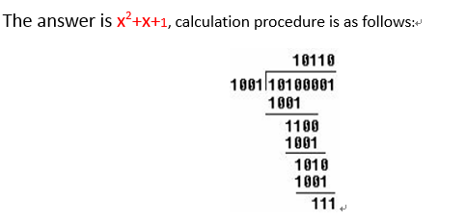

1．A group of N stations share a 56-kbps pure ALOHA channel. Each station outputs a 1000-bit frame on an average of once every 100 sec, even if the previous one has not yet been sent(e.g., the stations can buffer outgoing frames). What“is the maximum value of N?

答：对于100%的ALOHA，可用的带宽是0.184×56 Kb/s?=10.304?Kb/ s。每个站需要的带宽为1000/100=10b/s。而N=10304/10≈1030 所以，最多可以有1030 个站，即N 的最大值为1030。

3．Measurements of a slotted ALOHA channel with an infinite number of users show that 10 percent of the slots are idle.

(a) What is the channel load, G?

(b) What is the throughput?

(c) Is the channel underloaded or overloaded?

答：（a）从泊松定律得到p0＝e^-G ，因此G＝-lnp0= -ln0.1＝2.3

（b） 由题知S＝G *e -G ， G＝2.3，e^ -G=0.1

S=2.3×0.1=0.23

（c）因为每当G>1 时，信道总是过载的，因此在这里信道是过载的。

4．What is the baud rate of the standard 10 Mbps Ethernet?

答：以太网使用曼彻斯特编码，意味着发送每一位都有两个信号周期，标准以太网的数据率为10MB/S，一次波特率是数据率的两倍，为20MBaud。

5．A 1-km-long, 10-Mbps CSMA/CD LAN (not 802.3)has a propagation speed of 200 m/?sec. Repeaters are not allowed in this system. Data frames are 256 bits long, including 32 bits of header, checksum, and other overhead. The first bit slot after a successful transmission is reserved for the receiver to capture the channel in order to Send a 32-bit acknowledgement frame. What is the effective data rate, excluding overhead, assuming that there are no collisions?

答：依题意知道一公里的铜电缆中单程的传播时间为1、200000=5 usec，往返的时间为2t=10 usec，我们知道，一次完整的传输分为六步，发送者侦听铜电缆的时间为10 usec，若线路可用发送数据帧传输时间为256 bits、10MPS=25.6usec，数据帧最后一位到达时传播的延迟为5.0usec，接听者侦听铜电缆的时间为10 usec，若线路可用接听者发送确认帧所用的时间为3.2 usec，确认帧最后一位到达时的传播延迟为5.0 usec，总共58.8 sec,在这期间发送了224 bits的数据，所以数据率为3.8MPS。

6．Two CSMA/CD stations are each trying to transmit long (multiframe) files. After each frame is sent, they contend for the channel, using the binary

exponential backoff algorithm. What is the probability that the contention ends on round k, and what is the mean number of rounds per contention period?

答：把获得通道的尝试从1 开始编号。第i 次尝试分布在2 i-1 个时隙中。因此，i 次尝试碰撞的概率是2-(i-1)，开头k-1 次尝试失败，紧接着第k 次尝试成功的概率是：

Pk=（1-2^-（k-1））[2^-0*2*-1*······*2^-(k-2)]=（1-2^-（k-1））2^-(k-1)(k-2)/2所以每个竞争周期的平均竞争次数是Σkpk(k=1,2,3······∞)

8．An IP packet to be transmitted by Ethernet is 60 bytes long, including all its headers. If LLC is not in use, is padding needed in the Ethernet frame, and

if so, how many bytes?

答：最小的以太帧是64bytes，包括了以太帧头部的二者地址、类型/长度域、校验和。因为头部域占用18 bytes 报文是60 bytes，总的帧长度是78 bytes, 已经超过了64-byte 的最小限制。因此，不需要填补。

1. Describe distance vector (DV) algorithm. Discuss the feature of the DV routing algorithm.

Solution:

1. The basic idea of DV algorithm

Each node *x* begins with *Dx*(*y*), an estimate of thecost of the least-cost path from itself to node *y*, for all nodes in *N*. Let ***D****x*= [*Dx*(*y*): *y*in *N*] be node *x*’s distance vector, which is the vector of cost estimates from *x* to allother nodes, *y,* in *N.* With the DV algorithm, each node *x* maintains the followingrouting information:

• For each neighbor *v*, the cost *c*(*x,v*) from *x* to directly attached neighbor*v*

• Node *x*’s distance vector, that is, ***D****x*= [*Dx*(*y*): *y* in *N*], containing *x*’s estimate ofits cost to all destinations, *y,* in *N*

• The distance vectors of each of its neighbors, that is, ***D****v*= [*Dv*(*y*): *y* in *N*] for eachneighbor *v* of *x*

In the distributed, asynchronous algorithm, from time to time, each node sendsa copy of its distance vector to each of its neighbors. When a node *x* receives anew distance vector from any of its neighbors *v*, it saves *v*’s distance vector, andthen uses the Bellman-Ford equation to update its own distance vector as follows:

*Dx*(*y*) _ min*v*{*c*(*x,v*) *+ Dv*(*y*)} for each node *y* in *N*

If node *x*’s distance vector has changed as a result of this update step, node *x* willthen send its updated distance vector to each of its neighbors, which can in turnupdate their own distance vectors. Miraculously enough, as long as all the nodescontinue to exchange their distance vectors in an asynchronous fashion, each costestimate *Dx*(*y*) converges to *dx*(*y*), the actual cost of the least-cost path from node *x*to node *y*

1. The feature of the DV routing algorithm

The distancevector(DV) algorithm is iterative, asynchronous, and distributed.

It is distributedin that each node receives some information from one or more of its directlyattached neighbors, performs a calculation, and then distributes the results of itscalculation back to its neighbors.

It is iterative in that this process continueson until no more information is exchanged between neighbors. (Interestingly, thealgorithm is also self-terminating—there is no signal that the computation shouldstop; it just stops.)

The algorithm is asynchronous in that it does not require all ofthe nodes to operate in lockstep with each other.

2. Consider a configuration in which packets are sent from computers on a LAN to systems on other networks. All of these packets must pass through a router that connects the LAN to a widearea network and hence to the outside world.

Let us look at the traffic from the LAN through the router. Packets arrive with a mean arrivalrate of 5 per second. The average packet length is 144 bytes, and it is assumed that packet length is exponentially distributed. Line speed from the router to the wide-area network is9600 bps. The following questions are asked:

1. What is the utilization of the link of the router?
2. What is the mean residence time in the router?
3. How many packets are in the router, including those waiting for transmission and the one currently being transmitted (if any), on the average?

Solution:

1. Mean arrival rate(throughput): X=5 packets/sec

Average service time: S=((144bytes/packet)*(8bits/byte))/9600bps=0.12sec/packet

Utilization(time the router is busy): U=X*S=(5 packets/sec)*(0.12 sec/packet)=0.6

1. The mean residence time is T=S/(1-U)=(0.12 sec/packet)/(1-0.6)=0.3 sec/packet
2. Number of packets in the router is E[n]=U/(1-U)=1.5 packets
3. Consider the arrival traffic characterized by a token bucket with parameters ρ (average rate) = 1 Mbps, M (maximum output rate) = 2 Mbps, and C (token capacity) = 200Kb. What is the minimum rate r that needs to be allocated by a router in order to guarantee a delay no larger than 50ms?

Solution:

We build the equation according to the rule: the bits flowed in the router are equal to the bits flowed out the router. Let S be burst length, the maximum accumulative amount of arrival traffic to the router is C+ρS=MS.We get S=C/(M-ρ). When the router deal the arrival traffic at the minimum rate r with a delay no larger than 50ms, let D=50ms and the equation is MS=r*(S+D). So,



1. Describe the border gateway protocol (BGP) and discuss how a packet would be transmitted among different autonomous system (AS).

Solution:**Border GatewayProtocol** version 4 (BGP4)

We just learned how ISPs use RIP and OSPF to determine optimal paths for sourcedestinationpairs that are internal to the same AS. Let’s now examine how paths aredetermined for source-destination pairs that span multiple ASs.

BGPprovides each AS a means to

1. Obtain subnet reachability information from neighboring ASs.

2. Propagate the reachability information to all routers internal to the AS.

3. Determine “good” routes to subnets based on the reachability information andon AS policy.

1. Suppose that frames are 1250 bytes long including 25 bytes of head. Also assume that ACK frame are 25 bytes long. Calculate the efficiency of stop-and-wait ARQ in a system that transmits at R=1Mbps and with reaction time of 1ms for channels with a bit error of 10-6, 10-5, 10-4.

Solution:

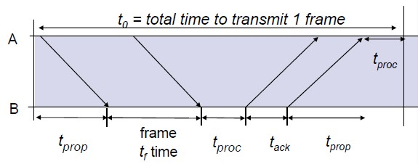

From the above figure and condition, we know the total time to transmit 1 frame is t0=2(tprop+tproc)+tf+ta.Here, 2(tprop+tproc) is the reaction time of 1ms, tf is the time to transmit the fames nf=1250 bytes with the head nh=25 bytes and ta is the time to transmit the ACK frame na=25 bytes. And the useful size of the frame is (nf-nh). Moreover, the probability of transmitting a frame without errors is (1-Pe). So the transmission efficiency is as follows.



When Pe=10-6,η=87.50%, when Pe=10-5,η=87.50%, when Pe=10-4,η=87.49%.

1. Describe the TCP congestion control scheme. Derive the delay modeling for TCP traffic in fixed congestion window when WS/R < RTT+S/R, assume that link bandwidth is R bps; maximum segment size is S bits, file object size is F bits, fixed window size is W segments, RTT is round trip time.

Solution:

TCP must use end-to-end congestion control rather than network-assisted congestion control, since the IP layer provides no explicit feedback tothe end systems regarding network congestion.

1. The basic idea of TCP congestion control scheme

The TCP congestion-control mechanism operating at the sender keepstrack of an additional variable, the **congestion window**. The congestion window,denoted cwnd, imposes a constraint on the rate at which a TCP sender can send trafficinto the network. Specifically, the amount of unacknowledged data at a sender maynot exceed the minimum of cwndand rwnd, that is:LastByteSent-LastByteAcked $≤$ min{cwnd, rwnd}.

1. The delay model for TCP traffic

From the above condition, cwnd=W $≤$ RTT*R/S + 1 and the cwnd is fixed. So, when R and S both are fixed and RTT is dynamic, the cwnd is the minimum (RTT*R/S + 1). When the network is perfect (RTT is smallest), though the network is not in congestion and the rwnd is big enough, the send rate can’t be increased. It is because the cwnd is limited the send rate.

*************

Link-State (LS) Routing algorithm OSPF

In practice this is accomplishedby having each node broadcast link-state packets to *all* other nodes in thenetwork, with each link-state packet containing the identities and costs of itsattached links.

Theresult of the nodes’ broadcast is that all nodes have an identical and complete viewof the network. Each node can then run the LS algorithm and compute the same setofleast-cost paths as every other node.

*************

Two routing protocols have been used extensivelyfor routing within an autonomous system in the Internet: the **Routing InformationProtocol (RIP)** and **Open Shortest Path First (OSPF)**.

RIP is a distance-vector protocol.The maximum cost of a path is limited to 15, thus limiting the use of RIP toautonomous systems that are fewer than 15 hops in diameter.In RIP, routing updatesare exchanged between neighbors approximately every 30 seconds using a**RIP response message**. The response message sent by a router or host containsa list of up to 25 destination subnets within the AS, as well as the sender’sdistance to each of those subnets. Response messages are also known as **RIPadvertisements**.

OSPF is a link-state protocol that usesflooding of link-state information and a Dijkstra least-cost path algorithm.With OSPF, a router broadcasts routing information to *all* other routers in theautonomous system, not just to its neighboring routers. A router broadcasts linkstateinformation whenever there is a change in a link’s state (for example, a changein cost or a change in up/down status). It also broadcasts a link’s state periodically(at least once every 30 minutes), even if the link’s state has not changed.

When multiple paths to a destination have the samecost, OSPF allows multiple paths to be used.(balance the network burden)*Integrated support for unicast and multicast routing.Support for hierarchy within a single routing domain.*

******************************************************************************************************************************************

* How long does it take to send a file of 640,000 bits from host A to host B over a circuit-switched (TDM) network?
  + All links are 1.536 Mbps
  + Each link uses TDM with 24 slots/sec
  + 500msec to establish end-to-end circuit

2. Packet-switching: store-and-forward



* Takes L/R seconds to transmit (push out) packet of L bits on to link of R bps
* Entire packet must arrive at router before it can be transmitted on next link: *store and forward*
* delay = 3L/R (assuming zero propagation delay

Example:

* L = 7.5MbitsR = 1.5 Mbps
* delay = 15 sec

3. Packet switching versus circuit switching

Packet switching allows more users to use network!

* 1 Mb/s link
* each user:
  + 100 kb/s when “active”
  + active 10% of time
  + circuit-switching:
  + 10 users
* packet switching:
  + with 35 users, probability > 10 active less than .0004

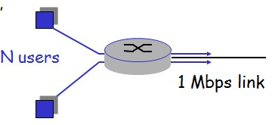

Q: how did we get value 0.0004?

4.Caravan analogy

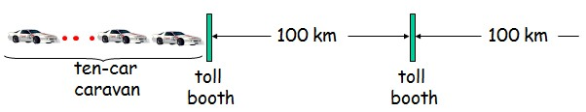

* Cars “propagate” at   
  100 km/hr
* Toll booth takes 12 sec to service a car (transmission time)
* car~bit; caravan ~ packet
* Q: How long until caravan is lined up before 2nd toll booth?
* Time to “push” entire caravan through toll booth onto highway = 12*10 = 120 sec
* Time for last car to propagate from 1st to 2nd toll both: 100km/(100km/hr)= 1 hr
* A: 62 minutes
* Cars now “propagate” at 1000 km/hr
* Toll booth now takes 1 min to service a car
* Q: Will cars arrive to 2nd booth before all cars serviced at 1st booth?
* Yes! After 7 min, 1st car at 2nd booth and 3 cars still at 1st booth.
* 1st bit of packet can arrive at 2nd router before packet is fully transmitted at 1st router!
  + See Ethernet applet at AWL Web site

5.

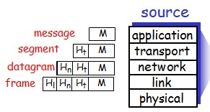

**6.Could the congestion problem be solved with a large buffer space?**

Too little memory:too much traffic will lead to buffer overflow and packet loss

• Too much memory:the queues and the delays can get so long that by the time the packets come out of the switch, most of them have already timed out and have been retransmitted by higher layers packets (or their retransmissions) have to be dropped after they have consumed precious network re-sources.

• Too much memory in the intermediate nodes is as harmful as too little memory.

**7.Could the congestion problem be solved with high-speed links?**

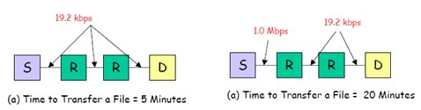

* Introducing high-speed links without proper congestion control can lead to reduced performance the same speed

(a) The time to transfer a particular file was five minutes.

(b) The link between the first two nodes was replace by a fast 1 Mbits link, the transfer time increased to 20 Minutes!

* With the high-speed link, the arrival rate to the first router became much higher than the departure rate, leading to long queues, buffer overflows, and packet losses that caused the transfer time to increase.
* The protocols have to be designed specifically to ensure that this increasing range of link speeds does not degrade the performance.

8.Could the congestion problem be solved with high-speed processors?

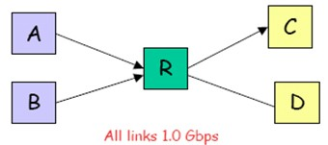

* Similar to that for links. Introduction of a high-speed processor in an existing network may increase the mismatch of speeds and the chances of congestion.
* Introducing high-speed links without proper schemes Congestion occurs even if all links and processors are of the same speed.
* An example of the balanced configuration
* - Assume all processors and links have a throughput capacity of 1 Gbits. A simultaneous transfer of data from nodes A and B to node C can lead to a total input rate of 2 Gbits per second at the router R while the output rate is only 1 Gbits per second, thereby, causing congestion.

1. solutions?

* Congestion in networks is a dynamic problem. It cannot be solved with static solutions alone.
* We need protocol designs that protect networks in the event of congestion.
* The explosion of high-speed networks has led to more unbalanced networks that are causing congestion.
* In particular, packet loss due to buffer shortage is a symptom not a cause of congestion.
* Solution: proper protocols and mechanisms design, e.g. Admission Control, Scheduling, et. al

1. “end to end” and “point to point”
   1. end to end communications:
      1. Data communications on a path between the source node and the destination node. The path possibly comprises multiple links
   2. point to point communications:
      1. Data communications on a link connecting the adjacent nodes
2. Performance Issue

* Stop-and-wait
* Without error t0 =2tprop+2tproc+tf+tack=2tprop+2tproc+nf/R+na/R
* Let Pf be the probability that a frame transmission has errors and needs to be retransmitted.
* tsw=t0/(1-Pf)Efficiency is: ηsw=((nf-no)/tsw)/R
* Where nf, nano are the total number of bits in the frame,number of bits in the ack, and number of bits in the overhead. R is the bandwidth.

1. Constrains on Windows’ Size(a sliding window protocol)

n bits sequence numberThe size of sending window: WsThe size of receiving window: WrWs+ Wr≤2n

1. Binary exponential backoff

* When a collision occur

each station waits 0 or 1 slots before try again

* In general, after i collision, a random number between 0 and 2i -1 is chosen.
* Maximum is 1023
* After 16 collisions, the controller gives up and reports failure.

1. Three types of switching fabrics

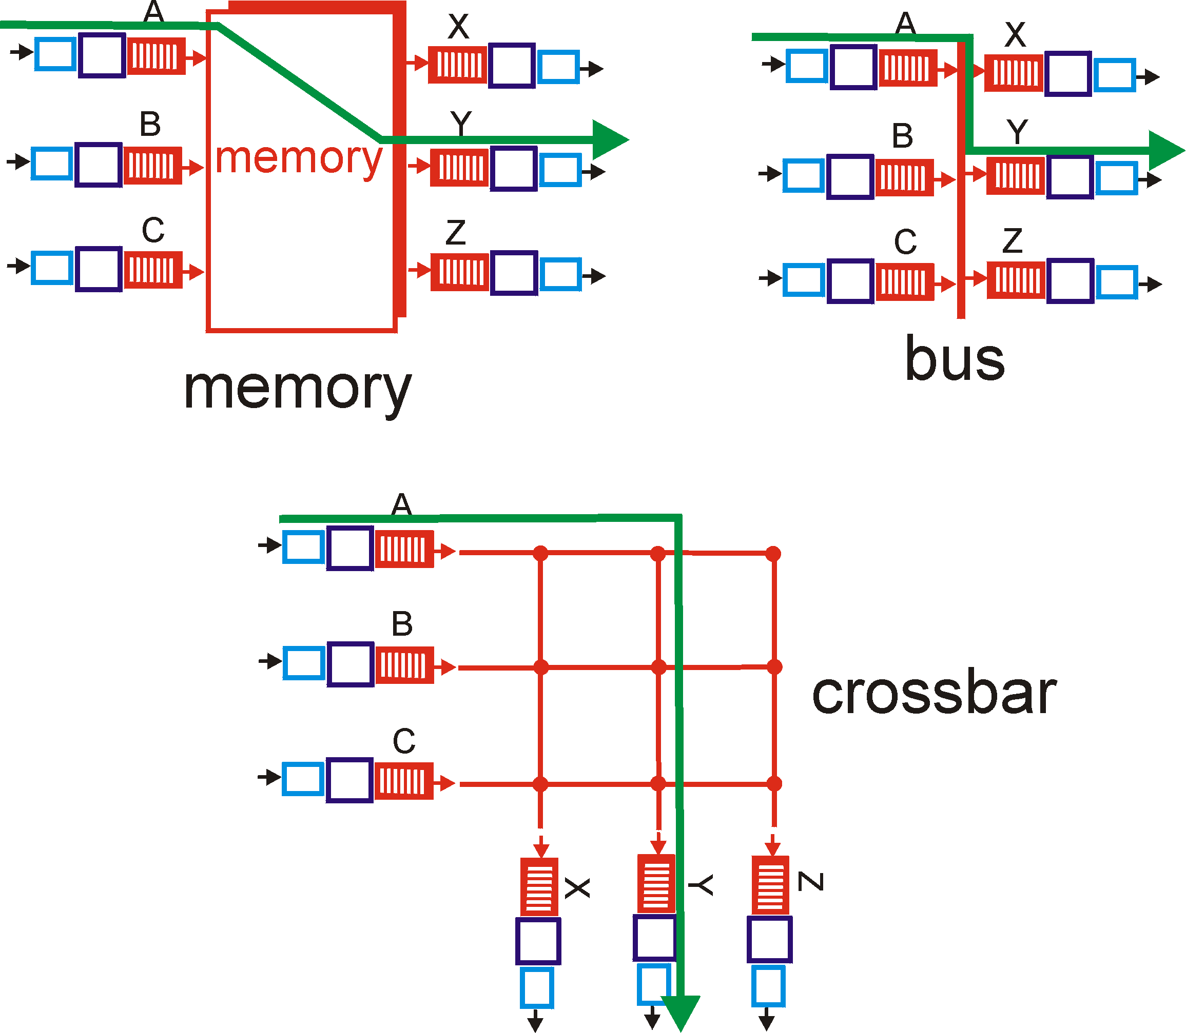

1. Input Port Queuing

* Fabric slower than input ports combined ->queueing may occur at input queues
* Head-of-the-Line (HOL) blocking: queued datagram at front of queue prevents others in queue from moving forward
* *queueing delay and loss due to input buffer overflow!*

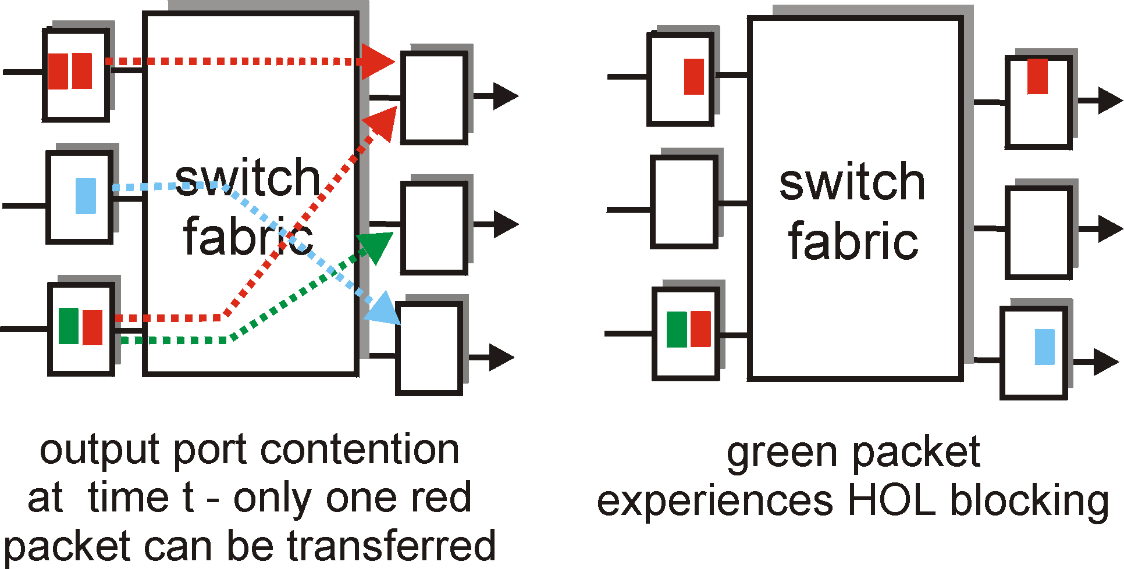

16IP Fragmentation and Reassembly

