**Pore Recognition**

The sweat pore is a circular hole in the fingerprint ridge. It is a high security fingerprint feature that greatly enhances the security of fingerprint recognition. As shown in Figure 1, There are three main types of pores: closed state, one side opening, double side opening. Now you have two tasks, please choose one.

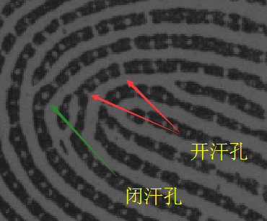 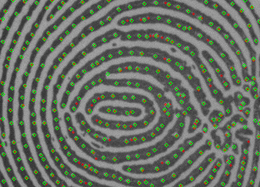

Figure 1 three type of pores Figure 2 result of pore recognition

1. **Please output pores coordinates base on project1.**

Possible methods include normalization, binarization, Jain, Ray, DoG model filtering.

[1]Jain A K，Chen Y，Demirkus M．Pores and Ridges：High-Resolution Fingerprint Matching Using Level 3 Features[J]．IEEE Transactions on Pattern Analysis & Machine Intelligence，2007，29(1)：15-27．

[2]Ray M，Meenen P，Adhami R．A Novel Approach to Fingerprint Pore Extraction[C]．Proceedings of the Thirty-Seventh Southeastern Symposium on．IEEE，2005：282-286．

1. **Please classify the pore images.**

An existing data set includes some pore-centered images 794 299 224 42 7 2 1 1805 and background images.5498 1000 2765 1463 7770 5601 2807 1327 Please extract image features and classify the images using traditional machine learning methods.

**Attention:**

1. You can use the program languages you prefer (such as c/c++, python, Matlab, etc).
2. Download data from the QQ group. For task(1), there are some instance including image and pore coordinates. For task(2), please set the training data and testing data from the given images.
3. Group members ≤ **3**.
4. Source codes and projects are required when you submit your report. You should send your project to the email: **[hitszdippro@sina.com](mailto:dip2018_project@163.com)**.
5. The file name is as ‘Pro2_leadername.zip/rar’. (**The leader must list every member’s work in the report and give a member list**).
6. For task (1), You need to give a visual result of the pore extraction such as figure2 for given images, and output the pore coordinates in txt. For task (2), you need to list your accuracy and other information in the report. we will verify the result in your report using new test dataset, so make sure your code can run in our computer and make sure the results can be reproduced.
7. **You need to give the program documentation and the necessary interfaces so that we can run it.**
8. **Paper report submitted to 602，Deadline**: 2018.5.10.

**TIPS:**

If you want to get high score, you need:

1. A high accuracy rate.
2. Creative ideas.