Makey Makey pour GarageBand azerty

Modifier le mapping des touches du MakeyMakey pour un clavier français

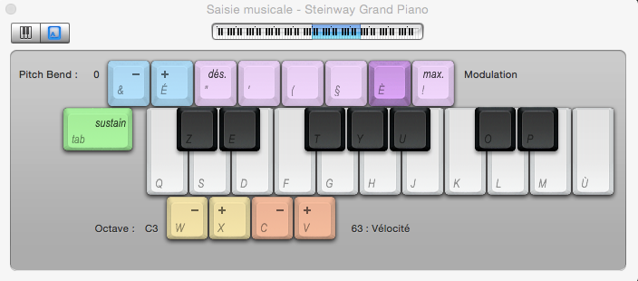

Modification du tableau de keyCodes dans settings.h du code Arduino MakeyMakey 1.4.1

/* Garageband keyboard */

int keyCodes[NUM_INPUTS] = {

// top side of the makey makey board

////// note: for fr keyboard but MakeyMakey use US keymap

////// sound control keys below

'w', // up arrow pad (w instead of z for azerty keyboard mismatch)

'e', // down arrow pad

't', // left arrow pad

'y', // right arrow pad

'u', // space button pad

'o', // click button pad

// female header on the back left side

///// note keys below

'a', // pin D5 (a instead of q for azerty keyboard mismatch)

's', // pin D4

'd', // pin D3

'f', // pin D2

'g', // pin D1

'h', // pin D0

// female header on the back right side

'j', // pin A5

'k', // pin A4

'l', // pin A3

';', // pin A2 (; instead of m for azerty keyboard mismatch)

'p', // pin A1

'\'' // pin A0 (' instead of ù for azerty keyboard mismatch)

};