Makey Makey pour LMMS azerty

Modifier le mapping des touches du MakeyMakey pour un clavier français

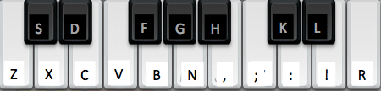

Modification du tableau de keyCodes dans settings.h du code Arduino MakeyMakey 1.4.1

/* LMMS keyboard */

int keyCodes[NUM_INPUTS] = {

// top side of the makey makey board

'z', // up arrow pad (z instead of w for azerty keyboard mismatch)

's', // down arrow pad

'x', // left arrow pad

'd', // right arrow pad

'c', // space button pad

'v', // click button pad

// female header on the back left side

///// note keys below

'g', // pin D5 (a instead of q for azerty keyboard mismatch)

'b', // pin D4

'h', // pin D3

'n', // pin D2

'j', // pin D1

',', // pin D0

// female header on the back right side

';', // pin A5

'l', // pin A4

':', // pin A3

'm', // pin A2 (; instead of m for azerty keyboard mismatch)

'!', // pin A1

'r' // pin A0 (' instead of ù for azerty keyboard mismatch)

};