**第二册读写作业参考答案：选词填空和翻译**

**Unit 3 Journey through the odyssey years**

**P70 Banked Cloze**

1) K 2) E 3) A 4) C 5) L 6) I 7) G 8) N 9) H 10) O

**答案是图片中的横排！！！**

**ABCD**

**EFGH**

**…**

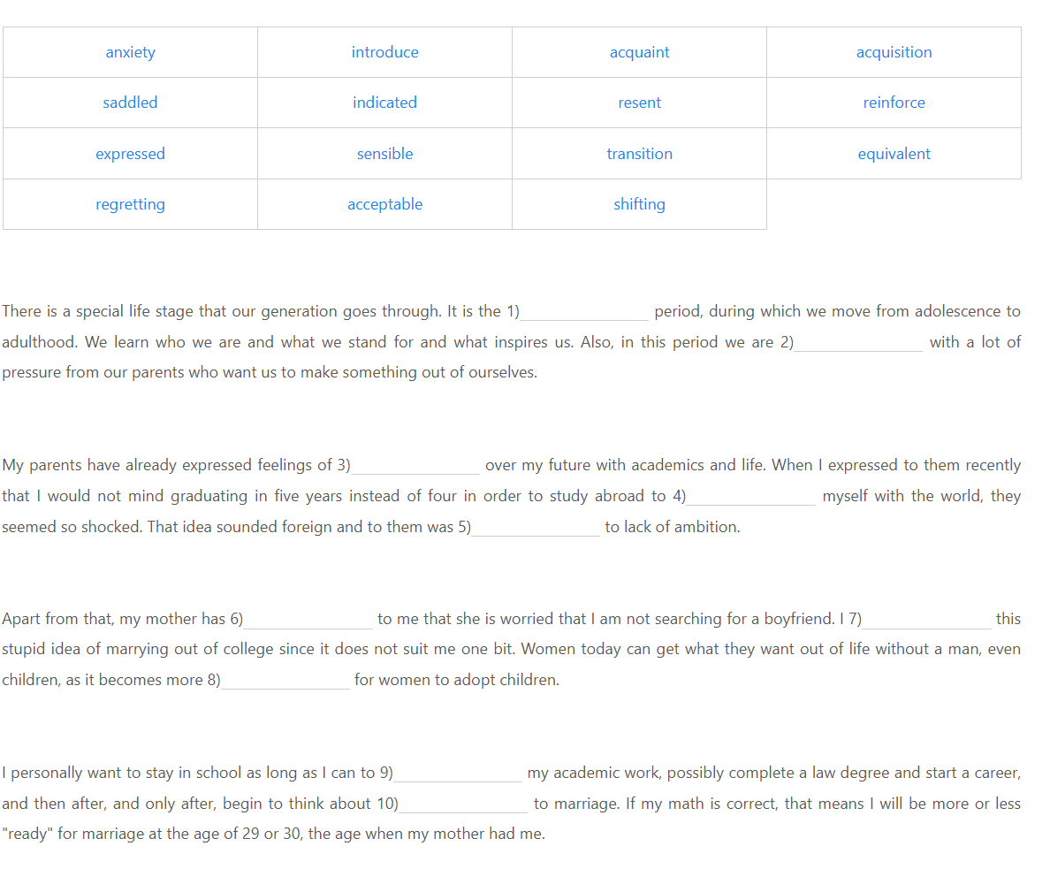

**P74 Translation**

孝道（filial piety）是中国古代社会的基本道德规范（code of ethics)。中国人把孝视为人格之本、家庭和睦之本、国家安康之本。由于孝道是儒家伦理思想的核心，它成了中国社会千百年来维系家庭关系的道德准则。它毫无疑问是中华民族的一种传统美德。孝道文化是一个复合概念，内容丰富，涉及面广。它既有文化理念，又有制度礼仪（institutional etiquette)。一般来说，它指社会要求子女对父母应尽的义务，包括尊敬、关爱、赡养老人等等。孝道是古老的“东方文明”之根本。

Filial piety is the basic code of ethics in the ancient Chinese society. Chinese people consider filial piety as the essence of a person’s integrity, family harmony, and the nation’s well-being. With filial piety being the core of Confucian ethics, it has been the moral standard for the Chinese society to maintain the family relationship for thousands of years. It’s undoubtedly a traditional Chinese virtue. The culture of filial piety is a complex concept, rich in content and wide in range. It includes not only cultural ideas but also institutional etiquettes. Generally speaking, it refers to the obligation of children to their parents required by the society, including respect, care, support for the elderly and so forth. Filial piety is fundamental to the ancient “Oriental civilization”.

**Unit 4 College sweethearts**

**P98 Banked Cloze**

1) N 2) B 3) G 4) I 5) H 6) L 7) E 8) M 9) K 10) C

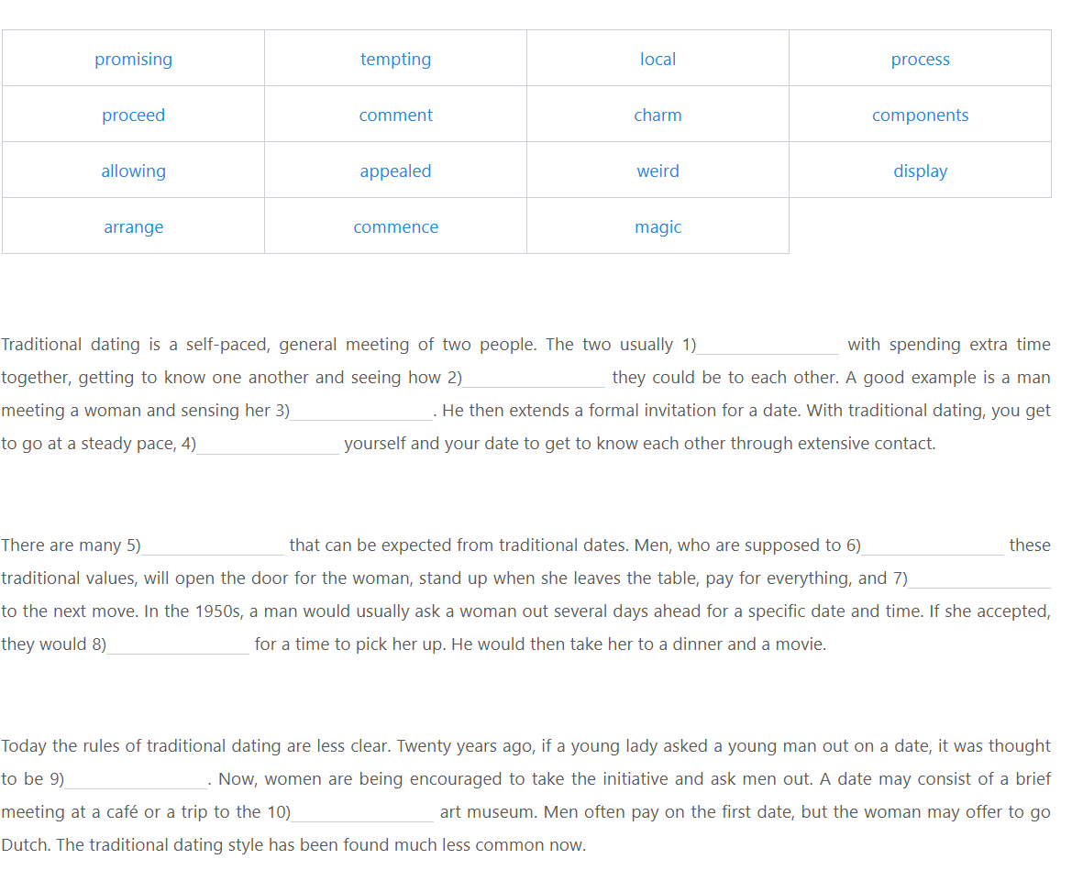

**P102 Translation**

农历七月初七是中国的七夕节（ Qixi Festival )，是中国传统节日中最具浪漫色彩的一个节日。一些大的商家每年都举办不同的活动，年轻人也送礼物给他们的情人。因此，七夕节被认为是中国的“情人节” ( Valentine’s Day )。七夕节来自牛郎与织女 ( Cowherd and Weaving Maid ）的传说。相传，每年的这个夜晚，天上的织女都会与牛郎相会。所以，在七夕的夜晚，人们可以看到牛郎织女在银河（the Milky Way）相会。姑娘们也会在这一天晚上向天上的织女乞求智慧，以获得美满姻缘。但随着时代的变迁，这些活动正在消失，唯有标志着忠贞爱情的牛郎织女的传说一直流传民间。

July 7th on the Chinese calendar is Chinese Qixi Festival, the most romantic of all the traditional Chinese holidays. Every year, some big businesses organize various activities, and young people send gifts to their lovers. As a result, the Qixi Festival is considered to be Chinese “Valentine’s Day”. The Qixi Festival is derived from the legend of Cowherd and Weaving Maid. The legend holds that on this particular night every year the Weaving Maid in heaven meets with Cowherd. So, people can see Cowherd and Weaving Maid meeting in the Milky Way on the night of Qixi. On this night, girls would also beg Weaving Maid for some wisdom for a happy marriage. But, with the changing of times, these activities are diminishing. All that remains is the legend of Cowherd and Weaving Maid, a sign of faithful love, continuously circulated among the folk.

**Unit 5 Spend or save ― The student’s dilemma**

**P126 Banked Cloze**

1) B 2) D 3) O 4)E 5) F 6) C 7) K 8) H 9) N 10) I

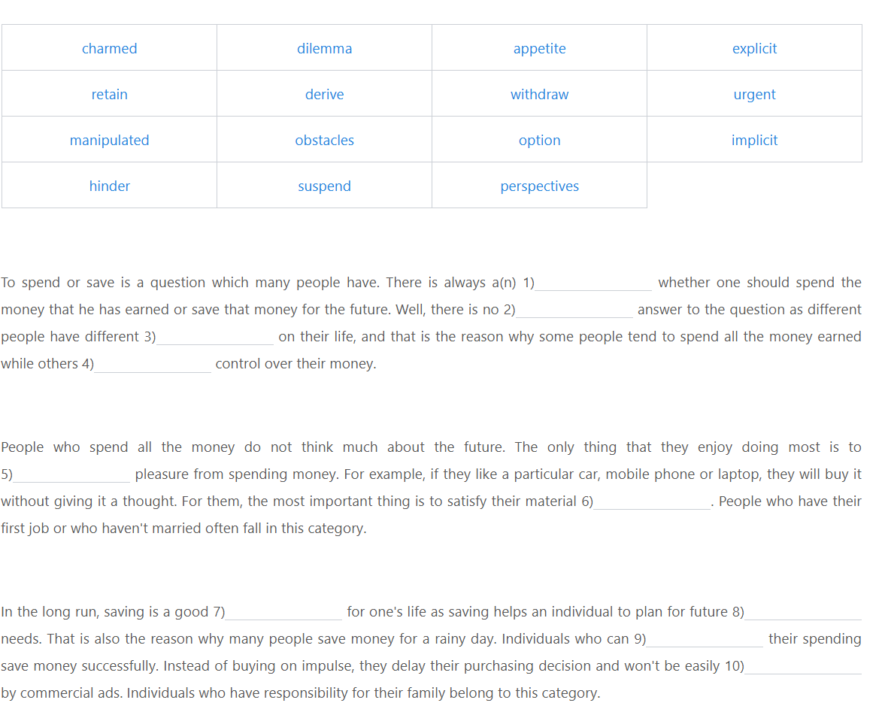

**P130 Translation**

丝绸之路（Silk Road）是我国古代一条连接中国和欧亚大陆（Eurasia）的交通线路，由于这条商路以丝绸贸易为主，故称“丝绸之路”。作为国际贸易的通道和文化交流的桥梁，丝绸之路有效地促进了东西方经济文化交流和发展，对世界文明进程有着深远影响。当前，在新的历史条件下，我国提出了“一带一路”(One Belt, One Road)（即“丝绸之路经济带”和“21世纪海上丝绸之路”)的战略构想。“一带一路”以合作共赢为核心，强调相关各国的互利共赢和共同发展。这一战略一经提出即受到沿线各国的积极响应。

The Silk Road is a traffic route in the ancient times connecting China and Eurasia. This trade route focuses on the trade of silk, hence the name “the Silk Road”. As an international trade channel and a bridge of cultural exchanges, the Silk Road effectively improved the economic and cultural exchanges and development between the East and the West, exerting a profound impact on the progress of the world civilization. Nowadays, under the new historical circumstances, our country proposes the strategy of “One Belt, One Road” (namely the Silk Road Economic Belt and the 21st-century Maritime Silk Road). The strategy of “One Belt, One Road” focuses on cooperation and mutual benefits, emphasizing mutual benefits, win-win, as well as common development of the related countries. Once proposed, the strategy has received positive responses from the related countries along the road.

**第三册读写作业参考答案：选词填空和翻译**

**Unit 3 Audrey Hepburn — A true angel in this world**

**P73 Banked Cloze**

1) C 2) I 3) F 4) L 5) A 6) H 7) K 8) N 9) E 10) B

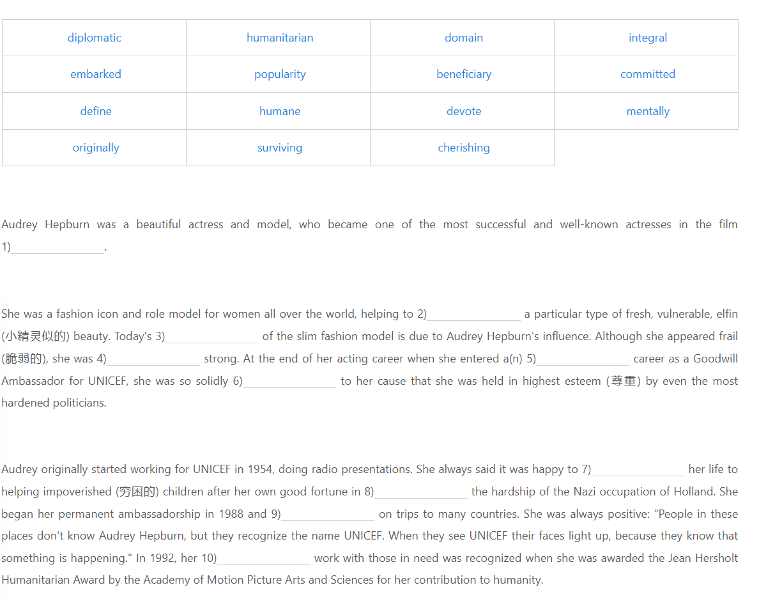

**P77 Translation**

水墨画（ink and wash painting）是中国独具特色的传统艺术形式之一，是中国国画的代表。它大约始于唐代，兴盛于宋代和元代，距今已有一千多年的历史，其间经历了不断的发展、提高和完善。水墨画的创作工具和材料是具有浓厚中国特色的毛笔、宣纸和墨，其作品特点也与此紧密相关。例如，水和墨相互调和，使作品具有干湿浓淡的层次。水墨和宣纸的交融渗透也使画作善于表现丰富的意象，从而达到独特的审美效果。水墨画在中国绘画史上具有很高的地位，甚至被认为是衡量东方绘画艺术水平的标准。

Ink and wash painting, one of the unique traditional art forms of China, is representative of Chinese painting. It began around the time of the Tang Dynasty, and then prospered in the Song and Yuan dynasties. With a history of over one thousand years, it has experienced constant development, improvement and perfection. The tools and materials used to create ink and wash painting, i.e. brushes, rice paper, and ink, are characteristic of Chinese culture and closely related to the features of the paintings. For example, the mixing of water and ink creates different shades of dryness, wetness, thickness and thinness. The integration and infiltration of water, ink, and rice paper enables such paintings to convey rich images, and hence to achieve unique aesthetic effects. Ink and wash painting holds a high status in the history of Chinese painting, and it is even regarded as the criterion to evaluate the artistic level of Oriental paintings.

**Unit 7 Surviving an economic crisis**

**P191 Banked Cloze**

1) E 2) J 3) B 4) H 5) A 6) K 7) G 8) I 9) C 10) N

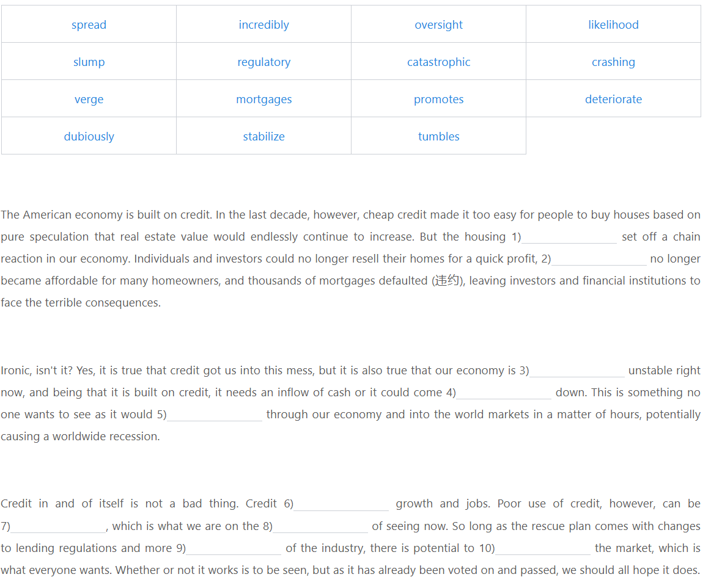

**P195 Translation**

上海自贸区（Shanghai Free Trade Zone）是中国政府于2013年设立在上海的自由贸易区。上海自贸区总面积为28.78平方公里，是中国大陆境内第一个自由贸易区，也是进行一系列经济改革的“试验田”(testing ground)。设立上海自贸区是顺应全球经贸发展新趋势，实行更加积极主动开放战略的一项重大举措。其主要任务是为全面深化改革开放探索新路径、积累新经验。上海自贸区作为试点（pilot project)，是中国经济的“试金石”(touchstone)，将为深化改革、促进经济活力起到积极的推动作用。

Shanghai Free Zone is a free trade zone in Shanghai that was launched in 2013 by the Chinese government. Covering an area of 28.78 square kilometers, Shanghai Free Trade Zone is the first of its kind in China’s mainland, and is regarded as a “testing ground” for a number of economic reforms. The establishment of the free trade zone is a significant measure taken to actively promote the opening-up strategy under the new global economic and trade situation. It undertakes a major task to explore new ways and accumulate new experience for the deepening of reform and opening up in an all-round way. As a pilot project, Shanghai Free Trade Zone will become a “touchstone” for Chinese economy. It will play an active role in deepening reforms and boosting economic vigor.

**Unit 8 Reflections of a Chinese mother in the West**

**P220 Banked Cloze**

1) J 2) L 3) C 4) O 5) K 6) G 7) A 8) H 9) E 10) D

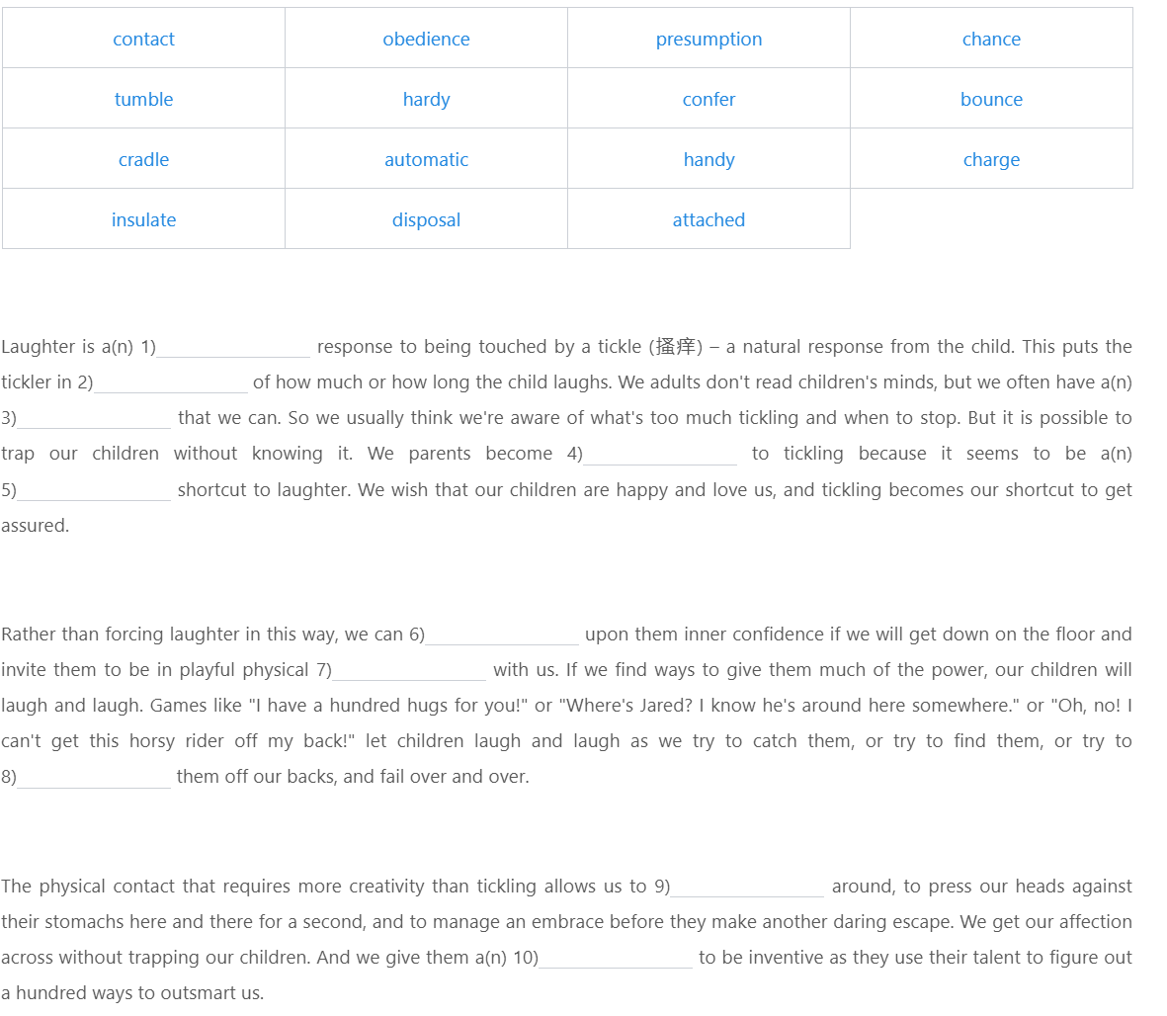

**P224 Translation**

中央电视台春节联欢晚会（简称“春晚”）自1983年开办以来，已成为中国人文化生活中不可缺少的文化消费品和一个挥之不去的文化符号。虽然众口难调，但必须承认的是，“春晚”已成为公众所不可缺少的“新民俗”。春晚不仅是一台晚会，更是一种仪式与象征，一种文化与标签，一种情感与寄托。随着时代发展及新媒体的出现，观众的选择和需求日渐多样化，“春晚”也在与时俱进，以满足大众日益增长的文化需求。

The CCTV Spring Festival Gala (Spring Festival Gala for short), which was started in 1983, has become an indispensable cultural consumer product and a cultural symbol in the cultural life of the Chinese people. Though it’s hard to satisfy the tastes of all the people, it has to be admitted that the Spring Festival Gala has become a “new custom” for the public that they can’t live without. The Spring Festival Gala is more than a gala; it is a ritual and a symbol, a culture and a label, and an emotion and a place where people entrust their hearts to. With the development of the times and the emerging of new media, the audiences are having more diversified choices and demands. Correspondingly, the Spring Festival Gala is also advancing with the times to satisfy the growing cultural needs of the people.

**第四册读写作业参考答案：选词填空和翻译**

**Unit 5 The weight men carry**

**P139 Banked Cloze**

1) H 2) D 3) N 4) G 5) A 6) F 7) O 8) K 9) J 10) E

**选项顺序是横排！！！**

**ABCD**

**EFGH**

…

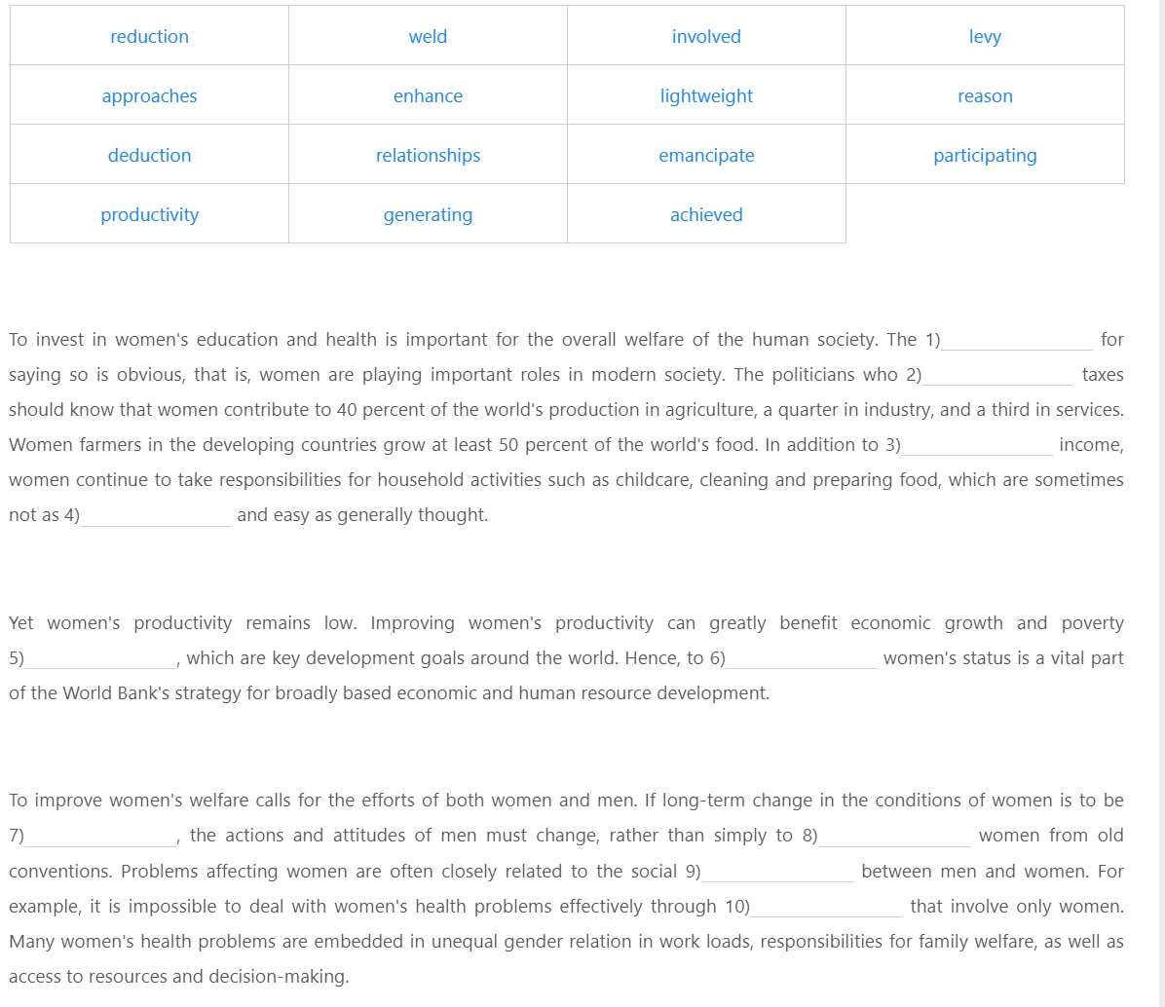

**P173 Translation**

博鳌亚洲论坛 (Boao Forum for Asia) 是一个非政府、非营利性的国际组织。它是由25个亚洲国家和澳大利亚发起的，于2001年正式成立，总部位于中国的海南省博鳌镇。博鳌亚洲论坛以平等、互惠、合作和共赢为主旨，致力于推动亚洲各国之间的经济交流、协调与合作，并增强亚洲与世界其他地区的对话和联系。它为有关国家的政府、企业及专家学者提供了一个共商亚洲以及全球事务的高层次平台。通过区域经济的进一步合作，博鳌亚洲论坛将推进亚洲国家实现发展目标，为建设一个更加繁荣、稳定、和平的新亚洲作出重要贡献。

Boao Forum for Asia (BFA) is a non-governmental, non-profit international organization. Initiated by 25 Asian countries and Australia, it was officially founded in 2001. The organization is headquartered in Boao Town in China’s Hainan Province. With equality, mutual benefit, cooperation and win-win as its objectives, BFA is devoted to promoting economic exchanges, coordination and cooperation between Asian countries as well as enhancing dialogs and ties between Asia and other parts of the world. The forum provides a high-level platform where governments, businesses and scholars from relevant countries discuss Asian and global affairs. Through further regional economic cooperation, BFA will facilitate the realization of Asian countries’ goals and contribute to a new Asia that boasts greater prosperity, stability and peace.

**Unit 6 The coming energy crisis**

**P202 Banked Cloze**

1) D 2) J 3) N 4) H 5) O 6) B 7) K 8) G 9) E 10) L

**选项顺序是横排！！！**

**ABCD**

**EFGH**

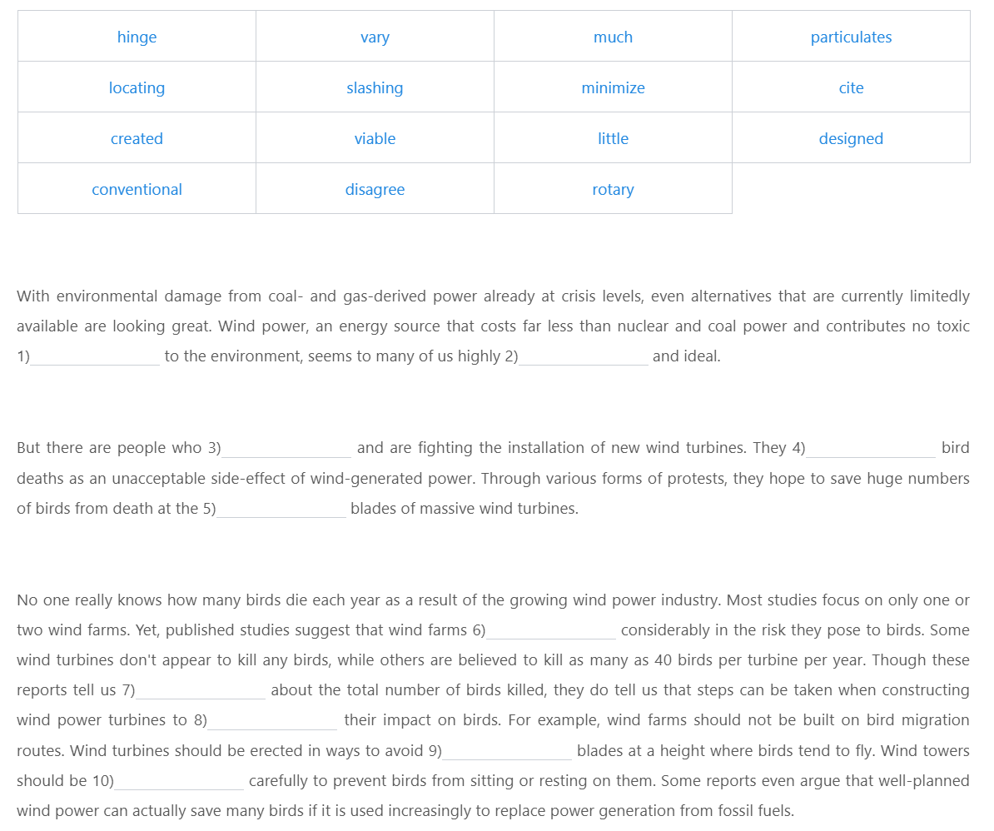

**P205 Translation**

城乡一体化是我国现代化和城市化发展的一个新阶段，是要通过对城乡发展实行统筹规划，并通过体制改革和政策调整，破除城乡二元经济结构，实现城乡在政策上平等，在产业发展模式上互补，让农村居民享受到与城镇居民同样的文明和福利。城乡一体化是一项重大而深刻的社会变革。它使整个城乡经济能够全面、协调、可持续地发展。只有大力推进城乡一体化，妥善处理城乡关系，加强城乡合作，缩小城乡差距，才能确保到2020年我国实现全面建设小康社会的宏伟目标。

Urban-rural integration is a new stage of China’s modernization and urbanization process. It aims to break the urban and rural dual economic structure through making integrated plans for urban and rural development, and through system reform and policy adjustment, so that the urban and rural areas will finally achieve equal policies and realize complementary developing patterns, enabling the rural residents to enjoy the same level of civilization and equal benefits with the urban residents. Urban-rural integration is a significant and profound social reform which enables comprehensive, coordinated and sustainable development of the entire urban-rural economy. Only by enhancing urban-rural integration, and by properly managing urban-rural relationships, increasing urban-rural collaboration, and narrowing the gap between urban and rural areas, can we guarantee that our country realize the blueprint goal of building a well-off society in an all-round way by 2020.