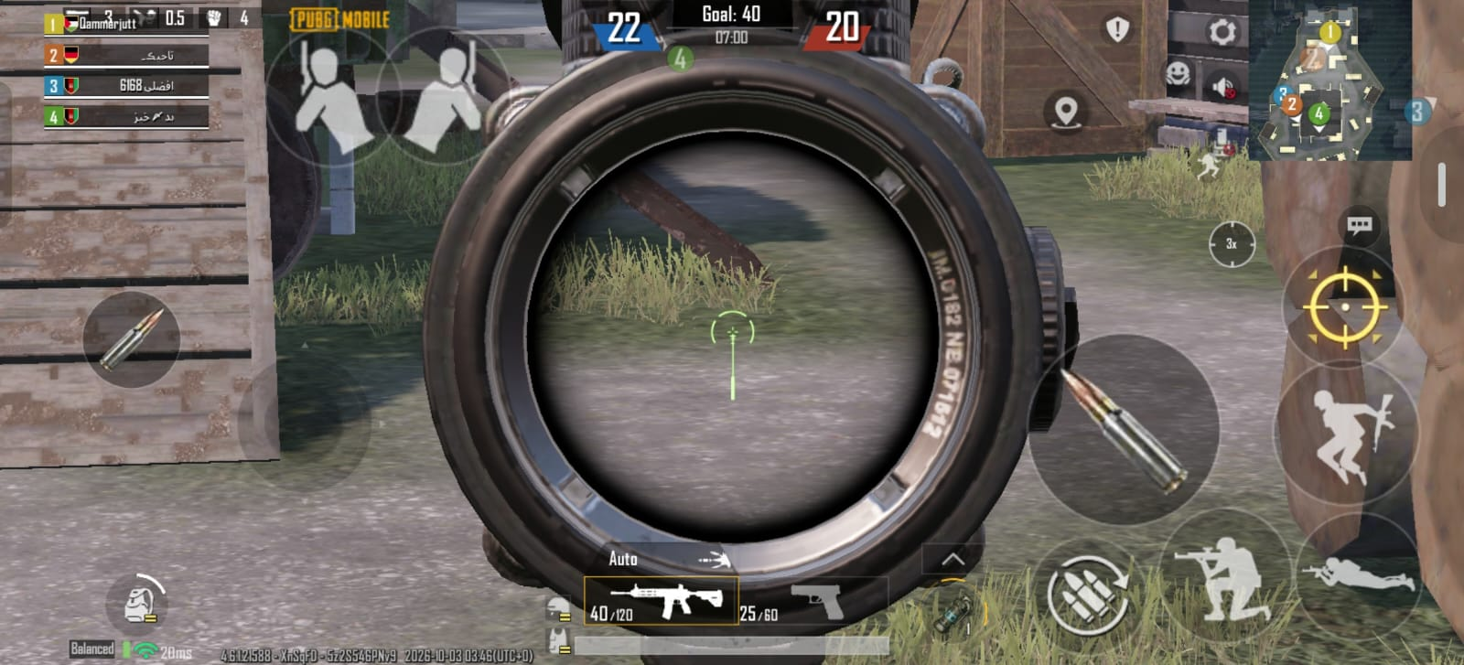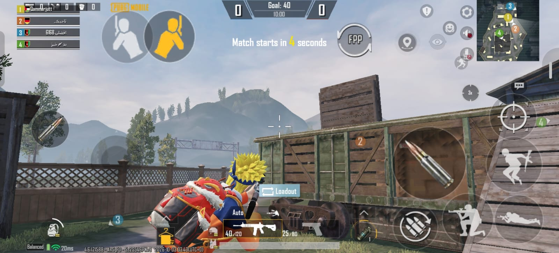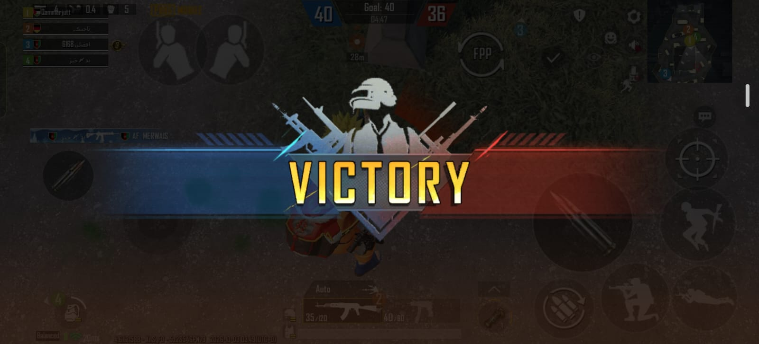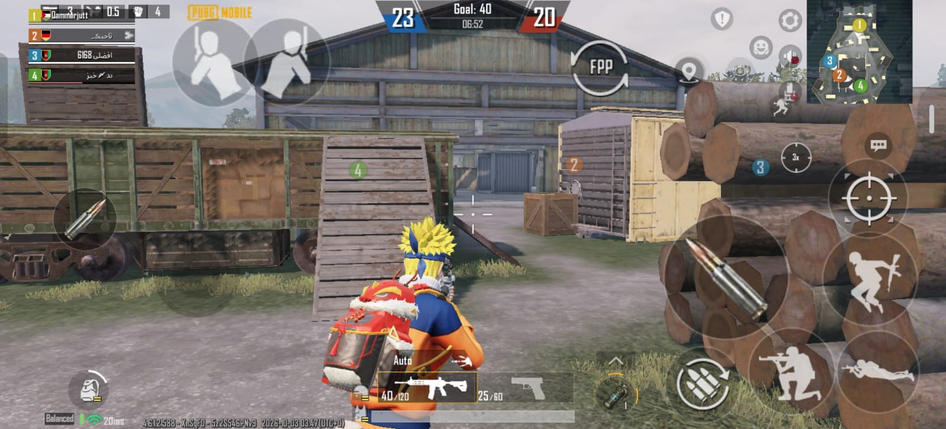Mechanics:
- Jump
- Run
- Fire
- Climb
- Crouch
- Slide
- Peek
- Auto Spawn
- Kill Count and Timer

Dynamics:
- Shoot while using eye button.

Aesthetics:
- Complete Arena

Inspired From Team Death Match
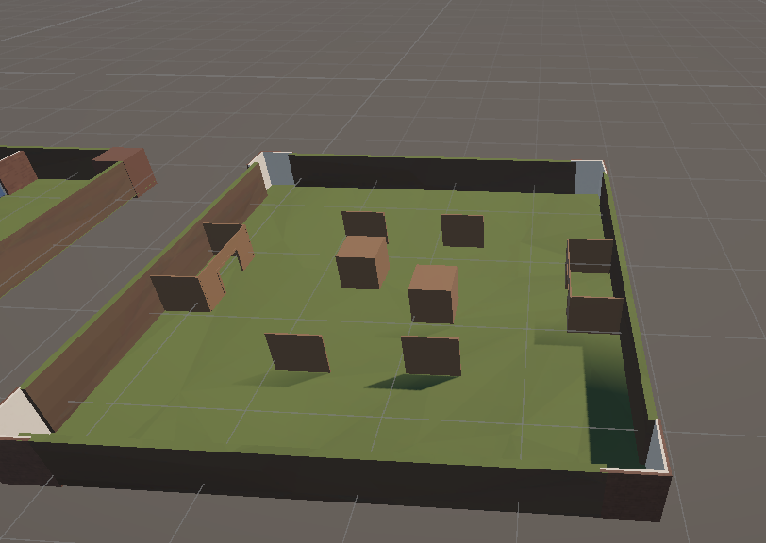

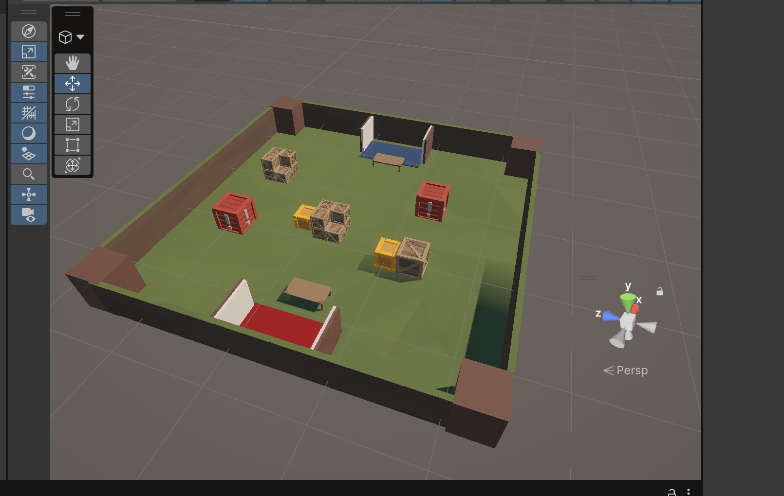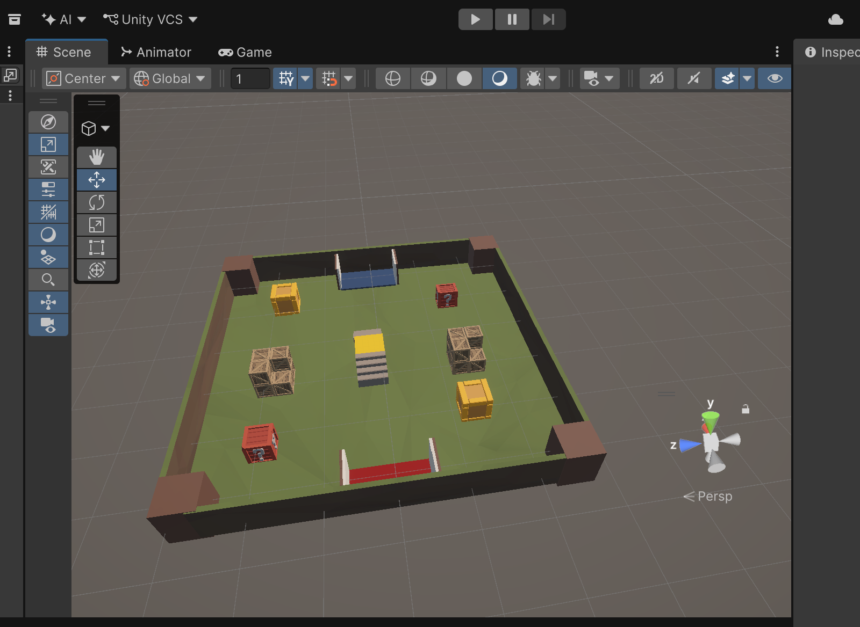
Inspired From Hop Ball 3D:
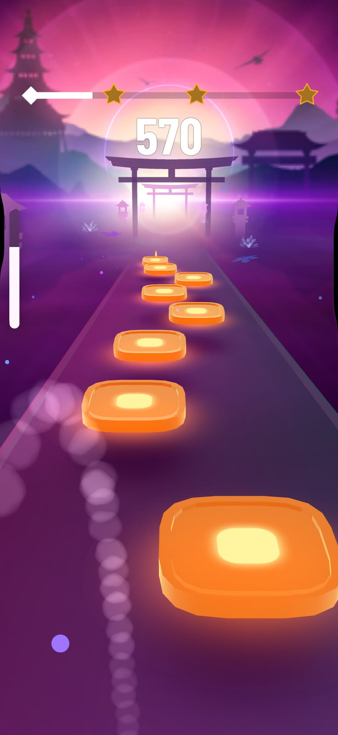

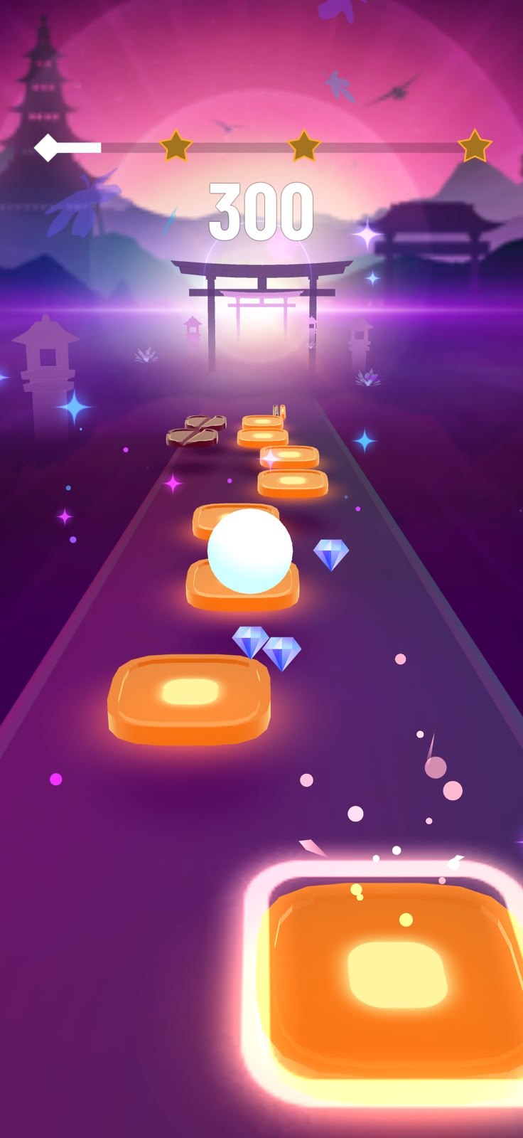
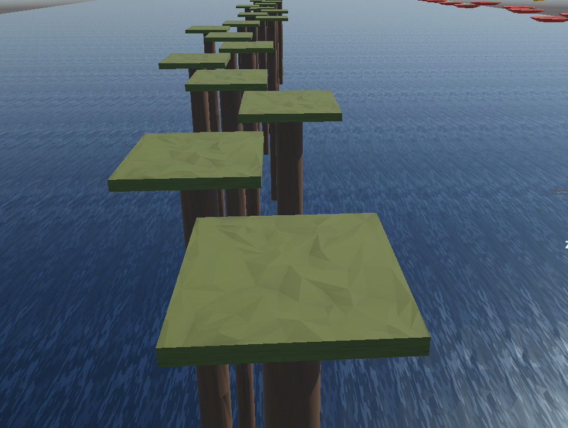
Level 1: Remains Still
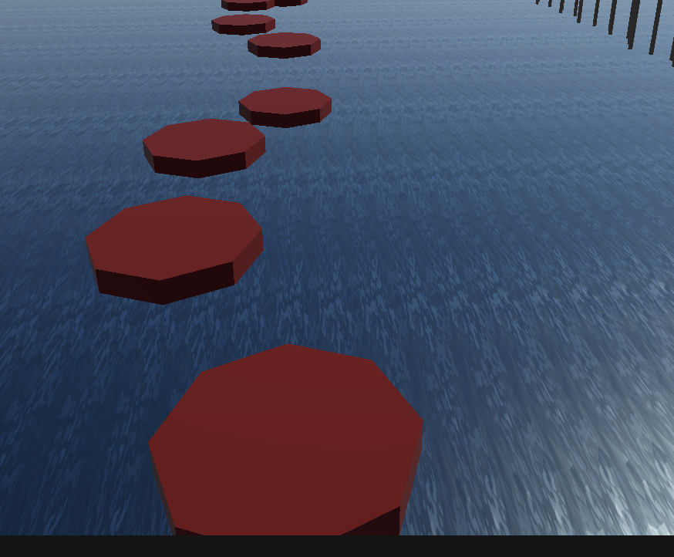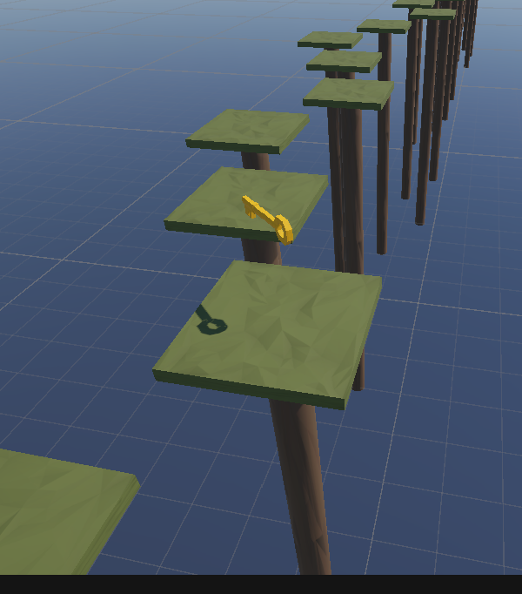
Move while player comes closer.
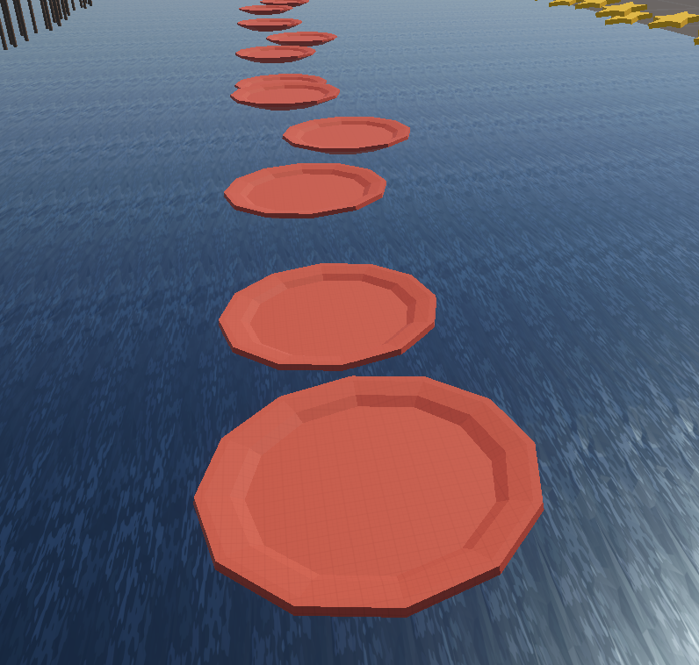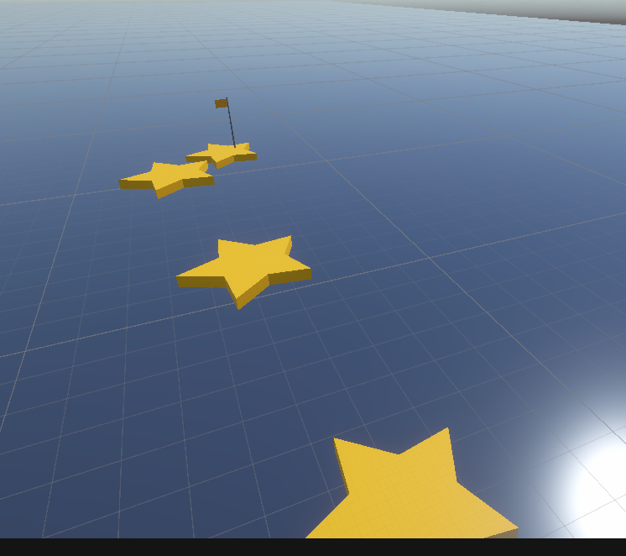
Star moves with high speed and cover long distance

Mechanics:
- Jump
- Collect keys
- Protection from Obstacle
- Speed up
- Slow down

Dynamics:
- Jump Twice and skip spots

Aesthetics:
- Ocean and Island view / Light House

