Write a short essay, plus screenshots talking about performance tuning in SQL Server. Must include Tuning Advisor, Extended Events, DMV, Logs and Execution Plan.

1. Extended events

*Extended Events* is a lightweight performance monitoring system which can gather information needed to improve query performance. This is the first thing you go, it uses SQL event bubbling system, and covers all the way from bottom layer to top layer. Like *Tuning Advisor*, it has a Wizard to help you easily create a session. we need to go to Object Explorer, Management, Extended Events, Sessions. After right clicking *Sessions*, *New Session Wizard* menu will pop up.

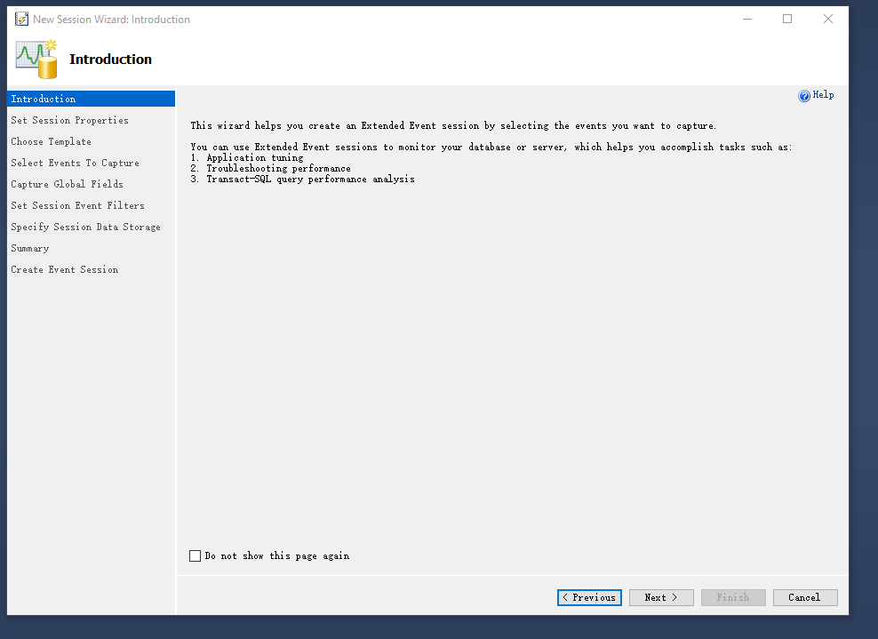

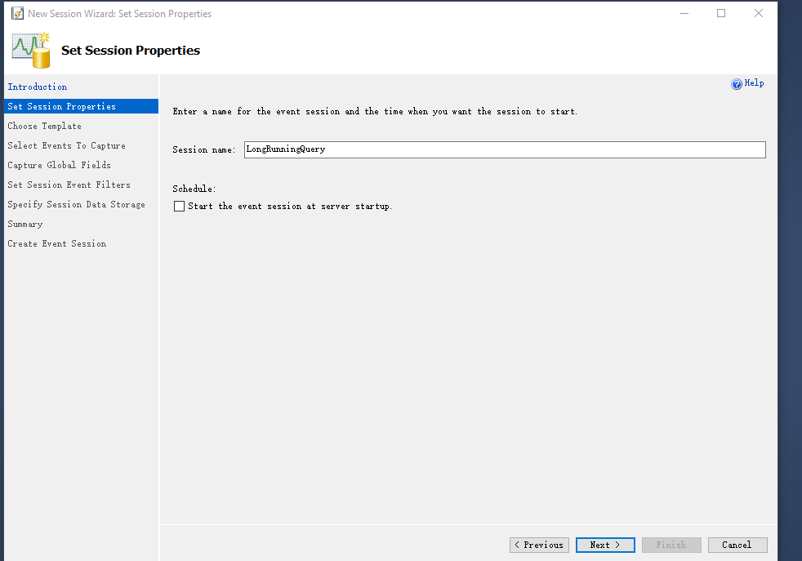

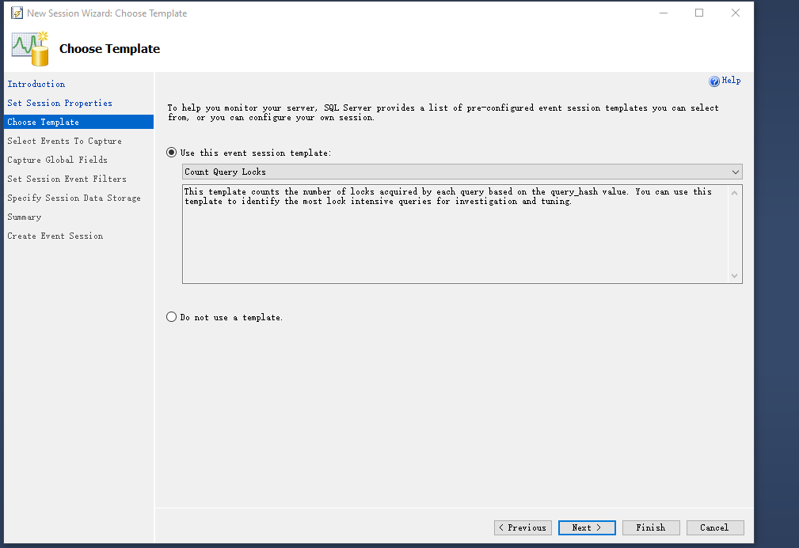

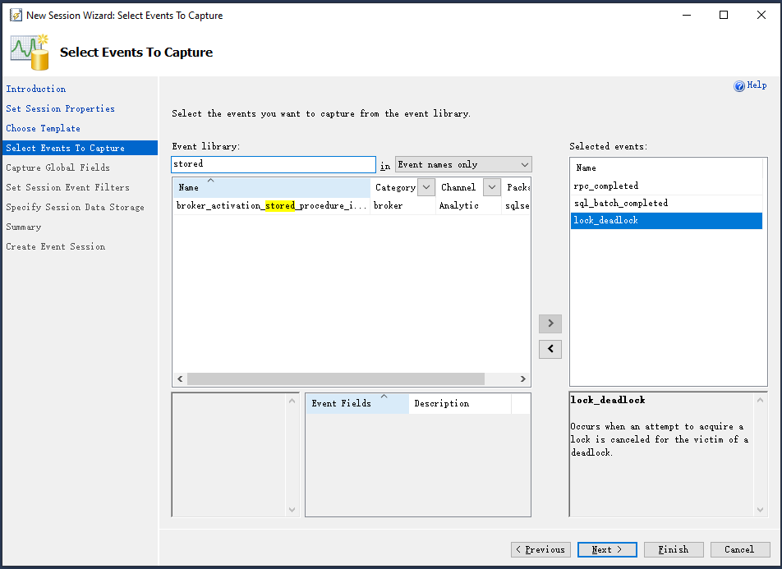

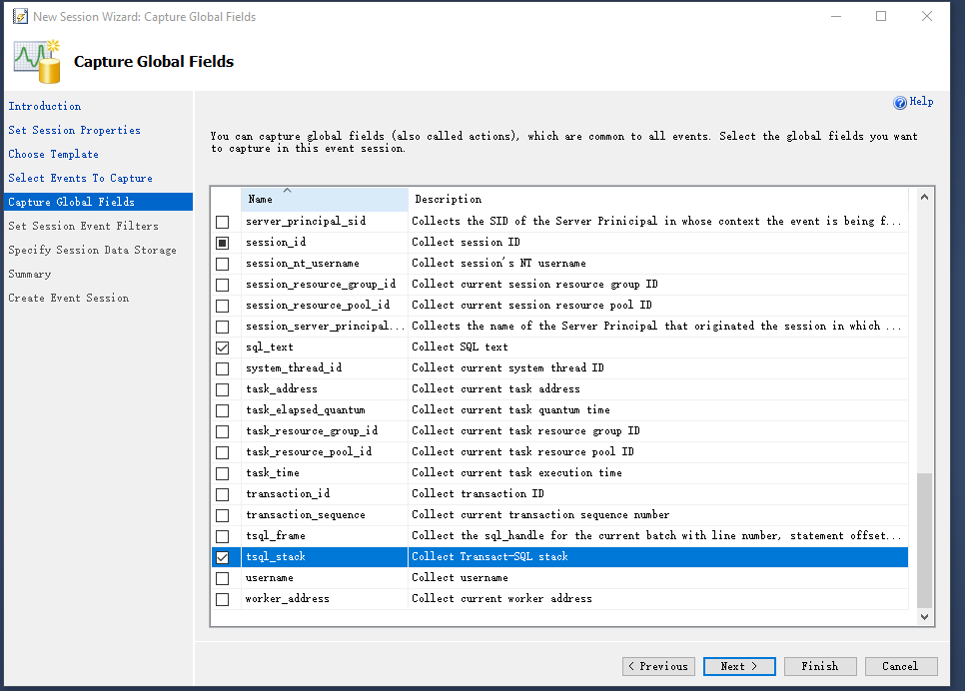

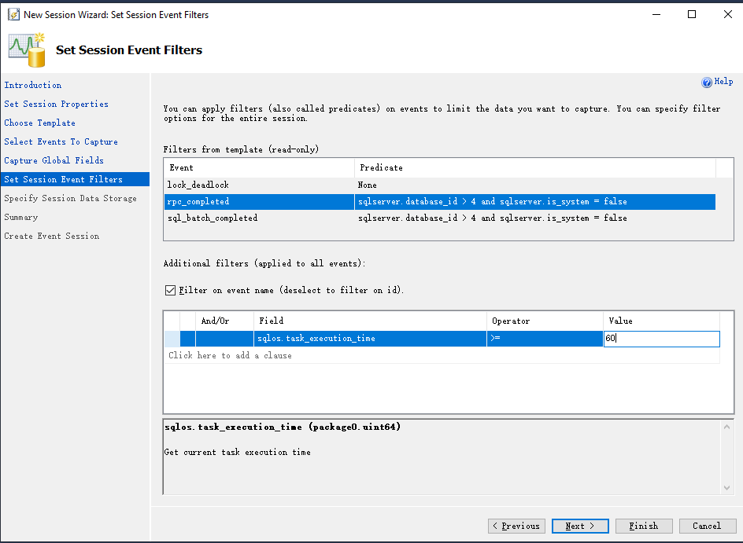

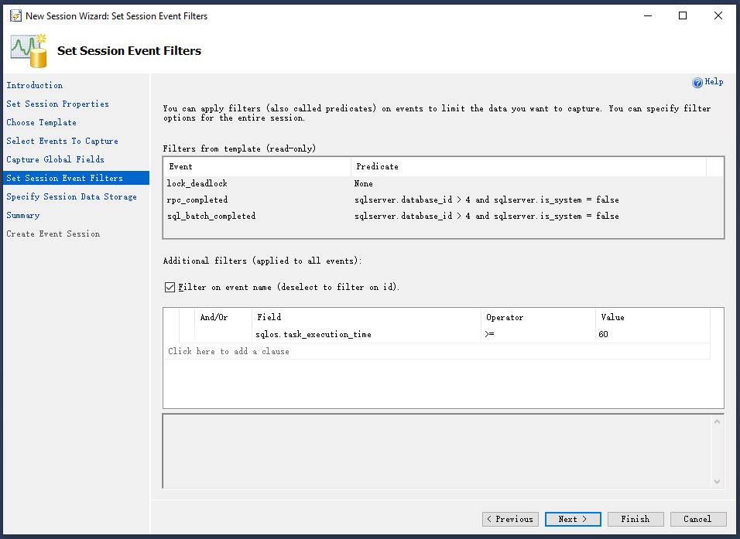

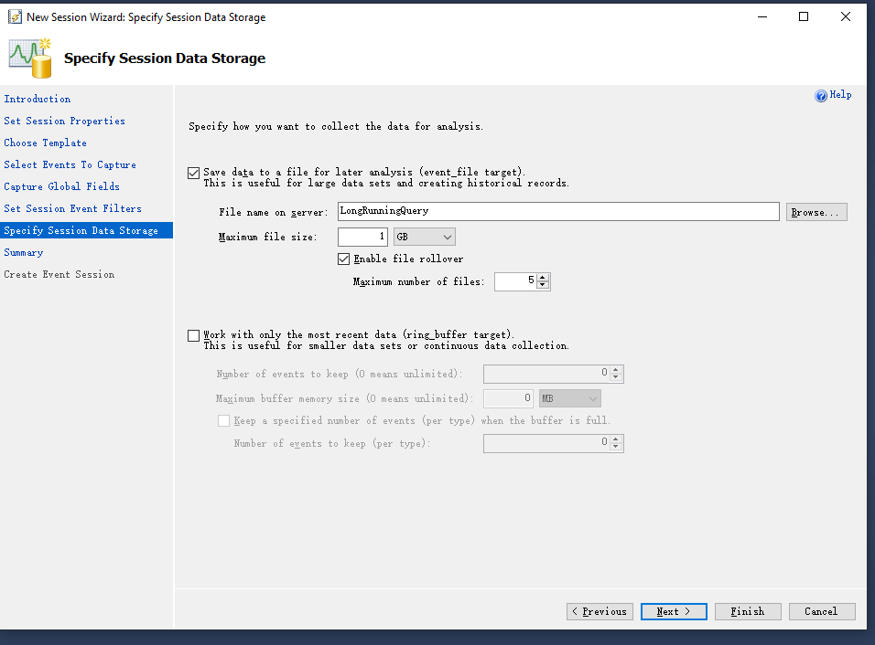

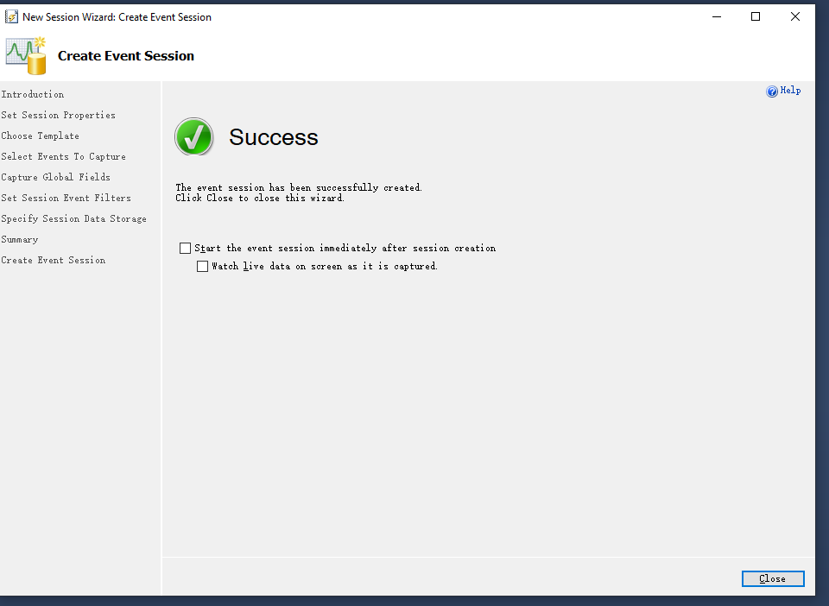

After you select any statistics that you want to know from Extended Events, you can select events to check the statistics. Next picture shows the statistical numbers to show your query performance.

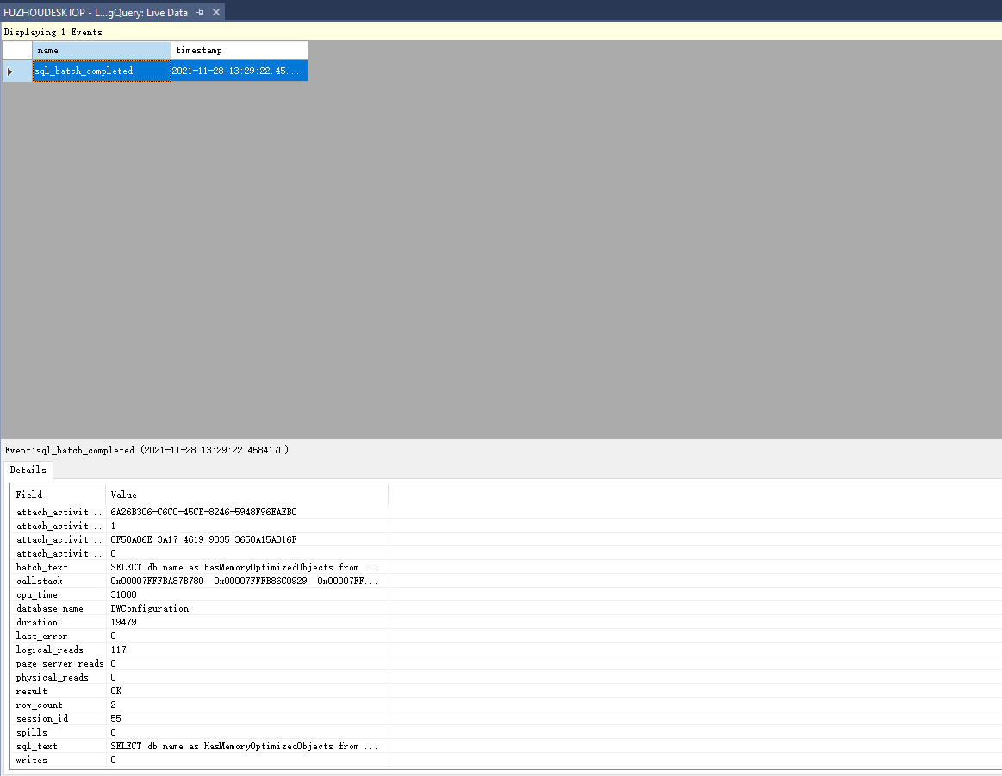

1. DMV

DMV is the collection of views in the master database. It will show the system status. It also can be used to monitor the health of server instance, determine problems and tune performance.

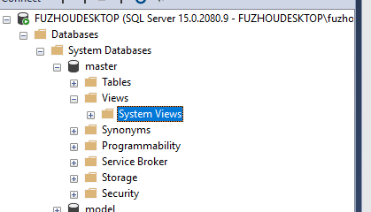

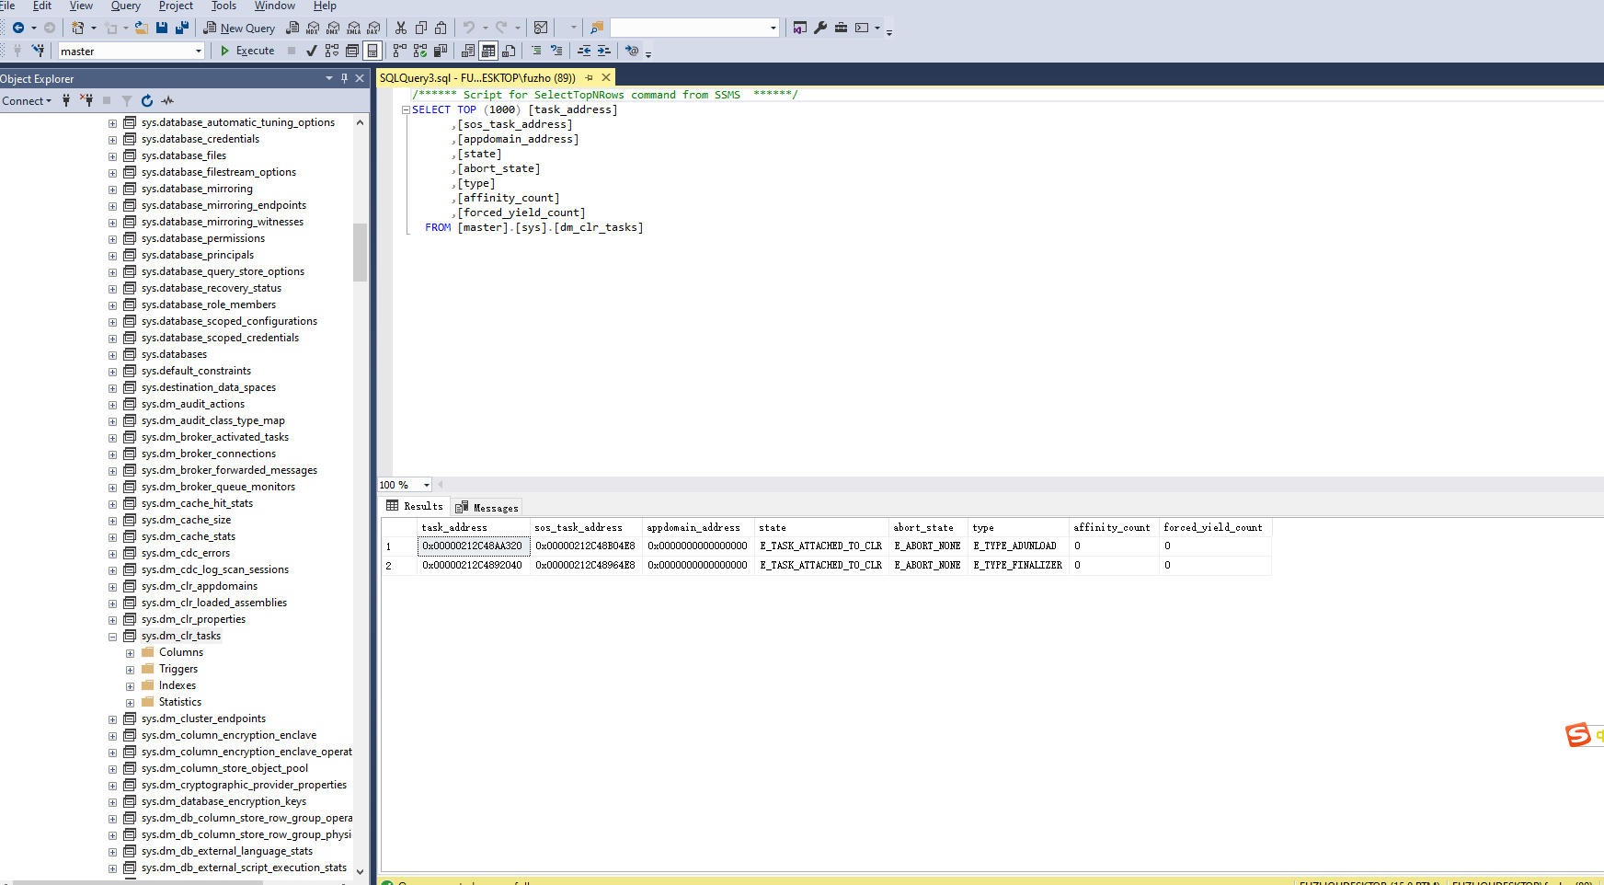

1. Execution Plan

Execution Plan provide more accurate data on how each step of queries are executed. You can click the icon next to execute to show the plan. The result shows different chart with percentage rate. The lower ones means it is performance well.

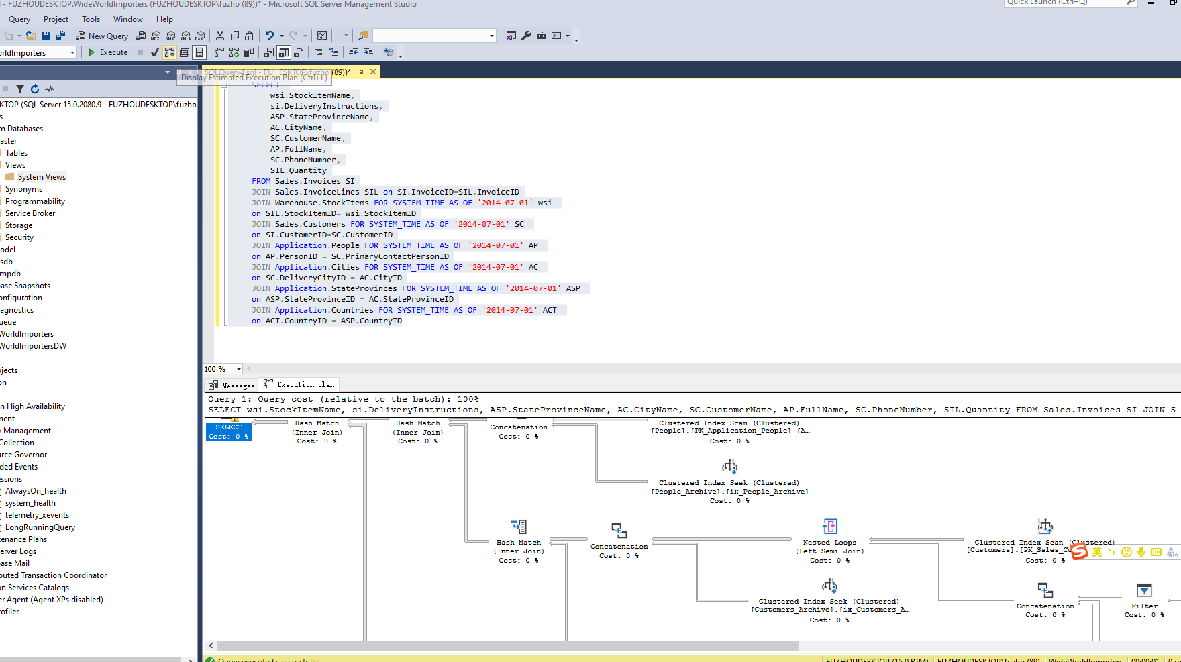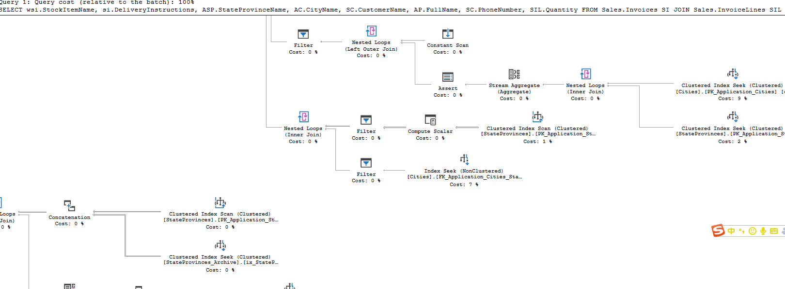

1. Tuning Advisor

It examines how queries are process in the database and make recommendation on database modification to improve the performance, such as index.

The whole process is below as screen shot:

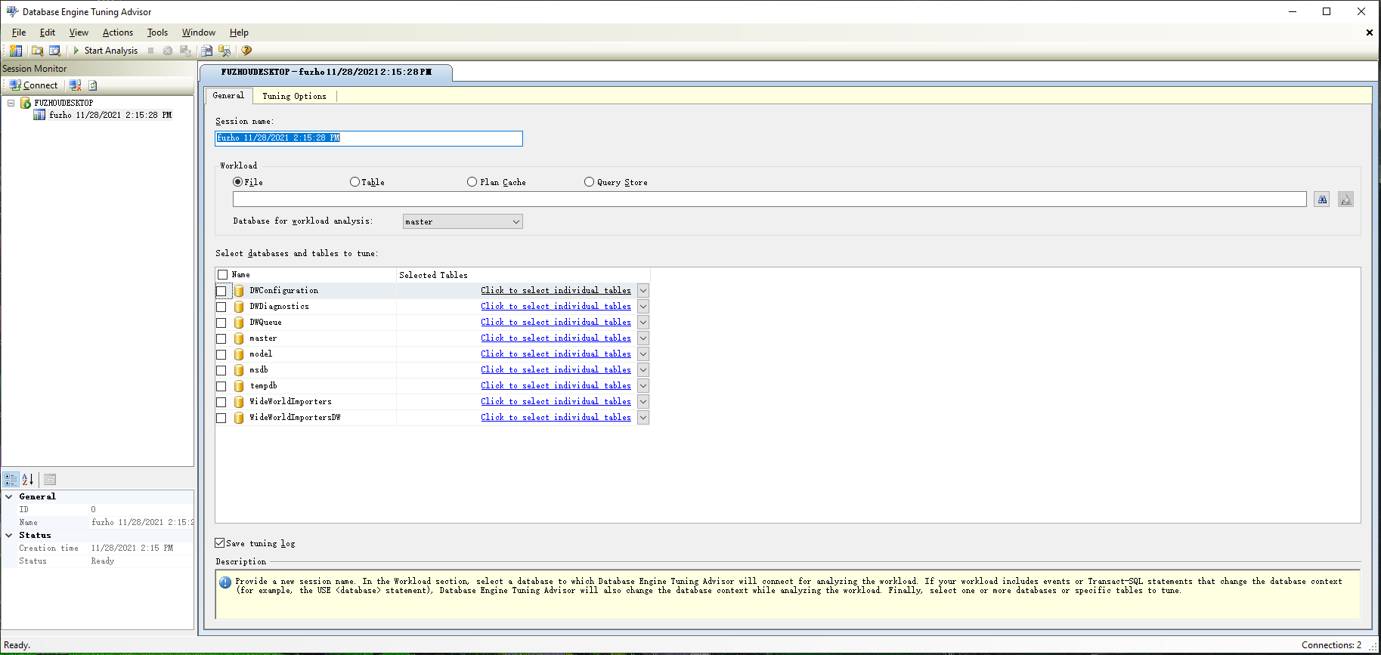

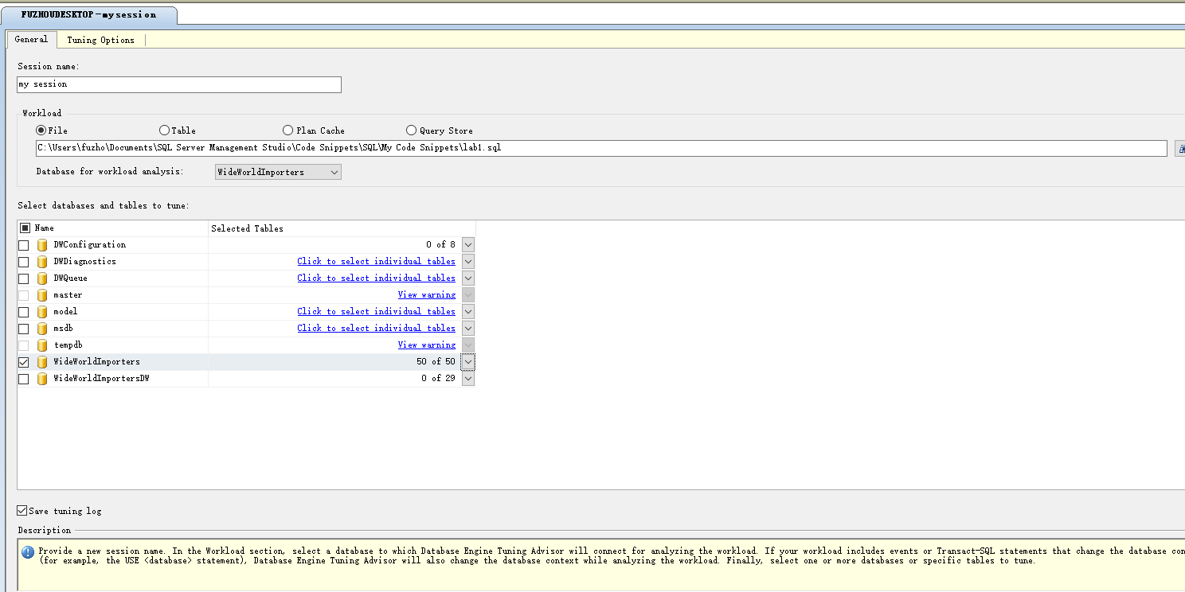

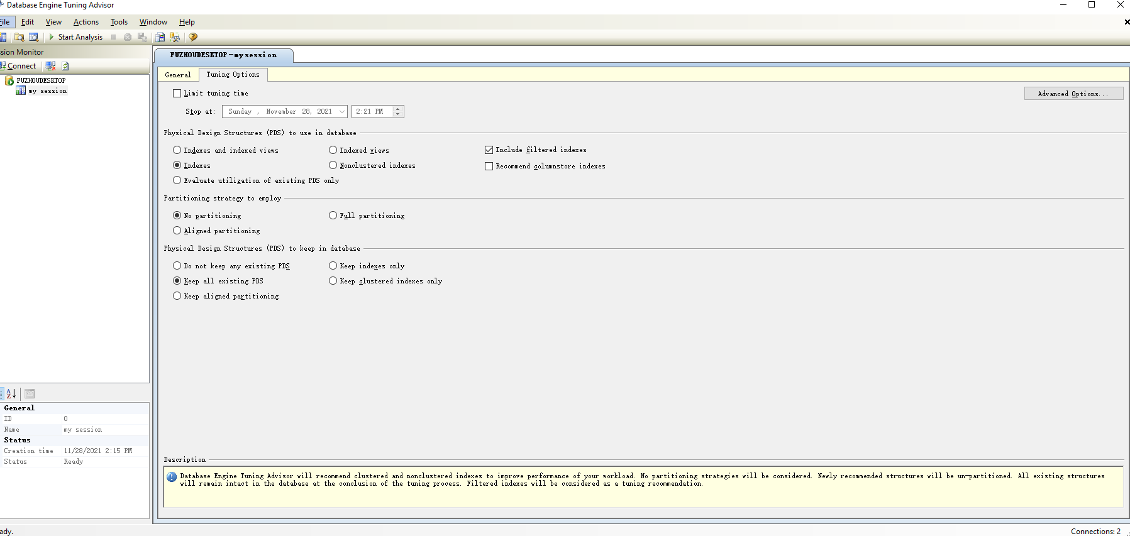

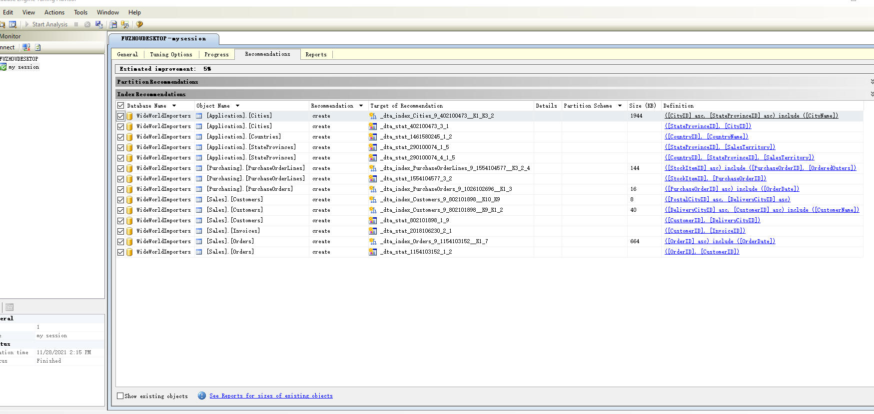

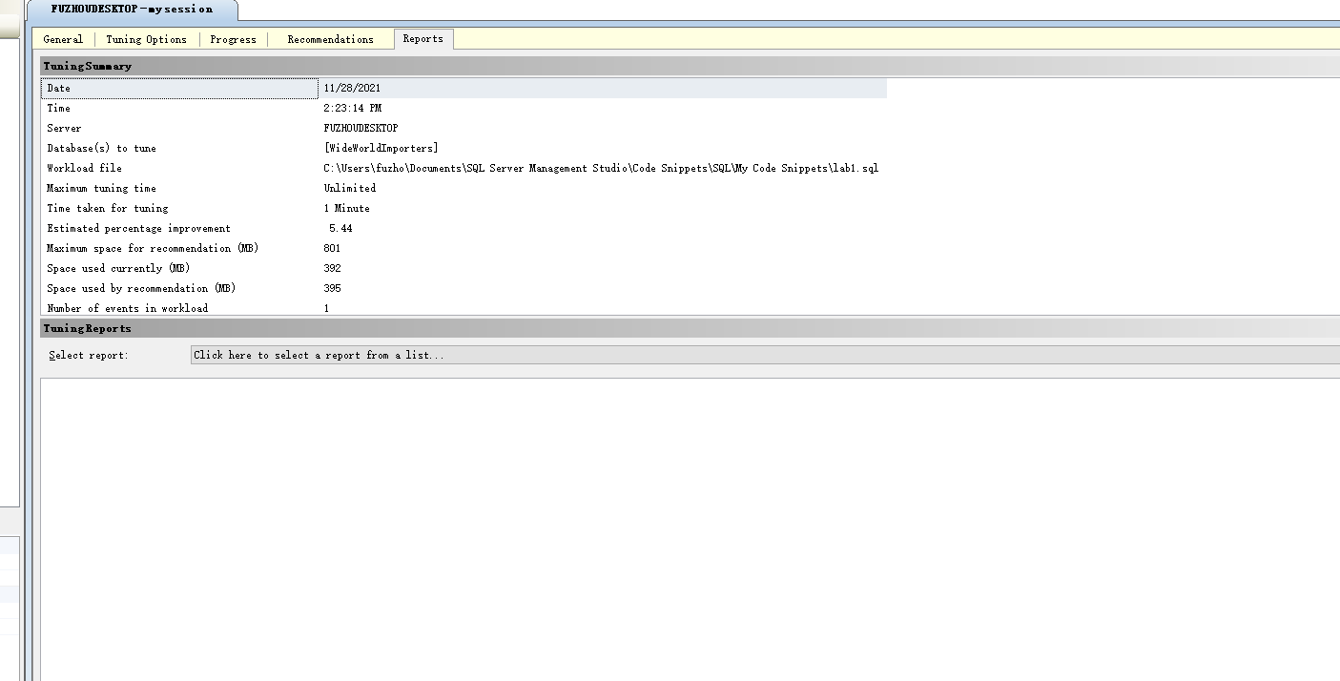

1. Logs

Logs record the status of system, and there are different tools to access the system logs. Besides Extended Events, you can use DBCC queries to trace the system logs.