

A Capstone Project presented to The Faculty on Information Technology Department of MADRIDEJOS COMMUNITY COLLEGE, Bunakan, Madridejos, Cebu.

BCTVI WEB-BASED CLIENT BOOKING AND APPOINMENT MANAGEMNT SYSTEM

A Research Paper presented to
The faculty of Information Technology Department of
MADRIDEJOS COMMUNITY COLLEGE
In Partial Fulfillment for the degree of
BACHELOR OF SCIENCE INFORMATION TECHNOLOGY
BY:
CLINTON JAY J. VILLACIN
JOHN ANTHONY B. ABELLO
JOEY A. MARCE
CRISTEL JOY U. BATOBALONOS

APPROVAL SHEET

RECCOMENDATION SHEET

ACKNOWLEDGMENT
The successful completion of this thesis capstone project would not have been possible without the guidance, support, encouragement, patience, and assistance of the many people who became part of this journey.
‎ ‎First and foremost, I would like to express my deepest gratitude to God Almighty for giving me the strength, wisdom, patience, and determination to overcome the challenges I encountered throughout the development of this capstone project. His guidance gave me the courage to continue even during difficult and stressful moments. ‎
‎I would like to sincerely thank our capstone adviser, and panel members for their valuable guidance, constructive suggestions, corrections, and recommendations. Their knowledge and feedback helped us improve our project and develop a better understanding of programming, system development, research, database management, testing, and problem-solving. ‎ ‎As the programmer and developer of our group, I am especially grateful for the opportunity to apply the knowledge and skills I have learned throughout my academic journey. Developing the system was not an easy task. I encountered different challenges involving coding, debugging, database integration, system functionality, testing, and fixing unexpected errors. There were times when I felt tired and frustrated, but every problem taught me to become more patient, responsible, and determined. These experiences helped me grow not only as a programmer but also as a student and future IT professional.
‎ ‎I would also like to express my sincere appreciation to my groupmates for their cooperation, patience, ideas, and hard work. Their contributions and willingness to work together made it possible for us to complete this project. Despite the challenges and pressure, we experienced, we continued to support one another and work toward the same goal. ‎
‎Most especially, I would like to give my heartfelt thanks to my stepfather, who has always been there to support and encourage me throughout this journey. Thank you for your patience, understanding, sacrifices, and constant support. Your encouragement gave me strength whenever I felt exhausted, pressured, or discouraged. Your support reminded me to keep going and finish what I started. I deeply appreciate everything you have done for me and for always believing in my ability to achieve my goals. This accomplishment is also a reflection of the support and sacrifices you have given me. ‎
‎I would also like to thank my kuya for his support, encouragement, advice, and for always being someone I could rely on during challenging times. Your presence and support have been a meaningful part of my journey.
‎ ‎To my family, friends, classmates, and everyone who supported me, thank you for your encouragement, understanding, and kind words throughout the completion of this capstone project. Whether through advice, assistance, motivation, or simply being there, your support helped me continue moving forward. ‎
‎Lastly, I am thankful for myself and for our entire team for having the courage and determination to finish this project. This capstone taught me that programming is not only about writing code. It is also about patience, critical thinking, problem-solving, teamwork, responsibility, perseverance, and continuous learning. Every error, revision, challenge, and success became an important part of our learning experience. ‎ ‎This capstone project is more than just an academic requirement. It represents the knowledge, effort, sacrifices, teamwork, and perseverance that we have invested throughout our journey. I am grateful to everyone who became part of this achievement. ‎ ‎To everyone who supported and believed in us, especially my stepfather and my family, thank you from the bottom of my heart. ‎
-CLINTON JAY VILLACIN

First and foremost, I would like to express my deepest gratitude to the Almighty God. For His endless grace, wisdom, and the strength He provided to overcome the challenges encountered throughout the development of this capstone project, all glory belongs to Him.
To my family, thank you for your unconditional love, patience, and support. Your continuous encouragement provided the foundation I needed to stay focused and driven throughout my academic journey.
To my partner, thank you for always supporting me. Your constant understanding, emotional support, and motivation during the most demanding phases of this project kept me grounded and inspired to push forward.
To our instructors, we extend our sincere appreciation. Thank you for your invaluable guidance, expertise, and patience. Your constructive feedback, direction, and mentorship throughout this entire journey shaped the success of our project and our growth as Information Technology students.
To my friends and groupmates, this milestone is a shared victory. Thank you for the countless hours of collaboration, the shared late-night debugging sessions, and the teamwork that made the completion of this system possible.
Finally, a special and profound thanks to Dave Alagdan. Your technical insights, hands-on assistance, and unwavering support throughout this capstone journey were instrumental in bringing this project to life. We could not have navigated the complexities of this system without your help, also thank you for the water you always provide when we have a session for working our capstone hahahahaha.
-JOHN ANTHONY B. ABELLO

First and foremost, I would like to thank Almighty God for giving me the strength, wisdom, patience, and guidance to successfully complete this Capstone Project. There were many challenges and difficulties along the way, but through His guidance, I was able to keep moving forward and finish what we started.
I would like to express my sincere gratitude to my Capstone groupmates for their hard work, cooperation, ideas, and dedication throughout the development of our project. Despite the challenges, misunderstandings, and stressful moments we encountered, we continued to work together and support one another until we successfully completed our Capstone.
I am also deeply thankful to my family for their unconditional love, encouragement, financial support, and understanding. Their sacrifices and constant motivation gave me the strength to continue, especially during the most difficult parts of this journey. To my friends, thank you for always being there to encourage me, listen to my problems, and give me motivation whenever I felt stressed or tired. Your support and friendship made this journey more enjoyable and meaningful.
To my girlfriend, thank you for your patience, understanding, encouragement, and unwavering support throughout the entire Capstone journey. Your words of motivation and presence helped me stay positive during stressful and challenging moments. I truly appreciate everything you have done for me.
Lastly, I would like to thank everyone who contributed, in any way, to the completion of this Capstone Project. Every piece of advice, encouragement, assistance, and support helped us reach this achievement. Completing this Capstone is not only a result of our hard work, but also a reflection of the support and encouragement we received from the people around us. To everyone who believed in us and helped us along the way, thank you from the bottom of my heart.This achievement is dedicated to everyone who stood by us until the very end.
-JOEY MARCE

First and foremost, we would like to thank God Almighty for giving us strength, wisdom, patience, and guidance throughout the completion of our capstone project.
We would like to express our sincere gratitude to our Capstone Adviser and teachers for their guidance, valuable suggestions, patience, and support. Their knowledge and encouragement helped us improve and complete our project.
We are also deeply thankful to our families for their love, understanding, financial support, and encouragement throughout this journey. thanks to my partner for the constant support, motivation, understanding, and encouragement, especially during difficult times.
We would also like to thank our friends and groupmates for their cooperation, teamwork, ideas, and support in completing this capstone project.
-CRISTEL JOY U. BATOBAONOS

ABSTRACT
The traditional method of managing and presenting client bookings, service appointments, installation schedules, and financial records for Bogo Cable Television Inc. (BCTVI) may lead to scheduling conflicts, manual tracking errors, limited accessibility, and reduced administrative efficiency. Clients and walk-in subscribers often experience delays when booking broadband services, checking installation statuses, or verifying their transaction histories, especially in Bantayan and Santa Fe operations.
To address these concerns, the researchers proposed the development of the BCTVI Client Booking and Appointment Management System. The system aims to provide a centralized and accessible platform where clients can submit service requests, select subscription plans (such as FTTH and WiFi troubleshooting), and schedule appointments, while administrators, staff, and counter personnel can efficiently manage client databases, track installation workflows, monitor service packages, and generate accurate financial and sales revenue reports. The proposed system also aims to streamline transaction verification, enhance appointment scheduling transparency, and improve overall service delivery.
The study focuses on developing a cross-platform web and mobile system that can improve the accessibility of service records and help administrators monitor revenue streams and client accounts more effectively. The system includes modules for user management, service package pricing, walk-in registration wizards, appointment and installation management, and real-time transaction monitoring to promote operational efficiency within the institution.
The researchers expect that the proposed system will minimize scheduling conflicts, reduce administrative overhead, improve customer convenience, and ensure transparent data record-keeping for Bogo Cable Television Inc.

CHAPTER I
INTRODUCTION
Background of the Study
In the current landscape of service-oriented institutions, the smooth delivery of services relies heavily on structured organization and precise tracking. At the heart of daily operations for community utility and service providers like Bogo Cable Television Inc. (BCTVI) is the management of client bookings, appointment histories, and organized records. When handled efficiently, these components ensure operational compliance and high customer satisfaction. However, a significant operational hurdle arises when organizations rely on manual processes. Clients and service providers frequently encounter frustrating bottlenecks—such as scheduling conflicts, missed appointments, and disorganized documentation—that disrupt service delivery and lower productivity (Reyes & Garcia, 2023; Santos et al., 2022).
To visualize this challenge, consider traditional appointment scheduling: clients call or walk up to a service desk, hoping a representative is available. Staff then sift through physical logbooks or scattered spreadsheets. Inevitably, human error creeps in. Double bookings occur, appointments are missed because reminders rely on memory, and client history files end up fragmented. For a growing service provider, these friction points translate directly into wasted hours and strained administrative resources.
Fortunately, modern web technologies offer a clear pathway forward. Contemporary appointment management systems provide real-time booking confirmations, automated notifications, and secure digital storage, which drastically cut down daily administrative workloads (Mendoza & Cruz, 2024). Recognizing this potential, the BCTVI Web-Based Client Booking and Appointment Management System is conceptualized as an integrated digital platform designed to enhance efficiency and reliability. The proposed system features an intuitive web-based interface enabling clients to schedule, modify, and cancel appointments at their convenience. By shifting from manual logs to a centralized digital calendar, the system introduces real-time monitoring of appointment slots, effectively eliminating scheduling overlaps (Torres & Navarro, 2023). Furthermore, a robust client management module automatically binds appointment records to respective client profiles and transaction histories.
Research highlights that digital booking solutions offer vastly superior data integrity compared to phone-based reservations or walk-in queues (Dela Cruz et al., 2022). Yet, many existing tools are fragmented; they focus strictly on calendar scheduling while ignoring client record storage, or vice versa. This disconnection leads to scattered files, missed follow-ups, and a lack of unified tracking tools. Moreover, many enterprise solutions require expensive infrastructure that is impractical for regional service operations.
This gap underscores an urgent demand for a straightforward solution that balances precision, accountability, and accessibility. The BCTVI Web-Based Client Booking and Appointment Management System directly addresses this need. By uniting real-time booking validation, automated notifications, and structured client record management into a single application, this study aims to deliver a functional prototype that cuts down error rates, injects transparency into service queues, and simplifies client appointment management at BCTVI.

Objectives of the Study
General Objective
To design, develop, and implement a comprehensive full-stack Booking and Appointment System for the Bogo Cable Television Inc. (BCTVI) Bantayan Branch to streamline WiFi and cable installation scheduling, minimize booking conflicts, and enhance overall customer service delivery across the island communities.

Specific Objectives
To achieve the general objective, the study specifically aims to:
- Allow admin to:
- Manage Bookings;
- Manage Walk-in Customers;
- Create Billing Statements for the clients;
- Manage Sales & Revenue Reports;
- Add Plans/Services and update using Create, Read, Update and Delete (CRUD) operations;
- View receipts in every transaction;
- Add time slots;
- Add equipment’s;
- Add staff;
- Display on the admin dashboard;
- Total bookings;
- Pending Approvals;
- Active Subscribers;
- Inactive Subcribers;
- system provides quick links to access Manage Appointment, Client Database, Billing & Payments, Manage Services;
- Allow users to:
- Create account;
- Book an appointment;
- Pay bills;
- Add payment methods (online payment/walk in);
- Manage notifications
- View plans;
- View appointments;
- Unsubscribe if they want to;
- Access the BCTVI application;
- Email Payment Notification- notify in users gmail when their payment already receives by the company.
- Mobile Application- develop a mobile application version of the system for Android devices to improve accessibility, enable push notification, and allow users to book an appointment, choose services package, select preferred date and time, select digital payment method, upload photo screenshot of receipts.
- Determine usability of the developed system based on the
following criteria: Usefulness, Satisfaction, Ease of Use and Ease of Learning.
- Evaluate the developed system based on the ISO/IEC 25010 Quality Standards in terms of functional suitability, performance efficiency, usability, reliability, security, and maintainability.

Scope and Limitations

Scope
This research focuses on the design and development of the BCTVI Web-Based Client Booking and Appointment Management System that enables clients and administrators to manage bookings and service records using web technology. The system is intended to assist users by verifying appointment availability in real time and compiling client interactions into organized digital records. The system is designed to function in real time, allowing administrators and clients to manage data without relying on multiple separate tools. The key features of the system include:

Web-Based Appointment Booking – Enables clients to browse available time slots and book, modify, or cancel appointments directly through the web platform without the need for phone calls or in-person visits.
Client Profile and Record Management – Provides a secure repository where clients can store their contact details, appointment history, service preferences, and related documents as evidence of their service engagements.

Appointment Monitoring and Administration – Allows authorized administrators to input service details, define available schedules, view booking statuses, and review client information in real time.

Limitations
Despite its functionality, the system has several limitations:

Internet Dependency – The system requires a stableinternet connection to process bookings, send notifications, and update appointment records; offline functionality is not supported.

Browser Compatibility – Optimal performance is guaranteed on modern web browsers; older browser versions may experience limited functionality or display issues.
No Payment Gateway Integration – The current version does not include an integrated payment processing feature; financial transactions, if applicable, must be handled separately.

Not for Internal Facility Management – The system is specifically designed for client-facing appointment booking and record management; it does not include features for internal staff scheduling, inventory management, or facility maintenance.

Device Requirement – Users must have a device with internet access and a compatible web browser to access and operate the system.

Significance of the Study
The BCTVI Web-Based Client Booking and Appointment Management System is a significant development in the field of service administration, particularly for improving the accuracy and reliability of appointment scheduling and client documentation processes. By utilizing a web-based platform and centralized data storage, the system provides a practical solution for common operational challenges encountered by BCTVI and its clients.

Clients:
The system promotes convenience and transparency by enabling clients to book and manage their appointments at any time and from any location. It also provides them with a secure and organized personal record where all their appointment histories, service details, and documents are kept, making it easier to track their engagement with BCTVI services.

Service Staff and Coordinators:
The system reduces the time and effort spent on manual appointment booking, phone-based confirmations, and paper-based record keeping. It offers a quick way to verify client bookings and review service requests digitally, allowing staff to focus more on delivering quality service rather than managing administrative tasks.

BCTVI Management and Administrators:
The project contributes to better governance and operational transparency within the organization. It provides standardized, reliable records of client appointments and service transactions, which can be used for performance evaluation, compliance reporting, and policy improvements regarding service delivery.

Researchers and Developers:
This study serves as a reference for future research in the development of web-based appointment management systems. It highlights the importance of integrating automated scheduling mechanisms and unified record-keeping, encouraging further innovation in service management technology.

Future Clients and Stakeholders:
The system provides assurance that service bookings are accurately recorded and managed. It gives all stakeholders confidence that appointment records reflect true client engagement and scheduling compliance, not just informal or unverified arrangements.

Definition of Terms

BCTVI Web-Based Client Booking and Appointment Management System:
Conceptually: An integrated digital platform designed to streamline appointment scheduling, client management, and documentation of service transactions.
Operationally: Refers to the developed system equipped with web-based booking tools, automated scheduling features, and client record management modules used by clients and administrators of BCTVI.

Web-Based System:
Conceptually: A software application accessible through a web browser over the internet, requiring no installation on the user’s device.
Operationally: Refers to the online platform through which clients and administrators access and use the booking and appointment management features of the system.

Appointment Booking:
Conceptually: The process of reserving a specific time slot with a service provider for a scheduled service or consultation.

Operationally: Refers to the action performed by clients within the system to select an available time slot, confirm a service type, and secure their reservation.

Client Management:
Conceptually: The process of collecting, organizing, and maintaining information about clients to support the delivery of personalized and efficient service.
Operationally: The module within the system where client profiles, appointment histories, and service-related documents are stored and managed by both clients and administrators.

Appointment Scheduling:
Conceptually: The systematic assignment of available time slots to clients based on service availability and client preferences.
Operationally: The function used by administrators to define service availability, manage time slots, and confirm or adjust client reservations within the system.

Role-Based Access:
Conceptually: A security method that restricts system functions according to the user’s assigned role or responsibility.
Operationally: Means clients can view available slots, book appointments, and manage their profiles, while administrators can create services, manage schedules, and review all client records.
Real-Time Notification:

Conceptually: Instantaneous alerts or messages sent to users upon the occurrence of a specific event or action within the system.
Operationally: Automated messages sent to clients and administrators when an appointment is booked, modified, cancelled, or confirmed through the system.

Digital Record-Keeping:
Conceptually: The practice of storing, organizing, and maintaining records in a digital format for easy access, retrieval, and management.
Operationally: The secure storage of all client appointment data, service histories, and related documents within the centralized database of the system.

CONCEPTUAL FRAMEWORK

The Conceptual Framework of the BCTVI Web-Based Client Booking and Appointment Management System illustrates an iterative, Agile-driven software development lifecycle. It demonstrates the continuous flow from gathering initial user requirements through sprint-based development to the final deployment, ensuring the system dynamically adapts to enhance accuracy and organization in client appointment management.
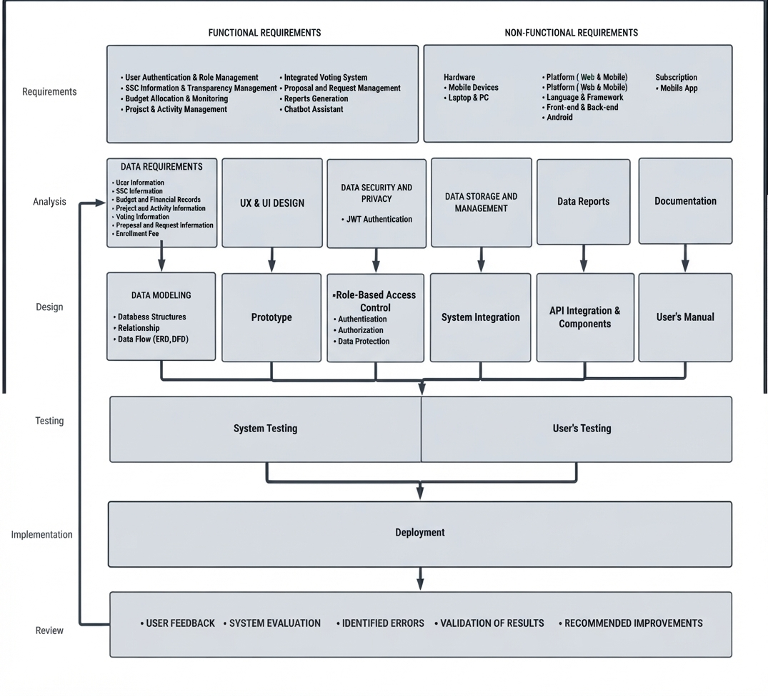

Figure 1. The Conceptual Framework of the BCTVI Web-Based Client Booking and Appointment Management System follows a six-phase iterative development life cycle. This structure drives the system from initial data inputs through to continuous refinement based on user feedback. The system development life cycle is structured across five core phases starting with the Requirements phase, which outlines functional elements like user authentication and non-functional specifications for cross-platform deployment. This transitions into the Analysis & Design phase to map database structures, UI prototypes, JWT authentication, and role-based access control. Subsequent Testing incorporates both system validation and user testing before proceeding to Implementation via deployment. Finally, the Review phase closes the feedback loop through user evaluation, error identification, and continuous system improvements.

CHAPTER II
REVIEW OF RELATED LITERATURE AND STUDIES

This chapter presents a review of existing literature and prior arts relevant to the development of the BCTVI Web-Based Client Booking and Appointment Management System. It covers studies on web-based scheduling systems, appointment management platforms, real-time booking technologies, client record management, and role-based access control in service-oriented systems. A synthesis of the reviewed materials is provided to highlight the gaps addressed by the current study.

RELATED LITERATURE
Web-Based Appointment and Booking Systems
Web-based appointment systems have grown significantly as service industries recognize the limitations of manual scheduling. According to Reyes and Garcia (2023), organizations that transitioned from walk-in or phone-based bookings to online scheduling platforms experienced a marked decrease in scheduling conflicts and administrative overhead. Web-based systems allow clients to book, modify, and cancel appointments at their convenience without requiring staff intervention, reducing response times and improving overall service satisfaction.
Santos et al. (2022) further observed that centralized digital booking platforms reduce the incidence of double-booking by providing a single shared view of available slots, accessible to all stakeholders simultaneously. This real-time synchronization is particularly critical for service providers operating across multiple branches or serving geographically dispersed clients. The BCTVI Bantayan Branch, which covers island communities with time-sensitive installation needs, exemplifies this kind of operational environment. Moreover, the integration of automated notifications within booking systems has been highlighted as a key driver of client retention. When clients receive immediate confirmation messages upon successful booking — along with reminders as their appointment approaches — they are significantly less likely to miss their scheduled service windows (Mendoza & Cruz, 2024). This feature reduces no-shows and allows administrators to reallocate resources more efficiently.

Real-Time Scheduling and Conflict Prevention
Real-time scheduling engines are at the core of modern appointment systems. Torres and Navarro (2023) emphasized that systems equipped with live slot-checking mechanisms prevent conflicts by querying the database before confirming a booking, ensuring that no two clients occupy the same time slot. This approach is especially vital in environments where demand is high relative to available service windows, such as community-level internet service providers managing installation backlogs. Dynamic slot configuration — the ability to set maximum bookings per time period — has been identified as a critical feature for managing technician workloads. Studies indicate that without enforced slot limits, administrators often find themselves overwhelmed with appointments that exceed their service capacity, leading to delays and client dissatisfaction (Dela Cruz et al., 2022). Implementing hard limits at the system level, rather than relying on manual monitoring, provides a reliable safeguard against overbooking. Furthermore, calendar-based visualization tools, such as those built on FullCalendar.js or similar libraries, have been shown to improve administrator decision-making by presenting appointment data in an intuitive, navigable format (Mendoza & Cruz, 2024). Administrators can quickly identify peak scheduling periods, redistribute bookings, and proactively communicate with clients about changes — capabilities that are absent in manual or spreadsheet-based tracking methods.

Client Record Management in Digital Service Platforms
Effective client record management is a foundational component of any service delivery system. Dela Cruz et al. (2022) noted that organizations relying on fragmented record-keeping — where appointment logs, client contact information, and service histories are stored in separate files or databases — experience significant difficulties in tracking service delivery and resolving disputes. Unified digital repositories that link client profiles directly to their appointment and transaction records dramatically improve the accuracy and accessibility of this data. Digital record-keeping platforms also support compliance and audit requirements by providing timestamped, immutable logs of all booking activities. For institutions like BCTVI, which must demonstrate service delivery accountability to both clients and regulatory bodies, this level of documentation integrity is essential. Santos et al. (2022) reported that organizations using integrated client management modules reduced data retrieval times by over 60% compared to those relying on physical files or disconnected spreadsheets. The adoption of role-based data access further enhances client record management by ensuring that sensitive information is only visible to authorized personnel. As Reyes and Garcia (2023) noted, distinguishing between client-facing views and administrative views within the same system allows organizations to maintain privacy standards while enabling efficient internal oversight — a balance that is difficult to achieve with generalized tools not designed for specific service workflows.

Role-Based Access Control in Service Management Systems
Role-based access control (RBAC) is a widely adopted security paradigm in web-based systems, particularly those handling sensitive client or organizational data. According to Torres and Navarro (2023), RBAC frameworks allow system designers to define discrete permission sets for each user type, ensuring that clients can only interact with features relevant to their needs — such as booking and profile management — while administrators retain full control over scheduling configurations, client records, and reporting tools. The implementation of JSON Web Tokens (JWT) has become a standard approach for enforcing role-based authentication in modern web applications. JWTs allow the server to issue digitally signed tokens upon login, which the client presents with each subsequent request to prove their identity and permissions without requiring repeated database lookups (Mendoza & Cruz, 2024). This stateless authentication model improves system performance and security simultaneously, making it well-suited for a booking system that must serve multiple user types concurrently. Password encryption using hashing algorithms such as bcrypt adds another layer of protection by ensuring that even if the database is compromised, plaintext credentials cannot be recovered by attackers. Dela Cruz et al. (2022) highlighted that implementing strong password hashing is a baseline requirement for any client-facing digital system, particularly those collecting personal information. The BCTVI system incorporates both JWT-based authentication and bcrypt password hashing to meet these security standards.

Agile Development Methodology in Software Systems
Agile development methodology has gained widespread adoption in software engineering due to its emphasis on iterative progress, stakeholder collaboration, and adaptive planning. Reyes and Garcia (2023) noted that Agile frameworks — such as Scrum and Kanban — are particularly effective for student-driven capstone projects, where requirements may evolve as the development team gains deeper understanding of the operational context and user needs.
By dividing the development process into discrete sprints, Agile allows developers to build, test, and refine individual features before integrating them into the broader system. This iterative approach reduces the risk of large-scale failure by catching and resolving issues early, while also providing stakeholders with working software at each milestone rather than only at project completion (Santos et al., 2022). For the BCTVI system, Agile methodology was applied to systematically build the booking module, administrative dashboard, and notification system across successive development cycles. Additionally, Agile promotes continuous user feedback as a driver of system improvement. By presenting prototypes to BCTVI administrators and representative clients at the end of each sprint, the development team was able to validate design decisions and prioritize features based on actual operational needs rather than assumptions — a practice that Torres and Navarro (2023) identify as a key predictor of successful software deployment in community-oriented organizations.

ISO/IEC 25010 Software Quality Standards
The ISO/IEC 25010 standard provides a comprehensive framework for evaluating software product quality across eight key characteristics: functional suitability, reliability, performance efficiency, usability, security, compatibility, maintainability, and portability. This framework is widely used in academic and professional software evaluations to ensure that developed systems meet established quality benchmarks (Dela Cruz et al., 2022).
For the purpose of the BCTVI system evaluation, three characteristics are of primary concern: functional suitability — the degree to which the system provides the correct functions for its intended purpose; reliability — the system’s ability to perform consistently under expected conditions; and usability — the ease with which target users (clients and administrators) can operate the system to achieve their goals. These dimensions directly correspond to the core challenges identified in the study’s problem statement: booking accuracy, system dependability, and ease of adoption. Mendoza and Cruz (2024) emphasized that applying ISO/IEC 25010 criteria during both development and evaluation phases encourages developers to design with quality in mind from the outset, rather than treating evaluation as a post-development formality. Using standardized rating instruments based on this framework ensures that the assessment of the BCTVI system is objective, reproducible, and comparable to evaluations conducted in similar studies.

Prior Arts (Existing Systems and Technologies)
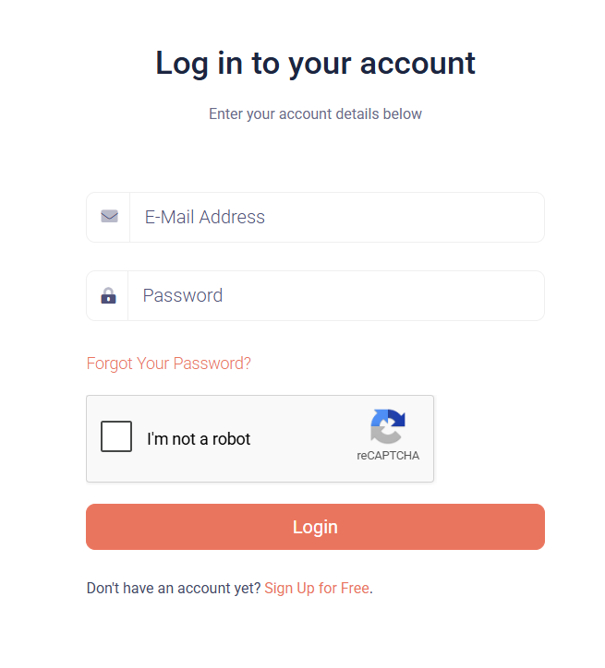
Themesberg Online Login Form
Source: https://themesberg.com/login

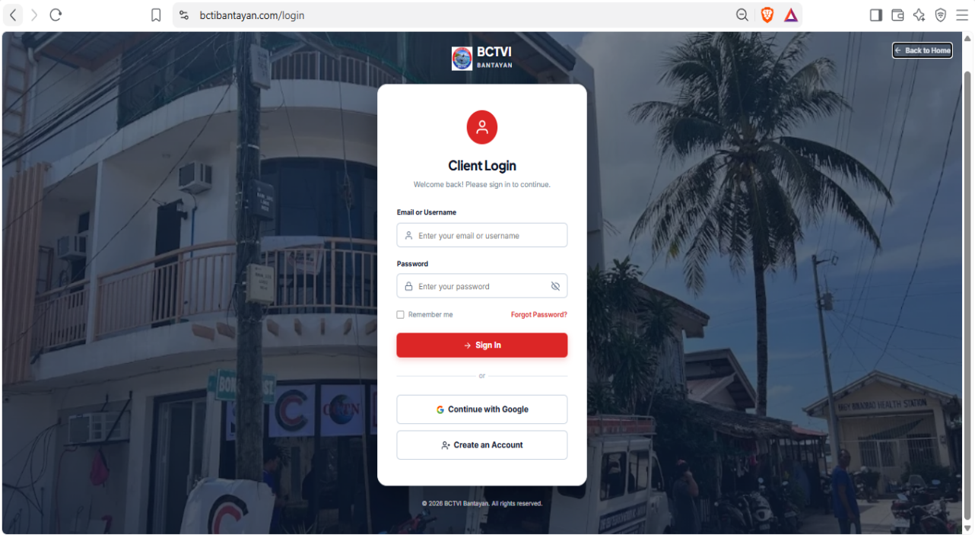
Themesberg is a web-based platform that offers professionally designed user interface templates and components. The login form featured on its website serves as a strong reference for the proposed system’s authentication page. The platform demonstrates how a modern, professional, and user-friendly interface can be structured to provide seamless access for users. The design employs a red and white color scheme that creates a strong visual contrast, making critical interface elements such as input fields, buttons, and navigational links easy to identify and interact with. The layout is thoughtfully organized to separate system information from user actions, enabling users to immediately understand the platform’s purpose while efficiently accessing the login and registration functions.
Figure 2: Log in form of BCTVI CLIENT BOOKING AND APPOINMENT MANAGEMNT SYSTEM

It shows the designs are presenting a modern, professional, and user-friendly interface. The red and white color scheme creates strong visual contrast, making important elements such as buttons and forms easy to identify. The layout effectively separates system information from user actions, allowing users to understand the platform’s purpose while providing quick access to login and registration functions. The system appears to be designed to streamline service requests and improve customer convenience through digital transactions.

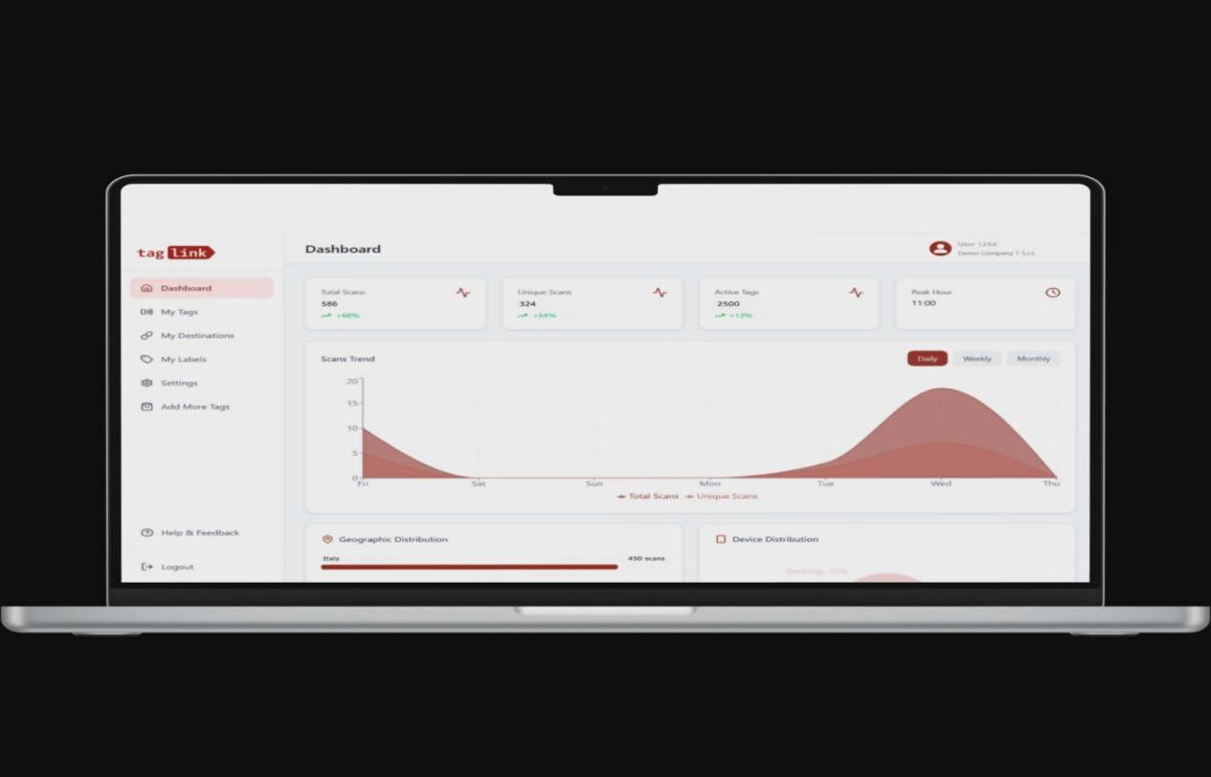
NFC Redirect Dashboard
Source: https://share.google/eehW7YDD2KEH9SM4x

Presents a dashboard interface that incorporates NFC (Near Field Communication) redirect functionality, allowing dynamic link management within a web-based system. This platform enables administrators to update or redirect NFC-linked URLs at any time without requiring physical changes to NFC tags or hardware. This feature reflects a growing trend in smart service management where flexibility and real-time control are essential.

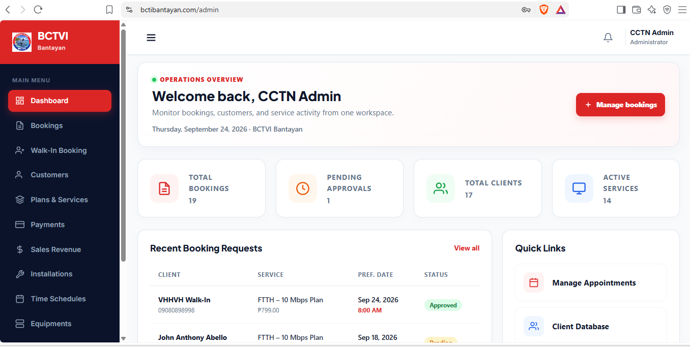
Figure 3: Admin Dashboard of BCTVI CLIENT BOOKING AND APPOINMENT MANAGEMNT SYSTEM

Figure 2 of the proposed system is rooted in the shared need for an organized and functional dashboard that consolidates system operations. The proposed system’s dashboard similarly aims to provide administrators and service personnel with a clear overview of ongoing transactions, pending requests, and system status. By referencing this source, the proposed system adopts dashboard layout conventions that prioritize usability, role-based access, and real-time information display — ensuring that authorized users can efficiently monitor and manage all aspects of the platform from a single interface.

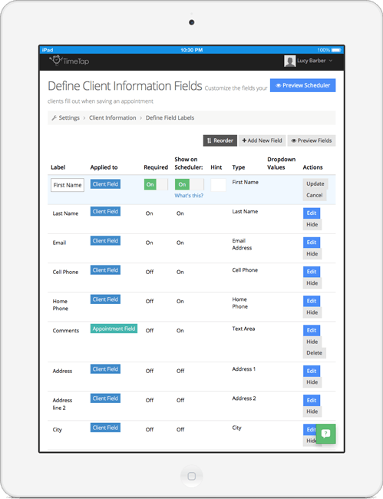
TimeTap Customizable Booking Forms
Source: Customize Client Booking Forms for Your Business

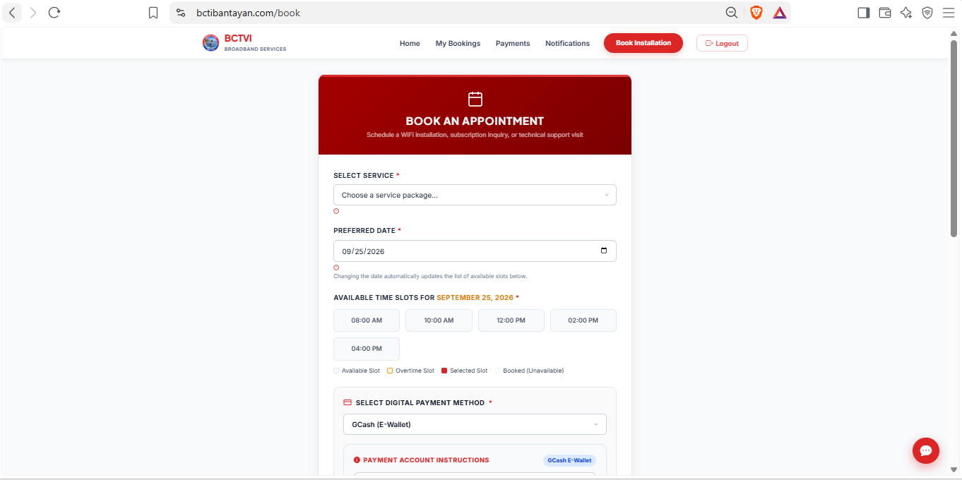
TimeTap is an online appointment scheduling and booking management platform that enables businesses to create fully customizable booking forms tailored to their specific service requirements. The platform allows service providers to define the fields and information they need from clients prior to an appointment, ensuring that both parties are adequately prepared before the scheduled interaction takes place. The booking form interface presented by TimeTap is intuitive and client-centered, guiding users through a step-by-step process of selecting services, providing personal information, and confirming their appointment details. The design emphasizes simplicity and accessibility, ensuring that clients of varying technical backgrounds can complete the booking process without difficulty. Fields are logically grouped, labels are clearly written, and validation feedback is provided in real time to reduce errors.
Figure 4: Customer Booking Directory of BCTVI CLIENT BOOKING AND APPOINMENT MANAGEMNT SYSTEM

Figure 3 of the proposed system is significant, as the proposed system similarly requires a client-facing form module where users can submit service requests and provide the necessary information for their appointments. By referencing TimeTap’s approach to customizable booking forms, the proposed system adopts best practices in form design — including clear field labeling, logical data grouping, and user-friendly input validation — to ensure a smooth and efficient client registration and booking experience.

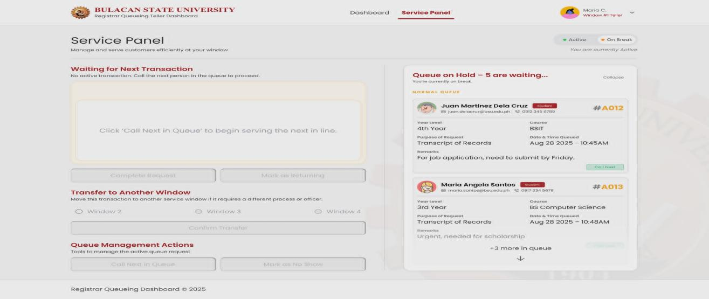
Service Panel Module
Source: https://share.google/KpktzUfzptcz1rV9m

The fourth source presents a Service Panel Module, a component commonly found in service management systems that organizes and displays the available services offered by a platform or business. This type of interface provides both administrators and clients with a structured view of service categories, descriptions, availability, and associated details, making it easier to navigate and select the appropriate service for their needs. The service panel referenced in this source demonstrates an organized, card-based or list-based layout where each service is presented with relevant information such as service name, description, duration, and pricing. The design ensures that users can quickly scan and compare services without information overload. Administrative controls are also integrated within the panel, allowing staff to add, update, or remove services as needed, maintaining the accuracy and relevance of the service catalog.
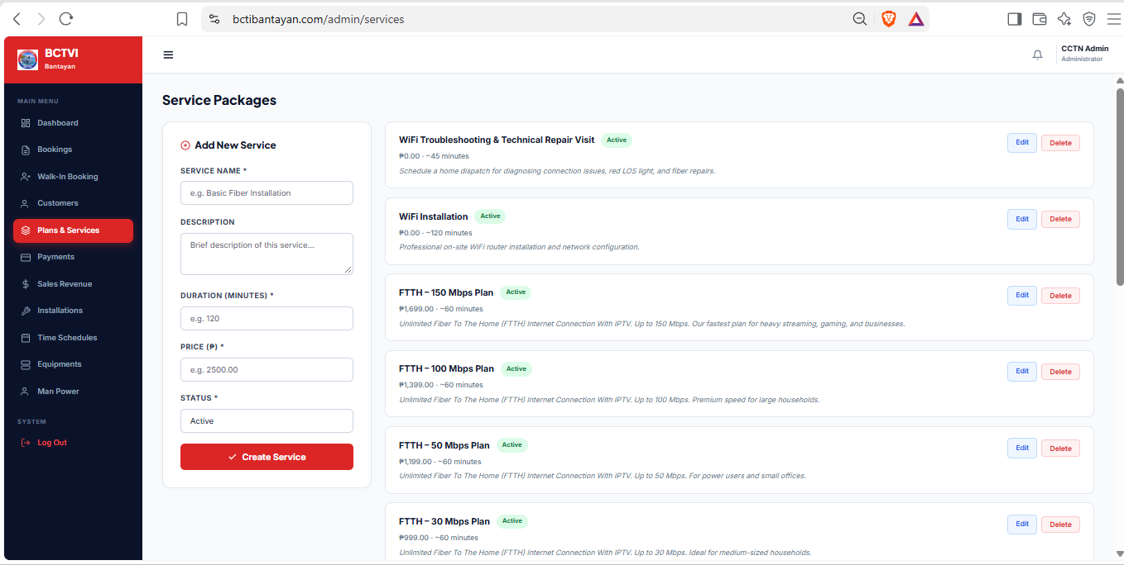
Figure 5: Service Panel of BCTVI CLIENT BOOKING AND APPOINMENT MANAGEMNT SYSTEM

Figure 5 of the proposed system is direct, as the proposed system incorporates a Service Panel Module that mirrors this functionality. The proposed system’s service panel allows administrators to manage the list of available services while enabling clients to browse and select services as part of their booking or registration process. This prior art validates the design decision to implement a dedicated service panel as a core module, ensuring that the system remains organized, scalable, and easy to maintain as service offerings evolve.
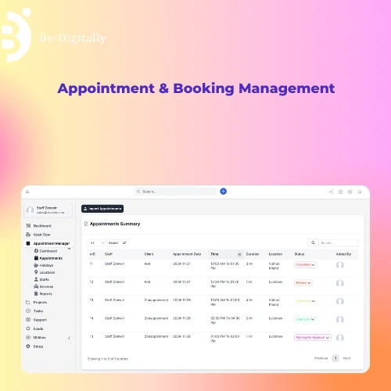
Appointment & Booking Management Software Development
Source: Appointment & Booking Management Software Development, Free demo available at ₹ 25000/year in Jaipur

The fifth source references a commercially available Appointment and Booking Management Software featured on India Mart, a leading B2B online marketplace. This software is designed to streamline the scheduling of appointments and management of bookings for businesses across various industries. It provides a comprehensive set of features including appointment calendar management, client record keeping, automated reminders, and reporting tools — all integrated within a single system. The system demonstrated in this source highlights the core functionalities that an effective appointment and booking platform must possess: a user-friendly booking interface for clients, an administrative backend for managing schedules and records, and reporting capabilities that allow businesses to monitor performance and service utilization. The software is positioned as a solution that reduces manual workload, minimizes scheduling conflicts, and improves overall service delivery efficiency.
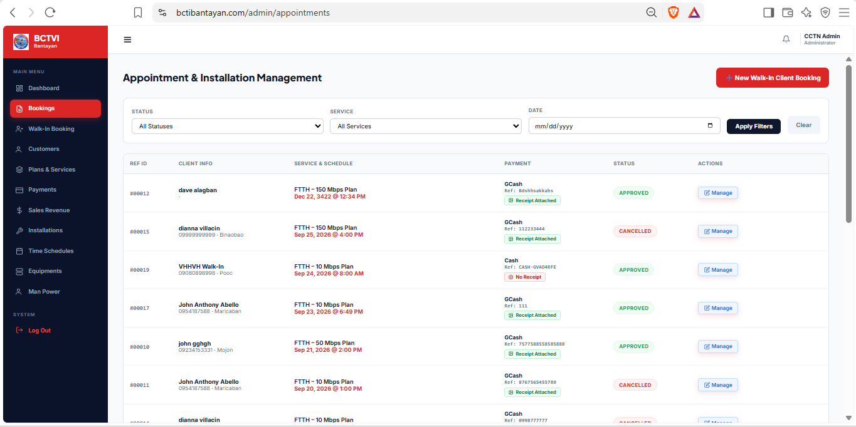
Figure 6: Booking Appointment of BCTVI CLIENT BOOKING AND APPOINMENT MANAGEMNT SYSTEM

Figure 6 of the proposed system is clear, as the proposed system is fundamentally an appointment and booking management platform tailored to the specific needs of its target organization. By examining this existing commercial solution, the proposed system identifies the essential features that must be present in any robust booking system and positions itself as a customized alternative that addresses the unique operational requirements of the institution. This prior art supports the rationale for developing the proposed system by confirming that the core functionalities it aims to implement are proven, widely adopted, and valued in real-world service environments.

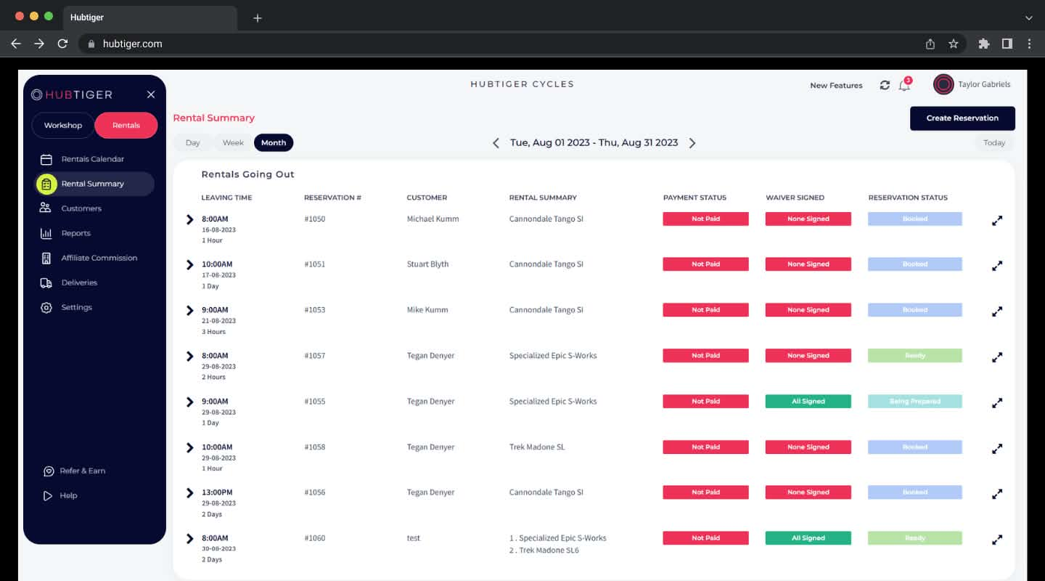
Hub tiger Cycles Rental Summary Dashboard Interface
Source: https://share.google/vn2N5Mz3jH1vPhPi2

The Hub tiger Cycles Rental Summary Dashboard Interface
The image displays the Hub tiger Cycles rental management web console interface, highlighting navigation menus for workshop and rentals, rental summary views by day, week, and month, and a detailed records table tracking leaving times, reservation numbers, customer names, rental summaries, payment statuses, waiver statuses, and reservation statuses. This interface illustrates a structured reservation tracking and cycle fleet management platform, providing administrators with transparent oversight of active customer bookings and equipment allocations.
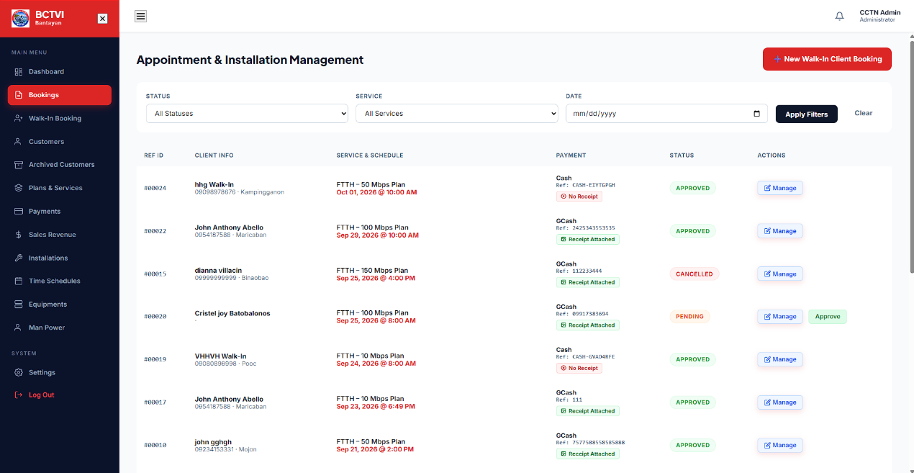
Figure 18. Appointment & Installation Management Dashboard Interface of BCTVI CLIENT BOOKING AND APPOINMENT MANAGEMNT SYSTEM

The image illustrates the BCTVI Bantayan administrator console for Appointment & Installation Management, featuring filtering options by status, service, and date, alongside a detailed table of client records displaying reference IDs, client info and locations, service plans and scheduled dates, payment details with receipt verification status, booking statuses (approved, cancelled, pending), and action buttons for managing or approving entries. This interface provides administrators with centralized control to review, track, and process customer service bookings efficiently.
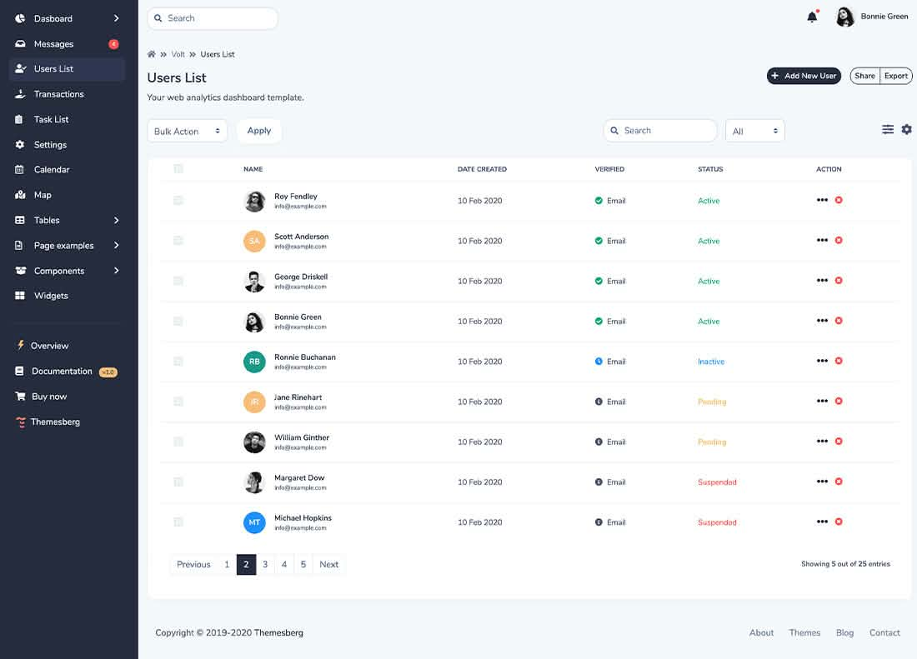
User Management Dashboard Interface
Source: https://share.google/GprHY6WblQm0EQ85y

The image displays the Volt web analytics dashboard template featuring a comprehensive "Users List" interface. It includes a sidebar navigation panel with options for dashboard, messages, users list, transactions, task list, settings, and components, alongside a main data table displaying usernames and emails, creation dates, email verification statuses, account statuses (Active, Inactive, Pending, Suspended), pagination controls, and action options for each user entry.

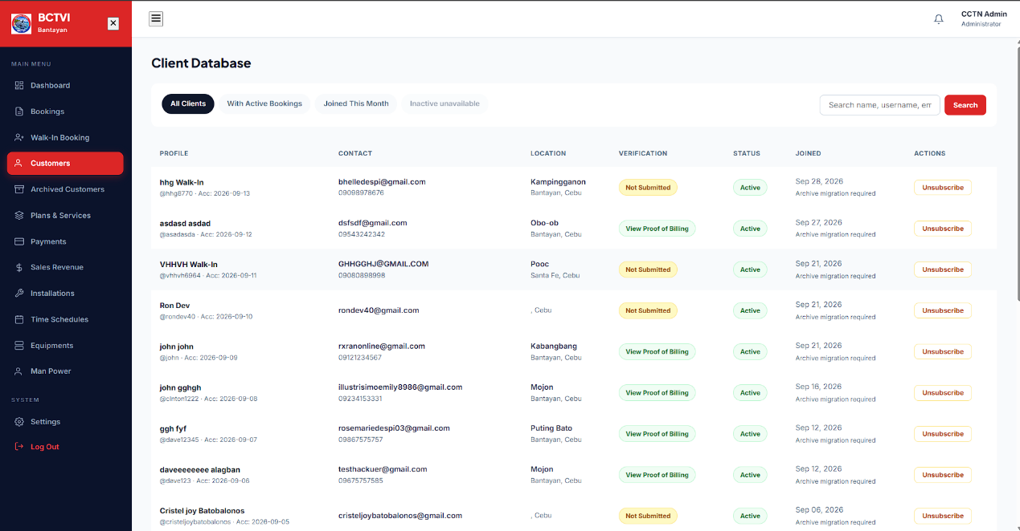
Figure 20. Client Database Management Dashboard Interface of BCTVI CLIENT BOOKING AND APPOINMENT MANAGEMNT SYSTEM

The image illustrates the BCTVI Bantayan administrator console for the Client Database, featuring filter tabs ("All Clients", "With Active Bookings", "Joined This Month", "Inactive unavailable") and a search bar, alongside a comprehensive records table displaying client profiles and usernames, contact details, geographical locations across Bantayan and Santa Fe, verification statuses, account statuses, registration dates, and management action buttons such as "Unsubscribe". This interface provides administrators with centralized control to monitor, filter, and maintain subscriber accounts across the network.

Sales Revenue and Transaction Monitoring Dashboard Interface
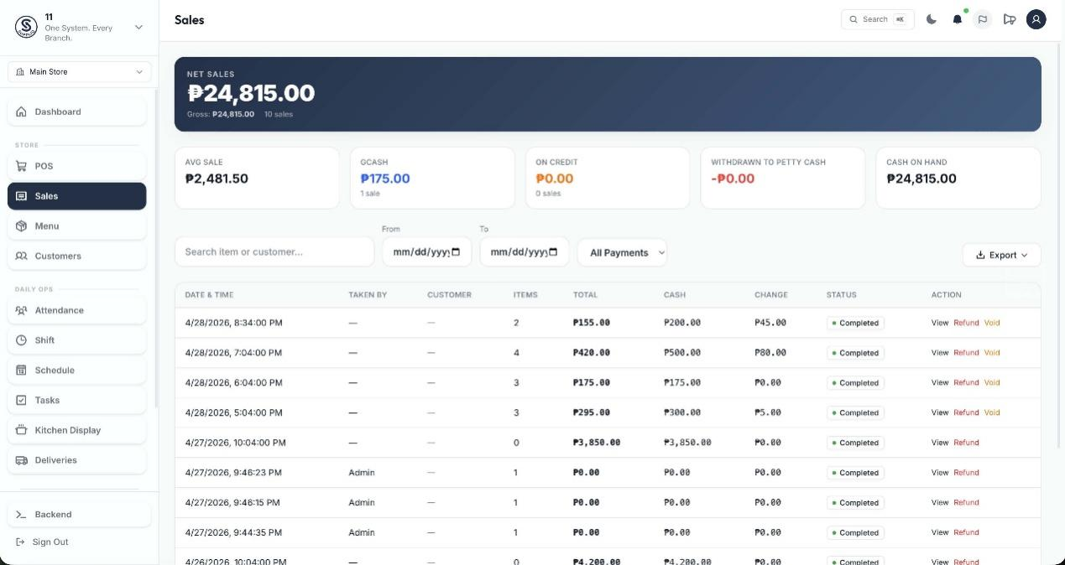
Source: https://share.google/M1FWg9CXcieFUB0Xp

The image illustrates a comprehensive POS and sales revenue monitoring dashboard featuring real-time financial metrics, including net sales (P24,815.00), average sale value (P2,481.50), digital wallet collections like GCash (P175.00), cash-on-hand tracking, and date-filtered transaction records with detailed logs of date and time, items purchased, totals, cash tendered, change, status (Completed), and management actions (View, Refund, Void). This interface provides administrators with robust financial oversight and transparent tracking of revenue streams.

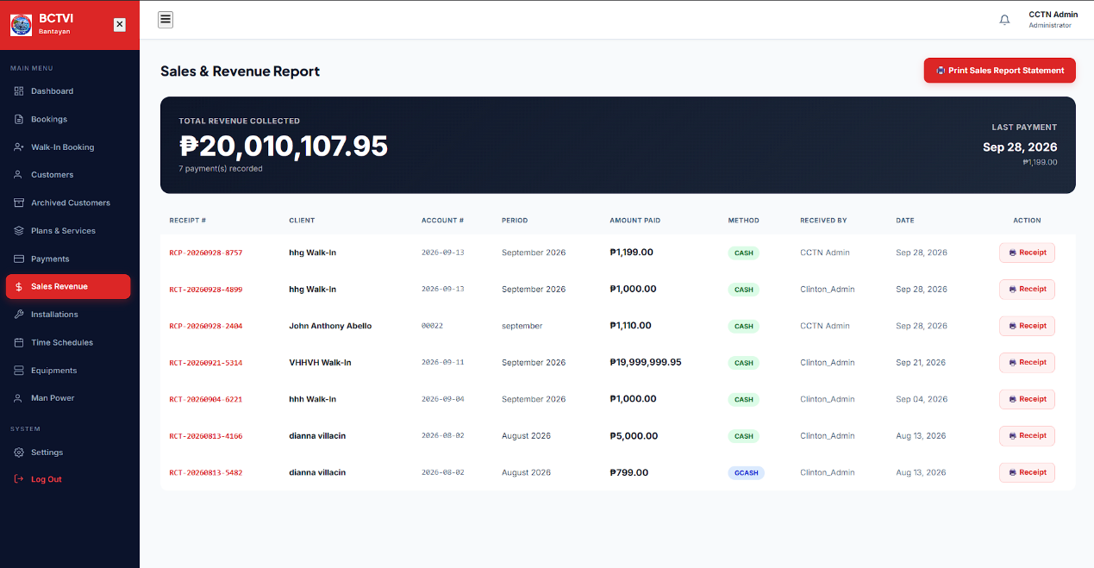
Figure 22. Sales & Revenue Report Dashboard Interface of BCTVI CLIENT BOOKING AND APPOINMENT MANAGEMNT SYSTEM

The image illustrates the BCTVI Bantayan administrator console for the Sales & Revenue Report, displaying real-time financial tracking metrics including total revenue collected (₱20,010,107.95 across recorded payments), last payment details, a "Print Sales Report Statement" action button, and a detailed transaction ledger tracking receipt numbers, client names, account numbers, billing periods, amounts paid, payment methods (Cash and GCash), handling administrators, transaction dates, and printable receipt options. This interface provides administrators with comprehensive financial visibility and reporting capabilities to monitor revenue streams and verify transaction histories.
User Profile and Status Management Interface
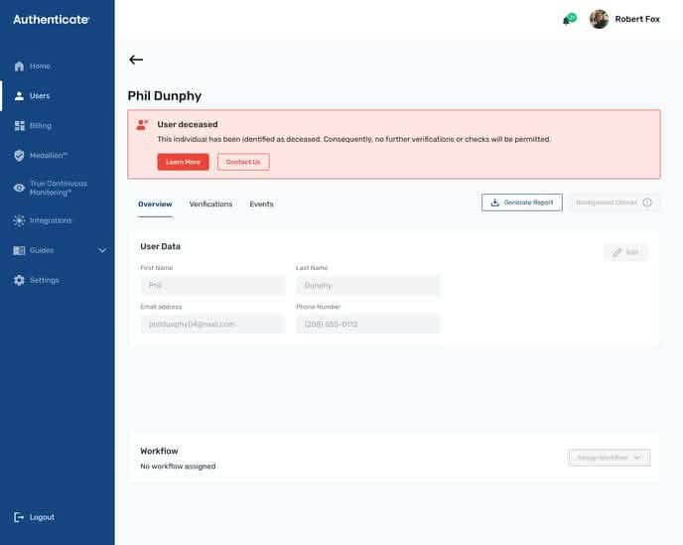
Source: https://share.google/8xXCPYH2i4woCb3db

The image displays an authentication and user management system interface featuring user profile details, contact information, and an account warning banner indicating a restricted user status ("User deceased") which blocks further verifications or checks. This interface illustrates administrative security and profile management controls, providing clear visual alerts for restricted or deactivated accounts.

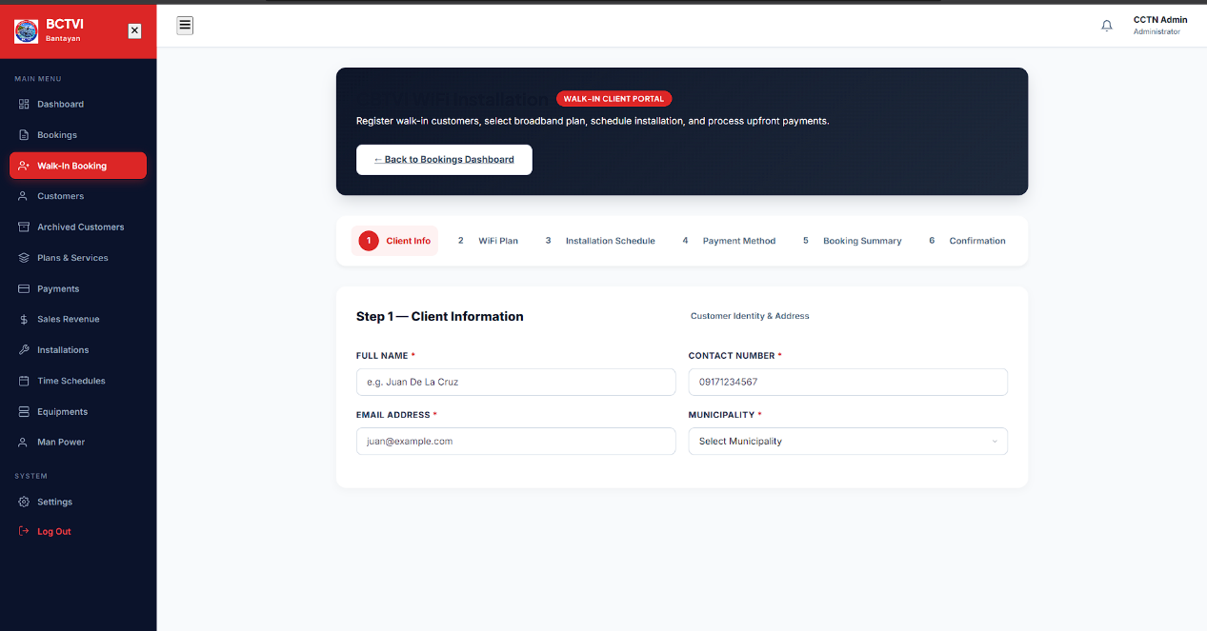
Figure 24. Walk-In Client Portal - Step 1: Client Information Interface of BCTVI CLIENT BOOKING AND APPOINMENT MANAGEMNT SYSTEM

The image illustrates the BCTVI Bantayan administrator console for the Walk-In Client Portal, highlighting a multi-step registration wizard (comprising Client Info, WiFi Plan, Installation Schedule, Payment Method, Booking Summary, and Confirmation). Specifically, Step 1 captures essential customer identity and address details, including full name, contact number, email address, and municipality selection. This interface empowers staff members to seamlessly register walk-in customers and initiate broadband service subscriptions directly from the office counter.

ISPBox Network Incident Management Dashboard Interface
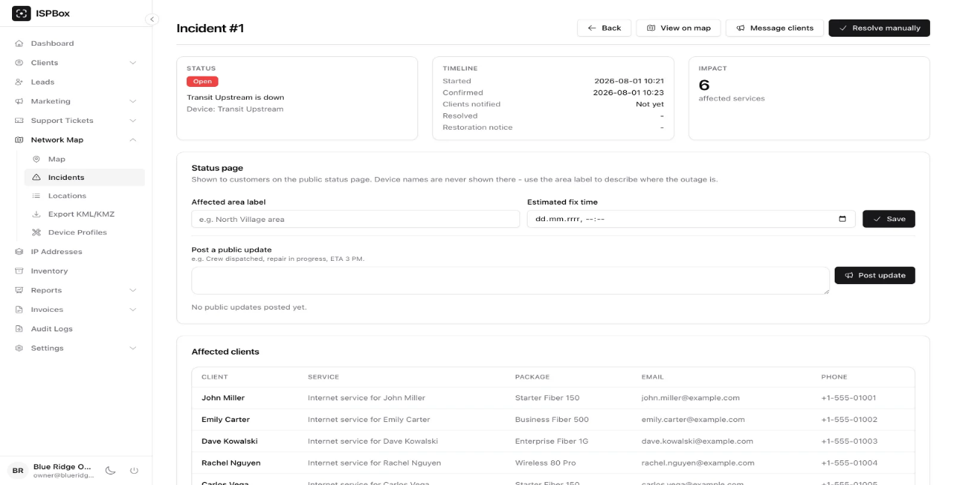
Source: https://share.google/aeXbJh8S0vs4HDjNb

The image displays an ISP network management console for Incident #1, detailing network outages and service disruptions (such as "Transit Upstream is down"). It features status tracking, timeline metrics (start and confirmation timestamps), impact metrics showing 6 affected services, status page controls for public updates and estimated fix times, and a comprehensive table of affected clients listing client names, services, packages, email addresses, and phone numbers. This interface provides network administrators with robust tools to monitor outages, communicate with affected subscribers, and manage incident resolution.

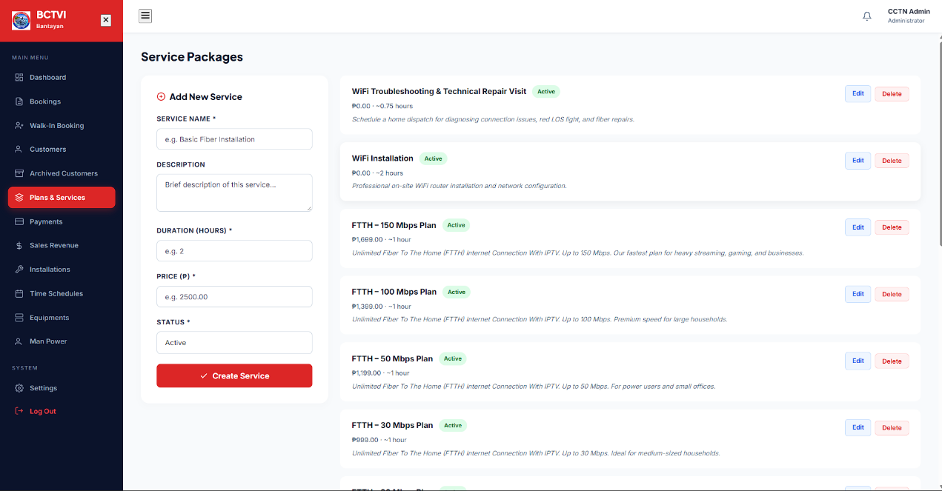
Figure 26. Service Packages and Pricing Management Dashboard Interface of BCTVI CLIENT BOOKING AND APPOINMENT MANAGEMNT SYSTEM

The image illustrates the BCTVI Bantayan administrator console for Service Packages, featuring a left-side form for adding new services (with fields for service name, description, duration in hours, price in pesos, status, and a "Create Service" button) and a right-side list of existing active service offerings—including WiFi Troubleshooting & Technical Repair Visit, WiFi Installation, and FTTH speed tiers ranging from 30 Mbps to 150 Mbps, complete with pricing, duration details, and action buttons for editing or deleting entries. This interface provides administrators with centralized catalog management capabilities to configure subscription plans and service fees seamlessly.
Prior arts such as generic calendar tools, commercial field service platforms, and social media-based booking methods offer partial solutions but fall short of addressing the specific operational context of a single-branch community ISP managing WiFi and cable installation appointments. These solutions either lack role-based access control, do not enforce slot limits, are financially prohibitive for small organizations, or do not provide centralized reporting capabilities. The BCTVI Web-Based Client Booking and Appointment Management System addresses these gaps by combining real-time availability checking with enforced administrative slot limits, role-separated portals secured by JWT authentication and crypt encryption, a Full Calendar-based administrative dashboard with statistical tracking, and CSV export functionality. This integration of features within a single, purpose-built platform represents a contribution that neither existing commercial tools nor generic scheduling utilities currently provide for community-level ISP operations in the Philippine context.
The development of this system using Agile methodology ensures that each component is iteratively tested and refined in alignment with actual user needs. Its evaluation using ISO/IEC 25010 criteria — specifically functional suitability, reliability, and usability — provides an objective basis for assessing whether the system achieves its intended operational outcomes. This study therefore contributes a targeted, technically grounded solution to a clear and documented gap in the available tools for small-scale internet service provider administration.

The following table presents an analysis of existing systems and technologies that share functional similarities with the proposed BCTVI Web-Based Client Booking and Appointment Management System. Each system is evaluated based on its key features and its specific limitations when considered in the context of BCTVI’s operational requirements.

Table 1. Comparison of Existing Systems and Technologies with the Proposed System

System / Technology | Key Features | Limitations in Relation to the Study
Manual Appointment Logbooks / Phone Calls | No cost, familiar to staff and clients | Prone to scheduling conflicts, double bookings, and lost records; no real-time visibility
Generic Scheduling Tools (e.g., Calendly, Google Calendar) | Easy setup, shareable links, automatic reminders | Not tailored to ISPs; lacks role-based access, CSV export, or slot-limit enforcement specific to BCTVI workflows
Ticketing/Helpdesk Systems (e.g., Freshdesk, Zoho Desk) | Centralized issue tracking, customer history, reporting | Focused on support tickets, not field installation scheduling; expensive for small-branch operations
Field Service Management Apps (e.g., ServiceTitan, Jobber) | Technician dispatch, job tracking, invoicing | Designed for large enterprises; excessive features and cost for a single-branch community ISP like BCTVI Bantayan
Social Media Booking (Facebook Messenger / Inbox) | Familiar, zero cost, accessible on mobile | No structured slot control; highly prone to missed messages, double bookings, and untracked requests
Proposed System (BCTVI Web-Based Client Booking and Appointment Management System) | Role-based portals (client/admin), real-time availability checking, slot-limit enforcement (max 3/slot), FullCalendar dashboard, CSV export, automated notifications | Prototype stage; internet connection required; limited to BCTVI Bantayan Branch use case

As shown in Table 1, no existing prior art integrates all four core operational requirements of the BCTVI Bantayan Branch: (1) role-based client and administrator portals, (2) real-time slot availability checking with enforced booking limits, (3) a centralized calendar-based administrative dashboard with statistical tracking, and (4) CSV report exporting for service record management. The proposed system was designed specifically to address this combination of requirements within a single, unified platform.

Synthesis
The reviewed literature consistently identifies three primary challenges that undermine effective appointment management in service-oriented organizations: scheduling conflicts arising from the absence of real-time availability validation, fragmented client records that hinder service continuity and accountability, and inadequate role differentiation that exposes sensitive administrative data to unintended users. These challenges are particularly pronounced in community-based service providers like BCTVI, which operate in geographically constrained environments with limited technical infrastructure. Studies by Reyes and Garcia (2023), Santos et al. (2022), Torres and Navarro (2023), Mendoza and Cruz (2024), and Dela Cruz et al. (2022) collectively demonstrate that web-based systems with integrated scheduling engines, unified client record repositories, and RBAC frameworks can effectively address these challenges. The research further indicates that systems evaluated against the ISO/IEC 25010 quality standard are more likely to meet user expectations for functionality, reliability, and usability in real-world deployment.

CHAPTER III
METHODOLOGY

RESEARCH DESIGN
This chapter describes how the researchers went about building the BCTVI Web-Based Client Booking and Appointment Management System for Bogo Cable Television Inc. (Bantayan Branch). From the early planning stages all the way to deployment, the team followed the Rapid Application Development (RAD) model and borrowed several practices from Agile to keep things moving and on track.
The group settled on RAD because it puts a strong emphasis on building working prototypes early and getting feedback from actual users before moving forward. Given that the project had a tight timeline and needed to work well for people who are not necessarily tech-savvy—BCTVI staff, administrators, and residents of the island communities—it made sense to go with a model that keeps users involved at every step. Adding Agile elements like short sprints, regular check-ins with stakeholders, and flexible planning helped the team adjust whenever new concerns or ideas came up during development.
This combination felt like the right fit for the project. The system has two different types of users (administrators and clients/residents), each with their own set of features, and the modules range from request management and dashboard analytics to report generation and user registration. On top of that, the end users at the branch are not developers—so it was important to keep showing them working versions of the system and asking whether it made sense to them, rather than just building everything behind closed doors and hoping for the best.
Development Methodology: RAD with Agile Integration The whole development process was broken down into six phases, following the RAD lifecycle. Each phase had specific goals and deliverables, and Agile practices were woven in wherever they could add value.

Agile Software Development Life Cycle Model
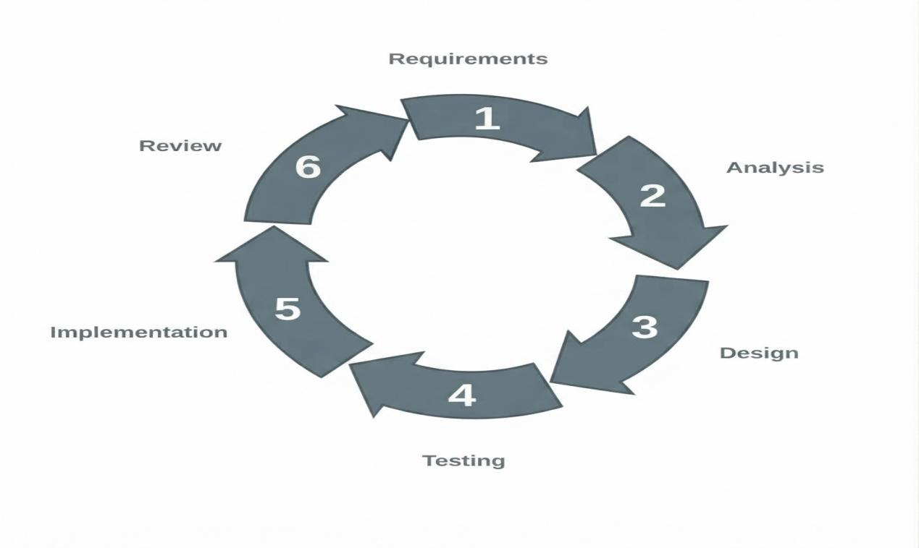
This study employed the Agile Software Development Life Cycle Model, enabling iterative development, continuous stakeholder feedback, and adaptive refinement throughout the development.
Figure 7. Agile Software Development Life Cycle Model

Phase 1:
Requirements
- Functional Requirements: Defines the core system actions, including user authentication, real-time client booking requests, scheduling module execution, document uploading, and automated reservation notifications.
- Non-Functional Requirements: Outlines the operational environment, specifying hardware compatibility (PC and mobile devices), software platform accessibility (web-based), and performance reliability for handling real-time bookings.

Phase 2:
Analysis
Deconstructs system needs into foundational components. This includes mapping Data Requirements (user account details, available appointment schedules, service information), planning the UX/UI Design of the booking interface, and establishing Data Security and Privacy for uploaded supporting documents.

Phase 3:
Design
Translates analytical planning into technical blueprints. This phase involves Data Modeling to structure organized client records, building interface Prototypes, and establishing Role-Based Access Control to separate client booking privileges from administrative dashboard access.

Phase 4:
Testing
Validates the scheduling logic and interface. System Testing ensures the system accurately validates client selections against current schedules to prevent conflicts, while User’s Testing confirms the booking process is intuitive and that automated notifications trigger correctly upon confirmation.

Phase 5:
Implementation
Executes the final Deployment of the platform. The live system delivers immediate confirmation of bookings, structured client profiles, service reports, and real-time monitoring dashboards that administrators can access without manual searching.
Phase 6:
Review
Evaluates the active system through User Feedback and continuous System Evaluation. Administrators and clients assess the platform to validate results and identify errors. This feedback routes back into the Analysis phase, ensuring continuous iterative improvements that reduce booking conflicts, decrease administrative workloads, and promote institutional transparency.
Agile Practice | How It Was Used
Product Backlog | A running list of all features and tasks (e.g., JWT login, 3-step wizard, FullCalendar view, CSV exporter), ranked by priority. The team referred to it constantly and updated it as new requirements emerged.
Sprint Cycles | Work was divided into 1–2-week sprints. Each sprint had a clear goal and ended with a usable piece of the booking system.
Sprint Reviews | At the end of each sprint, the team showed what they built to BCTVI administrators and users and asked for direct feedback.
Daily Stand-ups | Quick team check-ins where everyone shared what they were working on, what was blocking them, and what they planned to do next.
Iterative Refinement | Feedback from stakeholders was worked directly into subsequent sprints, ensuring continuous usability improvements.
User Stories | Requirements were written from the user’s perspective (e.g., “As a client, I want to view real-time available time slots so that I can avoid booking conflicting appointment times”).
Retrospectives | After each sprint, the team reflected on what went well and what could be improved in their development process.
Tools and Technologies Below is the technical stack utilized by the team to build and deploy the system. These tools were selected for their reliability, modularity, and suitability for full-stack web platforms:
- Programming Languages: JavaScript (ES6+), HTML5, Talewind CSS, SQL
- Frontend Framework & Styling: React.js, TailwindCSS
- Backend Runtime & Framework: Node.js, Express.js
- Database Management System: MySQL
- Authentication & Security: JSON Web Tokens (JWT), bcrypt
- Development Environment & Server: VS Code, Node Environment
- Version Control: Git and GitHub
- Diagramming & Prototyping: Draw.io
- API & System Testing: Postman, Browser Developer Tools
- Hosting Platform: Hostinger/Shared Hostinger
Evaluation Method To determine whether the system met its operational goals, the team evaluated the final software using the ISO/IEC 25010 Software Quality Model. A structured questionnaire was distributed to BCTVI administrators, branch staff, and client residents. The evaluation examined the following quality characteristics:
- Functional Suitability: Does the system accurately fulfill booking requirements and enforce slot limits without conflicts?
- Usability: Is the 3-step booking wizard and admin dashboard simple and intuitive for non-technical users?
- Reliability: Does the system handle real-time bookings consistently without crashing or loss of reservation data?
- Performance Efficiency: Does the interface load quickly and process queries without delay?
- Security: Are user profiles, passwords, and administrative routes properly protected using encryption and role-based validation?

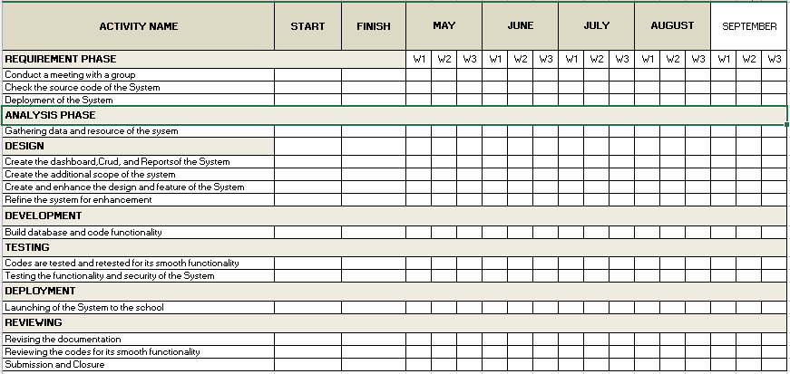
GANTT CHART
Figure 8: Project Timeline and Development Schedule.

The table illustrates the project timeline and development schedule spanning from May through September. It outlines the structured phases of the project lifecycle—including the Requirement Phase, Analysis Phase, Design, Development, Testing, Deployment, and Reviewing—providing a comprehensive schedule for tracking activities, milestones, and deliverables throughout the implementation of the system.

SYSTEM ARCHITECTURE
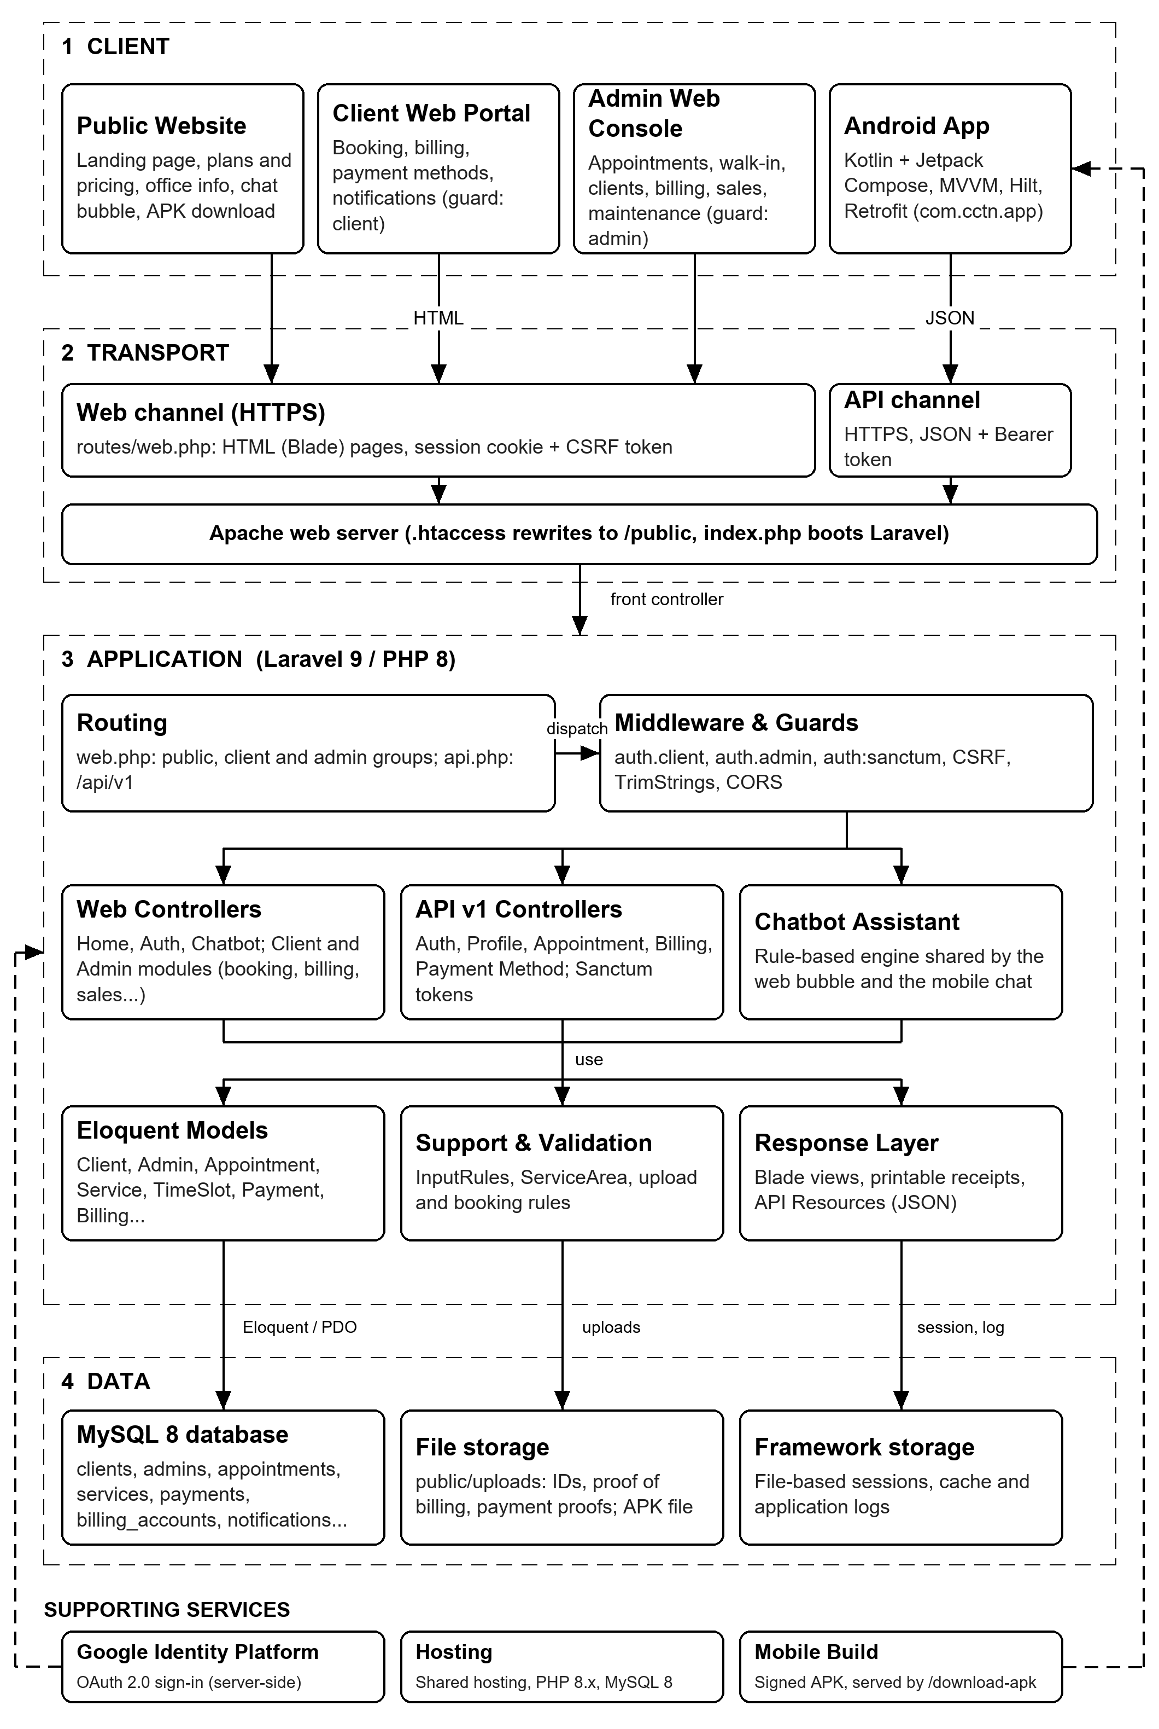
Figure 9: SYSTEM ARCHITECTURE of CLIENT BOOKING AND APPOINMENT MANAGEMNT SYSTEM.
The System Architecture of the BCTVI Web-Based Client Booking and Appointment Management System is structured across four primary layers and key supporting services that work together to deliver a secure, multi-channel platform for managing cable service operations.
The Client Layer consists of the user-facing interfaces, including the Public Website for guest visitors to view landing pages, service plans, pricing, office details, coverage areas, and download links; the Client Web Portal for signed-in subscribers to manage profiles, view dashboards, submit bookings, upload proof documents, and check billing history; the Admin Web Console for staff to manage walk-in applications, clients, services, schedules, payments, equipment, manpower, and maintenance; and the Android App, built with Kotlin and Jetpack Compose, providing mobile access to bookings, billing, and deep-link control. The Transport & Edge Layer handles secure web and API communication over HTTPS, utilizing a web channel with CSRF tokens on forms, an API channel authenticating JSON requests via bearer tokens (Laravel Sanctum), and an Apache/Nginx web server routing traffic to the backend framework.
The Application Layer (Laravel 9 / PHP 8) powers the core business logic, organized into key components: Routing for defining public, client, and admin endpoint groups; Middleware & Guards for enforcing session and token-based authentication, CSRF checks, and CORS rules; Web & API Controllers for processing incoming client and administrator actions across booking, billing, maintenance, and notification modules; Chatbot Assistant for delivering automated responses regarding plans, pricing, coverage, and account balances; Eloquent Models (ORM) for managing database interactions and complex relationships; Response Layer for rendering Blade views for web clients and JSON payloads for mobile apps; and Support & Validation for enforcing validation rules on uploads, file sizes, and slot availability.
The Data Layer serves as the system’s persistence tier, comprising the MySQL 8 Database storing clients, admins, services, slots, appointments, billing accounts, payments, and system logs; File Storage holding profile photos, valid IDs, proof of address, and payment receipts; and Framework Storage managing active file sessions, application logs, and cache data.
Finally, the architecture is supported by Mobile Build & Distribution for compiling signed APK release builds; Deployment / Hosting on a cPanel Apache/MySQL environment; External Services (Google Identity Platform) enabling OAuth 2.0 single sign-on authentication; and Security Controls implementing bcrypt password hashing, CSRF/Sanctum protection, and unique booking reference generation to safeguard operations across all components.

CONTEXT FLOW DIAGRAM
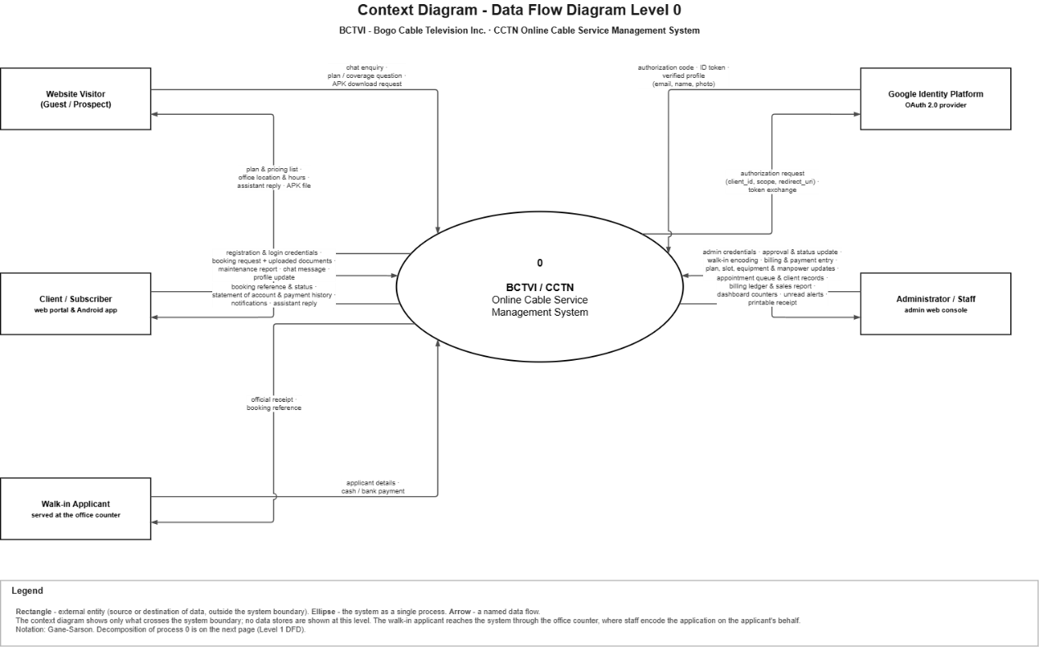
Figure 10: CONTECT FLOW DIAGRAM of CLIENT BOOKING AND APPOINMENT MANAGEMNT SYSTEM.

System Context Diagram for the BCTVI / CCTN Online Cable Service Management System
The diagram illustrates the top-level system context (Level 0 Data Flow Diagram) for the BCTVI / CCTN Online Cable Service Management System using Gane-Sarson notation. It maps out the interactions between the central system process and its external entities—including website visitors, clients/subscribers via web portal and Android app, walk-in applicants, administrators/staff via the admin web console, and the Google Identity Platform (Oauth 2.0 provider)—detailing the specific data flows such as registration credentials, booking requests, billing ledgers, payment details, and authentication tokens that cross the system boundary.
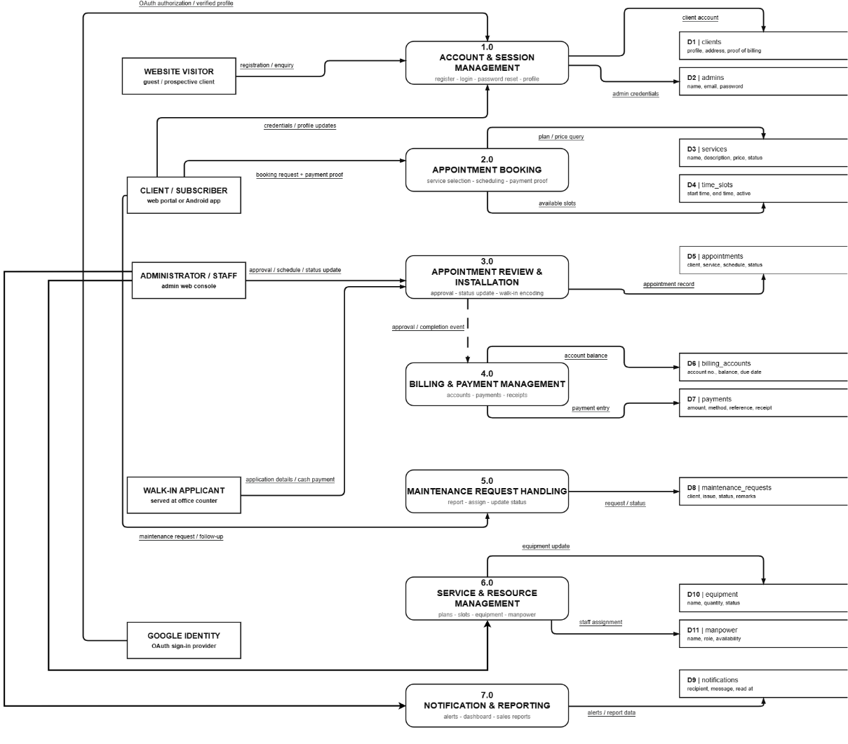
Figure 11: Level 2 DATA FLOW DIAGRAM of BCTVI WEB-BASED CLIENT BOOKING AND APPOINTMENT SYTEM

The implementation of the BCTVI/BCTVI Online Cable Service Management System is divided into nine major processes that work together to manage the organization’s cable service operations. The Account and Session Management module handles client and administrator registration, login, Google sign-in, password reset, and session or API token generation. The Appointment Booking and Scheduling module allows clients to select a service plan, check available installation slots, submit booking requests, and upload required documents. The Appointment Review and Installation Processing module enables administrators to review and approve appointments, process walk-in applications, update installation status, and print official receipts. The Billing and Payment Management module manages client billing accounts, statements of account, payment posting, penalties, and payment history. The Maintenance Request Handling module records customer complaints, assigns priorities, updates ticket statuses, and stores follow-up information. The Service and Resource Management module allows administrators to manage cable plans, installation time slots, equipment, and manpower availability. The Notification Management module generates alerts for important events such as bookings, approvals, billing, and maintenance updates. The Chatbot Assistant provides automated responses to inquiries about service plans, prices, office information, coverage areas, bookings, and account balances. Finally, the Reporting and Analytics module processes appointment, payment, and billing information to generate dashboard counters, sales reports, collection totals, and other management reports. These processes communicate with centralized data stores containing client records, administrator accounts, services, appointments, billing accounts, payments, maintenance requests, notifications, equipment, manpower, access tokens, and uploaded documents, ensuring that information is organized, accessible, and efficiently managed throughout the system.
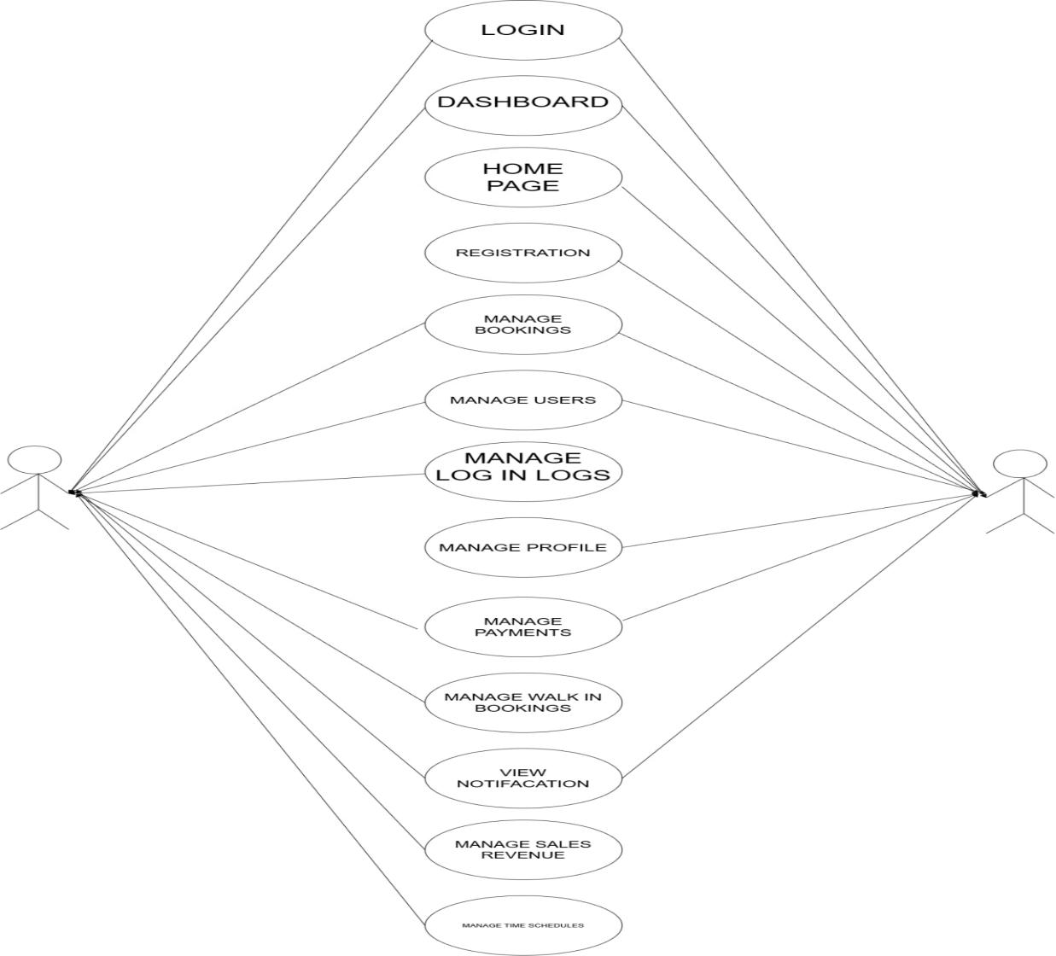
Figure 12: Use Case Diagram for the BCTVI / CCTN Online Cable Service Management System.

The diagram illustrates the use case model for the system, mapping out core functionalities—including Login, Dashboard, Home Page, Registration, Manage Bookings, Manage Users, Manage Login Logs, Manage Profile, Manage Payments, Manage Walk-In Bookings, View Notifications, Manage Sales Revenue, and Manage Time Schedules—as they interact with system actors. This structural blueprint outlines the scope of user and administrator interactions, providing a clear visual representation of system features and access boundaries.

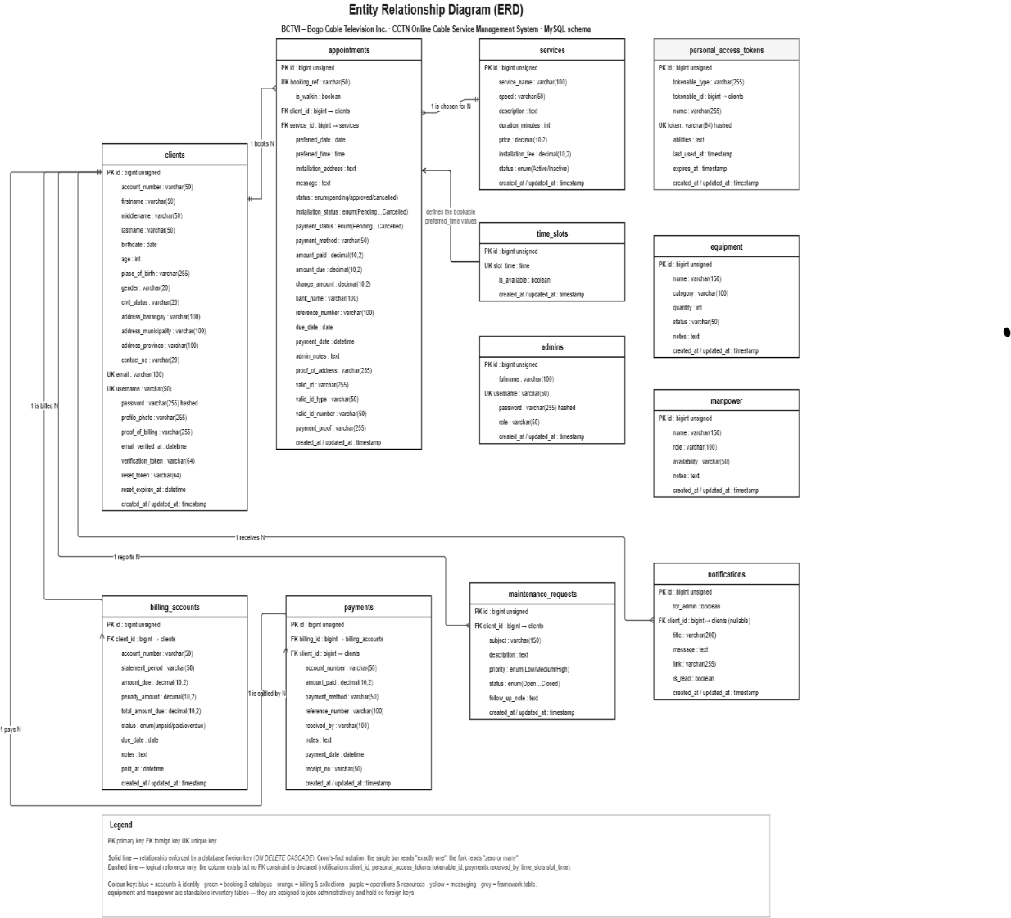
ENTITY RELATION DIAGRAM
Figure 13: ENTITY RELATION DIAGRAM of BCTVI WEB-BASEDCLIENT BOOKING AND APPOINMENT MANAGEMNT SYSTEM.

The implementation of the proposed BCTVI Online Cable Service Management System involves developing an integrated web and mobile-based platform that manages cable service operations, including user registration, authentication, service applications, appointment scheduling, billing and payments, maintenance requests, client records, notifications, and administrative transactions. The system allows clients to access services through the website or Android application, while walk-in applicants can be assisted by staff in encoding their information and processing their transactions. Administrators and authorized personnel can manage subscriber accounts, cable plans, appointments, payments, maintenance requests, equipment, manpower assignments, and generate reports and receipts. The system also incorporates secure authentication, including Google Oauth 2.0, to provide users with a convenient and reliable login method. All submitted information is processed and stored in a centralized database, allowing authorized users to retrieve accurate and updated records. Through this implementation, the system aims to reduce manual processes, improve transaction efficiency, provide real-time monitoring of service requests, and enhance the overall accessibility and management of BCTVI cable services.

SYSTEM FLOWCHART
The system flowchart shows the complete process of the BCTVI / CCTN Online Cable Service Management System, starting from the moment the user types or searches the website URL in the browser until the end of the process. The URL is checked first: the administrator, login, registration and forgot-password addresses are sent to their own processes, while any other address opens the BCTVI home page, where the visitor can view the home, plans, mobile app, support and about sections or proceed to login and registration. The off-page connectors (AA to AJ) lead to the detailed flowcharts shown on the following pages, one page for each connector: the administrator login and tasks, the client login, registration, forgot-password and reset-password processes, the client portal, and the booking and payment process, and the connector D returns to the End of the process after the user signs out.
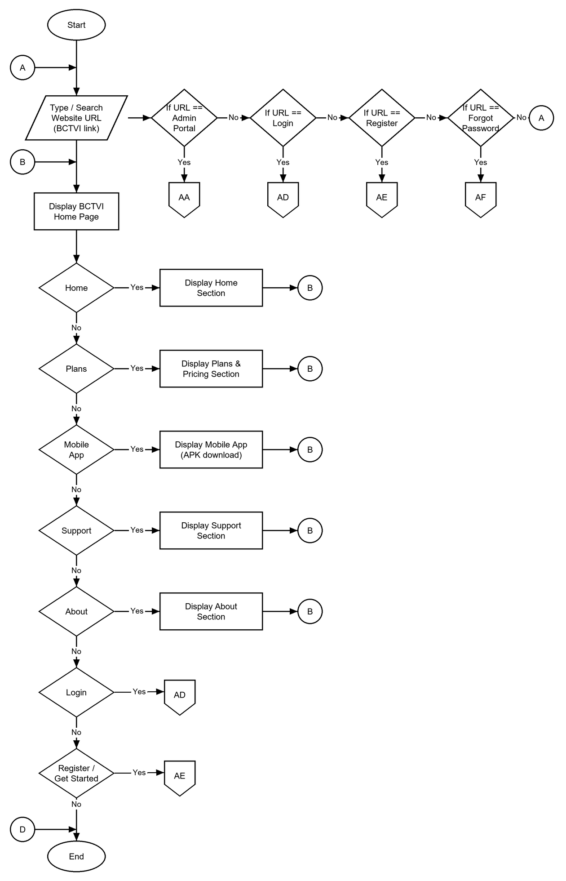
Figure 14.1: SYSTEM FLOWCHART (Type/Search URL to End) of BCTVI CLIENT BOOKING AND APPOINTMENT MANAGEMENT SYSTEM.
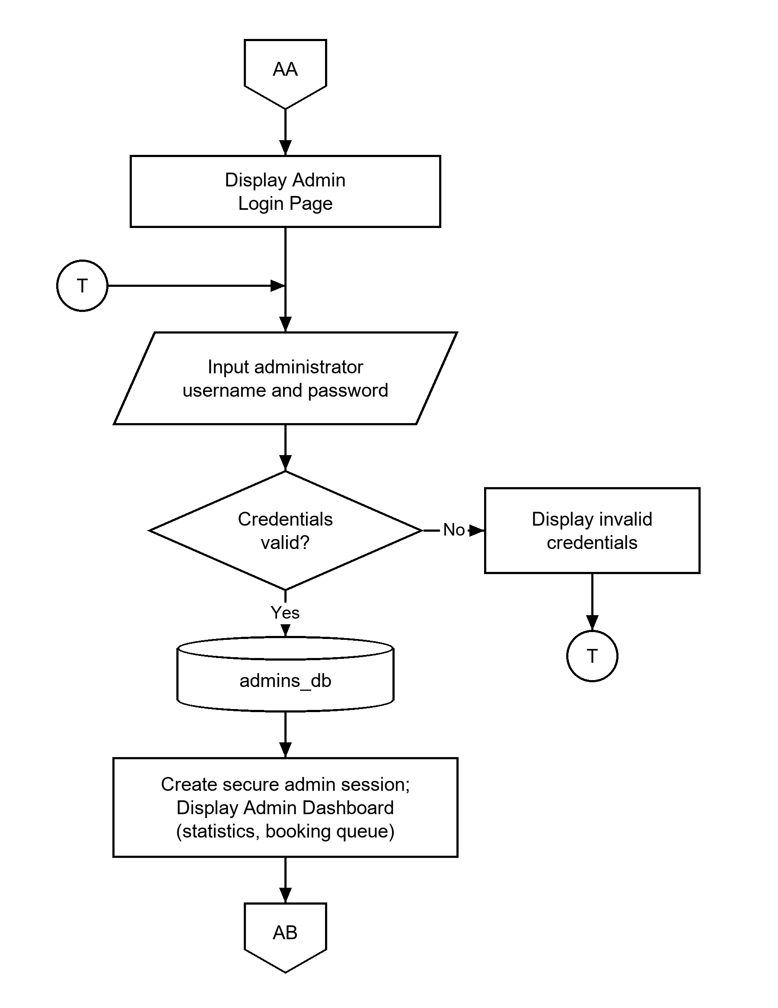
Figure 14.2: ADMIN LOGIN FLOWCHART (Connector AA).
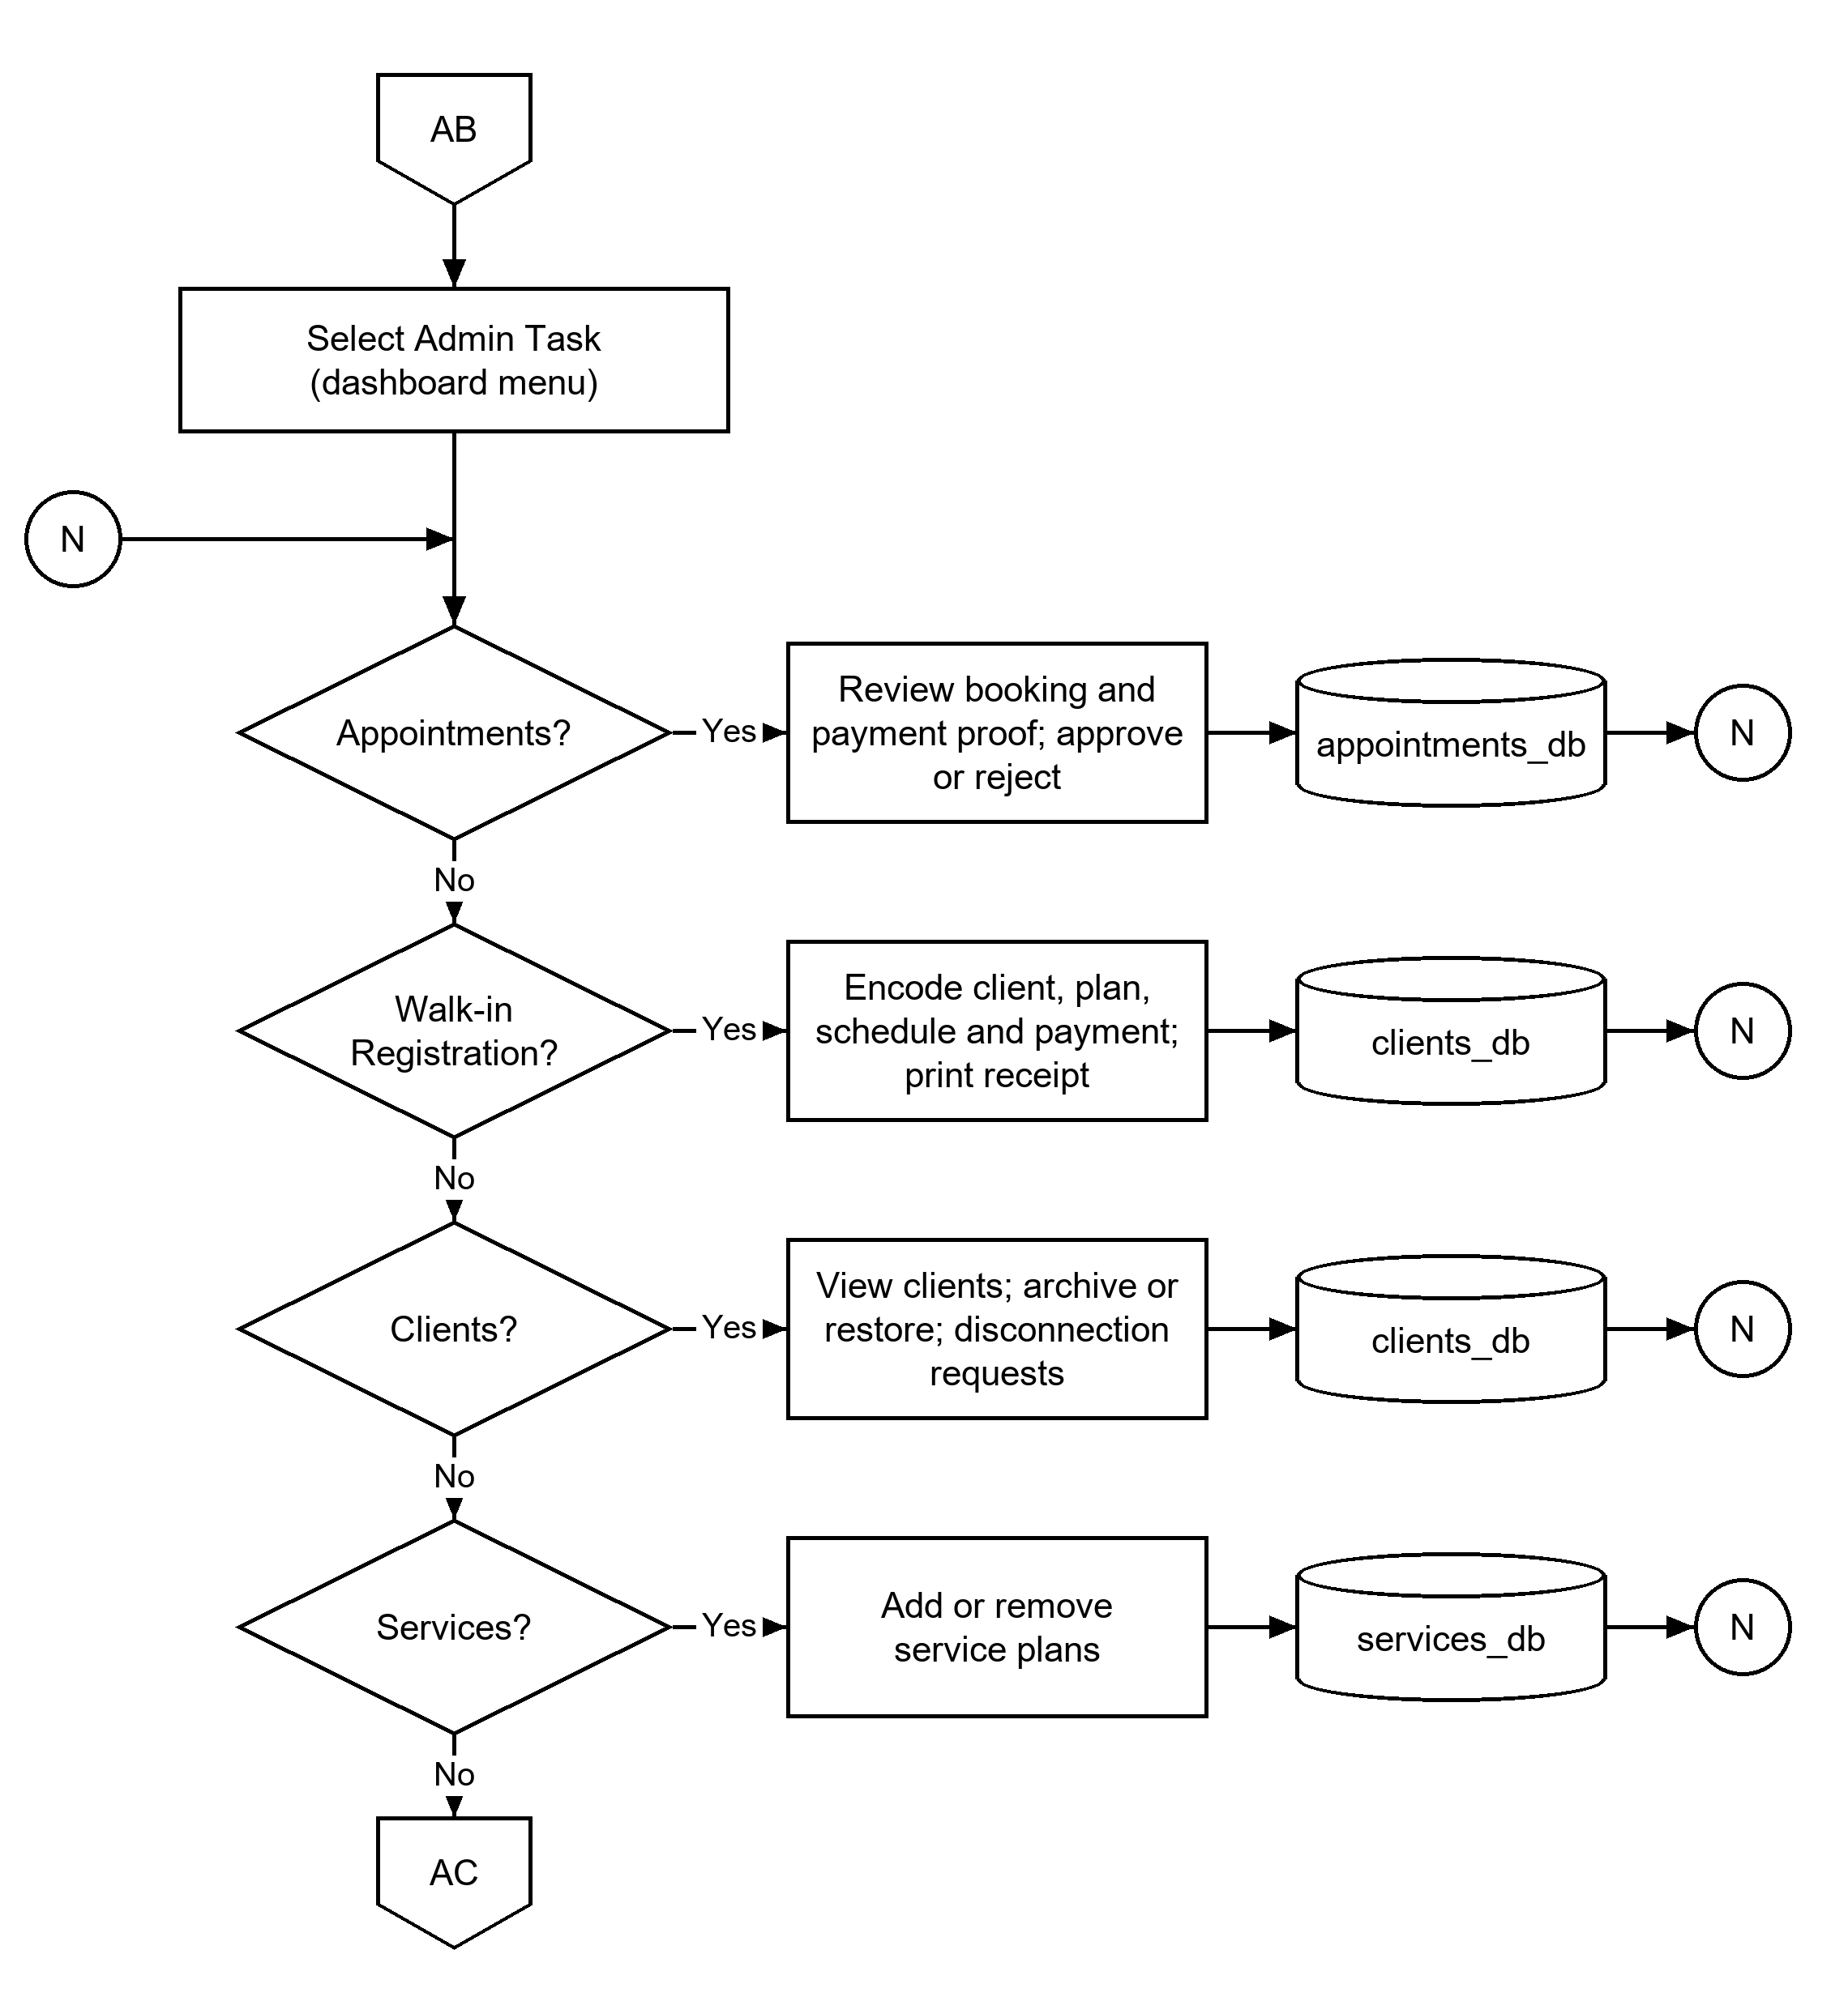
Figure 14.3: ADMIN TASKS FLOWCHART, Part 1 (Connector AB).
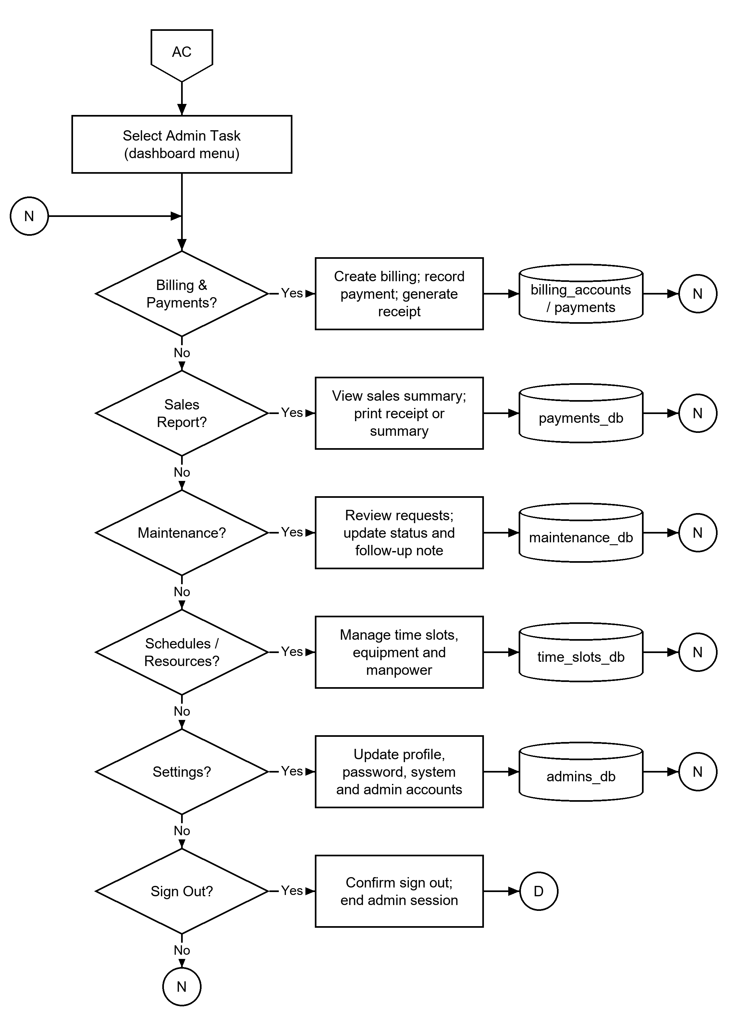
Figure 14.4: ADMIN TASKS FLOWCHART, Part 2 (Connector AC).
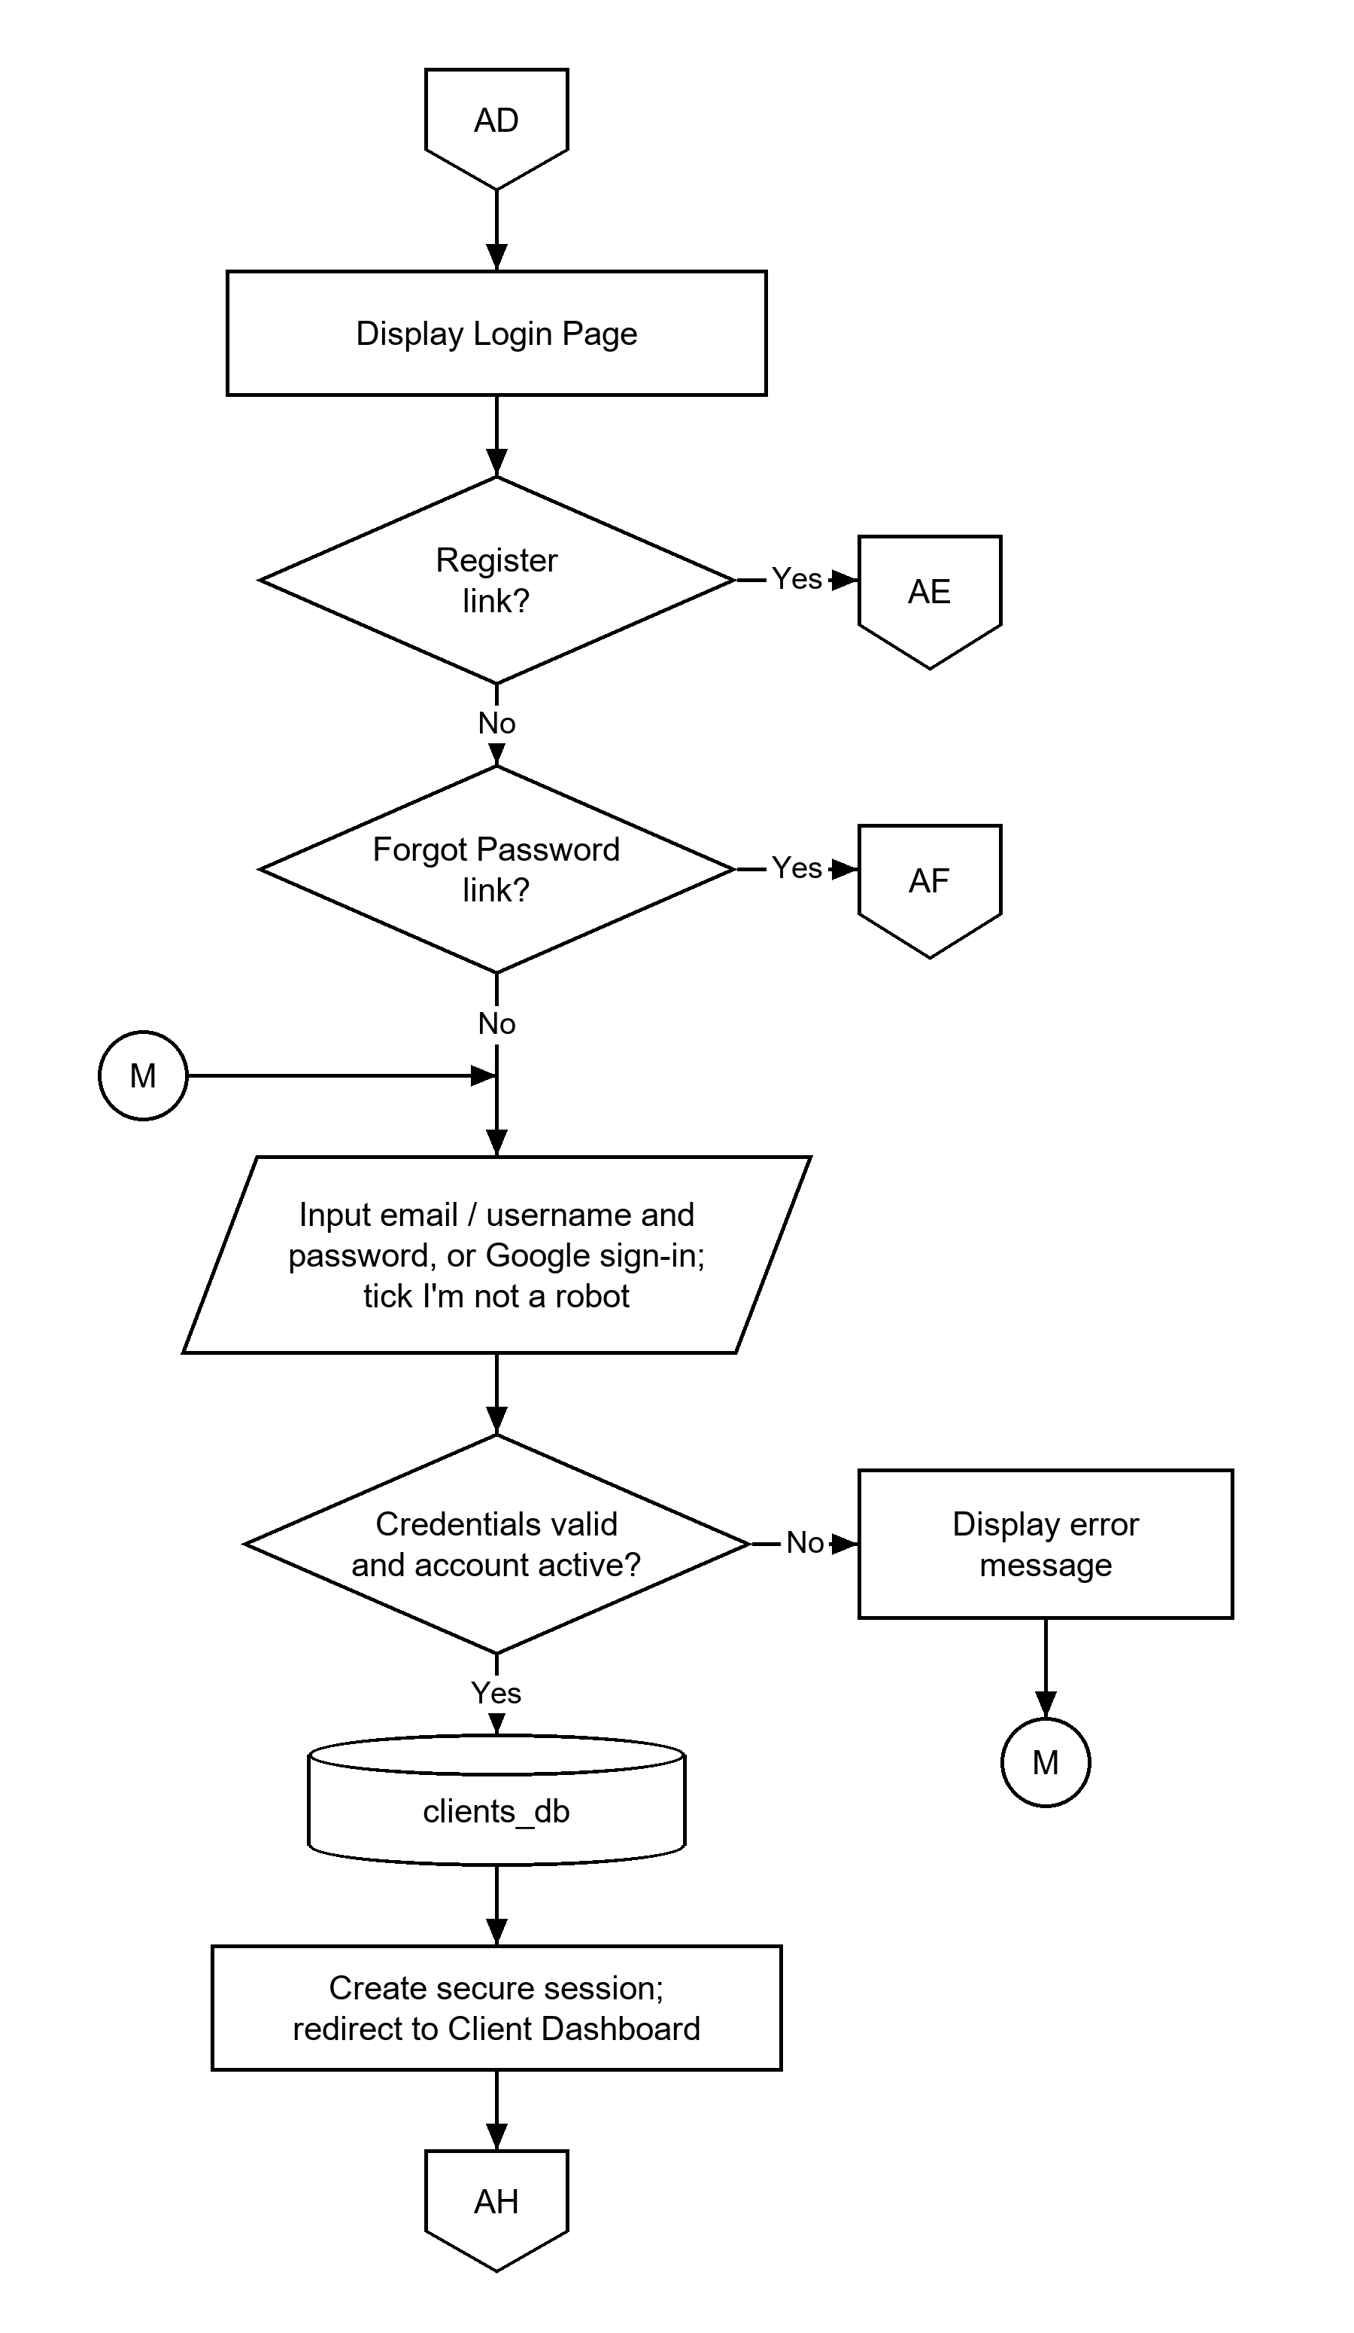
Figure 14.5: CLIENT LOGIN FLOWCHART (Connector AD).
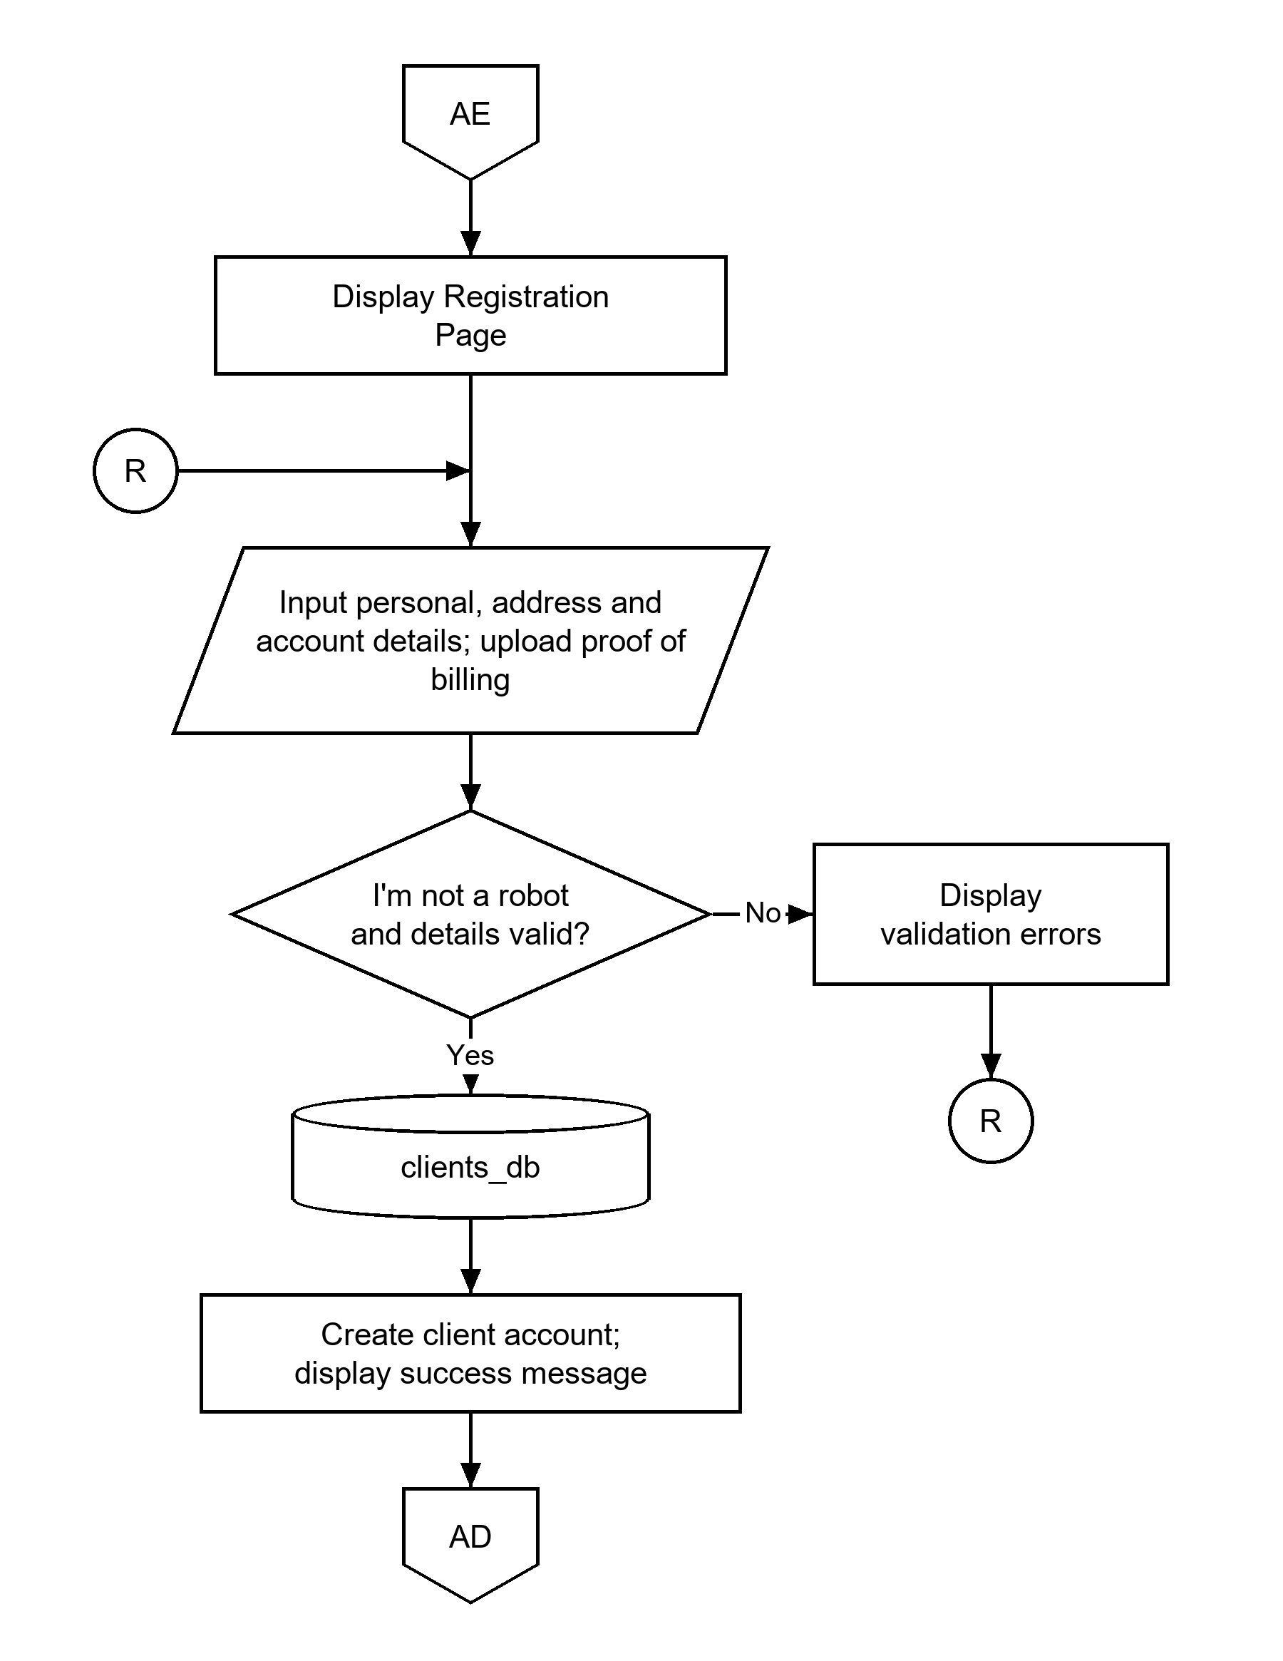
Figure 14.6: CLIENT REGISTRATION FLOWCHART (Connector AE).
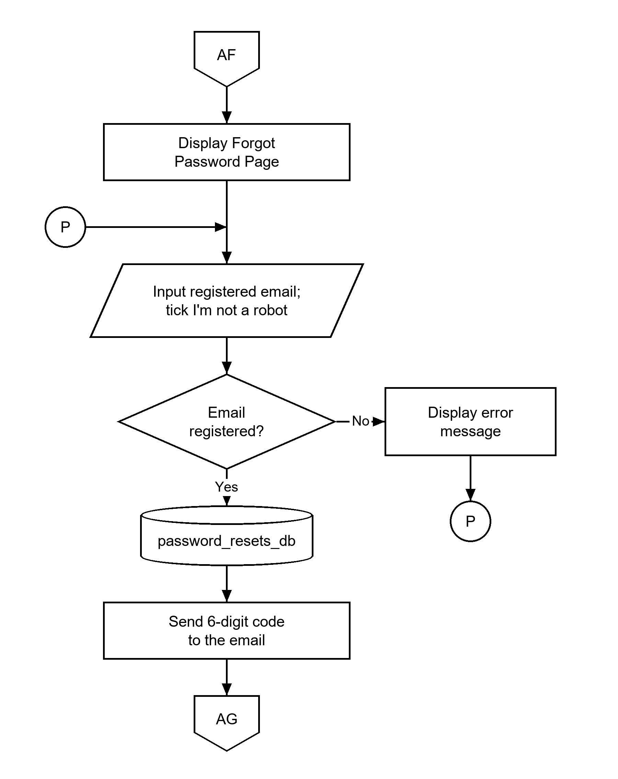
Figure 14.7: FORGOT PASSWORD FLOWCHART (Connector AF).
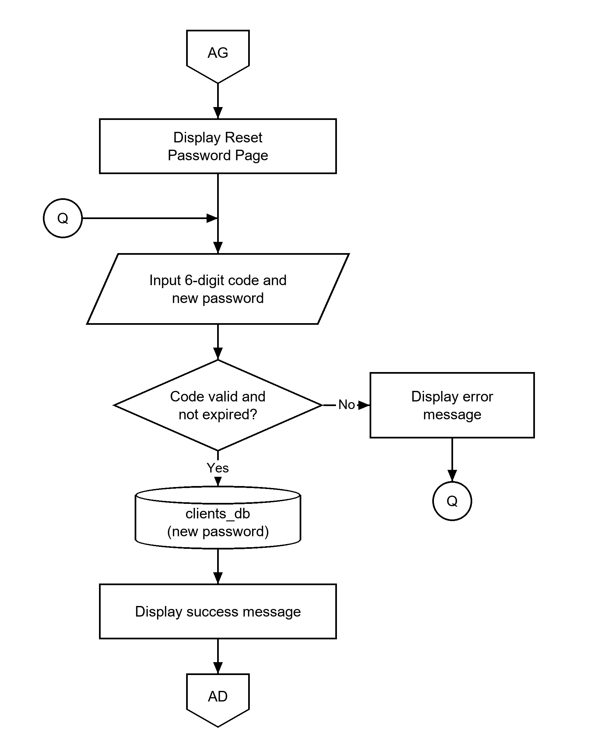
Figure 14.8: RESET PASSWORD FLOWCHART (Connector AG).
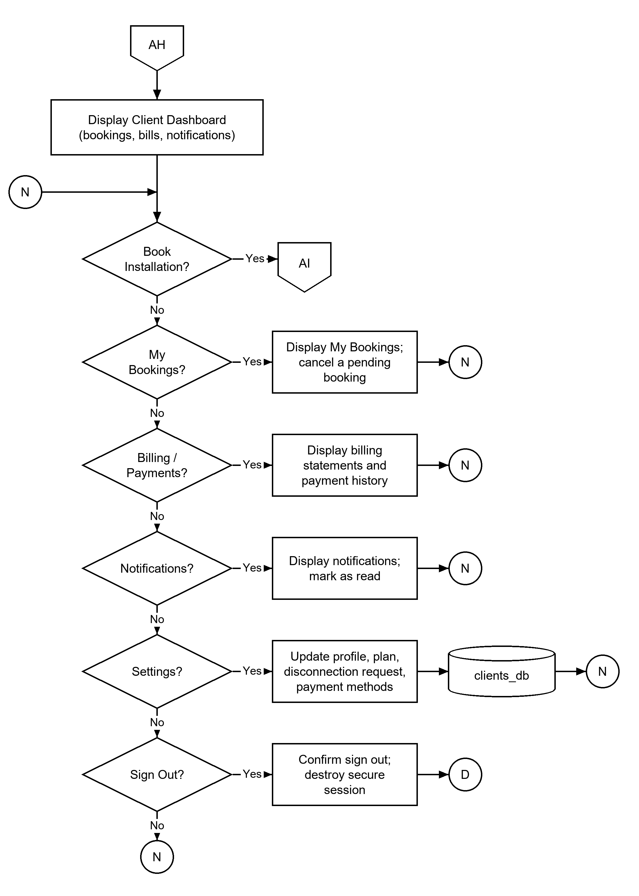
Figure 14.9: CLIENT PORTAL FLOWCHART (Connector AH).
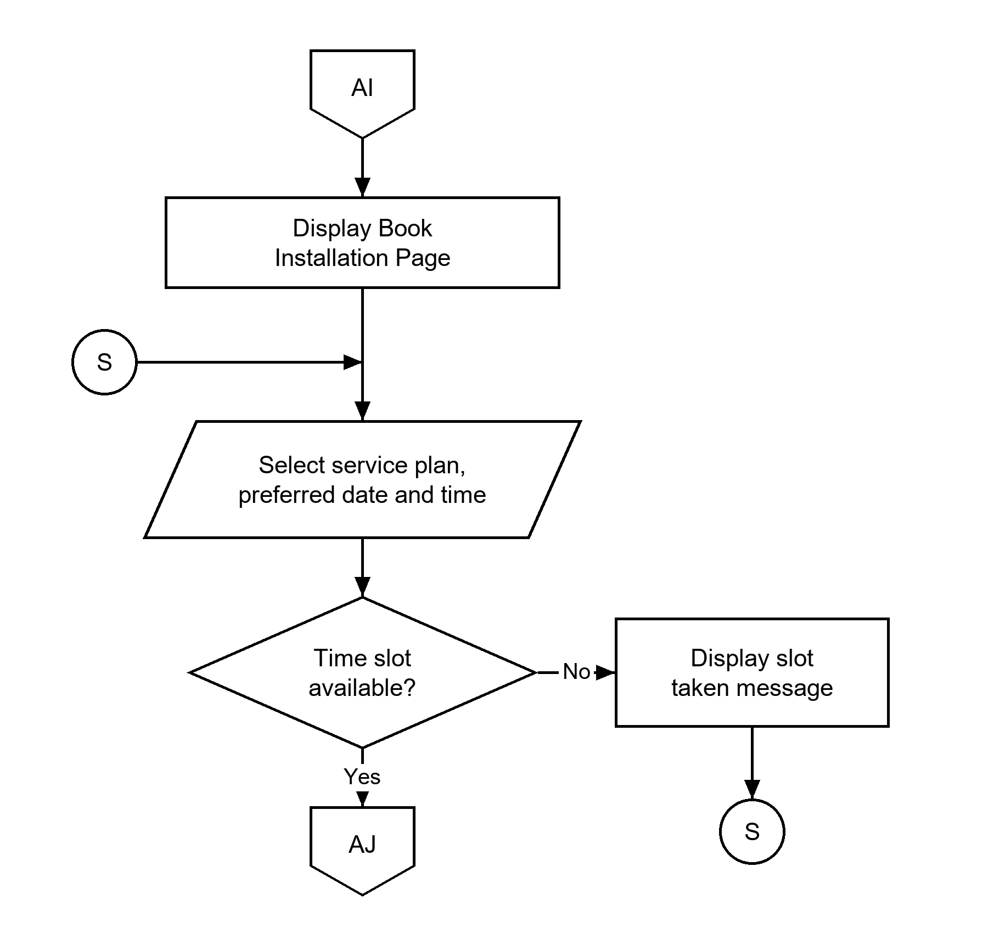
Figure 14.10: BOOKING FLOWCHART, Select Plan, Date and Time (Connector AI).
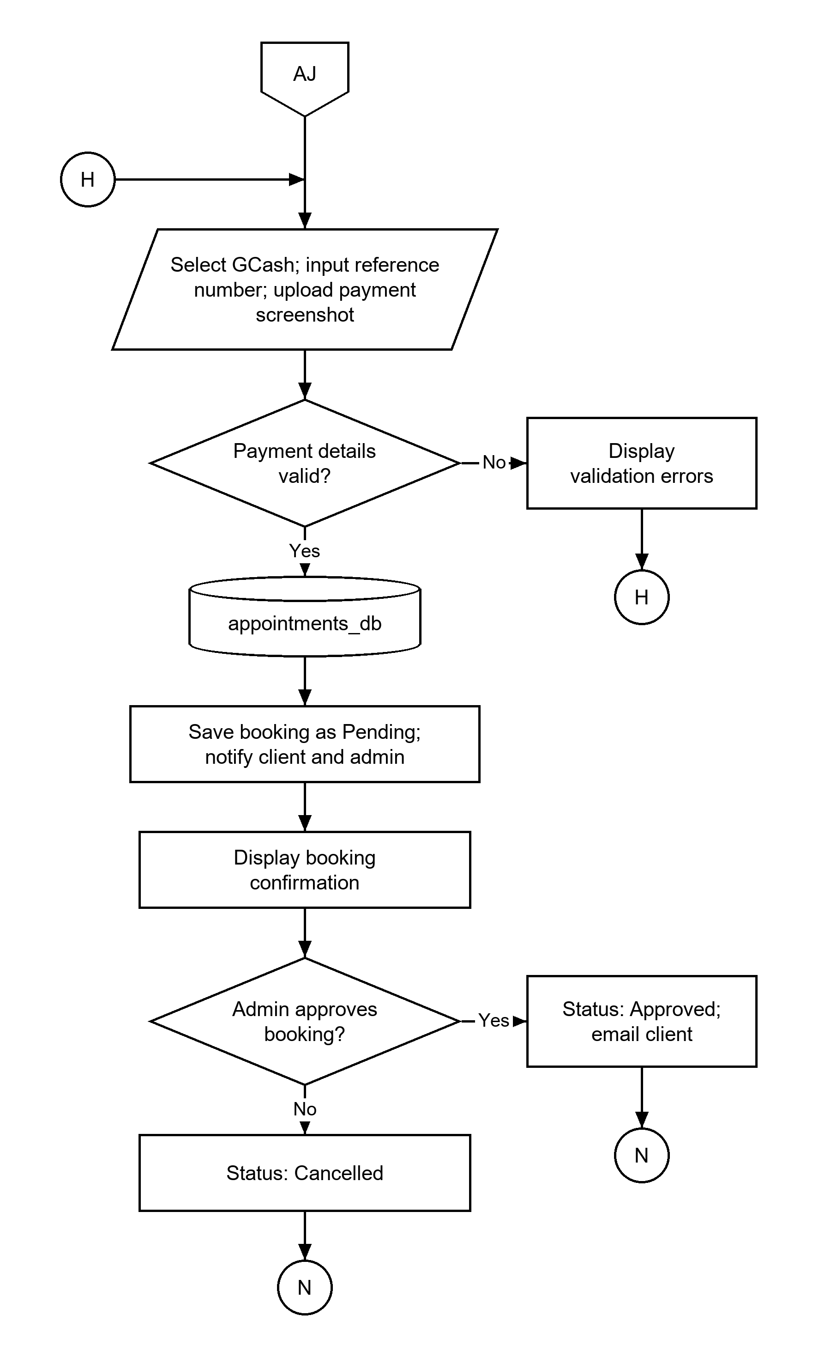
Figure 14.11: BOOKING FLOWCHART, Payment and Status (Connector AJ).

CHAPTER IV
PRESENTATION, ANALYSIS, AND INTERPRETATION OF RESULTS

After thorough evaluation by I.T. experts and respondents, the following are the results based on the survey.
CRITERIA | MEAN | VERBAL INTERPRETTION
How functional is our system in terms of allowing the admin to create billing statements for clients? | 4.34 | STRONGLY FUCTIOANAL
How functional is our system in terms of allowing the admin to add and update services using Create, Read, Update, and Delete (CRUD) operations? | 4.67 | STRONGLY FUCTIOANAL
How functional is our system in terms of allowing the admin to view receipts for every transaction? | 4.61 | STRONGLY FUCTIOANAL
How functional is our system in terms of allowing the admin to add time slots? | 4.46 | STRONGLY FUCTIOANAL
How functional is our system in terms of allowing the admin to add equipment? | 4.42 | STRONGLY FUCTIOANAL
How functional is our system in terms of allowing the admin to add staff? | 4.48 | STRONGLY FUCTIOANAL
TOTAL WEIGHTED MEAN | 4.50 | STRONGLY FUNCTIONAL
Table 1: In terms of creating, reading, updating and deleting the Appointment and Installation Management.

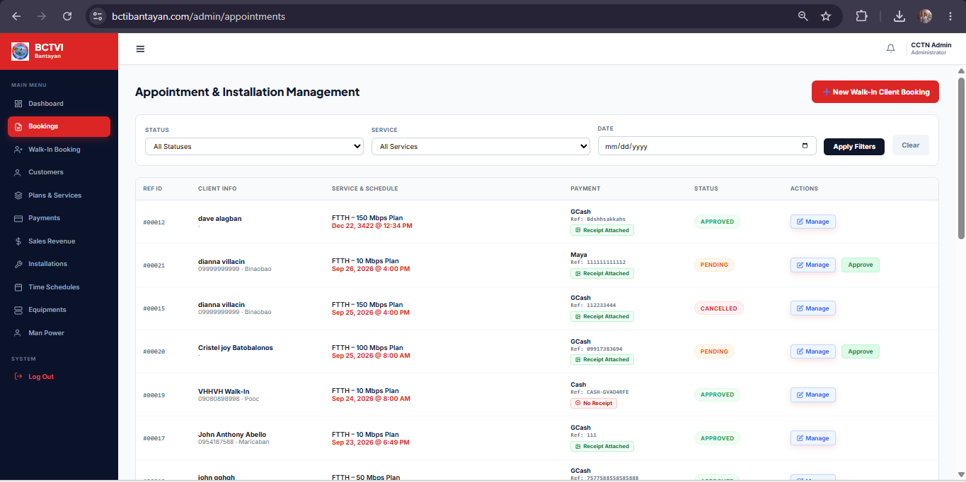
The table shows the evaluation of the system’s management and administrative functionalities yielded an overall Total Weighted Mean of 4.50 with a verbal interpretation of Strongly Functional, reflecting high overall effectiveness in handling back-end operations. Specifically, the capability allowing the admin to add and update services using CRUD operations received the highest mean of 4.67, closely followed by the ability to view receipts for every transaction at 4.61, indicating robust and reliable transaction and service management. Additionally, strong positive ratings were recorded for allowing the admin to add staff (4.48), add time slots (4.46), add equipment (4.42), and create billing statements for clients (4.34). Together, these results demonstrate that the system successfully equips administrators with comprehensive, highly functional tools to manage key business resources and financial records efficiently.
Figure 16: In terms of Appointment and Installation Management Interface.

The image displays the Appointment & Installation Management module interface, highlighting filters for status, service, and date, alongside a detailed records table tracking reference IDs, client info, service and schedule, payment details with receipt attachments, status indicators, and administrative action buttons. This visual representation illustrates how the system organizes complex scheduling and transaction data, directly reinforcing the strong evaluation scores by providing administrators with a transparent, highly manageable platform to process bookings and review client information.

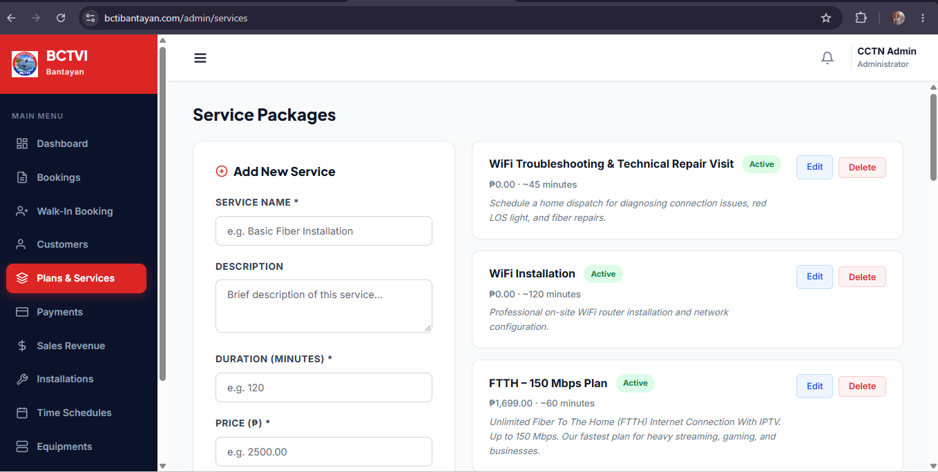
Figure 17: In terms of Service Packages and CRUD Operations Interface.

The image showcases the Service Packages module interface, featuring an “Add New Service” form on the left with fields for service name, description, duration, and price, alongside an existing list of services complete with status tags and active “Edit” and “Delete” buttons on the right. This layout demonstrates the practical implementation of Create, Read, Update, and Delete (CRUD) operations, visually validating the system’s high evaluation scores for service management by providing administrators with an intuitive tool to create and maintain service offerings.
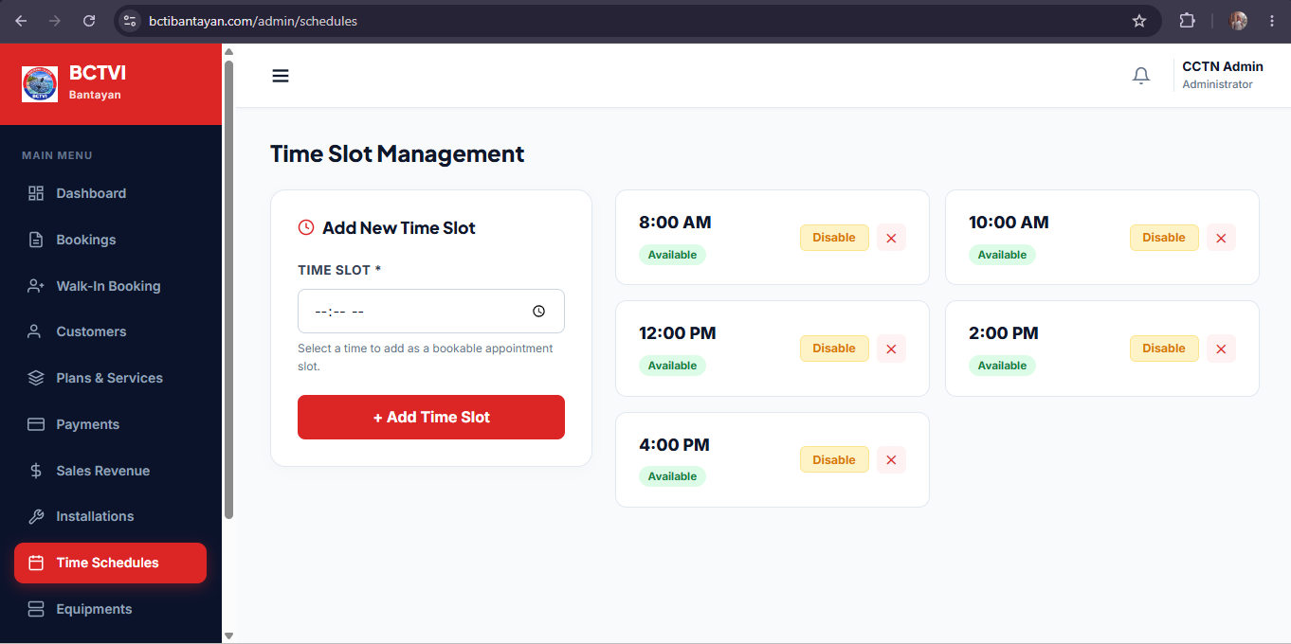
Figure 18: In terms of Time Slot Management Interface.

The image illustrates the Time Slot Management module interface, featuring an “Add New Time Slot” form on the left with a time selection input and an “+ Add Time Slot” button, alongside a structured grid of existing schedule cards on the right displaying individual time slots (such as 8:00 AM, 10:00 AM, 12:00 PM, 2:00 PM, and 4:00 PM) with “Available” status tags, “Disable” buttons, and deletion options. This clear layout visually reinforces the system’s strong evaluation scores for scheduling functionality by providing administrators with a straightforward, organized tool to configure and oversee bookable appointment hours.
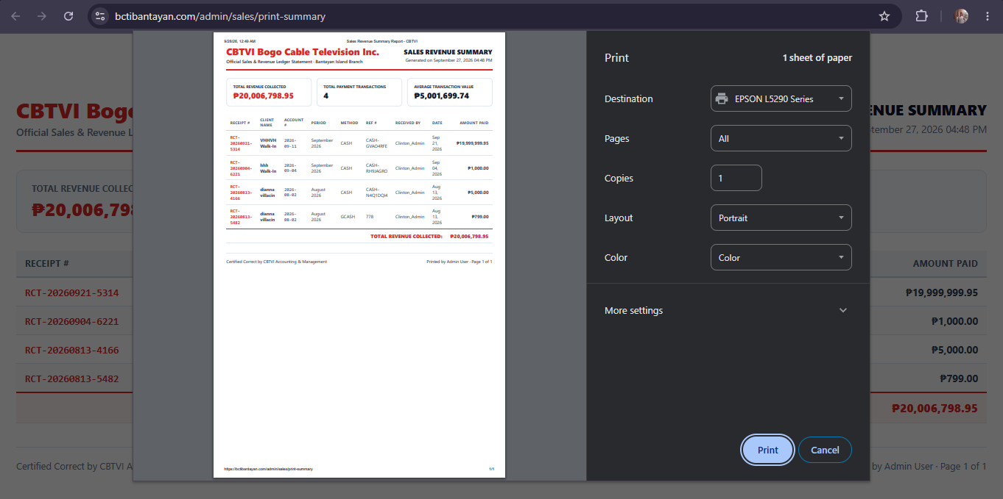
Figure 19: In terms of Sales Revenue Summary and Transaction Receipt Printing Interface.

The image illustrates the Sales Revenue Summary report and print preview interface, featuring a structured financial ledger breakdown displaying receipt numbers, client names, transaction periods, methods, reference numbers, dates, and amounts paid, alongside a browser print configuration panel. This visual layout provides direct support for the system’s evaluation scores regarding financial management and transaction review by offering administrators a clear, standardized document preview for tracking revenue and printing official records.

Criteria | MEAN | VERBAL INTERPRETATION
How functional is our system in terms of displaying the total number of bookings on the admin dashboard? | 4.66 | STRONGLY FUCTIOANAL
How functional is our system in terms of displaying the pending approvals on the admin dashboard? | 4.59 | STRONGLY FUCTIOANAL
How functional is our system in terms of displaying the total number of clients on the admin dashboard? | 4.66 | STRONGLY FUCTIOANAL
How functional is our system in terms of displaying the active services on the admin dashboard? | 4.42 | STRONGLY FUCTIOANAL
How functional is our system in terms of providing quick links to access Manage Appointment, Client Database, Billing & Payments, and Manage Services? | 4.42 | STRONGLY FUCTIOANAL
TOTAL WEIGHTED MEAN | 4.55 | STRONGLY FUNCTIONAL
Table 2: In terms of displaying the total numbers of Total Bookings, Pending Approvals, Total Clients, Active Service.

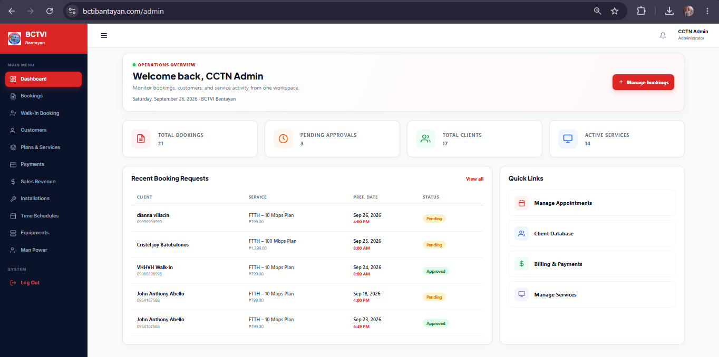
The table shows the evaluation of the admin dashboard yielded an overall Total Weighted Mean of 4.55 with a verbal interpretation of Strongly Functional, indicating high user satisfaction and effectiveness. Specifically, the features for displaying the total number of bookings and clients received the highest individual means of 4.66, closely followed by pending approvals at 4.59, demonstrating that the system excels at providing clear, high-level metrics and actionable workflow visibility. Meanwhile, the display of active services and the provision of navigation quick links both recorded means of 4.42, which, while slightly lower, still reflect a strong level of performance. Overall, these results confirm that the dashboard successfully centralizes critical operational data and streamlines administrative tasks, with only minor areas available for potential user experience refinement.
Figure 15: In terms of the Admin Dashboard Interface and Overview.

The image illustrates the deployed admin dashboard interface, showcasing the operational overview, metrics cards for total bookings, pending approvals, total clients, and active services, as well as the recent booking requests and quick links panel. This visual layout directly supports the high evaluation scores by demonstrating an organized, user-friendly workspace where administrators can efficiently monitor system activity and access core management modules from a single screen.

CRITERIA | MEAN | VERBAL INTERPRETATION
How functional is our system in terms of notifying users through their Gmail account once their payment has been received by the company? | 4.55 | STRONGLY FUNCTIONAL
TOTAL WEIGHTED MEAN | 4.55 | STRONGLY FUNCTIONAL
Table 3: In terms of Gmail Payment Notification Functionality.

The table shows the evaluation of the system’s automated notification feature regarding payment receipt via Gmail yielded a mean and Total Weighted Mean of 4.55, with a verbal interpretation of Strongly Functional. This score indicates that users and administrators find the automated email notification system highly reliable, efficient, and effective in keeping clients promptly informed once their payments have been successfully acknowledged and received by the company.
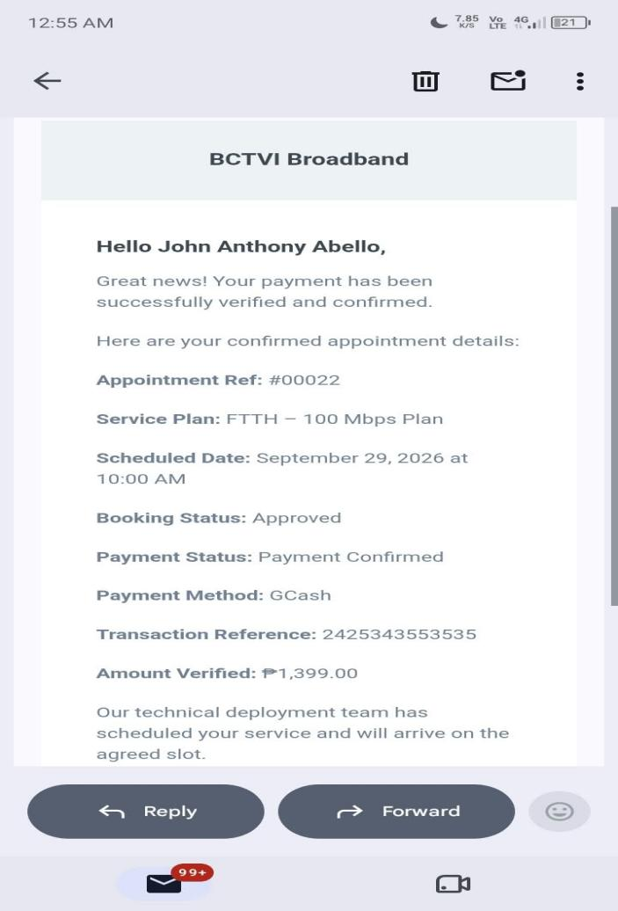

Figure 20: In terms of Automated Gmail Payment Notification and Confirmation Interface.

The image displays the automated email notification received by a client through Gmail from BCTVI Broadband, confirming that their payment has been successfully verified, along with details such as the appointment reference number, service plan, scheduled date, booking status, payment method, transaction reference, and verified amount. This visual layout provides direct support for the system’s strong evaluation scores regarding notification functionality by demonstrating a professional, clear, and informative communication channel that keeps clients promptly updated upon receipt of payment.
Criteria | Mean | Verbal Interpretation
How functional is our system in terms of providing a mobile application for Android devices that enables push notifications and allows users to book an appointment, choose a service package, select a preferred date and time, select a digital payment method, and upload a photo screenshot of the payment receipt? | 4.66 | STRONGLY FUCTIONAL
TOTAL WEIGHTED MEAN | 4.66 | STRONGLY FUNCTIONAL
Table $: In terms of being deployed and being accessible online event into a mobile application.

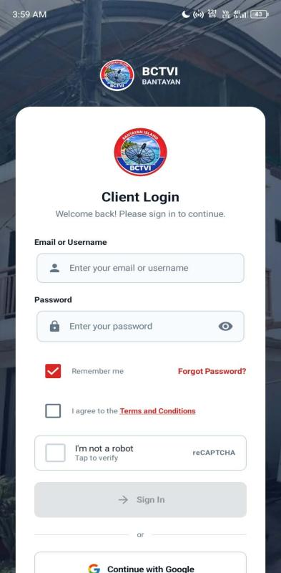
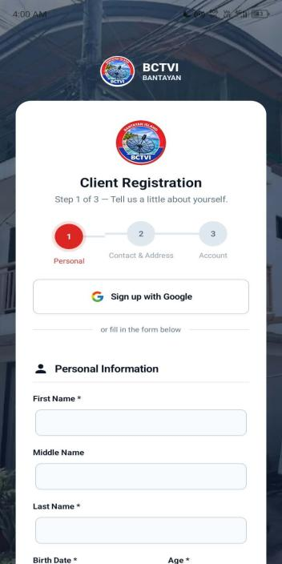
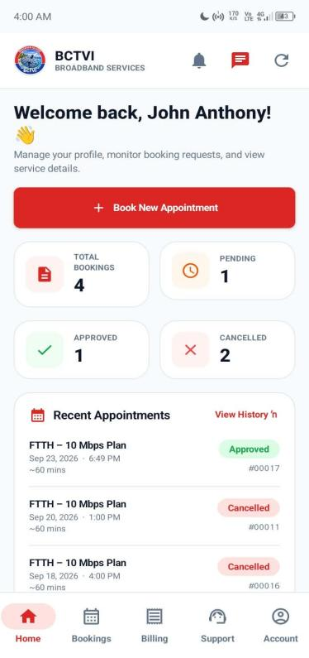
The table shows the evaluation of the system’s mobile application features—covering push notifications, appointment booking, service package selection, date and time slot scheduling, digital payment options, and receipt screenshot uploads—yielded a Total Weighted Mean of 4.66 with a verbal interpretation of Strongly Functional. This high score reflects strong user satisfaction and confirms that the Android application delivers a seamless, comprehensive mobile booking and transaction experience for clients.
Figure 21: In terms of Android Mobile Application Login, Registration, and Client Dashboard Interface.

The image displays the Android mobile application interface, featuring the Client Login screen, a multi-step Client Registration form with personal information fields, and the main client dashboard showcasing account overview metrics (total bookings, pending, approved, and cancelled), recent appointments, and bottom navigation tabs. This visual layout directly supports the high evaluation scores by demonstrating an intuitive, well-structured mobile interface that allows users to easily authenticate, register, manage profiles, and monitor their service requests on the go.
CRITERIA | MEAN | VERBAL INTERPRETATION
USEFULNESS | 4.40 | STRONGLY FUNCTIONAL
SATISFACTION | 4.46 | STRONGLY FUNCTIONAL
EASE OF USE | 4.46 | STRONGLY FUNCTIONAL
EASE OF LEARNING | 4.39 | FUNCTIONAL
TOTAL WEIGHTED MEAN | 4.42 | STRONGLY FUNCTIONAL
Table 5: In terms of System Usability, Satisfaction, Ease of Use, and Ease of Learning.

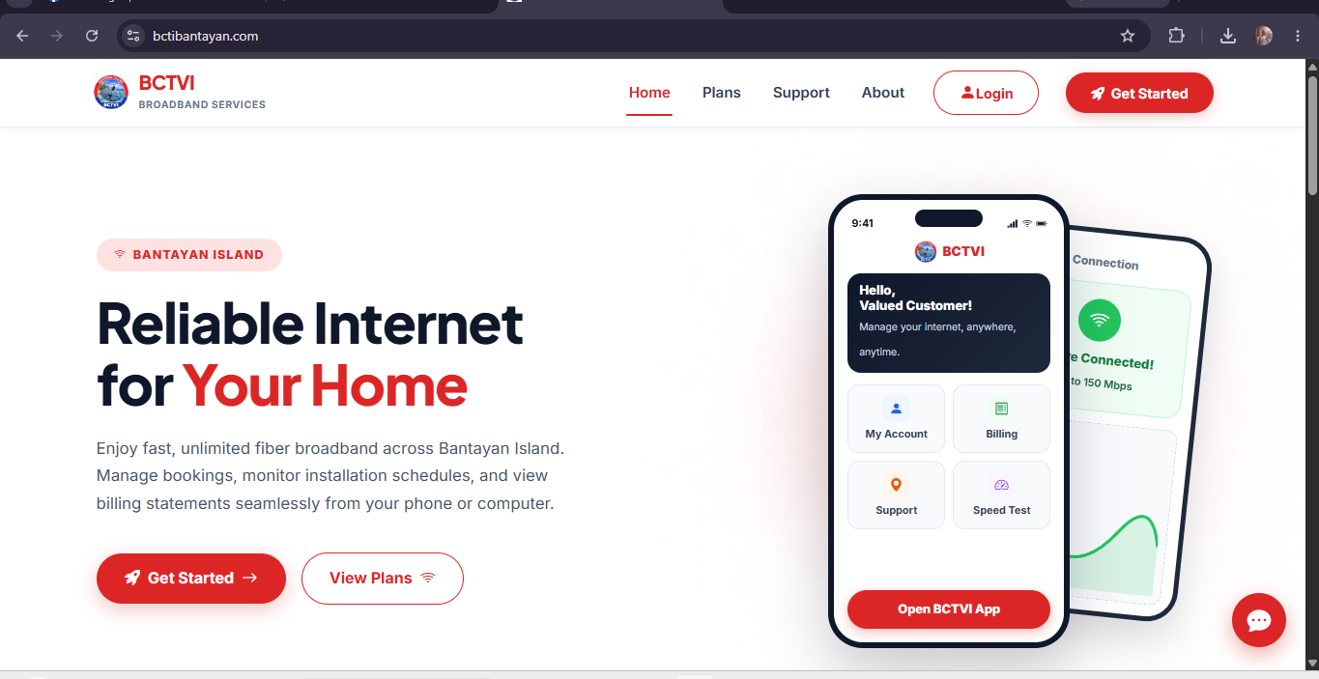
The table shows the evaluation of the system’s overall user experience dimensions yielded an overall Total Weighted Mean of 4.42 with a verbal interpretation of Strongly Functional. Specifically, the criteria for Satisfaction and Ease of Use received the highest individual ratings with a mean of 4.46 (Strongly Functional), followed closely by Usefulness at 4.40 (Strongly Functional) and Ease of Learning at 4.39 (Functional). These positive scores collectively demonstrate that the platform is intuitive, user-friendly, and well-received by respondents, ensuring both administrators and clients can efficiently learn and navigate the system with high satisfaction.
Figure 23: Software Usability

The figure above shows the functionality of the BCTVI WEB-BASED CLIENT BOOKING AND APPOINMENT MANAGEMNT SYSTEM which is useful for the clients to register and download the mobile application.

CRITERIA | MEAN | VERBAL INTERPRETATION
FUNCTIONAL SUITABILITY | 4.33 | FUNCTIONAL
PERFORMANCE EFFICIENCY | 4.11 | FUNCTIONAL
COMPATIBILITY | 4.58 | STRONGLY FUNCTIONAL
RELIABILITY | 4.42 | STRONGLY FUNCTIONAL
SECURITY | 4.44 | STRONGLY FUNCTIONAL
TOTAL WEIGHTED MEAN | 4.38 | FUNCTIONAL
Figure 6: In terms of System Quality Characteristics (Functional Suitability, Performance Efficiency, Compatibility, Reliability, and Security).

The table shows the evaluation of the system’s software quality characteristics yielded an overall Total Weighted Mean of 4.38 with a verbal interpretation of Functional. Specifically, Compatibility achieved the highest rating with a mean of 4.58 (Strongly Functional), followed by Reliability at 4.42 (Strongly Functional), Security at 4.44 (Strongly Functional), Functional Suitability at 4.33 (Functional), and Performance Efficiency at 4.11 (Functional). These positive findings demonstrate that the platform performs dependably across different environments, maintains secure and reliable data handling, and satisfies core functional requirements effectively.

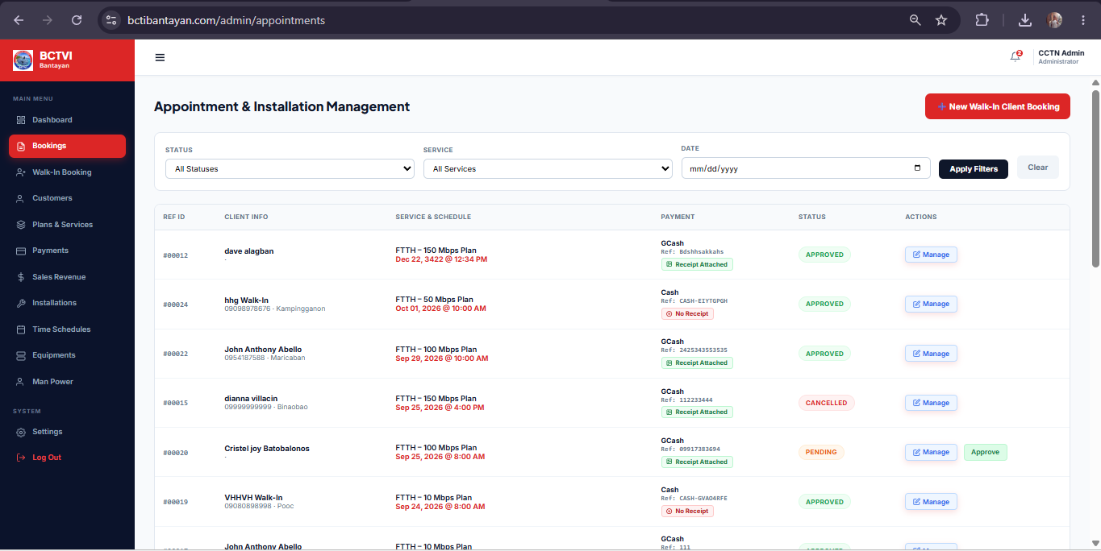
Figure 22: Software Best Quality Function

The figure shows the best quality function of BCTVI WEB-BASED CLIENT BOOKING AND APPOINMENT MANAGEMNT SYSTEM where the admin can be able to manage bookings and update booking status.

CHAPTER V
SUMMARY OF FINDINGS, RECOMMENDATIONS, CONCLUSION

SUMMARY OF FINDINGS
The evaluation of the BCTVI / CCTN Online Cable Service Management System was conducted across various operational, functional, mobile, and software quality dimensions, yielding consistently high evaluations from respondents:
- Admin Dashboard Functionality: Evaluated with an overall Total Weighted Mean of 4.55 (Strongly Functional), highlighting high ratings in displaying total bookings (4.66), pending approvals (4.59), total clients (4.66), active services (4.42), and quick navigation links (4.42).
- Management & Administrative Operations: Recorded a Total Weighted Mean of 4.50 (Strongly Functional), driven by strong scores in adding/updating services via CRUD operations (4.67), viewing transaction receipts (4.61), managing staff (4.48), time slots (4.46), equipment (4.42), and creating billing statements (4.34).
- Automated Gmail Payment Notification: Achieved a Total Weighted Mean of 4.55 (Strongly Functional), confirming the reliability and promptness of automated email confirmations sent to clients upon payment verification.
- Android Mobile Application Features: Rated with a Total Weighted Mean of 4.66 (Strongly Functional) for delivering a seamless mobile booking, scheduling, payment selection, and receipt upload experience alongside push notifications.
- System Usability and User Experience: Secured a Total Weighted Mean of 4.42 (Strongly Functional), with high marks across satisfaction (4.46), ease of use (4.46), usefulness (4.40), and ease of learning (4.39).
- Software Quality Characteristics: Yielded a Total Weighted Mean of 4.38 (Functional), led by standout evaluations in compatibility (4.58), security (4.44), reliability (4.42), functional suitability (4.33), and performance efficiency (4.11).

RECOMMENDATIONS
Based on the evaluation results and feedback gathered from the survey questionnaire, the following recommendations are proposed to further enhance the BCTVI / CCTN Online Cable Service Management System:
- Further Optimize Performance Efficiency: Although performance efficiency received a favorable rating (4.11), it was among the lowest scored system quality characteristics. Future developers should consider optimizing database queries, caching strategies, and asset delivery to ensure lightning-fast response times, especially during peak traffic or when handling extensive sales revenue ledgers.
- Enhance Ease of Learning and Onboarding: While ease of learning was rated as "Functional" (4.39), introducing interactive tooltips, a guided onboarding walkthrough within the mobile application, or a dedicated help/FAQ center can further shorten the learning curve for new users and elderly clients who may be less tech-savvy.
- Expand Real-Time Notification Channels: Building upon the success of the strongly functional automated Gmail notifications (4.55), future iterations could integrate SMS or in-app push notification triggers for immediate status updates regarding technician dispatches and scheduled home visits.
- Continuous Usability Refinement: Maintain regular usability audits focusing on user satisfaction and interface navigation quick links, ensuring that administrative workflows remain streamlined as new service packages or hardware inventories are added to the system.
CONCLUSION
Based on the comprehensive evaluation results, the BCTVI / CCTN Online Cable Service Management System has proven to be highly functional, reliable, secure, and user-friendly. The system effectively automates subscription bookings, payment processing, notification workflows, and administrative record-keeping across both web and mobile platforms. Ultimately, the software successfully accomplishes its objectives, significantly streamlining business operations and elevating service delivery for Bogo Cable Television Inc. (BCTVI).

REFERENCES
- Reyes, A., & Garcia, M. (2023). Transitioning from walk-in to online scheduling platforms: Reducing scheduling conflicts and administrative overhead in service industries.
- Santos, P., Cruz, J., & Villanueva, R. (2022). Centralized digital booking platforms and role-based data access in multi-branch service operations.
- Mendoza, L., & Cruz, D. (2024). The impact of automated notifications and digital appointment confirmations on client retention and no-show reduction.
- Torres, R., & Navarro, M. (2023). Real-time slot-checking mechanisms and role-based access control frameworks in web-based service systems.
- Dela Cruz, E., Ramos, J., & Aquino, T. (2022). Data integrity and digital record-keeping in client-facing service platforms.
- Lund, A. M. (2001). Measuring usability with the USE questionnaire. Usability Interface, 8(2), 3–6.

PRIOR ARTS’ SOURCES
- Themesberg Online Login Form
Image source: Customize Client Booking Forms for Your Business
- NFC Redirect Dashboard
Image source: https://share.google/KpktzUfzptcz1rV9m
- TimeTap Customizable Booking Forms
Image sources: Customize Client Booking Forms for Your Business
- Appointment & Booking Management Software Development
Image sources: Appointment & Booking Management Software Development, Free demo available at ₹ 25000/year in Jaipur
- Hub tiger Cycles Rental Summary Dashboard Interface
Image sources: https://share.google/vn2N5Mz3jH1vPhPi2
- User Management Dashboard Interface
Image sources: https://share.google/GprHY6WblQm0EQ85y
- Sales Revenue and Transaction Monitoring Dashboard Interface
Image sources: https://share.google/M1FWg9CXcieFUB0Xp
- User Profile and Status Management Interface
Image sources: https://share.google/8xXCPYH2i4woCb3db
- ISPBox Network Incident Management Dashboard Interface
Image sources: https://share.google/aeXbJh8S0vs4HDjNb

APPENDIX A
EXPERT EVALUATION USING ISO/IEC 25010
SOFTWARE QUALITY MODEL
Name: _____________________ Company: _______________
Position: _________________ Specialization: ________
Direction: Listed below are the characteristics of a Software or Product as based on ISO/IEC 25010 Software Quality Model.
Each of the items is provided with five options. Please read each item carefully and check (/) the box that closely represents your choice.

Rating Scale:
[5] Very Good [4] Good [3] Average [2] Fair [1] Poor

How would you rate the developed system, BCTVI WEB-BASED CLIENT BOOKING AND APPOINTMENT SYSTEM in terms of the following software criteria:

Functional Suitability
the degree to which a product or system provides functions that meet stated and implied needs when used under specified conditions
Functional completeness. Degree to which the set of functions covers all the specified tasks and user objectives. | [1] [2] [3] [4] [5]
Functional correctness. Degree to which a product or system provides the correct results with the needed degree of precision. | [1] [2] [3] [4] [5]
Functional appropriateness. Degree to which the functions facilitate the accomplishment of specified tasks and objectives. | [1] [2] [3] [4] [5]
Performance efficiency
the performance relative to the number of resources used under stated conditions
Time behavior. Degree to which the response and processing times and throughput rates of a product or system, when performing its functions, meet requirements. | [1] [2] [3] [4] [5]
Resource utilization. Degree to which the amounts and types of resources used by a product or system, when performing its functions, meet requirements. | [1] [2] [3] [4] [5]
Capacity. Degree to which the maximum limits of a product or system parameter meet requirements. | [1] [2] [3] [4] [5]
Compatibility
Degree to which a product, system or component can exchange information with other products, systems or components, and/or perform its required functions, while sharing the same hardware or software environment.
Co-existence. Degree to which a product can perform its required functions efficiently while sharing a common environment and resources with other products, without detrimental impact on any other product. | [1] [2] [3] [4] [5]
Interoperability. Degree to which two or more systems, products or components can exchange information and use the information that has been exchanged. | [1] [2] [3] [4] [5]
Appropriateness recognizability. Degree to which users can recognize whether a product or system is appropriate for their needs. | [1] [2] [3] [4] [5]
Learnability. degree to which a product or system can be used by specified users to achieve specified goals of learning to use the product or system with effectiveness, efficiency, freedom from risk and satisfaction in a specified context of use. | [1] [2] [3] [4] [5]
Operability. Degree to which a product or system has attributes that make it easy to operate and control. | [1] [2] [3] [4] [5]
User error protection. Degree to which a system protects users against making errors. | [1] [2] [3] [4] [5]
User interface aesthetics. Degree to which a user interface enables pleasing and satisfying interaction for the user. | [1] [2] [3] [4] [5]
Accessibility. Degree to which a product or system can be used by people with the widest range of characteristics and capabilities to achieve a specified goal in a specified context of use. | [1] [2] [3] [4] [5]
Reliability
Degree to which a system, product or component performs specified functions under specified conditions for a specified period
Maturity. Degree to which a system, product or component meets needs for reliability under normal operation. | [1] [2] [3] [4] [5]
Availability. Degree to which a system, product or component is operational and accessible when required for use. | [1] [2] [3] [4] [5]
Fault tolerance. Degree to which a system, product or component operates as intended despite the presence of hardware or software faults. | [1] [2] [3] [4] [5]
Recoverability. Degree to which, in the event of an interruption or a failure, a product or system can recover the data directly affected and re-establish the desired state of the system. | [1] [2] [3] [4] [5]
Security
Degree to which a product or system protects information and data so that persons or other products or systems have the degree of data access appropriate to their types and levels of authorization.
Confidentiality. Degree to which a product or system ensures that data are accessible only to those authorized to have access. | [1] [2] [3] [4] [5]
Integrity. Degree to which a system, product or component prevents unauthorized access to, or modification of, computer programs or data. | [1] [2] [3] [4] [5]
Non-repudiation. Degree to which actions or events can be proven to have taken place, so that the events or actions cannot be repudiated later. | [1] [2] [3] [4] [5]

APPENDIX B
RESULTS OF EVALUATION USING ISO/IEC 25010 SOFTWARE QUALITY MODEL
CRITERIA | MEAN | VERBAL INTERPRETATION
FUNCTIONAL SUITABILITY | 4.33 | FUNCTIONAL
PERFORMANCE EFFICIENCY | 4.11 | FUNCTIONAL
COMPATIBILITY | 4.58 | STRONGLY FUNCTIONAL
RELIABILITY | 4.42 | STRONGLY FUNCTIONAL
SECURITY | 4.44 | STRONGLY FUNCTIONAL
TOTAL WEIGHTED MEAN | 4.38 | FUNCTIONAL

APPENDIX C
EVALUATION USING USE QUESTIONANNIRE

EVALUATION INSTRUMENT
USE Questionnaire: Usefulness, Satisfaction, and Ease of use
Based on: Lund, A.M. (2001) Measuring Usability with the USE Questionnaire. STC Usability SIG Newsletter, 8:2.

Name of System: BCTVI WEB-BASED CLIENT BOOKING AND APPOINTMENT SYSTEM

Instruction: Please rate the system on how strongly you agree or disagree with each of the following statements by placing a check mark in the appropriate box.
Legend:
1 – Strongly Disagree 2 – Disagree
3 - Neither agree nor disagree 4 – Agree
5 – Strongly Agree

Usefulness | 1 | 2 | 3 | 4 | 5
It helps me be more effective.
It helps me be more productive.
It is useful.
It gives me more control over the activities in my life.
It makes the things I want to accomplish easier to get done.
It saves me time when I use it.
It meets my needs.
It does everything I would expect it to do.

Ease of Use | 1 | 2 | 3 | 4 | 5
It is easy to use.
It is simple to use.
It is user friendly.
It requires the fewest steps possible to accomplish what I want to do with it.
It is flexible.
Using it is effortless.
I can use it without written instructions.
I don't notice any inconsistencies as I use it.
Both occasional and regular users would like it.
I can recover from mistakes quickly and easily.
I can use it successfully every time.

Ease of Learning | 1 | 2 | 3 | 4 | 5
I learned to use it quickly.
I easily remember how to use it.
It is easy to learn to use it.
I quickly became skillful with it.

Satisfaction | 1 | 2 | 3 | 4 | 5
I am satisfied with it.
I would recommend it to a friend.
It is fun to use.
It works the way I want it to work.
It is wonderful.
I feel I need to have it.
It is pleasant to use.

List the most negative aspect(s):
_________________________________________________________________________________________________________________________________________________________________________________________________________________________________
List the most positive aspect(s):
____________________________________________________________________________________________________________________________________________________________________________________________________________________________________

APPENDIX D
RESULTS OF EVALUATION USING USE QUESTIONNAIRE
CRITERIA | MEAN | VERBAL INTERPRETATION
USEFULNESS | 4.40 | STRONGLY FUNCTIONAL
SATISFACTION | 4.46 | STRONGLY FUNCTIONAL
EASE OF USE | 4.46 | STRONGLY FUNCTIONAL
EASE OF LEARNING | 4.39 | FUNCTIONAL
TOTAL WEIGHTED MEAN | 4.42 | STRONGLY FUNCTIONAL

APPENDIX E
SURVEY QUESTIONNARE
BCTVI Booking System Functionality Evaluation Questionnaire
Name: _________________________________
Date: _________________
Position/Role: ____________________________
This instrument evaluates the functionality of the proposed BCTVI booking and appointment system across its Admin and User (Client) modules. For each item, please check the box corresponding to your assessment using the scale below.
Rating Scale:
5 – Highly Functional (Strongly Agree) ·
4 – Functional (Agree) ·
3 – Moderately Functional (Neutral) ·
2 – Slightly Functional (Disagree) ·
1 – Not Functional (Strongly Disagree)
Objective 1: Admin Dashboard Display
No. | Statement | 5 | 4 | 3 | 2 | 1
1 | How functional is our system in terms of displaying the total number of bookings on the admin dashboard?
2 | How functional is our system in terms of displaying the pending approvals on the admin dashboard?
3 | How functional is our system in terms of displaying the total number of clients on the admin dashboard?
4 | How functional is our system in terms of displaying the active services on the admin dashboard?
5 | How functional is our system in terms of providing quick links to access Manage Appointment, Client Database, Billing & Payments, and Manage Services?
Objective 2: Admin Functions
No. | Statement | 5 | 4 | 3 | 2 | 1
1 | How functional is our system in terms of allowing the admin to create billing statements for clients?
2 | How functional is our system in terms of allowing the admin to add and update services using Create, Read, Update, and Delete (CRUD) operations?
3 | How functional is our system in terms of allowing the admin to view receipts for every transaction?
4 | How functional is our system in terms of allowing the admin to add time slots?
5 | How functional is our system in terms of allowing the admin to add equipment?
6 | How functional is our system in terms of allowing the admin to add staff?
Objective 3: User Functions
No. | Statement | 5 | 4 | 3 | 2 | 1
1 | How functional is our system in terms of allowing users to create an account?
2 | How functional is our system in terms of allowing users to book an appointment?
3 | How functional is our system in terms of allowing users to pay bills?
4 | How functional is our system in terms of allowing users to add payment methods (online payment or walk-in)?
5 | How functional is our system in terms of allowing users to manage notifications?
6 | How functional is our system in terms of allowing users to view plans?
7 | How functional is our system in terms of allowing users to view appointments?
8 | How functional is our system in terms of allowing users to download the BCTVI application?
Objective 4: Email Payment Notification
No. | Statement | 5 | 4 | 3 | 2 | 1
1 | How functional is our system in terms of notifying users through their Gmail account once their payment has been received by the company?

Objective 5: Mobile Application
No. | Statement | 5 | 4 | 3 | 2 | 1
1 | How functional is our system in terms of providing a mobile application for Android devices that enables push notifications and allows users to book an appointment, choose a service package, select a preferred date and time, select a digital payment method, and upload a photo screenshot of the payment receipt?

APPENDIX F
RESULTS OF SURVEY QUESTIONNAIRE
CRITERIA | MEAN | VERBAL INTERPRETTION
How functional is our system in terms of allowing the admin to create billing statements for clients? | 4.34 | STRONGLY FUCTIOANAL
How functional is our system in terms of allowing the admin to add and update services using Create, Read, Update, and Delete (CRUD) operations? | 4.67 | STRONGLY FUCTIOANAL
How functional is our system in terms of allowing the admin to view receipts for every transaction? | 4.61 | STRONGLY FUCTIOANAL
How functional is our system in terms of allowing the admin to add time slots? | 4.46 | STRONGLY FUCTIOANAL
How functional is our system in terms of allowing the admin to add equipment? | 4.42 | STRONGLY FUCTIOANAL
How functional is our system in terms of allowing the admin to add staff? | 4.48 | STRONGLY FUCTIOANAL
TOTAL WEIGHTED MEAN | 4.50 | STRONGLY FUNCTIONAL

APPENDIX E
DOCUMENTATION
A capstone project evaluation for the I.T. expert aims to
determine the relevance and level of achievement of the
system objectives, development effectiveness, efficiency,
impact, and sustainability offering unique perspectives
based on their backgrounds. The first IT expert is Mark Jade Marce in Barangay Marikaban, Santa Fe, Cebu. He is an IT Officer and an IT Graduate at SCSIT Madridejos who developed their capstone project. Second is Mr. Kenneth Rey Tamis also from Barangay Marikaban, Santa Fe, Cebu. He is graduated as IT at Southwestern University (SWU) he is currently owning a printing shop and a programmer. Lastly, Mr. John Almaras from Barangay Ticad, Bantayan, Cebu. He is the head IT at LGU BANTAYAN, and he tested and determined
the system functionality from the system objectives. The researchers finally got the results, and most of their ratings were different in testing the system, they provided positive feedback, with constructive suggestions. The researchers were encouraged by the favorable responses, recognizing a solid foundation with room for enhancement.

(The photos below are the researcher with the IT
Experts and were taken during the system evaluation.)

First IT Expert
MARK JADE MARCE
Address: Marikaban, Santa Fe, Cebu
Position: IT Officer/Main Editor at TEKNOLIKHA PRINTING SERVICES


Second IT Expert
KENNETH REY TAMIS
Address: Marikaban, Santa Fe, Cebu
Position: IT Officer/Owner of TEKNOLIKHA PRINTING SERVICES

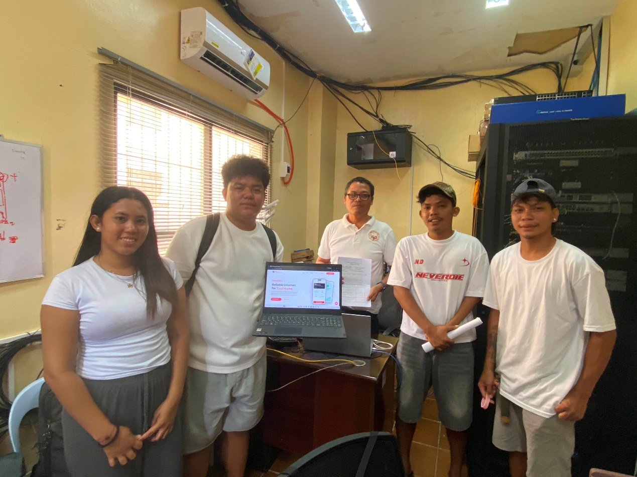Third IT Expert
JOHN ALMARAS
Address: Ticad, Bantayan, Cebu
Position: Head IT LGU BANTAYAN

