BCTVI ONLINE CABLE SERVICE MANAGEMENT SYSTEM
SYSTEM ARCHITECTURE
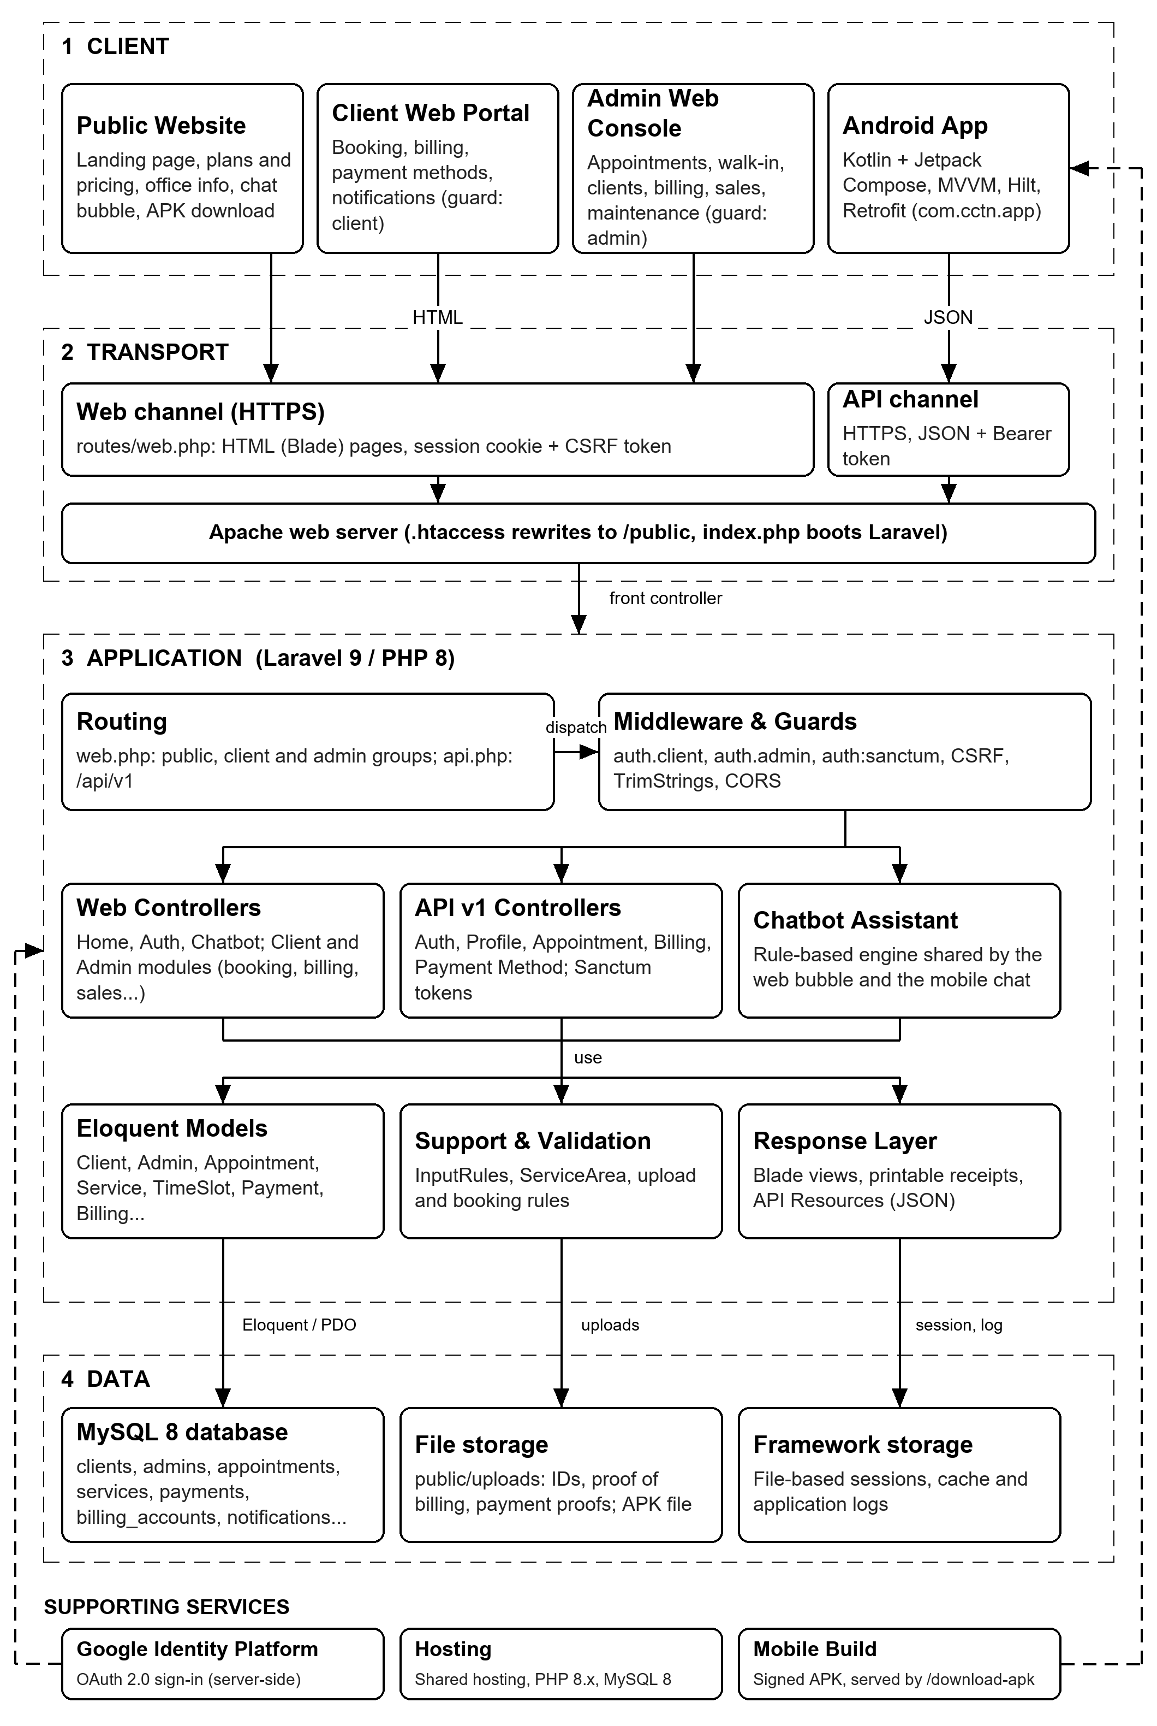
Figure 1. Layered system architecture of the BCTVI Online Cable Service Management System.

