**1.3. Autoevaluación Proyecto APV**

Estudiante – Manuel Cartes Senn

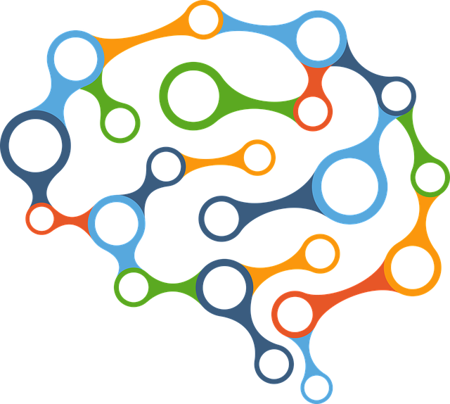

Docente – Cindy Contador Cisterna

Santiago, 27 de Agosto de 2024

**Índice**

Abstract 3

Conclusiones 4

Reflexiones 5

# Abstract

El proyecto a desarrollar dentro de la asignatura Capstone tiene como objetivo la maximización en eficiencia en el área de psicoterapia mediante tecnologías innovadoras. El proyecto como tal es una herramienta organizadora digital diseñada para mejorar la interacción entre el psicoterapeuta, el paciente y sus tutores (padres/guardianes). Actualmente está siendo diseñada con un foco hacia la terapia infantil, pero con el potencial de ampliarse hacia el área de salud mental y psicoterapia general.

El proyecto – nombrado “Don Terapia” – permite al psicoterapeuta tener un mejor manejo de sus notas y apuntes mediante una plataforma digital que guarda la información acorde, además de ofrecer la posibilidad de monitorear el progreso de las sesiones y realizar actividades dinámicas, las cuales tendrán implementado un sistema de recompensas y logros que pueden ser revisados por el terapeuta o el tutor del paciente infantil. Toda la información será desplayada de forma comprensible, con la posibilidad de crear Dashboards interactivos que permitan un manejo de los datos por la parte terapeuta y generar reportes, informes y boletas directamente para el tutor del paciente.

Dentro de las características del producto a desarrollar, se encuentran varias similitudes con respecto al perfil de egreso de la carrera. La planificación de proyectos informáticos es la base en la cual se levantan los requerimientos y necesidades del proyecto, además de obtener un mayor conocimiento sobre el mercado de tecnologías similares que ya han sido implementadas y, ante ello, mejorar nuestra versión del software. Además, al tener control sobre el proyecto a nivel grupal, existe la posibilidad de reorganizar decisiones e implementar lo que uno estime conveniente para un mejor desarrollo de software mediante la dinámica de trabajo en equipo, tomando sugerencias, criticismos e interacciones con los otros compañeros de trabajo para implementar mejores soluciones. Por último, se construyen soluciones de software mediante el uso de técnicas, herramientas y disciplinas que permiten la automatización y el cumplimiento de objetivos dentro del desarrollo del proyecto.

En relación a los intereses profesionales personales, el proyecto como tal coincide con los aprendizajes y prácticas preferentes dentro del área profesional. Existe un interés en mejorar e innovar prácticas en la industria mediante la realización de un software sofisticado, logrando así una modernización y oportunidades para un cambio positivo al área de la salud mental, algo que me motiva bastante por ser necesaria para la buena salud general de la población.

Por último, es posible realizar el proyecto dentro del transcurso de la asignatura, debido a su mediana escala y el equipo adherido al desarrollo. Estos dos factores influyen en un flujo de trabajo continuo con una constante comunicación grupal para la toma de decisiones y notificaciones de los procesos en desarrollo.

The project to develop within the Capstone class has the objective of maximizing efficiency in the psychotherapy field through the use of innovative technologies. The project itself is a digital organizing tool designed to better the interaction between the therapist, the patient and the patient’s tutor (parent or guardian). Currently, it’s being designed with the focus of being implemented in the field of child psychology, with the potential of being widened towards the mental health field and general psychotherapy.

The project – named “Don Terapia” – allows the psychotherapist to have a better understanding and management of their notes through the use of a digital platform that saves information accordingly, as well as allowing the possibility of monitoring the progress made throughout the sessions and perform dynamic activities, which shall have a rewards and achievements system that can be checked by the therapist or the child patient’s tutor. All the information will be displayed in a comprehensible form, with the possibility of creating interactive Dashboards that allow for a better handling of data by the psychotherapist and use it to generate reports, essays and billings to be sent directly to the patient’s tutor.

The characteristics of the product to develop include various similitudes with the career’s graduation profile. The planning of computer projects is the base in which the requirements and necessities of the project are lifted, as well as obtaining a better understanding of the market’s similar technologies that have been implemented before and, in sight of this, better our version of the software to create. Additionally, having control over the project as a group allows the possibility of reorganizing decisions and implement what one finds beneficial for a better software development through the teamwork dynamic, taking suggestions, criticisms and interactions with other colleagues to create better solutions. Last but not least, we create software solutions through the usage of techniques, tools and disciplines that allow for the atomization and completion of objectives within the project’s development.

In relation to the professional interests, the project itself coincides with the preferred knowledge and practices of the industry within the professional field. There is interest in bettering and innovate practices within the industry through the creation and implementation of a sophisticated software, obtaining a more modernized experience and opportunities for a positive change in the mental health field, something that motivates me a lot due to it being necessary for the well-being and general health of the population.

Lastly, I believe the project to be possible to realize throughout the class’ course, due to its medium scale and the team affiliated with development. These two factors affect the continued workflow with constant group communication and decision-taking, with notifying the processes being worked on.

# Conclusiones

The project we’re currently working on is a wonderful opportunity for developing my skills in project leadership, technological innovations, business intelligence, risk management, Scrum methodology and many more. Using a real-world client that requires this sophisticated software to perform and better his work-flow, I feel confident in delivering a product that allows psychotherapists manage their tasks and activities in a much more organized and innovative way. Utilizing the knowledge I have acquired within my career, I will try my best to use this as a learning experience going forward in my professional field of Computer Science and Software Development.

The project itself is entertaining to work on and it offers a variety of skills to be applied into, alongside teamwork which gives context as to how the future of professional environments will be similar to. The project also offers much freedom in regards to its designing and planning, as it is something that the team itself chooses to make with the professor’s approval and feedback; I find this an enjoyable practice to further propel the innovative mindset, giving the students the capacity of making their own projects and motivating them to do better.

# Reflexiones

Personal reflections in regards to the work being done, I have much faith in this project as I find it a rather welcome addition to the field of mental health, offering an alternative way to organize many tasks, activities, interactions and many other useful functions. I also have faith in my fellow colleague which works alongside me, as I know he’s doing a good job based on the process that we’re making together. The class is interactive and allows for plenty of discussion to further fix issues and obtain alternatives to development, as well as the professor answering many questions and doubts.

Overall, the experience of the assignment at hand is quite pleasant and I find it a great way of understanding how a team works and functions in a professional and organized manner. Alongside that, one learns to ask for help whenever possible when things don’t go as planned.

To conclude, I have faith in the project being worked on and the teammate I have been sided with, as well as the product itself taking form and giving much hope and knowledge necessary for future work experiences in the industry.