9/6/2017

Database Design

Major Project Report



Faizan Sheikh

TAFE NBC

Contents

Introduction 2

1.1 Project Objective 2

1.2 Project Scope 2

1.3 Project Boundary 3

Database Design 4

2.1 Expected Use 4

2.2 Clarifying User Needs 4

2.3 Business Rules 5

2.4 Initial ERD 5

Database Implementation 6

3.1 Toad Modeler 6

3.2 Microsoft SQL Server 2008 6

3.3 Final ER Diagram 7

3.4 Front-End Design 8

Conclusion 9

Glossary 10

Appendix A 11

# **Introduction**

The purpose of this report is to consider all the factors that went into the design and implementation of the database for my database design major project.

Before I explain how the database was designed and implemented, it would be wise to look at the nature of the project, including the project’s objective, scope and boundary.

## **1.1 Project Objective**

The objective of the project was to create a database for the IT section of TAFE NBC (TAFE Northern Beaches Campus).

The database will then be used to keep information about students and potential students to inform them about course offerings.

The database will also need to retain information about student enquiries relating to courses, information about information sessions, and information about students while they are studying and after they graduate.

## **1.2 Project Scope**

The project includes the three main components listed below:

1. The complete design of the database
2. The implementation of the database
3. The testing of the database (test data only)

The project will not include:

1. Training relevant users on how to use the database
2. Support/maintenance of the database after it has been implemented
3. Inserting existing data from TAFE NBC, (only test data will be used in database testing)
4. Generating reports for TAFE NBC from the database

## **1.3 Project Boundary**

The database project is for the IT Section of TAFE Northern Beaches Campus only.

All other sections of TAFE NBC are out of scope and not part of the project.

Lastly, the project deadline is set for the 14th of June 2017.

# **Database Design**

Before a database can be tested and implemented it first must be designed correctly. Correctly designing a database requires the database designer to identify the database’s expected use and to clarify the user needs.

## **2.1 Expected Use**

The project specifications clearly stated the uses of the database, which are listed below:

* Send out details about information sessions and enrolments times to students who have enquired throughout the term.
* Send follow-up information to students who have attended information sessions.
* Send details about new courses to existing students and graduating students.
* Follow up graduate students to analyse employment trends.

## **2.2 Clarifying User Needs**

The first deliverable of the major project was to create a list of questions to clarify the user needs, and to submit these along with corresponding assumptions.

I found this phase of the project to be very beneficial because it allowed me to not only understand in detail the exact requirements of the database, but it also removed many of the misconceptions that I had regarding the scope of the project.

## **2.3 Business Rules**

In the next part of the database design I focused on business rules. The reason for this is because properly defined business rules assist in database design, as they help in defining entities, attributes and relationships. The business rules for my project are listed below:

* Students can make man enquiries
* Each enquiry is for a single course
* Students can attend many information sessions
* An information session can be attended by many students
* Each information session is for a single course
* No historical data about employment is required

## **2.4 Initial ERD**

The second deliverable of the major project was to submit an initial ERD.

During the development of the diagram I had one clear objective and that was to keep the design of my database as simple as possible. I really believe that I achieved this goal in the design of my initial ERD, and the design has also been approved by the project manager.

The initial ERD that I created can be found in Appendix A of this report.

# **Database Implementation**

The next part of the project required the testing and implementation of the initial database design. The project manager decided that I would need to first model the ERD using a software called Toad Modeler.

## **3.1 Toad Modeler**

Toad Modeler is a database design tool created by Quest Software that allows users to create and maintain database models and it makes the database development process a lot simpler. I found this task to be very easy as I had already used Toad Modeler to model my database design for the enjoyable Puppy Project.

Moreover, an amazing feature of Toad Modeler is the ability to generate an SQL script from the database model. After generating the necessary script, the last part of the project would be to implement the database in Microsoft SQL Server 2008 using the generated script.

## **3.2 Microsoft SQL Server 2008**

The last phase of the major project involved implementing the database model and testing it in Microsoft SQL Server 2008 against some test data.

To complete this final task, I followed the process below:

1. I created a database called MajorProject.
2. I created the tables using the script that I had generated from Toad Modeler.
3. I created some test data and inserted them into the relevant tables.
4. I created some simple SQL queries to check the integrity of the data and to ensure that my database model was performing as intended.

## **3.3 Final ER Diagram**

Below is a screen capture of the final ER Diagram for my database design major project:

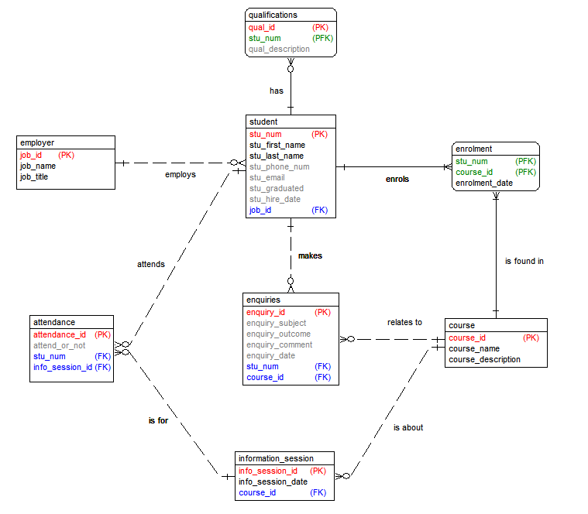

## **3.4 Front-End Design**

Below is a sketch of the recommended front-end design for my database design project:

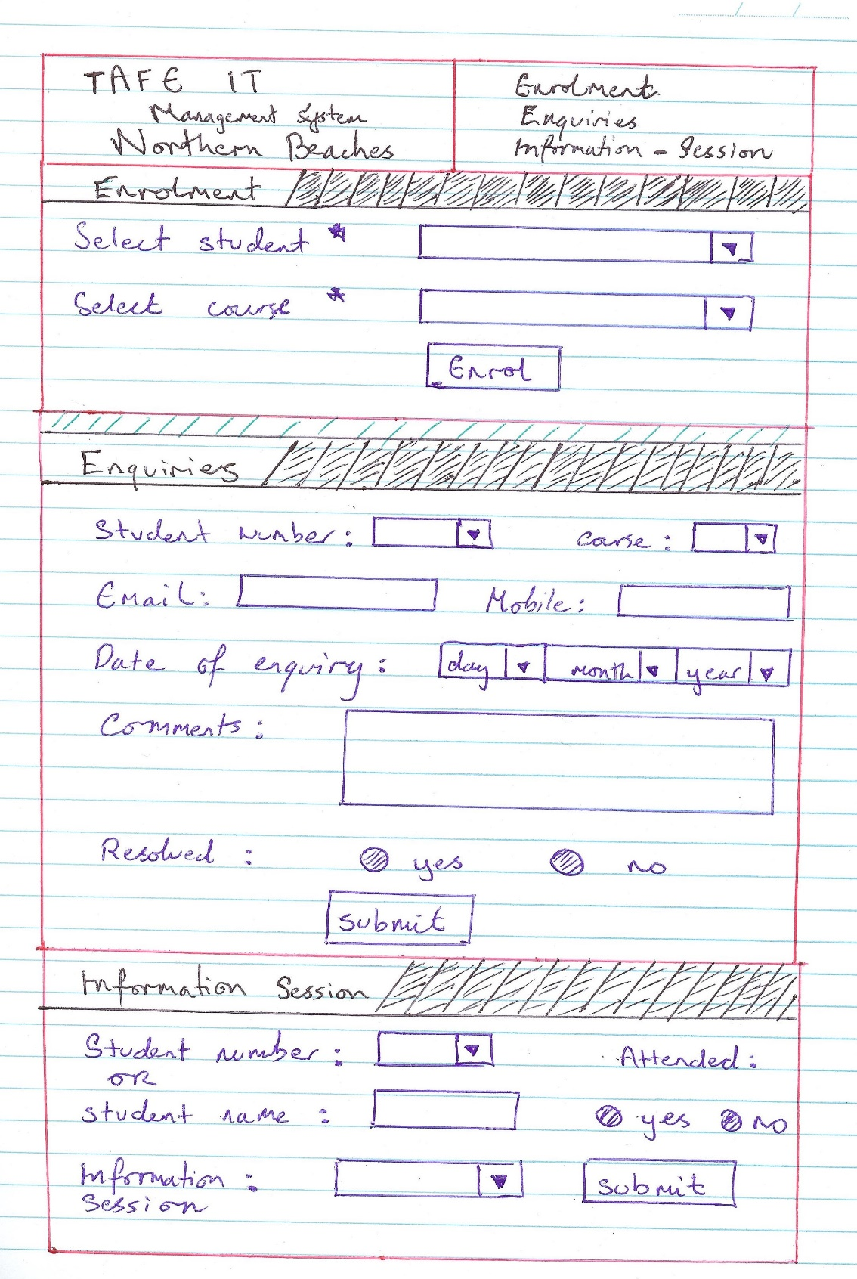

# **Conclusion**

In conclusion, I am very proud of the database that I have built for my client TAFE NBC.

It took a lot of effort in its development, but I hope that my client is pleased with the result.

I have learnt vital database design skills and skills in database testing and implementation.

Lastly it was an enjoyable experience and I hope that this project can be an entry point for myself and others into the wonderful world of database design and database modelling.

# **Glossary**

**Business Rule:**

A business rule is a brief, precise, and unambiguous description of a policy, procedure, or principle within a specific organization.

**Database:**

A database is a data structure that stores organized information.

**ERD:**

An entity-relationship (ER) diagram, is a graphical representation of entities and their relationships to each other, typically used regarding data within databases.

**Microsoft SQL Server:**

Microsoft SQL Server is a relational database management system developed by Microsoft.

**RDBMS:**

A relational database management system (RDBMS) is a [database management system](https://en.wikipedia.org/wiki/Database_management_system) (DBMS) that is based on the [relational model](https://en.wikipedia.org/wiki/Relational_model).

**SQL (Structured Query Language):**

SQL is a standard language for storing, manipulating and retrieving data in databases.

**TAFE NBC:**

Tafe Northern Beaches Campus

**Toad Modeler:**

Toad Data Modeler is a [database design](https://en.wikipedia.org/wiki/Database_design) tool allowing users to visually create, maintain and document new or existing database systems.

# **Appendix A**

Below is the initial ERD that I created for my database design major project:

