# P3

## Initial ERD

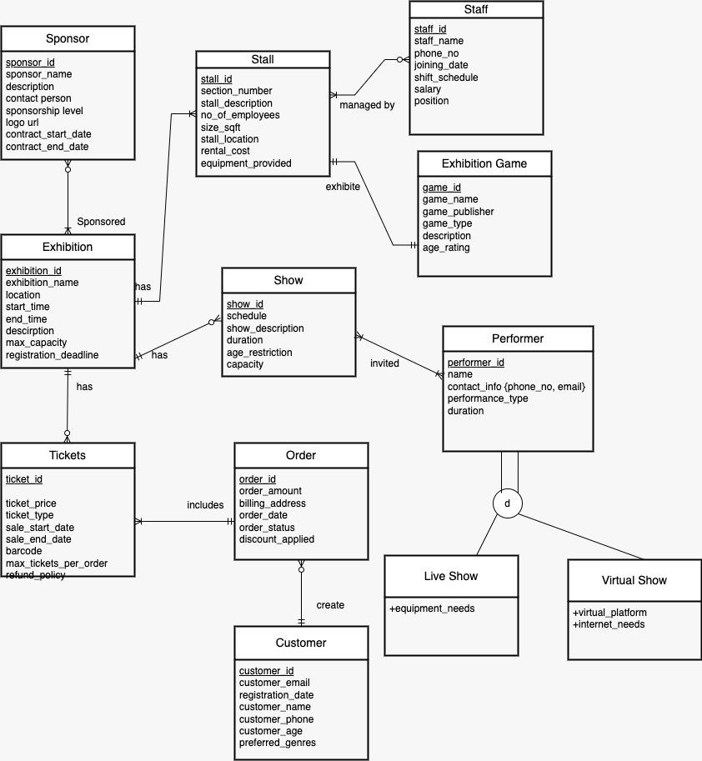

We added some attributes to some entities to make them more realistic. We changed the relationship between stall and staff and between show and performer. Both of them become mant to many. And we considered that performers may have different forms of performance, we created two subtype for the performer entity, one is live show and another one is virtual show.

## Normalization

* We normalized the contact_info in the Performer table by splitting it into separate fields, ensuring that there are no multivalued attributes, with distinct columns for contact_info_phone_no and contact_info_email.
* For each entity, we conducted the functional dependency analysis firstly.

### Functional Dependency





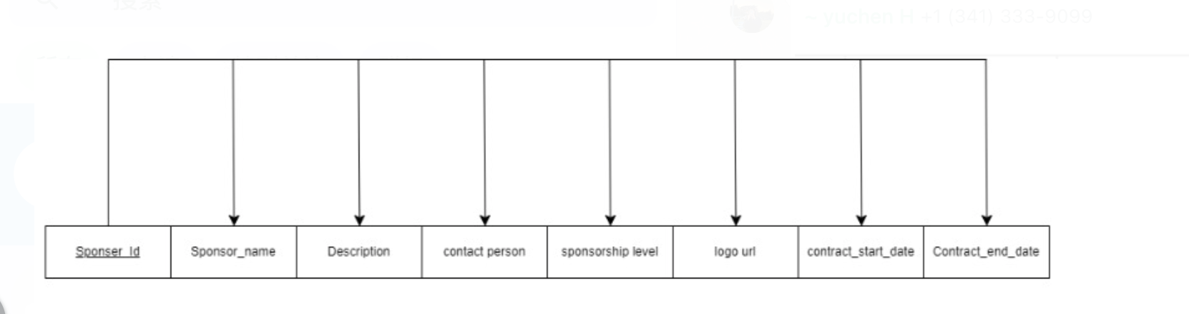

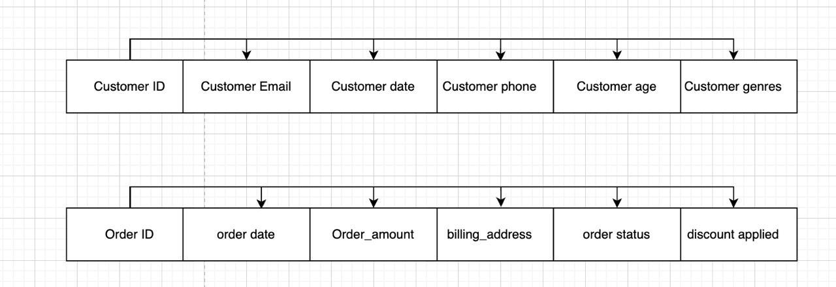

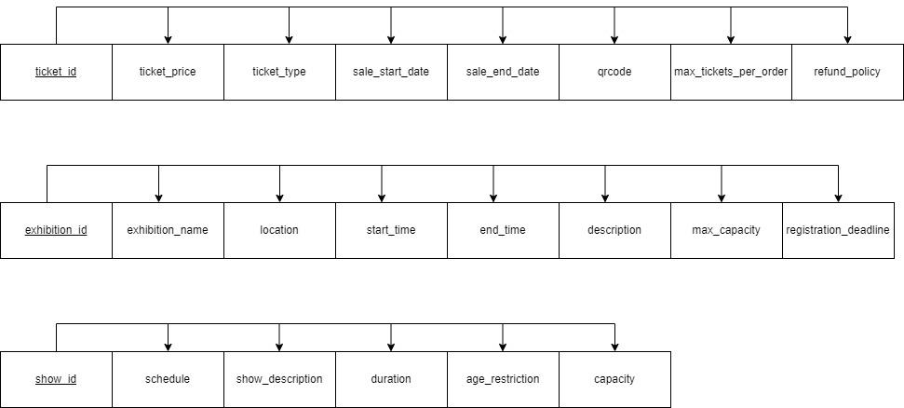

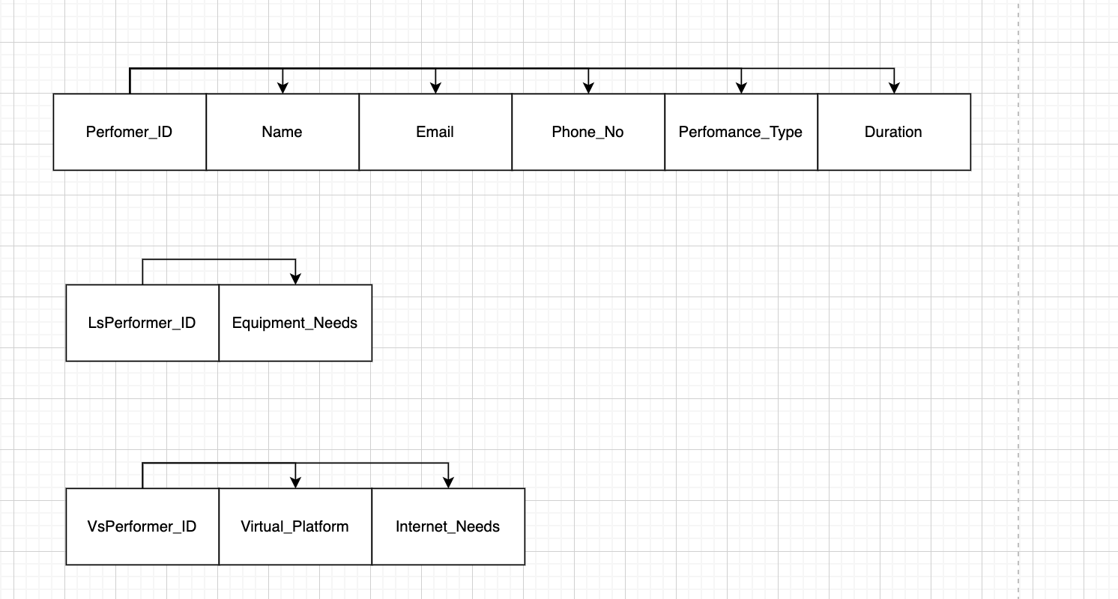

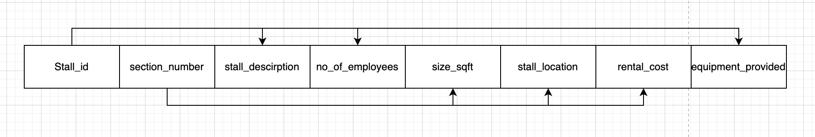

For the Stall, they have partial dependency, so we split it into two entities.

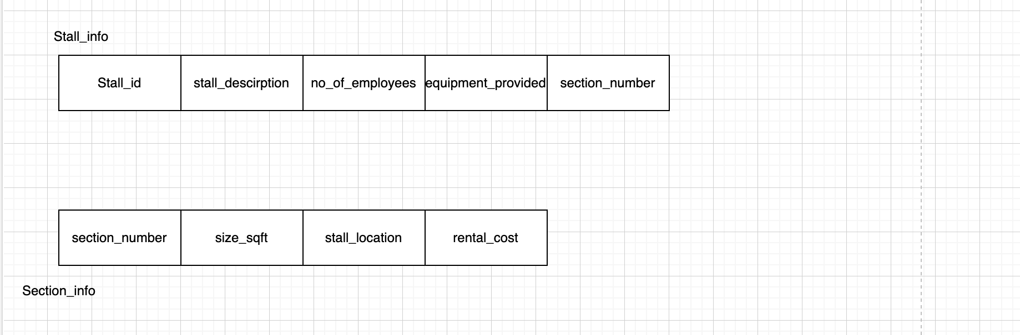

In this way, all entities are in the 3NF.

We added three associative entities to handle the many-to-many relationships in the model:

1.⁠ ⁠Contract to manage the relationship between Sponsor and Exhibition, allowing multiple sponsors for each exhibition and multiple exhibitions for each sponsor.

2.⁠ ⁠Stall_Staff to manage the relationship between Stall and Staff, allowing multiple staff members to manage multiple stalls.

3.⁠ ⁠Show_Performer to manage the relationship between Show and Performer, allowing multiple performers to be invited to multiple shows.

These associative entities ensure that the many-to-many relationships are properly normalized.

## Logical ERD

