|  |  |  |
| --- | --- | --- |
| **Problem Chosen** F | **2021 MCM/ICM Summary Sheet** | **Team Control Number** 2120155 |

**Summary**

**The higher education system** is an important foundation for a country's economy, technology, culture and many other aspects. It is an indispensable talent training method and industry for a strong country. Under the influence of the global epidemic, the higher education systems of many countries have been affected to varying degrees. In order to analyze what is a healthy and sustainable education system, we have established the following two models, hoping to make judgments about the higher education situation of any country based on these, and propose reasonable policies.

In order to measure health, we use **systematic clustering** to group the selected eight typical countries into 3 categories, and use the average value of the indicators of all countries in the category as the system balance point to create a discrete with associative memory function **Hopfield neural network** health model. In this way, we can evaluate the health of the education system of any country.

In order to measure **sustainability**, we combined **the subjective and objective weighting method** to divide higher education indicators into three parts with different weights: domestic level, international level and own strength, and then defined the direction from the current point to the highest point as the optimal direction. In this way, we can get the development direction, effective development amount and comprehensive sustainability metrics of any country in a certain period of time.

Combining the two models, we find that the health of higher education in the United States is at a leading level and the sustainability is slightly worse, while China is the opposite. Japan is healthy (sub-healthy) and has the worst sustainability (deviation direction and low effective development), so we choose Japan for further analysis.

Combining Japan's national conditions, we provided a reasonable vision for Japanese higher education, and used Discrete Hopfield Neural Network Model to show the rationality of doing so and the intensity of policy implementation. Based on this, a detailed timetable spanning 20 years was drawn up to gradually improve the health and sustainability of higher education in Japan.

Finally, we analyzed the difficulties and impacts of high-intensity policies on **Japan**, and conducted sensitivity analysis and analysis of advantages and disadvantages.

**Keywords**: The higher education system, systematic clustering, Hopfield neural network, sustainability, the subjective and objective weighting method

CONTENTS

1Introduction 3

1.1 Background 3

1.2 Restatement of the Tasks 3

2 Model Assumptions and Notations 3

2.1 Model Assumptions 3

2.2 Notations 4

3The models 5

3.1Create a health model 5

3.1.1 Preprocess Data Using Exponential Moving Weighted Average Algorithm 5

3.1.2 Create a discrete Hopfield neural network with the assistance of systematic clustering 6

3.2 Create a sustainability model 11

3.2.1Index classification 11

3.2.2 Sustainability analysis 13

3.3 The vision for Japan 15

4Our policy 19

4.1Policies for Japan's Education System 19

4.2Policy Implementation Schedule 20

4.3Policy Evaluation 21

4.4The Practical Influence Of Policy 25

4.4.1 Transition Stage 25

4.4.2 Final Stage 25

5Insufficiency of models and limitations of policies 26

6Sensitivity analysis 27

Reference 27

# 1 Introduction

## Background

The higher education system is an important foundation for a country's economy, technology, culture and many other aspects. It has value as an industry itself and as a source of trained and educated citizens in a country's economy. As higher education plays a prominent role in national construction and social development, the level of higher education has become one of the factors that measure the development of a country.

Faced with many influencing factors such as cost, admission opportunities, fairness, funding, degree value, education quality, research level, etc. how to evaluate higher education systems and systems in various countries, and how to carry out higher education reforms to enable healthy and sustainable development has become an international proposition.

During the current pandemic, the higher education system of many countries has been affected to varying degrees. In this environment, in order to reflect and adjust the higher education system in a timely manner, it is necessary to review the health and sustainability of the current higher education system in various countries. Evaluation, and implement practical policy adjustments and reforms based on the evaluation results.

## Restatement of the Tasks

* Establish a model to evaluate the health and sustainability of any country’s higher education system, and analyze several countries.
* Propose a reasonable vision for a country’s education system and use the model to compare the vision with the current education system.
* Give a detailed policy and timetable to move from the current state to the above state step by step, and use the model to evaluate the effectiveness of the policy.
* Discuss the actual impact on selected countries during the transition period and final im-plementation phase of the policy.

# 2 Model Assumptions and Notations

## 2.1Model Assumptions

To simplify the model, we propose the following assumptions:

* All index values that affect higher education are effective and easy to quantify.
* The global epidemic does not further affect the implementation and effectiveness of the policy.
* International exchanges between countries have no influence on each other’s index values (such as the number of international students).
* The health of the national education system is only limited by the indicators we propose, while the impact of other indicators is temporarily ignored.

## 2.2Notations

**Tab. 1** The Symbols of Definition and Description

|  |  |
| --- | --- |
| **Symbol** | **Meaning** |
|  | Moving average predicted value at time *t*（Initial value） |
|  | Proportion of real international students at time *t* |
|  | Weight coefficient |
|  | Moving average predicted value at time t with correction deviation |
| *f* | Threshold function |
|  | Threshold of the *j-*th dimension |
|  | The intermediate value calculated by the *j-*th neuron |
|  | The weight of the *i*-th neuron to the *j*-th neuron() |
|  | The output of the *j-*th neuron |
|  | External input of the *j*-th neuron |
|  | Degree of internationalization |
|  | Number of top 100 universities in the world |
|  | University awards doctoral degrees (10,000 people) |
|  | Expected years of school education |
|  | The total completion rate |
|  | Nobel laureate |
|  | Gross enrollment rate of higher education |
|  | Number of papers in important journals |
|  | public expenditure on education (% of GDP) |
|  | Number of universities per 10000 people |
|  | number of college students (10,000 people) |
|  | index *j* of nation |
|  | after normalization |
|  | vector of weights of indexex |
|  | vector of objective weights |
|  | vector of subjective weights |
|  | variability of index |
|  | correlation coefficient between index and |
|  | index correlation coefficient of index |
|  | weight of |
|  | weight of |
|  | evaluation of decision scheme |
|  | coordinate value of indexes at time |
|  | development direction angle of indexes at time |
|  | sustainability measurement of indexes at time |

# 3 The models

## 3.1 Create a health model

## 3.1.1 Preprocess Data

First,we determine 11 indicators:.

“The ability of a university to attract undergraduates and postgraduates from all over the planet is key to its success on the world stage.”Generally speaking, the higher the internationalization level of national higher education, the more conducive to the exchange of different ideas and cultures, the more conducive to the healthy and sustainable development of higher education.Considering that the application of the model may need more university data,in the process of solving degree of internationalization, we used Exponential Moving Weighted Average Algorithm.For the quantification of internationalization degree of higher education in each country, the most authoritative ranking of the world university rankings is used to select the value of international students of the top ten universities in each country, and then use the Exponential moving weighted average method on this data set to predict the average value of the internationalization level of higher education in each country.

First of all, the 10 universities in each country are ranked according to the comprehensive ranking. The formula of the moving average predictive value of the  University is:

Exponential weighted average formula:



Exponential plus group average formula with modified bias



The proportion of international students from the top 10 universities in the United States in 2020 is calculated.(select)

**Tab.2** The Internationalization Degree Table of the Top Ten Universities in America

|  |  |  |  |  |  |  |  |  |  |  |
| --- | --- | --- | --- | --- | --- | --- | --- | --- | --- | --- |
| **Symbol** | **Stanford** | **Harvard** | **CIT** | **MIT** | **UCB** | **Yale** | **Priceton** | **Chicago** | **JHU** | **Upenn** |
|  | 0.23 | 0.25 | 0.33 | 0.34 | 0.17 | 0.20 | 0.23 | 0.23 | 0.27 | 0.21 |

The moving average values obtained as shown in the figure 1.

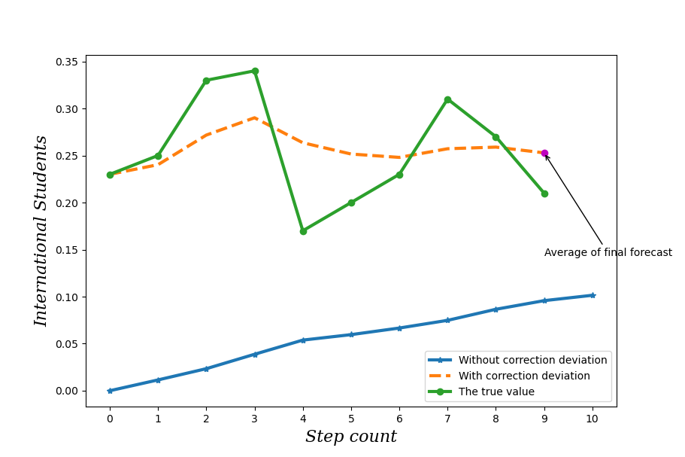

**Fig.1** Average Prediction

Through the figure 1, we can see that the average value obtained by the exponential weighted average algorithm with correction deviation is obviously better. So finally choose the exponential weighted average algorithm with corrected deviation to get 0.2528 as the average.

## 3.1.2 Health Analysis

Our group divides the health status of the national higher education system into three levels: health, sub-health and sick. We use the improved discrete Hopfield neural network model to describe the health status of national higher education, and use associative memory to measure and evaluate the health status of national higher education system.

We first use the systematic clustering algorithm to adopt the nearest neighbor rule to cluster eight countries, namely United States, Germany, Japan, Australia, China, India, Nigeria and Brazil, according to eleven indicators, and gather them into three categories.The first echelon: Australia; the second echelon: Japan, Germany, Brazil, China, the United States, India; the third echelon: Nigeria.The results are shown in the figure 2:

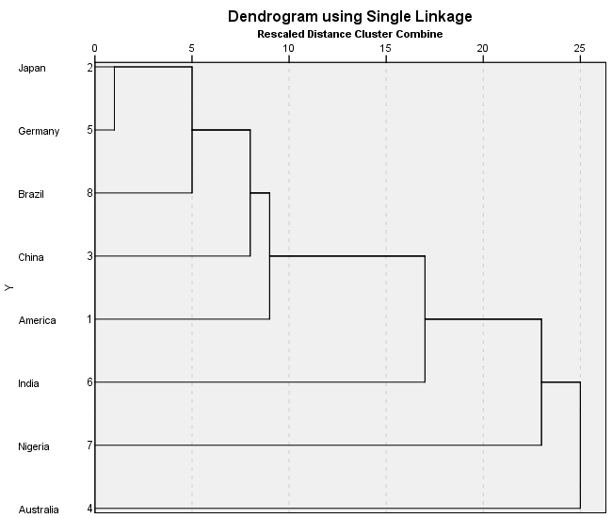

**Fig.2** Clustering Resultl

The average value of all indicators of all countries in each category is taken as the ideal evaluation index of each level, that is, the equilibrium point of Hopfield neural network.As is shown in the table below:

**Tab.3** Ideal evaluation indicators of different levels

|  |  |  |  |  |  |  |  |  |  |  |  |
| --- | --- | --- | --- | --- | --- | --- | --- | --- | --- | --- | --- |
| **Grade** |  |  |  |  |  |  |  |  |  |  |  |
| I | 0.26459 | 6 | 0.86 | 4.3 | 72.5 | 5.006 | 91.1 | 83.5 | 5.1 | 0.0168 | 0.0520 |
| II | 0.11568 | 8.667 | 3.5 | 2.7 | 35.2 | 4.435 | 56.5 | 54.9 | 4.2 | 0.2118 | 0.0336 |
| III | 0.00325 | 0 | 0.01 | 0.5 | 1 | 0.055 | 10.1 | 1.1 | 3.1 | 0.0073 | 0.0073 |

When the index value is greater than or equal to the index value of a certain level, the state of the corresponding neuron is set to 1, otherwise -1.As shown in the figure 3(where ⚫ means that the neuron state is "1", which is greater than or equal to the ideal evaluation index value of the corresponding level, otherwise it is represented by ⭘.)

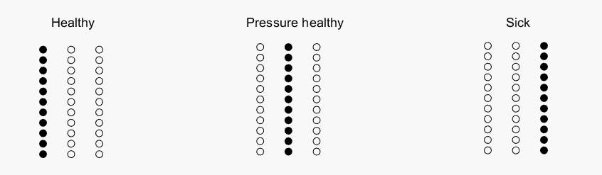

**Fig.3** Status Code

Then the countries to be classified can get the corresponding codes according to the above coding rules.Constructing Discrete Hopfield neural network model for health status(DHNH),as shown in Figure 4:

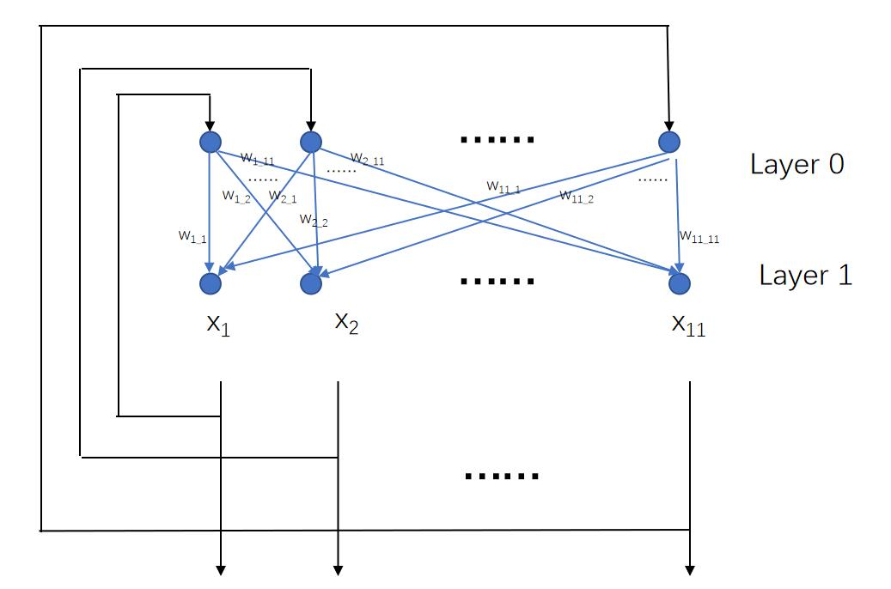

**Fig.4** Hopfield Neural Network Model

Layer 0 is only used as the input of the network, it is not an actual neuron and has no computing function; layer 1 is a real neuron, which performs the summation of the product of the input information and the weight coefficient, and generates the output information after processing by the nonlinear function . is a simple threshold function. If the output information of the neuron is greater than the threshold function value ,the output value of the neuron is 1; if it is less than the threshold function value , the output value of the neuron is -1.

For neurons, the output is as follows.



Where  is the external input,and



The state of DHNN network is a set of output neuron information. Since our output layer has 11 neurons, its  moment is an 11 dimensional vector.



For the updating rules of weights, we use the outer product method, for the sample vectors that need to be memorized:



Then for a neuron, the iterative formula



Taking the United States, China and Japan as examples, the corresponding codes are obtained according to the corresponding coding rules, and then the input countries are evaluated according to the model. The results are shown in the table below:

**Tab.4** Results of the Output of the Health Status of the Three Countries

|  |  |  |  |
| --- | --- | --- | --- |
| **country** | **Corresponding coding matrix** | **Coding matrix of judgment** | **Categories of forecasts** |
| America |  |  | Between health and sub-health |
| Japan |  |  | sub-health |
| China |  |  | sick |



Finally, because the value of part of the first gradient is smaller than the value of the first gradient, the United States is between health and sub-health.In this way, we specify that each line in has at most one 1.If there are more than one, change all the following dimensions to -1, and the result after changing the input matrix is shown in Figure 5 below:

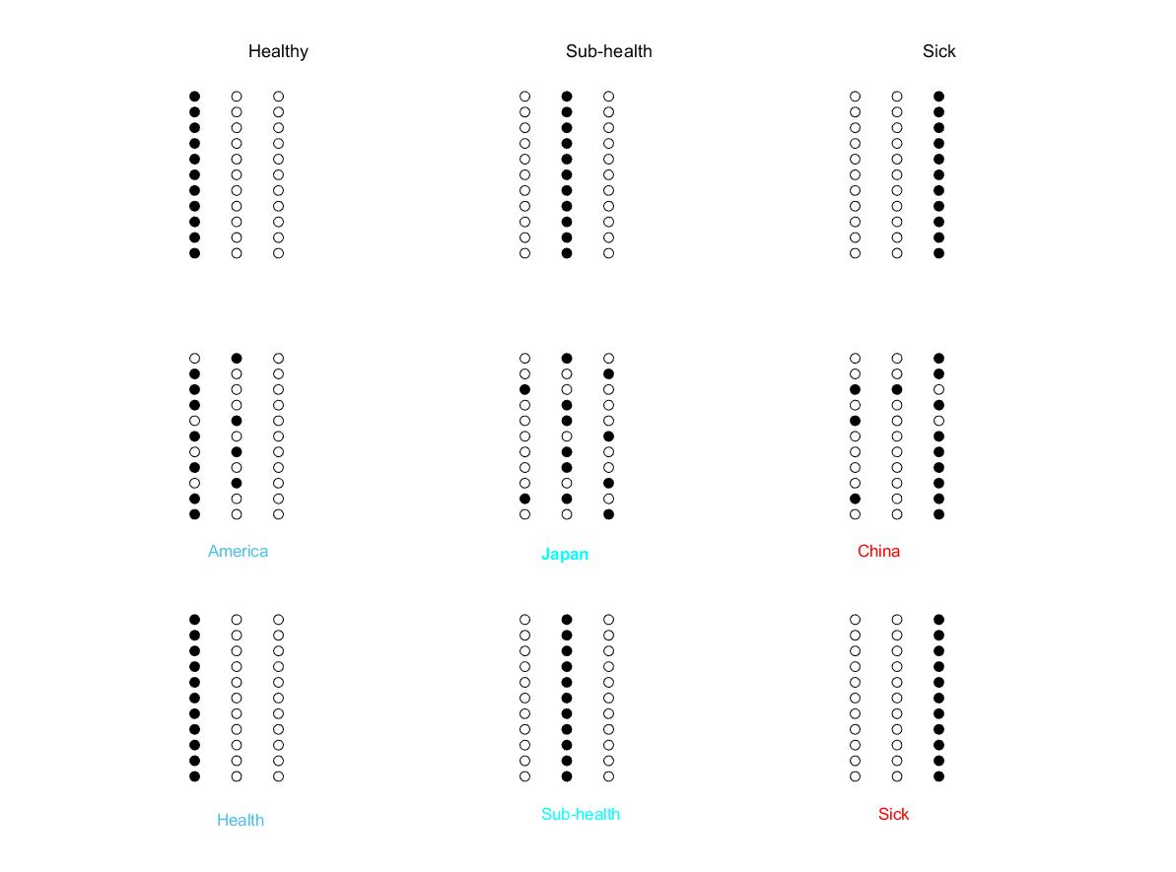



**Fig.5** Result Graph

Through the test results, we found that the health status of the national higher education system in the United States is healthy, Japan is sub-health, and China is sick. So we choose Japan and China as the pre selected countries to optimize.

## 3.2 Create a sustainability model

## 3.2.1 Index classification

For the sustainability of education system, we consider three parts: domestic education level, international education level and comprehensive education level. Sustainability requires them to achieve independent, stable and balanced development. The specific measurement indicators are shown in Figure 6 below:

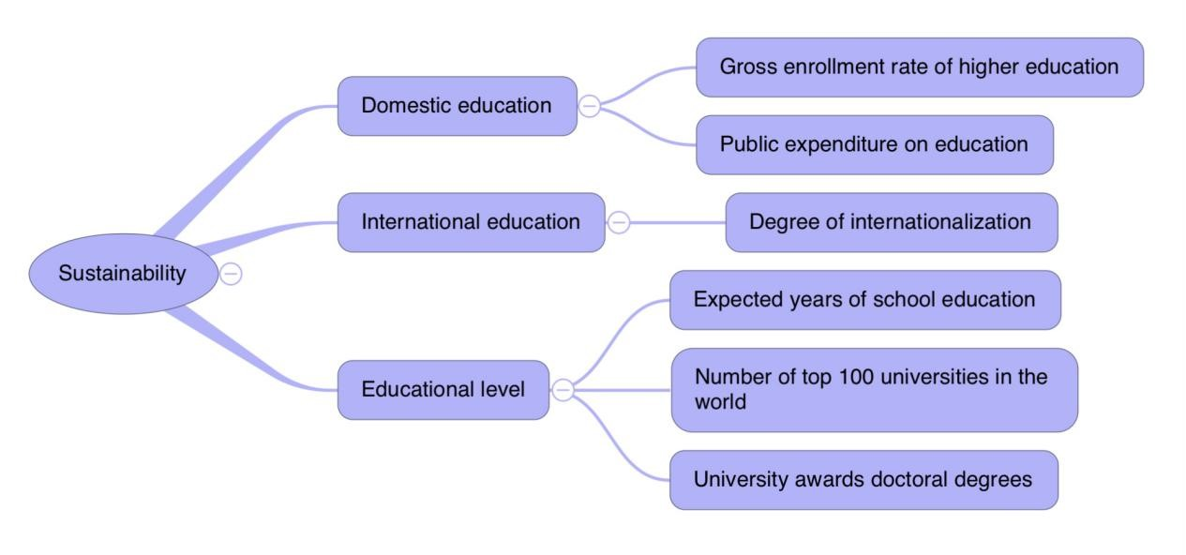

**Fig.6** Classification of Indexes to Measure Sustainability

First of all, for the calculation of the first layer to the second layer, we use the subjective and objective weighting method to weight each index. The subjective weight can be formulated by relevant experts, and the objective weight can be determined CRITIC method.

Note that the selected indicators are positive, we normalized the index value.



Next, the index variability is expressed in the form of standard deviation.



Considering that the selected indicators may have correlation, we define the index correlation coefficient. Correlation coefficient between attributes is



The index correlation coefficient.

The higher the index is, the higher the repetition between it and other indicators will be. Therefore, the weight of this indicator needs to be reduced.

We define the information content.Thus the objective weight of index.

For the comprehensive consideration of subjective and objective weight,we let.For the convenience of analysis, we add the restriction. According to the weighted rule of multi-attribute decision analysis, the evaluation value of each decision scheme is calculated:



Based on this, the following multi-objective programming model is constructed:



The solution of the equation is obtained:





Normalized:





In this way, the specific values of each index in the second layer are calculated.

First, the weights of the first and second levels are determined, taking the educational ability as an example,subjective weight, the objective weight calculated.

The joint weight .

## 3.2.2Sustainability analysis

Data quantification from the second level to the third level requires mathematical translation of sustainability. As mentioned before, the three parts need to achieve stable and balanced development, which means that the change direction and range of indicators need to be limited.So we set up the following vector graph,as shown in Figure 7:

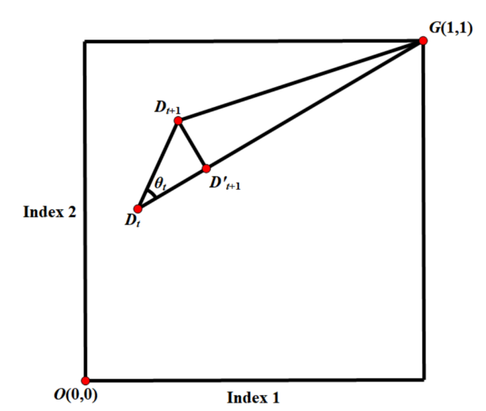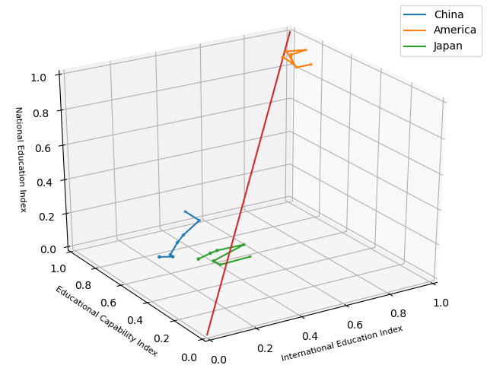

**Fig.7** Changes of Indexes **Fig.8** Change Chart of Education Indicators

of Three Countries in 2014-2020

Take two dimensions as an example, suppose that the development coordinate of a country at time  is . because the best state is in, we call the ideal development direction.Therefore, the angle  between the two reflects the balance of index development.Another important consideration is effective development, which is defined as the projection of  on .In sustainability, effective development is more valuable than development itself.

From the above analysis, it is not difficult to see that a small represents good sustainability.Based on this, we consider  as an indicator of sustainability.But this definition ignores the distance to the best point . Obviously, sustainable development should also ensure that it is gradually close to the best point.Therefore, we use  as a measure of sustainability.

By substituting the data of the three countries, we can get the change chart of their education indicators from 2014 to 2020. As shown in Figure 8:

It can be seen intuitively that the educational indicators of the United States are at a high level, with poor stability but little fluctuation; although China lags behind the United States in terms of indicators, its growth direction and speed are near the best state; Japan and China are similar in terms of indicators, and also maintain a good growth momentum, but the direction has deviated in some years.

Based on the previous discussion, we quantitatively analyzed the above observations.

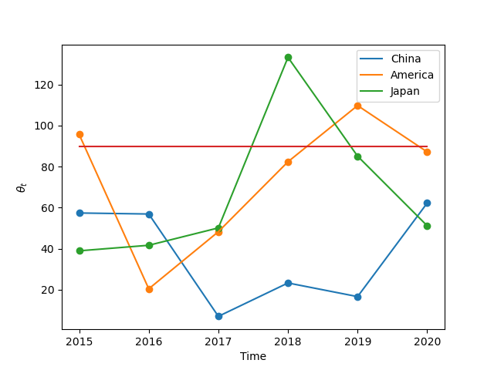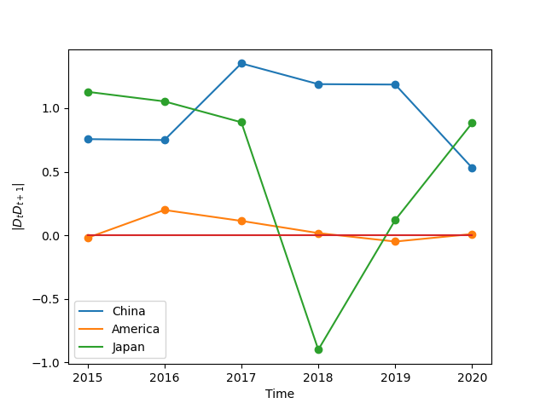

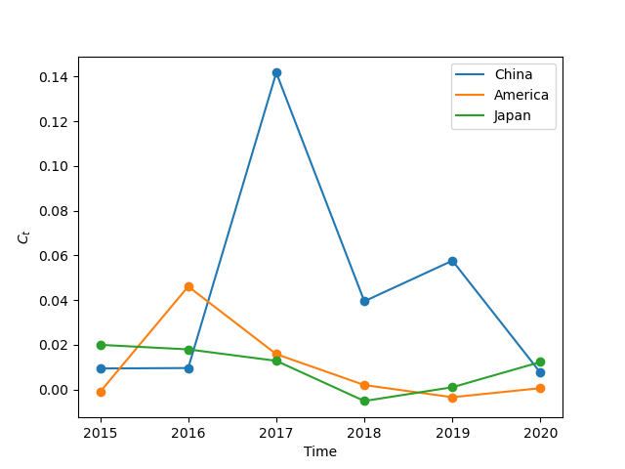

**Fig.9** Development Direction Deviation, Effective Development, Sustainability Measurement of Higher Education Indicators in Three Countries over Time

It can be from Figure 9 that China is in an advantageous state in these three indicators. Reasonable development direction and speed ensure its sustainability. Change of educational indicators in the United States and Japan is more than 90 degrees, that is, they deviate from the best development direction. Yet from the perspective of effective growth, the instability of America is reflected in the inability to maintain a stable improvement. If we turn to the volatility of the index itself, America will get a good result. This is in line with its own high level indicators. In Japan, because there is no guarantee of high indicators, sustainability directly leads to deviation from the best, and the three indicators are most prone to deviation.

Based on the above considerations, the leading level of higher education in America itself reduces its own requirements for sustainable development, while the momentum of sustainable development in China eases the low level of education itself. Japan is in the medium level in both indicators, and has a relatively comprehensive room for improvement. Therefore, we choose Japan as the country for further research.

## 3.3 The Vision for Japan

By observing the DHNH (Discrete Hopfield Neural Network Model for Health Status) model we created, Japan is in a sub-health state. The number of top 100 universities in the index, the proportion of Nobel Prize winners, public education expenditure and the proportion of university students are in a very poor position.However, degree of internationalization, expected years of school education, the total completion rate, gross enrollment rate of higher education, and number of papers in important journals are in general.

So our group found that Japan’s comprehensive strength in higher education ranks first in Asian. However, in recent years, strength of Japan’s higher education system has not increased, and there are obvious problems in its sustainability. There’re many reasons, especially since Heisei, conomic growth has slowed down or even stagnated. Comparing Japan’s GDP growth rate from 2008 to 2019 with that of developing country China, developed countries Germany and America, the result is as shown in Figure 10:

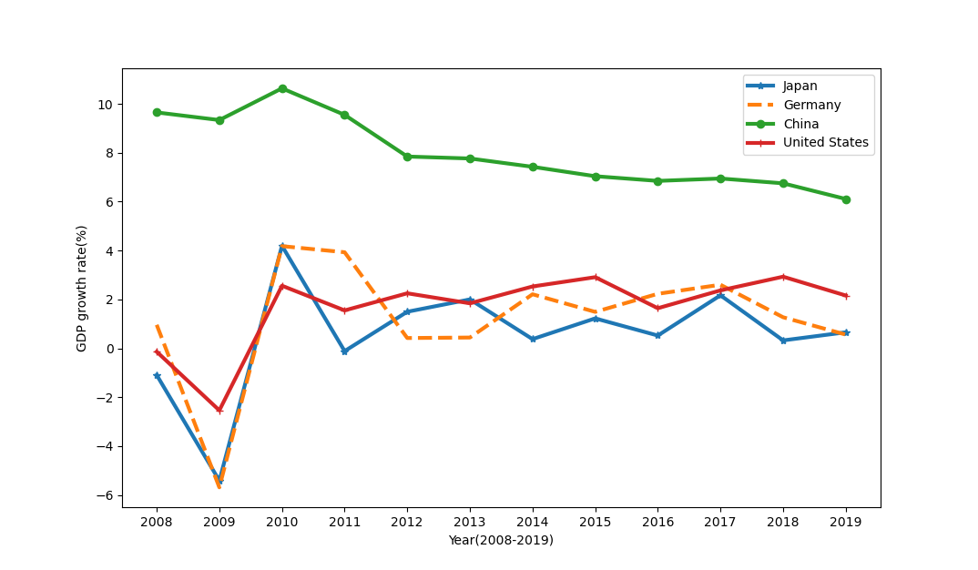

**Fig.10** Comparison of GDP Growth Rates in the Four Countries

From the figure, we can see that the growth rate of the United States, Germany and Japan is lower than that of developing country China. Among the three developed countries of Germany, the United States and Japan, Japan’s economic volatility is the largest and the year of negative growth is the most. This indicates that Japan’s economic growth rate is also relatively poor compared to developed countries.

Due to the continuous downturn of Japan's economic situation, the national expenditure on education budget continues to decrease, followed by the stagnation of the growth of doctoral enrollment and the decline of scientific research ability, which is reflected in the decline of the number and influence of papers.On the other hand, because Japan itself is a non English speaking country, Japanese is not the official language of the United Nations, and there are a lot of Japanese pronunciation in English, which makes it very difficult for Japanese to learn English and their English level is particularly poor, which also leads to the low degree of internationalization of Japan's national higher education system, which is not conducive to the sustainable development of the education system in the long run.

Therefore, based on our model, we give a vision that Japan can achieve and improve: increase research funding, enhance the social status of colleges and universities, and increase the independent, free and rigorous academic atmosphere of colleges and universities. Enhance the scientific research ability of universities and improve the ranking of universities. Of course, we must also enhance the English ability and internationalization level of the national education system, improve the English ability of education from the aspects of increasing English courses and strengthening English learning, increase the strength of receiving foreign students, and encourage students to go out, so as to enhance the internationalization level of colleges and universities. As for the number of papers, competition system should be introduced. The evaluation results are directly related to government funding. According to the results, key funding should be given to universities, and universities with strong scientific research ability should be promoted to become world-class universities. Through these achievable goals, the sustainability and health of Japan can be improved and improved.

If our vision can be realized, it can be divided into two stages according to the length of time and the difficulty of implementation. When the budget of public education is increased, the number of high-quality universities can be increased in a short time.When these two indicators reach the first level(The input matrix is), it is found that the model is still in sub-health state,the result is as shown in Figure 11:



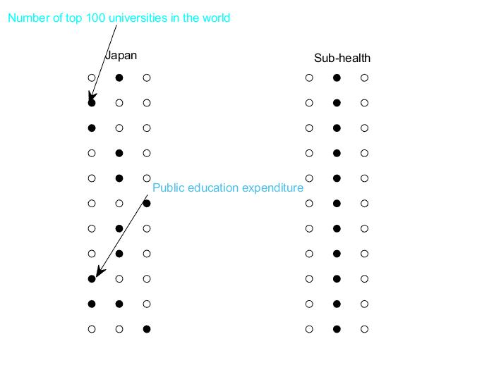

**Fig.11** Map of Health Status of Japanese Education System

At the same time, with the increase of funds and the number of high-quality universities, the scientific research ability will increase, the number and influence of papers will increase to a certain extent, and with the increase of foreign students, the improvement of English ability, the internationalization level will reach the first level. When the two items reach the first level(The input matrix is), it is found that the model will be between sub-health and health,the result is as shown in Figure 12 (left).

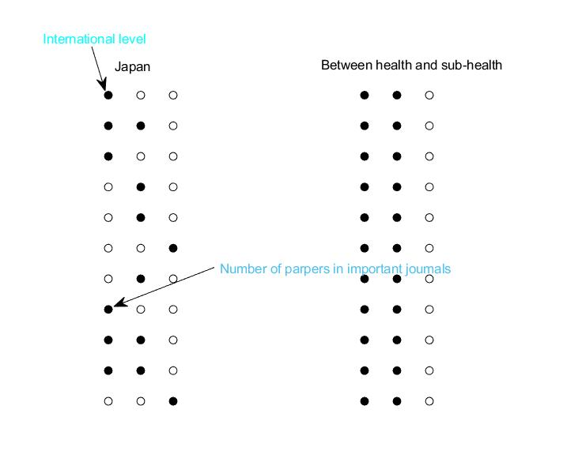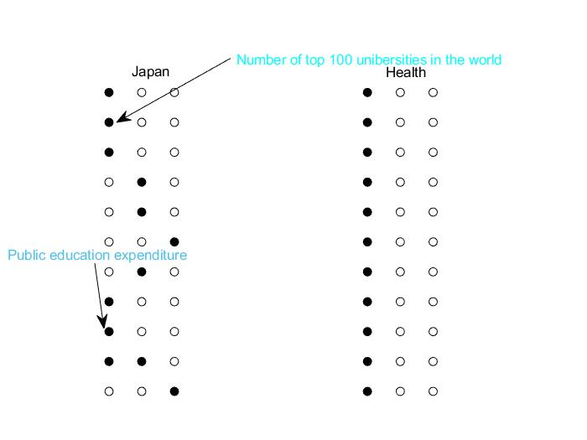

**Fig.12** Map of Health Status of Japanese Education System

When the state continues to increase the expenditure on public education, and the comprehensive ranking of national universities continues to rise, far beyond the second level (the input matrix is), the result is as shown in Figure 12 (right).

This result shows that according to our model, the sustainability of Japan's national higher education system has been improved, and the health status has become healthy.

From the perspective of sustainability, Japan has the problem of unstable development in the three modules, especially the education expenditure and the degree of internationalization, which can neither achieve the sustainable development of China nor maintain the high level of the United States. Therefore, it will take a long time if education indicators can be raised to a high level as expected without losing sustainability. But once this process is completed, the sustainability and health are in a good state, higher education will enter the optimal state of development.

# 4Our policy

## 4.1Policies for Japan's Education System

**Tab.5** Policies and Thier Corresponding Indexes Improved

|  |  |
| --- | --- |
| **Policies** | **Corresponding Index Improved** |
| 1. We should improve the awareness of university ranking, give subsidies to universities with fast growth in ranking, strengthen personnel training, especially give support to disciplines with long cycle and difficult to achieve results, so as to comprehensively enhance the strength of scientific research. | University Rankings |
| 1. We should increase the research funds and increase the budget for universities; universities should contact with the society and the people, and choose private enterprises with insight into business opportunities to cooperate with universities; we should innovate and reform to form a virtuous circle of economic growth and discipline progress (such as IT, IOT and other fields). | Education expenditure budget |
| 1. Primary education strengthens the foundation of English, higher education improves English teaching and increases English courses; universities strengthen the construction of internationalization and encourage academic exchanges with foreign students. 2. We should strengthen the acceptance of international students, simplify the visa procedures, extend the stay period, increase scholarships, and provide convenient services such as apartments for international students with difficulties, so as to stabilize the proportion of international students. | Degree of internationalization |
| 1. National universities are reorganized and merged, and competition mechanism and third-party evaluation system are introduced and improved to encourage and subsidize excellent universities. | Number of papers, University Ranking |

## 4.2Policy Implementation Schedule

In terms of the number of the top 100 universities in the world, Japan's universities, except Kyoto University and Japan's universities on the list, are ranked lower, so they are given a longer transition period.

For the proportion of foreign students with high volatility, we first use regression analysis to take a reasonable starting value, rather than further formulate the plan from the data of 2020, which is obviously reaching the peak.

In terms of education expenditure, it will take a long transition period to recover from the declining proportion of education expenditure year by year.

There is an increasing trend of papers published in important journals in Japan year by year, but there are also fluctuations. It is necessary to maintain stability before pursuing a breakthrough.

For some indicators not specially selected, regression method is also used to predict the development according to the original model.

**Tab.6** Policy Implementation Schedule

|  |  |  |  |  |  |
| --- | --- | --- | --- | --- | --- |
| **stage** | **Time/year** |  |  |  |  |
| Transition stage | 2022 | 2 | 0.019 | 3.18 | 65.3 |
| 2026 | 2 | 0.119 | 3.49 | 69.0 |
| Implementation stage | 2030 | 3 | 0.128 | 4.11 | 72.2 |
| 2034 | 4 | 0.137 | 4.83 | 75.9 |
| Matuirity | 2038 | 5 | 0.146 | 5.01 | 79.9 |
| 2042 | 6 | 0.154 | 5.18 | 83.3 |

## 4.3 Policy Evaluation

After adopting the policies covered by the above timetable, if the target can be achieved, the sustainability and stability of the higher education system will be affected as follows:

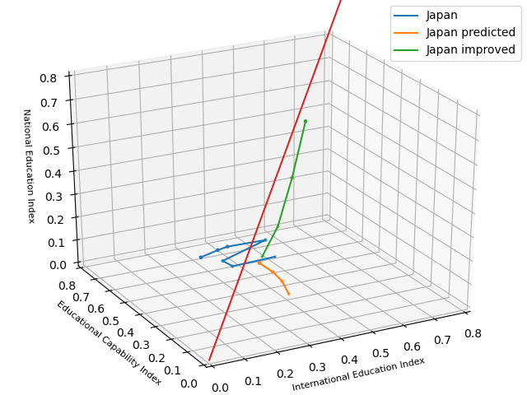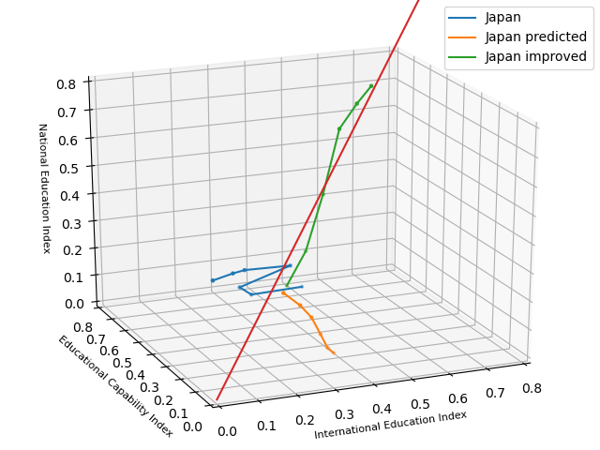

**Fig.13** The Change Chart of Each Index in the Policy Implementation and Maturity Stage

It can be seen that if the policy is not implemented, the indicators will show a downward trend in the direction of national education index, and there will be a weak and strong volatility improvement in the other two directions. After the implementation of the policy by the schedule, the indicators have achieved positive growth in the three directions, and the growth direction  is constantly tending to the best. This can be seen more clearly from the following chart:

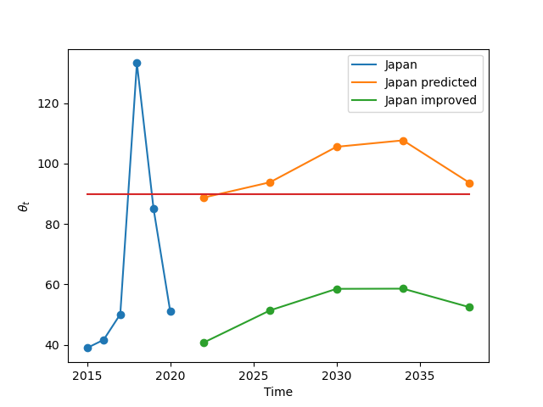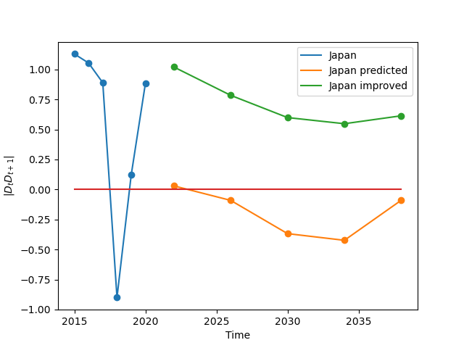

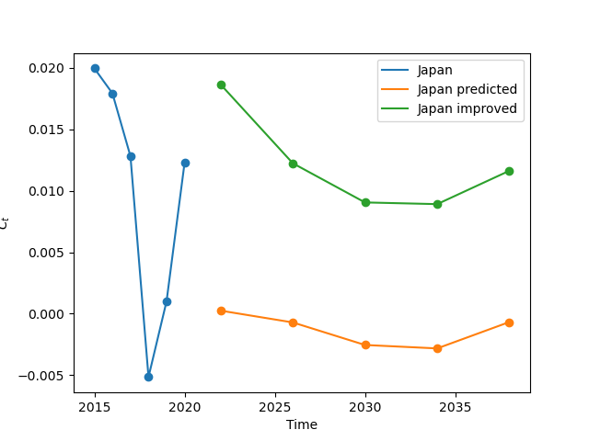

**Fig.14** Change Chart of Development Direction Angle, Effective Development and Sustainability Measurement Before and After Policy Implementation

**Tab.7** Changes of Three Indicators Before and After the Implementation of the Policy

|  |  |  |  |
| --- | --- | --- | --- |
| **country** |  |  |  |
| Before 2020 | 66.721 | 0.529 | 0.010 |
| 2020-2034 (improved) | 52.383 | 0.760 | 0.018 |
| 2020-2042 (predicted) | 99.953 | -0.236 | -0.002 |
| 2020-2042 (improved) | 32.771 | 1.093 | 0.027 |

It can be seen that  has decreased rapidly and effectively, which supports the development angle. The effective development has got rid of the disadvantage of decreasing year by year and excessive fluctuation, and ensured that the policy really plays a role in the direction of development.As a result, the overall sustainability measure  also shows a good improvement, from the original 0.01 to 0.018 until 0.027, and the picture shows a further growth trend. Thus from the perspective of sustainability and long-term development, the timetable plays a positive role in the protection of higher education indicators in Japan.

After the sustainability is effectively guaranteed, we discuss the rationality of the index values set in the two stages of the timetable.At the end of the implementation phase, i.e. in 2034, 11 indicators of the education system will be formatted as input matrix- of neurons.



Input it into DHNH model to get the following figure:

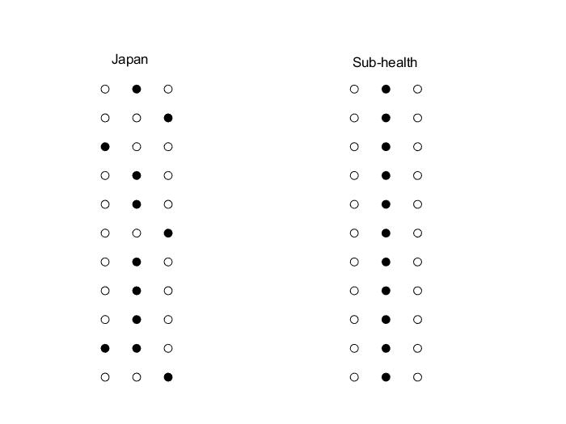

**Fig.15** The Schematics of Overtake Model

Although for the health model, the health status of Japan is still sub-health at this time, from the perspective of sustainability, the sustainability of Japan has been significantly improved (see the change chart of indicators in the policy implementation stage), so it shows that the policy is effective. Continue to format the 11 indicators of the Japanese education system into the input matrix- of neurons when reaching the maturity stage in 2032.

At this time, there is a situation where the model never appears:

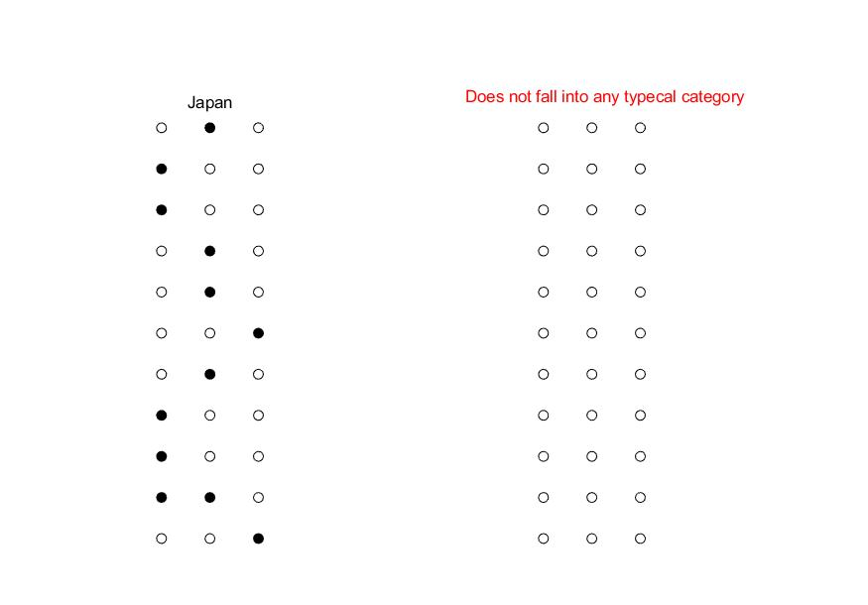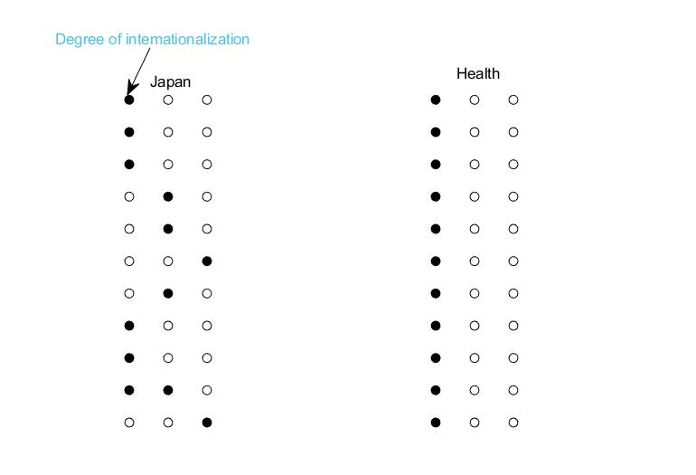

**Fig.16** The Schematics of Overtake Model

His stage does not belong to any kind of state category, which means that the designed model has not found the closest point with it. At this time, we find that Japan's advantages and disadvantages are more prominent, and it can not be divided into any category at this time. However, this state is not stable. With the advancement of policies, when the degree of internationalization reaches the first level, the model will reach a healthy and stable state (as shown in the Figure 14), and the sustainability also reaches the best (in Figure 13, the growth trend changes from close to the origin to close to the G point).

## 4.4 The Practical Influence Of Policy

## 4.4.1 Transition Stage

In the transitional stage of the policy, in order to prevent the drastic impact of the policy changes, we adopted a more moderate index requirements, and the ranking of universities was increased in order, and the proportion of foreign students was only increased by 0.01.

* At this time, the impact on ordinary students is not very big, and the country's increased expenditure on public education may make students get better education resources and bring better opportunities, but the school's internal enhancement of the intensity of English learning may lead to some students unable to adapt.
* For teachers, increasing the input of scientific research is conducive to the output of scientific research, so that teachers can put more energy on scientific research. However, due to the introduction of competition mechanism, researchers have to increase the energy investment in scientific research, and may no longer be keen on curriculum reform. At the same time, there are potential inequities.
* The introduction of competition system may lead to the shortage of resources and blind coping in some schools, resulting in an increase in the number of papers but a decline in the quality. At the same time, some weak universities may always be unable to get the government's funds, leading to unsustainable.
* As for the social and national level, from the figure above (comparison of national GDP growth rate), we can see that Japan's economy has been in the doldrums in recent years. Whether the country has the determination and ability to continue to increase investment in public education, and whether the legislators and the public agree with it, are issues that need to be considered.

## 4.4.2 Final Stage

When the policy enters the implementation stage, the policy needs to be implemented vigorously. The number of the world's top 100 universities should reach at least six, the degree of internationalization needs to be greatly improved. At this stage, the biggest impact is the problems in the process of promoting internationalization.

* For students, increasing the proportion of foreign students and preferential policies for foreign students may lead to the resources of some domestic students being seized, leading to unfair phenomenon.
* For teachers’ aspect, the excessive emphasis on competitive output may lead to the front-line researchers spend too much energy on participating in competition, and the time for research becomes shorter.
* For the school, increasing the scale of international students will bring certain benefits to the school. The communication between students of different cultures is also a problem that must be solved.
* At the social and national level, the most important problem is how to keep tradition and promote internationalization. Increasing the proportion of foreign students may lead to the collision and exchange of different cultures, which requires the whole country to treat different cultures with a tolerant and respectful attitude.

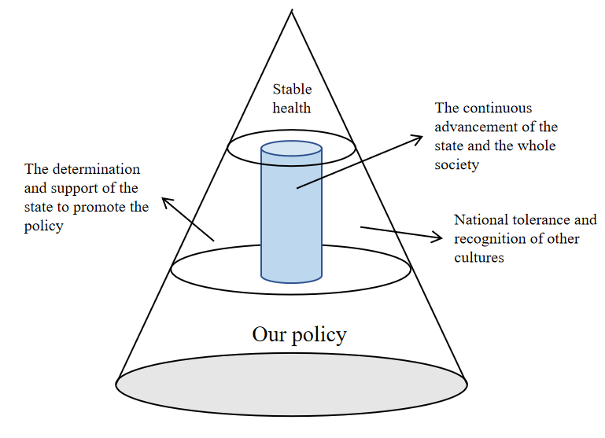

**Fig.17** Policy Implementation Process Chart

To sum up, it is always difficult for every country to implement the reform, and the resistance always comes from all aspects. However, in the face of the world trend, the country must actively comply with the trend, rather than passively involved in the trend.

# 5 Insufficiency of models and limitations of policies

**Advantages：**

* The health model can calculate the steady state of the health of a country’s current educa-tion system in a short period of time.
* The indicator values of the education system are discussed from the perspectives of value and stability.
* The model can be simply extended to high dimensions or simplified to low dimensions.

**Disadvantages：**

* When the advantages and disadvantages of a country's education system are very obvious, and the proportions are similar, the health model cannot accurately determine its true health status. At this time, expert intervention is required to correctly classify.
* In the sustainability model, as the final measurement result is composed of three sub-results, the accuracy of the assessment results of countries with similar sustainability is not high.
* Sustainability models have extremely high requirements for accurate and complete data.

# 6 Sensitivity analysis

We use sensitivity analysis to check the stability of the model. By changing the value of each variable from half of it to 1.5 times, we observe the effect on the results. The results show that for health, changes in variables within this range hardly cause changes in the classification results; for sustainability, the range of changes in each indicator is within ±5.7%, most of which are concentrated in Within ±5%, this shows the good stability of the model.

# Reference

1. ACADEMIC RANKING OF WORLD UNIVERSITIES.

<https://www.shanghairanking.cn/rankings/gras/2020/RS0101>

1. World Bank Open Data | Data.

<https://data.worldbank.org.cn/>

[3] Wikipedia, the free encyclopedia.

<https://en.wikipedia.org/wiki/Main_Page>

[4] World Data Atlas.

<https://knoema.com/atlas>

1. Fan Pingjun.International Comparison of higher education policy drivenmodels[J].2009-06-03.

[6] United Nations official website

<https://www.un.org/en>

[7] U.S. Department of Education official website

https://www.ed.gov/

[8] Japanese Ministry of Education official website

<https://www.mext.go.jp/>

[9] Maruyama Fumihiro. The reform and development of Japanese higher education since the 21st century.World education information,2016.

[10] Wei Chunyan. Higher education reform in Japan: current situation and Prospect. Foreign education research,2000.

[11] Guo Weixin. Research on the current situation and strategy of internationalization of higher education in Japan. Journal of Jilin radio and TV University, 2018.