服务器代码

开启服务不断监听端口13265
package com.fxk;

import java.io.IOException;
import java.io.InputStream;
import java.io.OutputStream;
import java.net.ServerSocket;
import java.net.Socket;
import java.util.ArrayList;
import java.util.Collection;

public class GPSServer {
static ArrayList<ServerChannels> list;
public static void main(String[] args) throws IOException {
list = new ArrayList<ServerChannels>();
ServerSocket serverSocket = new ServerSocket(13265);
Socket socket = null;
while(true) {
socket = serverSocket.accept();
System.out.println("已有客户端连接成功！");
ServerThread serverThreads = new ServerThread(socket);
}
}
}
class ServerThread extends Thread{
InputStream br;
OutputStream bw;
Socket s;
public ServerThread(Socket s) throws IOException {
this.s= s;
try {
System.out.println("连接成功");
br = s.getInputStream();
bw = s.getOutputStream();
ClientThreads clientthread = new ClientThreads(s,br,bw);
clientthread.start();
} catch (IOException e) {
e.printStackTrace();
if(br!=null) br.close();
if(bw!=null) bw.close();
if(s!=null) s.close();
}
}
}
class ClientThreads extends Thread{
private Socket s;
private InputStream br;
private OutputStream bw;
public ClientThreads(Socket s,InputStream br,OutputStream bw) {
this.s=s;
this.br=br;this.bw=bw;
}
public void run() {
try {
while(true) {
int length=-1;
byte[] buf = new byte[1024];
if(br!=null)
length = br.read(buf);
if(length!=-1) {
String info = new String(buf,0,length);
String infos[] = info.split(" ");
String info0 = infos[0];
if(info0.equals("login")) {
Login(infos[1], infos[2], infos[3]);
}
if(info0.equals("getgps")) {
getGPS();
}
if(info0.equals("stop")) {
Serverstop(infos[1]);
break;
}
}
}
}catch(IOException e) {
e.printStackTrace();
}
}
private void Login(String name,String longitude,String latitude) {
GPSServer.list.add(new ServerChannels(br, bw,name,Integer.parseInt(longitude),Integer.parseInt(latitude)));
System.out.println(name+" "+longitude+" "+latitude);
}
private void getGPS() {
try {
String allgps="";
for(ServerChannels a:GPSServer.list) {
allgps+=(a.name+":维度:"+a.latitude+"经度:"+a.longtitude+"\n");
}
bw.write(allgps.getBytes());
}catch (Exception e) {
e.printStackTrace();
}
}
private void Serverstop(String name){
try {
System.out.println(name);
bw.write("youstop".getBytes());
for(ServerChannels a:GPSServer.list) {
if(name.equals(a.name))
GPSServer.list.remove(a);

}
br.close();
bw.close();
s.close();
}catch (Exception e) {
}
}
}
class ServerChannels{
InputStream br;
OutputStream bw;
String name;
int longtitude;
int latitude;
public ServerChannels(InputStream br,OutputStream bw,String name,int longitude,int latitude) {
this.br=br;
this.bw=bw;
this.name = name;
this.longtitude = longitude;
this.latitude = latitude;
}
}

客户端代码

2.1java代码
package com.example.chatonewhoere;
import java.io.IOException;
import java.io.InputStream;
import java.io.OutputStream;
import java.net.Socket;
public class Client {
Socket s;
InputStream br;
OutputStream bw ;
public Client(){
try {
s = new Socket("192.168.0.108",13265);
br = s.getInputStream();
bw = s.getOutputStream();
} catch (Exception e) {
e.printStackTrace();
}
}
public String receive() {
String info="";
try {
byte[] buf = new byte[1024];
int length = br.read(buf);
info = new String(buf, 0, length);
} catch (IOException e) {
e.printStackTrace();
}
return info;
}
public void send(String a) {
try {
bw.write(a.getBytes());
} catch (IOException e) {
e.printStackTrace();
}
}
public void close(){
try {
br.close();
bw.close();
s.close();
} catch (IOException e) {
// TODO Auto-generated catch block
e.printStackTrace();
}
}
}

2.1ip地址查询
在Windows命令行输入ipconfig
一定是无线局域网适配器 WLAN的ip地址！！！
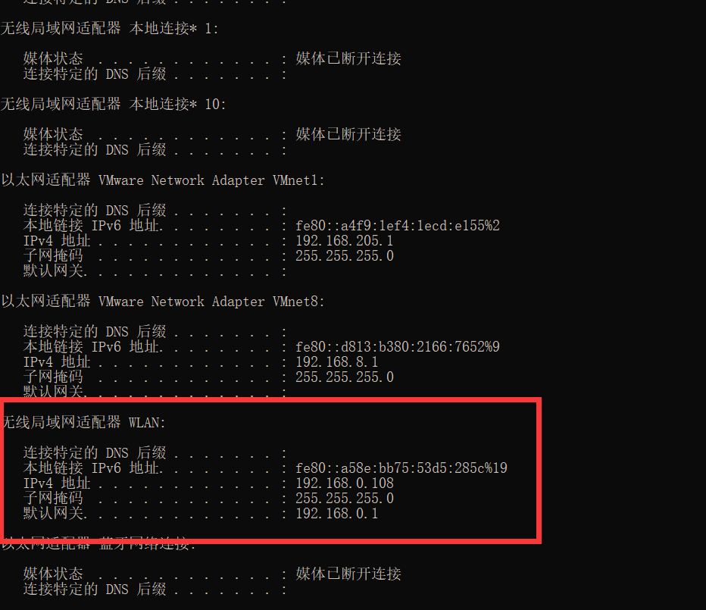

效果及测试
客户端
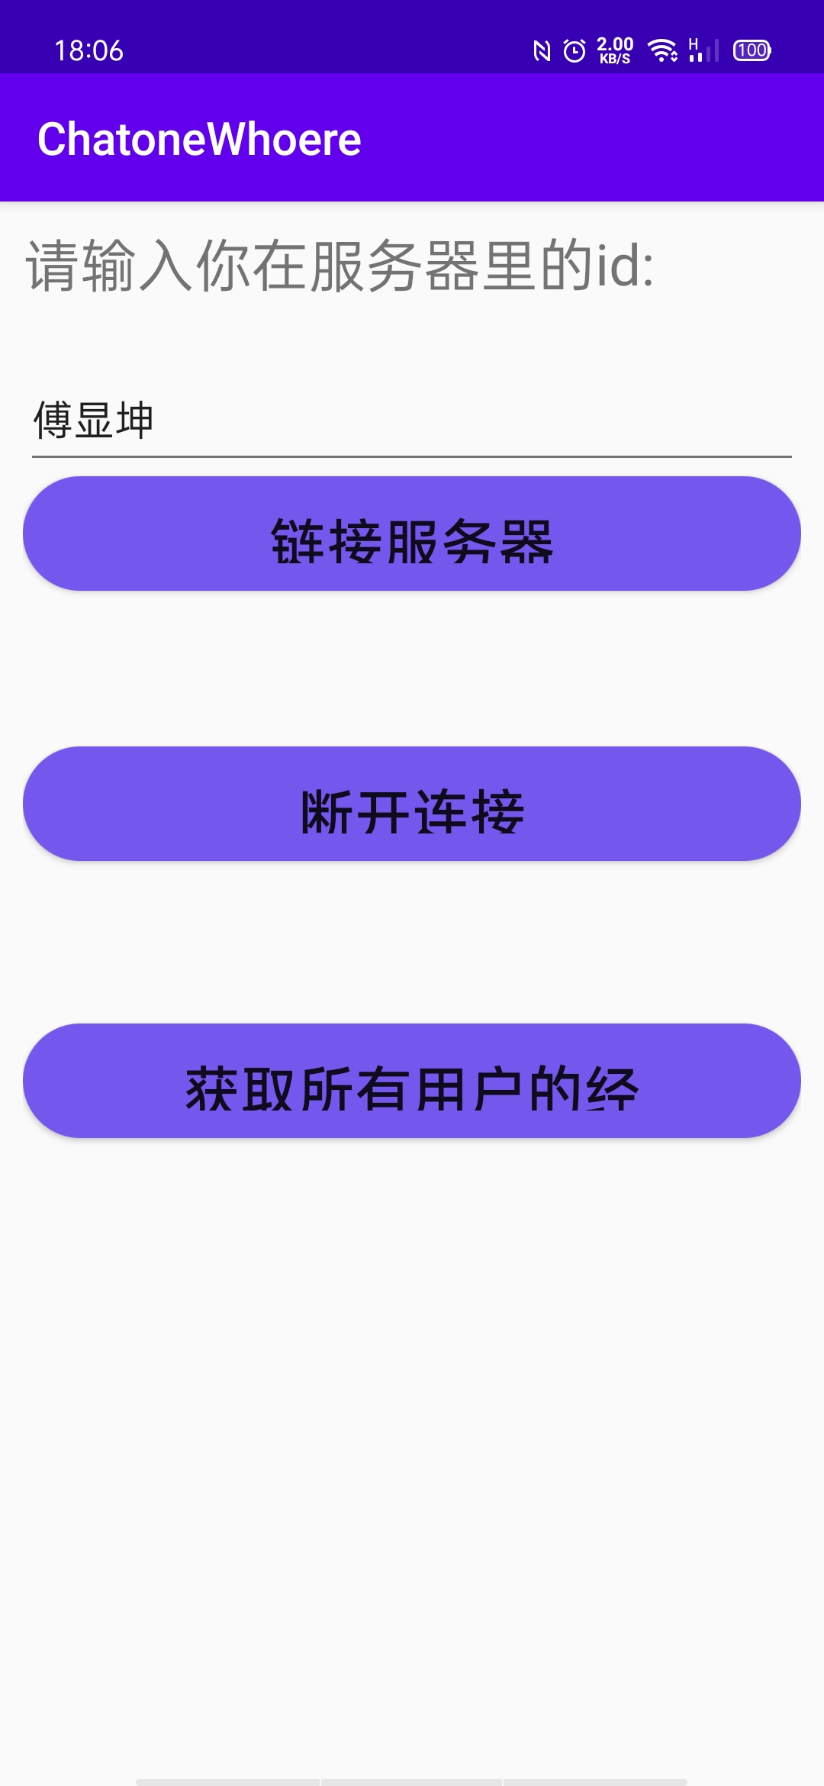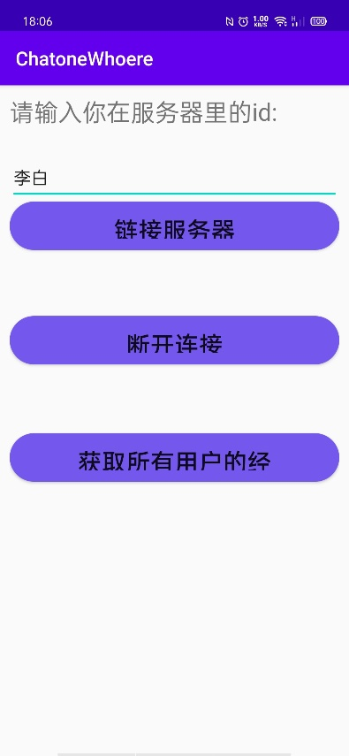

服务端
