



If you are using Android Studio 2.3 (with API 23) from our previous courses/sessions, please do the following steps to make your code works in Android Studio 3.4 (with API 26)

1. **Download** Android Studio (version 3.4.0 or newer). Replace the old Android Studio on your machine with the newly downloaded software.

<https://developer.android.com/studio>

1. Install and import Android Studio Settings from previous version

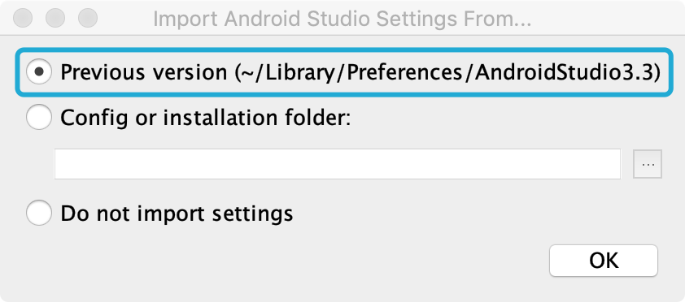

Delete **Unused Android Studio Directories** from old versions if you are not using them anymore

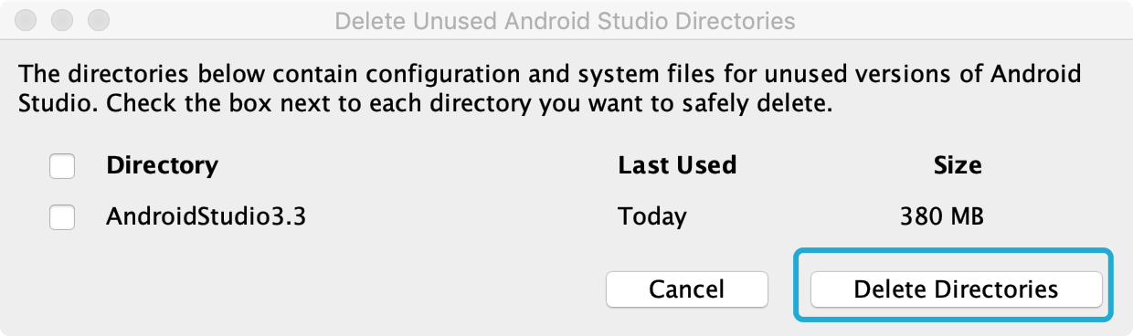

Open pre-existing code (See more detailed steps in **Android Studio Setup Tutorial - Mac/Windows,** follow until step 3**)**

1. Replace the content of **Module** level **build.gradle** 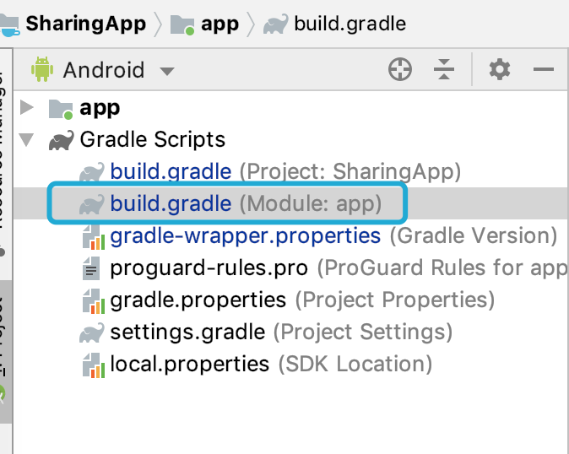 with the following:

apply **plugin**: **'com.android.application'**

android {

compileSdkVersion 26

defaultConfig {

applicationId **"com.example.sharingapp"**

minSdkVersion 19

targetSdkVersion 26

versionCode 1

versionName **"1.0"**

testInstrumentationRunner **"android.support.test.runner.AndroidJUnitRunner"**

}

buildTypes {

release {

minifyEnabled **false**

proguardFiles getDefaultProguardFile(**'proguard-android.txt'**), **'proguard-rules.pro'**

}

}

}

dependencies {

implementation fileTree(**dir**: **'libs'**, **include**: [**'*.jar'**])

configurations {

all*.exclude **group**: **'com.google.code.gson'**

}

androidTestImplementation(**'com.android.support.test.espresso:espresso-core:2.2.2'**, {

exclude **group**: **'com.android.support'**, **module**: **'support-annotations'**

})

implementation **'com.google.code.gson:gson:2.8.2'**

implementation **'com.android.support:appcompat-v7:26.1.0'**

implementation **'com.android.support:support-v4:26.1.0'**

implementation **'com.android.support:design:26.1.0'**

implementation **'io.searchbox:jest-droid:2.0.0'**

testImplementation **'junit:junit:4.12'**

}

Alternatively, you can also use the [content of this gist](https://gist.github.com/Aquafina99/749ebb0fccb6c8647c05a2641c45ea90) to copy the code.

1. Replace the content of **Project** level **build.gradle**

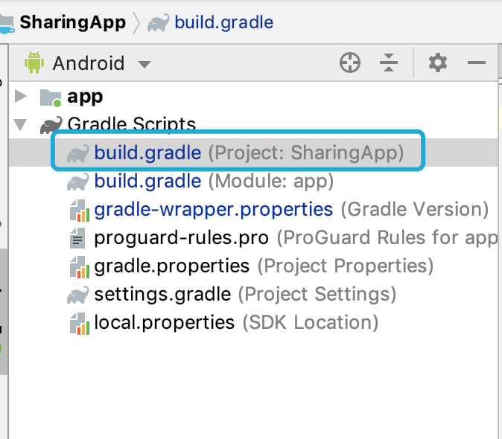 with the following:

*// Top-level build file where you can add configuration options common to all sub-projects/modules.*

buildscript {

repositories {

google()

jcenter()

}

dependencies {

classpath **'com.android.tools.build:gradle:3.4.0'**

*// NOTE: Do not place your application dependencies here; they belong*

*// in the individual module build.gradle files*

}

}

allprojects {

repositories {

google()

jcenter()

}

}

task clean(**type**: Delete) {

delete rootProject.buildDir

}

Alternatively, you can also use the [content of this gist](https://gist.github.com/Aquafina99/b8db1dd050e607ea4c0636a93c343b97) to copy the code.

5. Complete step 4 in **Android Studio Setup Tutorial - Mac/Windows.**

6. Rebuild the app by clicking: **Build** -> **Rebuild Project**

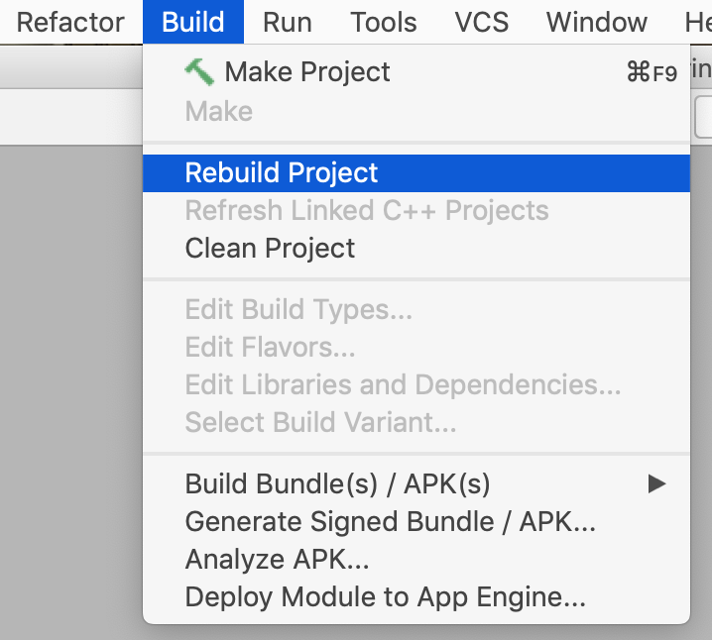

7. Complete step 5 in **Android Studio Setup Tutorial - Mac/Windows.**

8. Run the app. A this point you should be able to run the app by clicking the **play** button.

