Sewpads System Design

The concept of Sewpads is enhancing the Flex Modules for sewing. Flex Modules are circuit boards meant to soldered as modular components to a larger circuit board. Sewpads are a larger board containing one (possibly more of the Flex Modules) for the purpose of being attached to garment or accessories. Ideally, they are utilized to make a larger circuit by connecting multiple Sewpads and other peripheral electronics together by threading conductive wire or thread through the garment or accessory. We wrote a simple script (pad.py in Github) to space the pads out symmetrically along a circle and since the Flex Module layouts are consistent, many Flex Modules can use a single Sewpad layout. The pad layout becomes 2 rows after 12 pads.

Sewpads are soldered on to the bottom of the Flex Module. They may optionally be epoxied as well to improve attachment and a conformal coating applied to limit ESD and water damage.

We have not yet tested sewing with a machine, but it should be straight forward. If there is a huge demand we will convert Flex Modules into rigid-flex designs that laminate the flex as part of the Flex Module stack up.

Components
- Copper clad Kapton/polyimide
- Etching/Fabrication
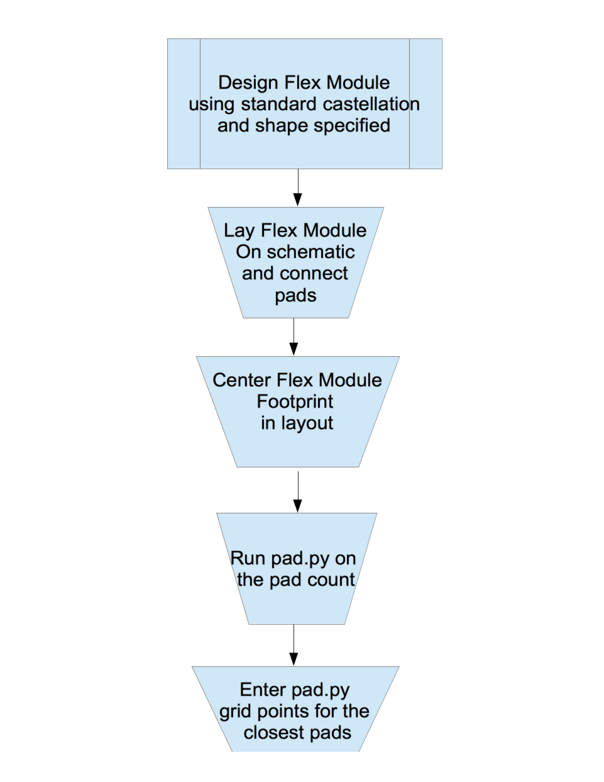

Flow of user usage:
