USB BiPower OTG

3.3V and -3.3V rails from USB or battery

Chris Hamilton - DATE \@ "MMMM d, y" March 10, 2015

# Design

USB BiPower OTG supports up to 2A VBUS input at 5V or 3A from the BQ24296 VSYS which is 4.2-3.5V depending on battery charge. The BQ24296 is on the Qi/USB Flex Module that pairs with board castellations on the sides. The top castellations are meant to connect to a USB OTG supported micro controller such as the STM32F401 based STM32 Flex Module.

The MAX3353 charge pump is optional to the design and only utilized for OTG charging with microcontrollers that do not support OTG natively. BQ24296 boost mode switching should be fast enough to negotiate OTG.

## Power Supplies

TPS2115A determines whether the source of the power supplies is battery or VBUS. TPS2115A can switch up to 2.5A. The TPS62086 provides 3.3v at up to 3A from the input. The LMR70503 can provide up to 300mA of -3.3v.

## Control logic

i2c control of the TSU6721 and MAX3353 is available, though default operation will negotiate USB or battery based power to drive the TPS62086 3.3v power supply. The TPS2115A should pull VBUS power through the TSU6721 once negotiated. The TSU6721 VBUS switch can be turned off when providing on system OTG based VBUS power to draw VSYS power directly. INTB is open drain. TSU6721 INTB is push/pull, so it is not used.

# Schematic

USB micro A/B on the bottom right with ferrite coil isolation from the case, ground, and VBUS. Protection is D+/- common choke/ESD ECMF02-2AMX6 and VBUS OVP/ESD provided by the TPD1S514. The MAX3353 which routes around the choke is ESD protected. Power supplies are reference designs from Webench. TSU6721 pins are shorted to support i2c layout without via in pad.

# BOM

Ferrite coils are in the 200Ohm+ range which seems to be standard for USB isolation.

Inductors are from TI design recommendations.

I specified Samsung capacitors are they are common among distributors now and appear to have stock of larger va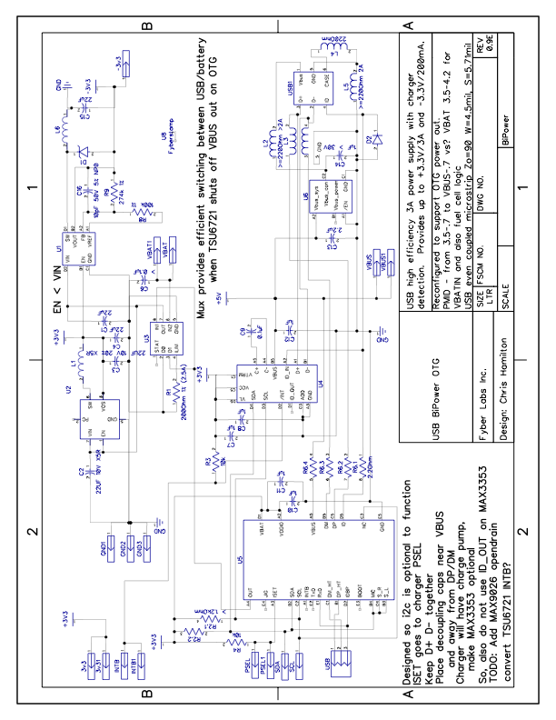lues in small sizes. The reference designs for bulk caps were 1206, but 0603 can now be found with the same V and F.

I similarly picked Panasonic resistors based on availability and price.

Diodes should be correct, but

there is limited spec.

# Layout

Traces are correct for the required currents - 2A VBUS/5V and 3A for VSYS/BAT. USB Case ground plane and general ground plane are isolated. TSU6721 internal vias are aligned to be on unused output pads. They should not interfere with i2c as long as firmware does not switch those pins.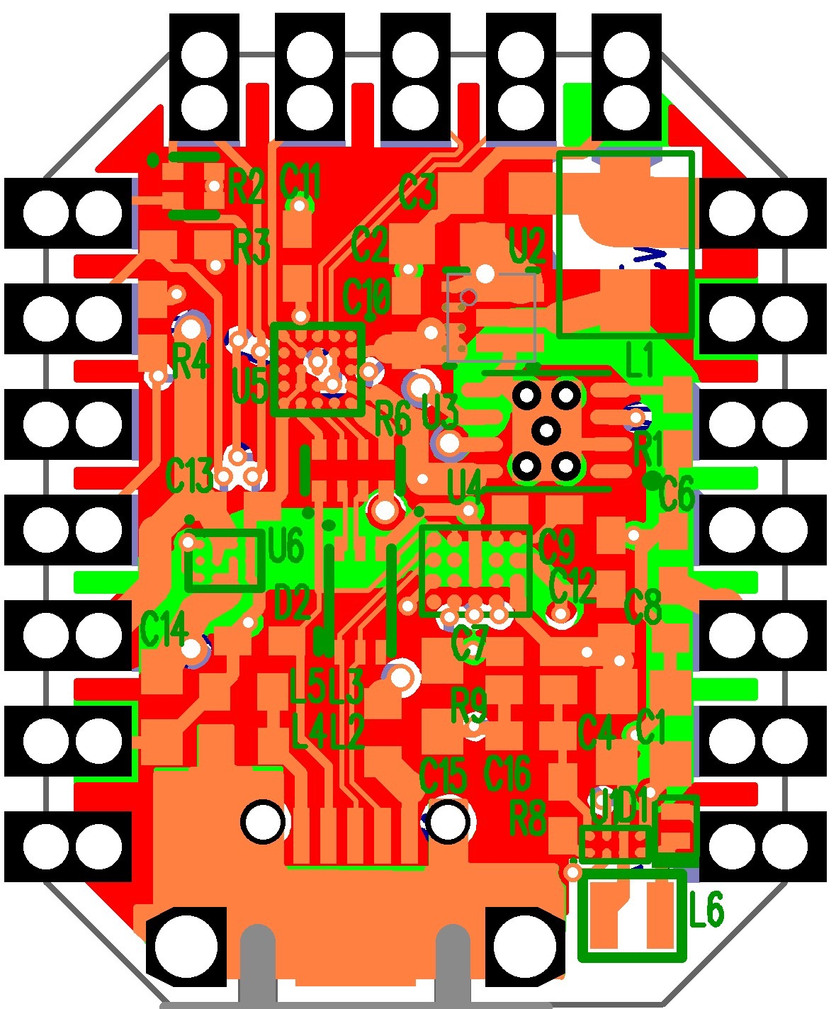

## Top Layer 1oz

## 2nd/GND Layer 0.5oz

## 3rd/3.3v/VDD Layer 0.5oz

## Bottom Layer 1.0oz