通货膨胀率，tradingeconomics
https://zh.tradingeconomics.com/egypt/inflation-cpi
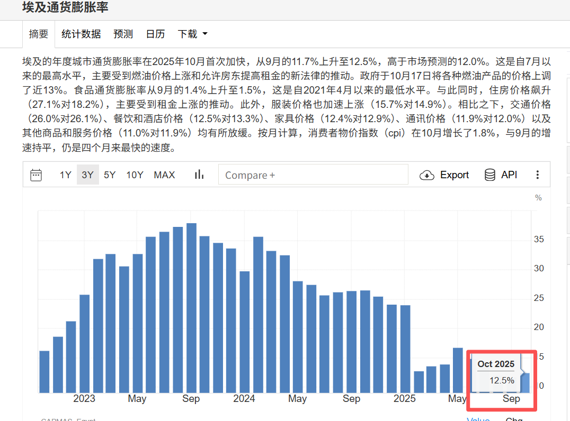

失业率：tradingeconomics
https://zh.tradingeconomics.com/egypt/unemployment-rate
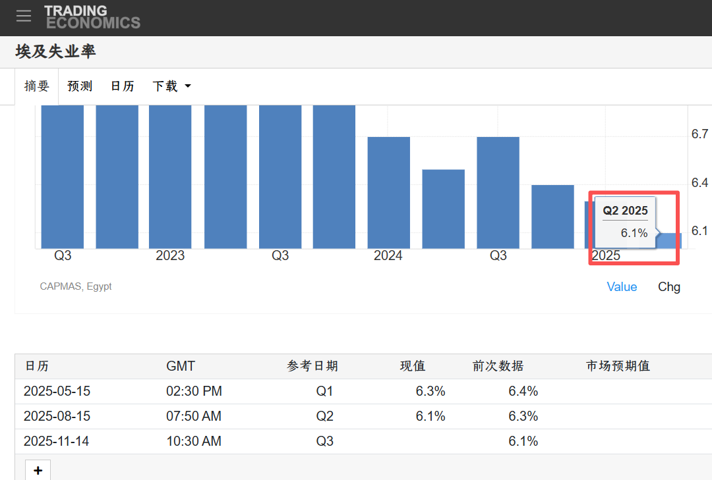

贸易逆差，埃及中央公共动员和统计局 （CAPMAS）
https://sigmacapital.com.eg/main/news_page_exact?u_sess=%27&newsType=MIST&newsId=45755872
https://www.capmas.gov.eg/publications/22
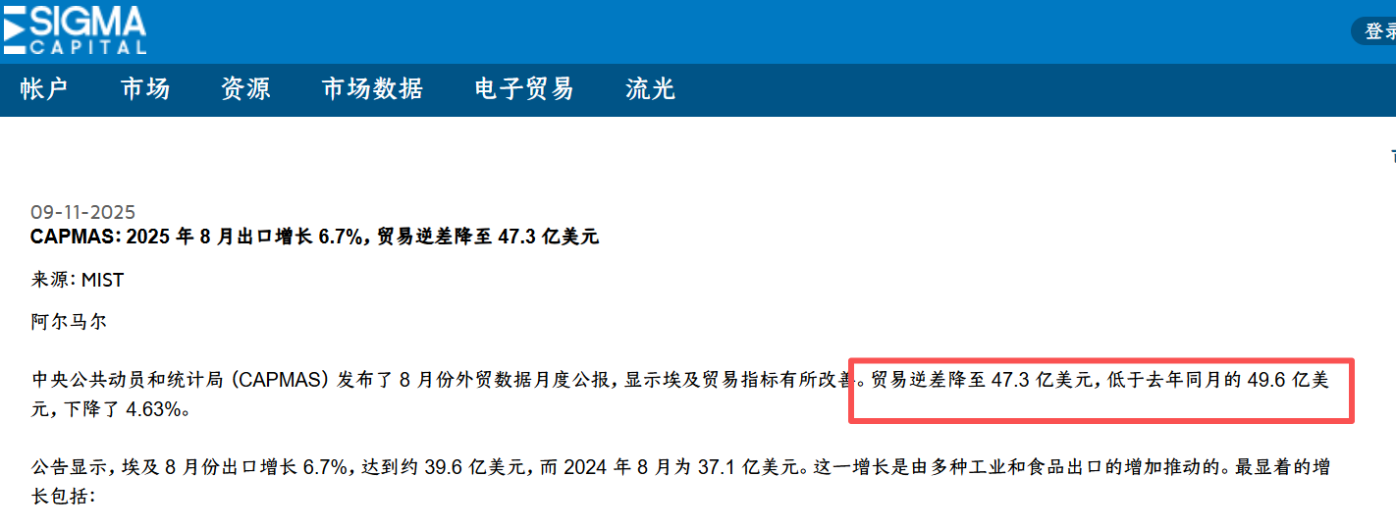
外汇储备，埃及央行
https://www.cbe.org.eg/en/news-publications/news/2025/11/09/08/06/net-international-reserves-at-the-end-of-october-2025
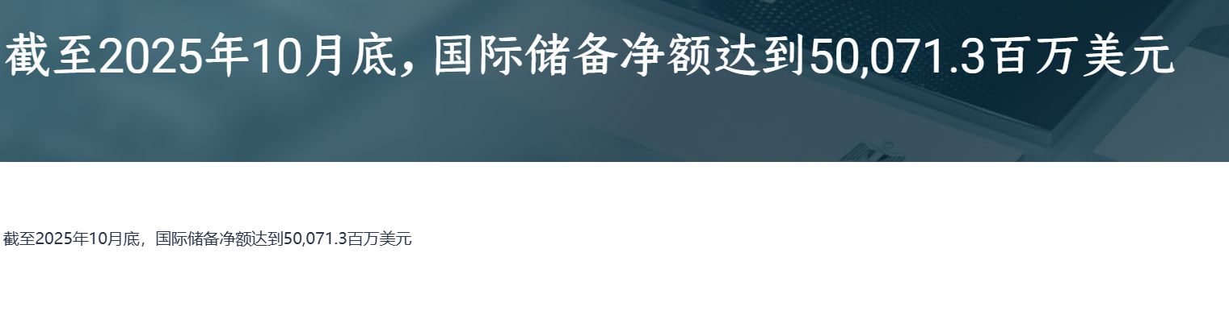

股指，tradingeconomics
https://zh.tradingeconomics.com/egypt/stock-market
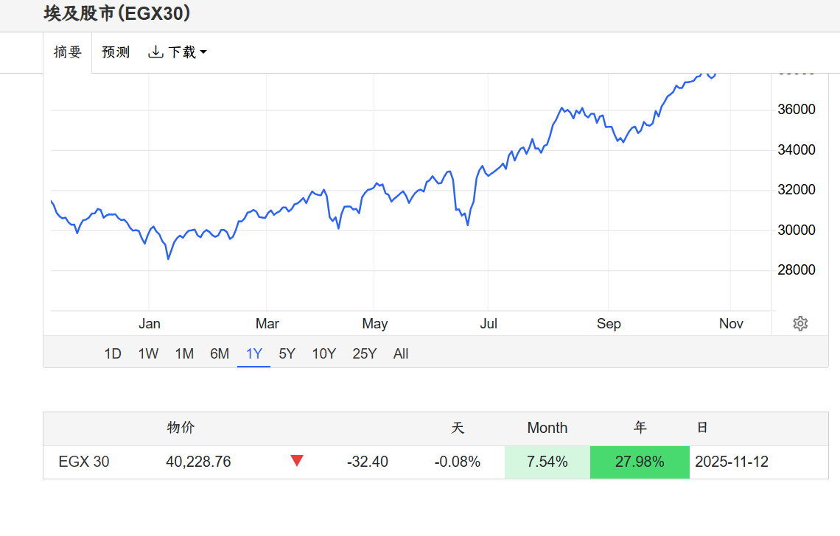国债收益率，英为财情
https://cn.investing.com/rates-bonds/egypt-10-year-bond-yield-historical-data
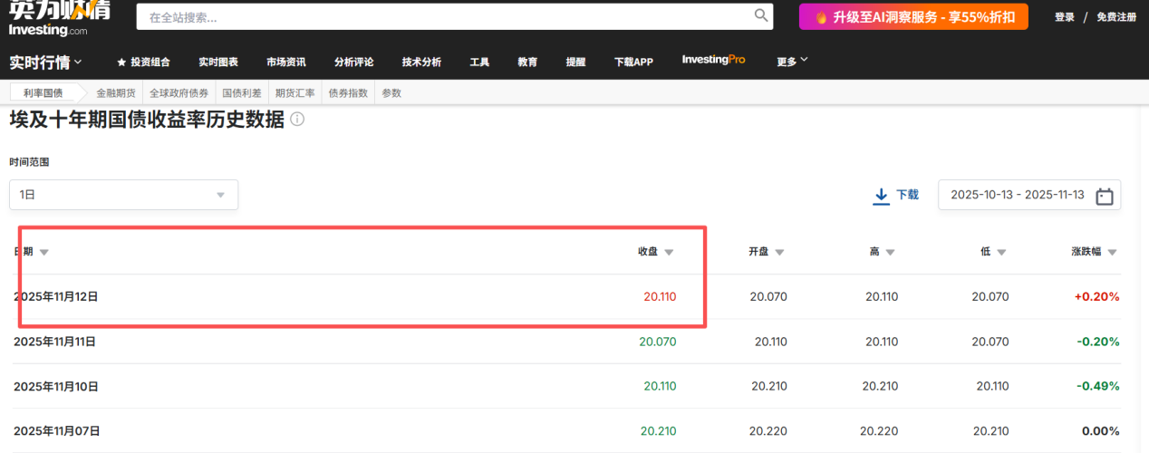
汇率，tradingeconomics
https://zh.tradingeconomics.com/egypt/currency
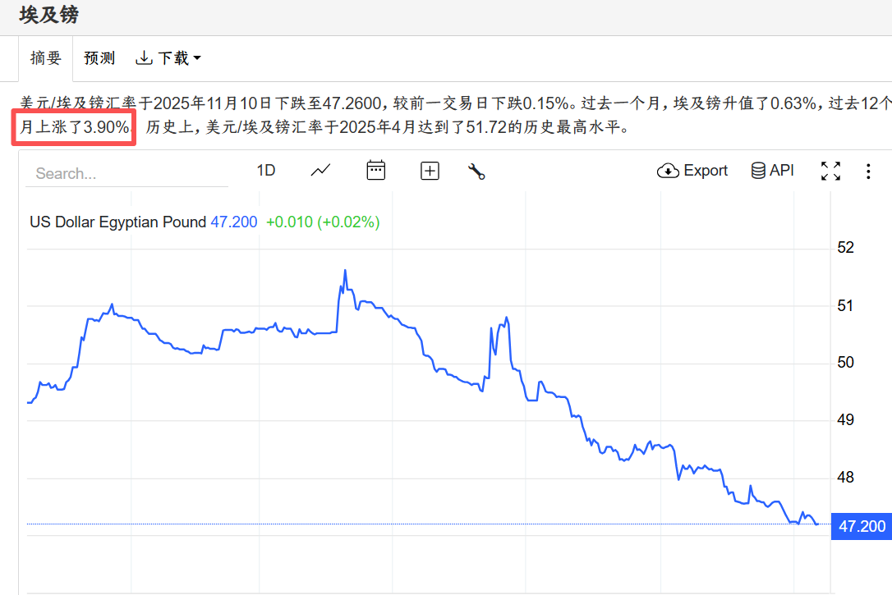

宏观经济政策：
财政刺激计划、发行主权债券，埃及财政部
https://mof.gov.eg/ar/posts/media/
上调燃油价格，美联社
https://apnews.com/article/egypt-fuel-prices-economy-inflation-diesel-gas-e001493d45c58389cbbe82899a37d74f
上调工资，第七日
https://www.elbalad.news/#google_vignette

