## Observations

Setting small temperature values for the model isn’t yielding a sufficient number of JSON fields mentioned in the Pydantic Formats.

## Actual Information from StraightTalk Page

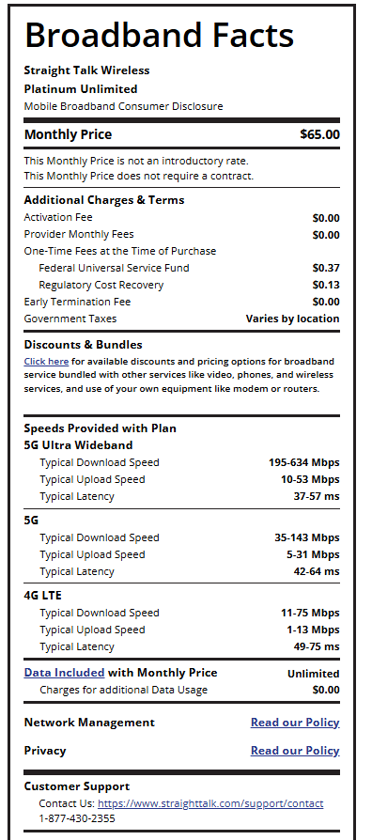

## Formatted Outputs

### Model: Llama3.2:3b

Improved System Prompt and temperature

{

"provider": "Verizon",

"plan_name": "Platinum Unlimited",

"disclosure_title": "Facts About Your Plan",

"monthly_price": "$70.00",

"monthly_price_notes": [

"$0.00 for additional data usage"

],

"additional_fees": [],

"one_time_fees": [],

"discounts_and_bundles_link": "<a href=\"https://www.verizon.com/support/tracfone-open-internet-legal/\">Data Included</a>",

"speeds": [

{

"network_type": "4G LTE",

"typical_download_speed": "> 20 Mbps",

"typical_upload_speed": "> 5 Mbps",

"typical_latency": "< 50 ms"

},

{

"network_type": "5G",

"typical_download_speed": "> 100 Mbps",

"typical_upload_speed": "> 10 Mbps",

"typical_latency": "< 30 ms"

}

],

"data_included": "Unlimited",

"additional_data_charges": "$0.00",

"network_policies": [

{

"title": "Network Management",

"policy_link": "https://www.verizon.com/about/our-company/network-management"

},

{

"title": "Privacy",

"policy_link": "https://www.tracfonewirelessinc.com/en/Privacy%2BPolicy/"

},

{

"title": "Customer Support",

"policy_link": "https://www.straighttalk.com/support/contact"

}

],

"customer_support": {

"website": "https://www.straighttalk.com/support/contact",

"phone_number": "1-877-430-2355"

},

"fcc_consumer_info_link": "https://www.fcc.gov/consumer",

"reference_code": "M0006855639ST0000957009143"

}

Normal Prompt

{

"provider": "Verizon",

"plan_name": "Platinum Unlimited",

"disclosure_title": "Broadband Facts Label",

"monthly_price": "$60.00",

"monthly_price_notes": [

"Data Included with Monthly Price"

],

"additional_fees": [

{

"name": "Additional Data Usage",

"amount": "$0.00"

}

],

"one_time_fees": [],

"discounts_and_bundles_link": "/products/platinum-unlimited",

"speeds": [

{

"network_type": "Verizon Wireless",

"typical_download_speed": "25 Mbps",

"typical_upload_speed": "10 Mbps"

,

"typical_latency": "20 ms"

},

{

"network_type": "Verizon Wireless",

"typical_download_speed": "50 Mbps",

"typical_upload_speed": "20 Mbps"

,

"typical_latency": "15 ms"

},

{

"network_type": "Verizon Wireless",

"typical_download_speed": "100 Mbps",

"typical_upload_speed": "30 Mbps"

,

"typical_latency": "10 ms"

},

{

"network_type": "Verizon Wireless",

"typical_download_speed": "200 Mbps",

"typical_upload_speed": "40 Mbps"

,

"typical_latency": "5 ms"

}

],

"data_included": "<a href=\"https://www.tracfonewirelessinc.com/en/Our-Plans/Data-Usage-Policy/\">Data Included</a> with Monthly Price",

"additional_data_charges": "$0.00",

"network_policies": [

{

"title": "Network Management Policy",

"policy_link": "<a href=\"https://www.verizon.com/about/our-company/network-management\">Read our Policy</a>"

},

{

"title": "Privacy Policy",

"policy_link": "<a href=\"https://www.tracfonewirelessinc.com/en/Privacy%2BPolicy/\">Read our Policy</a>"

}

],

"customer_support": {

"website": "https://www.straighttalk.com/support/contact",

"phone_number": "1-877-430-2355"

},

"fcc_consumer_info_link": "https://www.fcc.gov/consumer",

"reference_code": "M0006855639ST0000957009143"

}