Set up - experimented on Windows

Cloned Repo
https://github.com/moltbot/moltbot

Install Node.js from https://nodejs.org/en/download

In windows powershell in Administrator mode (Required) -
pnpm moltbot onboard --install-daemon

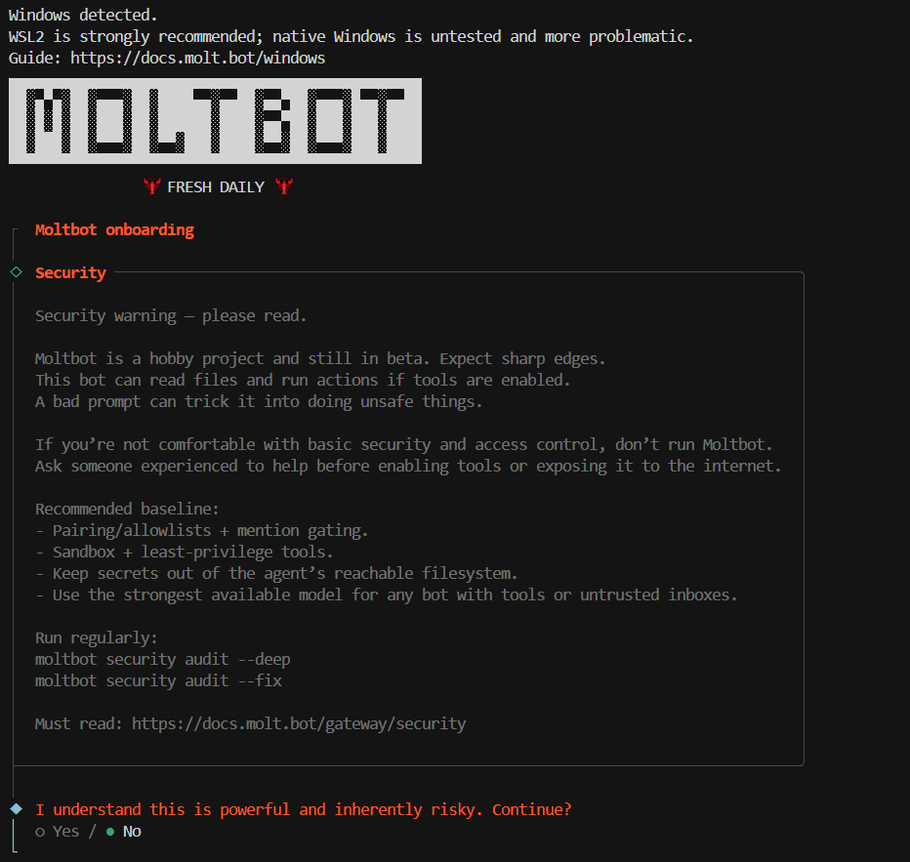

Choosing Models:
Provided Open AI API Key

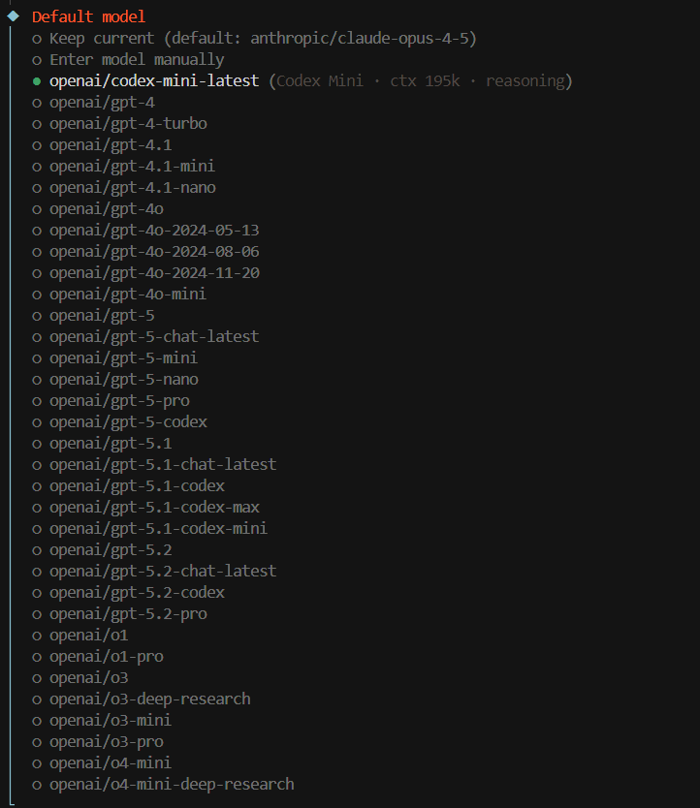

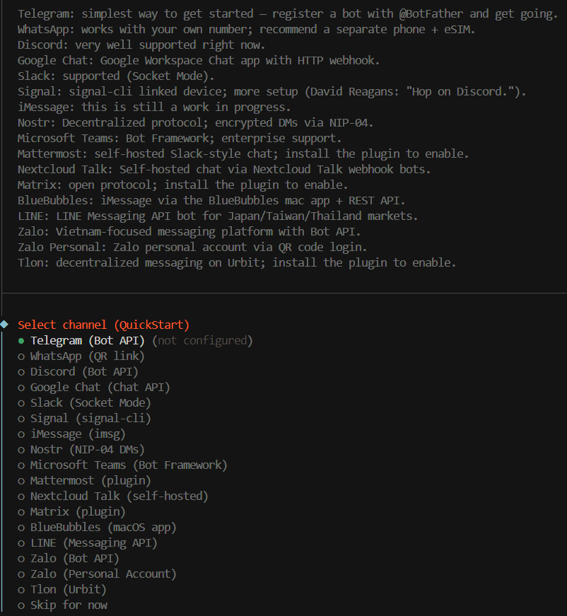

Setting up Telegram Bot API:

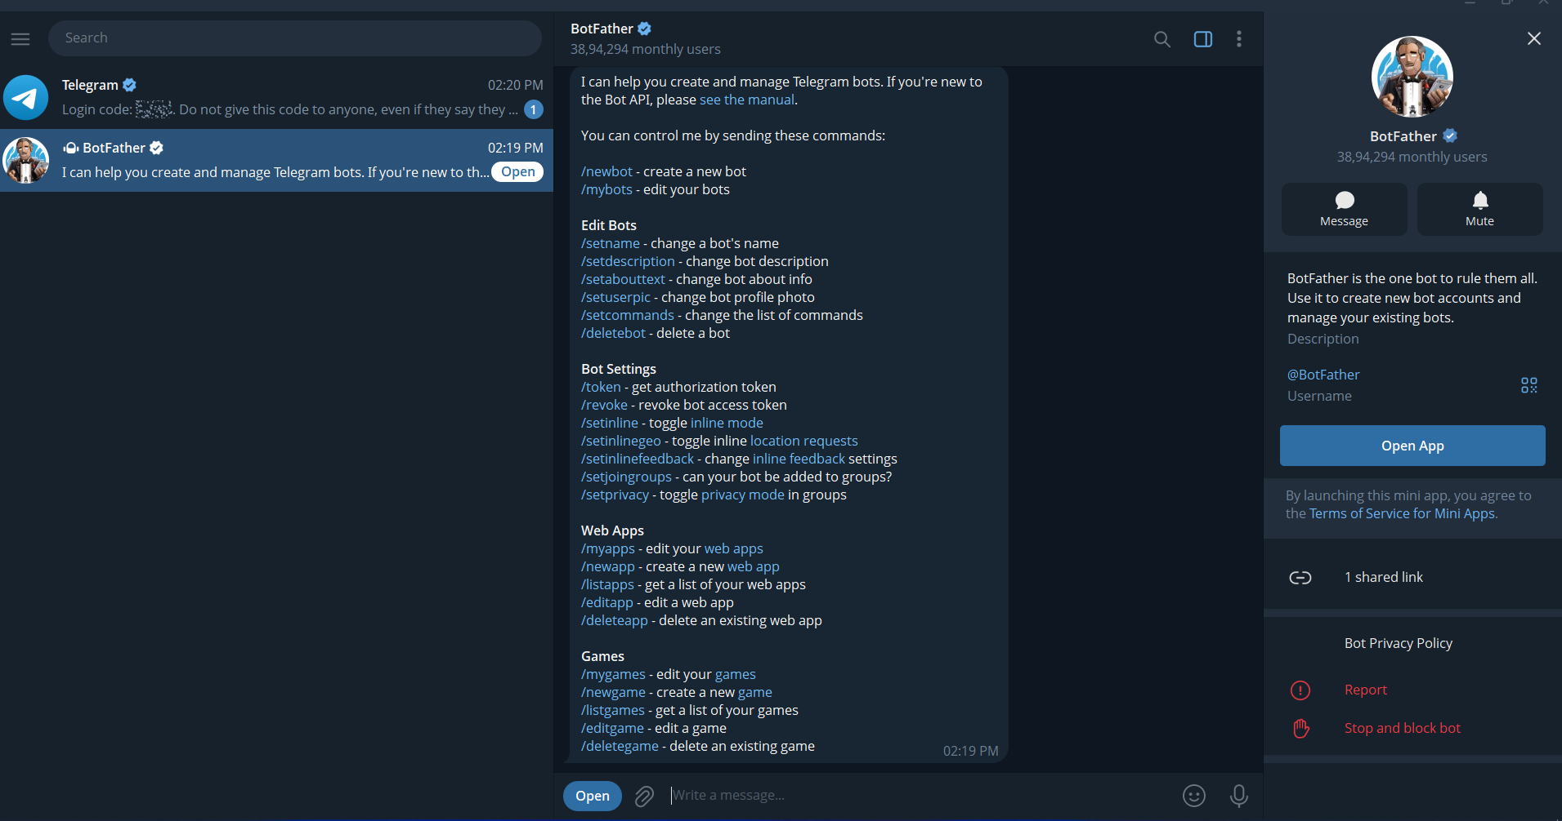
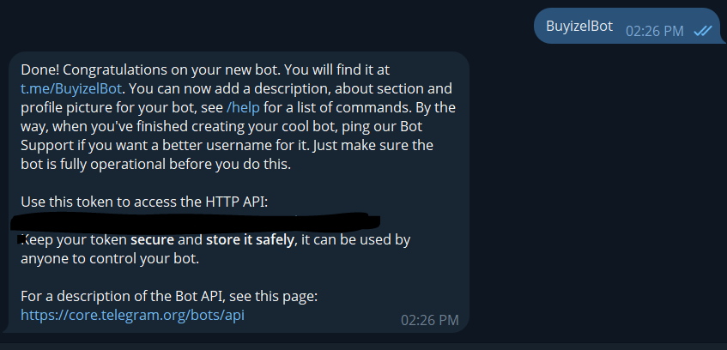
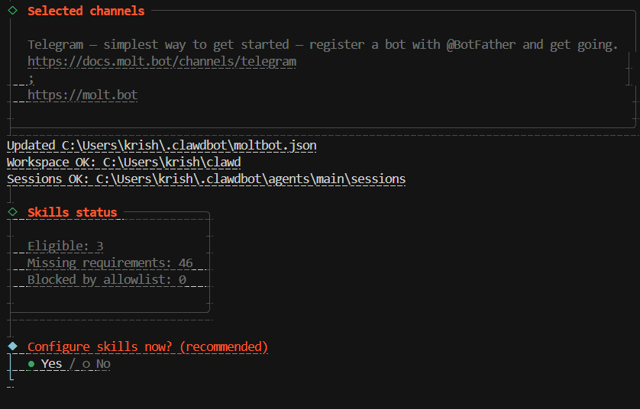
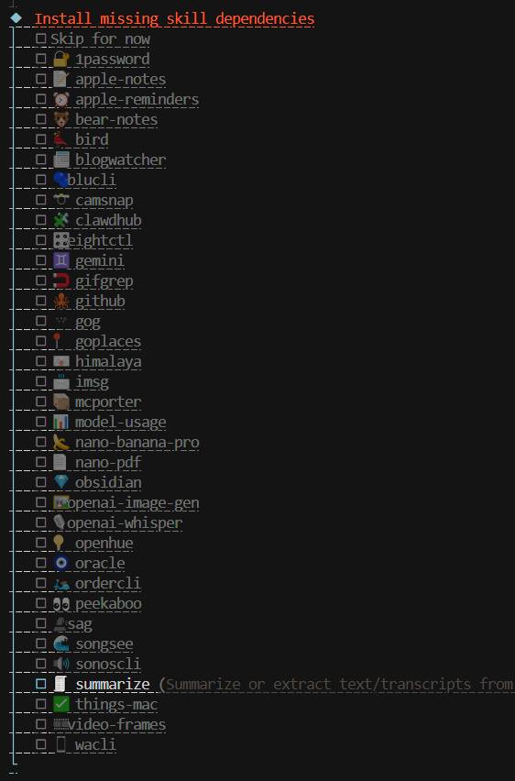
After some configurations we get the following interface for Moltbot.

