Tower of Hanoi Lab Report – Leo Canales

IMPORTANT NOTES FOR THE TA’S
This link provided in task 4 “http://proprogramming.org/solution-for-tower-of-hanoi-c/” goes to an AI gambling site. Please make sure to remove this in the future for obvious reasons.

Compilation and Running:
Just run main.exe. Don’t bother manually compiling anything. Everything is explained inside.

Explored Objectives/Concepts:
The main concepts explored in this project were stack and queue implementation in C++. These two data structures are especially important, as many other data structures are based on the same functions that these two implement. I personally chose to do an array-based implementation for one and pointer-based implementation for the other, to get practice with both options.

Multiplayer Discussion:
The original form of the multiplayer is fairly unbalance. Even with only three disks, it’s incredibly easy to stall the game out for a very long time, especially when you can stack disks on disks of equal size. It’s even possible (though very unlikely) to completely softlock the game, as shown below.

Figure 3.4. Two-Player Softlock
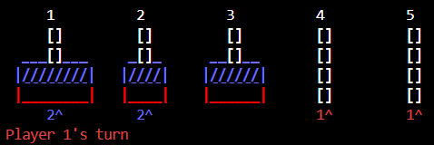
As such, I’ve added a setting to disallow stacking same size disks, which forces the players to both progress the game. Unfortunately, trying to play this game competitively is still incredibly tedious because of how slow and repetitive it is. As such, I decided I needed a more chaotic gamemode to create interest. As I wanted to keep the deterministic nature of the mathematical puzzle intact, I figured the best way would be to simply add more players so each player has to progress and defend on multiple fronts, as shown below.

Figure 3.3. Four-Player Game Interface
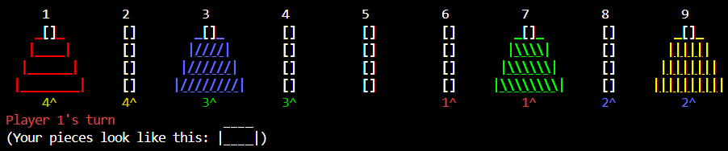
Another interesting thing to note about the structure of this game is the result of cooperation. If both players progress by the same amount, the recursive nature of the original mathematical puzzle ensures that the game simply turns into another evenly matched game with shorter towers. As such, it is much more beneficial to instead rush for advantage rather than trying to cooperate with the opponent. You also can’t just ignore the opponent, since you functionally need three towers’ worth of space to progress.
Gamestate Storage and Playback Discussion:
This part of the design was pretty straightforward. I used a simple structure storing nodes containing from and to towers in a queue. As such, it was fairly simple to expand that to storing move sequences in .csv files, which I did, as shown below.

Figure 4.1. Example Save Data
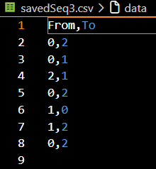
The automation for playback of these move sequences was actually pretty simple too; I just created a new class containing a move sequence, a Hanoi class, and a few helper functions to connect them. No notes on this step.

Figures:
Figure 1. Mode Select
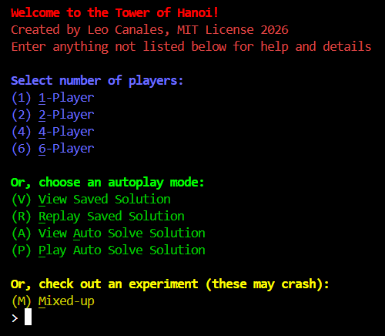
Figure 2.1. Single-Player Settings
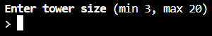
Figure 2.2. Single-Player Game Interface
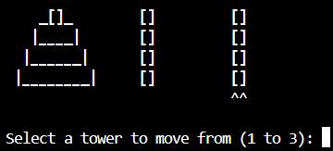
Figure 2.3. Single-Player Win Screen
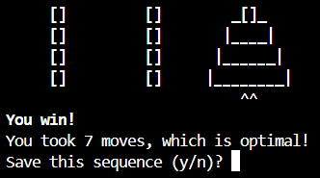
Figure 3.1. Multiplayer Settings
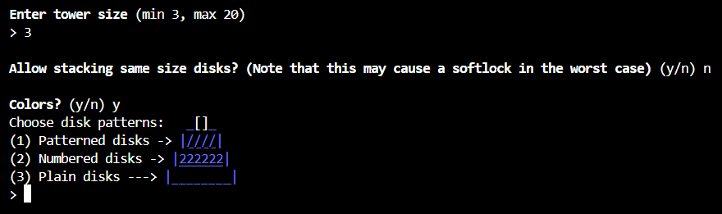
Figure 3.2. Two-Player Game Interface
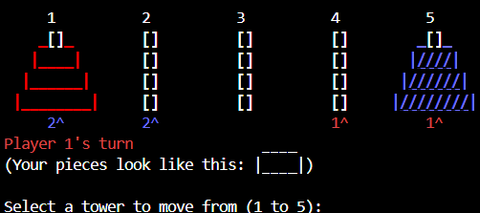

Figure 3.3. Four-Player Game Interface
Figure 3.4. Two-Player Softlock
Figure 4.1. Example Save Data
Figure 4.2. Example Saved Sequence View
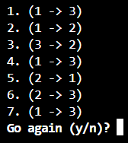

Figure 4.3. Example Saved Sequence Playback


