Lejeune Hugo Groupe TPD 11/10/2021
TP2

Travaux effectués

A retenir
SELECT datname FROM pg_database WHERE datbda IN (SELECT usesysid FROM pg_user WHERE usename= 'nom de connexion'); | 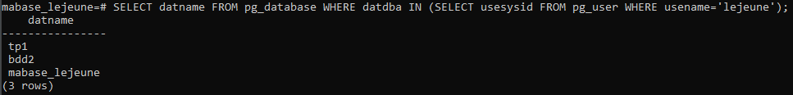 | 4)Sert a afficher toute les base de donnée d’un utilisateur
SELECT * FROM client; | 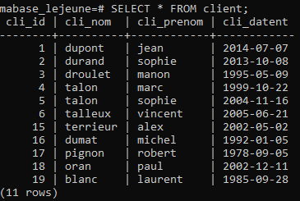 | 9)a)
SELECT cli_nom FROM client; | 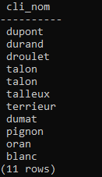 | 9)b)
SELECT DISTINCT (cde_commande) FROM commande; | 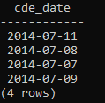 | 9)c)
SELECT cli_prenom FROM client WHERE cli_prenom LIKE 'sophie'; | 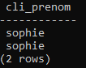 | 9)d)
SELECT art_id, cde_qte FROM commande WHERE cli_id=1; | 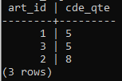 | 9)e)
SELECT upper (cli_nom) FROM client; | 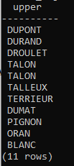 | 9)f) upper sert a afficher le nom des client en majuscule
SELECT cli_nom FROM client WHERE upper(cli_nom)='%'; | 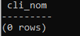 | 9)g)
SELECT cli_nom FROM client WHERE LENGTH(cli_nom) BETWEEN 1 AND 5; | 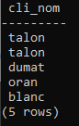 | 9)h) length sert à calculer la longueur d’un mot
SELECT cli_nom FROM client WHERE cli_nom LIKE 't_l%'; | 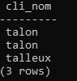 | 9)i)
SELECT cli_id, art_id, cde_date, cde_date + integer '15' AS date_paiment FROM commande; | 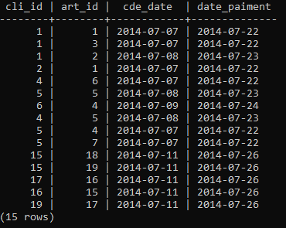 | 9)j)
SELECT cli_nom, cli_prenom, cli_datent FROM client ORDER BY cli_datent ASC; | 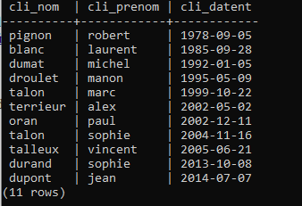 | 9)k) Version 1
SELECT cli_nom, cli_prenom CURRENT_TIMESTAMP-cli_datent FROM client ORDER BY cli_datent ASC; | 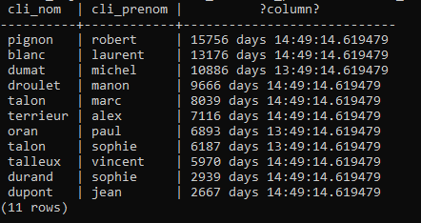 | 9)k) Version 2
SELECT CURRENT_TIMESTAMP; | 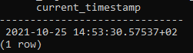 | 9)l)
ALTER TABLE commande ALTER COLUMN cde_qte TYPE integer USING (cde_qte::integer); |  | Sert a changer un type de varchar a entier
SELECT MAX(cde_qte) AS cde_qte_max FROM commande; | 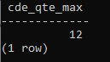 | 9)m)
SELECT SUM (cde_qte) AS cde_qte_total_client1 FROM commande WHERE cli_id=1; | 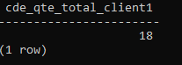 | 9)n)
SELECT ROUND(AVG(cde_qte), 2) AS cde_qte_moeyenne_client2 FROM commande WHERE cli_id=2; | 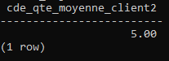 | 9)o)
SELECT cli_id, cli_nom, cli_prenom FROm client ORDER BY cli_nom ASC; | 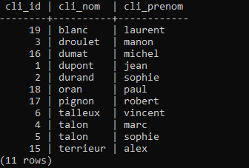 | 9)p)
SELECT * FROM article ORDER BY art_prix DESC; | 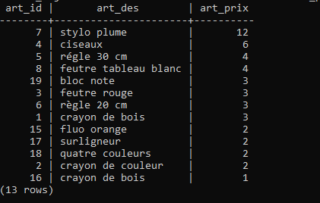 | 9)q)

