Fynn Thompson

Student number W1666825

FM procurement

Contents

2 – What is procurement?

2 – Project Team

2 – Objective Setting

2 – Market Analysis

3 – Soft Market Testing

3 – Risk Register

3 – Submission Requirements and Evaluation Criteria

4 – Detailed Scoping

4 – Service Specification

4 – Cost Structure

5 – Procurement Process

6 – Award of Contract

6 – Post Procurement

The aim of procurement is to select the bidder best able to supply the defined services over a set term at a price that is acceptable to the client, with optimal commercial and legal outcome for both parties.

Procurement process in FM can be broken down into 3 key stages: Planning, Procurement, Post Procurement.

PLANNING STAGE

Project Team: Once a business has decided to undertake a procurement project, it must create a project team of advisors and stakeholders to support and manage the procurement project through to completion. Key roles are:

* Sponsor – senior leader within the business providing leadership and governance throughout the process.
* Project manager – providing coordination for day to day management of the process
* Procurement lead – someone experienced in the market for the service being procured
* Technical lead – someone who understand the requirements of the business
* Financial lead – understanding of costs, budgets and affordability
* Legal lead – able to advise of legal issues and terms and conditions of the contract
* HR lead – for considerations of the implications on people
* Other specialist advisers (It, H&S etc)

Objective Setting: The objectives for the project must be clearly defined – using the “SMART” system (Specific, Measurable, Attainable, Relevant, Timed). Using the SMART system will ensure the project has defined parameters and a measure of success. An example of a stupid goal could be “To reduce costs of the cleaning service”. A SMART way to put this would be “To reduce cleaning cost by 10% over the next two financial years while maintaining quality of service”.

Market Analysis: In order to identify suppliers to ask to bid for the contract, it is necessary to carry out market analysis. This should take into account geographic suitability of the suppliers, and other relevant critera. The following are a few examples which can be used as a test of suitability:



Figure : Supplier Evaluations

Soft Market Testing: Once you have selected some potential suppliers, it may be necessary to conduct some soft market testing by providing them with a brief, and invite them to discuss the outline proposal. This will help inform the ITT documents later in the procurement process.

Risk Register: As with any major project it is necessary to develop a risk register for the procurement process. This will ensure any risks are identified and mitigated prior to them becoming a problem. The risk register should be continually updated and reviewed to ensure the procurement project runs smoothly from start to finish.

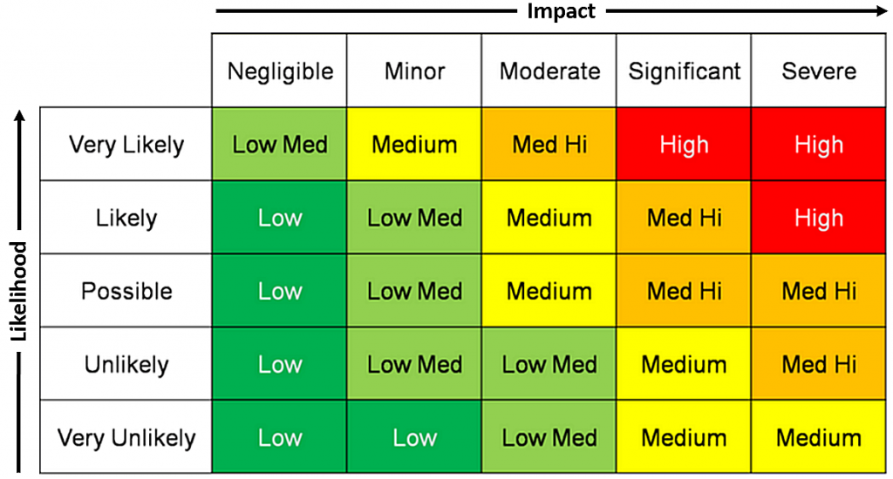

Figure : Risk Matrix

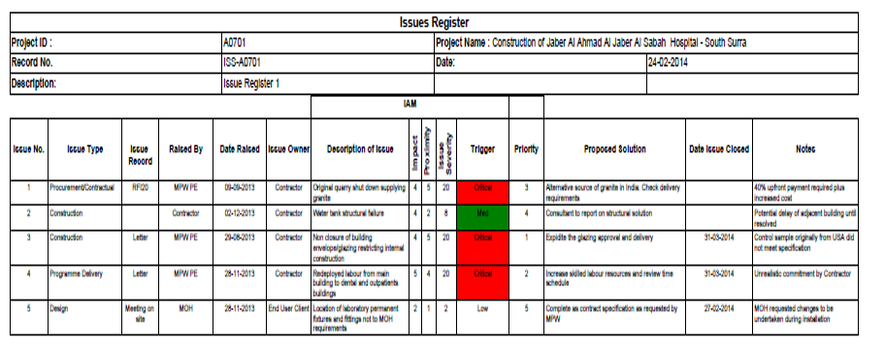

Figure : Risk Register

Submission Requirements & Evaluation Criteria: The submission requirements should be clearly identified so each supplier is working towards the same set of submission criteria. The submission template must be as clear as possible. Likewise, the evaluation criteria must be the same for every tender submission; the client must not assess different submissions of different criteria. The evaluation criteria will be supplied to the bidder in the interests of transparency.

PROCUREMENT STAGE (DEVELOPING ITT DOCUMENTS)

Detailed scoping as part of the ITT is required to ensure each bidder is able to cost all elements of the submission effectively. This means the client, as part of their submission criteria, should break down each element of the service the supplier is contracting for. For example if cleaning is part of the tender, it should specify cleaning at separate sites and types of cleaning as separate cost lines.



Figure : Detailed Scope

A detailed service specification will inform the supplier of what is required on an operational level, and further allow them to cost accurately. For example the specification for window cleaning may include internal, external, signage and window frames, monthly. Service specifications may also outline requirements on the part of the supplier to adhere to specific practices; for example carrying ID at all times, or not attending sites to conduct filter cleans during trading hours.

For an R&M contract, the client must ensure asset registers are available for the supplier to cost accurately. Failure to provide full information about the estate could result in financial risk for the client at a later date.

There are various price structures for FM contracts which have pros and cons;



Figure : FM contract price structures

PROCUREMENT STAGE (PROCESS OF PROCUREMENT)

AWARD OF CONTRACT

Feed back to unsuccessful bidders with caution to avoid damaging a relationship – they may be invited to bid in future. Try to keep feedback top line.

Begin to plan for mobilisation. In the case of the incumbent supplier winning the bid, there may be no mobilisation costs.

Costs for transferring suppliers may be negotiated during the bid stage – often borne by the supplier as a goodwill gesture, or included in the price.

Mobilisation includes 3 categories:

* People: Transfer of staff, communications, training plans, HR support, uniforms etc.
* Equipment: Purchase and installation of new equipment – this may be bought out from the previous supplier.
* Systems: ensuring all reporting systems are in place prior to contract go live date.

POST PROCUREMENT

CONTRACT MANAGEMENT

Management structure should be designed to match the contract, with the relevant people and reporting structures in place. Best practice is to have one point of contact for the contract who can pursue any queries within the supplier organisation. Depending on the contract structure it may be necessary to have multiple points of contact – for national or international contracts, or subdivisions of a larger company providing multiple services.

Performance management tools should be used throughout the lifecycle of the contract to ensure the supplier continues to deliver within their SLA’s. Failure to deliver within agreed KPI’s may result in penalties – for example falling below a certain threshold could mean the supplier has to credit the client an agreed sum.

Good financial management is also a key indicator of contract success – checking of invoices and works to ensure the business gets value for money is essential. It is key to determine what falls within the scope of the contract, otherwise the client could be liable for unexpected costs.

Ongoing data analysis and dashboards will help the supplier and client identify areas in which the supplier needs to improve, ensuring any risk is dealt with before it gets out of control. For example in areas of statutory compliance.

Use of technology can greatly enhance the value of a contract through use of PDA’s (saving time when signing off works and reducing the amount of paper used by the business), or GPS tracking to ensure the supplier’s contractors are checked in to site without any need from the client to sign them in or out – particularly useful if works are conducted outside of trading hours.

Bibliography

Procurement of Facility Management 1st Edition (RICS)

Chartered Institute of Procurement and Supply ([www.cips.org](http://www.cips.org/))

BIFM ([www.bifm.co.uk](http://www.bifm.co.uk/))

IMFA ([www.IMFA.org](http://www.imfa.org/))

RIBA Plan of Work