Project Report

Design and Implementation of FTP Server

Course: Internet Applications
Name: Lian Yibo (2018212672)
Yang Zhengxiao (2018212680)
Date: 2021/6/16

Overview
The requirement of the project is implementing a simple Linux command-line terminal-based FTP client to achieve the data transfer between the FTP server and client and Wireshark can capture the communication between client and server.
The basic commands to be implemented are AUTH, PWD, CWD, PWD, CWD, LIST, MKD, DELE, RNFR/ RNTO, STOR, and RNTR. There are also two expansion functions ,which are speed limit and access levels.

Requirements Analysis
- Development Environment
- Installed Linux system in VM environment
- TCP-based socket programing
- C language and related libraries
- gcc compiler
- Wireshark capture analysis tool
- Task decomposition and analysis
We can divide the task into two parts. The first part is to create a TCP connection between the FTP server and the client used to control the command; The second part is to convert user commands into control commands and perform some operations according to FTP response code; It is worth noting that to achieve data transmission, we need to establish a new TCP connection for data transmission before data transmission, and close the data connection after transmission.
To complete this task, we need to start the function to configure the server boot, and then complete the most critical part of socket communication.
After the normal communication between the server and the client, we have realized the functions of various commands and the processing of the command line as follows:
User command | Control command | Function
pwd | PWD | Print working directory
cd | CWD | Change working directory
ls | LIST | Display the contents and information of the files in the current directory
mkdir | MKDIR | Create a folder in the current directory
delete | DELE | Delete a file in the current directory
rename | RNFR/RNTO | Change the name of a file in the current directory
get | RNTR | Download the specified file from the server to the client
put | STOR | Upload the specified file from the client to the server
Table 1. Function list

Preliminary Design
  - Decomposition of functional modules
In our implementation of the FTP server, we have abstracted our code into THREE modules: Server Booting and Connection module, Handling Command module, and Close Connection module.
Module Name | Function
Server Booting and Connection module | Listen at port 21, and accept FTP connection request then set up a TCP connection. In our program, there can only be one login client at the same time.
Handling Command module | The server will send a 220 to the client to initiate the login process. After login, the server will keep listening to the client Control command and find corresponding handling functions.
Close Connection module | When the user Control command is QUIT, we will start FTP connection close phase and say goodbye to the client. The current client will login out and server is still listening for more clients.
Table 2. Main functional modules
  - Relationship and interfaces between the modules
Server Booting and Connection module are started after we start the server program.
While the Handling Command module is the stage right after the TCP connection is established. At the start of this module is the server sending a 220 response to the client to start up the login procedure. After login, the server will keep listening to the control commands from the client.
The Close Connection module is started when the Handling Command module receives a QUIT control command from the user.
As a result, all three modules are closely related, which gives a high cohesion to the system. The last two modules started because of a particular event happening at the server end.
  - Overall flow chart
The overall flow chart is shown in the following figure 1.
Firstly, we will boot the server to keep listening. When a client tries to establish a connection with the server, it will accept the connection request and send a 220 response to start the login process.
After login, the server will listen to user commands.
- If login not successful (except for USER and PASS command) or the receiving command is not accessible for this login user.
- When the received control command is concerned with PORT, the server will ask for establishing a new TCP connection for data transmission.
- When the received control command is QUIT, close connection with this particular client and keep listening.
- Other control commands will be handled according to corresponding functions.
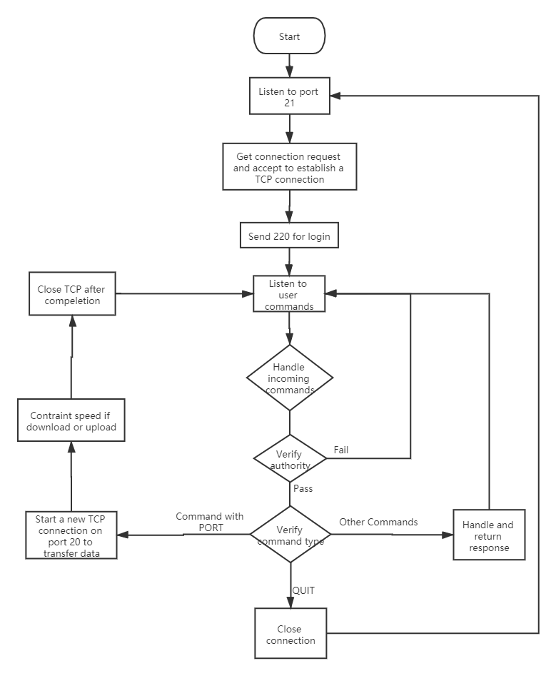
Figure 2. Overall flow chart of the FTP server
  - Design of data structures
    - FtpClient
We defined a structure called FtpClient as shown in the following figure. The aim of designing this structure is to model client attributes. When the FTP server receives a PORT control command from the client, we will handle the argument of the PORT (for example, the incoming message is PORT 127,0,0,1,12,31) to transform it into the IP address and port number of the client.
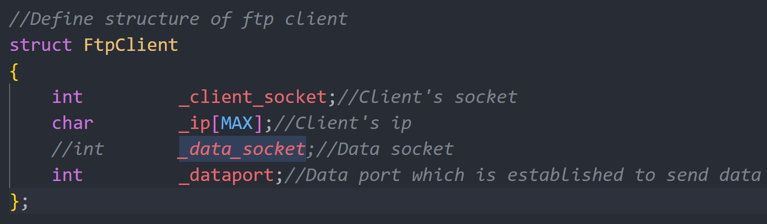
Figure 3. FtpClient structure
The reason why we did not design a corresponding server structure is that we used the socket created by socket() function to represent the server-side, which is enough information to use in our program.
    - Global Variables
There are also three global variables we declared in the ftp.c. The variable names and functions can be summarized in the following table.
Global variable name | Function
loginSuccess | Default set to 0. If login is successful, it will be set to 1. When the server receives control commands from the client, it will verify whether the user login successfully or not.
data_sock | Data socket is used for data transmission. It can only be assigned a value by connecting () function in PORT handling.
level | User authority. We have set user command “get” command and “delete” command as level-3 commands. In the meanwhile, we have also set user “test” as a level-2 authority user and user “super” as a level-3 authority user.
Table 3. Global variables
    - Error code
To make our code more concise and readable, we also defined error messages used for perror() function in the ftp.h header file, which are shown in the following figure 3.
Two messages are also used when the client entered and left the server defined in the header file.
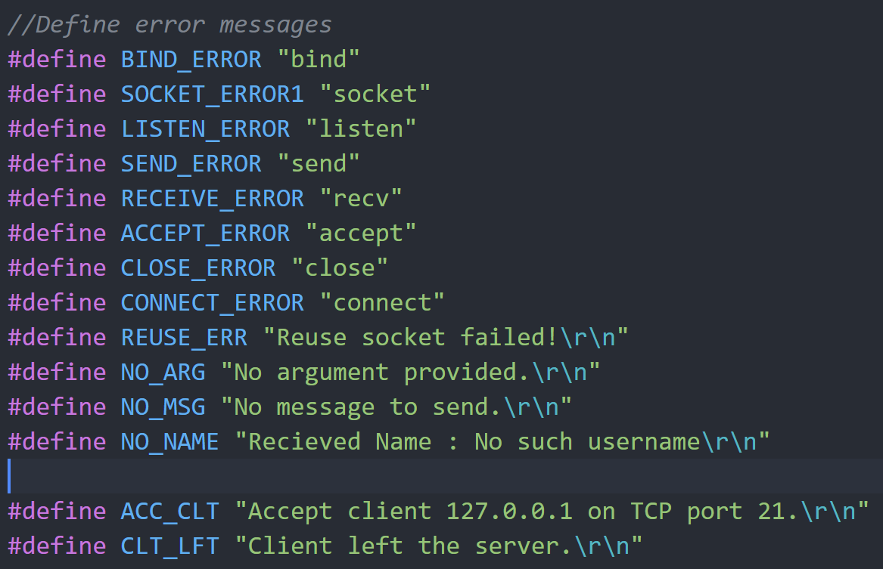
Figure 4. Error messages

Detailed Design
  - Server Booting and Connection module
This module can be further broken into two individual modules, which are the server booting and listening module, and the connection establishment module.
The server booting and listening module is controlled by a functioning startup() in our program. The aim of this function is to take in the port number to be listening on and then after a series of function calls and error prevention. The return value of the function is the socket number of connections if successfully started up to listen to the procedure. Else, the corresponding error code will be returned and printed on the server log, which is negative numbers.
The connection establishment module is started when the server is listening and received a connection establishment request from the client. The server will use accept() function to accept connect() function from the client. Again, if this process failed, there will be an error printed on the server log. After establishing the connection, we also initialized the values of the struct FtpClient.
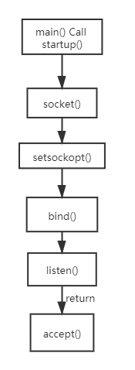
Figure 5. Flow chart of Server Booting and Connection module
  - Handling Commands module
This is the core module of our design. After establishing a TCP connection, we enter another endless listening circle (using for(;;)) to listen and handle client control commands. In this part of the listening, we will keep calling a function named handle_command() for each iteration. The return value of this function could be 0 or 1. If the return value is 1, it will jump out of this for(;;) and close the connection between this particular client and keep listening for more clients.
To be more concrete. Our function handle_command() has two submodules, which are the login and access authentication module coupled in this function, and other command-handling functions like hand_USER().
The login and access authentication module are embedded before each command-handling function except for USER and PASS, for they are universal procedures of connecting to an FTP server and we will depend on the result of login correctness to check. So, the general process is shown in figure 6. Firstly, we will check if the user successfully login, and then check for the authority level of the user if there is any. If all procedures are passed, the corresponding handling function can be called. Else, corresponding error messages will be returned. The following table shows the authority of different users.
User Name | Password | Access level | Constrained functions
test | 123 | 2 | put, delete
Super | 123 | 3 | /
Table 4. Login and access control
Handling other functions module can be further separated into two categories, which are commands with PORT and commands without PORT, where containing PORT means there is a new TCP connection on port 20(FTP data) is set up. We will not separate it into two modules but only to distinct them in the following table and flow chart.
Function name | Description | PORT
handle_USER() | Handle USER control command. We provide two user names “test” and “super” with access level 2 and 3, respectively. | No
handle_PASS() | Handle PASS control command. We assumed all passwords are “123” as a string. loginSucess will be assigned a value. | No
handle_PWD() | Handle PWD control command. This is to look up the current file path. | No
handle_CWD() | Handle CWD control command. This is to change the directory of the server. | No
handle_RETR() | Handle RETR control command. This is to get a file from the server with a limited of 10kB/s. | Yes
handle_LIST() | Handle LIST control command. This is to display a list of directory contents. | Yes
handle_MKD() | Handle MKD control command. This is to make a directory at the server. | No
handle_DELE() | Handle DELE control command. This to delete a file in the server. | No
handle_RNFR() | Handle RNFR control command. This is for renaming. | No
handle_RNTO() | Handle RNTO control command. This is for renaming as well. | No
handle_PUT() | Handle STOR control command. This is for upload files to the server. | Yes
Table 5. Handling different control command
The overall flow chart of this module is shown in figure 6.
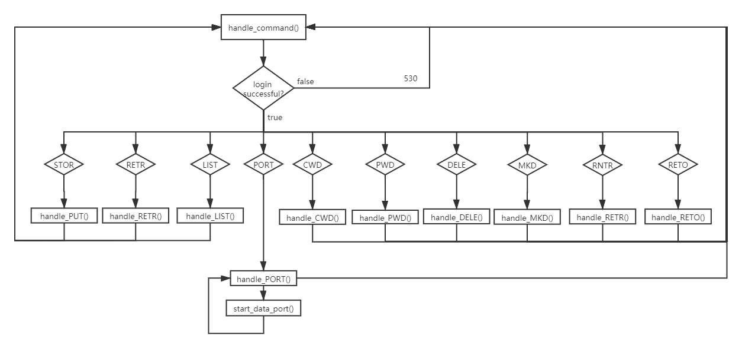
Figure 6. Flow diagram of Handling Commands module
  - Close Connection module
This is rather easy to handle with the previous work. When the server receives a QUIT control command from the client. The handle_command() will return 1 and the program will jump out of the current for(;;) , then close the connection.
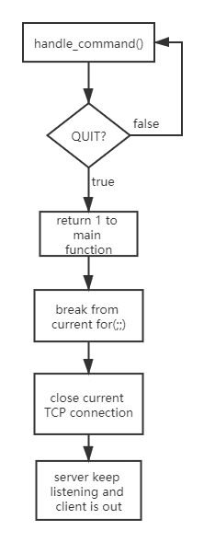
Figure 7. Flow chart of Close Connection module
  - Algorithms of small modules
Constrain speed limit to 10kB/s
int cst_spd = 10;
gettimeofday(&start, NULL); //Start timer
//read files
int tt_tfc = strlen(buf) + (pkt_num - 1) * 255;
//get total traffic of the tranfer for all paktets
sleep_ms(1 + tt_tfc/cst_spd);//Sleep for a while
gettimeofday(&end, NULL);//End timer
Bind port 20 when creating new data socket
int reuse = 1;
if((setsockopt(sock, SOL_SOCKET, SO_REUSEADDR, &reuse, sizeof(reuse))) != 0){//socket reuse setting
printf(REUSE_ERR);
return -2;
}
/* Bind to the local address */
if((bind(sock,(struct sockaddr*)&servAddr, sizeof(servAddr))) < 0){
perror(BIND_ERROR);
return -3;
}

Results
- Client
Open ftp client (USER、PASS)
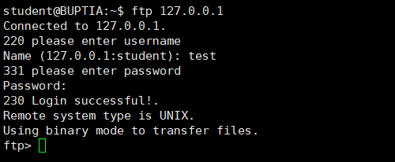
Wrong user name
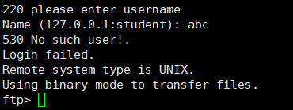
Wrong password
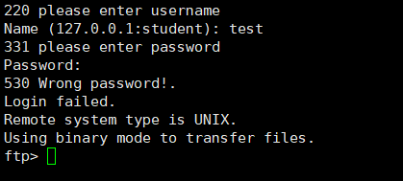
Once failed to login, you cannot use any command, for example, pwd
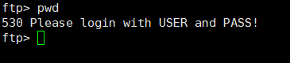
When logging in with an account with low authority, some functions will be disabled (AUTH)
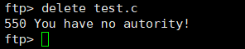
Print working directory (PWD)
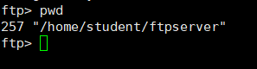
Change working directory (CWD)
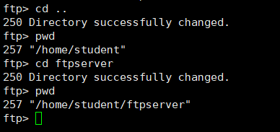
List current directory (LIST)
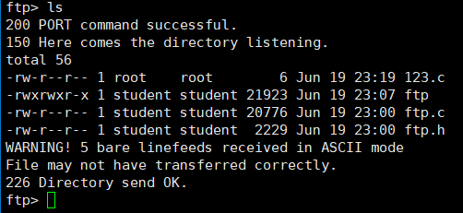
Create a directory (MKD)
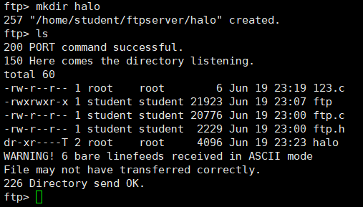
Create a folder with a duplicate name (MKD)
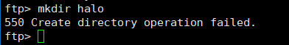
Delete files or directories (DELE)
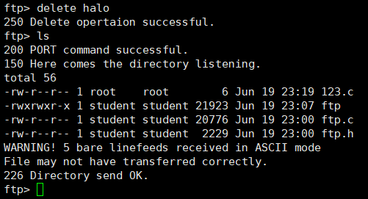
Delete a file that does not exist (DELE)
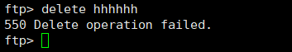
Rename files or directories (RNFR/RNTO)
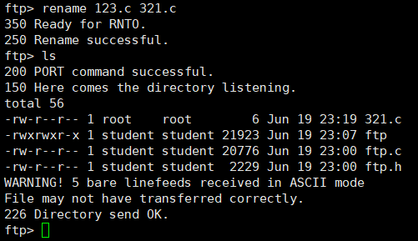
Rename a file that does not exist (RNFR)
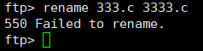
Rename a file that already exists
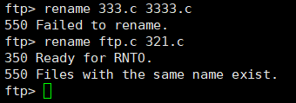
Store files (STOR)
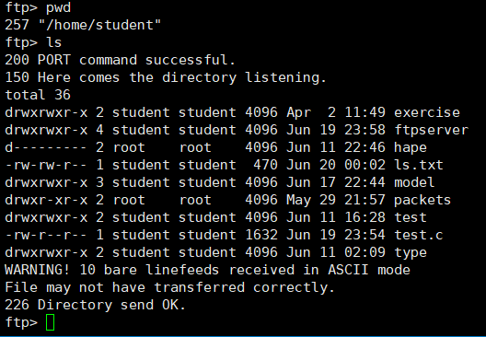
Before putting
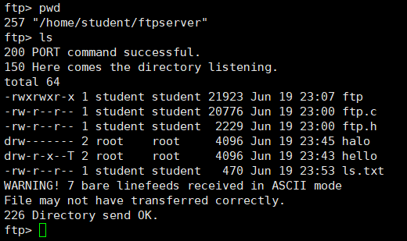
After putting
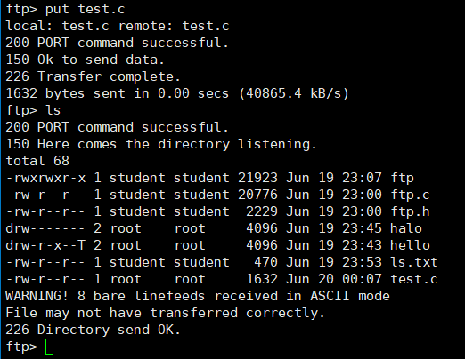
Put a file that already exists
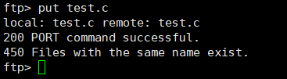
Retrieve files (RETR)
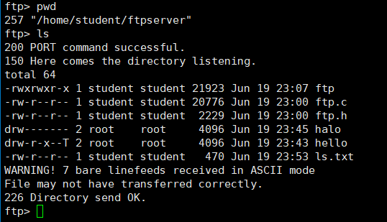
Before getting
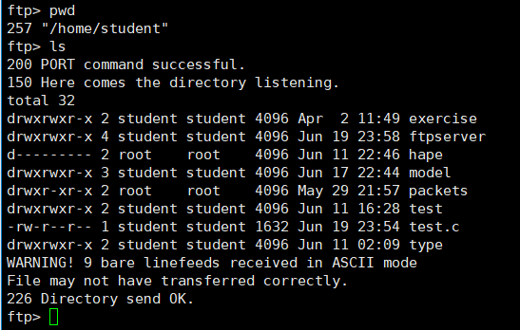
After getting
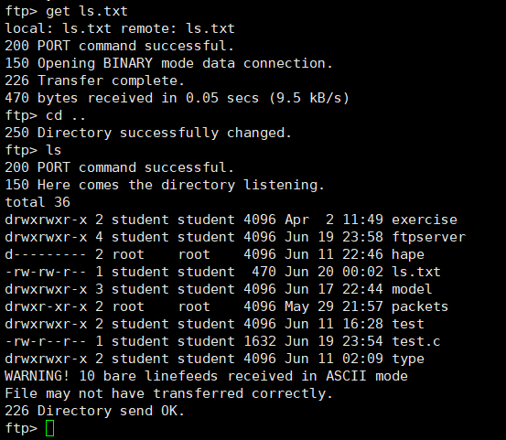
Exit the system (QUIT)
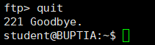
- Server
Open ftp server
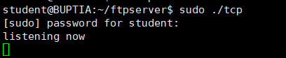
When the port is occupied
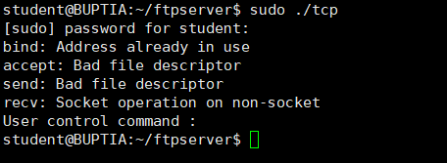
Login (USER、PASS)
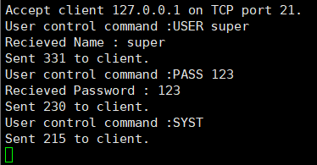
Print working directory (PWD)
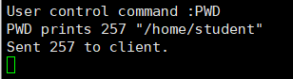
Change working directory successfully (CWD)
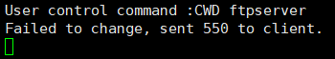
Failed to change working directory (CWD)
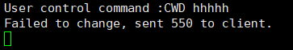
List current directory (LIST)
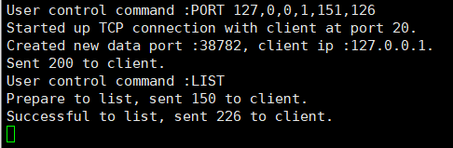
Create a directory successfully (MKD)
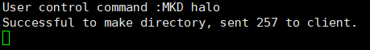
Failed to create a directory (MKD)
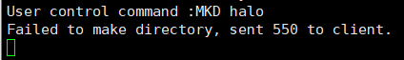
Delete files successfully (DELE)
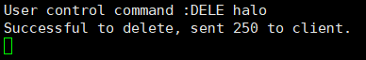
Failed to delete files (DELE)
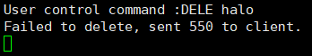
Rename a file successfully (RNFR/RNTO)
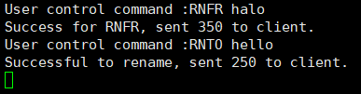
The file does not exist (RNFR)
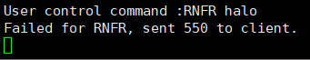
The file with the same name exists (RNTO)
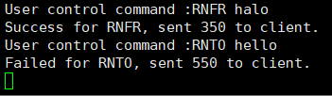
Store files (STOR)
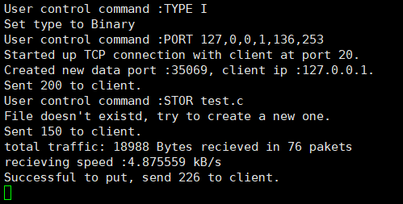
The file with the same name exists (STOR)
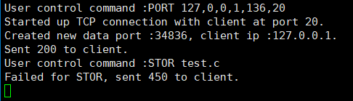
Retrieve files (RETR)
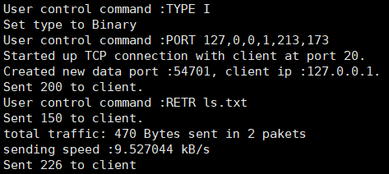
Exit the system (QUIT)
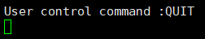
- Wireshark capture results
USER、PASS
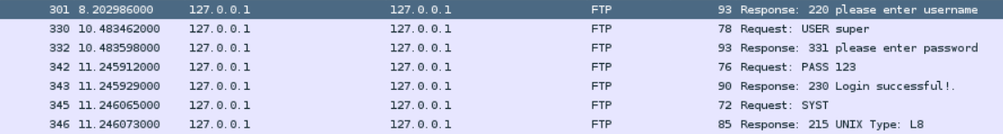
PWD
CWD
LIST
LIST (ftp-data)
MKD
DELE
RNFR/RNTO
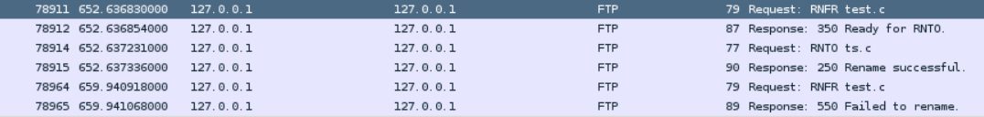
STOR
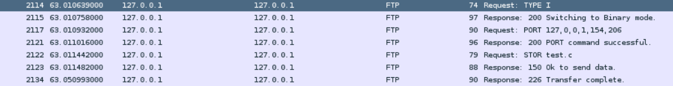
STOR (ftp-data)
RETR
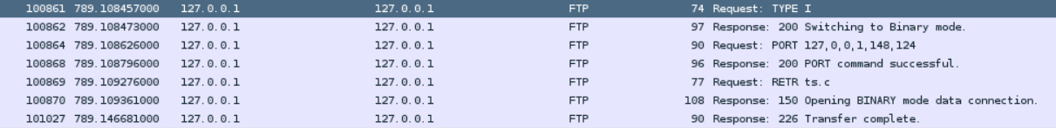
RETR (ftp-data)
QUIT
- Files before and after putting
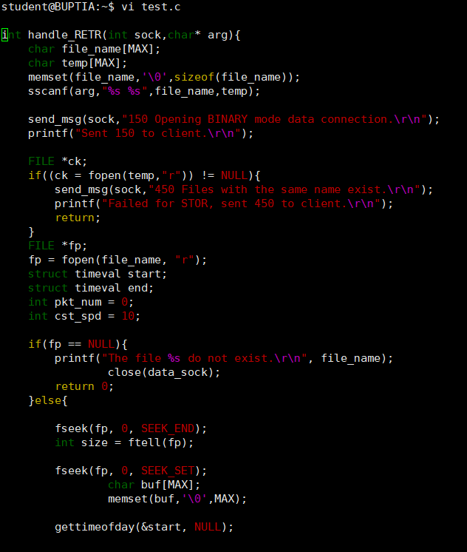
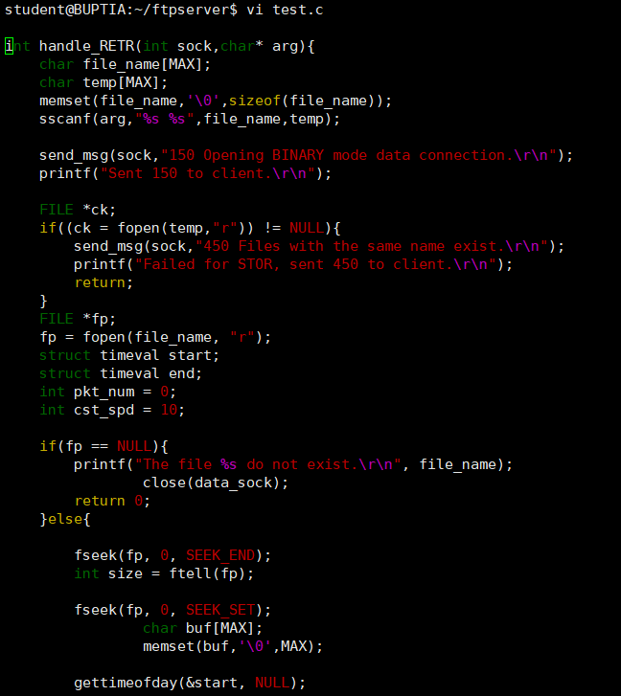

Summary and Conclusion
Because it's a two-person team, the assignment of tasks will be more flexible. In the beginning, Yibo Lian was responsible for building the server. He was responsible for building a system that can communicate with TCP protocol and realizing the login function. The specific code part was the completion of startup, USER, PASS and recv_ msg、Send_ MSG, PORT, and main functions. Then Zhengxiao Yang is responsible for the completion of some functions in FTP, and the code parts are PWD, CWD, list, MKDIR, DELE, RNFR / RNTO. So far, the FTP system construction and basic commands have been realized, and then the two completed the writing of STOR command and RNTR command respectively, and finally completed the writing of the whole simple FTP system.
In this process, we can complete the task on time and according to the quality, and every night two people will meet to discuss the progress of the work, and according to the progress of the task acceptance and distribution. The whole construction period is completed very quickly under the efficient organization. However, there are still some improvements in this process. For example, we should use vsftpd to test and record the whole system before writing. Because when implementing specific FTP commands, some functions such as LIST cannot work normally due to the lack of PORT command. This part of the problem should be understood and solved before writing. For example, advance the priority of the PORT function and complete the writing of the port function in advance.

