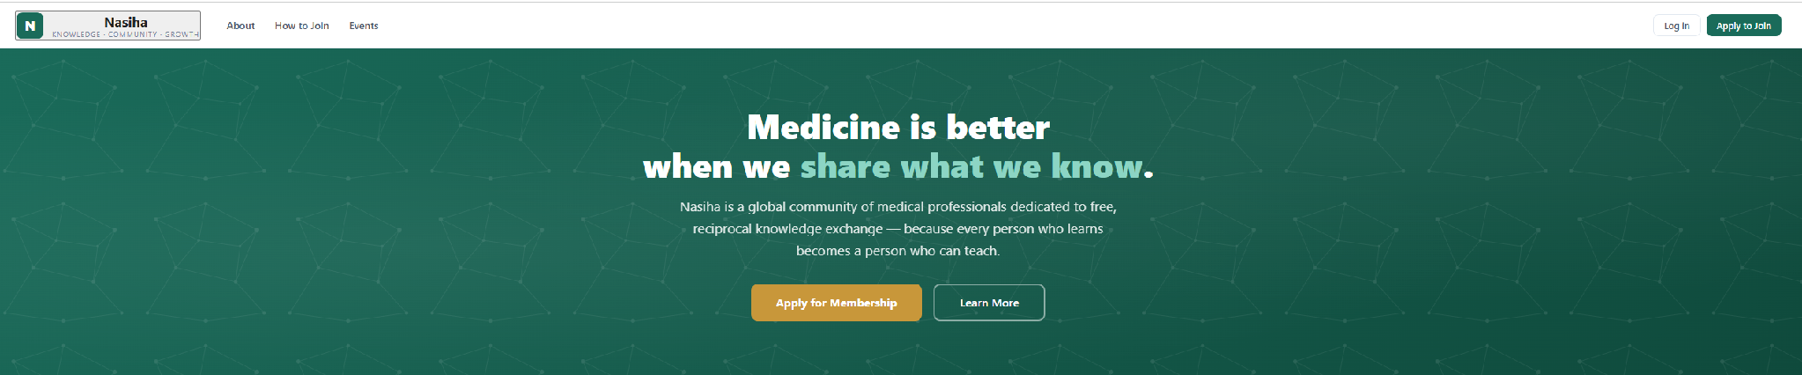

We need some more colors and photos or pictures also
Need to make a logo instead of the simple N in the green box
Make Nasiha , all caps “ NASIHA”
Move boxes > About, How to join, Events , to the middle
Change “ Apply to Join” to “ Join NASIHA”
Add another box in the top “ Contact us”
Think of another word for Medicine, ----- Knowledge, Learning......
NASIHA is a global community where members are dedicated to free, reciprocal knowledge exchange – because every person who learns becomes a person who can teach.
Change box “ Apply for Membership" to “ Join NASIHA”
Remove “ unconditionally” from the teach box
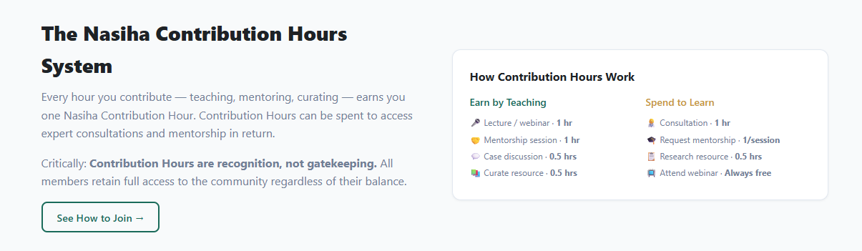
The NASIHA Knowledge Exchange System..... create a new one line statement in this box to entice viewers to click it
Remove mentoring, we may add it later but right now we are not doing mentoring or coaching, just knowledge sharing
Make this is a click box, a person has to click on it to learn the details
Once it is clicked, there can be small boxes -----for the different hours
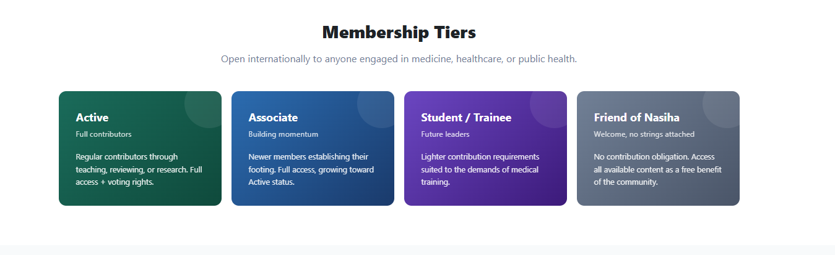
Join NASIHA
Remove internationally, Just say “ Open to all learners and teachers”
In student/Trainee : Remove medical
Friend of Nasiha : Access free content available for the benefit of the community. When someone clicks on this it should take them to a page that has the event calendar and recordings of the free webinars
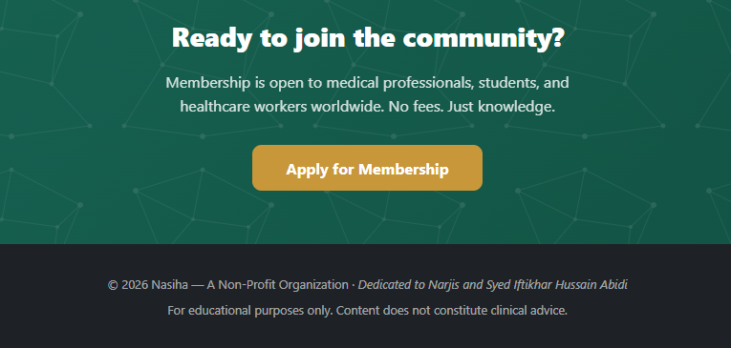
Membership is open to professionals, students and teachers who are enthusiastic about sharing their knowledge.

Under the About tab.
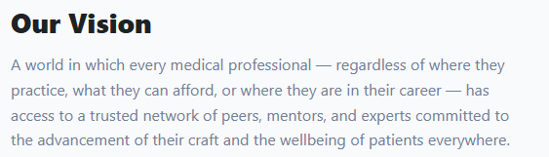
Remove “ medical” from all sentences, what about?
A world in which every person-regardless of where they live, what they can afford, or where they are in their path to learning= have access to a trusted network of peers, advisors and experts committed to the advancement of theie craft and sharing their knowledge.
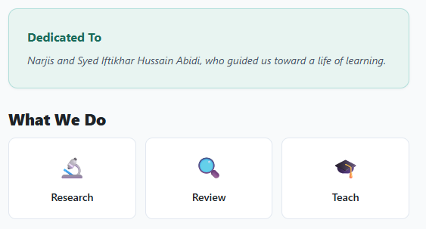
NASIHA- Dedicate to
Narjis and Syed Iftikhar Hussain Abidi
What we do is good – the boxes should link to other resources

In the evnts tak

We should have the calendar available for all, when they open it they can see the events as “Free” or “ For Members”.
In the application , instead of the drop down options focused on doctors, we can say, Expert, Early career, student

