Working of Minor Project in Flutter

When you run this project, you see a **Splash Screen**

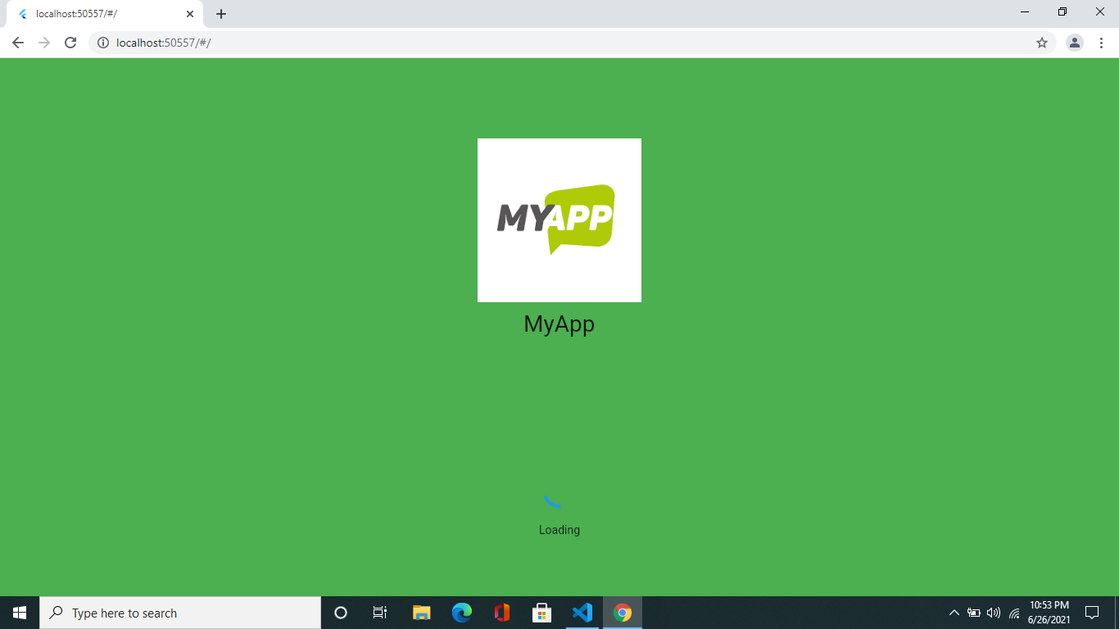

After this Splash screen you see a screen in that screen you see Two Buttons **Login** and **Register**

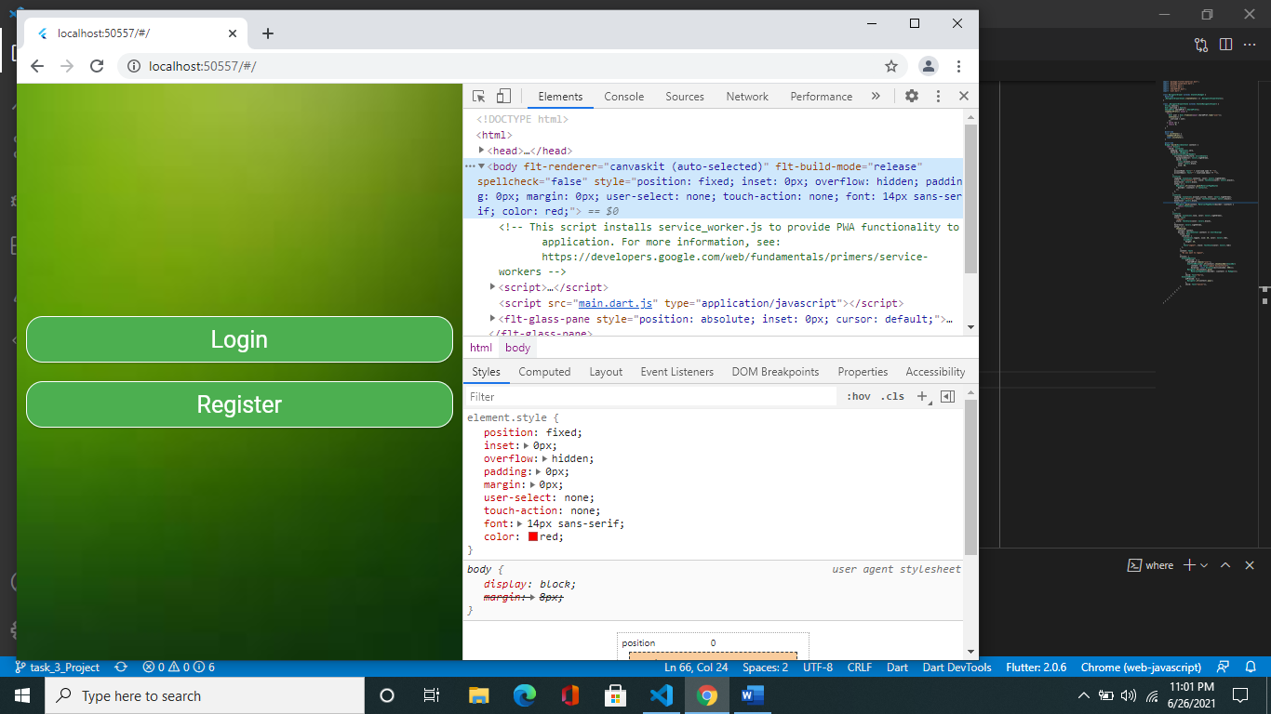

When click on **Login Button** then you see like this output

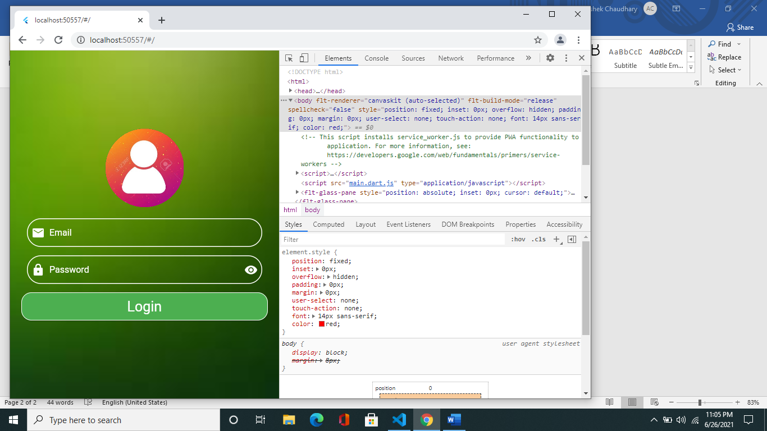

And when you click on **Register button** then this screen will display to you

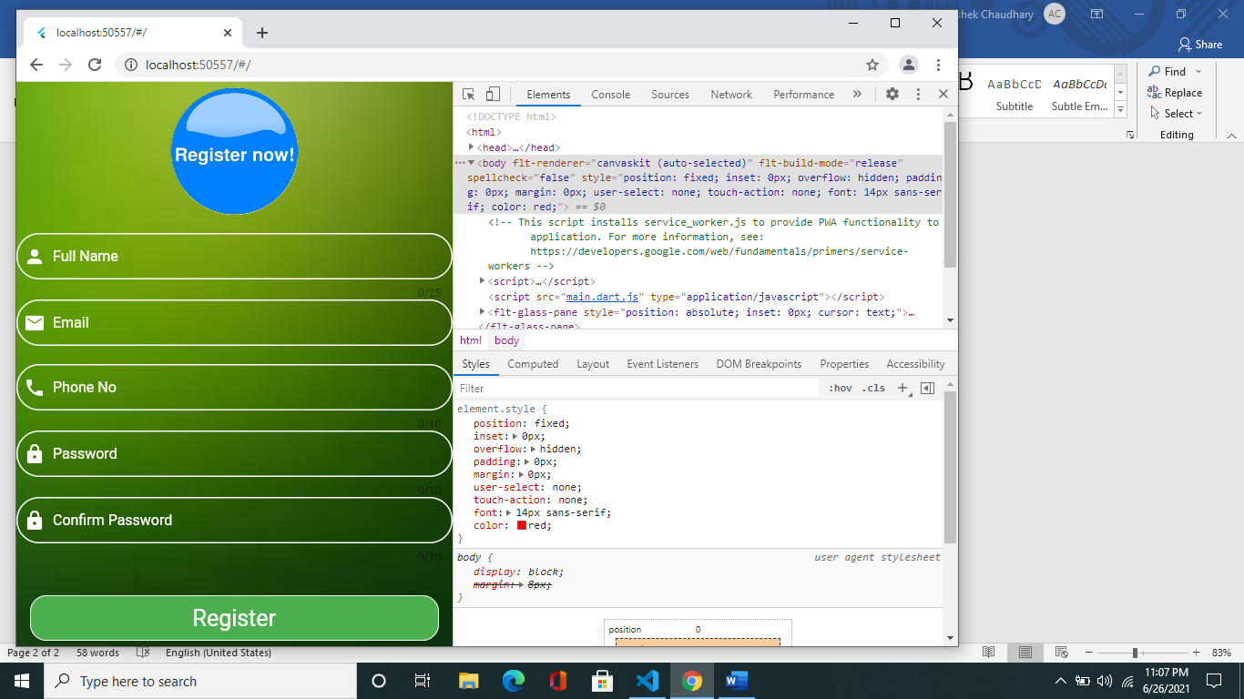

In Login screen I have add some validations

Just like

* When you empty the both textformfield value they give you error like **“Please Enter your value”**
* When you enter a Wrong email, they will give you an error

**“Please enter a valid email”**

You in login Screen That when you enter a password you see an icon by this icon you can see your password that you right

If your email and password are not getting match in shared preferences value yha not present in those values then you redirect to Register Screen

In that Register Screen you fill some details like

**Full Name, Email, Phone No., Password, Confirm Password**,

As a login screen I have add some small validations also

Like when you do not fill any textformfield then they give you an error like **Please enter your name**, password, email, confirm password etc.

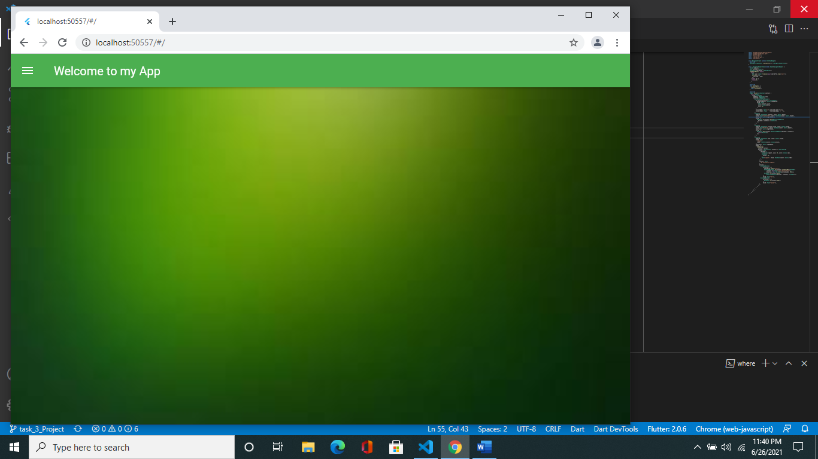After fill this all details then you **Login in** and then you redirect to this Screen

When click on here then you see a Burger Menu

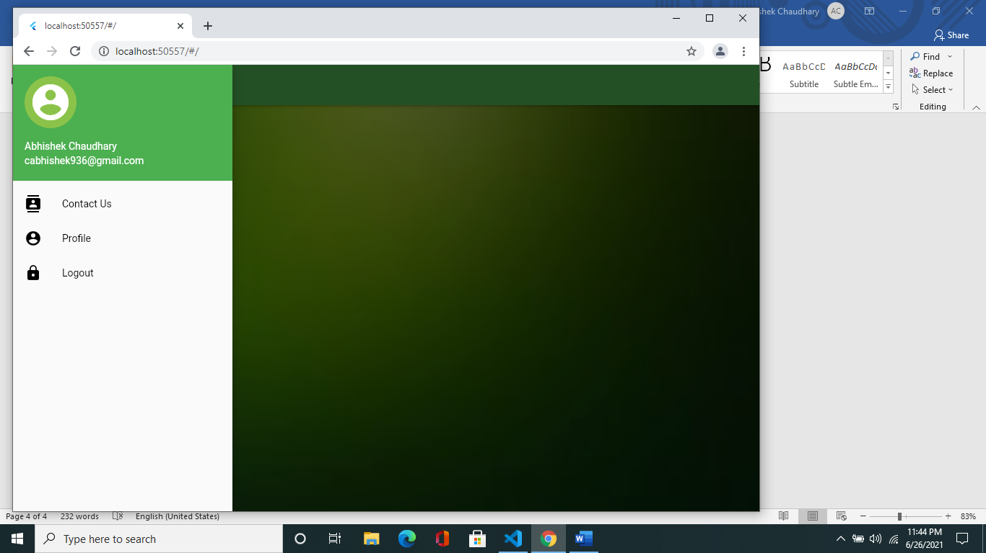Just like this

In this Burger menu I will add 4 different blocks

* In 1 block that see your detail like name and email are those when you enter it on register form



* In 2 block you see that there is a **Contact Us** menu basically when you click on then you go on to this page in that you can contact us

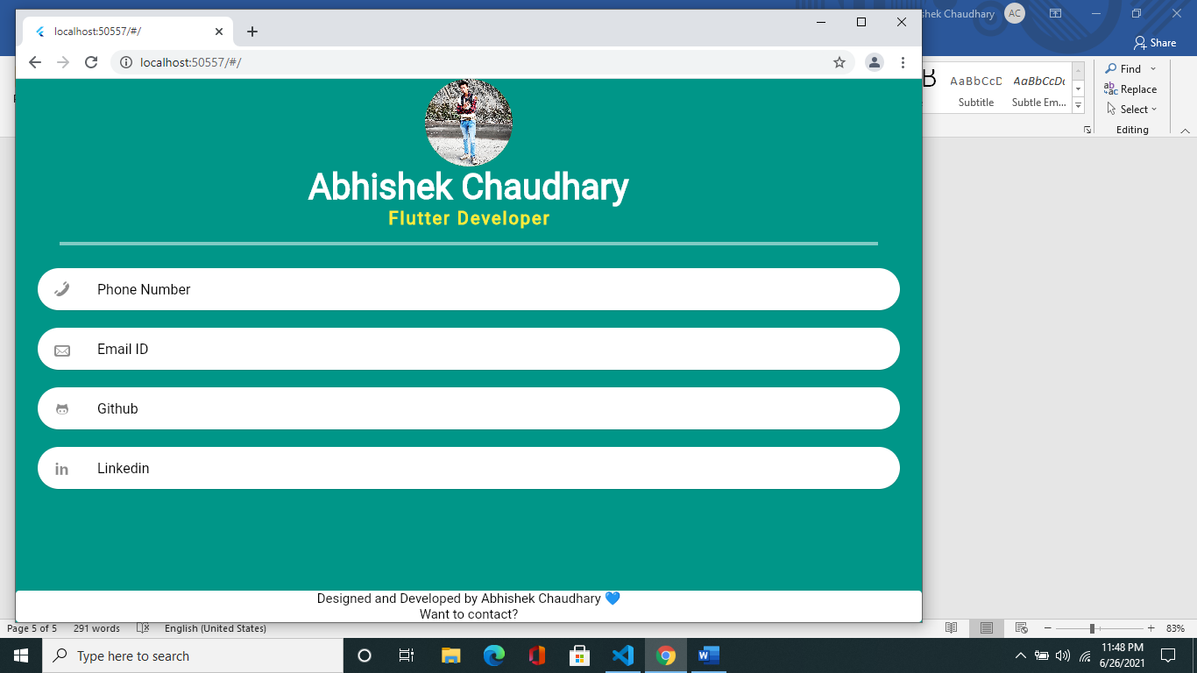

* In 3 block that you see a **Profile** menu in that when you click on that you see our profile with your details like name, email, phone no etc. are those when you enter it on register form

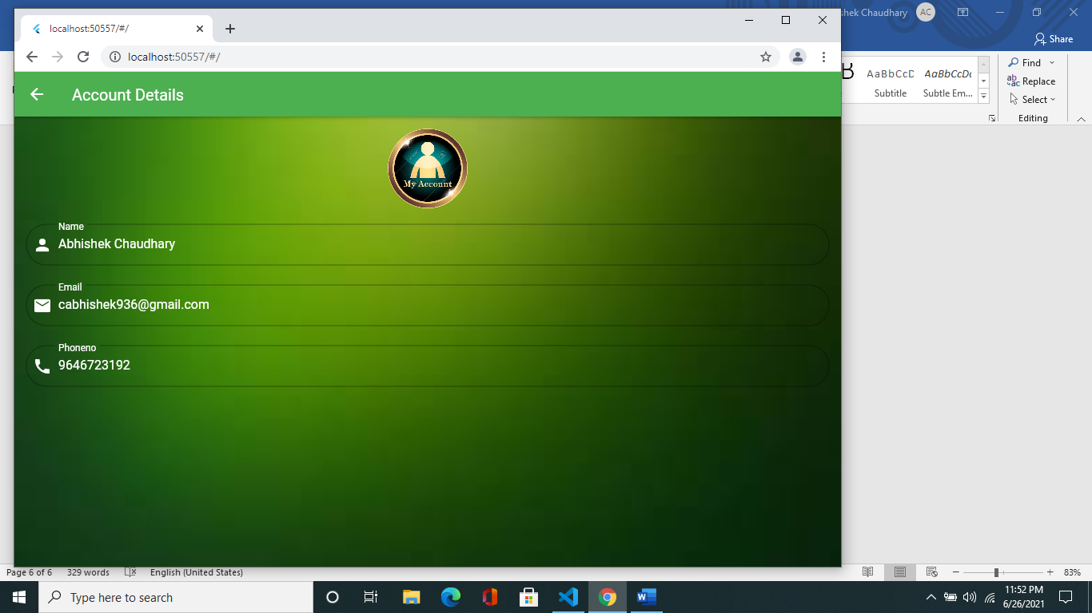

In 4th when you click on **Logout**, they will show you an **Alter Dialog Box** in that

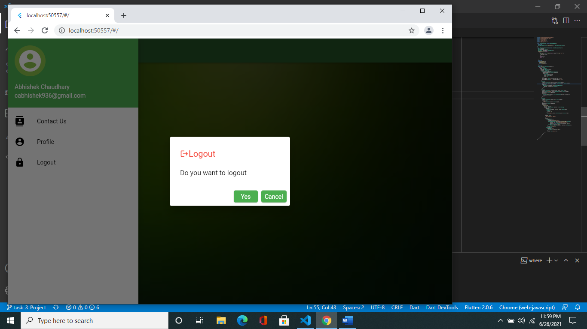

they will ask you that

**Do you want to logout**

**Yes Cancel**

When you clicked on **Yes** button then you will redirect to that screen



Otherwise, when you click on **Cancel** button then you redirect to that screen