## Case Study Work Week 1

### 6.2 Unit 6 Overview

Unit Objectives

1. Define a testable hypothesis for a data set
2. Synthesize material from a data analysis into a coherent document
3. Create a Makefile for code from a project

Case Study Assignment

* Write up a final draft of the Case Study 1. Due at the beginning of Unit 9. Date to be set by the live session instructor.

### 6.3 What is a Makefile?

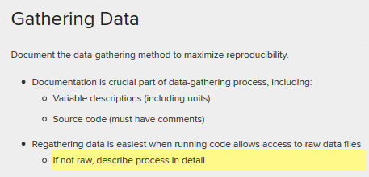

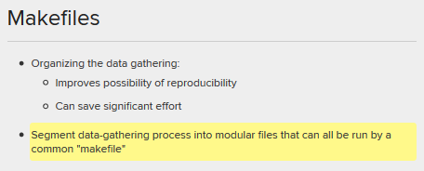

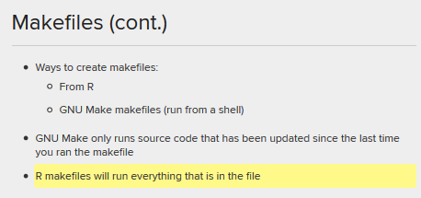

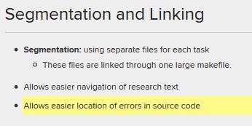

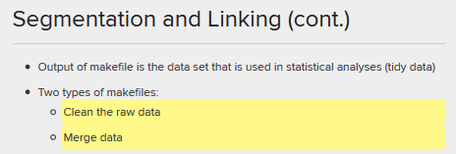

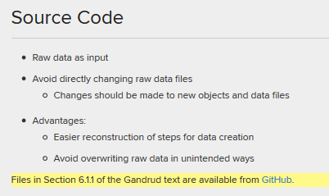

The above GitHub link is [here](https://github.com/christophergandrud/Rep-Res-Examples/tree/master/DataGather_Merge).

### 6.4 R-like Make files Page

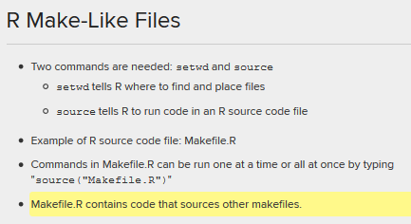

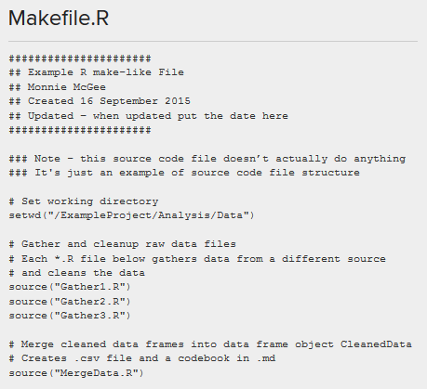

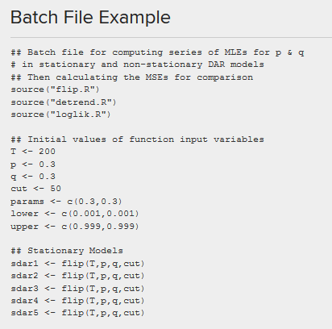

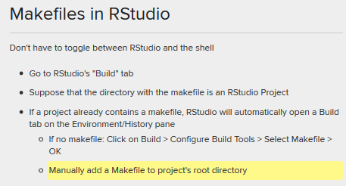

### 6.5 R-like Make files example

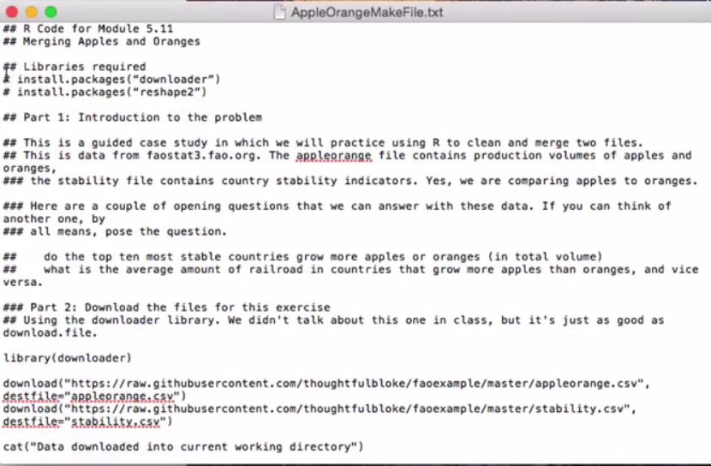

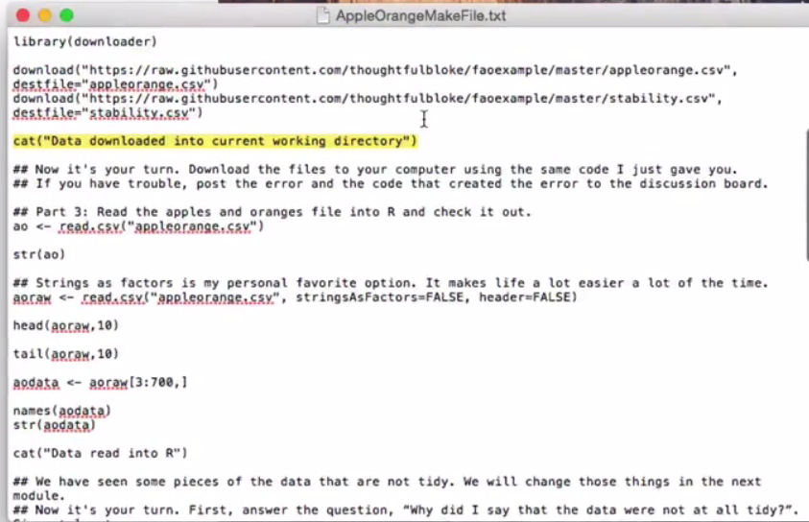

#### Smart Quotes Smart Dashes

Cat(“Data read into R”)

In R go to Edit\Substitutions, make sure select “Smart Quotes” and “Smart Dashes” are deselected. The issue is how they are interpreted in R.

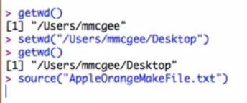

### 6.6 Makefiles and R Studio Projects

#### RScript

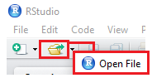

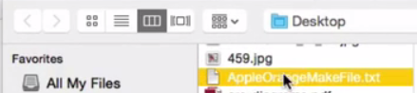

From this “AppleOrangeMakeFile.txt”, make an RScript and RMarkdown files.

Copy the contents of the “AppleOrangeMakeFile.txt” and paste it into the RScript, select “Source on Save”, as seen below:

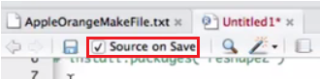

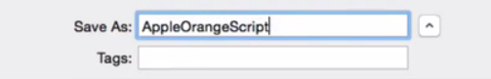

The file will run and generate files.

#### RMarkdown

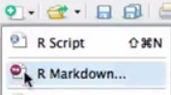

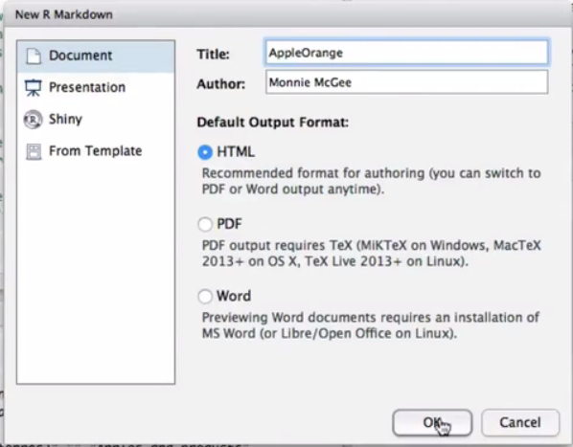

Take the comments from RScript and paste into RMarkdown

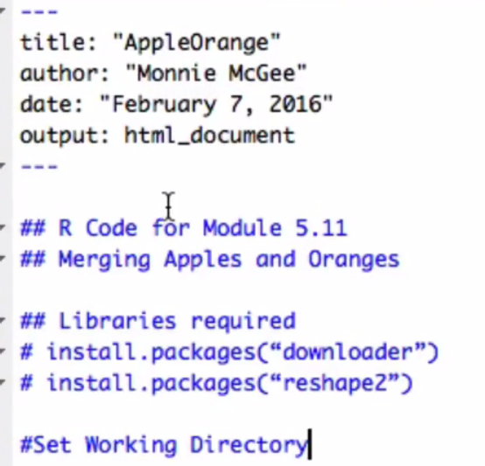

Copy the code from script and put into RMarkdown

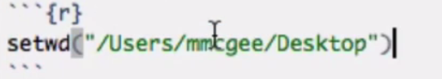

Repeat the copy of comments and code until finished.

### 6.7 Writing Up a Case Study