Report on URECA Research Project: Holographic Reduced Representations for Working Memory Concept Encoding
Grayson M. Dubois
The field of artificial intelligence (AI) is synergistic with a wide range of disciplines but artificial neural networks (ANNs) is perhaps the most prolific subfield. Not only are biological principles of neural computation and neuroanatomy adapted to solve engineering problems, but ANNs also serve as formal, testable hypotheses of brain function and learning in the cognitive sciences. Still, since ANN models often employ distributed encoding (DE), most have limited application in other areas of AI where symbolic encoding (SE) is the norm (e.g. planning, reasoning, robotics).
For example, there is extensive evidence that the brain contains a working memory (WM) system that actively maintains a small amount of task-essential information that focuses attention on the most task-relevant features, supports learning that transfers across tasks, limits the search space for perceptual systems, provides a means to avoid the out-of-sight/out-of-mind problem and more robust behavior in the face of irrelevant events [1,2]. The prefrontal cortex and mesolimbic dopamine system have been implicated as the functional components of WM in humans and animals, and biologically-based ANNs for WM have been developed based on electrophysiological, neuroimaging, and neuropsychological studies [3]. A software library, the working memory toolkit (WMtk), was developed to aid the integration of ANN-based WM into robotic systems by mitigating the details of ANN design and providing a simple DE interface [4].
Despite the fact that the WMtk can solve common tests of working memory performance such as the DST, the DE/SE distinction is problematic for the WMtk since DE/SE conversion needs to be programmed directly by the user and tuned specifically to each learning task. A technique called holographic reduced representation (HRR) [5] may provide the technical assistance needed to overcome this limitation. HRRs provide a framework for creating and combining symbolic concepts using a distributed formalism that is compatible with ANNs. The name HRR summarizes how many different concepts, each represented by separate, unique vectors, can be combined and reduced to a single vector that represents the combined knowledge of the concepts while still retaining information about each constituent concept which is closely related to the concept of holographic storage. By replacing the DE interface of the WMtk with an HRR interface, DE/SE conversion would be automated, concepts learned from one task would naturally carry over to new tasks, and additional cognitive phenomena (e.g. chunking) may be investigated. Therefore, my goal was to develop and test a holographic reduced representation engine that can be integrated with the Working Memory toolkit.
Methodology
Over the course of this semester, I created an engine to generate and manipulate HRRs. This engine is capable of working with simple and complex concepts such as those used by the WMtk. It may be useful to other researchers in the cognitive sciences who wish to follow an HRR approach to concept encoding, but the primary purpose of this engine is to eventually augment the WMtk to allow more powerful manipulation of concepts as well as to simplify the interface for users programming with the toolkit. This augmentation of the WMtk was beyond the scope of this semester's research, but will be continued as the next stage of this project.
My 3-part plan for creating the HRR engine consisted of (a) learning and gathering information, (b) developing a conjunctive encoding engine, and (c) creating a conjunctive decoding engine. I implemented these phases as follows:
a) Gathering information / background for HRRs and HRR generation. I spent the first month of this project researching methods for generating HRRs and manipulating them to encode and decode conjunctive concepts using circular convolution. I learned the basics of what an HRR is, and the equations for performing circular convolutions and correlations for combining and extracting concepts. A Holographic Reduced Representation is simply a vector of real numbers gathered from a Gaussian distribution with the mean 0 and a standard deviation of 1. The longer the vector, the more accurate the computations, but for this report, we use vectors of length 8 in our examples.
b) Developing a conjunctive encoding engine. By early March, I had set up a GitHub repository for the project, and began developing the engine. This encoding will consist of taking concepts in the form of common words, creating a representation for each one, constructing a table of each concept and all possible combinations of concepts. As an example, the encoding engine could take two concepts, “red”, and “ball”, and create HRRs for each, as well as a new HRR for the complex concept “red ball.” Figure 1 shows a snapshot of a test run of the engine doing the steps described above.
It is important to note that the names of complex concepts are always the concatenation of the names of a representation's constituent concepts, delimited by a “*”, and the engine always reorders the names in lexicographical order. Thus, “ball*red” is the same as “red*ball”.
Figure 1: Sample run of the HRR engine generating representations for "red" and "ball", and convolving them into the complex concept "red ball".
c) Developing a conjunctive decoding engine. Decoding was much more complicated than encoding. The decoding capabilities of the engine includes taking a complex concept (such as ab) and another concept (a), and performing involution operations on them to extract the other constituent concept (b). In this way, we could perform a correlation operation on the unique concepts “red*ball” and “red” to retrieve the concept “ball.” This retrieval is done by taking the dot product of the extracted concept and each other representation in memory. The dot product that is closest to 1 or above is the closest match to the extracted concept. An example of this process is shown in Figure 2.
Figure 2: By performing a circular correlation operation on the representations for "red*ball" and "red", we get a representation for the other constituent concept. After comparing the extracted hrr against the other representations in memory by checking the dot products, we see that the extracted representation must refer to the concept "ball".
Another part of decoding is being able to extract the representations for all constituent concepts of a complex concept. This was where decoding became complicated. This requires a function that would unpack a complex concept into all combinations of constituent concepts. It uses an algorithm that produces 2^{n} - 1 combinations of representations, where n is the number of concepts in a complex concept. For example, “big*red*ball” would yield 2³ – 1, or 7 combinations of concepts. This is shown in Figure 3.
Results and Future Impact
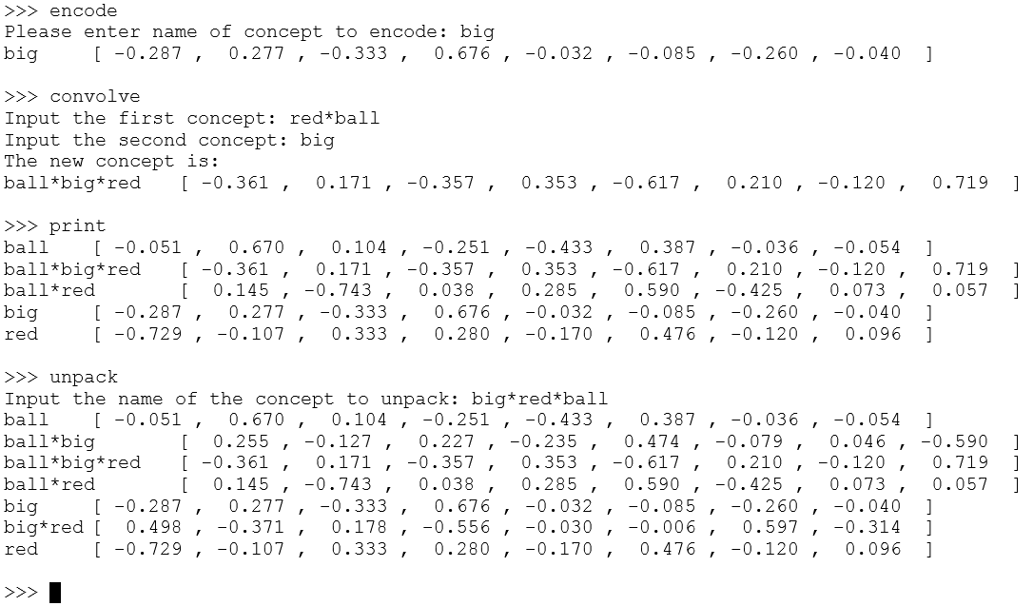Figure 3: After encoding "big" into memory and convolving it with "red*ball" to form "big*red*ball", we print all known concepts, but find that not every possible combination of the concepts "ball", "big", and "red" are present. The unpack function solves this problem by calculating all seven possible combinations of constituent concepts.
Adding a holographic reduced representation engine to the Working Memory toolkit will open up many possibilities for future research and development in modeling working memory. Not only will it antiquate the tedious process of manually programming representations for concepts, but it will also give the toolkit the power and versatility to allow future researchers to tackle more complex issues in cognitive science, such as transferability of learned information between similar tasks, chunking similar concepts together in memory, and storing concepts across a continuum, rather than in discrete space. For example, colors could be represented across a scale, rather than storing a few base colors as concepts, and using complex concepts formed from combinations of these base colors (like red and blue) to represent other colors (such as purple). By creating this HRR engine and preparing it for being added to the WMtk, I have contributed to opening up the playing field to cognitive scientists to more effectively solve issues in ANN-based computing, and discover more about how the human brain functions.

References
[1] A. Baddeley. Working Memory, volume 11 of Oxford Psychology Series. Clarendon Press, Oxford, 1986.
[2] N. C. Waugh and D. A. Norman. Primary memory. Psychological Review, 72:89–104, 1965.
[3] R. C. O’Reilly, D. C. Noelle, T. S. Braver, and J. D. Cohen. Prefrontal cortex and dynamic categorization tasks: Representational organization and neuromodulatory control. Cerebral Cortex, 12:246–257, 2002.
[4] J. L. Phillips and D. C. Noelle. Working Memory for Robots: Inspirations from Computational Neuroscience. in Proceedings of the 5th International Conference on Development and Learning, 2006.
[5] T. A. Plate. Holographic reduced representations. IEEE Trans. Neural Networks, vol. 6, no. 3, pp. 623–641, May 1995.

