ANSIBLE TAKEAWAYS

Getting started with Ansible : <https://www.youtube.com/watch?v=wgQ3rHFTM4E&t=302s>

I had a good working and infrastructure basics via: <https://www.youtube.com/watch?v=D3UoCASvUT8>

Researched about the installation process of Ansible and found that it is a linux exclusive server but it can control windows clients(nodes) and had some basics YAML language.

Went through a blog which instructs about the basic configuration of the ansible :https://medium.com/@somakdas/setting-up-and-executing-basic-ansible-playbook-643ac983680

started with a basic code:

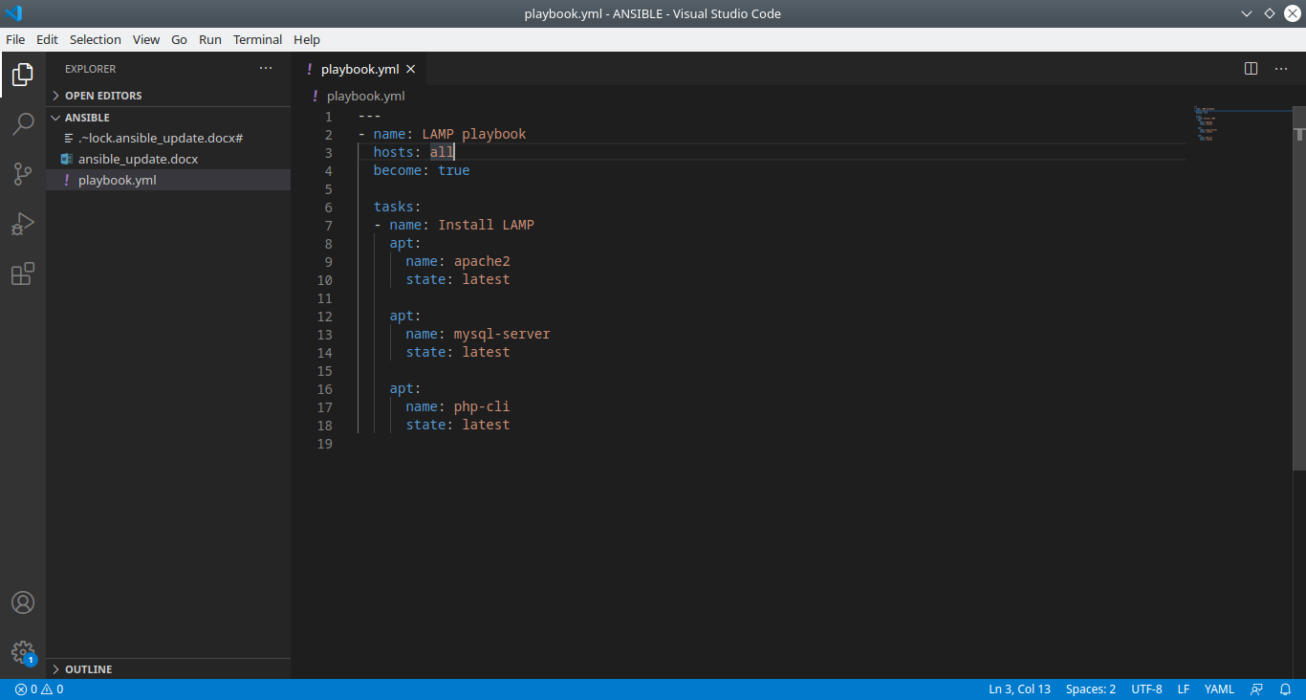

written yml code to Install LAMP in 3 different distros Debian,Redhat,Windows:

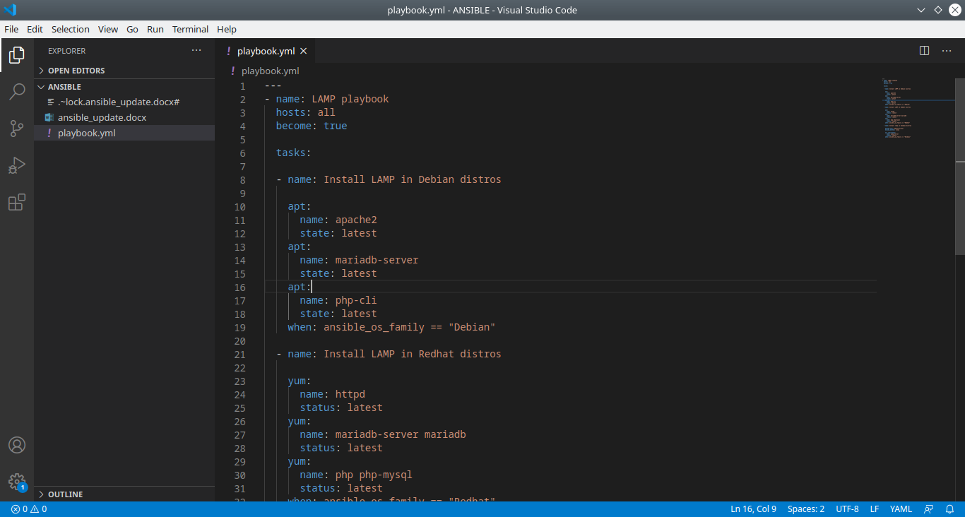

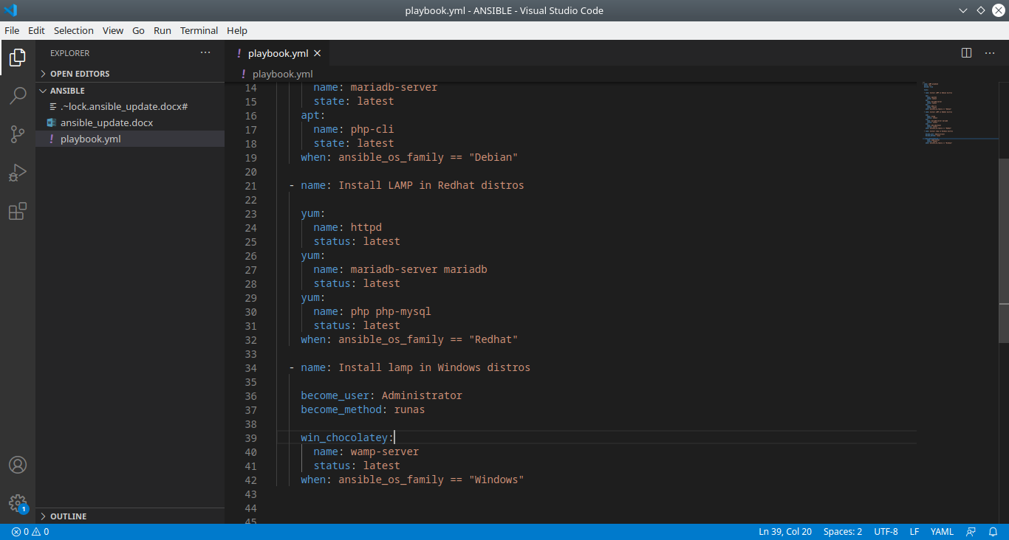

After readings some good blogs I have found that ansible os family tag can be used to distinguish between the distros so I have combained the tag with When and implemented.

Blogs and docs:

https://medium.com/@somakdas/setting-up-and-executing-basic-ansible-playbook-643ac983680

https://riptutorial.com/ansible/example/12268/-when--condition----ansible-os-family--lists

https://docs.ansible.com/ansible/latest/user_guide/playbooks_conditionals.html

Due to lack of machines the code testing process is undone for different distros.

Found a efficient way of installing apt and yum packages via blog :

https://www.toptechskills.com/ansible-tutorials-courses/ansible-apt-module-tutorial-examples/

Downloaded and Installed VM player and then booted my old linux in and tested my playbook against a host machine got succeeded. After installation my linux installed ssh server in that for the communication. Specified username and password in the hosts file.

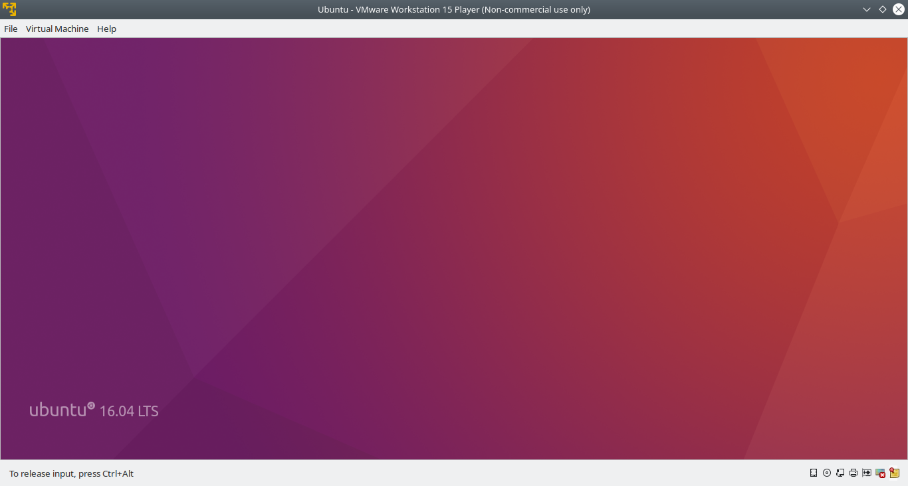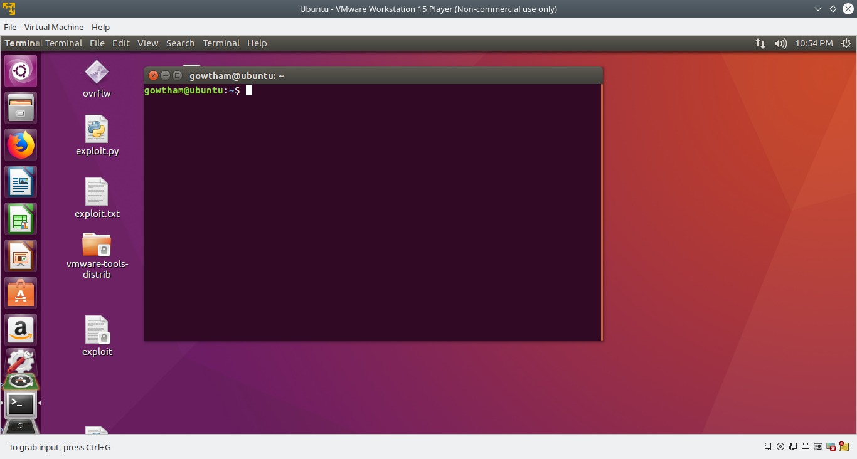

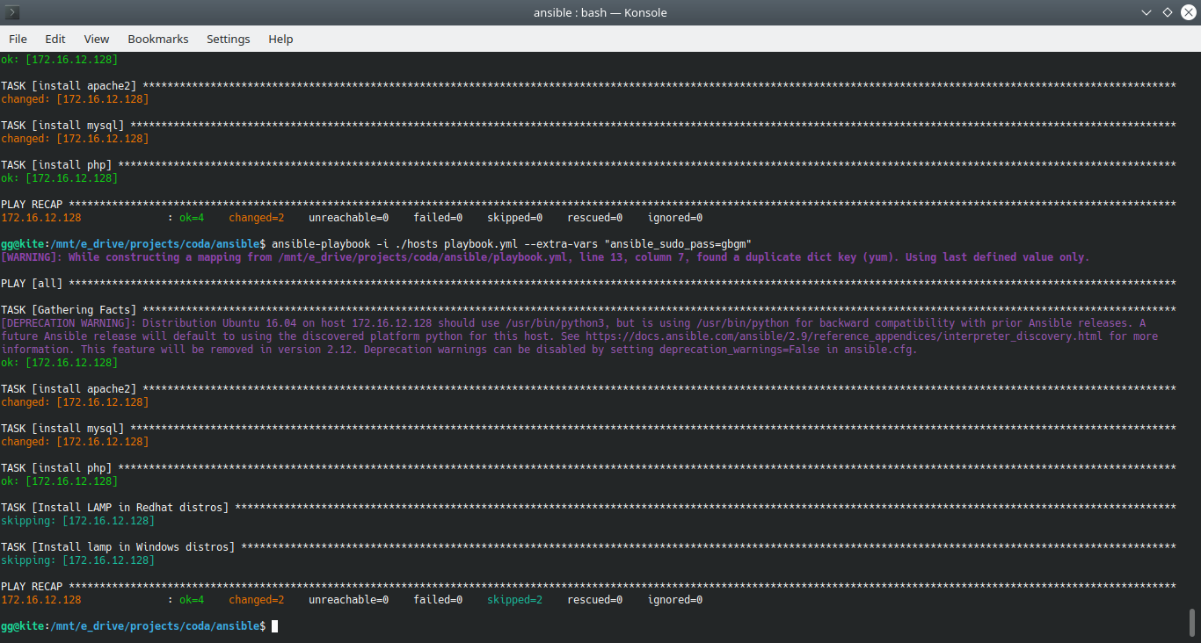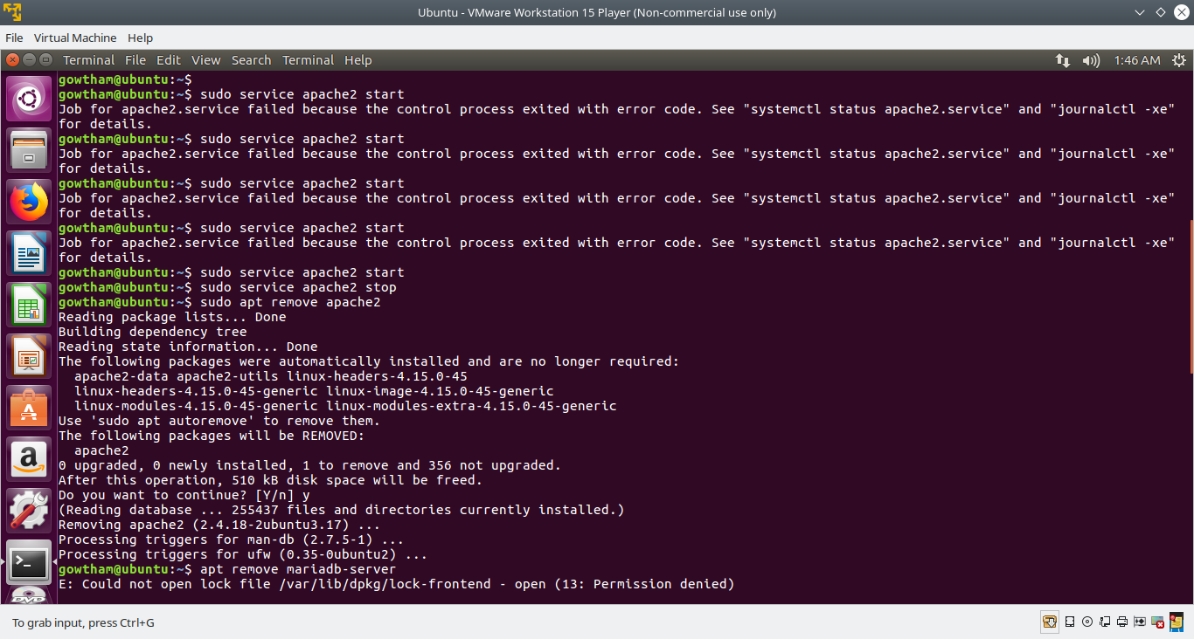

Installed windows 8.1 and configured the ssh and choco in windows and set them to the environment variables working in establishing the ansible-windows communication.

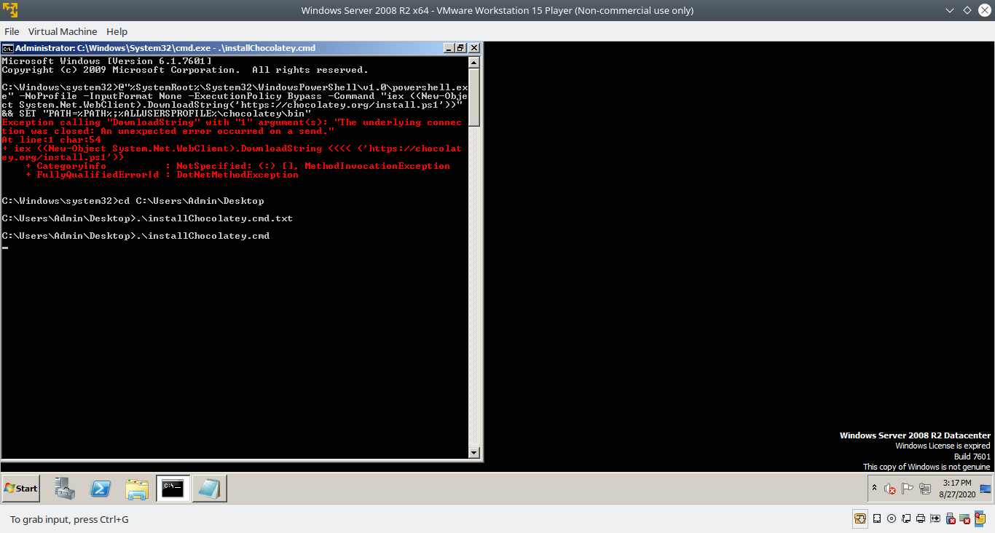

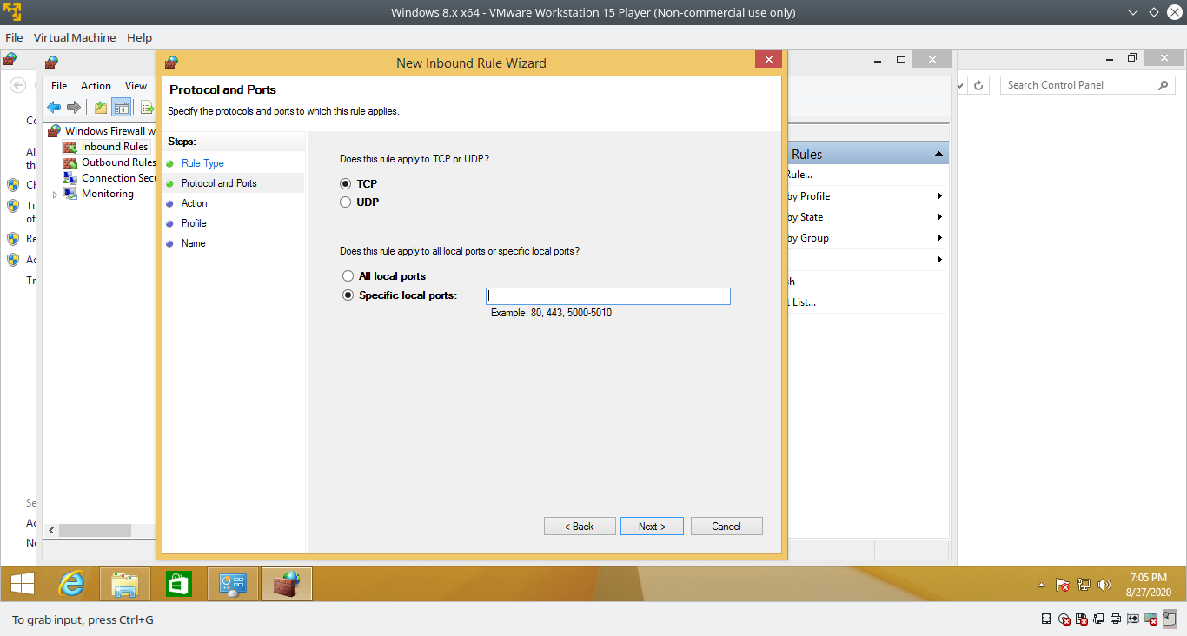

Due to lot of errors paused my windows work and went to redhat distro work. Installed and verified the play book against fedora (a redhat family os) after installing fedora just installed ssh-server for communication and motioned the ip with credentials in hosts file.

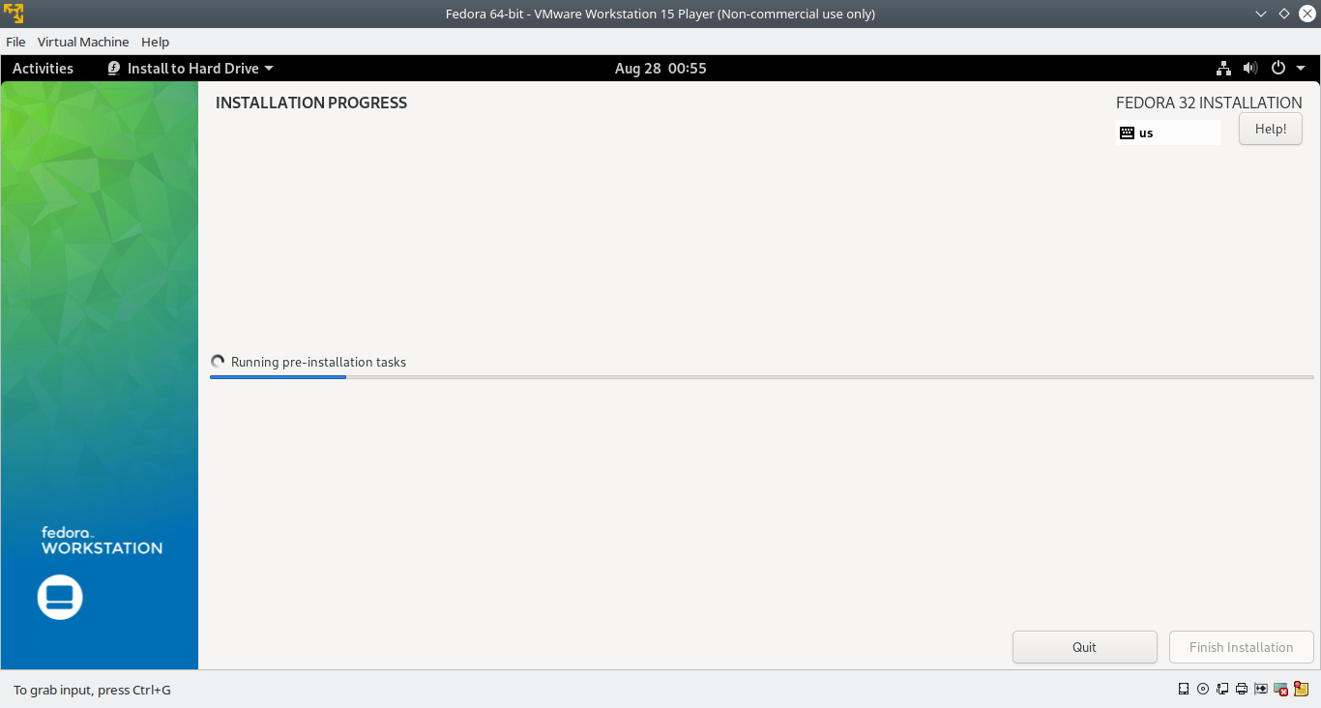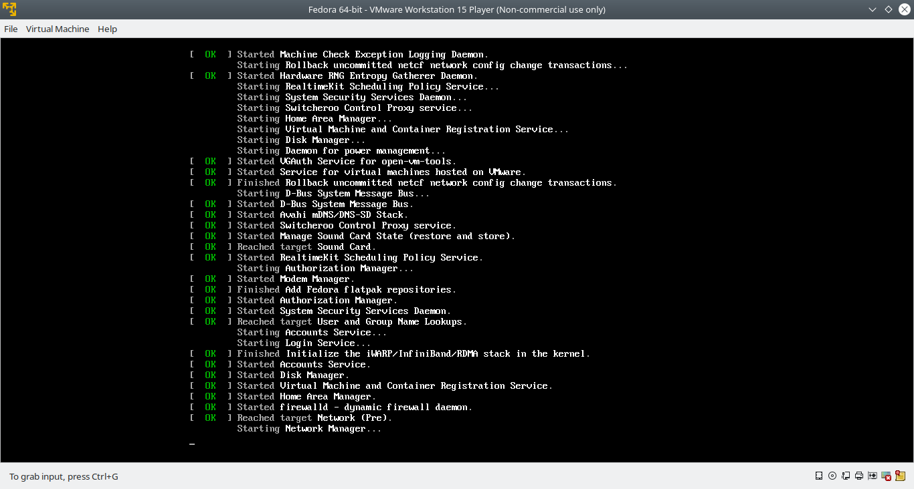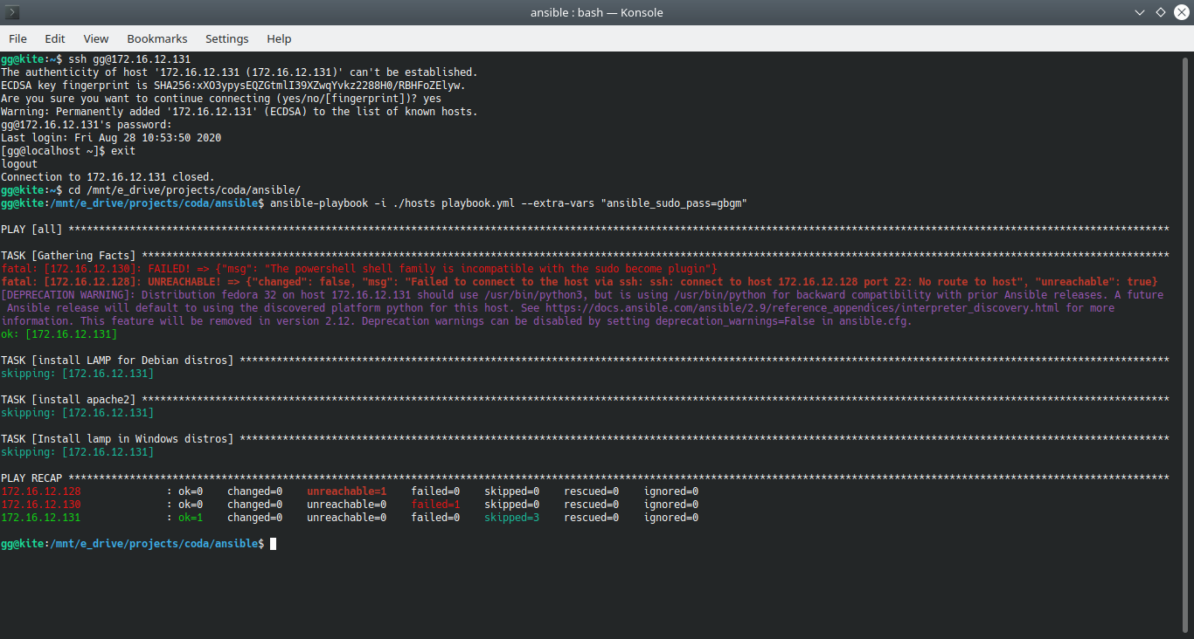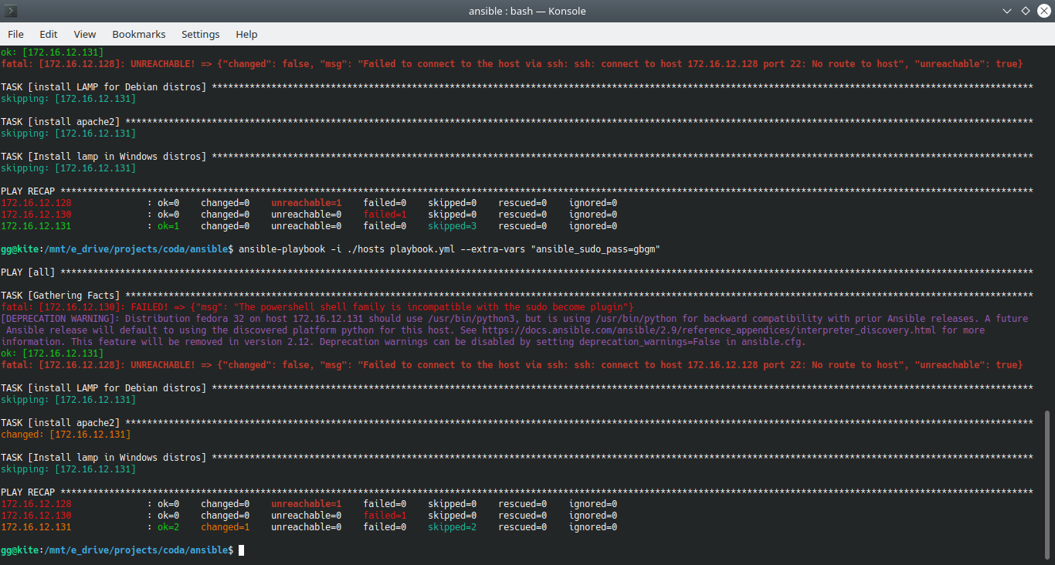

Get back to the windows WinRm configuration work!

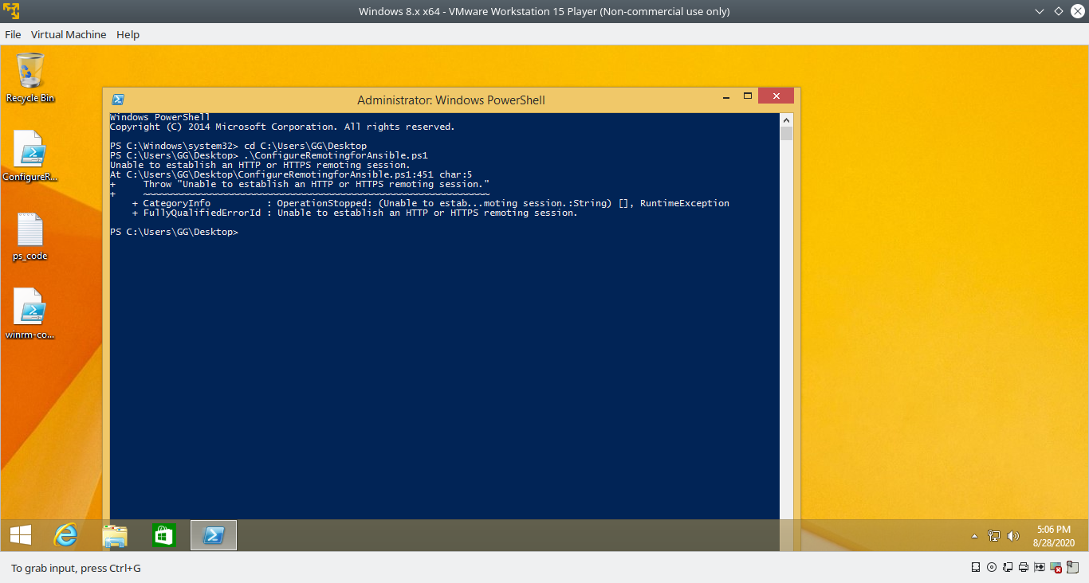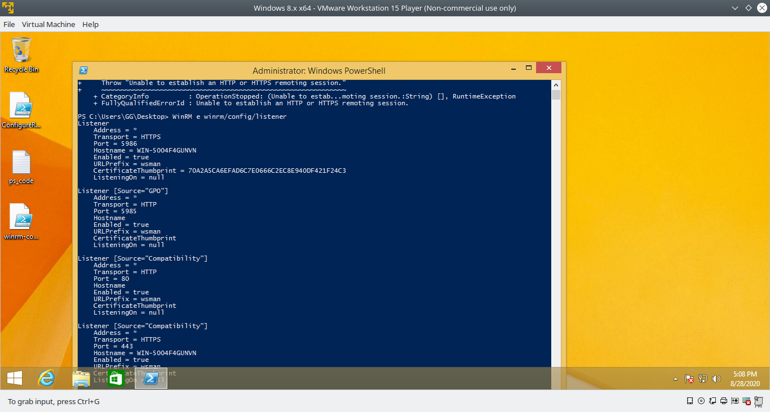

Google a lot about the error over hours and reconfigured WinRm from the beginning but still unsolved. Meanwhile also configured the firewall port settings and verified that firewall not blocking the connections.

Found the same issue in : https://groups.google.com/g/ansible-project/c/cV5VPSubcH4?pli=1

status : Resolved

Restarted everything with fresh new windows 10 installation, and attached it to a domain which I create using win-server 2008(Not required but to make sure everything is working perfect) after that edited group polices in windows and configured gp to allow connection also configured win-firewall (allowed the ports) and created a self-signed ssl certificate to establish HTTPS connection.

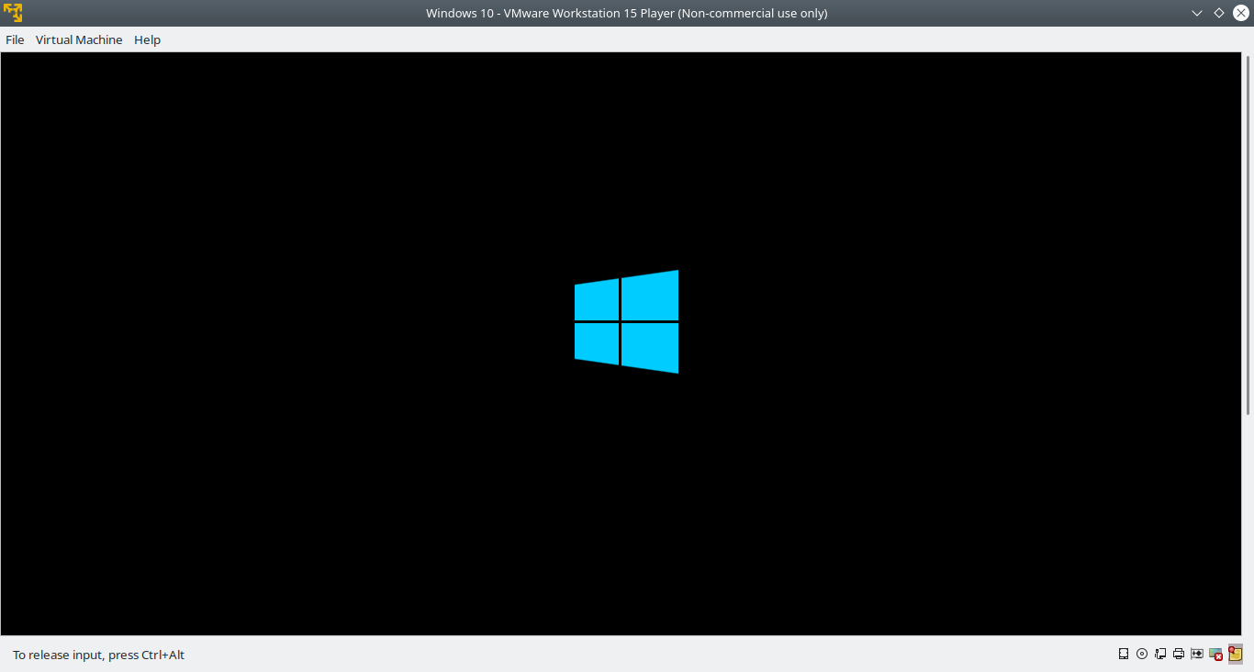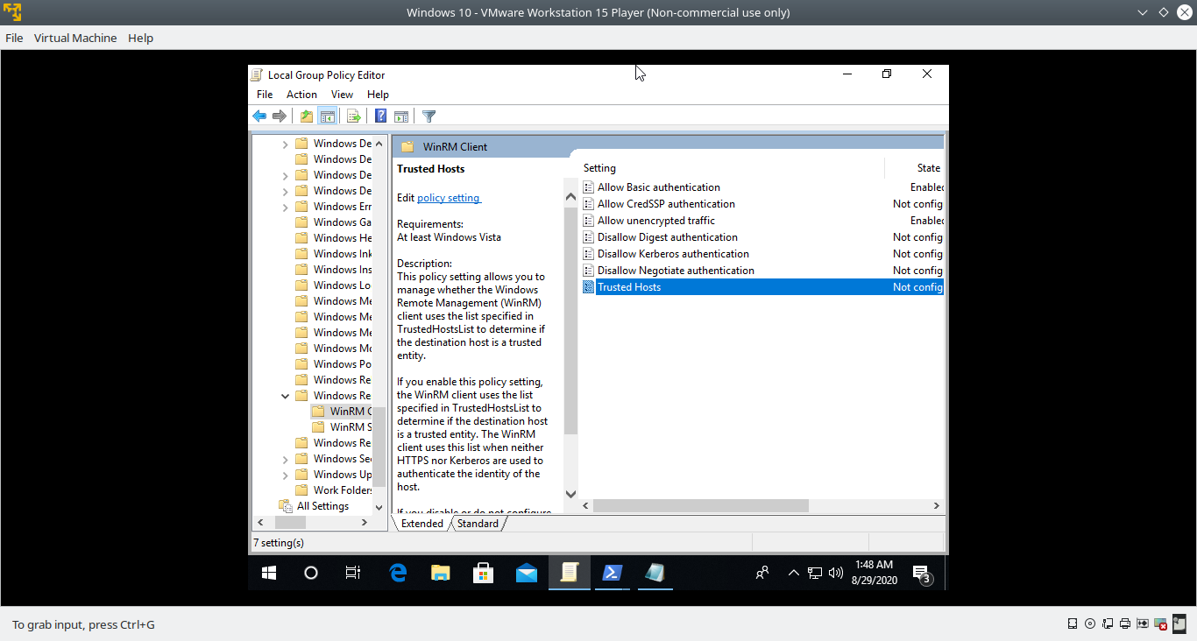

Tested the connection multiple times and installed the packages.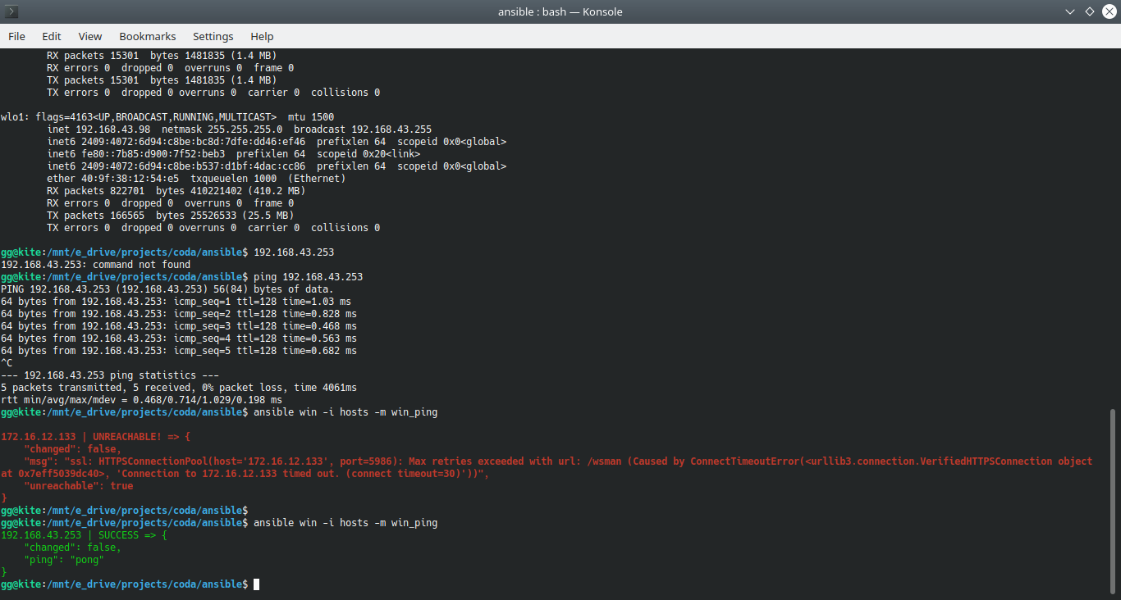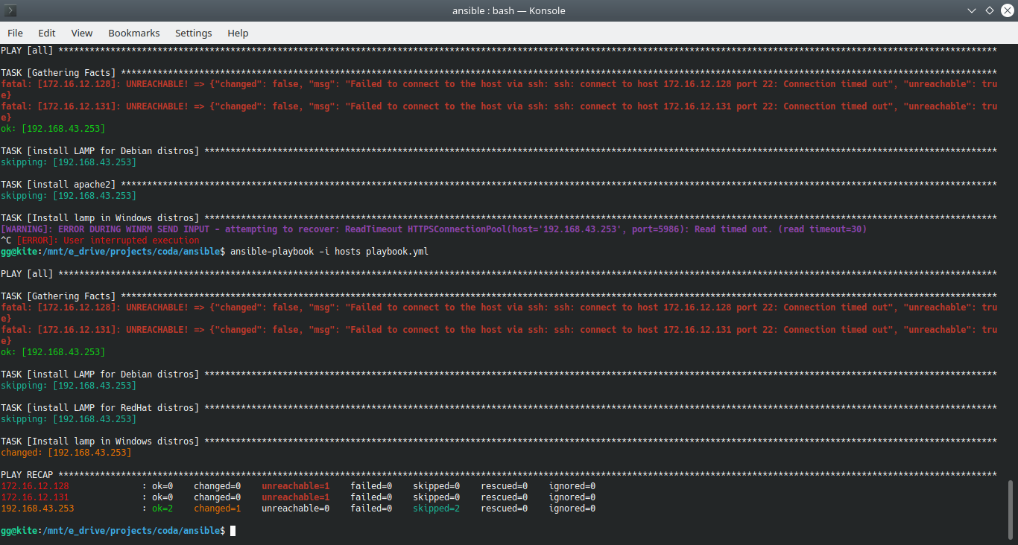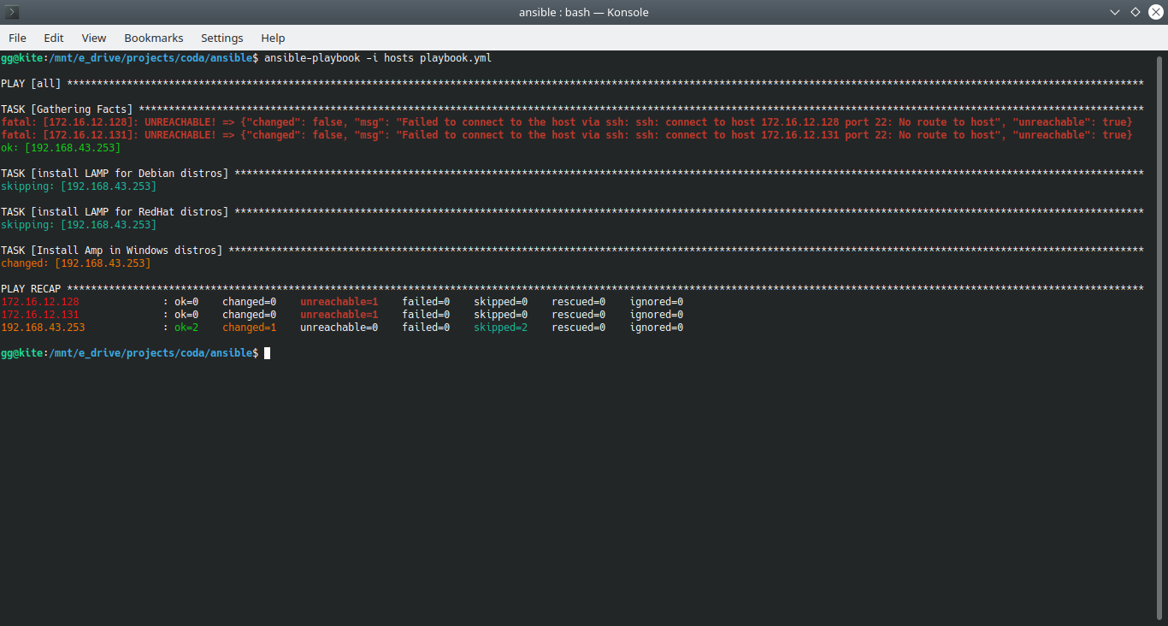

My Ansible playbook code:

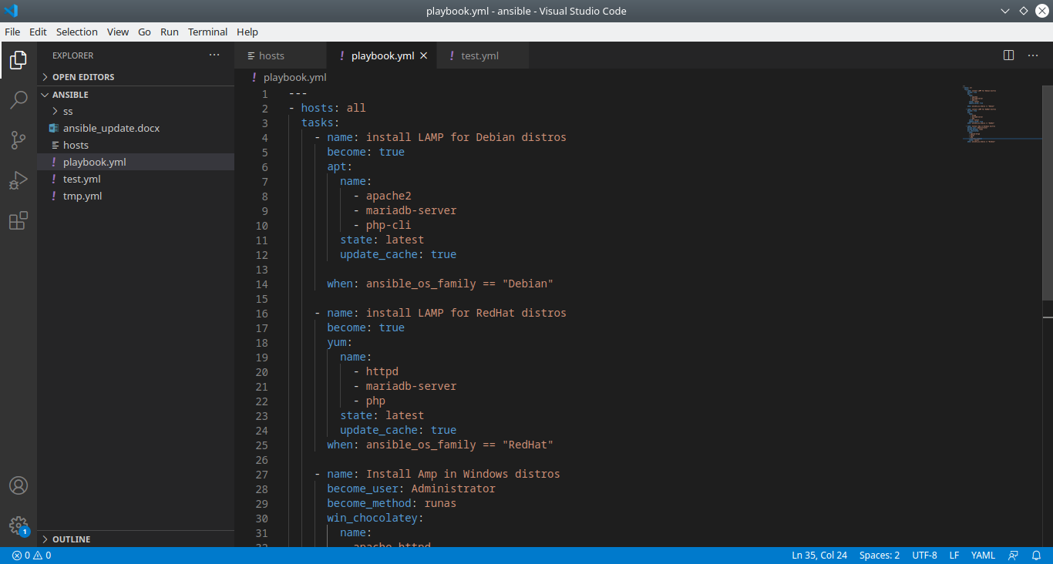

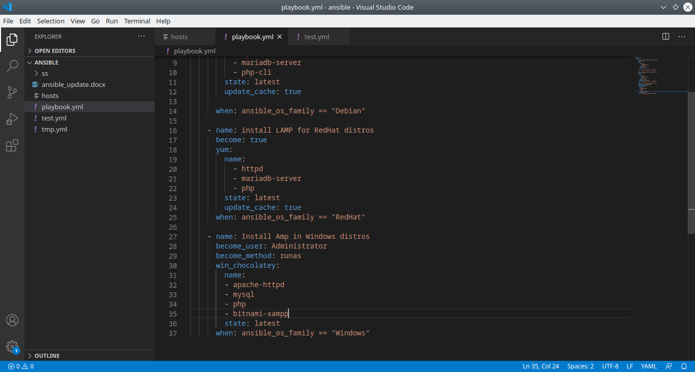

My Ansible hosts file:

