- Table of vulnerabilities by severity
The manually run report has a table of vulnerabilities discovered during scanning, but it is unclear what the table is reporting on due to the count of vulns not matching between the table and the “total vulnerabilities found” count. We need the table to either display all vulnerabilities or have an explanation of why the other 9 are not listed.
ex:
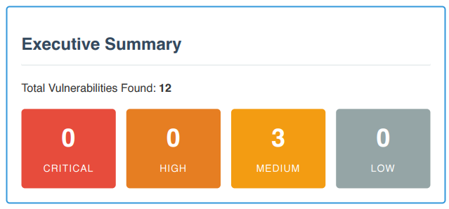
- Detections to be included in a report
Currently in CG, we see vulnerabilities like CORS headers included in the vulnerabilities. We agree with APISec’s analysis that these detections should not be classified as full vulnerabilities, but we would still like to have these detections included in some type of report, so that we can provide a report of these detections to teams in a convenient way, should we direct teams to resolve the detections.
The detections can be included either in the Developer report as Informational severity findings, or a specific Detections report where they retain their severities. Either solution would work for BMO.
- Table of potential vulnerability statuses
To explain all potential statuses and their meaning, so that developers can have more context on what an “active” vulnerability is, as well as differences between any other statuses that might appear in the report.
- New status - Reopened
For compliance and vuln tracking purposes, we’d like the reports to mention if the vulnerability is a formerly closed vulnerability that has come back. This helps us identify if a team has accidentally reintroduced vulnerabilities that are closed, or if a vulnerability is still active in the application since the previous scan.
Please note that we do not need this status to replace “Active/Open” within the tool itself, only in the reports. We are completely satisfied with a solution where the “reopened” status is used during report generation for vulns that have a corresponding “closed” vulnerability, without the “reopened” status being implemented anywhere else.
- Date of last scan for each endpoint
The NG Pentest report lists all the endpoints in the application but does not provide clear confirmation of which endpoints were scanned. It is important for our compliance/audit purposes that our scan reports clearly state that an endpoint was scanned
ex:
Similar to the CG Endpoint list, but with the date of the last scan in place of “OK” for the Tested column
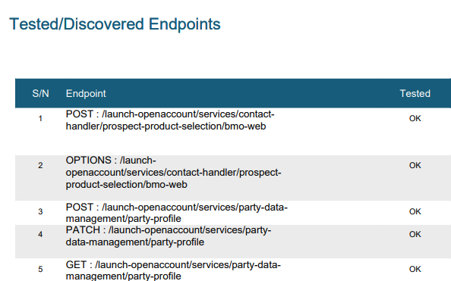
Vs NG
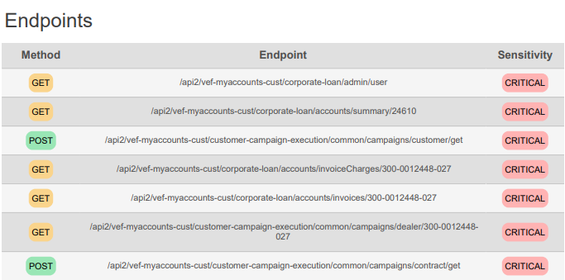
- Authentication status per endpoint
Confirmation of which endpoints had an authentication configuration applied to it would provide useful context to catch if an authenticated endpoint did not have authentication configured for it (which would allow developers to see at a glance the scan was not performed appropriately and the results should not be accepted), or vice versa.
- Remediation details
The CG Developer report has a lot of great details for the vulnerabilities, including references to OWASP, vulnerability/business impact, and plain language about what would be required to exploit the vulnerability. These provide useful context to help developers understand why a particular vulnerability is critical/high, and some resources to learn about it if they’re unsure about what it means.
- Vulnerable parameter value
For vulnerabilities that were detected by modifying the payload (ex: SQL injection, RBAC), highlighting which parameter was modified and what the malicious value was would help developers easily see what triggered the vulnerability and how to recreate it locally.

