Adaptive Budget-Aware Validation Framework for Cross-Language Software Migration Using Multi-Agent Systems.

Abstract
Cross-language software migration involves converting software from one programming language to another while maintaining its original functionality and behaviour. Although recent advances in automated code translation have made this process easier, the translated programs may still contain logical errors, execution differences, or unexpected behaviour. Identifying these issues requires effective testing, which can become time-consuming and computationally expensive when a large number of test cases are available. Existing validation approaches may also spend limited testing resources on less informative test cases.
To address these challenges, this paper proposes an Adaptive Budget-Aware Validation Framework for Cross-Language Software Migration Using Multi-Agent Systems. The framework uses collaborative agents to perform code analysis, translation, risk assessment, test generation, test prioritization, and behavioural validation. Its main contribution is an adaptive test-selection strategy that considers migration-related risk, estimated execution cost, and feedback from previously executed tests to prioritize test cases. Instead of executing all available tests, the proposed approach selects the most useful test cases within a predefined testing budget. Differential testing is then performed by executing the original and migrated programs with the same inputs and comparing their outputs to identify behavioural differences.
The proposed framework will initially be evaluated using Java-to-Python migration tasks. Its effectiveness will be compared with conventional testing and fixed risk-based test-selection approaches under equivalent testing budgets. Evaluation will consider the number of behavioural differences detected, detection rate, testing cost, time required to identify the first mismatch, and overall execution overhead. The study aims to improve the efficiency of cross-language software validation while making better use of limited testing resources.

keywords: Cross-language software migration, multi-agent systems, Adaptive testing, Budget-aware validation, Differential testing, Test prioritization, Behavioural equivalence.

Your project has three major parts:

1. Software Migration: Java-to-Python code translation.
2. Software Validation: Checking behavioural consistency between original and translated software.
3. Adaptive Testing (Research Focus): Intelligently selecting test cases to improve detection efficiency under a limited budget

Abstract
Cross-language software migration involves converting software from one programming language to another while preserving its intended functionality and behaviour. Although recent advances in automated code translation have simplified this process, migrated programs may still contain logical errors, data-type inconsistencies, dependency compatibility issues, and unexpected execution differences. Detecting these problems requires effective validation, which can become time-consuming and computationally expensive when a large number of test cases are available. Conventional testing approaches may also allocate limited testing resources to less informative test cases.
To address these challenges, this paper proposes an Adaptive Risk- and Budget-Aware Validation Framework for Java-to-Python Software Migration Using Multi-Agent Systems. The framework employs collaborative agents for source-code analysis, code translation, migration-risk assessment, test generation, adaptive test selection, differential validation, feedback analysis, and result reporting. Initially, the Code Analysis Agent examines the Java source code and identifies potentially risky constructs and dependency-related concerns. The Translation Agent converts the source program into Python, while the Risk Assessment Agent estimates the potential risk of behavioural differences. The Test Generation Agent creates candidate test cases, and the Adaptive Selection Agent prioritizes them based on migration-related risk, estimated execution cost, and feedback from previously executed tests. This enables the framework to select informative test cases within a predefined testing budget rather than executing every available test. The Validation Agent executes both versions using identical inputs and compares their outputs, exceptions, and relevant program states to identify behavioural differences, including those arising from sequences of operations.
The proposed framework will initially be evaluated using Java-to-Python migration tasks and compared with random and fixed risk-based test-selection approaches under equivalent testing budgets. Its effectiveness will be assessed using mismatch detection rate, number of behavioural differences detected, time to first mismatch, testing cost, and algorithm execution overhead. The study aims to improve the efficiency of cross-language software validation through risk-informed and feedback-driven test selection.

Agent | How to develop it | Need to train a model?
Code Analysis Agent | Java parser + static analysis rules | No
Translation Agent | Existing LLM or code translation model | No, initially
Risk Assessment Agent | Migration rules + risk-scoring algorithm | No, initially
Test Generation Agent | Existing testing tools + LLM | No, initially
Adaptive Selection Agent | Your own adaptive selection algorithm | No ML training required initially
Validation Agent | Java/Python execution + output comparison | No
Feedback Agent | Update test priorities from execution results | No
Reporting Agent | Templates + optional LLM explanations | No

Research idea | Real-world problem it solves | Research idea
1. Migration Risk Prediction | Predicts which parts of old software are most likely to fail before migration begins. | 1. Migration Risk Prediction
2. Database Migration Validation | Detects missing records, incorrect values and data inconsistencies when companies move databases between different systems. | 2. Database Migration Validation
3. API Migration Compatibility | Detects when a new API version breaks existing applications that depend on the old API. | 3. API Migration Compatibility
4. Legacy Software Dependency Migration | Identifies outdated libraries and incompatible dependencies that cause migrated applications to fail. | 4. Legacy Software Dependency Migration
5. Automated Migration Error Repair | Identifies translation errors and attempts to repair the migrated code automatically. | 5. Automated Migration Error Repair
6. Stateful Behaviour Validation | Detects errors that occur only after a sequence of operations, such as depositing, withdrawing and transferring money. | 6. Stateful Behaviour Validation
7. Security-Aware Software Migration | Detects security weaknesses introduced when software is migrated to another language or platform. | 7. Security-Aware Software Migration
8. Cloud Migration Validation | Detects functional and configuration errors when applications move from local servers to cloud platforms. | 8. Cloud Migration Validation

No. | Missing aspect | Why it matters
1 | Migration feasibility analysis | Determines whether the Java application can actually be migrated
2 | Behaviour preservation | Checks whether important business logic remains unchanged
3 | Dependency compatibility | Checks whether required libraries are available and compatible in Python
4 | Data-type mapping | Handles differences between Java and Python data types
5 | Database compatibility | Checks whether database operations and stored data remain consistent
6 | API compatibility | Checks whether external applications can still communicate with the migrated system
7 | Security validation | Identifies security weaknesses introduced during migration
8 | Performance benchmarking | Measures whether the migrated application becomes slower or faster
9 | Failure recovery | Handles translation failures, compilation errors and test timeouts
10 | Explainability | Explains why the system detected a potential problem
11 | Human approval | Allows developers to review proposed changes before deployment
12 | Reproducibility | Allows other researchers to repeat your experiments

How will all these agents communicate
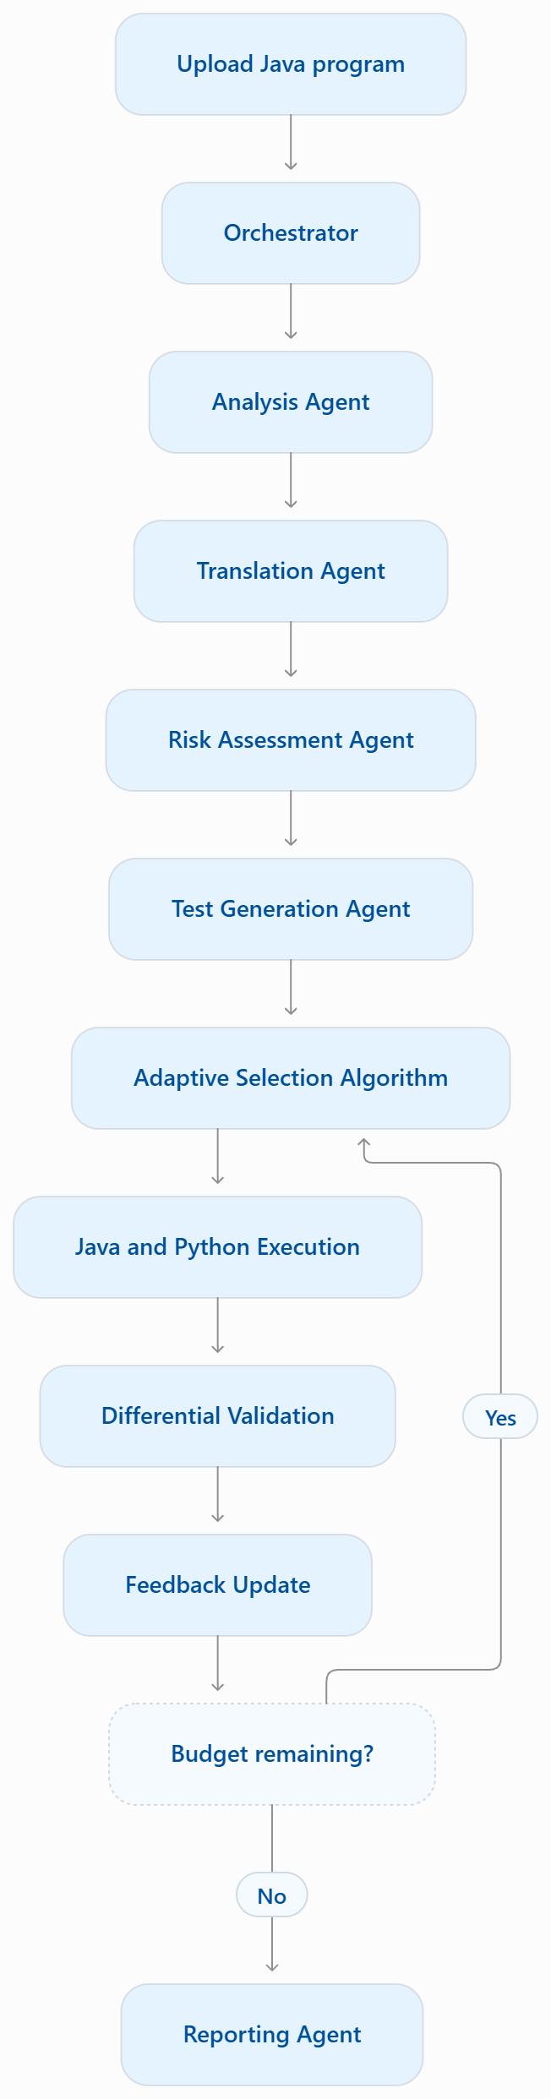

Proposed architecture
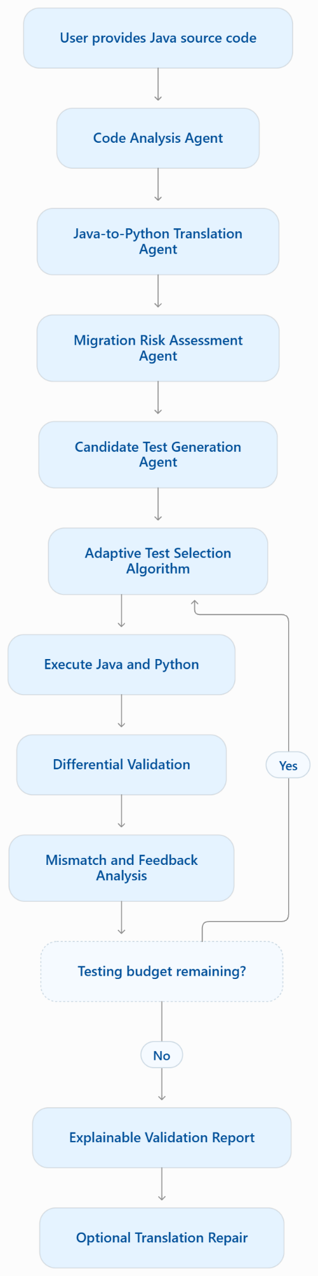
The orchestrator passes information between agents. For example:
- Analysis Agent sends the identified methods to Risk Agent.
- Translation Agent sends Python code to Validation Agent.
- Risk Agent sends risk information to Adaptive Selection Agent.
- Validation Agent sends mismatch results to the Feedback component.
- Reporting Agent receives the final experimental results.
Migration-Aware Adaptive Test Selection (MATS) algorithm
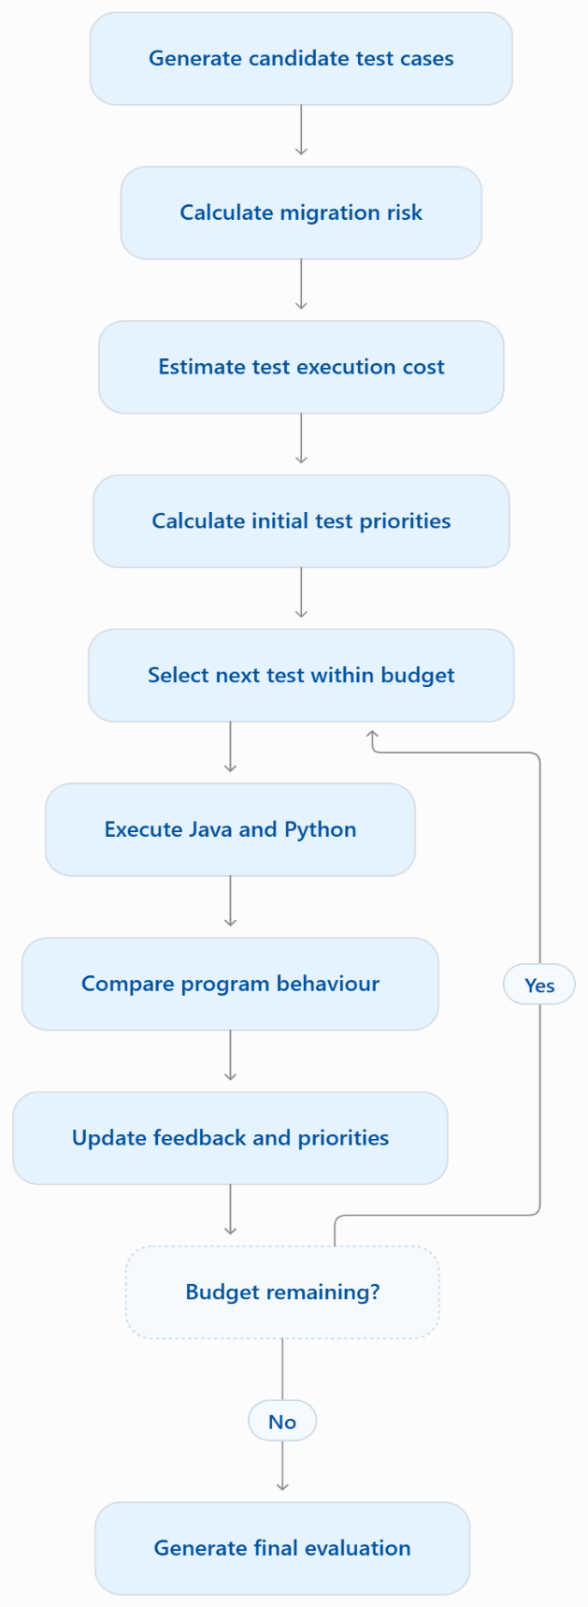
multi-agent system could work:

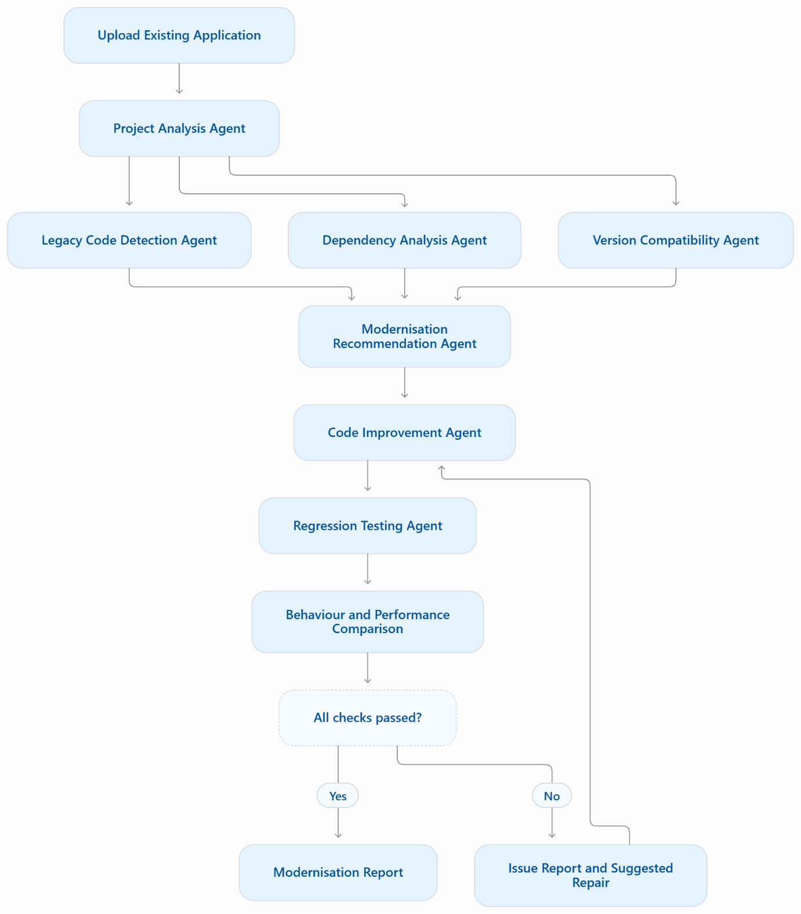

System architecture


