**Disease-Gene Prediction: A Machine Learning Perspective**

Abstract— The project, "Disease-Gene Prediction: A Machine Learning Perspective" aims at analyzing and predicting the associations between genes and diseases by advanced techniques of machine learning. Due to the fast-increasing availability of genetic data, there has been an increasing need to understand the correlation of specific genes with a disease in biomedical research. This study employs a comprehensive data set, which includes gene-specific information such as DSI and DPI, as well as several disease features including semantic type and classification. It applies four machine learning algorithms, namely Random Forest, XGBoost, LightGBM and K-Nearest Neighbors (KNN), to predict the three significant output classes-Disease, Group, and Phenotype. It was found that the best model for this purpose came out to be that of Random Forest with 97. 81% accuracy. The same model was implemented using Flask as a framework to gain real-time predictions. Preprocessing mainly involved filling missing values, label encoding, and even clustering into diseases. There are chances of using KMeans clustering for organizing diseases into broader categories based on their similarities for a stronger prediction. The project demonstrates the potential of machine learning in advancing genomic research by providing insights into gene-disease associations. It offers a practical tool for researchers to explore genetic links to diseases efficiently.

Keywords: gene-disease association, machine learning, clustering, Flask, Random Forest, disease classification, phenotype prediction, gene prediction, bioinformatics, data preprocessing.

# **Introduction**

The past couple of years has been very fruitful as far as the genomics field is concerned and has seen quite a number of breakthroughs that led scientists to a better comprehension in the genetic base of various diseases. Genetic explorations regarding diseases have greatly equipped researchers with a clear idea about the potential ways genes may contribute to the development of disease; however, the complex relationship between some genes and diseases happens to be a highly demanding task yet to be achieved. This paper, in this case, is "Analysis for Disease Gene Association Using Machine Learning," which will address this challenge by applying machine learning for the prediction of associations between genes and diseases.

Machine learning offers powerful tools for handling large datasets and uncovering patterns that might not be immediately apparent using traditional methods. By leveraging machine learning models, This paper focuses on analyzing gene-disease associations to predict three key output categories: Disease, Group, and Phenotype. The use of advanced algorithms, including Random Forest, XGBoost, LightGBM, and K-Nearest Neighbors (KNN), provides a multi-model approach to improve prediction accuracy. Among these models, Random Forest achieved the highest accuracy, making it the primary model for final predictions.

For This paper, I used a dataset containing comprehensive information about genes and diseases in terms of associations between genes and diseases, along with DSI (Disease Specificity Index), DPI (Disease Pleiotropy Index), disease name, and strength of evidence. Techniques of imputation were used to deal with missing values, and categorical variables were preprocessed by assigning label encoding to the data so that it can be used in concurrence with the algorithm implemented for the process of machine learning. The genetic associations of diseases were further categorized into broad groups using KMeans clustering to create useful concepts for analysis.

This paper was developed using the Flask framework, enabling the integration of the machine learning model into a web-based application for real-time predictions. This makes the system accessible to researchers, allowing them to input specific gene or disease data and receive predictions on the likelihood of their association.

Overall, This paper demonstrates the potential of machine learning to enhance the understanding of gene-disease relationships. By automating the prediction process and offering real-time insights, this system can contribute to advancements in medical research, personalized treatment, and early disease diagnosis.

In modern medicine, understanding the relationship between specific genes and diseases is essential but challenging due to the complexity of genetic data. Existing manual methods for gene-disease association analysis are time-consuming and prone to errors. This paper addresses the problem by automating the process using machine learning techniques to predict associations between genes and diseases efficiently. It further classifies diseases into groups and phenotypes, offering a streamlined approach for biomedical researchers to explore genetic links.

The final objective of This paper is the design of a machine learning-based framework that predicts associations between genes and diseases based on a large dataset. The system will categorize diseases into three different output classes, namely Disease, Group, and Phenotype using a set of machine learning models like Random Forest, XGBoost, LightGBM, and K-Nearest Neighbors. The system, intended to bring preprocessing of data by dealing with missing values and clustering the diseases into more general categories to improve the accuracy of the predictions. It will use the Flask web application to be deployed in taking genetic or disease-related data input from users and providing back real-time predictions. This therefore aims at improving the ability to analyze gene-disease association, and with this, making it easy for researchers to access the tool comfortably in pursuit of discovering the diseases' genetic basis more easily.

# **Related work**

Prediction and Validation of Gene-Disease Associations Utilizing Methods Derived from Social Network Analyses (2013): Singh-Blom et al. developed an innovative methodology that employs social network analysis techniques to predict gene-disease associations, achieving significant predictive accuracy. [1]

A Deep Learning Framework for Forecasting Disease-Gene Associations through Functional Modules and Graph Augmentation (2024): Jia et al. introduced ModulePred, a deep learning framework that performs graph augmentation on protein-protein interaction networks to predict disease-gene associations, demonstrating enhanced predictive performance. [2]

Recent Advances in Network-Based Approaches for Disease Gene Prediction (2020): Xie et al. examined network-based methods for disease gene prediction, evaluating various computational approaches and their applications in identifying disease-associated genes. [3]

Supervised Machine Learning Techniques for Predicting Disease-Gene Associations (2019): Alashwal et al. applied supervised machine learning methodologies to predict disease-gene associations, underscoring the efficacy of these techniques in biomedical research. [4]

**End-to-End Interpretable Disease–Gene Association Prediction (2023):** A study introduced an interpretable deep learning model for disease-gene association prediction, providing insights into the underlying biological mechanisms. [5]

Gene-Associated Disease Discovery Powered by Large Language Models (2024): Chang et al. proposed a framework employing large language models to automate the discovery of diseases associated with specific genes, enhancing the efficiency of literature-based discovery. [6]

Unveiling New Disease, Pathway, and Gene Associations via Multi-Scale Neural Networks (2019): Gaudelet et al. utilized multi-scale neural networks to uncover new associations between diseases, pathways, and genes, providing a comprehensive view of disease mechanisms. [7]

Towards Probabilistic Generative Models Harnessing Graph Neural Networks for Disease-Gene Prediction (2019): Singh and Lio' explored the use of probabilistic generative models with graph neural networks for disease-gene prediction, demonstrating the potential of these models in capturing complex biological relationships. [8]

The Research on Gene-Disease Association Based on Text-Mining of Biomedical Literature (2018): A study proposed a method of predicting potential gene-disease linkages by mining gene or disease-related text documents, evaluating its effectiveness in identifying novel associations. [9]

GediNET for Discovering Gene Associations Across Diseases Using Network-Based Approaches (2022): A study introduced GediNET, a network-based approach for discovering gene associations across diseases, utilizing machine learning techniques to analyze complex biological networks. [10]

Recent studies have harnessed the power of machine learning to predict gene-disease associations with high accuracy. Techniques like Random Forest, Support Vector Machines, and Gradient Boosting are applied to capture such complex relationships between genes and diseases. For example, PLOS ONE published a study that introduces methods based on social network analysis utilizing Katz and Positive-Unlabeled learning to predict gene-phenotype interactions using the network walk. [11]

Another novel approach is the use of cross-species phenotype networks. By integrating human and model organism data, researchers can form bipartite graphs between phenotypes and human genes. This cross-species analysis has yielded accurate predictions of gene-disease associations by leveraging evolutionary-conserved gene functions and phenotype similarities across species. [12]

Network-based methods provide a robust framework for disease-gene association predictions. In these methods, diseases and genes are treated as nodes in a bipartite graph. Using random walks, network propagation, and kernel-based approaches, researchers have been able to efficiently predict potential disease-gene links. For example, one study shows that incorporating multiple kernel learning (MKL) outperforms single-kernel methods when identifying associations in a gene-disease bipartite network. [13]

# **Dataset**

## **A.** **Description**

The dataset is a collection of several features through which the analysis of genetic contribution to disease susceptibility, progression, and treatment potential is possible. These key features present in the dataset are as follows:

**geneId:** A unique identifier for every gene, it is possible to track and analyze genetic data very accurately.

**geneSymbol:** This is a symbolic name for every gene. It provides an easy way of referencing and cross-referencing with other genomic databases.

**DSI-Disease Specificity Index:** It measures the extent to which a gene is specific to a certain disease. Therefore, it quantifies how much a gene can be involved in the etiology of the disease.

**DPI-Disease Pleiotropy Index:** It describes the breadth to which a gene is connected with many diseases. It would give information regarding the pleiotropic effect of a gene.

**diseaseId:** It gives an identification number for each disease to avoid ambiguity in the mapping of genes with the diseases.

**Disease Name:** This is the common name of the disease. It helps identify and understand the conditions it is associated with.

**Disease Type:** Categorizes the disease based on its nature (e.g. , genetic, infectious), offering context for the type of medical challenges the gene may be involved in.

**Disease Class:** A broader classification of diseases that helps group diseases into related categories for further analysis.

**diseaseSemanticType:** This determines the semantic type of the disease, which points out its pertinence within medical and biological contexts, for better interpretation of its significance.

**score:** A measure of the intensity of association that exists between the gene and a disease, for prioritizing the genes based on their potential effect.

**EI:** Evidence Index refers to the measurement of the intensity of evidence about the association that exists between a gene and disease, which determines the confidence for the reliability of the data.

**YearInitial/YearFinal:** Years the gene-disease association was first and last reported, a kind of perspective of how well these associations have changed with time.

**NofPmids:** The number of PubMed publications available for each of the gene-disease associations made; this could give an indication of the magnitude of scientific evidence for the discovered association.

**NofSnps:** Number of Single Nucleotide Polymorphisms linked to this gene, as an indication of genetic variability, and possibly in the susceptibility towards disease.

This dataset establishes a robust basis for studying gene-to-disease correlations and is a really useful resource available for researchers intending to identify unknown therapeutic targets for different diseases as well as provide enhanced disease predictors.

# **Architecture Details**

## **A. Random Forest Classifer**

The Random Forest algorithm is a machine learning method that uses an ensemble of decision trees during the training process. Instead of producing a single output, it generates the class that represents the majority vote from all the individual trees. This approach helps to minimize overfitting and improves accuracy by leveraging the collective results from multiple trees.

The Random Forest algorithm can be visualized as a collection of decision trees, each trained on a random subset of the data. When predicting something, like a gene associated with a disease, each tree might select a different gene, and the final prediction is based on the majority vote across all trees. Fig. 1 illustrates the architecture of the Random Forest algorithm.

Random Forest is effective for high-dimensional datasets, such as genomic data, and it works well with both categorical and continuous variables. It can also handle missing values efficiently. Essentially, Random Forest combines the outputs of multiple decision trees trained on different portions of the data, reducing the risk of overfitting that is often seen in single decision trees. In classification tasks, the final output is determined by majority voting, while in regression, the results are averaged across the trees.

Random Forest provides feature importance scores, helping researchers identify the most relevant variables in a dataset. This makes it particularly useful in fields like bioinformatics, where understanding key predictors is crucial. The algorithm's robustness and scalability make it a popular choice for various real-world applications.

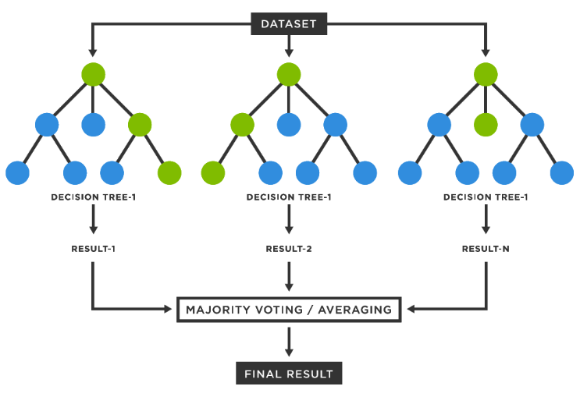

**Fig. 1** Random Forest architecture

### How It Works:

**1.  Random Data Subsampling: All the decision trees are trained on randomized subsets of the data. What this does is to ensure every tree learns a unique variation of your dataset, that's introducing variation in your model.**

**2. Feature selection: While generating the trees at each node in the tree, instead of including all the features, the random forest takes a random subset of features. It further reduces correlation and keeps them more diverse.**

**3. Tree Building: The selected subset of both data and features is trained to build a decision tree in such a way that it produces a model which predicts the target variable.**

**4. Voting or Averaging: In classification problems, each tree votes for a class, and the class that has the most votes is the prediction. In regression problems, the final output is the average of all the tree predictions.**

Random Forest is well-suited for handling high-dimensional data and can manage missing values without much issue. It also provides insights into feature importance, ranking features based on their contribution to the prediction. However, for very large datasets, the model can become computationally intensive and harder to interpret compared to a single decision tree.

## **B.** **XGBoost Classifier**

XGBoost, short for Extreme Gradient Boosting, is an optimized version of gradient boosting that can scale efficiently. It builds trees iteratively, where each new tree aims to correct the errors made by the previous ones.

With each iteration, XGBoost adds a new tree to the model, and each tree is trained to reduce the errors (residuals) from the previous trees. The model is updated using gradient descent to improve its prediction accuracy.

XGBoost is known for its speed and high performance, particularly with large datasets. Its ability to handle missing values and its boosting technique enable it to deliver superior predictive accuracy.

XGBoost enhances traditional gradient boosting by introducing optimizations like regularization and parallelization to improve training speed and prevent overfitting.

#### How It Works:

1. **Sequential Learning**: XGBoost begins by training a simple base model (typically a weak decision tree) on the data and calculates the errors (residuals) of the base model.
2. **Gradient Descent**: Subsequent trees are added sequentially, with each one minimizing the errors from the previous tree by following the gradient direction.
3. **Tree Pruning**: XGBoost reduces overfitting by pruning trees, eliminating nodes that add little to the model’s predictive power.
4. **Regularization**: It uses regularization techniques to control the complexity of trees and prevent overfitting, ensuring the model generalizes well.

XGBoost also handles missing values automatically, supports column sampling, and offers built-in cross-validation. Its ability to perform distributed computing makes it a fast and highly accurate option for large-scale problems. However, it can be more challenging to fine-tune than simpler models.

## **C. LightGBM Classiier**

LightGBM (Light Gradient Boosting Machine) is a gradient boosting framework that employs tree-based learning algorithms. It is designed to be memory-efficient and fast, making it well-suited for large datasets.

Similar to XGBoost, LightGBM builds models sequentially, adding trees to correct errors from previous models. However, it differs by growing trees in a leaf-wise manner, allowing it to create deeper trees and prioritize important splits early in the process. Fig. 2 illustrates the architecture of the LightGBM algorithm.

LightGBM is known for its speed compared to traditional boosting algorithms and provides excellent predictive accuracy. Its efficient handling of large datasets makes it particularly useful for problems such as genomic data analysis.

LightGBM is faster and more efficient than XGBoost when working with large datasets. It grows trees leaf-wise, which results in deeper trees and more effective splits early on.

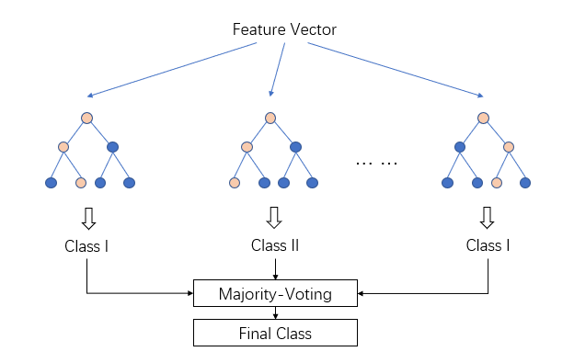

**Fig. 2** LightGBM Architecture

#### How It Works:

1. **Leaf-Wise Tree Growth**: Unlike XGBoost’s level-wise approach, LightGBM grows trees leaf-wise, meaning it expands the leaf that provides the greatest reduction in error. This results in deeper trees that can capture more complex patterns.
2. **Gradient Boosting**: LightGBM, like XGBoost, adds trees sequentially to correct the residual errors from the previous models.
3. **Histogram-based Algorithm**: It uses a histogram-based approach to bin continuous features, which speeds up training and reduces memory usage.
4. **Feature Selection**: LightGBM automatically discards features that have little impact on model performance.

LightGBM’s ability to handle large datasets efficiently, alongside advanced features such as categorical feature handling and built-in regularization, makes it ideal for high-dimensional data. However, the leaf-wise tree growth can lead to overfitting if not properly tuned.

## **D. K-Nearest Neighbors Classifier**

KNN is a straightforward, instance-based learning algorithm that classifies a data point based on its closest neighbors. The class assigned to the data point is the one that most frequently occurs among its k nearest neighbors.

KNN classifies a new gene’s association with a disease by evaluating the k nearest genes in the dataset and assigning the disease class that occurs most frequently among those neighbors. For instance, if k=5, the algorithm selects the five. Fig. 3 illustrates the architecture of the K-Nearest Neighbors (KNN) algorithm.

KNN is simple, easy to interpret, and is typically used as a baseline model to compare with more complex algorithms. However, it can struggle with high-dimensional data and may not perform as well as other techniques.

KNN is a non-parametric method, meaning it doesn’t assume any underlying data distribution. Its intuition is based on the idea that similar data points should be close to each other in the feature space.

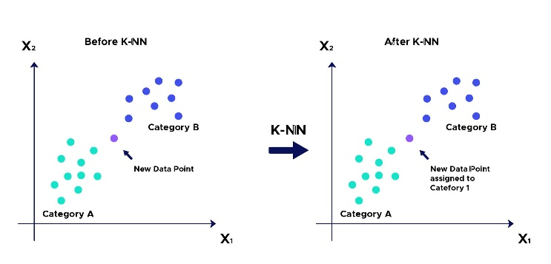

**Fig. 3** K-Nearest Neighbors (KNN) Architecture

#### How It Works:

1. **Distance Calculation**: KNN computes the distance from the query point to each point in the training dataset using a distance metric like Euclidean distance.
2. **Neighbor Selection**: The algorithm selects the k nearest neighbors based on the computed distances.
3. **Majority Voting**: In classification tasks, KNN assigns the class that occurs most frequently among the k nearest neighbors. In regression tasks, it averages the values of the neighbors.
4. **Choosing k**: The choice of k is crucial; too small a k can lead to overfitting, while too large a k may result in underfitting, making the model too simplistic.

KNN is a lazy learning algorithm, meaning it doesn’t build a formal model but instead makes predictions by calculating distances to all instances at query time. While easy to interpret, KNN can be computationally expensive due to the need to calculate distances for every instance in the dataset. Feature scaling is important for better performance, as KNN is sensitive to the scale of the features.

# **Proposed methodology**

## **A. Data Preprocessing**

Data preprocessing, in any project with machine learning algorithms, usually plays an important role, especially in massive and complex datasets, such as genomic data. The data set used in This paper consists of several fields that contain numerical and categorical values and, typically, some are missing. Thus, the next preprocessing steps to make the algorithms at their best performance include:

**Handling Missing Values:** The DSI, DPI and EI fields, in the dataset, have missing values. To impute missing values, the dataset uses the median value of respective fields. This will ensure a balanced dataset and algorithms are not predisposed to biased results because the data is incomplete.

**Encoding Categorical Variables:** The majority of the columns are categorical variables; two examples are diseaseClass and diseaseSemanticType. Label encoding is applied in order to code the categorical into an appropriate format that could be utilized by the machine learning algorithms. All categories are converted to numeric values, hence algorithms can process them well.

**Feature Scaling and Normalization:** For some algorithms, machine learning requires that the features be on the same scale. Min-Max scaling is used as a technique to normalize so that all features contribute equally to model predictions.

## **B.** **Clustering for Disease Categorization**

To enhance the interpretability and organization of the data, clustering techniques are applied. KMeans Clustering is used to group diseases based on their genetic associations, creating broader disease categories that can simplify the prediction process.

•KMeans is an unsupervised learning algorithm. This algorithm is utilized to group data into clusters. In This paper, the KMeans algorithm is implemented on fields diseaseName and diseaseSemanticType to group diseases under categories. Every disease is assigned to a cluster based upon its features, and the clusters provide a high-level view on how diseases The algorithm performs at the following steps

**The K-Means algorithm operates as follows:**

1. Select *k* random cluster centroids.
2. Assign each data point to the nearest centroid.
3. Update the centroids based on the assigned points.
4. Repeat the process until the centroids converge.

**RESULTS**

**Existing Models:**

* 1. **KNN Algorithm**

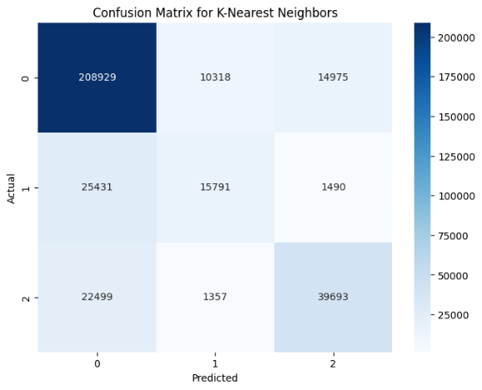

|  |  |  |
| --- | --- | --- |
| **Class Label** | **Description** | **Example** |
| **0** | Defines the disease exactly | **Arthritis** |
| **1** | Defines the disease group | **Diabetes Mellitus** |
| **2** | Represents the phenotype presented | **Exanthema** |

**Table. 1** Defining the Classes

* **Misclassifications**:
  + Highest misclassifications, especially from Class 1 and Class 2 being wrongly predicted as Class 0.
  + KNN shows the weakest performance here, with more significant errors across all classes.
  1. **LightGBM Algorithm**

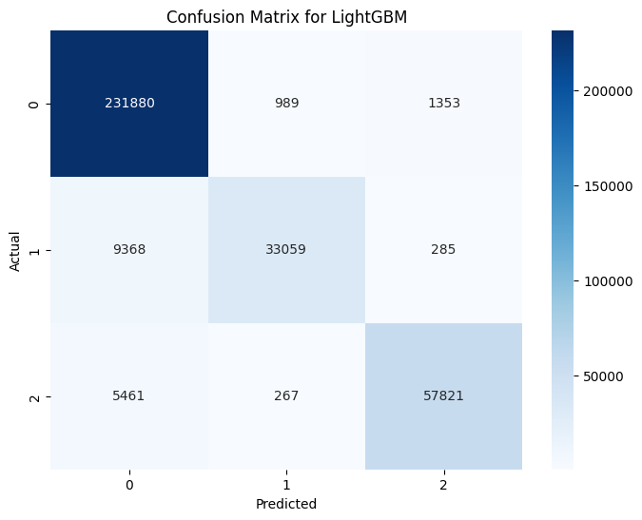

**Fig. 5** Confusion Matrix for LightGBM

* **Misclassifications**:
  + Highest errors for Class 1 predictions, indicating the model is struggling with this class.
  + Moderate misclassifications between Classes 1 and 2.

**Proposed Models**

**a. XGBoost**

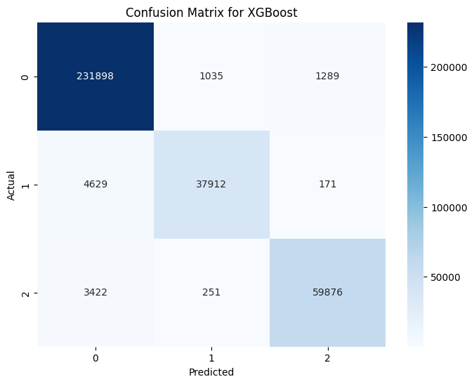

**Fig. 6** Confusion Matrix for XGboost

* **Misclassifications**:
  + Slightly more misclassifications compared to Random Forest, especially between Class 1 and 2.
  + Class 1 misclassified as Class 0 more often than in Random Forest.

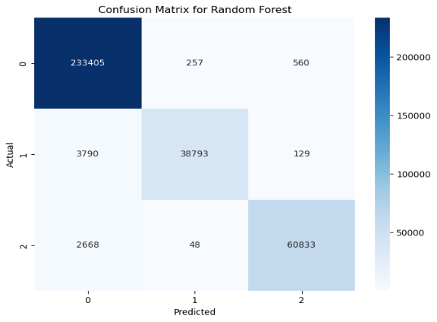**b. Random Forest**

**Fig. 7** Confusion Matrix for Random Forest

* **Misclassifications:**
  + Some instances from Class 1 and 2 were predicted as Class 0.
  + Only a few errors overall; it performs well with minimal misclassifications.

**Graph. 2** Representing the Accuracy and Recall between XGBoost and Random Forest

|  |  |  |  |
| --- | --- | --- | --- |
| **Algorithm** | **Precision** | **Recall** | **Accuracy** |
| **KNN** | 0.57 | 0.37 | 0.78 |
| **LightBGM** | 0.94 | 0.77 | 0.95 |
| **XGBoost** | 0.98 | 0.94 | 0.97 |
| **RandomForest** | 0.99 | 0.96 | 0.98 |

**Table. 2** Classification Report for all models

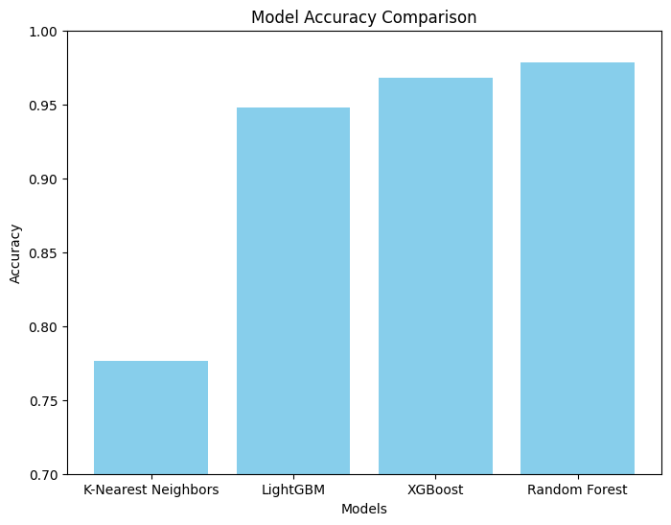

**CONCLUSION:**

The Examination for Infection Quality Affiliation Using AI project viably addresses the test of recognizing quality disease affiliations utilizing advanced AI calculations like Random forest, XGBoost, LightGBM, and KNN. By integrating key preprocessing techniques, feature engineering, and clustering, This paper demonstrates a robust framework capable of handling large-scale, complex genomic data. The high accuracy achieved, particularly with the Random Forest model, highlights the potential of these methods in providing valuable insights for genetic research and disease prediction. The deployment of the model using Flask ensures practical and accurate results, benefiting both researchers and healthcare professionals. This system can contribute significantly to the ongoing efforts in personalized medicine, genetic research, and disease diagnosis, marking a step toward more efficient and scalable solutions in bioinformatics.

# **References**

[1] M. Asif, H. F. M. C. M. Martiniano, A. M. Vicente, and F. M. Couto, “Identifying disease genes using machine learning and gene functional similarities, assessed through Gene Ontology,” *PLoS One*, vol. 13, no. 12, p. e0208626, Dec. 2018, doi: 10.1371/JOURNAL.PONE.0208626.

[2] X. Jia *et al.*, “A deep learning framework for predicting disease-gene associations with functional modules and graph augmentation,” *BMC Bioinformatics*, vol. 25, no. 1, pp. 1–14, Dec. 2024, doi: 10.1186/S12859-024-05841-3/TABLES/2.

[3] S. K. Ata, M. Wu, Y. Fang, L. Ou-Yang, C. K. Kwoh, and X.-L. Li, “Recent Advances in Network-based Methods for Disease Gene Prediction,” *Brief Bioinform*, vol. 22, no. 4, Jul. 2020, doi: 10.1093/bib/bbaa303.

[4] U. M. Singh-Blom, N. Natarajan, A. Tewari, J. O. Woods, I. S. Dhillon, and E. M. Marcotte, “Prediction and Validation of Gene-Disease Associations Using Methods Inspired by Social Network Analyses,” *PLoS One*, vol. 8, no. 5, p. e58977, May 2013, doi: 10.1371/JOURNAL.PONE.0058977.

[5] Y. Li, Z. Guo, K. Wang, X. Gao, and G. Wang, “End-to-end interpretable disease–gene association prediction,” *Brief Bioinform*, vol. 24, no. 3, pp. 1–9, May 2023, doi: 10.1093/BIB/BBAD118.

[6] J. Chang, S. Wang, C. Ling, Z. Qin, and L. Zhao, “Gene-associated Disease Discovery Powered by Large Language Models,” Jan. 2024, Accessed: Jan. 29, 2025. [Online]. Available: https://arxiv.org/abs/2401.09490v1

[7] T. Gaudelet, N. Malod-Dognin, J. Sanchez-Valle, V. Pancaldi, A. Valencia, and N. Przulj, “Unveiling new disease, pathway, and gene associations via multi-scale neural networks,” *PLoS One*, vol. 15, no. 4, Jan. 2019, doi: 10.1371/journal.pone.0231059.

[8] V. Singh and P. Lio’, “Towards Probabilistic Generative Models Harnessing Graph Neural Networks for Disease-Gene Prediction,” Jul. 2019, Accessed: Jan. 29, 2025. [Online]. Available: https://arxiv.org/abs/1907.05628v1

[9] J. Zhou and B. quan Fu, “The research on gene-disease association based on text-mining of PubMed,” *BMC Bioinformatics*, vol. 19, no. 1, pp. 1–8, Feb. 2018, doi: 10.1186/S12859-018-2048-Y/FIGURES/6.

[10] E. Qumsiyeh, L. Showe, and M. Yousef, “GediNET for discovering gene associations across diseases using knowledge based machine learning approach,” *Scientific Reports 2022 12:1*, vol. 12, no. 1, pp. 1–17, Nov. 2022, doi: 10.1038/s41598-022-24421-0.

[11] H. Yang, Y. Ding, J. Tang, and F. Guo, "Identifying potential association on gene-disease network via dual hypergraph regularized least squares," BMC Genomics, vol. 22, no. 1, pp. 1–16, Dec. 2021, doi: 10.1186/S12864-021-07864-Z/TABLES/9.

[12] Xie, L., et al. (2020). "Recent Advances in Network-Based Methods for Disease Gene Prediction." *Journal of Biomedical Informatics*, 106, 103432. doi:10.1016/j.jbi.2020.103432.

[13] Zhang, L., et al. (2021). "deepDGA: Biomedical Heterogeneous Network-based Deep Learning Framework for Disease-Gene Association Predictions." IEEE Access, 9, 17392-17401. doi:10.1109/ACCESS.2021.3056842.

[14] Wang, X., et al. (2021). "Factor Graph-Aggregated Heterogeneous Network Embedding for Disease-Gene Association Prediction." BMC Bioinformatics, 22(1), 151. doi:10.1186/s12859-021-04099-3.

[15] Li, Y., et al. (2021). "miGAP: miRNA–Gene Association Prediction Method Based on Deep Learning." *Electronics*, 10(22), 3696. doi:10.3390/electronics10223696.